School of Medicine

Graduate Entry year 1

2012-13

General Pathology, Microbiology and ID

Spring term course guide

Course Leader: **Professor Karim Meeran**

Tel: 020 3311 1065

Email: [k.meeran@imperial.ac.uk](mailto:k.meeran@imperial.ac.uk)

https://education.med.imperial.ac.uk

General Pathology

Graduate Entry Year 1 – Spring Term Course Guide

CONTENTS

Page



SOLE *iii*

PATHOLOGY INTRODUCTION 1

COURSE STRUCTURE 1

ASSESSMENT 1

PATHOLOGY CONTACT DETAILS 1

TIMETABLE 2

TUTORIALS 5

MICROBIOLOGY & INFECTION INTRODUCTION 6

LEARNING OBJECTIVES 7

MICROBIOLOGY & INFECTION CONTACT DETAILS 10

HISTOPATHOLOGY INTRODUCTION 11

SESSION MATERIALS 12

What are viruses and how do they replicate? 12

How do viruses cause disease? 18

How may virus diseases be prevented or treated? 20

Diagnostics 1: Chemical Pathology 25

Diagnostics 2: Virology 27

Diagnostics 3: Bacteriology 30

Diagnostics 4: Cellular Pathology 32

Diagnostics 5: Immunology 35

Gram Positive Bacteria 40

Gram Negative Bacteria 43

Case Study Tutorials 49

Control of Calcium and Phosphate 53

Acute Inflammation 55

Chronic Inflammation 62

Healing – Tissue Repair 63

Degeneration 66

Dysplasia & Carcinogenesis 67

Malignancy in Clinical Practice 68

READING LIST 69



<https://education.med.imperial.ac.uk>

**SOLE FEEDBACK – Pathology**

The following pages provide you with templates on which you can record your thoughts as the course proceeds. At the end of the course you can enter your views onto SOLE.

**Please answer all questions by selecting the response which best reflects your view.**

|  |  |  |  |  |  |
| --- | --- | --- | --- | --- | --- |
|  | Strongly Agree | Agree | Neutral | Disagree | Strongly Disagree |
| The content of this module is useful. |  |  |  |  |  |
| The support materials available for this module (e.g. handouts, web pages, problem sheets) are helpful. |  |  |  |  |  |
| I receive sufficient feedback and guidance. |  |  |  |  |  |
| Overall, I am satisfied with this module. |  |  |  |  |  |

Please use this box for constructive feedback and suggestions for improvement.

|  |
| --- |
|  |

**SOLE FEEDBACK - INDIVIDUAL LECTURERS**

Please note that for SOLE, a Lecturer’s name will only appear once. This template gives you the opportunity to record your comments about each lecture in the order of delivery.

**On the following section, you have an opportunity to record any comments and constructive feedback you have for each lecturer.**

|  | **The lecture(s) are well structured** | | | | | | **The lecturer explains concepts clearly** | | | | | **The lecturer engages well with the students** | | | | |
| --- | --- | --- | --- | --- | --- | --- | --- | --- | --- | --- | --- | --- | --- | --- | --- | --- |
| **Lecturer and Lecture Title** | Strongly Agree | Agree | | Neutral | Disagree | Strongly Disagree | Strongly Agree | Agree | Neutral | Disagree | Strongly Disagree | Strongly Agree | Agree | Neutral | Disagree | Strongly Disagree |
| **Professor Peter O’Hare**  What are viruses and how do they replicate? |  |  | |  |  |  |  |  |  |  |  |  |  |  |  |  |
| **Professor Peter O’Hare**  How do viruses cause disease? |  |  | |  |  |  |  |  |  |  |  |  |  |  |  |  |
| **Professor Peter O’Hare**  How may virus diseases be prevented or treated? |  |  | |  |  |  |  |  |  |  |  |  |  |  |  |  |
| **Dr James Hatcher**  Microbes and society |  |  | |  |  |  |  |  |  |  |  |  |  |  |  |  |
| **Dr Hugo Donaldson**  Differentiating between microbes part 1 |  |  | |  |  |  |  |  |  |  |  |  |  |  |  |  |
| **Dr Hugo Donaldson**  Differentiating between microbes part 2 |  |  | |  |  |  |  |  |  |  |  |  |  |  |  |  |
| **Dr Darius Armstrong James**  Fungi and Human Disease |  | |  |  |  |  |  |  |  |  |  |  |  |  |  |  |
| **Prof. Alan Fenwick OBE**  Diseases caused by Helminth Parasites |  |  | |  |  |  |  |  |  |  |  |  |  |  |  |  |
| **Dr Lucy Lamb**  Malaria |  |  | |  |  |  |  |  |  |  |  |  |  |  |  |  |
| **Dr Maria-Cristina Loader**  Fever in the Returning Traveller |  |  | |  |  |  |  |  |  |  |  |  |  |  |  |  |
| **Dr Claire Thomas**  Gram Negative Bacteria |  |  | |  |  |  |  |  |  |  |  |  |  |  |  |  |
| **Dr Annette Jepson**  Diagnostic Tests in Microbiology |  |  | |  |  |  |  |  |  |  |  |  |  |  |  |  |
| **Dr Hema Sharma**  Mechanisms of Action of Antibiotics |  |  | |  |  |  |  |  |  |  |  |  |  |  |  |  |
| **Dr Luke Moore**  Resistance to Antibiotics |  |  | |  |  |  |  |  |  |  |  |  |  |  |  |  |
| **Mr Mark Gilchrist**  Principles of Good Prescribing |  |  | |  |  |  |  |  |  |  |  |  |  |  |  |  |
| **Dr Eimear Brannigan**  How Infection Spreads: How it is interrupted |  |  | |  |  |  |  |  |  |  |  |  |  |  |  |  |
| **Dr Mark Atkins**  Principles of Vaccination |  |  | |  |  |  |  |  |  |  |  |  |  |  |  |  |
| **Professor Sunil Shaunak**  Pathogenesis of AIDS |  |  | |  |  |  |  |  |  |  |  |  |  |  |  |  |
| **Dr Moerida Belton**  Tuberculosis |  |  | |  |  |  |  |  |  |  |  |  |  |  |  |  |
| **Dr Lionel Tan** Gram Positive Bacteria |  |  | |  |  |  |  |  |  |  |  |  |  |  |  |  |
| **Professor Shiranee Sriskandan**  Physiological and Immunological Changes in Sepsis |  |  | |  |  |  |  |  |  |  |  |  |  |  |  |  |
| **Dr Eimear Brannigan**  Infection Case Studies |  |  | |  |  |  |  |  |  |  |  |  |  |  |  |  |

**SOLE FEEDBACK - INDIVIDUAL LECTURERS**

Please note that for SOLE, a Lecturer’s name will only appear once. This template gives you the opportunity to record your comments about ***each*** lecture in the order of delivery.

**On the following section, you have an opportunity to record any comments and constructive feedback you have for each lecturer.**

|  | **The lecture(s) are well structured** | | | | | **The lecturer explains concepts clearly** | | | | | **The lecturer engages well with the students** | | | | |
| --- | --- | --- | --- | --- | --- | --- | --- | --- | --- | --- | --- | --- | --- | --- | --- |
| **Lecturer and Lecture Title** | Strongly Agree | Agree | Neutral | Disagree | Strongly Disagree | Strongly Agree | Agree | Neutral | Disagree | Strongly Disagree | Strongly Agree | Agree | Neutral | Disagree | Strongly Disagree |
| **Dr Justin Weir**  Acute Inflammation |  |  |  |  |  |  |  |  |  |  |  |  |  |  |  |
| **Dr Hazem Ibrahim**  Chronic inflammation |  |  |  |  |  |  |  |  |  |  |  |  |  |  |  |
| **Dr Gemma Petts**  Healing |  |  |  |  |  |  |  |  |  |  |  |  |  |  |  |
| **Dr Abigail Speller**  Scarring |  |  |  |  |  |  |  |  |  |  |  |  |  |  |  |
| **Dr Justin Weir** Practical / tutorial- 1  Pathology Museum |  |  |  |  |  |  |  |  |  |  |  |  |  |  |  |
| **Dr Ruchi Tandon**  Degeneration |  |  |  |  |  |  |  |  |  |  |  |  |  |  |  |
| **Dr Jason Wang**  Dysplasia and carcinogenesis |  |  |  |  |  |  |  |  |  |  |  |  |  |  |  |
| **Dr Mihir Gudi**  Malignancy in clinical practice |  |  |  |  |  |  |  |  |  |  |  |  |  |  |  |
| **Dr Mihir Gudi** Practical - 2  Pathology Museum |  |  |  |  |  |  |  |  |  |  |  |  |  |  |  |

|  | **The lecture(s) are well structured** | | | | | **The lecturer explains concepts clearly** | | | | | **The lecturer engages well with the students** | | | | |
| --- | --- | --- | --- | --- | --- | --- | --- | --- | --- | --- | --- | --- | --- | --- | --- |
| **Lecturer and Lecture Title** | Strongly Agree | Agree | Neutral | Disagree | Strongly Disagree | Strongly Agree | Agree | Neutral | Disagree | Strongly Disagree | Strongly Agree | Agree | Neutral | Disagree | Strongly Disagree |
| **Prof Karim Meeran** Diagnostics 1 –Chemical pathology |  |  |  |  |  |  |  |  |  |  |  |  |  |  |  |
| **Dr Mark Atkins** Diagnostics 2 – Virology |  |  |  |  |  |  |  |  |  |  |  |  |  |  |  |
| **Dr Hugo Donaldson** Diagnostics 3 – Microbiology |  |  |  |  |  |  |  |  |  |  |  |  |  |  |  |
| **Prof. Rob Goldin** Diagnostics 4 – Histopathology |  |  |  |  |  |  |  |  |  |  |  |  |  |  |  |
| **Dr Keith Gould** Diagnostics 5 – Antibody detection |  |  |  |  |  |  |  |  |  |  |  |  |  |  |  |
| **Prof. Rob Goldin** Diagnostics roundup |  |  |  |  |  |  |  |  |  |  |  |  |  |  |  |
|  |  |  |  |  |  |  |  |  |  |  |  |  |  |  |  |
|  |  |  |  |  |  |  |  |  |  |  |  |  |  |  |  |
|  |  |  |  |  |  |  |  |  |  |  |  |  |  |  |  |
|  |  |  |  |  |  |  |  |  |  |  |  |  |  |  |  |
|  |  |  |  |  |  |  |  |  |  |  |  |  |  |  |  |

| **Lecturer and Lecture Title** | **Please use this box for additional constructive feedback.** |
| --- | --- |
| **Professor Peter O’Hare**  What are viruses and how do they replicate? |  |
| **Professor Peter O’Hare**  How do viruses cause disease? |  |
| **Professor Peter O’Hare**  How may virus diseases be prevented or treated? |  |
| **Dr James Hatcher**  Microbes and society |  |
| **Dr Hugo Donaldson**  Differentiating between microbes part 1 |  |
| **Dr Hugo Donaldson**  Differentiating between microbes part 2 |  |
| **Dr Darius Armstrong James**  Fungi and Human Disease |  |
| **Prof. Alan Fenwick OBE**  Diseases caused by Helminth Parasites |  |
| **Dr Lucy Lamb**  Malaria |  |
| **Dr Maria-Cristina Loader**  Fever in the Returning Traveller |  |
| **Dr Claire Thomas**  Gram Negative Bacteria |  |
| **Lecturer and Lecture Title** | **Please use this box for additional constructive feedback.** |
| **Dr Annette Jepson**  Diagnostic Tests in Microbiology |  |
| **Dr Hema Sharma**  Mechanisms of Action of Antibiotics |  |
| **Dr Luke Moore**  Resistance to Antibiotics |  |
| **Mr Mark Gilchrist**  Principles of Good Prescribing |  |
| **Dr Eimear Brannigan**  How Infection Spreads: How it is interrupted |  |
| **Dr Mark Atkins**  Principles of Vaccination |  |
| **Professor Sunil Shaunak**  Pathogenesis of AIDS |  |
| **Dr Moerida Belton**  Tuberculosis |  |
| **Dr Lionel Tan**  Gram Positive Bacteria |  |
| **Professor Shiranee Sriskandan**  Physiological and Immunological Changes in Sepsis |  |
| **Dr Eimear Brannigan**  Infection Case Studies |  |
| **Dr. Justin Weir**  Acute Inflammation |  |
| **Dr Hazem Ibrahim**  Chronic inflammation |  |
| **Lecturer and Lecture Title** | **Please use this box for additional constructive feedback.** |
| **Dr Gemma Petts**  Healing |  |
| **Dr Abigail Speller**  Scarring |  |
| **Dr. Justin Weir** Practical - 1  Pathology Museum |  |
| **Dr Ruchi Tandon**  Degeneration |  |
| **Dr Jason Wang**  Dysplasia and carcinogenesis |  |
| **Dr Mihir Gudi**  Malignancy in clinical practice |  |
| **Dr. Mihir Gudi** Practical - 2  Pathology Museum |  |
| **Prof Karim Meeran** Diagnostics 1 Chemical pathology |  |
| **Dr Mark Atkins** Diagnostics 2 Cellular pathology |  |
| **Dr Hugo Donaldson** Diagnostics 3 Antibody detection |  |
| **Prof. Rob Goldin** Diagnostics 4 Cellular pathology |  |
| **Dr Keith Gould** Diagnostics 5 Antibody detection |  |
| **Prof. Rob Goldin** Diagnostics roundup |  |

**Pathology**

**INTRODUCTION**

The ***Pathology*** course is taught in the Spring Term of Year 1 of the Graduate Entry MBBS (GE).

**COURSE STRUCTURE**

Lectures and practicals are run in the 9th floor lecture theatre on Friday 1 March and Monday 4 March. There is also a diagnostics session on Monday 4 February.

**ASSESSMENT**

**Summative Assessment**

The course will be examined in a single examination. Pathology will form a component of Paper 3 (Support Systems) at the end of Year 1 term 3.

The questions will be SBA and EMQ format.

Further details about examinations are provided on the Intranet.

**CONTACT DETAILS:**

Course Leader: **Professor Karim Meeran**

Tel: 020 8846 1065

Email: [k.meeran@imperial.ac.uk](mailto:k.meeran@imperial.ac.uk)

**TIMETABLE 2012/13 – Spring term**

Details are correct at the time of going to press. Any amendments will be shown on the intranet.

**Timetable**

Details correct at time of going to press. Any amendments will be shown online.

11th January 2013 – Wolfson Lecture Theatre 2

|  |  |  |
| --- | --- | --- |
| **Time** | **Title** | **Speaker** |
| 09.00-10.00 | What are viruses and how do they replicate? | Professor Peter O’Hare |
| 10.00-11.00 | How do viruses cause disease? | Professor Peter O’Hare |
| 11.00-12.00 | How may virus diseases be prevented or treated? | Professor Peter O’Hare |

22nd January 2013 – Wolfson Lecture Theatre 3

|  |  |  |
| --- | --- | --- |
| 09.00-10.00 | Microbes and Society: The Burden of Infectious Disease | Dr James Hatcher |
| 10.00-11.00 | Differentiating between Microbes 1: Bacteria | Dr Hugo Donaldson |
| 11.00-12.00 | Differentiating between Microbes 2: Viruses, Fungi and Parasites | Dr Hugo Donaldson |

4th February 2013 – Wolfson Lecture Theatre 3

|  |  |  |
| --- | --- | --- |
| 2.00pm | Diagnostics: chemical pathology | Prof Karim Meeran |
| 2.45pm | Diagnostic virology | Dr Mark Atkins |
| 3.15pm | Diagnostic microbiology | Dr Hugo Donaldson |
| 3.40pm | Break |  |
| 4.00pm | Diagnostics Histopathology | Prof Rob Goldin |
| 4.15pm | Diagnostics: immunology | Dr Keith Gould |
| 4.50pm | Diagnostics roundup | Prof Rob Goldin |

7th February 2013 – Wolfson Lecture Theatre 3

|  |  |  |
| --- | --- | --- |
| 09.00-10.00 | Fungi and Human Disease | Dr Darius Armstrong James |
| 10.00-11.00 | Helminth Infections | Professor Alan Fenwick O.B.E. |
| 11.00-12.00 | Malaria | Dr Lucy Lamb |

8th February 2013 - Wolfson Lecture Theatre 3

|  |  |  |
| --- | --- | --- |
| 14.00-15.00 | Fever in the Returning Traveller | Dr Maria-Cristina Loader |
| 15.00-16.00 | Gram Negative Bacteria | Dr Claire Thomas |
| 16.00-17.00 | Diagnostic Tests in Microbiology | Dr Annette Jepson |

12th February 2013 – Wolfson Lecture Theatre 3

|  |  |  |
| --- | --- | --- |
| 14.00-15.00 | Mechanisms of Action of Antibiotics | Dr Hema Sharma |
| 15.00-16.00 | Resistance to Antibiotics | Dr Luke Moore |
| 16.00-17.00 | Principles of Good Antibiotic Prescribing | Mr Mark Gilchrist |

18th February 2013 – Wolfson Lecture Theatre 3

|  |  |  |
| --- | --- | --- |
| **Time** | **Lecture topic** | **Lecturer** |

|  |  |  |
| --- | --- | --- |
| 10.00-11.00 | How Infection Spreads: How it is Interrupted | Dr Eimear Brannigan |
| 11.00-12.00 | Principles of Vaccination | Dr Mark Atkins |

22nd February 2013 - Wolfson Lecture Theatre 3

|  |  |  |
| --- | --- | --- |
| **Time** | **Lecture topic** | **Lecturer** |
| 09.00-10.00 | Pathogenesis of AIDS | Professor Sunil Shaunak |
| 10.00-11.00 | Tuberculosis | Dr Moerida Belton |
| 11.00-12.00 | Gram Positive Bacteria | Dr Lionel Tan |

25th February 2013 - Wolfson Lecture Theatre 3

|  |  |  |
| --- | --- | --- |
| **Time** | **Lecture topic** | **Lecturer** |
| 11.00-12.30 | Physiological and Immunological Changes in Sepsis | Professor Shiranee Sriskandan |

1st March 2013 – 9th Floor Lecture Theatre, Charing Cross

|  |  |  |
| --- | --- | --- |
| **Time** | **Lecture topic** | **Lecturer** |
| 9.00 | Control of calcium and phosphate: Vitamin D, PTH and the kidney | Prof Karim Meeran |
| 9.45 | Predict the consequences of loss of endocrine functions of the kidney | Prof Karim Meeran |
| 10:15 | Break |  |
| 10.30 | Acute Inflammation | Dr Justin Weir |
| 11:00 | Chronic inflammation | Dr Hazem Ibrahim |
| 11.30 | Degeneration | Dr Ruchi Tandon |
| 12.00 | Healing | Dr Gemma Petts |
| 12.30 | Scarring | Dr Abigail Speller |

1st March 2013 – 11th Floor Pathology Museum

|  |  |  |
| --- | --- | --- |
| **Time** | **Lecture topic** | **Lecturer** |
| 1.00pm | Lunch |  |
| 2.00pm | Break (white space reading of micro) or tutorial (practical) Group 1  (group 1 break is at 2.45pm) |  |
| 2.50 pm | Break or tutorial (practical) 2. Group 2 (group 2 break is at 2.00pm)  Practical – 2 | Dr Justin Weir |
| 3.45pm | White space time-further review of microbiology cases. |  |

4th March 2013 – 9th Floor Lecture Theatre, Charing Cross

|  |  |  |
| --- | --- | --- |
| **Time** | **Lecture topic** | **Lecturer** |
| 9.00 am | Dysplasia and Carcinogenesis | Dr Jason Wang |
| 9.45 am | Malignancy in Clinical Practice | Dr Mihir Gudi |

4th March 2013 – 11th Floor Path Museum, Charing Cross

|  |  |  |
| --- | --- | --- |
| **Time** | **Lecture topic** | **Lecturer** |
| 10.45 am  11.30am till 12.15 pm. | Practical – 2 for group 1.  (malignancy)  Practical 3 for group 2. | Dr Mihir Gudi |

15th March 2013 – 9th Floor Lecture Theatre, Charing Cross

|  |  |  |
| --- | --- | --- |
| **Time** | **Lecture topic** | **Lecturer** |
| 13.00-14.00 | Infection Case Studies | Dr Eimear Brannigan |

**Pathology Tutorials**

Tutorials last 45 minutes and students should organise into 2 tutorial groups (1 - 2)

Tutorials for groups 1 and 2 are held consecutively.

**SESSION 1 - Tutorial 1st March**

**Dr Justin Weir**

**11th Floor Pathology Museum**

**Group 1 Group 2**

|  |  |  |  |
| --- | --- | --- | --- |
| **First Name** | **Surname** | **First Name** | **Surname** |
| Chiwendu | Abani | Mary-Rose | Ballard |
| John | Allen | Alain | Chaglassian |
| Felicia | Bamgbose | Rachel | Cotton |
| James | Bloomer | Graeme | Downes |
| Rebecca | Cusack | Paula | Heister |
| David | Everton | Amy | Innes |
| Annabel | Groome | Lisa | Jones |
| Auriol | Harford | Harriet | Jordan |
| Chantal | Heppolette | Maria | Karavassilis |
| Stephanie | Joppa | Siddharth | Ninan |
| Adam | Jowicz | Anna | Pick |
| Dominic | Marshall | Charles | Rookes |
| Patricia | Mighiu | Mert | Sirakaya |
| Justin | Salciccioli | Eleanor | Smith |
| Jessica | Sharp | Katrina | Spensley |
| Alexandra | Sloan | Jack | Spinner |
| John | Sullivan | Mark | Sykes |
| Simon | West | Hsiu Tzu | Tung |
| Hannah | Wilson | Joe | Vincent |
| Caraline | Wright | Thomas Edward | Webb |
| Theodore | Young | Luke | Williams |

**Microbiology and Infection**

**INTRODUCTION**

The ***Microbiology*** course is taught in year one of the Graduate entry programme as part of the Pathology module.

The components of the course include a series of lectures that give an overview of the topic areas, illustrations of infection control practices and worked cases that illustrate the breadth of infectious disease and the pathogenesis of sepsis

By the 1960s, there was a general belief in the medical community that the battle with infectious diseases had been won. The then U.S. Surgeon General was quoted in saying that “*it might be possible with interventions such as antimicrobials and vaccines to close the book on infectious diseases and shift public health resources to chronic diseases*”. In many ways this view was ambitious but at the time, was not deemed impossible. However, recently there have been resurgences of well-known infectious diseases as well as numerous epidemics such as HIV, SARS, tuberculosis to name but a few. The increasing awareness of resistance to many available antimicrobial agents means that rather than heading to an era of no infectious diseases, we may be heading to an era where infectious diseases cannot be treated with current methods, if at all. Therefore, the study of infectious diseases, infection prevention and awareness of doctors’ roles in antimicrobial stewardship as well as the basic understanding of how infectious diseases infect their human hosts is paramount to the continued treatment of patients with infections.

**COURSE STRUCTURE**

There are 20 lectures and 1 worked multidisciplinary case meeting in this module.

The case students will consist of 5 infection related scenarios. The class will be split into 5 groups and as a group you will work through the scenario. There will be members of the Infection team on hand with more information as and when you request it and by the end of the session you will be expected to present back to the entire group a short overview of your case and its management.

**ASSESSMENT**

The course will be examined in a single examination within the Support Systems Theme (paper 4).

The questions will be in Single Best Answer (SBA) and Extended Matching Questions (EMQ) formats, both of which are machine marked.

Further details about examinations will be provided on the Intranet.

# Learning Objectives

**The aim** of the microbiology and infection course is to provide a basic understanding of human infection, pathogens involved, and general treatments.

**At the end** of this part of the course, students should be able to

* Demonstrate an understanding of the burden of infectious diseases
* Demonstrate an understanding of the pathogenesis of infection.
* Know the common pathogens infectious to man and major virulence attributes thereof, be able to illustrate this with examples
* Understand how the laboratory is used to detect and diagnose infection.
* Explain how bacteria, viruses and other pathogens stimulate the immune system
* Understand the links between immune responses to pathogens and effects on vascular endothelium, and other organ systems
* Explain the pathophysiology of sepsis.
* Demonstrate an understanding of how infection is spread and the principles of infection prevention and control
* Describe the major HCAIs, how they affect patient outcome and the current methods for prevention and control

**Lecture Aims and Objectives**

Please note that these objectives are to provide a guide to the main concepts to be taken from the lecture but are not exhaustive. All material provided in the lectures is examinable.

|  |
| --- |
| **Microbes and Society: The Burden of Infectious Disease**   * Describe the history of infectious diseases and microbiology and how it led us to the current situation * Explain the concept of R0, the basic reproduction number and how this number affects infection rates * Name the major infectious diseases in the world today |
| **Differentiating between Microbes 1: Bacteria**   * Explain the basis of classification of bacteria and purposes beyond this * Describe the components of bacteria and their functions in pathogenesis * Describe, with examples, how these affect identification and management |
| **Differentiating between Microbes 2: Viruses, Fungi and Parasites**   * Explain the basis of classification of micro-organisms and purposes beyond this * Describe the components of viruses, fungi and parasites and their functions in pathogenesis * Describe, with examples, how these affect identification and management |
| **Fever in the Returning Traveller**   * Discuss the principles of diagnosis * Name and describe common examples of causes of ‘fever in the returning traveller’ * Explain the use of prophylaxis |
| **Gram Negative Bacteria**   * Describe features of gram negative bacteria * Name the major clinically relevant pathogens and understand the range of disease caused * Explain the targets for therapy in gram negative bacteria |
| **Diagnostic Tests in Microbiology**   * Discuss the techniques available for the diagnosis of infection * Discuss the relative merits and demerits of the techniques available * Be aware of the quality assurance process that underlies all good laboratory practice |
| **Mechanisms of Action of Antibiotics**   * Explain the basic principles of antibiotic actions * Describe the major targets for antibiotics * Describe the mechanisms of action of antibiotics |
| **Resistance to Antibiotics**   * Understand the principles of antibiotic resistance * Explain the key resistance mechanisms bacteria use * Describe some of the common strategies in place to reduce antimicrobial resistance |
| **Principles of Good Antibiotic Prescribing**   * Discuss the basics of good antibiotic prescribing, including:   + Dose   + Route of administration   + Timing   + Stop/Review * Describe common strategies to influence antibiotic prescribing practice |
| **What are viruses and how do they replicate?**   * Describe the structure and composition of viruses * Describe the life-cycle of viruses and explain their replication * Give examples of viruses |
| **How do viruses cause disease?**   * Describe how viruses are transmitted * Explain the outcomes caused by viral infection * Give examples of clinically relevant viruses e.g. HIV and influenza |
| **How may virus diseases be prevented or treated?**   * Describe, with examples, anti-viral drugs * Describe, with examples, viral vaccination programmes * Explain why the eradication of small pox was possible |
| **Malaria**   * Discuss the life cycle of the malaria parasite * Describe the clinical features and diagnostic workup * Describe the management of a patient diagnosed with malaria |
| **Helminth Infections**   * Describe the burden and life cycles of helminth parasites * Explain the epidemiological approaches to effective international disease control * Discuss the current state of control |
| **Fungi and Human Disease**   * Describe ways in which fungus infects humans * Name the major fungal infections that affect humans and understand the range of disease caused * Describe anti-fungal treatment, with examples |
| **How Infection Spreads: How it is Interrupted**   * Demonstrate an understanding of how infection is spread * Describe the principles of infection prevention and control |
| **Physiological and Immunological Changes in Sepsis**   * Understand how bacterial virulence leads to disease * Describe the physiological and immunological changes that occur during sepsis |
| **HIV**   * Describe the current world and UK epidemiology of HIV * Describe the major clinical features of HIV infection * Discuss the risk factors for HIV infection * Describe the treatment of HIV * Discuss, with examples, opportunistic infections |
| **TB**   * Describe the current world and UK epidemiology of TB * Describe the major clinical features of TB * Discuss the risk factors for TB * Describe the treatment of TB * Discuss MDR-TB and XDR-TB, and the consequences of these for treatment and epidemiology of disease |
| **Gram Positive Bacteria**   * Describe features of gram positive bacteria * Name the major clinically relevant pathogens and understand the range of disease caused * Explain the targets for therapy in gram positive bacteria |
| **Principles of Vaccination**   * Describe the differences between active and passive immunity * Discuss the reasons for immunization, including examples of the major clinically important vaccines and the diseases they work against * Discuss the general considerations for a vaccination programme * Give examples of vaccines from the current UK immunization schedule |
| **Case Studies**   * Demonstrate an understanding of how infection is spread * Describe the principles of infection prevention and control as applied to clinical cases |

**CONTACT DETAILS   
for Microbiology / ID**

For general information re GEP course/administrative issues please contact your course administrator.

For Infectious Diseases/Microbiology queries you can contact Prof. Jon Friedland

For clarification about individual lecture content please ask the relevant lecturer

|  |  |
| --- | --- |
| **Lecturer** | **email** |
| Darius Armstrong-James | [d.armstrong@imperial.ac.uk](mailto:d.armstrong@imperial.ac.uk) |
| Mark Atkins | [m.atkins@imperial.ac.uk](mailto:m.atkins@imperial.ac.uk) |
| Moerida Belton | [m.belton@imperial.ac.uk](mailto:m.belton@imperial.ac.uk) |
| Eimear Brannigan | [eimear.brannigan@imperial.nhs.uk](mailto:eimear.brannigan@imperial.nhs.uk) |
| Hugo Donaldson | hugo.donaldson@imperial.nhs.uk |
| Alan Fenwick | [a.fenwick@imperial.ac.uk](mailto:a.fenwick@imperial.ac.uk) |
| Mark Gilchrist | [mark.gilchrist@imperial.nhs.uk](mailto:mark.gilchrist@imperial.nhs.uk) |
| James Hatcher | [james.hatcher@imperial.nhs.uk](mailto:james.hatcher@imperial.nhs.uk) |
| Annette Jepson | [annette.jepson@imperial.nhs.uk](mailto:annette.jepson@imperial.nhs.uk) |
| Lucy Lamb | [l.lamb10@imperial.ac.uk](mailto:l.lamb10@imperial.ac.uk) |
| Maria-Cristina Loader | [maria.loader@imperial.nhs.uk](mailto:maria.loader@imperial.nhs.uk) |
| Luke Moore | [luke.moore@imperial.nhs.uk](mailto:luke.moore@imperial.nhs.uk) |
| Peter O’Hare | [p.ohare@imperial.ac.uk](mailto:p.ohare@imperial.ac.uk) |
| Sunil Shaunak | [s.shaunak@imperial.ac.uk](mailto:s.shaunak@imperial.ac.uk) |
| Shiranee Sriskandan | [s.sriskandan@imperial.ac.uk](mailto:s.sriskandan@imperial.ac.uk) |
| Lionel Tan | [lionel.tan@imperial.ac.uk](mailto:lionel.tan@imperial.ac.uk) |
| Claire Thomas | [clairep.thomas@imperial.nhs.uk](mailto:clairep.thomas@imperial.nhs.uk) |
| Hema Sharma | [h.sharma@imperial.ac.uk](mailto:h.sharma@imperial.ac.uk) |

**Histopathology**

These session objectives may include tasks you should be able to carry out after you have completed the relevant activity. They provide you with a way to assess how well you are keeping up with the material. Note that they are also provided to the external examiners as a guide to what you should know at the end of the course.

**1 Diagnostics -1 Chemical Pathology (Prof Karim Meeran)**

* List five common diagnostic tests carried out by the department of chemical pathology
* Know how to collect specimens for common tests including electrolytes, urea, glucose and glycosylated haemoglobin
* Describe a typical chemical pathology request form

**2 Diagnostics -2 Cellular Pathology (Prof. Rob Goldin)**

* List diagnostic tests carried out by the department of ceullar pathology
* Summarise the main steps involved in processing a specimen for routine histopathology diagnosis and indicate the likely time needed to carry out these steps.

**3. Acute Inflammation (Dr Justin Weir)**

* To understand the purpose, the causes and mechanisms of acute inflammation
* To understand the clinical manifestations of acute inflammation

**4 Chronic Inflammation (Hazem Ibrahim)**

1. To understand the term “chronic inflammation”.
2. To know the causes of chronic inflammation.
3. To recognise the histological features of chronic inflammation.
4. To understand what is meant by the term “granuloma.”
5. To know some of the causes of granulomatous inflammation.

**5 Healing & Regeneration (Dr Gemma Petts, Dr Abigail Speller and Dr Ruchi Tandon)**

* tissue repair: 2 processes 🡪*regeneration* and *healing*
* the difference between healing and regeneration
* the essential components of regeneration
* the potential use of the science behind regeneration for future medical use**.**.

**6 Dysplasia & Carcinogenesis (Dr Jason Wang)**

* To learn the medical and scientific terminology for different growth disorders.
* To appreciate that cancer is a genetic disorder, resulting from an accumulation of non-lethal mutations to growth regulatory genes.
* To understand that origin and development of such mutations.
* To apply the dysplasia-carcinoma model of progression to different cancers.

**7 Malignancy in Clinical Practice (Dr Mihir Gudi)**

* To understand the difference between in in-situ and invasive cancer
* To recognize macroscopy and microscopy of common visceral malignancies.
* To understand the mechanisms of metastases.
* To understand the role of pathology within the MDT.
* To understand the importance of screening in prevention of cancer.

11th January 2013 – Wolfson Lecture Theatre 2

|  |  |  |
| --- | --- | --- |
| 09.00-10.00 | What are viruses and how do they replicate? | Professor Peter O’Hare |
| 10.00-11.00 | How do viruses cause disease? | Professor Peter O’Hare |
| 11.00-12.00 | How may virus diseases be prevented or treated? | Professor Peter O’Hare |

**1. What are Viruses and how do they replicate?**

History of early virology:

In 1892 Ivanovsky working on a plant disease, tobacco mosaic disease, suggested there must be a pathogenic organism smaller than a bacteria because it passed through a filter. The inability to filter out the agent at first confounded attempts at identification, since bacterial agents could be filtered.The same year, Beijerink concluded this must be a distinctive entity and called such things *contagium vivum fluidum*, or ‘ultrafilterable viruses’. Virus means poison in Latin.

The first animal virus to be discovered, in 1898, was Foot and Mouth Disease Virus, also shown to be filterable by Loeffler and Frosch. This and the plant agent TMV replicated ONLY in a susceptible host, not in broths that would support amplification of bacteria.

The first human virus to be described was Yellow Fever Virus. In 1901 Colonel Walter Reed of the US Army was intensely researching this disease because it caused havoc during the building of the Panama canal. There was a clear link with mosquitoes. Reed injected filtered serum from a patient into non-immune individuals and reproduced the disease, thus fulfilling Koch’s postulates.

#### (Example Learning objectives in bold)

**•         Describe the nature of viruses: their small size, dependence on a host and their structural and genetic diversity**

Two key features of viruses are:

1. **Structural simplicity**: Virus particles are structurally simple. They have highly repetitive units that are so regular they can be crystallized. TMV was crystaliized in 1932. This achievement fed the debate as to whether viruses were alive or not. Their capacity to form crystals made them seem more like an inorganic substance.
2. **Intracellular parasitism**.

A usable definition of a virus would include:

1. Viruses are infectious OBLIGATE intracellular PARASITES.
2. A virus has a genome that comprises DNA or RNA.
3. Within an appropriate cell, the viral genome is replicated and directs the synthesis, by cellular systems, of more viral components and genomes.
4. The components effect the transport of replicated viral genomes through the environment to new host cells.

**•         Define the following terms as used in the description and classification of viruses:   
DNA virus, RNA virus, capsid, enveloped, non-enveloped**

Classification. Virus names are random. Viruses have been historically named after:

:associated disease, e.g. poliovirus, rabies,

:type of disease e.g. murine leukemia,

:place in the body where isolated, e.g. rhinovirus

:geographical location where first found e.g. Sendai, Coxsackie,

:person who discovered it e.g. Epstein Barr,

:possible more of spread e.g. dengue means evil spirit, influenza means influence of bad air

It is more sensible to use common features to assign viruses to taxonomical groups, such as;

1. Nature of nucleic acid in the virion
2. Symmetry of the protein shell
3. Presence or absence of a membrane
4. Dimensions

Commonly used nowadays is the **Baltimore Classification system** which places viruses into groups depending on the pathway they use to make their genomes into mRNAs

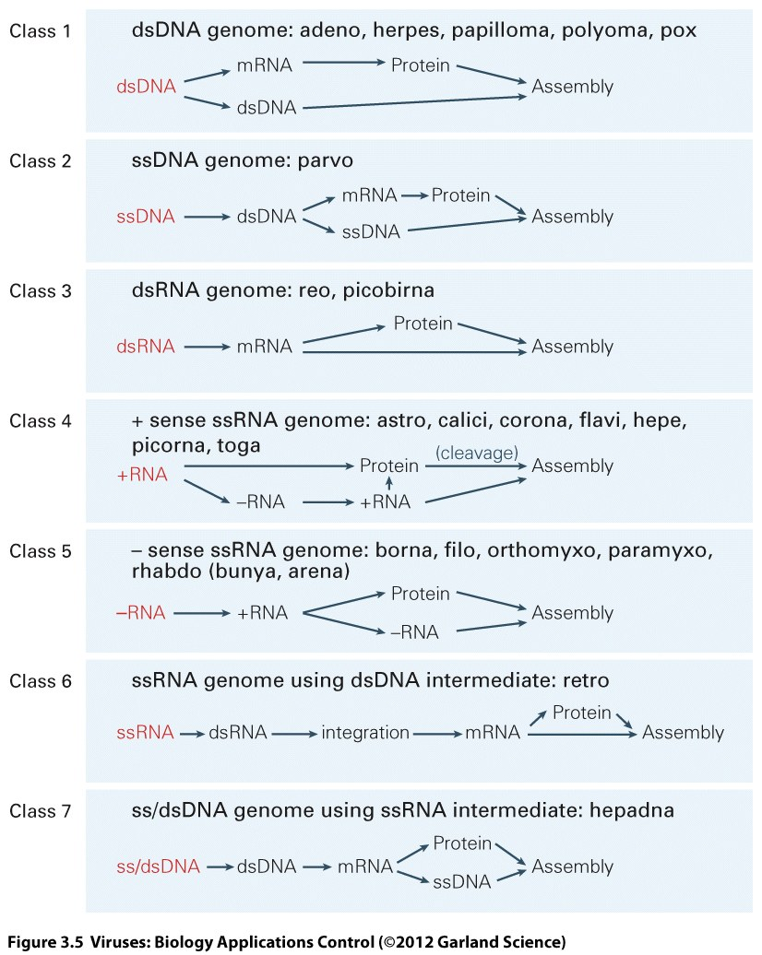

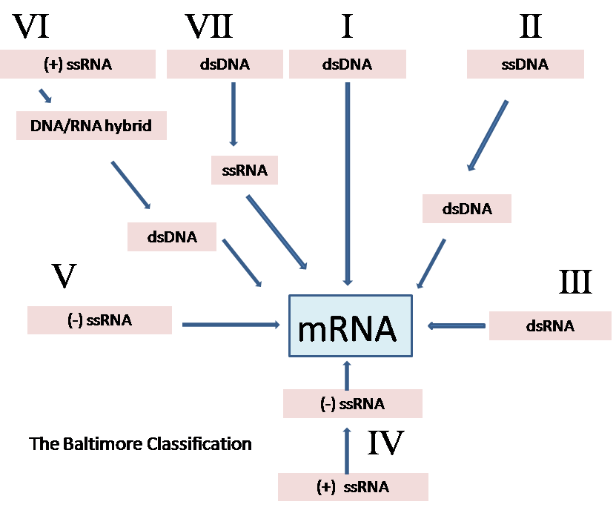

**•         Describe a generic virus replication cycle**

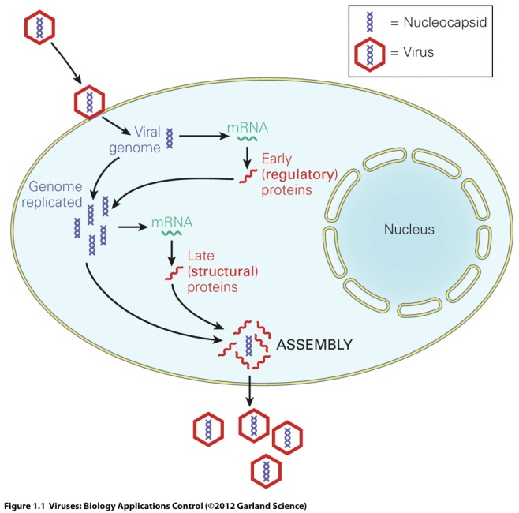

The various sequential steps of the replication cycle of a typical virus are:

1. **Attachment** to the host cell by specific interaction between the virus attachment protein and a host cell receptor (a molecule on the surface of a host cell that has a completely different role but that the virus has evolved to use as its key for entry to the interior of the cell).
2. **Entry** of the virus genome to the host cell and synthesis of viral mRNA (primary transcription).
3. **Translation** of viral mRNAs into viral proteins by host cell ribosomes in the cytoplasm.
4. **Replication** of the viral genome, usually by making a small number of complementary copies that are then themselves copied at high numbers into new genomes (asymmetric replication).
5. **Assembly** of the virus proteins into new virions, association and encapsidation of the new genomes.
6. **Exit** from the infected cells and dissemination to new hosts.

The kinetics of virus replication is described in the one step growth curve:

Time

Plaque forming units

Latent period

Mean burst size

* **Describe how viruses are detected, cultivated and manipulated**

Viruses are very small (10-500 nm diameter) and are visualized with the **electron microscope**.

We also ‘see’ viruses by their effects on their hosts. This can be a plant or animal (*in vivo*) or cells cultured in the laboratory (*in vitro*).

**Primary cell cultures** may include several different cell types and may retain aspects of the original tissue.

**Continuous cell lines** are monocultures propagated indefinitely due to their transformation. They may grow as monolayers on a plastic support or in suspension.

Viruses may produce effects on the cells as they replicate such as **cytopathic effect, cpe**, or syncytia, inclusion bodies, membrane blebbing.

Dilutions of virus can be assayed to find the end point at which they no longer produce such effects. This allows their quantification.

A specific example is the **plaque assay** in which foci of infection can be counted.

Some viruses produce little visible change on the cells but can be detected using antibodies to their proteins that will be expressed during replication. **Immune fluorescence** or immunohistochemistry allow the antibody binding to be seen.

Techniques for ‘seeing’ viruses that do not use cell cultures include detection of the particles or the viral proteins, or the virally encoded nucleic acid.

Viruses that attach to red blood cells can be visualized using the **haemagglutination assay**.

Cells infected by viruses can be lysed and antibodies to viral antigens used in **Western Blot** or **ELISA**.

Nucleic acid detection is usually by **PCR**.

Viruses can be manipulated in the laboratory in order to study them.

Classical genetic techniques involve growing the virus under different conditions, for example temperature or in the presence of a drug, that may induce changes in the genome and studying their effects.

Reverse genetics techniques involve engineering cDNA that represents the sequence of the virus genome, introducing it into cells and recovering an altered virus.

**Give examples of different viruses associated with infectious disease in humans and describe their replication cycles and the way in which they cause disease**

**HIV (human immunodeficiency virus)** is a lentivirus and a member of the retrovirus family. HIV infects and destroys helper T cells of the immune system causing a marked reduction in their numbers. Loss of CD4 cells leads to generalized failure of the immune system and susceptibility to life threatening opportunistic infections.

**gp120** – an HIV glycoprotein having a molecular weight of 120 that protrudes from the outer surface of the virion. This glycoprotein binds to a CD4 receptor on a T cell to facilitate entry of viral nucleic acid and proteins into the cell.

**CD4** – a large glycoprotein that is found on the surface of helper T cells, regulatory T cells, monocytes, and dendritic cells. Its natural function is as a co–receptor that assists the T cell receptor (TCR) to activate its T cell following an interaction with an antigen presenting cell. CD4 is a primary receptor used by HIV–1 to gain entry into host T cells.

**Co–receptor (CCR5 or CXCR4)** – protein molecules on the surface of lymphocytes or monocytes that bind to the gp120 protein of HIV and facilitate, usually with CD4, entry of viral nucleic acid and proteins into the cell.

**Fusion of virus and cell membranes** – a merging of cell and virus membranes that permits HIV proteins and nucleic acids to enter the host cell.

**Preintegration complex (PIC)** – It is composed of viral RNA and proteins (nucleocapsid, p6, Vpr, integrase, and matrix) as well as some host proteins. It functions to reverse transcribe genomic RNA into double stranded DNA prior to integration into the host genomic DNA.

**Reverse transcriptase** – an enzyme found in HIV that creates double stranded DNA using viral RNA as a template and host tRNA as primers.

**Integrase** – An enzyme found in retroviruses including HIV that permits the viral DNA to be integrated into the DNA of the infected cell.

**Protease** – an enzyme that hydrolyzes or cuts proteins and is important in the final steps of HIV maturation.

**Steps in the HIV Replication Cycle**

1. Fusion of the HIV cell to the host cell surface.
2. HIV RNA, reverse transcriptase, integrase, and other viral proteins enter the host cell.
3. Viral DNA is formed by reverse transcription.
4. Viral DNA is transported across the nucleus and integrates into the host DNA.
5. New viral RNA is used as genomic RNA and to make viral proteins.
6. New viral RNA and proteins move to cell surface and a new, immature, HIV virus forms.
7. The virus matures by protease releasing individual HIV proteins.

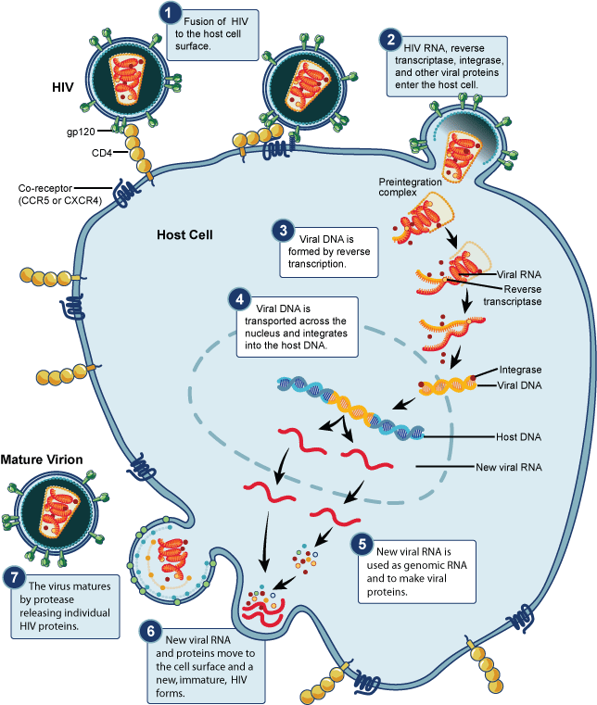**2. How do Viruses cause disease?**

**•       Describe different routes of infection by viruses: define the term tropism and understand what defines the tropism of a virus**

Viruses can enter the body

1. Through the epithelial layers; respiratory tract, GI tract, genital tract
2. Directly into the blood through a bite or needle
3. Through the skin, often following abrasion

From the site of entry the virus may travel, often in the blood (primary **viraemia**), to another organ where amplification via replication takes place. There may be secondary viraemia to the main organ site for replication.

The **tropism** of the virus is the place where it replicates.

Tropism may be determined by the expression of the **host cell receptor**. HIV enters cells through the CD4 molecule found on T cells.

Tropism may also be limited by the ability of the virus to replicate inside a particular cell type due to abundance or paucity of **essential intracellular host cell components**. Polioviruses with mutations in their 5’ noncoding regions cannot utilize neuronal host cell factors to translate their mRNAs.

Tropism may also depend on **extracellular factors** required for activation of virus infectivity. Influenza virus HA protein requires to be cleaved by a host encoded protease expressed in respiratory secretions.

**•      Outline, with named examples, the different modes of transmission of viruses**

Transmission of a virus from one host to another usually requires it to be shed into the environment.

Rarely viruses are transmitted through the germline, acquired through cannibalism (prion diseases like Kuru) or through nosocomial blood contamination (HIV or hepatitis B or C).

Respiratory transmitted viruses are carried in aerosols (influenza, rhinovirus).

Viruses may be shed into the oral cavity and transmitted in saliva (human cytomegalovirus, EBV, mumps).

Enteric viruses are transmitted through the fecal oral route (poliovirus, norovirus, hepatitis A virus)

Viraemic viruses are transmitted through blood (dengue virus when bitten by an arthropod, Ebola virus)

Virus can be present in urine of animals (hantaviruses in rodents) but urine is rarely a source of human to human transmission.

Viruses in skin can be transmitted by direct skin contact, poxvirus, papillomavirus.

**•       Describe different outcomes of infection by viruses: acute infection, persistent infection, latent re-activating infection, slow infection, oncogenesis**

To be a human pathogen, a virus will need to have strategies to counteract host defenses.

The capacity of the virus to cause disease (pathogenesis) will depend on

1. the effects of its replication
2. the strength of the host’s defense system
3. the ability of the virus to spread in and amongst its hosts

**Acute infection** is the typical expected outcome for **influenza**.

Rapid production of infectious virus, rapid resolution and elimination of virus by host immune system.

The outcome is determined by intrinsic and innate immunity.

Acquired immunity stimulated after several days mediates final clearance from the host. Memory provides defense against subsequent exposure.

Acute infections frequently cause epidemics. Transmission occurs before symptoms. Inapparent infections (asymptomatic) are common.

**Persistent infections** also have to overcome innate defense at the start of infection. They are not cleared by the adaptive immune response. They may be **chronic** or lifelong (**latent, slow**).

75-85% people infected by **Hepatitis C virus** will not clear the virus with their CTL response. This may be because the virus rapidly mutates to escape the response by changing its T cell epitopes. Of these chronically infected people, 1-5 % will develop hepatocellular carcinoma. Since more than 170 million people are infected, this accounts for up to 3 million hep carcinoma cases. Chronically infected hepatocytes are destroyed by the immune system leading to fibrous scars (cirrhosis).

The classic example of a **latent virus infection** is **herpes simplex virus**. The virus first replicates in mucosal or epidermal cells. Perpiheral ganglia become infected and produce a large burst of virus that disappears after 1-2 weeks. The virus establishes a latent infection in **terminally differentiated non-dividing neurons** of the peripheral nervous system. Since neurons do not replicate their DNA nor divide, the HSV genome survives inside these host cells. The only evidence of the virus is the expression of RNAs known at latency associated transcripts LATs. By this time the infected host is ‘immune’, they have antibodies to their latent virus. Some people reactivate their virus every 2-3 weeks, others experience few or no reactivation events. Stress signals can trigger reactivation. **Reacitvation** can also be by drugs like glucocorticoids that stimulate transcription but suppress immune responses. Transient production of virions allows spread of the virus across innervated mucosal surfaces to a new host. Then the infected host’s immune response curtails virus production.

**3. How may virus diseases be prevented or treated?**

**•      Describe the difference between prophylactic and therapeutic approaches to virus control**

We use drugs and vaccines to combat viruses. Most vaccines are used **prophylactically**. Most antiviral drugs are given after the person is infected as a **therapeutic** agent, although in controlling diseases outbreaks prophylactic antiviral administration has been used.

**•         Understand the difference between a live attenuated vaccine and an inactivated or subunit vaccine**

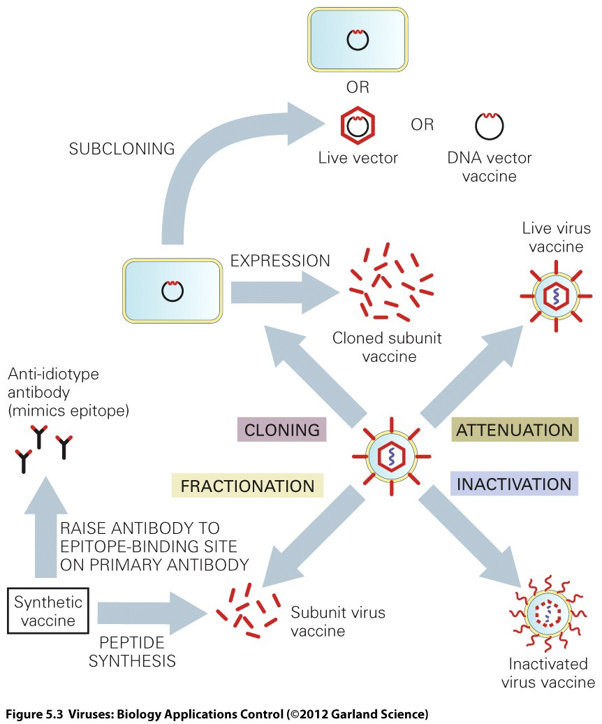

Vaccine history:

The process of **scarification** to prevent smallpox had been practised in the Far East for centuries. Lady Mary Montague encouraged it after observing it in Turkey. Jenner noted that milkmaids exposed to cowpox rarely suffered smallpox. He infected subjects (James Phipps with cowpox (vacca = cow) and proved his theory by showing they did not get smallpox after deliberate inoculation with it.

This was **live vaccination** with a virus attenuated in human host.

Pasteur used dried spinal cords from rabbits infected by rabies to immunize against that disease. This was likely vaccination with **inactivated virus**. The antigen still induced a humoral immune response that was protective.

Today we often further purify the inactivated virus to make a **subunit** preparation of the relevant antigenic viral proteins. Most influenza vaccines contain purified HA and NA proteins. It is impossible to catch flu from this type of vaccine because it is an inert fragment of the virus. Similarly hepatitis B virus vaccine is a subunit vaccine that consists of the surface antigen protein of HBV that has been expressed in recombinant yeast.

**•         Give examples of viral infections for which vaccination can be a successful strategy**

[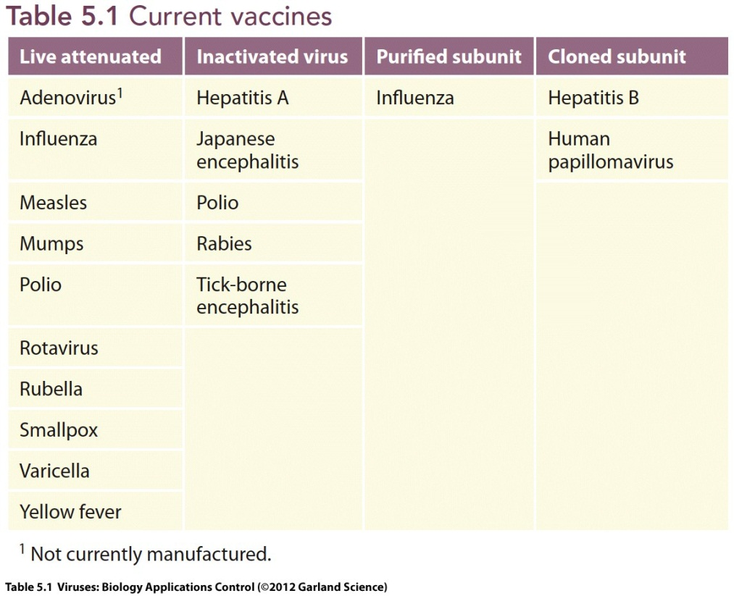](http://www.garlandscience.com/res/9780815341505/figure/table_05_01.jpg)

**•        Describe the eradication of smallpox and similar efforts to control other viral diseases**

After Jenner’s success in 1796 the cowpox used for vaccination was propagated by growth on people’s arms. During the 20th century other strains of poxvirus (vaccinia) that could be grown in quantity on the skins of calves or other animals were used. Although vaccination was widely practised, epidemics flared sporadically across the world. In 1966 WHO invested $2.5 million for an immunization campaign designed to eradicate the disease. This aim was achieved in 1977 after the last case of natural smallpox was detected in Somalia. The end game involved intensive ring vaccination of all persons in the vicinity of the detected cases.

Eradication of smallpox was possible because there is **no animal reservoir** and thus once eliminated from man the disease cannot be reseeded. In addition the ability to detect infected cases due to the **obvious symptoms** and the fact that all infected individuals become symptomatic was crucial.

Today **variola major virus** exists in just two laboratories in the world where it is preserved. Newer versions of vaccinia virus exist that have been developed as safer live attenuated vaccines such as **MVA Ankara**. These can be genetically manipulated to express other antigens and may be used in the future as vaccines against other diseases.

WHO also aims to eliminate poliovirus and measles virus using a vaccination strategy. Poliovirus was largely controlled by two different types of vaccine, an inactivated vaccine known as the **Salk vaccine** and a live attenuated vaccine known as the **Sabin vaccine**.

The animal virus Rinderpest, a relative of measles, was successfully eradicated in 2008.

**•         Explain why it is difficult to develop drugs which selectively act against viral infections**

Viruses are intracellular obligate parasites.

This makes them particularly difficult to combat with chemotherapeutic agents.

It is hard to find a stage of the virus replication cycle to attack with a drug that does not involve a host function. A drug that inhibited viral translation for example would knock out our own cells’ ability to translate mRNAs.

Most antiviral drugs used today are very specific for the particular virus their work against. They usually target **viral enzymes** that have been found to differ from any enzymes used by our own cells. They are difficult to use because an **accurate diagnosis** is required to inform the correct drug choice. Viruses also often develop **resistance** to the drugs particularly if they are used individually.

**•         Give examples of classes of drugs which have been used successfully in antiviral therapy**

The most successful antiviral drug in use today is acyclovir, used to treat herpes virus infections.

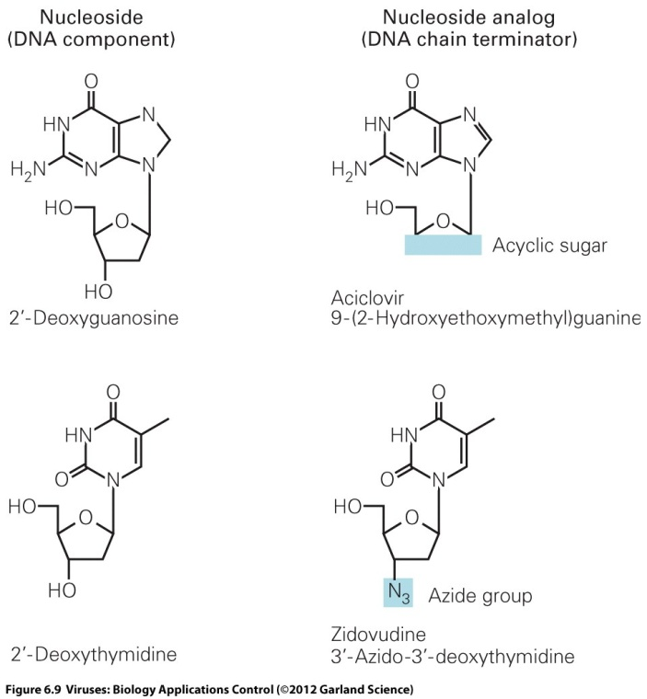

**Acyclovir** is a nucleoside analogue. It is given to the patient in an unphosphorylated (inactive) form, a **prodrug**, that means it cannot yet be used as a substrate in DNA replication. Its specificity comes from the fact that it is only converted into its active form inside a cell that is already infected by herpes virus. This is because the virus encodes an enzyme **thymidine kinase** that can phosphorylate the drug. Once acyclovir triphosphate is incorporated into the growing DNA chain in the herpes virus genome, it **terminates** the reaction because it lacks the OH groups by which the next nucleoside would normally be attached.

**Zidovudine AZT** is also a nucleoside analogue. It was the first anti HIV drug but resistance quickly emerged. Current HIV therapy uses three or four different drugs in combination known as **HAART** highly active antiretroviral therapy. This prevents the virus from being able to generate resistance mutants but does lead to difficult drug regimens and is associated with significant side effects.

Other types of antiviral drugs are protease inhibitors (HCV and HIV), ion channel blockers (influenza) neuraminidase inhibitors (influenza). Interferon is also currently used in combination with ribavirin to treat HCV.

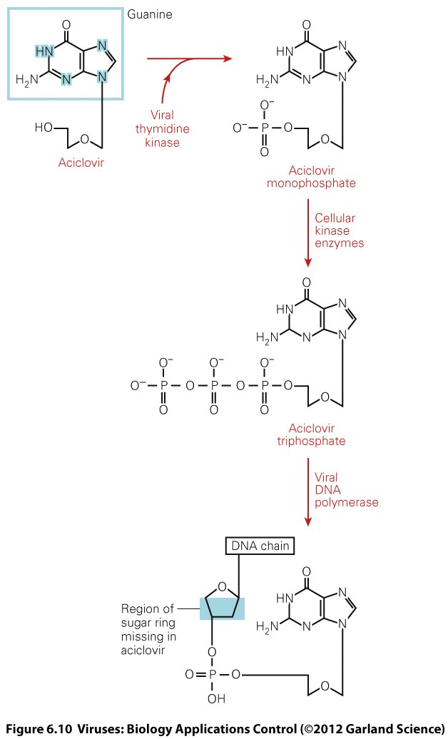

**•         Describe the strategies underlying the search for novel antiviral agents**

A new era of antiviral drug discovery has been sparked by the genomics revolution. We can now identify many host cell genes that viruses need for their replication The hope is that we can target some of them because our genome has some redundancy. A good example of this is the CCR5 protein used by HIV to enter cells and the fact that a group of exposed uninfected individuals remain resistant to HIV because they have a 32bp deletion in CCR5 but are otherwise completely healthy.

There is hope that more broadly acting antivirals may be discovered. New breakthroughs include small molecules that freeze the lipids on enveloped viruses but seem not to affect the plasma membranes of our own host cells.

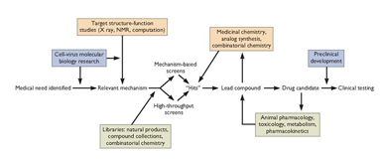

22nd January 2013 – Wolfson Lecture Theatre 3

|  |  |  |
| --- | --- | --- |
| **Time** | **Title** | **Speaker** |
| 09.00-10.00 | Microbes and Society: The Burden of Infectious Disease | Dr James Hatcher |
| 10.00-11.00 | Differentiating between Microbes 1: Bacteria | Dr Hugo Donaldson |
| 11.00-12.00 | Differentiating between Microbes 2: Viruses, Fungi and Parasites | Dr Hugo Donaldson |

The space below is for you to make notes on the above topics

**DIAGNOSTICS 1**

**Introduction to chemical pathology**

Professor Karim Meeran ([k.meeran@imperial.ac.uk](mailto:k.meeran@imperial.ac.uk))

#### Learning objectives

1. List five common diagnostic tests carried out by the department of chemical pathology
2. Know how to collect specimens for common tests including electrolytes, urea, glucose and glycosylated haemoglobin
3. Describe a typical chemical pathology request form

The Department of Chemical Pathology processes samples and measures the concentrations of many important metabolites. Changes in the concentration of metabolites can suggest particular illnesses.

The most commonly requested tests include:

1. **Electrolytes** (including, sodium and potassium).
2. **Urea and creatinine**. High levels suggest failure of renal excretion of these substances and hence renal failure.
3. **Calcium and phosphate**
4. **Markers of liver function** (liver enzymes). Only very small amounts of liver enzymes should enter the bloodstream. Damage to the liver may result in extra amounts of these enzymes leaking into the blood. Particular diseases seem to be associated with particular patterns of liver enzymes. Enzymes commonly measured include
   1. alkaline phosphatase
   2. aspartate amino-transferase (AST)
   3. alanine amino-transferase (ALT)
   4. gamma glutamyl transferase (GGT)
5. **Hormone assays** are done within a subdivision of the chem. Path department (endocrinology). Hormones commonly measured include thyroxine, TSH and cortisol.
6. **Glucose**. This can be rapidly measured using a glucose sensitive stick which can be undertaken in the Ward/clinic/home. A more accurate method is carried out within the laboratory. Red cells will consume glucose, even after it is out of the patient, unless they are poisoned.

What poison is used for this purpose? _____________________________

**Case Study**

Billy is a 26-year-old who has blood taken by his GP.

The chemical pathology department undertake the following tests using the GP request form.

* U + E
* LFT
* Glucose

1. What can you infer from the electrolytes? (Na and K).

2. If the potassium is raised, what important question does the lab need to check?

3. What can you infer from the discrepancy between the urea and the creatinine?

4. Liver “function” tests include albumin and bilirubin as well as the liver enzymes.

5. What can you infer from Billy’s Albumin result?

6. What can you infer from the Bilirubin result, and what would you see on careful examination of Billy’s eyes?

7. Looking at the rest of the form, what are “cardiac enzymes”?

**DIAGNOSTICS 2**

**The diagnosis of infection and the use of the virology laboratory**

Dr. Mark Atkins ([m.atkins@imperial.ac.uk](mailto:m.atkins@imperial.ac.uk?subject=MCD-Virology%20Lab%20lecture))

**Learning objectives**

* Appreciate the range of viruses that can cause human disease.
* Understand what tests are available for diagnosing viral infections.
* Know what clinical samples to take to enable you to make the correct diagnosis.

**When diagnosing a viral illness, taking a good history and performing a clinical examination can often give you the diagnosis. Some infections are easy to diagnose such as shingles and chicken pox. However many have more subtle signs. When talking a history it is important to include, vaccination history, travel (especially in the previous 3 weeks), contact with animals/pets, contact with infected persons and occupation. This information may give you some important clues.**

**Diagnosis depends on the clinical findings, the detection of specific antibodies and/or the detection of a virus in the appropriate clinical sample.**

# Virological tests- ideal tests should have the following qualities

## High specificity i.e. have a low level of cross reactivity.

## Sensitive- detect the virus or the antibody at very low levels

## Rapid- results should be available in a timely fashion.

## Non-invasive. This reduces the risks of the procedure and makes then easier to repeat if necessary.

## Cost effective. Most virology tests only cost a few pounds each but some of the molecular tests are significantly more expensive, so use them wisely.

# Diagnostic methods

## Cell culture

## Electron microscopy (EM)

## Antibody detection e.g. HIV antibody

## Antigen detection e.g. HBsAg in hepatitis B infection or RSV antigen in respiratory sample

## Genome detection – e.g. using PCR to detect viral DNA or RNA

## Quantification of antigens and genomes (now essential for diagnosis and monitoring of HIV, HBV and HCV)

# Samples to take will depend on the disease being investigated

## Throat swab - for virus isolation (in virus transport medium, VTM) - useful in the diagnosis of enteroviruses and respiratory viruses.

## Stools - for EM and Rotavirus EIA (in sterile pot) - for the diagnosis of enteroviruses and viruses that cause diarrhoea such as rotavirus, astrovirus, adenovirus, noroviruses, etc.

## CSF - PCR for herpes and enteroviruses (in sterile container, VTM (viur transport medium) not required) - for the diagnosis of viruses causing meningitis or encephalitis such as HSV, VZV, enteroviruses, mumps, etc.

## Nasopharyngeal aspirate (NPA) - for respiratory viruses using Immunofluoresence (IF) or PCR, such as RSV, influenza A&B, adenovirus, parainfluenza viruses, SARS etc.

## Urine - virus isolation or PCR depending on which viruses you are interested in (in sterile container), e.g. BK virus, CMV, etc.

## Blood (clotted) - for antibody detection

## Blood (EDTA) - for PCR. Used for detection and quantification of HIV, HBV and HCV.

**Biopsy samples can be useful in certain circumstances e.g. brain biopsy in encephalitis.**

# Electron microscopy

## Virus structures can be visualised using an electron microscope

## Used mostly for stool samples.

# Immunofluorescence (IF)

## Useful for the direct detection of viral antigens in clinical samples (eg respiratory viruses)

## Can be used for typing and culture confirmation

## Relatively quick and inexpensive but subjective and very dependent on the skill of the technician and the quality of the sample

# Enzyme Immuno assays (EIA’s)

# Detection of antibodies and antigens using immunoassays.

## EIA’s (enzyme immunoassays)

## Western blots

## RIBA’s (recmbinant immunoblot assays useful for eg typing anti-HIV 1 &/or 2)

## Specific, sensitive and relatively easy to automate.

## Can be adapted to detect specific antibody classes e.g. IgM IgG or IgA.

## Sensitive and can quantify amounts of antibody (e.g. anti –HBs antibody)

## Adaptable to antibody or antigen detection

## Examples include HIV antibody and antigen, Hepatitis A,B,C serology, rubella, mumps, parvo etc

# EIA’s for HIV antibody detection

## Detection of specific antibody is an indirect method of detecting infection.

## Non-specific reactions can be a problem, therefore it is important to use multiple formats (generally use 3 different assays).

## Interpretation of results must take the clinical circumstances into account.

# Viral gene detection and quantification

## Polymerase chain reaction PCR (a target amplification system)

## bDNA (signal amplification system)

## Both assays used to measure “viral load” in HIV, HCV HBV infection.

# Polymerase chain reaction

## Target amplification to allow detection and quantification over very large dynamic ranges (> 5-8 logs)

## Can be very sensitive (as low as 1 genome copy)

## Can subtype viruses from PCR products

## Problems with contamination. This can be overcome using “Real Time” PCR.

# “Real Time” PCR. Advantages

## Quantification during linear phase gives better reproducibility, precision and dynamic range.

## Readily adapted to multi-plexing i.e. detect multiple viruses in the samples simultaneously.

## Closed tube monitoring eliminates contamination

# Summary

Many virus infections can be diagnosed by the detection of specific antibodies. This is particularly so for HIV, HCV and HAV.

The detection of viruses in the appropriate clinical sample using cell culture, immunofluorescence or PCR can be diagnostic during acute or chronic infections.

Modern detection methods e.g. PCR can be applied to most viruses. These are very powerful diagnostic tools but they must be used with caution.

## Antibody and antigen detection will be supplemented by genome detection and quantification for a wider range of viruses

## Resistance testing, genotyping and other DNA/RNA based tests are become more widely used.

## However, as with all tests, the results need to be interpreted in the clinical context of the patient.

**DIAGNOSTICS 3**

**The diagnosis of infection and the use of the bacteriology laboratory**

**Dr Hugo Donaldson (**[**h.donaldson@imperial.ac.uk**](mailto:h.donaldson@imperial.ac.uk) **)**

**Learning Objectives:**

1. Explain the concept of best-guess microbiological diagnosis and the contribution of the laboratory to it.
2. Describe the investigations the microbiology laboratory does and their limitations
3. Describe the limitations of microbiology laboratory investigations.
4. Be aware of the turn-around times of different investigations, particularly the delays inherent in making cultural diagnoses.
5. To know how to interpret laboratory results of the commonly used tests.

The initial diagnosis of infection is based on the principles of making an informed best-guess clinical diagnosis.

Present illness: date of onset, symptoms, signs (esp. rashes)

Past history: previous infections particularly with resistant organism e.g. MRSA, hospitalizations, travel, antimicrobial use.

**Types of investigation made by the microbiology lab:**

* **Most microbiology samples are cultured on agar plates, which takes time:**

For organisms to multiply sufficiently: usually 24-48 hours

(Some need longer incubation: e.g. TB, brucella, actinomycetes)

To culture again for antibiotic sensitivities: another 24 hours

* **Microscopy**

direct under the microscope – urine

various stains (Gram, Ziehl-Nielsen (ZN), *etc*.) – pus, tissue fluids

fluorescence, with conjugated antibodies to specific antigens

* **Direct antigen detection** (particle agglutination tests, ELISA)
* **Molecular probes and amplification** (PCR, *etc*.)
* **Serology**: looking for antibodies as evidence of infection/immunity

**Optimal time of Collection of Specimen**

* In the acute phase of illness and before staring antimicrobials
* Collection from proper site, avoiding contamination by normal flora
* Prompt transport to lab since micro-organisms multiply in transit
* Adequate quantity and appropriate number of specimens
* Acute sera and Convalescent sera (paired), for rising antibody titres

**EXAMPLES:**

**Microbiological examination of Urine**

* Bedside: Naked eye - clear, cloudy, haemorrhagic.   
  note: although these are NOT microbiological investigations dipstick tests for nitrites, leucocytes, blood, protein, bilirubin, ketones may provide indication of there being an infection. Nitrites strongly suggest bacteriuria as many species of gram-negative bacteria convert nitrates to nitrites.
* Microscopy: WBC (pyuria suggests infection), RBC (may also indicate tumour/microemboli/trauma), epithelial cells (suggest the specimen has been contaminated during collection), crystals, casts.
* Culture on MacConkey agar (urine should be sterile so any microbial growth is potentially significant in an appropriately taken sample)
* Quantitative colony count for “significant” bacteruria (>105 bacteria/mL)
* Antibiotic sensitivity testing of bacteria that grow

**Microbiological examination of faeces**

* Naked eye, consistency, blood stained, colour, presence of worms
* Microscopy: ova, cysts, parasites
* Culture on inhibitory media – e.g. deoxycholate-citrate agar (DCA), selenite (Faeces contains 1012-14 bacteria per gram, so selective media are used to suppress background ‘flora’ organisms)
* Certain organism such as *Vibrio cholerae* are not looked for routinely therefore it is important adequate clinical information is provided on the request to allow the appropriate laboratory investigations to be carried out.
* Toxin detection (*Clostridium difficile*)
* Special stains, *e.g.* for cryptosporidia

**Examples - microscopy**

* Gram stain of CSF, joint fluid, purulent exudates.
* ZN/auramine stain of *e.g*. sputum, for TB
* FTA (fluorescent treponemal antibody) for antibodies to *T. pallidum*

**Examples – direct antigen detection**

* Meningococcal antigen in CSF
* *C. difficile* toxin in faeces
* Legionella and Pneumococcal antigen in urine

**Examples – PCR**

* Chlamydia in genital specimens
* Rapid PCR for MRSA

**Investigations on Billy** (case study)

**Diarrhoea**

* **Microscopy of stool for parasites**, especially giardia, amoeba (which cause diarrhoea but not rashes) and for higher parasites (may cause rashes but rarely diarrhoea). Stool culture for the common bacterial pathogens – salmonella, campylobacter, shigella. Stool result often negative.
* **Rash/skin lumps**. Often viral aetiology. Also, infected insect bites, syphilis, gonococcal infection, typhoid, endocarditis, systemic parasites.   
  ? Take skin biopsy – prolonged cultures for TB, fungi.

**DIAGNOSTICS 4**

**Cellular pathology**

# Prof. Rob Goldin

**Aims & Objectives:**

The aim of this lecture is to gain a broad understanding of how histopathology and cytopathology aid in diagnosis of disease.

By the end, students should be able to:

* List 3 situations where histopathology and cytopathology might commonly be used as a diagnostic method.
* Describe the nature of specimens sent for histopathology and cytopathology laboratory diagnosis.
* List 2 situations where frozen section diagnosis is required
* Summarise the main steps involved in processing a specimen for routine histopathology diagnosis and indicate the likely time needed to carry out these steps.
* Explain the additional information available from immunohistochemistry, and give an example of when this technique may be used
* Describe the benefits of the autopsy
* List 3 benefits of cytology screening

**Pathology** is the medical science and specialty practice that deals with all aspects of disease, but with special reference to the essential nature, the causes, and development of abnormal conditions, as well as the structural and functional changes that result from disease processes - more simply it is the study of disease. The literal translation of pathology from Greek (pathos, -logos) is "the words of suffering." Pathologists study: the causes of disease; how various internal and external derangements or injuries affect certain cells and tissues; the progression of disease in the human body (its pathogenesis); how disease is manifest (its clinical expression and the lesions produced); and methods for monitoring disease progression. Pathology provides a scientific foundation for clinical medicine and serves as a bridge between the basic sciences and patient care.

**Histopathology** encompasses surgical and autopsy pathology and histopathologists make diagnoses on tissue - biopsy material, surgical specimens removed at operation, make rapid diagnoses when necessary at operations by use of “frozen sections”. The autopsy (post mortem) is performed to determine the cause of death of a patient, explain why treatment was unsuccessful, to show the spread of disease and to educate doctors regarding disease processes.

**Cytopathologists** make diagnoses on cells - cellular specimens – sputum, body fluids which contain cells, cervical smears and tissue obtained by fine needle aspirate (FNA). This is a less invasive technique than obtaining tissue for a biopsy and thus has advantages to the patient.

**Biopsies are taken for numerous reasons.** Common conditions that require biopsies are skin lesions (inflammatory and suspected tumours). If a tumour is suspected clinically this may be removed intact, with a margin of normal skin to ensure excision of the tumour. However a rash may simply require a punch biopsy to determine the nature of the inflammation.

Endoscopy enables the clinician to view the gastrointestinal tract. Biopsies are commonly taken from the stomach to exclude for example cancer, the duodenum to exclude coeliac disease and the large bowel to confirm cancer or diagnose inflammatory bowel disease.

Bronchoscopy allows a view of the trachea and bronchi and biopsies of suspected tumours or inflammatory lung conditions can be taken

Liver biopsies can be performed under imaging guidance for tumours or for diagnosis of liver disease.

Renal biopsies are taken to determine the nature of glomerulonephritis and other renal disease

**Cytopathology** is very helpful in diagnosis of lung tumours and is non invasive.

Cytopathology can also aid diagnosis in endoscopy when brushings of the tumour can be taken. It is used in cervical and breast screening. Fluids such as urine and ascities can be examined for cells,

Surgical specimens removed at operation are all sent to Histopathology for diagnosis and to determine if a tumour is completely excised.

The histopathologists and cytopathogists will generate a report of the examination of the specimen, which is sent to the clinician responsible for the patient. It is important that the report gives a conclusive diagnosis and a statement of tumour excision and prognostic features – for example if surrounding lymph nodes are involved or the tumour spread on to the peritoneum.

# How long does a histopathology result take to reach the clinician?

Specimens for histopathology (biopsies and whole tissue) must be “fixed” in formalin, a preservative that stabilises protein bonds and prevents autolysis. The tissue then must be processed, sections cut and stained and the histopathologist must write the report.

For large specimens, allowing for overnight fixation or longer if the specimen is large or fatty, this process should take 2-3 days. Small biopsies can be processed in a day and if a rapid diagnosis is required then rapid processing takes 4-5 hours.

A very rapid diagnosis may be required during an operation – is this a tumour? Is the margin of excision adequate? Is this lymph node involved? Have I got the parathyroid?

Frozen section tissue is received in the laboratory without any fixative. A small sample is selected and frozen rapidly. A thin section is cut on a microtome contained in a refrigeration cabinet, fixed rapidly and then stained with haematoxylin and eosin. An answer can be given by phone within 20 minutes.

# How are sections obtained?

All specimens are allocated an identity number and logged in to the computer.

During the daily cut up of specimens the pathologist or biomedical scientist selects and describes the tissue samples to be examined. Some specimens (for example biopsies) are processed whole, while larger specimens (e.g. mastectomies, colonic specimens) have a few selected pieces removed. Each selected piece of tissue is placed in a small perforated plastic container with a lid. This plastic cassette receives the laboratory number. These tissue blocks are processed to paraffin wax. This small sample of the tissue must have the water extracted by dehydration through alcohols to be impregnated with paraffin wax that allows the block to be cut to thin sections using a microtome and the section mounted on glass slides. Sections are usually cut at around 5 microns thick - a micron is one thousandth of a millimetre!

The number of blocks cut every day varies from 50-400 and several sections may be taken from certain blocks – levels through the tissue to extract maximum information. The sections are rehydrated and stained with haematoxylin and eosin (H&E). Haematoxylin stains nuclei blue and eosin the cytoplasm pink. The sections are then viewed using the microscope.

# Additional stains

Most diagnoses can be made by simple H&E staining, however additional stains can help diagnosis. According to the dyes or chemicals used it is possible to stain certain tissue components selectively. For example, silver nitrate solutions may be used to identify melanin pigment, fungi, calcium deposits and certain types of fibres. Other dyes are used to show glycogen, mucins and types of structure within the tissues. It is also possible to demonstrate tuberculosis bacilli by the Ziehl-Neelsen methodand bacterial infections by Gram’s method. However for difficult tumours immunocytochemistry techniques are needed which use antibody systems to label antigens within tissues. Thus epithelial, mesochyme, nerve, prostate tissues can be specifically identified.

# The autopsy

Autopsies may be performed by authority of the Coroner (suspicious/ unknown cause of death) or by permission of the relatives of the decreased – the questions that can be answered include:

* What happened as a terminal event?
* Was the treatment successful but complications occurred?
* Where did the cancer originate?
* Was my diagnosis correct?

# Cytopathology

Cervical smears are prepared preserved (fixed) with alcohol, stained by a special stain called Papanicolaou and permanently preserved. Most of the preparation methods within the laboratory are automated. Preparatory work is carried out by well-trained and experienced MLSOs. Slides are read by trained screening technical staff and abnormalities found checked by consultants.

Cervical smears are performed to pick up cervical cancer as part of the screening programme - Screening only has value if these (and other) criteria can be met:

1. Test is easy and non invasive
2. High take up in the population
3. A significant number of cases can be detected.
4. Something can be done about the disease.

However there are problems with for example, cervical screening:

1. Failure to obtain a satisfactory sample (smear).
2. Failure to make a proper smear.
3. Poor staining.
4. Poor interpretation

For benefit analysis of screening see <http://bmj.com/epidem/epid.a.html>

DIAGNOSTICS 5

ANTIBODIES AS DIAGNOSTIC TOOLS: Immunology in Diagnostics

**Dr. Keith Gould ([k.gould@imperial.ac.uk](mailto:k.gould@imperial.ac.uk) )**

**Key Developments**

* Immunology is a rapidly growing field
* Following infections, patients’ sera contain antibodies which neutralise the infective agent
* There are different classes of antibody proteins – immunoglobulins (Igs) with overlapping and unique functions
* The unique specificity of antibodies for their target antigens is the basis of many diagnostic tests.
* The ability to immunise animals to obtain antibodies with defined specificities
* Coupling of reporter molecules to antibodies
* Hybridoma technology and monoclonal antibodies
* Genetically engineered antibodies
* Therapeutic antibodies

**TECHNOLOGY**

* **Antibody Manufacture**
  + Polyclonal antibody production
  + Monoclonal antibody production
  + Engineered antibodies
* **Antigen-Antibody Interaction**
  + Immunoprecipitation
  + Haemagglutination
  + Agglutination
* **Labeling with reporter molecules**
  + Radioisotopes
    - Radioimmunoassays (RIA)
    - Autoradiography
  + Enzymes
    - Enzyme-linked immunoassays (ELISA)
    - Immuno-enzyme staining
  + Fluorescent probes
    - Fluorescent microscopy
    - Flow Cytometry
  + Magnetic Beads
    - Cell separation
  + Coloured Beads
    - Luminex assays

**USE OF MANUFACTURED ANTIBODIES**

**Therapeutic**

* Prophylactic protection against microbial infection
* Anti-cancer therapy
* Removal of T-cells from bone marrow grafts
* Block cytokine activity

**Diagnostic**

* Tissue typing
* Blood group serology
* Immunoassays
  + Hormones
  + Antibodies
  + Antigens
* Immunodiagnosis
  + Infectious diseases

**ANTIBODIES IN CLINICAL PRACTICE**

**Clinical Immunology**

* Immunodeficiency
* Malignancy
* Autoimmunity
* Inflammation
* Tissue typing and transplantation

**Pathology**

* Clinical Chemistry
* Haematology and Blood Transfusion
* Medical Microbiology
* Histopathology

**Antibodies produced by the patient**

**Manufactured antibodies**

**BACK TO THE CASE:-**

|  |  |
| --- | --- |
| **Signs & Symtoms** | **Immunological Concerns** |
| * vague aches and pains * Loss of appetite Weight loss * “Glands” up in his neck * Fever, rash, small red patches, some lumpy * Diarrhoea | * Immune complexes * Effect of poor nutrition on bone marrow cells * Immune activation * Acute Phase, activation, complexes * Protein-losing enteropathy |

|  |  |
| --- | --- |
| **Immunological Work Up** | |
| **First Line Tests**   * FBC and differential * CRP, ESR, etc. * Immunoglobulins * Complement C3 & C4 * Lymphocyte subsets * Autoantibody screening tests | **Second Line Tests**   * Complement Functions * Specific antibodies * Neutrophil functions * Lymphocyte functions * Molecular tests |

Useful links

[www.science4u.info](http://www.science4u.info)

a website created for the annual Schools Science Conference project and showing how a modern Immunology Lab functions.

**Visit the** [Virtual laboratory (http://www.science4u.info/virtuallab/index.htm)](http://www.science4u.info/virtuallab/index.htm)

<http://www.hfhealth.nhs.uk/pathlab/default.asp>

7th February 2013 – Wolfson Lecture Theatre 3

|  |  |  |
| --- | --- | --- |
| 09.00-10.00 | Fungi and Human Disease | Dr Darius Armstrong James |
| 10.00-11.00 | Helminth Infections | Professor Alan Fenwick O.B.E. |
| 11.00-12.00 | Malaria | Dr Lucy Lamb |

The space below is for you to make notes on the above topics8th February 2013 - Wolfson Lecture Theatre 3

|  |  |  |
| --- | --- | --- |
| 14.00-15.00 | Gram Positive Bacteria | Dr Lionel Tan |
| 15.00-16.00 | Gram Negative Bacteria | Dr Claire Thomas |
| 16.00-17.00 | Diagnostic Tests in Microbiology | Dr Annette Jepson |

The space below is for you to make notes on the above topics

Classification of medically important bacteria



**Others**

**Organisms that stain poorly with gram’s stain -**

**Mycobacteria - Acid Fast**

**Spiral bacteria - Treponema, Leptospira, Borrelia**

**Mycoplasma - lack cell wall**

**Rickettsia, Coxiella, Chlamydia - intracellular**

12th February 2013 – Wolfson Lecture Theatre 3

|  |  |  |
| --- | --- | --- |
| 14.00-15.00 | Mechanisms of Action of Antibiotics | Dr Hema Sharma |
| 15.00-16.00 | Resistance to Antibiotics | Dr Luke Moore |
| 16.00-17.00 | Principles of Good Antibiotic Prescribing | Mr Mark Gilchrist |

The space below is for you to make notes on the above topics

18th February 2013 – Wolfson Lecture Theatre 3

|  |  |  |
| --- | --- | --- |
| 10.00-11.00 | How Infection Spreads: How it is Interrupted | Dr Eimear Brannigan |
| 11.00-12.00 | Principles of Vaccination | Dr Mark Atkins |

The space below is for you to make notes on the above topics

22nd February 2013 - Wolfson Lecture Theatre 3

|  |  |  |
| --- | --- | --- |
| 09.00-10.00 | Pathogenesis of AIDS | Professor Sunil Shaunak |
| 10.00-11.00 | Tuberculosis | Dr Moerida Belton |
| 11.00-12.00 | Fever in the Returning Traveller | Dr Maria-Cristina Loader |

The space below is for you to make notes on the above topics

25th February 2013 - Wolfson Lecture Theatre 3

|  |  |  |
| --- | --- | --- |
| 11.00-12.30 | Physiological and Immunological Changes in Sepsis | Professor Shiranee Sriskandan |

# The space below is for you to make notes on the above topics

**Important note for students.**

**The papers below (cases 1-5) are reviews that will be discussed in the session on March 15th. Please read these papers and write short notes on the cases 1-5 for that interactive session. You have some white space time this afternoon to do this.**

**Case study tutorials: Pathophysiology of Infection**

**Microbiology Case 1**

An elderly woman, with a background history of type 2 diabetes mellitus, is readmitted one week after discharge from the Care of the Elderly ward, where she was treated for an infective exacerbation of COPD (airways disease). She has profuse diarrhoea, abdominal pain, and a white cell count of 40 x109/L (normal 4-9 x109/L). Abdominal xrays reveal megacolon and faecal testing demonstrates presence of Clostridium difficile toxin A and B. Despite treatment for Clostridium difficile (metronidazole), 2d after admission the patient suffers a sudden deterioration due to large bowel perforation. Faecal culture confirms Clostridium difficile, strain type 027. The patient develops overt septic shock with hypotension, renal impairment, acidosis, and acute respiratory distress syndrome.

1. What are the factors contributing to the illness leading to this patient’s re-admission and its severity?
2. What aspects might be amenable to therapy?
3. What are the factors (microbial and others) contributing to her secondary illness?

**Case 2**

An 85 year old man with congestive cardiac failure develops a suppurating wound infection overlying a total knee replacement. Cultures of pus yield Staphylococcus aureus, and oral flucloxacillin therapy is commenced. The infection continues with a rising CRP although the wound appears to heal over and he is sent home to complete a 2 week course . Two months later he is re-admitted with an apparent acute stroke, but blood cultures show S. aureus in multiple bottles. Echocardiography shows a large vegetation on the aortic valve and a CT head scan shows a lesion compatible with a brain abscess .

1. What are the bacterial factors which have allowed this infection to start and progress (biofilm, resistance to immune response)?
2. Why were the antibiotics insufficient (bacterial factors, patient factors)?

**Case 3**

A 73 year old alcoholic man is brought to casualty unconscious with a high fever, plus a vague history from friends of ‘not being quite right’ for a few days. Examination reveals a high fever, signs of a pneumonia on the left, and hypotension. The patient is confused and disorientated. Blood tests show a neutrophil leukocytosis (high neutrophil count), raised CRP, renal and liver impairment. He is hypoxic, needs oxygen therapy, and a chest x-ray shows consolidation throughout the left lower lobe. He is commenced on broad spectrum antibiotics and initial blood cultures yield Gram positive cocci subsequently identified as Streptococcus pneumoniae .

1. What are the likeliest mechanisms for confusion in this patient (consider infective or non-infective)?

2. can you explain how severe disease has developed in this patient?

**Case 4**

A previously fit 60 yr old Nigerian postman, who has lived in the UK for 40 years, has just returned from a trip to Nigeria where he stayed for 3 weeks, visiting his brother, who has returned with him. His friends bring him into hospital with a fever and weakness which is of two days duration; he stopped passing any urine one day ago. His blood film shows 20% falciparum malaria. He also has a severe coagulopathy, severe anaemia, renal failure and pulmonary oedema. His brother also has a fever and mild headache but is otherwise well and has only 0.3% falciparum malaria on his blood film.

# 1. Discuss what has led to the severe disease in the postman.

# 2. What might be the consequences of these clinical findings?

# 3. Why is his brother so mildly affected?

# Case 5

A 29 year old marketing consultant falls ill towards the end of a ski-ing trip, staying in a chalet with his 20 year old brother and 3 of the brother’s university friends. Despite being unwell with a petechial rash, he travels back to the UK on Eurostar and presents himself to A&E. On examination he has signs of fever, tachycardia, and meningism but is otherwise well. A lumbar puncture shows abundant neutrophils, elevated protein, and Gram negative diplococci in the csf. Immediate treatment is commenced with cefotaxime, and switched to benzyl penicillin when sensitivities are confirmed. Blood cultures were also positive for meningococci (serogroup C) The patient makes a slow but steady recovery.

1. Briefly discuss how he might have contracted this infection, and what factors may have permitted colonization and development of invasive infection.

2. Why did none of his co-travellers fall ill?

**Suggested reading for cases 1-5**

All articles should be available either directly via PubMed using a College computer OR via the College electronic journal listing (accessed via the library website). Please notify the module leader if you cannot access an article only after trying both routes (check with colleagues first) As this is a rapidly moving subject and the course brings together several classically ‘separate’ fields there is no current textbook which is recommended.

# Clostridium difficile and septic shock (Case 1)

Hurley BW, Nguyen CC. The spectrum of pseudomembranous enterocolitis and antibiotic-associated diarrhea.Arch Intern Med. 2002 Oct 28;162(19):2177-84. Review.

Voth DE, Ballard JD. Clostridium difficile toxins: mechanism of action and role in disease. Clin Microbiol Rev. 2005 Apr;18(2):247-63. Review.

Aslam S, Hamill RJ, Musher DM.Treatment of Clostridium difficile-associated disease: old therapies and new strategies. Lancet Infect Dis. 2005 Sep;5(9):549-57. Review.

*OPTIONAL (Warny M, Pepin J, Fang A, Killgore G, Thompson A, Brazier J, Frost E, McDonald LC. Toxin production by an emerging strain of Clostridium difficile associated with outbreaks of severe disease in North America and Europe. Lancet. 2005 Sep 24-30;366(9491):1079-84).*

Geerlings SE, Hoepelman AI. Immune dysfunction in patients with diabetes mellitus FEMS Immunol Med Microbiol. 1999 Dec;26(3-4):259-65. Review.

[Zeerleder S, Hack CE, Wuillemin WA.](http://www.ncbi.nlm.nih.gov/entrez/query.fcgi?cmd=Retrieve&db=pubmed&dopt=Abstract&list_uids=16236964&query_hl=16&itool=pubmed_docsum)Disseminated intravascular coagulation in sepsis.Chest. 2005 Oct;128(4):2864-75. Review.

Hack CE, Zeerleder S. The endothelium in sepsis: source of and a target for inflammation. Crit Care Med. 2001 Jul;29(7 Suppl):S21-7. Review

# Staphylococcus aureus and biofilm (case 2)

Darouiche RO. Treatment of infections associated with surgical implants. N Engl J Med. 2004 Apr 1;350(14):1422-9. Review.

Dunne WM Jr. Bacterial adhesion: seen any good biofilms lately?Clin Microbiol Rev. 2002 Apr;15(2):155-66. Review.

[Foster TJ.](http://www.ncbi.nlm.nih.gov/entrez/query.fcgi?cmd=Retrieve&db=pubmed&dopt=Abstract&list_uids=16322743&query_hl=1&itool=pubmed_docsum) Immune evasion by staphylococci.Nat Rev Microbiol. 2005 Dec;3(12):948-58. Review

**S. pneumoniae and respiratory tract/CNS infection (case 3)**

1. <http://www.ncl.ac.uk/nsa/coma.html>

2. van de Beek D, de Gans J, Tunkel AR, Wijdicks EF.Community-acquired bacterial meningitis in adults. N Engl J Med. 2006 Jan 5;354(1):44-53. Review

3. [Gillespie SH, Balakrishnan I.](http://www.ncbi.nlm.nih.gov/entrez/query.fcgi?db=pubmed&cmd=Retrieve&dopt=AbstractPlus&list_uids=11129716&query_hl=39&itool=pubmed_DocSum) Pathogenesis of pneumococcal infection.

J Med M

**Malaria immunity and pathophysiology (case 4)**

[Planche T, Krishna S.](http://www.ncbi.nlm.nih.gov/entrez/query.fcgi?db=pubmed&cmd=Retrieve&dopt=AbstractPlus&list_uids=16148522&query_hl=45&itool=pubmed_DocSum) The relevance of malaria pathophysiology to strategies of clinical management. Curr Opin Infect Dis. 2005 Oct;18(5):369-75. Review

Marsh K, Kinyanjui S. Immune effector mechanisms in malaria.

Parasite Immunol. 2006 Jan-Feb;28(1-2):51-60. Review.

Holmes CL et al: Chest. 2003 Sep;124(3):1103-15.

**Inherited and acquired influences on meningococcal infection (groups doing case 5)**

[MacLennan J, Kafatos G, Neal K, Andrews N, Cameron JC, Roberts R, Evans MR, Cann K, Baxter DN, Maiden MC, Stuart JM; United Kingdom Meningococcal Carriage Group.](http://www.ncbi.nlm.nih.gov/entrez/query.fcgi?db=pubmed&cmd=Retrieve&dopt=AbstractPlus&list_uids=16707051&query_hl=87&itool=pubmed_DocSum)Social behavior and meningococcal carriage in British teenagers.Emerg Infect Dis. 2006 Jun;12(6):950-7

Vermont CL, de Groot R, Hazelzet JA. Bench-to-bedside review: genetic influences on meningococcal disease. Crit Care. 2002 Feb;6(1):60-5. Epub 2001 Nov 26. Review

**Non-essential additional reading for those who are interested**

***Innate immune response to infection***

Toll receptors Akira S, Uematsu S, Takeuchi O.Pathogen recognition and innate immunity. Cell. 2006 Feb 24;124(4):783-801. Review.

Defensins/antimicrobial peptides Ganz T. Nat Rev Immunol. 2003 Sep;3(9):710-20.

Complement Gasque P. Mol Immunol. 2004 Nov;41(11):1089-98

## Neutrophils and bacterial clearance

[Nourshargh S, Marelli-Berg FM.](http://www.ncbi.nlm.nih.gov/entrez/query.fcgi?cmd=Retrieve&db=pubmed&dopt=Abstract&list_uids=15745858&query_hl=74&itool=pubmed_docsum)Transmigration through venular walls: a key regulator of leukocyte phenotype and function.Trends Immunol. 2005 Mar;26(3):157-65. Review.

Underhill DM, Gantner B. Integration of Toll-like receptor and phagocytic signaling for tailored immunity. Microbes Infect. 2004 Dec;6(15):1368-73. Review.

Segal AW.How neutrophils kill microbes. Annu Rev Immunol. 2005;23:197-223. Review.

*Evasion of the innate host immune response by pathogens*

Coombes BK. Curr Biol. 2004 Oct 5;14(19):R856-67.

Voyich. Microbes Infect. 2004 Oct;6(12):1117-23. Review.

**CONTROL OF CALCIUM AND PHOSPHATE: VITAMIN D, PTH AND THE KIDNEY**

Prof Karim Meeran

([k.meeran@imperial.nhs.uk](mailto:k.meeran@imperial.nhs.uk))

Calcium, phosphate, vitamin D and parathyroid hormone.

99 % of the calcium in a human is in his or her skeleton. The plasma calcium is tightly controlled to remain between 2.2 and 2.6 mM and represents a tiny proportion of the total body calcium. Circulating calcium important in the control of nerve and muscle and changes cause muscle depolarisation .

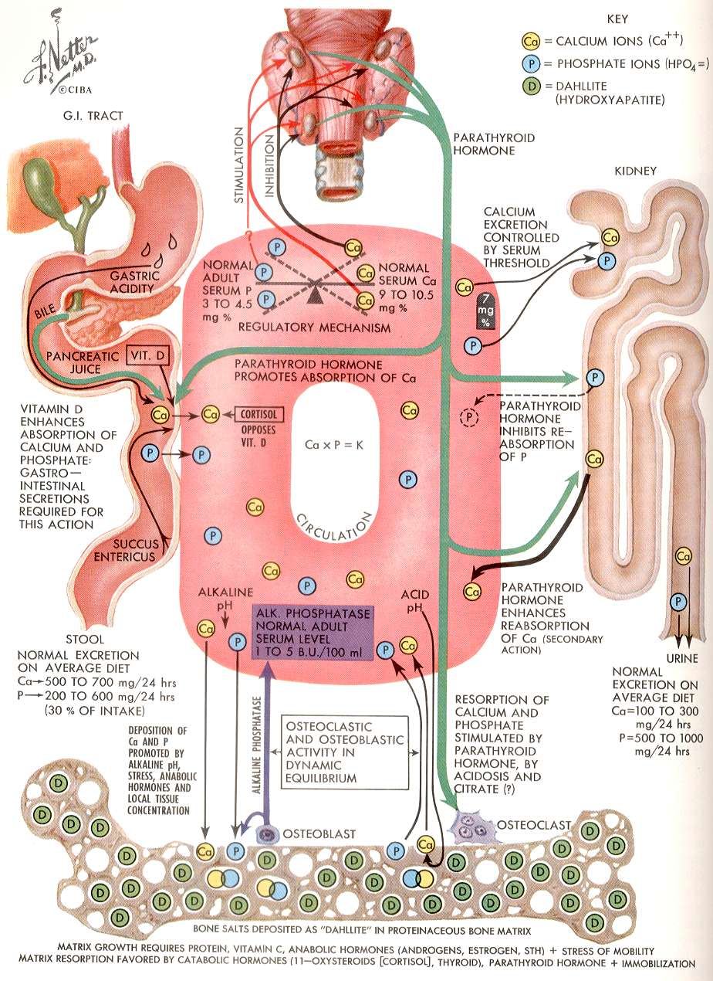

The control of calcium is mainly through PTH, which in turn is regulated by the plasma calcium. When the calcium falls, the parathyroid glands detect this, and PTH is released. This in turn has effects to liberate some calcium from bone, and to reabsorb calcium from the kidneys. In addition the renal enzyme 1-alpha hydroxylase is turned on. This is the rate-limiting step in vitamin D activation.

List four features of hypercalcaemia.

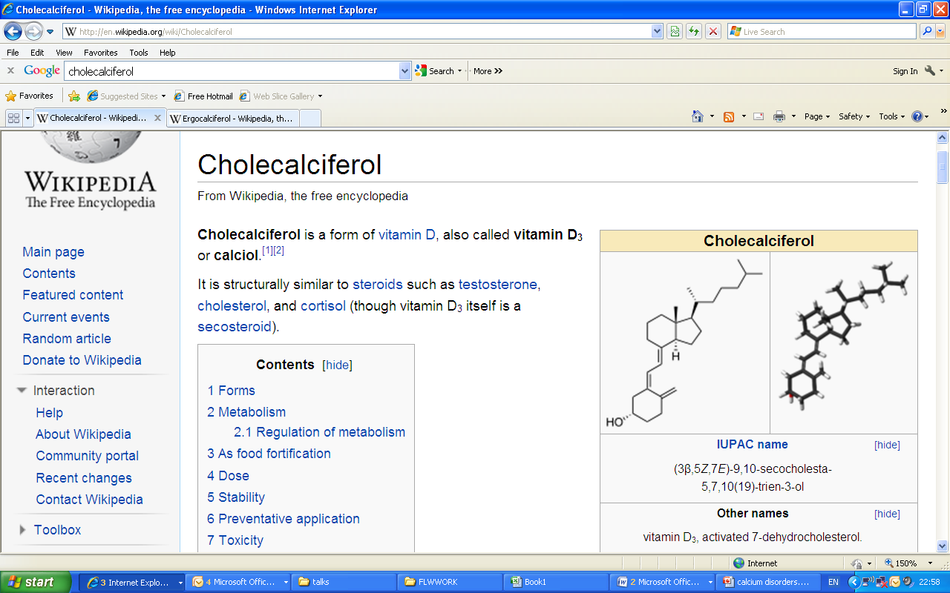

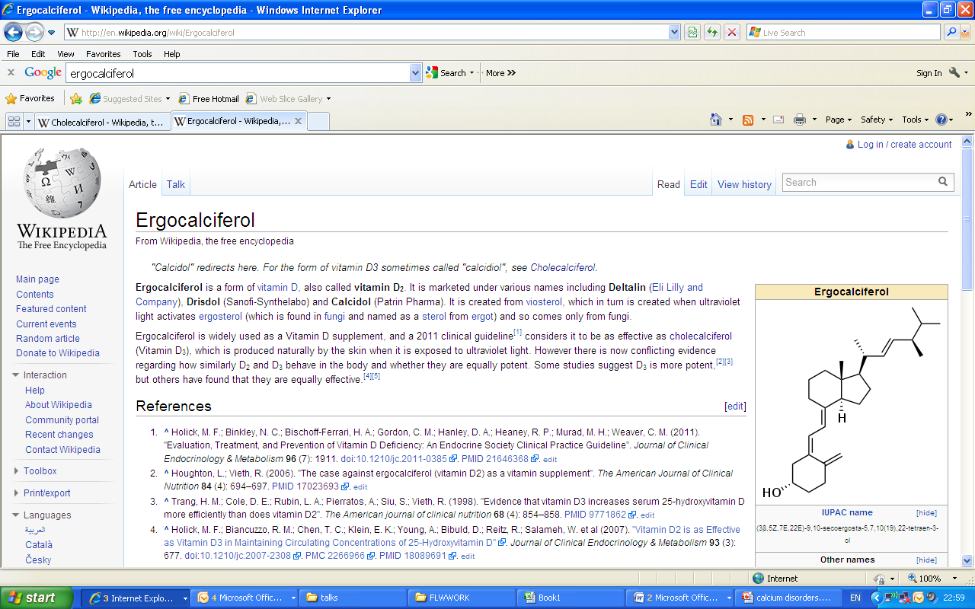

Cholecalciferol (vitamin D3) comes from animals and ergocalciferol (vitamin D2) comes from plants. Both are activated first by 25 hydroxylation, then by 1 alpha hydroxylation, the latter occurring in the kidney under the control of PTH.

Active vitamin D increases the absorption of calcium and phosphate from the gut. In the absence of vitamin D, calcium levels fall, and secondary hyperparathyroidism results.

**Histopathology**

**ACUTE INFLAMMATION**

Dr Justin Weir

[Justin.Weir@imperial.nhs.uk](mailto:Justin.Weir@imperial.nhs.uk)

**Learning Objectives**

1. To understand the purpose, the causes and mechanisms of acute inflammation

2. To understand the clinical manifestations of acute inflammation



**INTRODUCTION**

* A complex reaction of vascularised connective tissue to injurious stimuli.
* Aim of this process is to destroy, dilute or wall off the injurious agent.
* This is fundamentally a protective response whose ultimate goal is to get rid of both, the initial cause of cell injury and the consequence of such injury i.e. Necrotic cells and tissues.
* The process is usually described by the suffix ‘itis’ preceded by the name of the organ or tissue involved e.g. appendicitis, arthritis, sinusitis.

**CLASSIFICATION**

* Inflammation is classified according to its time course into;

**-**Acute inflammation of relatively short duration

**-**Chronic inflammation of relatively long duration

The processes of inflammation can be studied under following headings:

* ETIOLOGY
* CLINICAL FEATURES
* PATHOGENESIS
* MORPHOLOGY
* SEQUELAE

**ETIOLOGY**

Physical agents

- Physical trauma, radiation, extremes of temperature

Chemical agents

- Acids, alkalis, poisons

Biological agents

- Bacteria, fungi, viruses, parasites etc

Immunologic reactions

- Anaphylactic reaction

Hypoxia

- Loss of blood supply

**CLINICAL FEATURES**

* Redness – rubor
* Swelling – tumour
* Heat – colour
* Pain – dolor
* Loss of function – functio laesa

**PATHOGENESIS**

* VASCULAR CHANGES
* CELLULAR EVENTS
* CHEMICAL MEDIATORS

**VASCULAR CHANGES**

* CHANGES IN VASCULAR CALIBRE
* CHANGES IN BLOOD FLOW
* CHANGES IN VASCULAR PERMEABILITY

**VASCULAR CHANGES**

* Initial transient vasoconstriction of arterioles.
* Followed by vasodilatation of arterioles.
* Opening of new capillary bed in the area.
* Increased blood flow
* Increase permeability of microvasculature
* Outpouring of protein rich fluid called exudates
* Increased viscosity of blood
* Slowing of blood flow

**Difference between exudates and transudate**

**Exudate**

* Inflammatory extravascular fluid
* Protein rich
* Sp. Gravity >1.020

**Transudate**

* Ultra filtrate of blood
* Low protein contents
* Sp. Gravity <1.012

**CELLULAR EVENTS**

These can be divided into following steps:

* Margination
* Rolling
* Adhesions/pavementation
* Diapedesis
* Chemotaxis
* Phagocytosis

**Margination**

* In normally flowing blood RBCs & WBCs are confined to central axial column
* When flow of blood slows down WBCs fall out of central axial column and assume a peripheral position along the endothelial surface called margination.

**Rolling, adhesions, diapedesis**

Transmigration of leukocytes during inflammation is largely determined by the binding of complementary **Adhesion molecules** on the leukocytes and endothelial surfaces. These belong to four families:

* Selectins
* Immunoglobulins
* Integrins
* Mucin-like glycoproteins

**Selectins**

Mainly three types:

- E Selectin (CD62E) – endothelium

- P Selectin (CD62P) – platelets & endothelium

- L Selectin (CD62L) – leukocytes

-Bind through their lectin domain to sialylated form of oligosaccharides e.g. sialylated

Lewis X which themselves are covalently bound to various mucin-like glycoproteins (Glycam-1 & CD34)

**Immunoglobulins family**

* ICAM-1-β2 integrins (LFA-1 & MAC-1)
* VCAM-1-β1 integrin (VLA4)
* PECAM-1/CD31 – homophilic adhesion molecule

**Intergins**

**-** These are trasmembrane – adhesive heterodimeric glycoproteins made up of α and β

chains. It also functions as a receptor for extracellular matrix.

**Modulation of adhesion molecules**

* Redistribution of adhesion molecules to the cell surface
* Induction of adhesion molecule to the cell surface
* Increased avidity of binding

a) Redistribution of adhesion molecules to the cell surface

On stimulation by mediators e.g. histamine P selectin present in Weible-Palade bodies are redistributed to the surface.

b) Increased avidity of binding

- Normally LFA is present on leukocytes but does not adhere to ICAM-1 on endothelium.

- Conformational changes occur in LFA molecule under influence of cytokines which leads to increased affinity for ICAM-1.

**Rolling**

Occurs due to relatively loose adhesion between selectins and their carbohydrate ligands.

**Adhesion/pavementation**

Under the influence of cytokines, LFA-1 on leukocytes develop affinity for ICAM-1 present on endothelial surface, thus resulting in stable binding between leukocytes and endothelium.

**Diapedesis**

Transmigration across the endothelium is mediated by PECAM-1 (CD31) present on leukocytes and endothelial cells.

After traversing the endothelium leukocytes are transiently retarded in their journey by continuous basement membrane but eventually pierce it by secreting collagenase that degrade the basement membrane.

**Chemotaxis**

* Locomotion oriented along a chemical gradient
* Chemoattractants

a. Exogenous

i. bacterial products

b. Endogenous

i. Complement factor C5a

ii. Arachidonic acid metabolite – Leukotrine B4

iii. Cytokines – IL8

**Phagocytosis**

* The process whereby cells ingest solid particles is called phagocytosis
* It occurs in following steps:

- Recognition and attachment

- Engulfment

- Killing or degradation

**Phagocytosis – Recognition and attachment**

* Usually micro-organisms are identified when they are coated by naturally occurring factors called **opsonins**. Major opsonins are:

- Fc Fragment of IgG - FcγR

- C3b component of complement – CR1-3

- Collectins – carbohydrate binding proteins of plasma – C1q receptor

**Phagocytosis – Engulfment**

* Binding of opsonized particle to the FcγR trigger engulfment.
* During engulfment pseudopods flow around the object to be engulfed, eventually resulting in complete closure of the particle within a phagosome created by cytoplasmic membrane of the cell.

**Phagocytosis – Killing of degradation**

* Fusion of phagosome with lysosomes produces phagolysosomes
* Within phagolysosome killing of micro-organisms take place

- Oxygen dependent: with the help of H2O2

- Oxygen independent: lysozymes, lactoferin and cationic proteins

**CHEMICAL MEDIATORS OF INFLAMMATION**

* Mediators originate whether from plasma or from cells.
* Plasma derived mediators are present in precursor form and needs to be activated.
* Cell derived mediators are normally sequestered in intracellular granules or are synthesized do novo.
* Once activated and released from the cell most of these mediators are short lived.

**Chemical Mediators of Inflammation**

* Vasoactive amines

- Histamine and serotonin

Plasma proteases

* - Complement system
* - Kinin system
* - coagulation system
* Arachidonic acid metabolites
* Cytokines and chemokines
* Nitric oxide
* Platelet activating factor
* Lysosomal constituents of leukocytes
* Oxygen derived free radicals
* Neutropeptides

**Vasoactive Amines**

**Histomine**

* Widely distributed, present in mast cells, basophils and platelets
* Released by these cells in response to:

- Physical injury such as trauma, cold or heat

- Immune reaction etc

* Causes dilatation of arterioles and increases vascular permeability of the venules

**Serotonin**

* Present in platelets and enterochromaffin cells
* Actions are similar to those of histamine.

**Plasma Proteases**

**Complement system**

* Found in plasma has 20 components
* Causes lysis of microbes by the so-called membrane attack component (MAC) C5-9.
* Component C3b act as opsonin
* Component C5a is a powerful chemotactic agent
* Component C3a & C5a are called anaphylotoxins as they increase vascular permeability and cause vasodilatation through histamine

**Coagulation system**

* The coagulation system is responsible for the conversion of soluble fibrinogen into fibrin.
* Following components of coagulation system play important role in inflammation:

- Thrombin – increases leukocyte adhesion and fibroblast proliferation

- Fibrinopeptids – increases vascular permeability and chemotaxis

- Factor X1 – increases vascular permeability and leukocyte exudation.

**Kinin system**

* Activation of kinin system results in release of bradykinin. It causes;

- Increased vascular permeability

- Contraction of smooth muscle

- Vasodilatation

**-** Pain

**Arachidonic acid metabolites(AA)**

* AA is 20-carbon polyunsaturated fatty acid that is derived directly from dietary sources or by conversion from essential fatty acid lenoleic acid.
* It is normally esterified in membrane phospholipids.
* AA metabolites, also called eicosanoids are synthesized by two major classes of enzymes:

- Cyclooxygenase

- Lipooxygenase

**Cytokines and chemokines**

* Cytokines are protein mainly produced by lymphocytes and macrophages, that modulates the function of other cell types.

- Monokines – produced by mononuclear phagocytes

- Lymphokines – produced by lymphocytes.

- Chomokines are cytokines that share the ability to stimulate leukocyte movement

(chemokinesis) and directed movement (chemotaxis).

* Major cytokines that mediate inflammation are IL1 AND TNF.

**Nitrous oxide (NO)**

* NO is a soluble gas produced by endothelial cells, macrophages and specific neurons in the brain.
* Short half-life, therefore paracrine effect.

Functions:

* Potent vasodilator
* Involved in pathogenesis of shock
* Takes part in antimicrobial activity
* Reduces platelet aggregation and adhesion
* Reduces leukocyte adhesion and migration

**Platelet Activating Factor (PAF)**

* Sources of PAF include platelet, basophils/mast cells, neutrophils, monocytes/macrophages and endothelium.
* Beside platelet activation PAF causes vasoconstriction, bronchoconstriction, leukocyte adhesion, chemotaxis, degranulation and oxidative burst.
* In low concentration it is a powerful vasodilator and increase vascular permeability.

**Lysosomal constituents of leukocytes**

* Neutrophils and monocytes contain lysosomal granules
* Neutrophils contain two main types of granules:
* Larger azurophilic or primary granules, contain

- Myeloperoxidase

- Bactericidal products – lysozyme and defensins

- Neutral proteases – elastate, collagenase, proteinase 3

- Acid hydrolase

- Smaller specific or secondary granules contains

**-** Lysozyme, collagenase, gelatinase, lactoferin

- Histominase, alkaline, phosphatase

**SUMMARY**

* **Vasodilation**

- Prosaglandins

- Nitric oxide

* **Increased vascular permeability**

- Vasoactive amines

- C3a and C5a

- Bradykinin

- Leukotrines

- PAF

* **Chemotaxis and leukocyte activation**

- C5a and leukotrines

- Chemokines

- bacterial products

* **Fever**

- IL1, IL6 NAD TNF

- Prostaglandins

* **Pain**

- Prostaglandins

- Bradykinin

* **Tissue damage**

- Neutrophil and Macrophage lysosomal enzymes

- Oxygen metabolites

- Nitric oxide

**Morphology**

* Serous inflammation
* Fibrinous inflammation
* Purulent inflammation
* Ulcers

**Outcome**

* Complete resolution
* Abscess formation
* Healing by fibrosis
* Chronic inflammation

**CHRONIC INFLAMMATION**

Learning Objectives

**Objectives**

1. To understand the term “chronic inflammation”.

2. To know the causes of chronic inflammation.

3. To recognise the histological features of chronic inflammation.

4. To understand what is meant by the term “granuloma.”

5. To know some of the causes of granulomatous inflammation.

**CHRONIC INFLAMMATION**

**Definition**

* Inflammation of prolonged duration (weeks / months) in which there is simultaneous active inflammation, tissue destruction and attempts at repair.
* May follow acute inflammation or may have insidious onset.

**Causes**

* Persistent infection eg syphilis
* Prolonged exposure to potential toxins eg silicosis
* Autoimmunity eg rheumatoid arthritis

**Histological features**

* Mononuclear cell infiltrate – including **macrophages**, lymphocytes, plasma cells.
* Tissue destruction
* Attempts at healing – angiogenesis and fibrosis

**Granuloma**

* Focus of chronic inflammation consisting of an aggregate of macrophages that are transformed into epithelium-like (“epithelioid”) cells, surrounded by a collar of mononuclear leukocytes.
* Often contains giant cells (due to fusion of the epithelioid cells)
* 2 types:
  + Foreign body granuloma - eg around talc (in IVDU), ruptured implants
  + Immune granulomas - classic example = tuberculosis.
  + Other examples include sarcoidosis, leprosy.

**HEALING - TISSUE REPAIR (regeneration)**

Dr Gemma Petts and Dr Abigail Speller

The body's ability to replace injured or dead cells and to repair tissues after inflammation is critical to survival.

**OBJECTIVES (to understand the following)**

**• tissue repair: 2 processes 🡪*regeneration* and *healing***

**• the difference between healing and regeneration**

**• the essential components of regeneration**

**• the potential use of the science behind regeneration for future medical use.**

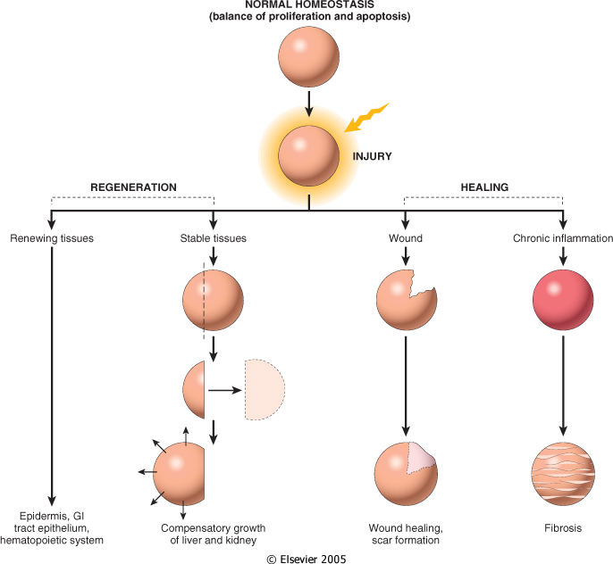

## Definitions

**TISSUE REPAIR**🡪 replacement of lost or damaged tissue by *regeneration* or *healing* and combinations of the two.

**REGENERATION**🡪 growth of cells and tissues to replace lost structures.

**HEALING**🡪 a tissue response leading to the formation of scar tissue or fibrosis.

**DIFFERENTIATION🡪** the process by which a less specialized cell becomes a more specialized cell type.

**Regeneration**

Regenerative capacity is inversely related to complexity: in general, the more complex an animal is the less regeneration it is capable of. Examples of complete regenerative capacity are seen in lower animals such as newts .

**True regeneration**🡪de-differentiation of adult cells into a stem cell state similar to embryonic cells and second, development of these cells into new tissue more or less the same way it developed the first time (as in the newt above)

In mammals including humans, true regeneration is relegated to so-called labile tissue i.e. gastric epithelia, cornea , skin etc..

…whole organs and complex tissues rarely regenerate after damage, and the term is usually applied lazily to processes such as liver and kidney growth after, respectively, partial hepatectomy and unilateral nephrectomy. These processes consist of **compensatory growth** rather than true regeneration.

For ‘regeneration’ to take place in human organs requires an intact **connective tissue scaffold**. By contrast, **healing** with scar formation occurs if the extracellular matrix (ECM) framework is damaged, e.g. tissue repair in liver after single massive dose of carbon tetrachloride VS chronic administration of low dose.

**Some basic principles of tissue regeneration**

1. **Maintenance of a constant organ mass**

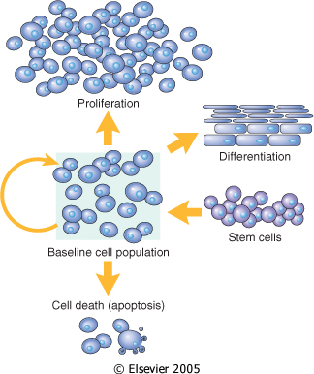 These processes must be balanced

1. **Different tissues have different** **TISSUE-regenerative capacity**

### Labile tissue

Consist of loosely aggregated cells which are highly susceptible to sublethal injury but are readily able to regenerate on the condition that their stem cells remain intact, e.g skin epidermis, bronchial mucosa, intestinal mucosa, cervical mucosa , haematopoietic tissue.

### Quiescent tissue

This tissue has a complex structure of cells with high longevity having a low rate of cell elimination and proliferation. e.g. liver , kidney, pancreas, mesenchymal cells such as fibroblasts and smooth muscle. The regenerative capacity of this type of tissue is best exemplified by the ability of the liver to ‘regenerate’ after partial hepatectomy and after acute chemical injury.

### Permanent tissue

This issue is highly complex and cannot undergo cell division in postnatal life. To this group belong neurons and skeletal and cardiac muscle cells. If *neurons* in the central nervous system are destroyed, the tissue is generally replaced by the proliferation of the central nervous system supportive elements, the glial cells. However, recent results demonstrate that neurogenesis from stem cells may occur in adult brains.

1. **Stem cells**

*Stem cells are characterized by their prolonged self-renewal capacity and by their asymmetric replication.* Asymmetric replication describes a special property of stem cells; that is, in every cell division, one of the cells retains its self-renewing capacity while the other enters a differentiation pathway and is converted to a mature, nondividing population.

Embryonic Stem Cells (ES)🡪 Embryos contain pluripotent ES cells, which can give rise to all the tissues of the human body.

Adult Stem Cells🡪 Compared to ES cells, which are pluripotent, adult stem cells have a more restricted differentiation capacity and are usually lineage-specific

Bone marrow contains 2 types of progenitor cells

(1) Hematopoietic stem cells (HSCs)🡪 HSCs generate all of the blood cells and can reconstitute the bone marrow after depletion caused by disease or irradiation..

(2) *Bone marrow stromal cells*, depending on the tissue environment, can generate chondrocytes, osteoblasts, adipocytes, myoblasts, and endothelial cell precursors

1. **Growth factors**

The term **growth factor** refers to a naturally occurring proteins capable of stimulating cellular growth, proliferation and cellular differentiation.

For example, bone morphogenic proteins stimulate bone cell differentiation, while fibroblast growth factors and vascular endothelial growth factors stimulate blood vessel differentiation (angiogenesis).

1. **Extracellular Matrix (ECM) and Cell-Matrix Interactions**

Cells are surrounded by an extracellular matrix of proteins, glycoproteins ,proteoglycans and hyaluronic acid.. This matrix has a number of functions. It forms a significant proportion of the volume of any tissue. The ECM serves many functions.

1. matrix proteins sequester water that provides turgor to soft tissues and minerals that give rigidity to skeletal tissues.
2. function as a reservoir for growth factors controlling cell proliferation.
3. ECM is important for cell-to-cell interactions and provides a substratum for cells to adhere, migrate, and proliferate, directly modulating cell form and function. Synthesis and degradation of ECM accompanies morphogenesis, wound healing, and chronic fibrotic processes, as well as tumor invasion and metastasis.

Images: Courtesy of Robbins and Cotran Basics of Pathology

References: Robbins and Cotran Basics of Pathology

Wikipedia

Webpath

**DEGENERATION**

Dr Ruchi Tandon

**OBJECTIVES:**

1. To understand the consequences of degeneration in tissue.
2. To appreciate the different types of degenerative processes.
3. To understand the different types of substances that can accumulate in the body.

**DEGENERATIVE JOINT DISEASE**

Osteoarthritis associated with wear and tear of joints/articular cartilage from aging or injury.

Leads to loss of chondrocytes, flaking of the cartilage, subchondral bony thickening, osteophytes

**NEURODEGENERATIVE DISORDERS**

Progressive and selective loss of functional systems

* Dementia - Alzheimer’s resulting from amyloid (Ab), Tau protein, MAP2 or ubiquitin deposition.
* Parkinsonism - Idiopathic Parkinson disease, Progressive supranuclear palsy and corticobasal degeneration.

**FATTY ACCUMULATION (Steatosis)**

Early indicator of stress and injury

Can occur in the liver, heart, muscle and kidney

**HAEMOSIDERIN DEPOSITION**

Hb derived iron pigment

Can accumulate in skin, muscle, liver, pancreas, lymph nodes, bone marrow, spleen.

**MELANIN**

Can accumulate in benign and malignant neoplasms

Or as a consequence of inflammation within the skin

**LIPOFUSCIN**

A sign of free radical injury and lipid peroxidation

Can accumulate in liver and heart of ageing and cachetic patients

**CHOLESTEROL and CHOLESTEROL ESTERS**

As seen in atherosclerosis, xanthomas and cholsteroris

**CARBON**

Inhaled as coal dust and silica

Can cause anthracosis, emphysema and pnemoconiosis

**AMYLOID**

Complex insoluble beta pleated sheets

Amyloid light chain (AL), Amyloid associated protein (AA), beta 2 amyloid protein (Ab2)

Primary/Systemic amyloidosis associated with AL type and B cell dyscrasias

Secondary/Reactive amyloidosis associated with AA type often from chronic inflammation

Localised amyloidosis

Amyloidosis of ageing

# DYSPLASIA AND CARCINOGENESIS

Dr Jason Wang

(jason.wang@imperial.nhs.uk)

## Learning objectives

1. To learn the medical and scientific terminology for different growth disorders.
2. To appreciate that cancer is a genetic disorder, resulting from an accumulation of non-lethal mutations to growth regulatory genes.
3. To understand that origin and development of such mutations.
4. To apply the dysplasia-carcinoma model of progression to different cancers.

## Summary

In living multicellular organisms, the development and maintenance of life requires a well-coordinated feedback-regulated growth of cells, sufficient for overall growth of the organism and replenishment of lost or dying cells. There are several pathological conditions in which disorders of growth occur. For example, hyperplasia is an increase in cell number without significant structural change. Hypertrophy is an increase in cell size within an organ. Metaplasia is the change from one cell type to another, and dysplasia is a disordered growth, with loss of cell uniformity. All the above growth patterns are responses to physiological or abnormal (pathological) stimuli, but are reversible when the stimulus is removed.

In contrast, a neoplasm (literally: new growth) is an abnormal and autonomous growth of cells which exceeds and is uncoordinated with the surrounding tissues. A tumour is synonymous with a neoplasm. Tumours can be classified into benign or malignant, which are separated on appearances (morphology) or behaviour (clinical). Although sometimes difficult to distinguish, benign tumours are usually characterised by well-differentiated cells, a slow rate of growth, and a lack of invasion and metastasis. Clinically, benign tumours rarely kill. In contrast, malignant tumours have a wide range of growth rates, can become de-differentiated (anaplastic), and are characterised by local invasion and metastasis, which lead often to death.

Cancer is a genetic disease, and results from an accumulation of non-lethal mutations for growth regulating genes. These include growth promoters or oncogenes (which can be growth factors, their receptors, intracellular signalling pathway members or nuclear transcription factors), growth inhibitors (also known as tumour suppressor genes), genes that control apoptosis and DNA repair genes. The mutations of the genes can occur either by point mutation, translocation of segments of chromosomes, deletion or amplification. Each mutation is passed on to the progeny of cells, which then develop new mutations. A single mutation is often not sufficient to result in cancer. The Knudson two-hit hypothesis suggests that carcinogenesis requires at least two events, an initiation and a promotion. Mutations can occur either by inheritance from the parents, or by de novo somatic mutations, such as by DNA-damaging chemicals (carcinogens), infective agents or radiation.

The fact that cancers develop from multiple sequential mutations also means that cancers develop stepwise in phases, from a pre-malignant proliferation, to dysplasia, to invasive malignancy. The earliest proven model of this development is the adenoma-carcinoma sequence in colorectal cancers. Studies have shown that at least 4 genetic changes occur in sequence as the colonic mucosa develops from normal to adenomas with dysplasia, to carcinoma. The genes involved sequentially are the APC gene, K-ras, SMAD2/4 and p53.

Following the development of frank malignancy, neoplastic cells continue to acquire genetic mutations, which allow them to be selected for increasingly aggressive biological behaviour, including angiogenesis, invasion and metastasis.

**MALIGNANCY IN CLINICAL PRACTICE**

Dr Mihir Gudi

(m.gudi@imperial.ac.uk)

## Learning objectives

1. To understand the difference between in in-situ and invasive cancer
2. To recognize macroscopy and microscopy of common visceral malignancies.
3. To understand the mechanisms of metastases.
4. To understand the role of pathology within the MDT.
5. To understand the importance of screening in prevention of cancer.

## Summary

Invasion and metastases are the biologic hallmarks of malignant tumours. Neoplasms are essentially parasites and cause morbidity and mortality. Paraneoplastic syndromes occur in up to 10 % of patients with malignant disease.

Cancers are graded on the basis of degree of differentiation of the tumour cells and the number of mitoses within the tumour. There are different grading systems used in different cancers but essentially all depend on the degree of differentiation of the tumour.

Cancers are staged on basis of size of the primary lesion, spread to regional lymph nodes and the absence or presence of blood borne metastases. The TNM staging system is the one most widely used in the UK.

Histopathological and cytological examination plays an extremely important role in tumour diagnosis. However this cannot be done in isolation and requires a multidisciplinary approach which includes clinical history and imagining.

Screening plays an important role in preventing cancers. This has been proved beyond doubt in cervical cancer.

**Recommended course reading**

Any short textbook (eg Lecture notes on…, Short textbook of..) of medical microbiology and infection is suitable. It is recommended that you invest in one, it will be useful throughout your undergraduate studies. Pick one you like.

An example is:

Gillespie S and Bamford K, Medical Microbiology and Infection at a Glance, 3rd Ed, Blackwell (2007) ISBN

**Supplementary reading**

McNeill, W.H. Plagues and Peoples. Anchor Press NY, 1976.

Zinnser, H. Rats, Lice and History, 1934. Free download from: http://www.archive.org/details/ratsliceandhisto035207mbp

Diamond, J. Guns, Germs and Steel: the fates of human societies. W.H. Norton, 1997.

Camus, A. The Plague. Librairie Gallimard, 1948.

Lydyard P et al (Eds) Case studies in Infectious disease. Garland Science, 2009.

Mandell, Douglas, Bennett, Principles and Practice of infectious diseases 6th Ed Elsevier (2005)

Armstrong, Cohen, Infectious Diseases, Mosby (1999)

**Online resources**

Each of these websites provides information on different aspects of infectious diseases. These are useful reference sites Many of these societies/organisations will have Twitter feeds that you can join to keep up-to-date with the latest infectious diseases information.

<http://www.hpa.org.uk/> The Health Protection agency – the section on infectious diseases deals with all aspects of infectious diseases in the UK

<http://www.bsac.org.uk/> the British Society for antimicrobial chemotherapy

<http://www.britishinfection.org/drupal/> The British Infection Association

<http://www.sgm.ac.uk/> The Society for General Microbiology This is a more science/research orientated group

<http://www.idsociety.org/> Infectious diseases society of America

<http://www.cdc.gov/> The Centers for Disease Control and Prevention

<http://www.ecdc.europa.eu/en/Pages/home.aspx> The European Centre for Disease Control

<http://www.nathnac.org/pro/index.htm> National Travel Health Network and Centre (NATHNAC)

<http://www.who.int/en/> World Health Organisation

<http://www1.imperial.ac.uk/medicine/about/institutes/cipm/> The National Centre for Infection Prevention and Management, Imperial College London