School of Medicine

Graduate Entry Year 1

## Alimentary System

## (GI & liver)

2012 / 2013 course guide



Course Leader:

**Prof Julian RF Walters**

tel: 020 3313 2361

email: [julian.walters@imperial.ac.uk](mailto:julian.walters@imperial.ac.uk)

https://education.med.imperial.ac.uk

GRADUATE ENTRY

ALIMENTARY SYSTEM

Year 1 – Autumn Term

Course Guide

CONTENTS

Page

SOLE *iii*

INTRODUCTION 1

COURSE STRUCTURE 1

ASSESSMENT DETAILS 1

TIMETABLE 2

LEARNING OBJECTIVES 3

READING LIST 7

CONTACT DETAILS 7

LECTURE NOTES AND OTHER BACKGROUND READING 8

**SESSION MATERIALS** xx

**<Lecture/Practical Title>** xx

**<Lecture/Practical Title>** xx

**<Lecture/Practical Title>** xx

**<Lecture/Practical Title>** xx

**<Lecture/Practical Title>** xx

<https://education.med.imperial.ac.uk>

**SOLE FEEDBACK – ALIMENTARY**

The following pages provide you with templates on which you can record your thoughts as the course proceeds. At the end of the course you can enter your views onto SOLE.

**Please answer all questions by selecting the response which best reflects your view.**

|  |  |  |  |  |  |
| --- | --- | --- | --- | --- | --- |
|  | Strongly Agree | Agree | Neutral | Disagree | Strongly Disagree |
| The content of this module is useful. |  |  |  |  |  |
| The support materials available for this module (e.g. handouts, web pages, problem sheets) are helpful. |  |  |  |  |  |
| I receive sufficient feedback and guidance. |  |  |  |  |  |
| Overall, I am satisfied with this module. |  |  |  |  |  |

Please use this box for constructive feedback and suggestions for improvement.

|  |
| --- |
|  |

**SOLE FEEDBACK - INDIVIDUAL LECTURERS**

Please note that for SOLE, a Lecturer’s name will only appear once. This template gives you the opportunity to record your comments about each lecture in the order of delivery.

**On the following section, you have an opportunity to record any comments and constructive feedback you have for each lecturer.**

|  | **The lecture(s) are well structured** | | | | | **The lecturer explains concepts clearly** | | | | | **The lecturer engages well with the students** | | | | |
| --- | --- | --- | --- | --- | --- | --- | --- | --- | --- | --- | --- | --- | --- | --- | --- |
| **Lecturer and Lecture Title** | Strongly Agree | Agree | Neutral | Disagree | Strongly Disagree | Strongly Agree | Agree | Neutral | Disagree | Strongly Disagree | Strongly Agree | Agree | Neutral | Disagree | Strongly Disagree |
| Andrew Thillainayagam |  |  |  |  |  |  |  |  |  |  |  |  |  |  |  |
| Julian Walters |  |  |  |  |  |  |  |  |  |  |  |  |  |  |  |
| Lakshmana Ayaru |  |  |  |  |  |  |  |  |  |  |  |  |  |  |  |
| Kevin Murphy |  |  |  |  |  |  |  |  |  |  |  |  |  |  |  |
| Jonathan Hoare |  |  |  |  |  |  |  |  |  |  |  |  |  |  |  |
| Abigail Zabron |  |  |  |  |  |  |  |  |  |  |  |  |  |  |  |
| Gary Frost |  |  |  |  |  |  |  |  |  |  |  |  |  |  |  |
| Tim Orchard |  |  |  |  |  |  |  |  |  |  |  |  |  |  |  |
| Janice Main |  |  |  |  |  |  |  |  |  |  |  |  |  |  |  |
| Jonathan Nolan |  |  |  |  |  |  |  |  |  |  |  |  |  |  |  |
| Horace Williams |  |  |  |  |  |  |  |  |  |  |  |  |  |  |  |
| Shahid Khan |  |  |  |  |  |  |  |  |  |  |  |  |  |  |  |
|  |  |  |  |  |  |  |  |  |  |  |  |  |  |  |  |
| Marco Purbhoo |  |  |  |  |  |  |  |  |  |  |  |  |  |  |  |
| Harry Antoniades |  |  |  |  |  |  |  |  |  |  |  |  |  |  |  |
| Ameet Dhar |  |  |  |  |  |  |  |  |  |  |  |  |  |  |  |
|  |  |  |  |  |  |  |  |  |  |  |  |  |  |  |  |

**ALIMENTARY SYSTEM**

**INTRODUCTION**

The ***Alimentary system*** course is taught in the Autumn Term of year 1.

The components of the course are nine teaching sessions held at the end of the first term covering the physiology, pharmacology and pathology of the gastrointestinal system, pancreas and liver, with an introduction to some of the clinical situations where knowledge of these is important.

The course will also be dependent on the completion of the additional self-directed “Cellular and Molecular Science” course and the Abdomen components of the taught Anatomy course.

**COURSE STRUCTURE**

There are 20 lectures, 2 tutorials

**ASSESSMENT**

**Formative Assessments**

See general course details.

**Summative Assessment**

See general course details.

**Examples of specimen questions**

See general course details.

Further details about examinations are provided on the Intranet.

**TIMETABLE 2012 – Autumn term**

Details are correct at the time of going to press. Any amendments will be shown on the Course Timetable shown on the Intranet.

|  |  |  |  |
| --- | --- | --- | --- |
| **Date and campus** | **Time** | **Lecture topic** | **Lecturer** |
| Tuesday **4 Dec 2012** Hammersmith Wolfson LT III | 9.00-10.00 |  |  |
| 10.00-11.00 | Structure and functional relationships: GI Motility | Andrew Thillainayagam |
| 11.00-12.00 | Burden of GI disease | Julian Walters |
| Thursday **6 Dec 2012** Hammersmith Wolfson LT III | 10.00-11.00 | Abdo pain & Pancreatitis | Lakshmana Ayaru |
| 11.30-12.30 | Pancreatic exocrine function | Kevin Murphy |
| 2.00-3.00 |  |  |
| 3.00-4.00 | Acid secretion | Kevin Murphy |
| 4.00-5.00 | Gastro-oesophageal reflux disease and ulceration | Jonathan Hoare |
| Friday  **7 Dec 2012**  Hammersmith Wolfson LT III | 9.00-10.00 | Liver structure and function | Abigail Zabron |
| 10.0 –11.00 | Intestinal cell development | Julian Walters |
| 10.00-12.00 | Intestinal absorption | Julian Walters |
| Monday  **10 Dec 2012**  Hammersmith Wolfson LT III | 9.00-10.00 |  |  |
| 10.00-11.00 | Inflammatory bowel diseases | Tim Orchard |
| 11.00-12.00 | GI hormones & Appetite control | Kevin Murphy |
| 2.00-3.00 | Infections of the GI tract | Janice Main |
| 3.00-4.00 | Intestinal immune system | Jonathan Nolan |
| 4.00-5.00 | Genetic and environmental effects on development of colonic neoplasia | Horace Williams |
| Tuesday  **11 Dec 2012**  Hammersmith Wolfson LT III | 9.00-10.00 |  |  |
| 10.00-11.00 | Bilirubin, jaundice, bile secretion & cholestasis | Shahid Khan |
| 11.00-12.00 | Mechanisms of liver injury: viral | Marco Purbhoo |
| Wednesday  **12 Dec 2012**  Hammersmith Wolfson LT III | 9.00-11.00 | Tutorials:  Review of Nutrition  Digestion & Cell Transport | Gary Frost  Julian Walters |
| 11.00-12.00 | Malabsorption | Julian Walters |
| Thursday **13 Dec 2012** Hammersmith Wolfson LT III | 9.00-10.00 | Mechanisms of liver injury: alcohol | Harry Antoniades |
| 10.00-11.00 | Liver failure | Harry Antoniades |
| 11.00-12.00 | Pathophysiology of Portal hypertension | Ameet Dhar |

Tutorials

The class will be divided into two groups for the tutorials reviewing Nutrition, and Digestion and Cell transport. These groups will be selected according to previous experience in Gastrointestinal physiology.

**Learning Objectives**

These session objectives may include tasks you should be able to carry out after you have completed the relevant activity. They provide you with a way to assess how well you are keeping up with the material. Note that they are also provided to the external examiners as a guide to what you should know at the end of the course.

The overall learning objectives of this course are:

* To review the basics and to introduce advanced concepts of the main physiological aspects of the normal alimentary system.
* To outline examples of malfunction within the alimentary system and to recognise some of the pathophysiological processes involved.

.

Specific objectives of each session are as follows: (order of presentation differs from year to year)

**Lecture 1 Introduction: the Burden of GI disease Julian Walters**

* List the names of the organs of the alimentary tract
* Describe symptoms and signs of alimentary tract disease
* List the main diseases of the GI tract and liver
* Be aware of the economic burden of GI and liver diseases

**Lecture 2 Structure and functional relationships: GI Motility**

**Andrew Thillainayagam**.

* To understand the passage of food through the GI tract
* To recognise the functions of the different regions of the GI tract
* To link secretion and absorption to different areas
* To appreciate the role of GI motility in digestion
* To be able to describe some of the mechanisms of motility

**Tutorials: Review of nutrition Gary Frost**

**Digestion & cell transport Julian Walters**

* To review the principles of nutrition
* To understand the types of nutrients
* To recognise diseases associated with impaired nutrition
* To review the basics of nutrient digestion
* To review cellular mechanisms relevant to intestinal absorption.

**Lecture 3 Acid secretion Kevin Murphy**

* To understand the role of gastric acid secretion in digestion
* To recognise the mechanisms of gastric acid secretion
* To be able to describe the regulation of acid secretion

**Lecture 4 Gastro-oesophageal reflux disease Jonathan Hoare**

* To recognise diseases of the upper GI tract
* To describe some of the pathophysiological processes involved
* To appreciate the role of acid and motility in gastro-oesophageal reflux disease
* To recognise common drugs used in disorders of acid secretion

**Lecture 5 Intestinal absorption Julian Walters**

* To consolidate knowledge of the mechanisms of protein and lipid absorption
* To review absorption of electrolytes and water
* To appreciate mechanisms of absorption of certain other nutrients

**Lecture 6 Malabsorption Julian Walters**

* To know what problems may result from malabsorption
* To recognise diseases and mechanisms leading to malabsorption
* To be introduced to the presentation, pathology and treatment of coeliac disease

**Lecture 7 Pancreatic exocrine function Kevin Murphy**

* To know the different functions of the pancreas
* To recognise the pathways of pancreatic exocrine secretion
* To learn about the hormonal control of pancreatic secretion

**Lecture 8 Abdo pain & Pancreatitis Lakshmana Ayaru**

* To be able to list conditions that produce abdominal pain
* To describe some features of the enteric nervous system
* To recognise the symptoms of acute and chronic pancreatitis
* To appreciate the mechanisms that cause pancreatitis
* To be introduced to the therapeutic principles of pancreatic diseases

**Lecture 9 GI hormones & Appetite control Kevin Murphy**

* To recognise specific gut hormones and their actions
* To appreciate the coordination of gastrointestinal function by hormone secretion
* To be introduced to mechanisms of appetite control

**Lecture 10 Infections of the GI tract Janice Main**

* To know the types of gastrointestinal infections that may occur
* To recognise causes of infective gastroenteritis
* To appreciate the ways to prevent food poisoning
* To learn about *C. difficile*
* To be introduced to parasitic conditions of the GI tract

**Lecture 11 Inflammatory bowel diseases Tim Orchard**

* To recognise the types of inflammatory bowel disease (UC and Crohn's)
* To appreciate some of the symptoms produced by IBD
* To learn about pathological processes that may be implicated in IBD
* To recognise drugs used in the treatment of IBD

**Lecture 13 Review of intestinal cell development Julian Walters**

* To review the structure of the small and large intestine
* To review the types of cells found in the intestinal mucosa
* To appreciate mechanisms of cell turnover and differentiation

**Lecture 14 Genetic & environmental effects on development of colonic neoplasia Horace Williams**

* To know the types of colorectal neoplasia and their presentation
* To recognise the genetic changes occurring in the progression of colorectal neoplasia
* To learn about familial syndromes and their management
* To appreciate some of the environmental factors that influence neoplasia

**Lecture 15 Intestinal immune system Jonathan Nolan**

* To be introduced to the concept of the intestine as an immunological organ
* To be able to describe the immunological cells found in the GI tract
* To appreciate innate and adaptive immune mechanisms
* To recognise conditions of normal and abnormal immune response in the GI tract

**Lecture 16 Liver structure and function Abi Zabron**

* To understand hepatic structure and blood supply
* To recognise the cellular organisation of the liver
* To be able to describe the key functions of the liver

**Lecture 17 Bilirubin & jaundice; Bile secretion & cholestasis Shahid Khan**

* To know the metabolic pathways involving bilirubin
* To recognise jaundice and to be able to describe the types of jaundice
* To learn about the investigation and treatment of diseases producing jaundice
* To know the pathway for bile secretion
* To recognise the components of bileandmechanisms of bile secretion
* To be introduced to pathological mechanisms that produce cholestasis

**Lecture 19 Liver failure Harry Antoniades**

* To recognise the picture produced by liver failure
* To list the metabolic problems resulting from liver failure
* To know additional conditions causing liver failure
* To be introduced to treatment options

**Lecture 18 Mechanisms of liver injury: alcohol Harry Antoniades**

* To appreciate the problems resulting from alcohol
* To be able to describe features of alcoholic liver disease
* To have an understanding of the mechanisms that lead to liver injury

**Lecture 20 Mechanisms of liver injury: viral Marco Purbhoo**

* To list viruses that injure the liver and their epidemiological features
* To compare acute and chronic hepatitis
* To have an understanding of the course of hepatitis A, B and C

**Lecture 21 Pathophysiology of Portal hypertension Ameet Dhar**

* To understand the portal venous system
* To recognise disorders that affect the portal circulation
* To appreciate pharmacological and other interventions in portal hypertension

**Recommended reading**

Kumar P, Clark M. Kumar and Clark Clinical Medicine; 6th Edition. Elsevier Saunders (2005)

Johnson LR. Gastrointestinal physiology; 7th Edition. Mosby (2006)

**Supplementary reading**

Butcher GP. Gastroenterology: An Illustrated Colour Text. Churchill Livingstone, (2003)

Feldman M, Friedman LS, Brandt LJ. Sleisenger & Fordtran Gastrointestinal and Liver disease; 8th Edition Saunders 2006)

**THE LECTURE NOTES ON THE FOLLOWING PAGES SHOULD BE USED IN CONJUNCCTION WITH THE SPECIFIC SLIDES FROM THE INDIVIDUAL TALKS.**

**NOT ALL MATERIAL IS COVERED IN BOTH FORMATS AND YOU ARE ADVISED TO READ AROUND THESE TOPICS IN THE RECOMMENDED TEXTS.**

**CONTACT DETAILS**

Course Leader:

Julian RF Walters

Professor of Gastroenterology

Hammersmith Hospital

Imperial College London

tel: 020-3313-2361

email: [julian.walters@imperial.ac.uk](mailto:julian.walters@imperial.ac.uk)

**THE BURDEN OF GI DISEASES**

Lecture material developed by Prof HC Thomas, Dr A Thillainayagam, Dr J Main, Prof M Thursz, Prof Julian Walters

**Minimum learning Objectives**

Following this lecture you should be able to;

* List the names of the organs of the alimentary tract
* Describe symptoms and signs of alimentary tract disease
* List the main diseases of the GI tract and liver
* Be aware of the economic burden of GI and liver diseases

The **organs** of the GI Tract are:

Mouth and Oesophagus

Stomach

Duodenum

Liver

Biliary system

Pancreas

Small intestine consisting of duodenum**,** jejunum & ileum

Large intestine consisting of colon, rectum & anus

These are some **symptoms** (what the patient may complain of) of diseases of the Alimentary system;

(these will be defined in the lecture and we suggest that you look them up later if you are not sure as these are important terms)

Anorexia, nausea & vomiting

Dysphagia

Heartburn, acid regurgitation & belching.

Chest pain (oesophageal spasm: differentiate from cardiac pain)

Abdominal pain (localised – peritoneal inflammation; and central – referred pain due to GI distention))

Icterus (jaundice), pruritus dark urine & pale stools (cholestasis)

Abdominal distention (fluid – ascites; gas – obstruction)

Diarrhoea

Constipation

Faecal incontinence

These are examples of **signs** (what we find on examination) which lead us to consider underlying diseases of the Alimentary system

(these will be defined in the lecture and we suggest that you look them up later if you are not sure as these are important terms)

Anaemia (pale skin, conjunctivae): koilonychia (iron deficiency); B12 deficiency due to ileal disease.

Clubbing (chronic inflammation or neoplasia);

Leuconychia (serum protein dysfunction);

Jaundice;

Enlarged liver, splenomegaly

Palmar erythema, Dupuytren’s contracture

These are some examples of **tests** used to help us diagnose conditions of the Blood tests, Ultrasound scans, CT scanning, Other imaging, Endoscopy, Laparoscopy

These are some **examples** of acid-related GI diseases

Gastro-oesophageal Reflux Disease (GORD)

Barrett’s oesophagus

Peptic ulcer disease

Non-steroidal anti-inflammatory drugs (NSAIDs)

**Cancers** of the digestive tract

Examples are:

Oesophageal cancer

Gastric (stomach) cancer

Colorectal cancer

Pancreatic cancer

**Hepatobiiary** diseases include

Chronic liver disease

ongoing injury to liver cells

inflammation lasting >6 months

viruses, immunological & metabolic abnormalities, drugs & toxins, etc.

Cirrhosis

nonfunctioning scar tissue and liver regeneration (nodules) throughout organ

scar tissue disturbs the normal blood flow through liver

renerative nodules give rise to HCC

hepatitis B &C virus, alcohol excess most common

Gallbladder disease

Gallstones, cholecystitis, cholangitis,acute pancreatitis

Liver cancer

most are metastatic ( secondary cancers)

primary liver cancer eg hepatocellular and cholangio carcinomas

primary liver cell cancer (HCC) higher in cirrhosis

**Acute pancreatitis**

mild to life-threatening

blockage of pancreatic duct

back-up of pancreatic enzymes causing severe inflammation

ethanol & gallstones in 80%

**Chronic pancreatitis**

permanent damage to pancreas

alcohol excess main cause

can greatly impair Quality of Life

**Facts about bowels**

People open their bowels between three times a day and three times a week in the UK

The normal daily stool weight in the UK is 50-200 g. However, in countries where the diet is higher in fibre, the average stool weight is 500 g

A normal individual passes wind by the rectum on average 15 times per day

Water and Foodborne infections include;

Viruses, Bacteria, Parasites

**Small bowel conditions include**

Coeliac disease is very common in the West, but virtually unknown elsewhere in the world. In Britain there is high incidence, with 1 in 100 people affected; Caused by gluten sensitivity

**Large bowel conditions include**

Irritable bowel syndrome (IBS)

disorder of GI tract motility

prevalent, especially among women

no long-term damage to gut

Inflammatory bowel disease (IBD)

Crohn’s disease

Ulcerative colitis

relatively uncommon

can be difficult to diagnose & manage

significantly impair QoL

increased risk for colorectal cancer

Diverticular disease

Associated with constipation

**INTESTINAL CELL DEVELOPMENT**

**Duodenum, Jejunum And Ileum**  
Lecture material developed by Drs Kevin Murphy, N Martin & J Walters

Learning Objectives

1. List the main functions of the small intestine.
2. Distinguish between the duodenum, jejunum and ileum.
3. Draw a labelled sketch of the mucosa of the small intestine to explain the nature of villi and crypts.
4. Describe the source and migration route of newly formed enterocytes and explain how enterocytes are adapted for absorption.
5. *Compare* the turnover time of intestinal epithelium with epithelia from other sites.
6. Describe the structure/function relationship of the digestive epithelium.
7. Describe the structure/function relationship of the circular muscles.

Bird’s-eye view of intestinal mucosa:

Simple epithelium (= one cell thick)

Has unbranched, tubular mucosal glands called *crypts*

Dominant epithelial cell type is columnar absorptive cell with microvillous brush border *(enterocyte)*

Proportion of mucus-secreting cells increases from proximal to distal

Very high cell epithelial cell turnover – proliferative site from stem cells near bases of crypts

Mucosal connective tissue rich in blood and lymphatic capillaries

Fingerlike or flattened *villi* increase surface area in *small intestine only*

Bicarbonate-secreting submucosal glands in *duodenum only*

# Small intestine; Duodenum, jejunum and ileum

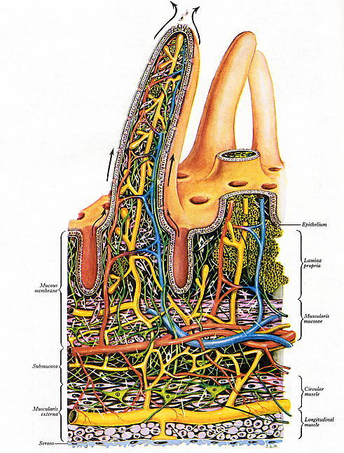The small intestine is conventionally divided into duodenum, jejunum and ileum.   
The mucosa is thrown into circular folds that become progressively less prominent from proximal to distal. In all parts of the small intestine the surface between the crypts carries projecting finger-like or flattened villi. The folds and villi both provide increased surface area for absorption.

Each villus contains a core of the lamina propria (mucosal connective tissue) containing blood and lymphatic microvessels and strands of smooth muscle.

Between the villi can be seen the openings of the intestinal crypts (simple, unbranched glands.

The black arrows indicate the direction of epithelial cell migration from the depths of the crypts onto the villi, where they are shed from the tips.

This low-magnification EM image of the small intestinal villous epithelium shows a section of an entire enterocyte and parts of two others, and a mucus-secreting (goblet) cell.

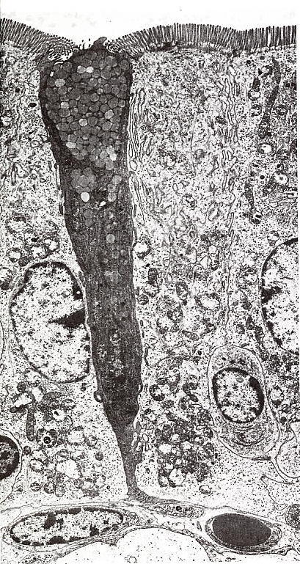

Enterocytes have a brush border of microvilli, moderate amounts of apical rough ER and numerous basolaterally placed mitochondria, whereas the goblet cell has abundant basal rough ER and an apical region packed with secretion granules containing mucus.

A capillary containing a single red cell can be seen at lower right. What information does this give about the size of the enterocytes?

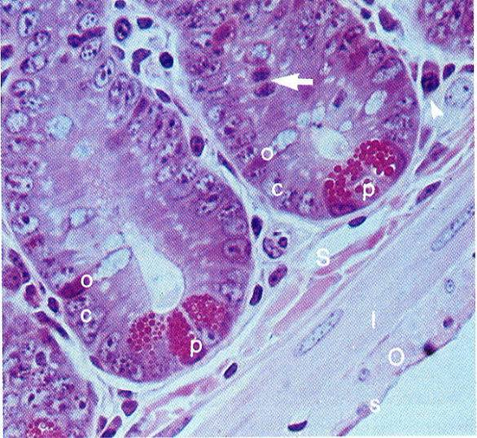

This histological picture of the basal parts of two jejunal crypts shows epithelial stem cells in mitosis (arrow). The granule-rich cells (labelled *p*) at the crypt bases are Paneth’s cells, known to secrete various enzymes such as lysozyme.

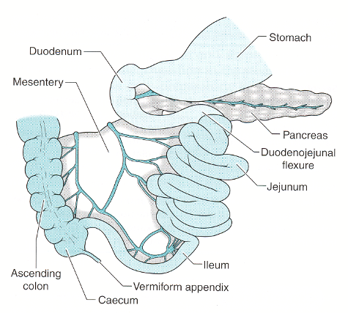**Duodenum, jejunum and ileum**

Main Functions: Digestion, absorption, motility.

Duodenum 25cm

Jejunum 2.5m

Ileum 3.75m

Fan shaped mesentery throws intestine into folds and supports the blood supply.

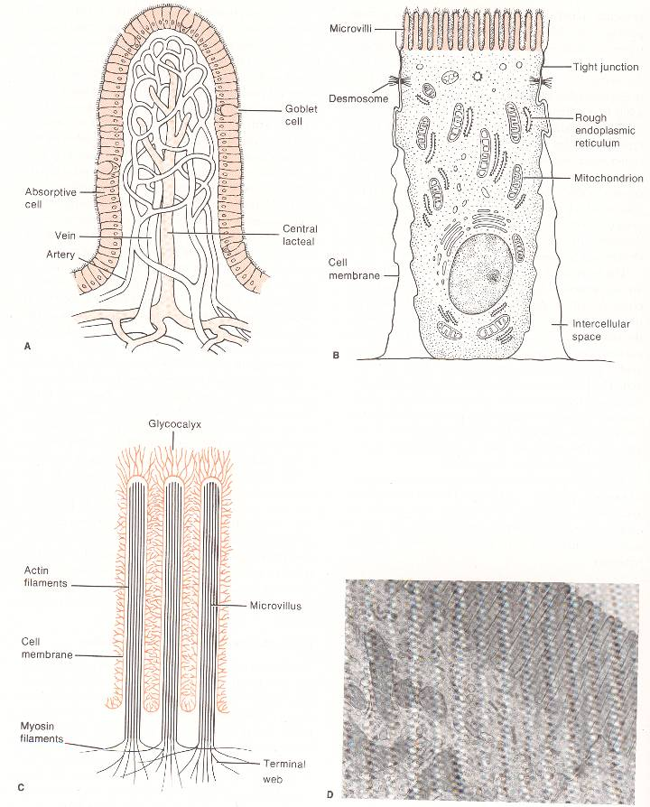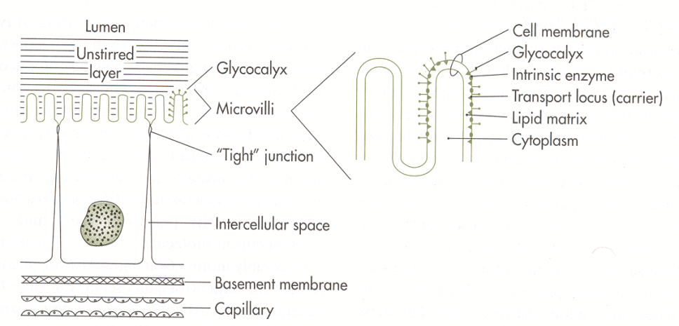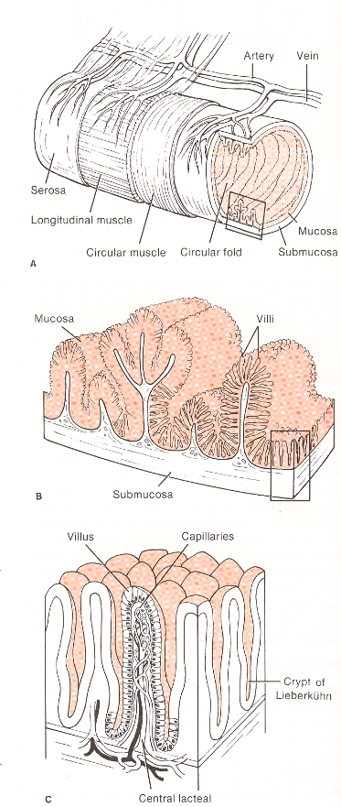

1.

2.

3.

4.

5.

6.

7.

The hierarchy of folds, villi and microvilli serve to increase the absorptive surface area by >500 fold compared to a cylindrical structure.

The circular muscles contract in patterns to facilitate segmentation, mixing and peristalsis.

Digestion occurs in an alkaline environment in the lumen (pancreatic enzymes and bile) and at the membrane (duodenal enzymes).

**Colon and rectum**

Minimal Learning Objectives for the Large Intestine

1. *Review* the anatomical sections and main anatomical relations of the large intestine and related structures.
2. *Describe* the main functions of the large intestine.
3. *Compare* the structure and functions of the small and large intestines.
4. *Describe* how the motility of the large intestine is regulated.
5. *Describ*e the control of defaecation.

The large intestine consists of the colon, cecum, appendix, rectum and anal canal.

The cecum is a blind pouch just distal to the ileocecal valve. The appendix is a thin, finger-like extension of the cecum and is not physiologically relevant in humans.

**Key features of the large intestine illustrated in pictures below.**

Villi are absent, but crypts are abundant. Absorptive cells are mainly associated with uptake of salt, and the accompanying osmotic outflow of water renders the gut contents increasingly solid. Mucous-secreting cells that lubricate transit of these contents dominate the crypts. Movements of the gut wall are more complicated than simple peristalsis, with adaptations such as the three thickened taeniae (tapes) of longitudinal smooth muscle that are a prominent feature of the colon. The peritoneum carries fatty tags (*appendices epiploicae*), and the gut wall is pouched in appearance (haustra). Nodules of lymphoid tissue are common in the walls of the distal small intestine (Peyer’s patches) and large intestine (solitary nodules).

The principal functions of the colon are the reabsorption of electrolytes and water and the elimination of undigested food and waste.

Large intestine histology:

* Mucosa appears smooth at the gross level because it has no villi.
* Enterocytes and goblet cells are abundant.
* Enterocytes have short, irregular microvilli and actively transport electrolytes
* Water is also absorbed as it passively follows the electrolytes.
* No paneth cells and enteroendocrine cells are rarer than in small intestine.
* Glycocalyx does not contain digestive enzymes.
* As in the small intestine, stem cells are found in the crypts.

**LARGE INTESTINE**

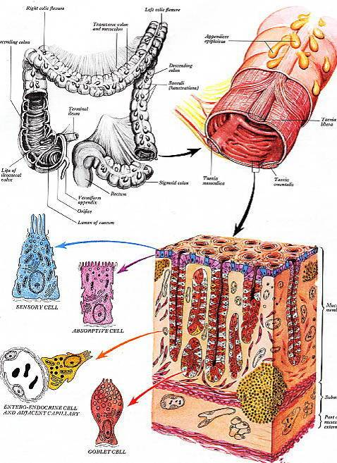

# PHYSIOLOGICAL PRINCIPLES IN THE ALIMENTARY TRACT

Dr Kevin Murphy & Dr Andrew Thillainayagam

**Minimum Learning Objectives**

1. Label a diagram of the alimentary system identifying the following:- mouth, oesophagus, salivary glands, stomach, pancreas, liver, gall bladder, duodenum, jejunum, ileum, colon, rectum, and anus. Mark on the diagram the position of the sphincters – gastro-oesophageal, pyloric, ileo-caecal, anal and sphincter of Oddi
2. Label a simple diagram of a typical gut wall section identifying: epithelial lining of gut lumen, mucosa, circular and longitudinal muscle, myenteric and submucosal plexuses and extrinsic nerves
3. Briefly explain the terms “intrinsic” and “extrinsic” nerve supply to the gut, and how these nerves may modify secretion, absorption, motility and blood flow of the gut
4. State that the extrinsic nerve supply has both a parasympathetic (mainly excitatory) and a sympathetic (mainly inhibitory) component
5. Explain that mechano- and chemoreceptors in the gut wall may invoke both local reflexes involving the intrinsic nerve system and “long” reflexes involving the brain via afferent nerve fibres in the vagus and splanchnic nerves
6. Describe how the activity of the gut muscles mixes contents with the digestive secretions and also aids efficient absorption of nutrients
7. Describe how the structure of the mucosal lining of the gut leads to a large surface area for absorption
8. State that the maximum rates of absorption of fat, protein and carbohydrate are about 10x greater than the normal daily rates
9. State that some 7 litres of fluid are secreted into the gut lumen during a day
10. Explain the importance of the reabsorbtion of this secreted fluid.
11. State that nearly all of the nutrients and most of the fluid secreted by the gut is reabsorbed in the small intestine
12. Describe how gut function is regulated by a combination of neural (both central and local), humoral and local paracrine activity. Illustrate this with a suitable example

* GI tract is hollow tube from mouth to anus made of smooth muscle and lined by epithelium + associated structures (salivary glands, liver and pancreas). Mouth – oesophagus – stomach – small intestine (duodenum, ileum and jejunum) – colon (ascending, transverse and descending) – rectum - anus
* Flow through tube regulated by activity smooth muscle and 4 sphincters (specialised regions of smooth muscle) – gastro-oesophageal, pyloric, ileo-caecal and anal
* Bile (liver) and pancreatic secretions enter the duodenum via common bile duct and regulated by sphincter of Oddi
* 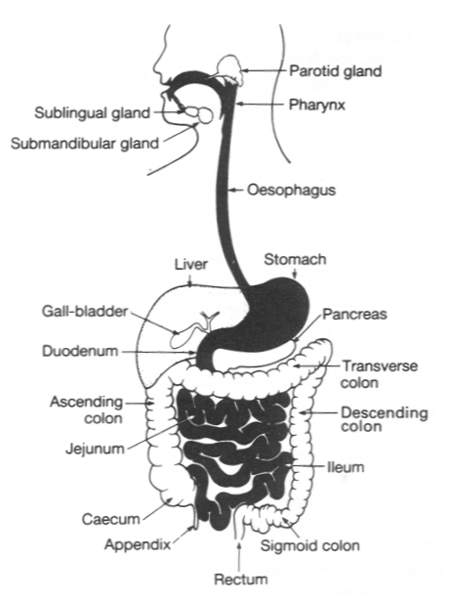
* Typically the gut wall has the epithelial lining (mucosa), 2 layers of smooth muscle (circular and longitudinal) and 2 nerve plexi (sub-mucosal and myenteric)
* Mucosal function shows specialisation for secretion or absorption. May be invaginated to form glands (gastric glands, Brunner’s glands)
* Gut neural plexi have multiple interconnections (“gut brain”) both within/between plexi as well as connections from external nerves of ANS. Both local and “long” (involving brain) reflexes are present
* Gut receives blood flow of about 30% resting cardiac output but this may fall during heavy cvs demand (exercise, haemorrhage)
* 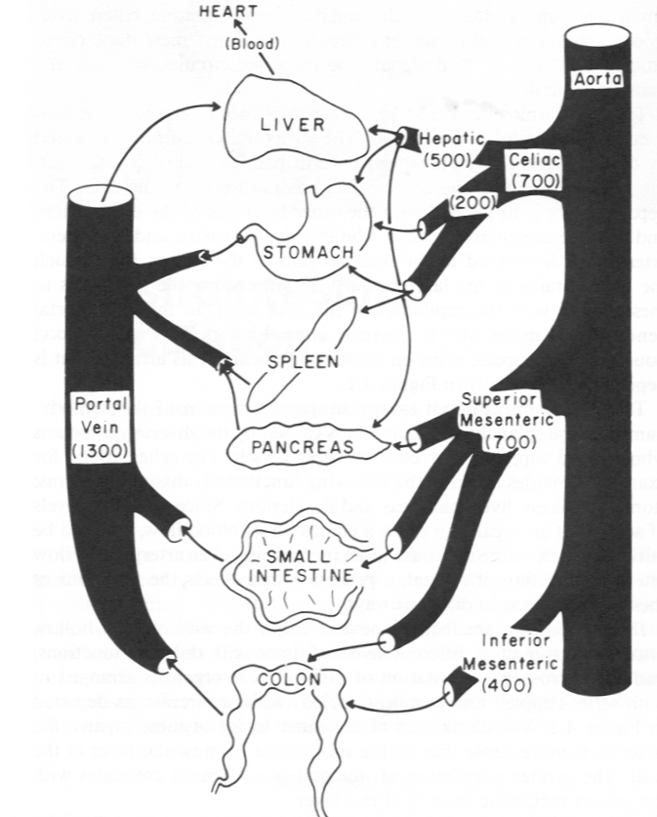
* Contractions smooth muscle both mix contents of lumen and also propel (peristalsis) contents towards anus
* Gut has large surface area for absorption due to mucosal folds, villi and brush border of mucosal cell membranes. Large capacity to absorb nutrients. Max rate absorption some 10x normal daily requirements – problem of obesity
* About 7.5l/day of water + ions are secreted into the gut – this is equivalent to 50% of the extracellular volume- together with some 1.5l in the diet. Need to reabsorb most of this – faecal volume normally 100-150ml/day
* Control of GI functions involves both local and central effects. Local – neural plexus reflexes and “hormones” (paracrine) such as histamine and 5HT. Central - long reflexes involving CNS plus circulating “true” hormones produced both by the gut itself (secretin, gastrin, CCK) and by other endocrine glands (aldosterone)
* These mechanisms regulate secretion, absorption, motility and blood flow.  
  The lecture uses control of the gastric parietal cell to illustrate this
* Ion transport mechanisms in the gut are important both for secretion and absorption processes – “tight” and “leaky” cell junctions, ion channels, ion exchange transporters and active transport mechanisms using ATP

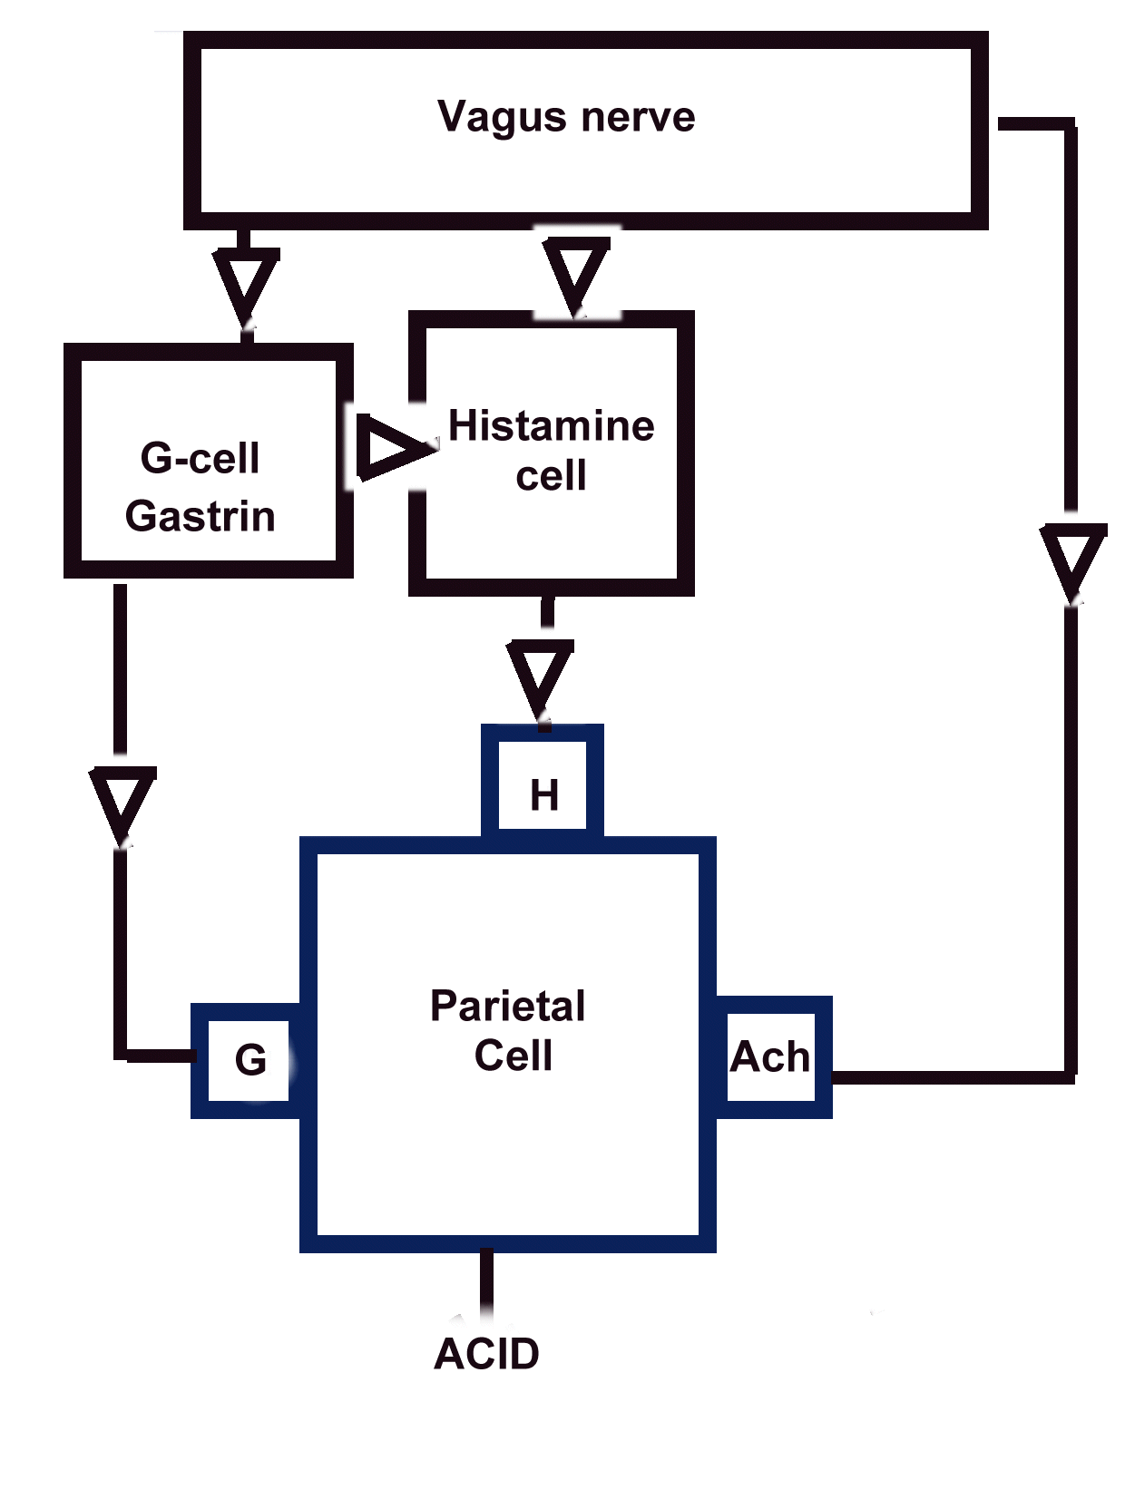

### OESOPHAGUS & STOMACH

**Keynote Structure-Function Relationships**

Professor Anthony Firth, Dr Kevin Murphy,

# Minimum Learning Objectives

1. *List* the main functions of the oesophagus
2. *Define* the anatomical levels and relations of the oesophagus
3. *Summarize* the organization of muscle types and function within the oesophagus
4. *Define* the structural basis for the gastro-oesophageal sphincter
5. *Define* the epithelial type that lines the oesophagus and *explain* how this is adapted to its function
6. *List* the main functions of the stomach
7. *Demarcate* the functionally distinct regions of the gastric mucosa
8. *Sketch and label* a typical acid- and enzyme-secreting gastric gland, showing the pit, neck and gland, the location of the epithelial stem cells and of surface mucous cells, oxyntic cells and chief cells
9. *Summarize* the functions of the cell types named in 8
10. Using simple diagrams, *explain* the mechanism of secretion of pepsinogen by the chief cells
11. Using simple diagrams, *explain* the mechanism of secretion of HCl by the oxyntic cells
12. *Summarize* the control of gastric secretion and outline the basis for the use of H2 inhibitors and proton pump inhibitors in pharmacological control of gastric acid secretion

# The Oesophagus:

Peristaltic conduit carrying swallowed material rapidly from pharynx to stomach

#### Links with anatomy

Extends from laryngopharynx (C5 posterior to cricoid) to diaphragm at T10

Passes through inferior neck and superior and posterior mediastinum

Anterior relations with trachea and fibrous pericardium

Posterior relations with prevertebral muscles, vertebral bodies and descending aorta

Thoracic duct crosses posterior to oesophagus between T7 and T4

Recurrent laryngeal nerves in groove between trachea and oesophagus

## *Muscular organization*

Muscle coats of oesophagus continuous with laryngopharynx

Lowest part of inferior constrictor (cricopharyngeus) is upper oesophageal sphincter

“Longitudinal” and “circular” layers of muscle really helices of various pitches

Muscle undergoes transition from skeletal to smooth between pharynx and stomach

## *Oesophageal epithelium*

Oesophagus lined throughout by stratified squamous, non-keratinising epithelium Associated with wet environments subject to “wear-and-tear”

Epithelial cells firmly linked by desmosomes braced by keratin intermediate filaments

Surface replacement from stem cells at base takes several weeks

**The stomach:**

Site of digestion of food in acid environment principally by pepsin

Little physiological absorptive function

Contents mixed by complex kneading movements of smooth muscle coats

Retains contents for minutes or hours

## *Links with anatomy*

Oesophagus enters at cardia on lesser curvature between fundus and body

Antrum tapers to pyloric sphincter

Suspended in mesenteries (lesser & greater omenta & gastrosplenic ligament

Functional gastro-oesophageal sphincter depends on skeletal muscle of diaphragm

Foregut derivative receiving blood from all 3 branches of coeliac axis

Parasympathetic nerves from vagus, sympathetic from T6-T8 via coeliac plexus

## *Gastric mucosa*

Entire epithelium is *simple* (= one cell thick)

Surface epithelium secretes mucus-HCO3- blanket protecting gastric surface

Covered in conical *pits* leading to gastric glands

Entire surface thrown into fixed ridge-like longitudinal folds called *rugae*

No villi anywhere in stomach

## *Gastric glands*

Tubular glands lying entirely within mucosa (*mucosal glands*)

Arise from bottom of gastric pits

Glands of fundus and body secrete HCl and enzymes

Inactive proenzyme (pepsinogen) secreted by chief cells

HCl secreted by parietal (oxyntic) cells by apical proton pump ATPase

H+ generated by ionisation of H2CO3 formed by carbonic anhydrase

Parietal cells when activated bring pump membrane into apical surface

## *Control of gastric acid secretion*

Stimulated by thought of food, taste/smell, food in stomach

Neural (vagal parasympathetic) and endocrine (gastrin) inputs

Final common pathway is intramucosal histamine release from ECL cells

Histamine acts on parietal cells through H2 receptors

Inhibited by H2 blockers (Ranitidine) or by proton pump inhibitors (Omeprazole)

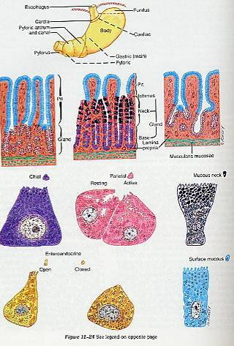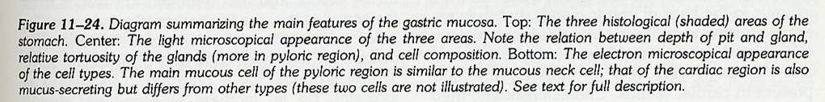

**GASTRO-OESOPHAGEAL REFLUX DISEASE**

Dr Anton Emmanuel, Dr Michael Lomax and Dr Jonathan Hoare

**Objectives**

* **Oesophageal symptoms**
  + Dysphagia - approach to patients
* **Gastro-oesophageal reflux disease**
  + pathophysiology – lower oesophageal function and hiatus hernia
  + management – lifestyle change, antacids, acid suppression and surgery
* **Oesophageal motility**
  + normal oesophageal motility
  + achalasia – paradigm of control of oesophageal motility
  + other motility disorders
* **Oesophageal neoplasms**
  + benign
  + malignant – relationship with reflux disease, principles of palliation

**Information Resources**

**Standard Text books** Souhami and Moxham Textbook of Medicine

***(relevant chapters)*** Kumar and Clark Textbook of Medicine

**Detailed Gastroenterology Text** Sleisenger and Fordtran:   
**(*relevant chapters)*** Gastrointestinal Disease

**Detailed recent information** Gastroenterology Clinics of North America,2002

***(if very interested only)*** December, Volume 31(4) – whole edition

**Websites** <http://www.netdoctor.co.uk/diseases/facts/gastrooesophagealreflux.htm>

**Investigating the Oesophagus**

* Structural
  + radiology
  + endoscopy
* Functional
  + manometry – pressure measurement
  + pH study – acid exposure
* Complications
  + anaemia
  + dehydration

**Gastro-Oesophageal Reflux Disease (GORD)  
Pathogenesis**

* LOS dysfunction
  + reduced LOS pressure
  + transient LOS relaxations (TLOSR)
* Hiatus hernia
* pH<4 refluxate into distal oesophagus…  
  …not cleared

**Gastro-Oesophageal Reflux Disease (GORD)  
LOS function**



* LOS is main component of anti-reflux barrier
* LOS dysfunction main mechanism of GORD
* Controls: reflux exclusively during TLOSRs
* GORD: 80% reflux episodes related to TLOSRs
* Oesophagitis: LOS pressure proportionally more relevant

**Hiatus Hernia**

weak, short LOS

stretched, torn phreno-

oesophageal ligament

loss of diaphragmatic

support of LOS

Loss of intra-abdominal LOS

retention of fluid

in hernia sac

widened diaphragmatic

hiatus

**Gastro-Oesophageal Reflux Disease  
Management – Lifestyle Modification**

* Weight loss
* Stop smoking
* Avoid alcohol binges
* Elevation of head of bed
* Meals
  + little and often
  + reduce fat
  + avoid late evening meals, hot drinks
* Use antacids

**Gastro-Oesophageal Reflux Disease  
Management**

* Need acid suppression if antacids fail
  + H2-receptor antagonists (H2RAs)
  + Proton pump inhibitors (PPIs)
* PPIs are more effective (90% vs 65% symptom improvement)
* Only a minority of symptomatic patients have severe oesophagitis – require long term PPI
* Eradicate *Helicobacter pylori* if considering long term PPI
* Intermittent PPI courses or as required PPI for recurrent symptoms

**Gastro-Oesophageal Reflux Disease**

**Oesophageal Carcinoma  
Pathology**

* Upper two-thirds cancers usually squamous
* Distal cancers usually adenocarcinoma
  + Barrett’s
  + spread from gastric cardia
* Pathology influences therapy

**Oesophageal Carcinoma - Palliative Treatment**

* If tumour cannot be stented, endoscopic laser ablation or alcohol injection to necrose tumour
* Palliative radiotherapy
  + good for pain
  + no good for long tumours
* Chemotherapy – encouraging recent results
  + Improved quality of life
* Knowing when to pull out

**Glossary of Terms**

**Acid suppression** *Medication aimed at reducing amount of gastric acid production, and hence oesophageal exposure to acid; the two main classes are H2-receptor antagonists (directed at the Histamine-2 receptors on gastric parietal cells) and proton pump inhibitors (blocking the H+/K+ ATPase pump on gastric parietal cells).*

**Ambulatory pH monitoring** *Measurement of amount of gastric acid the oesophagus is exposed to over a prolonged period of recording (usually 24 hours)*

**Angle of His** *The acute angulation of the stomach with respect to the oesophagus – contributes to the anti-reflux mechanism*

**Barrett’s oesophagus***Localised areas of columnar epithelium occurring in the distal oesophagus in response to chronic reflux – rarely may be a pre-malignant lesionin the development of oesophageal adenocarcinoma*

**Fundoplication** *Surgical correction of hiatus hernia or incompetent lower oesophageal sphincter*

**Hiatus Hernia** *Upward displacement of stomach through diaphragmatic hernia into thorax*

**Lower Oesophageal** *Condensation of oesophageal smooth muscle in* **Sphincter** *distal oesophagus, comprising the major contribution   
 to the anti-reflux mechanism*

**Sample Questions**

1. Outline a general approach to the management of a patient with dysphagia for whom a definitive diagnosis has yet to be established.
2. In what ways may a patient with gastro-oesophageal reflux disease present?
3. Discuss why prescribing a proton pump inhibitor may not be the correct first management in a 66-year-old patient complaining of heartburn.
4. From the pathophysiological point of view, explain how fundoplication aims to alleviate gastro-oesophageal symptoms. How successful is this approach to treatment?

Intestinal Absorption

Dr Kevin Murphy, Prof Julian Walters

Absorption occurs by several mechanisms:

|  |  |  |  |
| --- | --- | --- | --- |
| **Type of Transport** | **Carrier Proteins** | **Against/With Gradient** | **Energy Required** |
| Passive Diffusion | No | With | No |
| Facilitated Diffusion | Yes | With | No |
| Primary Active Transport | Yes | Against | Yes (hydrolysis of ATP) |
| Secondary Active Transport | Yes | Against | Yes (Electrochemical Gradient) |

**Carbohydrates**

Complex carbohydrates are digested in the lumen by pancreatic amylase.

Amylase products and simple carbohydrates are digested by various membrane enzymes

Absorption occurs by facilitated diffusion and secondary active transport (carrier proteins = SGLT-1, GLUT-5 and GLUT-2).

**Proteins**

Pancreatic proteases are secreted as precursors and activated in the duodenum by membrane enterokinase (trypsin) and trypsin (trypsin, chymotrypsin, elastase, carboxypeptidase A & B).

Peptides digested by brush border peptidases.

Absorption by facilitated diffusion and secondary active transport.

**Lipids**

Lipids emulsified (by bile salts) to increase surface area for digestion.

Digested by pancreatic lipase (combined with colipase).

Incorporated into Bile Salt Micelles for transport across unstirred layer to apical membrane.

Intracellular fatty acid binding proteins facilitate solubilisation and transfer across membrane.

Converted to triglycerides by monoglyceride acylation and the phosphatydic acid pathway and incorporated into chylomicrons.

Secreted across basement membrane by exocytosis and taken into lacteal

**SPECIFIC ISSUES IN ALIMENTARY ABSORPTION**

(Including water, electrolytes, minerals and vitamins)

Dr Caroline Small, Dr Kevin Murphy, Prof Julian Walters

Minimum Learning Objectives

1. Briefly describe the processes of diffusion and osmosis.
2. Describe the different protein-mediated transport systems that move substances across membranes.
3. Explain the mechanisms involved in absorbing water, Na+ K+ Ca++ Cl- HCO3-, Iron and vitamins in the alimentary tract.

Transport of molecules through membranes occurs by three processes:

Diffusion

The process whereby atoms or molecules intermingle because of their random thermal motion. Diffusion occurs rapidly over microscopic distances, but slowly over macroscopic distances. The time required for diffusion increases with the square of the distance over which diffusion occurs (i.e. a ten fold increase in diffusion distance will require a hundred times longer to complete the diffusion process). This is why multicellular organisms tend to evolve circulatory systems to bring individual cells within diffusion range.

The plasma membrane of cells acts as a diffusion barrier, enabling cells to maintain cytoplasmic concentrations of substances different from their extracellular concentrations. The lipoid nature of the cell membrane means that lipid soluble (non-polar) molecules can cross more easily than water soluble (polar) molecules.

Osmosis

The flow of water across a semi-permeable membrane from a solution of lower concentration to a solution of higher concentration.

## Protein-mediated transport systems are responsible for moving important substances across membranes. Specific ions or molecules enter or leave cells by way of specific carriers or channels that are intrinsic proteins of the plasma membrane. There are two types of such transport:

Active transport which is capable of ‘pumping’ a substance against a gradient of concentration or electrochemical potential: this requires energy. A primary active transport process is linked directly to cellular metabolism (uses ATP to power the transport). Once created, a concentration gradient represents a store of chemical potential energy that can be harnessed. A secondary active transport process derives energy from the concentration gradient of another substance that is actively transported.

Facilitated transport enhances the rate a substance can flow down its concentration gradient. This tends to equilibrate the substance across the membrane and does not require energy.

Humans absorb approximately 99% of the water and ions in ingested food and gastrointestinal secretions.

**Water absorption**

The net absorption of water is powered by the absorption of solutes from the intestine. A significant fraction of the net water absorption occurs by a mechanism known as standing gradient osmosis. The active pumping of sodium into the lateral intercellular spaces by sodium/potassium ATPase drives the absorption of chloride ions and water. Typically 2 litres of water is ingested per day, and 7 litres contained in gastrointestinal secretions. Of this, only 50-150ml water per day is lost in the faeces.

***Diarrhoea***. In secretory diarrhoeal diseases such as cholera, the secretion of Cl-, Na+ and water into the intestinal lumen by cells in the crypts of Lieberkuhn is specifically elevated. Cholera toxin permanently activates adenylyl cyclase, elevating cAMP in the crypt cells and thus enhances the secretion of Cl- (and therefore also of Na+ and water). Cholera patients may produce up to 20 litres per day of watery stool. Such patients are likely to die unless they are promptly and adequately rehydrated.

***Ion absorption:***

Electrolytes (including Na+ K+ Ca++ Cl- HCO3- and Iron) are absorbed differentially by parts of the GI tract. Electrolyte transport in the intestine is regulated by hormones, neurotransmitter and paracrine substances.

***Vitamins:***

Fat soluble vitamins are absorbed by the epithelial cells of the small intestine by simply diffusing across their luminal plasma membranes.

Water soluble vitamins, in contrast, do not readily diffuse across biological membranes, and require special membrane transport proteins.

### MALABSORPTION

### Prof Julian Walters

**Minimum Learning Objectives:**

1. To recognise the clinical presentation of malabsorption
2. To understand the disease mechanisms leading to malabsorption
3. To learn about the clinical importance, presentation, complications and treatment of coeliac disease

## Clinical Presentation of Malabsorption

Generalised or specific malabsorption

Diarrhoeal and steatorrhoea

Nutritional assessment

Growth failure, weight loss

## Disease Mechanisms leading to Malabsorption

Maldigestion (pancreatic) or malabsorption (intestinal)

Specific gene disorders

* lactose intolerance
* other rare disorders

Loss of intestinal mucosa

* short bowel syndrome
* villous atrophy / enteropathy

Clinical disorders

## Coeliac Disease (gluten-sensitive enteropathy)

Presentation

* typical case
* symptoms
* investigations

Diagnosis

* duodenal biopsy (villous atrophy & crypt hyperplasia)
* serology (tissue transglutaminase)

Epidemiology

* the coeliac iceberg
* prevalence 1 in 100

Pathology

* gluten (gliadin in wheat)
* sensitivity (genetic associations, HLA-DQ2)
* enteropathy (immune mechanisms)

Treatment

* gluten-free diet
* nutritional support from dietitians
* possible supplements
* prevention of complications
* intestinal lymphoma, osteoporosis

**THE PANCREAS:**

# Keynote Structure-Function Relationships

## Lecture material developed by Dr Kevin Murphy & Dr A Wren

***Consolidate your knowledge by using these keynotes as a guide  
to the lecture slides on the Intranet***

Minimum Learning Objectives

1. Distinguish between the exocrine and endocrine parts of the pancreas in structural and functional terms
2. Review the anatomical regions and main anatomical relations of the pancreas
3. Sketch the duct system of the pancreas
4. Define a pancreatic acinus
5. Describe the subcellular organisation of synthesis and secretion by the pancreatic acinar cells
6. Outline the embryonic development of the pancreas
7. List the most important components of the pancreatic (exocrine) secretions and define their roles in digestion
8. Explain the mechanism for bicarbonate secretion in terms of ion exchange pumpsb and membrane ion channels and the dependence on active transport
9. Understand that acinar cells synthesise enzymes for the digestion of carbohydrate, lipids and proteins and store these in an inactive form in zymogen granules, and explain how these enzymes are activated when they enter the duodenum
10. Explain how nervous stimulation and the hormones secretin and CCK regulate the release of pancreatic juice.

**Exocrine and Endocrine Pancreas:**

Consists mainly of exocrine tissue secreting pancreatic juice rich in digestive enzymes and HCO3-

Interspersed though this are islets of endocrine tissue that secrete protein hormones

## *Links with anatomy*

Lies mainly on posterior abdominal wall extending from C-shaped duodenum to hilum of spleen

Subdivided into head, neck, body, tail and uncinate (= hook-like) process

Islet tissue usually throughout, but most abundant in tail

Close relations with (and supply from) coeliac and superior mesenteric arteries

Main posterior relations are IVC, abdominal aorta and left kidney

Pancreatic juice reaches 2nd part of duodenum via main and accessory pancreatic ducts

## *Development*

Pancreatic buds grow out into dorsal and ventral mesenteries of foregut near junction with midgut

Ventral bud shares opening into duodenum with common bile duct

Dorsal bud expands on left to form head (part)-neck-body-tail

Ventral bud swings posteriorly to duodenum to fuse with dorsal bud and forms rest of head and uncinate process

Duct of ventral bud usually acquires drainage from neck-body tail to become main pancreatic duct opening with common bile duct

Residual part of dorsal bud drains though accessory pancreatic duct directly to 2nd part of duodenum

Branches of duct system give rise to both exocrine (acinar) and endocrine (islet) tissue

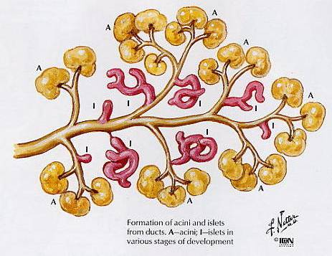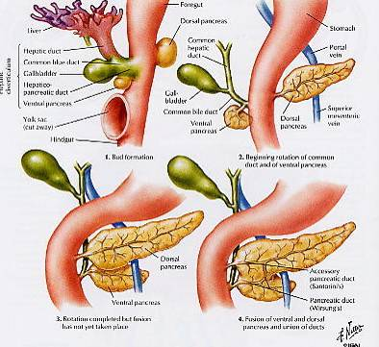

**Pancreatic acini:**

Secretory units of exocrine pancreas

Spheroidal cluster of 10+ secretory epithelial cells

Enzyme protein synthesised on RER, glycosylated sorted and packed in Golgi complex, stored in secretion granules and secreted by apical exocytosis

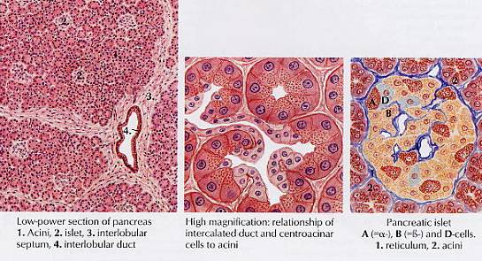

* 2 components of pancreatic secretions – endocrine from Islets Langerhan (blood glucose control) and exocrine – pancreatic juice for digestion secreted into duodenum
* Acinar cells secrete a low volume, viscous solution rich in digestive enzymes. Duct and centroacinar cells secrete a high volume, watery solution rich in bicarbonate
* Bicarbonate concentration 120mM – pH 7.5-8. Neutralises acid chyme from stomach protecting the duodenal mucosa and secreted enzymes from acid damage. High volume also washes low volume enzyme secretion into duodenum
* Bicarbonate is formed in duct cells from CO2 and H2O to give H+ and HCO3- ions. HCO3- enters the duct via a luminal Cl-/HCO3- exchange and H+ enters the blood via Na+/H+ exchange
* Enzymes produced in acinar cells are stored as inactive precursors in granules to protect the tissue from auto-digestion. There are enzymes for fat, carbohydrate and protein breakdown. Adequate secretion of these enzymes is essential for the complete digestion of food. Bile salts (see liver session) are also required for fat digestion
* Duodenal mucosa secretes an enzyme – Enterokinase – that converts inactive trypsinogen to trypsin and this then activates the other inactive precursor enzymes
* Pancreatic secretion begins before food enters the duodenum via a vagal reflex in response to smell/taste of food – Cephalic phase. This stimulates only enzyme secretion
* When acid chyme enters the duodenum from the stomach it stimulates the duodenal mucosa to release hormones (secretin & CCK) into the blood.   
  Secretin is released by acid pH and stimulates bicarbonate secretion.   
  CCK (cholecystokinin) released in response to fats/protein/peptides and stimulates enzyme secretion
* Cephalic phase of secretion ceases once the meal is eaten and serves to “mobilise” the digestive enzymes. Neutralisation of the acid stops secretin release whilst digestion/absorption of “food” removes stimulus for CCK release.

**REGULATION OF FUNCTION:   
ENTERIC NERVOUS SYSTEM AND GUT HORMONES** Lecture material developed by Dr Caroline Small, Dr Kevin Murphy, Dr A Wren

Much hormonal and neural regulation is intrinsic to the gastrointestinal tract. Over-lapping layers of extrinsic and intrinsic hormonal and neural control allow for the subtle and precise control of gastrointestinal functions.

**The enteric nervous system**

In addition to innervation by the sympathetic and parasympathetic nervous systems (extrinsic innervation), the digestive system is endowed with its own, local nervous system referred to as the enteric nervous system (intrinsic innervation).

The principal components of the enteric nervous system are two networks or plexuses of neurons, both of which are embedded in the wall of the digestive tract and extend from oesophagus to anus:

1. The myenteric plexus
2. The submucous plexus

Both plexuses consist of ganglia that are interconnected by tracts of fine, unmyelinated nerve fibres. The neurons in the ganglia are of three types, most of which are multipolar:

*Sensory neurons* which respond to mechanical deformation, particular chemical stimuli, and temperature.

*Motor neurons* which send axons to smooth muscle cells of the circular or longitudinal layers, secretory cells of the gastrointestinal tract, or gastrointestinal blood vessels.

*Interneurons* that form part of the network integrating the sensory input and effector output.

Interneurons in the plexuses connect afferent sensory fibres with efferent neurons to smooth muscle and secretory cells to form reflex arcs that are wholly within the gastrointestinal tract wall. Consequently the myenteric and submucosal plexuses can co-ordinate activity in the absence of extrinsic innervation of the gastrointestinal tract.

**The enteric endocrine system**

The gastrointestinal tract also has a great deal of intrinsic hormonal regulation. Endocrine cells in the mucosa or submucosa of the stomach and intestine and pancreas produce an array of hormones. Three of the best-studied enteric hormones are:

1. Gastrin: Secreted in the stomach and plays an important role in control of gastric acid secretion.
2. Cholecystokinin: A small intestinal hormone that stimulates secretion of pancreatic enzymes and bile.
3. Secretin: Another hormone secreted from small intestinal epithelial cells; stimulates secretion of bicarbonate-rich fluids from the pancreas and liver. **PANCREATITIS**

Lecture material developed by Ruben Canelo, Mr G Hanna, Dr Laksh Ayaru

**Minimam learning objectives**

1 Define acute and chronic pancreatitis

2 List four causes of acute pancreatitis

3 List the symptoms and signs of acute pancreatitis

4 List blood tests and imaging modalities which are useful for patients with pancreatitis

5 List three causes of chronic pancreatitis

6 List the complications of acute and chronic pancreatitis

Introduction

Inlammatory disease of the pancreas has two different entities acute and chronic. The pancreas is a long flat gland that lies horizontally behind the stomach. The head of the pancreas rests against the duodenum and the tail reaches towards the spleen. It has two main functions:

* 1. Exocrine: Production of digestive juices and enzymes for the metabolism of fats, carbohydrates and protein.
  2. Endocrine: Secretion of insulin, glucagon and somatostatin. The pancreatitis has an incidence of 17 new cases per 100,000 people.

Acute pancreatitis

Is an acute inflammatory process of the pancreas with variable involvement of other regional tissues or remote organ systems. Clinical presentations:

1.Severe acute pancreatits, 2. Mild acute pancreatitis, 3. Acute fluid collection, 4. Pancreatic necrosis and infected necrosis, 5. Acute pseudocyst, 6. Pancreatic abscess. Mortality has remained at 10-15% over the past 20 years.

Causes: The most common causes of pancreatitis are alcoholism and cholelithiasis. Other causes are metabolic, infections, medications and vasculitis.

Clinical diagnosis: History of upper abdominal pain and vomiting with epigastric or diffuse abdominal tenderness. Occasionally body wall ecchymosis (Cullen`s sign at the umbilicus, Grey-Turner`s sign in the flanks) will be found.

Biochemical diagnosis: Elevated levels of pancreatic enzymes, amylase and lipase. Elevated white blood cell count, liver enzymes and bilirubin, hyperglycemia, hypocalcemia. C-reactive protein (CRP) concentration has independent prognostic value. A peak level of > 210 mg/l in the first four days of the attack or > 120mg/l at the end of the first week has a predictive accuracy of around 80%.

Radiological diagnosis: Plan x rays: Chest and abdominal plain x rays in order to detect local ileus (sentinel loop) and in case of the chest x ray the pleural effusion is the most common finding and the alveolar interstitial shadowing may suggest an adult respiratory distress syndrome (ARDS). Ultrasound: Is valuable in detecting free peritoneal fluid, gallstones, and dilatation of the bile duct. MRCP: Non invasive investigation of the bile duct. ERCP: In patients thought to have a severe biliary pancreatitis secondary to gallstones.

CT-scanning: For the diagnosis and eventually for the drainage of fluid under radiological guidance. Severity stratification: Biochemical and objective criteria: Glasgow and Ramson scoring systems. Those scoring systems improve the accuracy of prognostication around 70-80%. The APACHE II scoring system can be used to assess the initial severity of disease and the chances of developing a subsequent complication.

Management of mild acute pancreatitis: Monitoring of temperature, pulse, blood pressure, and urine output. Line for IV fluids, nasogastric tube and urine catheter. Antibiotics should not be administrated routinely as there is not evidence that their use in mild cases will affect outcome or reduce the incidence of septic complications. Nutritional recommendations: 2-5 days: fasting, 3-7 days: referring (diet rich in carbohydrates, moderate protein, moderate in fat). After 7 days may start a normal diet.

Management of severe acute pancreatitis: The initial management involves full resuscitation and a multidisciplinary approach. These patients should be managed in ITU. When cardiocirculatory compromise exists a Swan-Ganz catheter is required. The administration of intravenous antibiotics as a treatment of infections following severe acute pancreatitis is justified. CT scanning should be done. Nutritional support: enteral/parenteral. Enteral nutrition should be attempted in all patients.

The severe gallstone pancreatitis should be treated with ERCP and sphincterotomy urgently. Gallstones eradication should be done by cholecystectomy within two or four weeks. If local complications develop, such as pseudocyst or infected necrosis, cholecystectomy should be performed when the complications are treated surgically.

Chronic pancreatitis

The most common causes of chronic pancreatitis are alcoholism, microlithisasis and idiopathic. Rare causes are hereditary pancreatitis, hyperparathyroidism, and obstruction of the main pancreatic duct caused by stenosis, stones or cancer. Symptoms may be identical to those of acute pancreatitis. Although occasionally there is no pain, severe epigastric pain may last for many hours or several days. Possible causes include acute inflammation not recognised by conventional tests, distension of pancreatic ducts caused by strictures or calculi, a pseudocyst, or obstruction of either the duodenum or the common bile duct caused by fibrosis of the head of the pancreas. When lipase and protease secretions are reduced to < 10% of normal level, the patient will develop steatorrhea.

Diagnosis: Laboratory tests, including amylase and lipase, are frequently normal, probably because of significant loss of pancreas function. Inflammatory markers can be minimally elevated as well. Structural abnormalities can be visualised in plan x-ray abdomen, showing pancreatic calcifications, which indicates intraductal stones. Abdominal ultrasound, CT scan can show abnormalities in size and consistency of the pancreas, pancreatic pseudocysts, or dilated pancreatic duct. The ERCP can show abnormalities in the pancreatic duct. Tests to assess the endocrine function of the pancreas can show diabetes mellitus. The most sensitive tests of the exocrine function of the pancreas: is the secretin test. Other tests include measurement of serum trypsinogen, faecal chymotrypsin, and urinary p-aminobenzoic acid.

Treatment: A relapse of chronic pancreatitis may require similar management to that of acute pancreatitis. The supply of IV fluids, dietary restriction including fat and proteins in order to reduce stimulus to the pancreas secretion. H2 or PPI blockers to reduce acid stimulation and relieve of the pain. To treat the chronic pain, pancreatic enzymes (30,000 U of lipase) have been used with each meal. A pancreatic pseudocyst can be decompressed into a nearby structure eg. stomach or into a defuntionalized loop of jejunum via a Roux-en-Y. If the pain is refractory and the main pancreatic duct is dilated a lateral pancreaticojejunostomy (Puestow Procedure) may be indicated.

If the duct is not dilated a resection can be considered like a distal pancreatectomy or Whipple`s operation. These operative approaches may relieve pain in 60 to 80% of patients and should be reserved for patient with a nondilated duct who have discontinued using alcohol and who can manage diabetes that may be intensified by pancreatic resection. Steatorrhea can be improved with pancreas extracts containing lipase. H2 blockers can be used to reduce the intragastric acidity. Use of Insulin to treat the diabetes should be managed carefully due to the associated glucagon deficiency.

Patients with chronic pancreatitis are at increased risk for pancreatic cancer. Worsening of symptoms should prompt an examination for malignancy, including brushing of strictures for cytological analysis or measurements of serum markers (eg. CA 19-9, CEA).

**HUNGER, THIRST AND CONTROL OF INTAKE**

Dr Kevin Murphy

Minimum Learning Objectives

1. Draw a simple diagram explaining how the hypothalamus regulates appetite.
2. Describe the main neural populations involved.
3. Explain how mutations disrupting these neural systems can influence energy balance.
4. Describe the role of leptin in energy homeostasis.
5. Explain why gut hormone systems may be good targets for anti-obesity drugs.
6. Briefly describe the role of ADH in water balance.
7. Detail how the hypothalamus regulates water intake.
8. Describe the role of angiotensin II in the perception of thirst.

The hypothalamus is the main CNS region directly regulating appetite. The arcuate nucleus (called the infundibular nucleus in man) of the hypothalamus plays an integrative role in appetite regulation, receiving signals from the brain stem and the periphery, including circulating factors such as leptin, ghrelin and PYY. There are two main arcuate neuronal populations involved – appetite inhibiting pro-opiomelanocortin (POMC) and cocaine- and amphetamine-regulated transcript (CART) co-expressing neurones, and appetite stimulating neuropeptide Y (NPY) and agouti related peptide (AgRP) co-expressing neurones. These neuronal populations project to the paraventricular nucleus (PVN), another nucleus important in the regulation of food intake. The PVN also receives inputs from other hypothalamic nuclei, including neurons containing orexin and melanin concentrating hormone (MCH) from the lateral hypothalamic area, and other brain areas, such as the brainstem and amygdala. Mutations disrupting these hypothalamic systems can cause obesity in man.

In recent years great advances have been made in our understanding of the peripheral signals that regulate appetite from the gut and adipose tissue, and how these act within the brain.

Leptin is a protein hormone secreted from white adipose tissue which circulates at concentrations proportional to fat mass and inhibits food intake. Leptin crosses the blood brain barrier to act via its receptor to inhibit orexigenic and stimulate anorexigenic neuropeptides in the arcuate nucleus of the hypothalamus, and is believed to play an important role in long-term energy balance.

The gut hormones ghrelin and peptide YY (PYY), secreted from the gut in response to changes to nutritional status, also act on the ARC to regulate appetite. While food intake is stimulated by ghrelin, it is inhibited by PYY. Ghrelin and PYY are important therapeutic targets in the quest to find an effective anti-obesity treatment.

**Thirst:**

The ADH and thirst systems work in concert to maintain water balance. An increase in plasma osmolality invokes drinking and via ADH action on the kidneys, the conservation of water. Conversely, when plasma osmolality is decreased thirst is suppressed, and in the absence of ADH, renal water excretion is enhanced.

ADH regulates renal water excretion and the secretion of ADH is regulated by osmotic and hemodynamic factors. Factors that influence ADH secretion also affect the perception of thirst. The “thirst” centre is located in the anterolateral region of the hypothalamus. Whilst distinct from the osmoreceptors involved in ADH secretion the cells of the “thirst” centre also respond to osmolarity. Angiotensin II also acts on the cells of the thirst centre to evoke the sensation of thirst. Because angiotensin II levels are increased when blood volume and pressure are reduced, this acts to restore body fluids at their normal volume.

The sensation of thirst is satisfied in the short term by the activation of oropharyngeal and upper GI receptors. However, thirst is only completely satisfied when plasma osmolality, or blood volume and arterial pressure, is corrected.

**IMMUNOLOGICAL MECHANISMS AND INFECTIONS IN THE ALIMENTARY TRACT**

Lecture material developed by Dr Janice Main , Dr Matt Shale, Dr Kip Cheent & Dr Jonathan Nolan

# AIMS AND OBJECTIVES

* List the innate functions of the alimentary system which are part of our defence systems
* Define MALT and GALT
* Describe a Peyer’s patch
* Define the role of IgA in the GI tract
* Describe the importance of colonic flora
* Describe the circulation of lymphocytes within the alimentary system and how this relates to the immune system elsewhere
* List three mechanisms of infectious diarrhoea
* Describe the global importance of childhood diarrhoea

The alimentary system is exposed to many antigens on a daily basis. These antigens can be derived from food and from potential invaders such as bacteria and viruses. Recognition and appropriate handling of these antigens are vital to survival.

If the immune system is poorly functioning then we are at risk of infections and if too vigorous can lead to hypersensitivity reactions and auto-immune diseases.

# INNATE MECHANISMS

i.e. what we are born with …

* **Gastric acid** – acid bath- kills micro-organisms

Hypochlorhydria (low acid) –more likely to get salmonella infections

# Normal oral flora

Upset with antibiotics

# Peristalsis

# Mucus

From goblet cells

* **Proteases**

Intraluminal enzymes

# Enterocyte membrane

Protective shield

# ADAPTIVE IMMUNITY

We are exposed to thousands of antigens on a daily basis.

MALT = mucosa associated lymphoid tissue

GALT = gut associated lymphoid tissue

* generates lymphoid cells and antibodies
* IgA secretory and interstitial
* IgG
* IgM
* Cell mediated immunity

GALT is composed of:

Lymphoid follicles

Tonsils

Peyer’s patches (distal ileum) and scattered lymphoid follicles

Antigen presenting cells (lamina propria )

Intraepithelial lymphocytes (mainly CD8)

Mesenteric lymph nodes

# Peyer’s patches and scattered lymphoid follicles

A bit like passport control?

Specialised epithelium – “dome epithelium”

Controlled uptake of antigens

Smaller epithelial cells and brush border

Less goblet cells

Less mucus

No sIgA

M cells = membranous or microfold

Portal of entry for antigens

Transported to lymphocytes, macrophages and dendritic cells

The mucosal lymphocytes stimulated by antigens and cytokines migrate to the mesenteric lymph nodes then into the thoracic duct then back to mucosal surfaces. The primed B cells from the Peyer’s patches journey off to the laminal propria and generate IgA.

Thus, antigen exposure at one part of the gut leads to an immune response throughout the alimentary system.

# INFECTIONS OF THE ALIMENTARY SYSTEM - EXAMPLES

You are not expected to know the details of alimentary infections – this will be taught later in Microbiology, *etc*. The examples are given to illustrate how despite the sophistication of the immune system that sometime the micro-organisms win.

Be prepared to hear of some interesting outbreaks and how you can avoid tummy upsets on holidays.

Copies of the slides shown are available on the Intranet.

## *E. coli*

*E. coli* gut infections are common causes of infection and are, for example, the main cause of travellers’ diarrhoea. Listen out for the other names for this!

Strains of *E. coli* produce different toxins which cause diarrhoea in different ways.

These can be:

* Enterotoxigenic
* Enterohaemorrhagic (O157:H7)
* Enteropathogenic

Listen out for the dangers of school trips to farms!

## Cholera

Cholera causes watery diarrhoea = very watery. The stools are described as “rice water”. Victims can lose litres of fluid and become rapidly dehydrated.

## Childhood diarrhoea

## Sadly, poor sanitation in many countries exposes babies and young children to the risks if infective diarrhoea. This can be life threatening. Learn how simple measures can help save children’s lives and how, already your knowledge of fluid secretion and absorption in the gut may help save children.ORGANISATION OF THE LIVER Professor Anthony Firth and Dr Abigail Zabron

**Minimum Learning Objectives**

1. *List* the main functions of the liver
2. *Review* the organisation of the liver and biliary system at the level of gross anatomy
3. *Describe* the main features of the blood supply to the liver
4. *Explain* the organisation of liver tissue in relation to its microcirculation, *making correct use* of the terms portal triad, central vein, sinusoidal capillary, hepatocyte, lobule, periportal region and centrilobular region
5. *Summarise* the functional importance of the main structural features of hepatocytes (rough ER, Golgi complex, secretion granules, glycogen granules, mitochondria, smooth ER, junctional complexes)
6. *Draw* a simple diagram outlining the relationships of hepatocytes to bile canaliculi and sinusoidal capillaries, and *use this* to explain major hepatic functions
7. *Define* the position and main roles of the fixed macrophages (Kupffer cells)
8. *Outline* the embryological origins of the liver
9. Explain the main structural and functional changes in the liver between the embryonic period and the postnatal period

**Bird’s-eye view of liver functions:**

1. Secretes bile into duodenum (via gall bladder where bile is stored and concentrated) – bile salts are needed to emulsify dietary fats for efficient digestion and absorption
2. Phagocytoses and breaks down over-dates red cells
3. Excretes bile pigments (Hb breakdown products) into bile
4. Metabolises many natural and synthetic molecules to prepare them for excretion
5. Synthesises and secretes key blood proteins (eg albumin and fibrinogen)
6. Key site of insulin dependent glycogen storage (“glucostat”) and of intermediary metabolism of nutrients
7. And much else …

# Cellular organisation of the liver

Except for red cell recycling, all the major functions of the liver are carried out by **hepatocytes**, which for about 70% of the organ’s mass.

At first sight the organisation of the hepatocytes appears quite unlike normal epithelial cells. Instead of forming simple sheets or glands facing a lumen on one side and the capillary bed on the other, hepatocytes are arranged as complex, anastomosing sheets separated by wide sinusoidal capillaries.

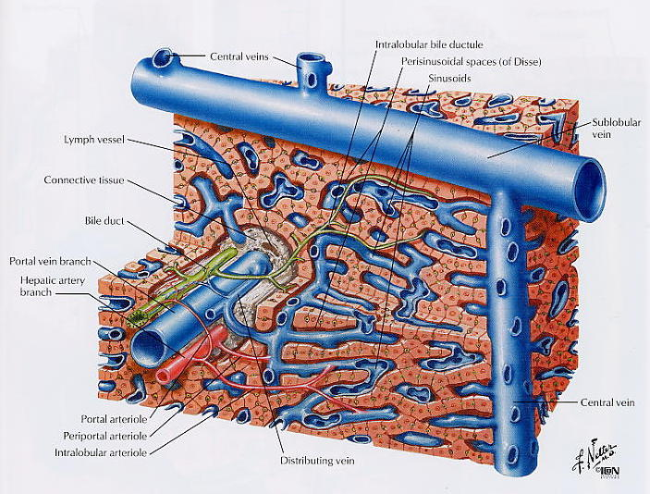

The apical part of the hepatocyte is reduced to a narrow band surrounding the cell within the plane of the sheet of hepatocytes. These apical domains bound a meshwork of narrow intercellular spaces called bile canaliculi. Bile is secreted into the canaliculi; tight junctions on each side of the canaliculus prevent leak-back to the circulation.

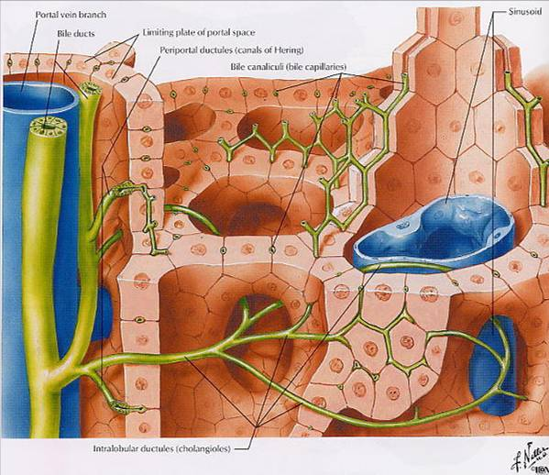

The portal vein, hepatic artery and bile ducts that enter the liver together retain their relationship even after multiple branching; these microscopic vascular bundles within the liver are termed portal triads. A region of liver parenchyma surrounded by a ring of about 5 or 6 portal triads is called a lobule. A tributary of the hepatic veins at the centre of each lobule receives the blood draining from the sinusoidal capillaries. In other words, the lobule is a unit of vascular supply within the liver, the blood circulating from the peripheral triads to the central vein.

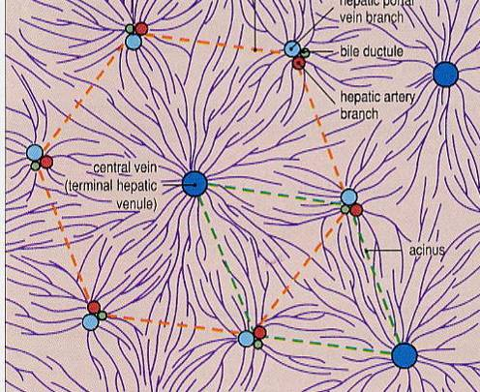

However, the bile canalicular network drains towards the bile ductules within the triad, and the term acinus is used for a unit of biliary secretion. These are simply different ways of looking at the same thing.

**To summarise:**

Bile secreted from the apical (canalicular) surfaces of the hepatocytes drains through the canalicular network to the bile ductules in the triads

All other liver secretion products (such as albumin, fibrinogen and glucose) are released at the non-canalicular surfaces of the hepatocytes into the perivascular space (of Disse) and thus enter the very permeable sinusoidal capillaries.

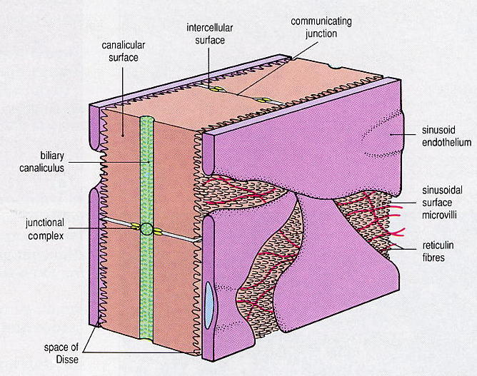

**Hepatic macrophages (Kupffer cells)**

One major function of the liver is not attributable to the hepatocytes. This is the phagocytosis and lysosomal breakdown of old red cells, which is handled by fixed macrophages called Kupffer cells that form part of the lining of the sinusoids.

**LIVER FUNCTIONS**

Dr Kevin Murphy, Dr Abigail Zabron, Dr Shahid Khan

Minimum Learning Objectives

1. Briefly describe how the liver is supplied with blood
2. Describe how the liver “buffers” the blood glucose concentration in terms of glycogen storage/breakdown and glucose synthesis from non-carbohydrate sources (gluconeogenesis)
3. Describe the role of liver in protein and fat metabolism.
4. Describe how bile is stored and concentrated in the gall bladder, and reabsorbed in the ileum, the main contents of bile and the role of bile in the digestion of fats. are bile salts, bilirubin, cholesterol, phosphlipids, bicarbonate ions and water
5. Define the term jaundice. Explain the difference between haemolytic and obstructive jaundice
6. Briefly describe the role of the liver in metabolising/inactivating steroid and peptide hormones and various “foreign” chemicals (drugs) which are then excreted in bile, the storage of fat soluble vitamins (A,D,E,K), vitamin B12, iron (as ferritin)
7. Describe how Kupffer cells in liver sinusoids destroy any bacteria which have entered the blood from the gut lumen
8. Describe how the liver performs the first hydroxylation step on vitamin D necessary to convert it to the biologically active form

The liver is a large, multifunctional organ involved in digestion, biosynthesis, energy metabolism, degradation/detoxification and excretion of many substances. Has a high blood flow – 25% resting cardiac output but 80% of this flow is venous blood coming from the gut via the hepatic portal vein

### Blood Glucose Buffering

* Stores glucose as glycogen during digestion and later releases it between meals to maintain blood glucose (muscle glycogen stores unavailable for this). 24h fast would exhaust liver glycogen
* Can synthesise glucose from blood lactate via pyruvate, from triglycerides via glycerol and from amino acids via Deamination

### Protein Metabolism

* Synthesise 90% plasma proteins – 15-50g/day. These important in blood clotting, binding/carrier function for hormones, maintenance of blood colloid osmotic pressure (oedema)
* Synthesise “non-essential” amino acids from essential amino acids in diet. Eg: pyruvic acid + glutamine – alanine + α-ketoglutaric acid
* Deaminates amino acids prior to their being used as an energy source
* Metabolism amino acids results in production of toxic NH3. Converts this to urea which is non-toxic, metabolically inert, very soluble and excreted in urine

### Fat Metabolism

* Can convert excess glucose and amino acids to fat for storage in liver/adipose tissue when liver glycogen store is full
* Can convert acetylCoA to acetoacetic acid for transport in blood to other tissues for use as energy source
* Synthesises lipoproteins, cholesterol and phospholipids. Lipoproteins contain triglycerides, phospholipids and cholesterol wrapped in a protein coat for transport in blood. Cholesterol used in synthesis of various compounds such as steroid hormones and bile salts. Phospholipids are important cellular messengers and are important elements in structure of cell membranes and intracellular organelles.

### Bile

* Continually secreted by liver – stored and concentrated in gall bladder. Major components – bile salts, cholesterol, bilirubin, HCO3 and water. Released into duodenum by CCK ( contraction gall bladder and opening of sphincter of Oddi) during digestion
* Main functions – digestion/absorption fats, excretion of variety substances via alimentary tract
* Bile salts essential for digestion fats – emulsify fats into small droplets in aqeous medium – lipases act at fat/water interface to breakdown triglycerides into fatty acids and glycerol which are then wrapped in bile salts to form a micelle. When these contact mucosal wall – contents enter cell and bile salts remain in lumen to be reused. Finally, bile salts are actively reabsorbed in terminal part ileum – pass into hepatic portal vein back to liver where they are secreted again into bile. Enterohepatic circulation of bile salts
* Cholesterol is converted to cholic and chenodeoxycholic acids which are conjugated with taurocholic and glycocholic acids to form “bile acids”. Effect of this is greatlt increase water solubility of cholesterol enabling its excretion

### Detox Functions

* Breakdown/inactivation steroid and peptide hormones – also a variety of “foreign” compounds such as drugs. Excretes bilirubin –product of haemoglobin breakdown when red blood cells destroyed (haem is retained for reuse)

### Larder Functions

* Stores fat soluble vitamins – ADE & K and vitamin B12 (pernicious anaemia, demyelination of nerves)
* Stores iron as ferritin – available for erythropoeisis
* Already seen that it also stores glycogen and fat

### Other Functions

* Liver sinuses contain Kupffer cells (macrophages) that destroy bacteria in hepatic portal blood which may have entered from the gut
* Carries out the first hydroxylation of vitamin D that is necessary to activate it ( 2nd in kidney)

### Jaundice

Results from high concentrations of bilirubin in extracellular fluid giving yellowish tint to skin and whites of eyes. Two forms – Haemolytic and Obstructive

* Haemolytic jaundice caused by abnormally high rate of red cell breakdown. Biliary excretion is normal but overwhelmed by rate of production bilirubin
* Obstructive jaundice due either to damage to liver cells (hepatitis) or to blockage of the biliary duct (gallstones, cancer). Rate bilirubin production is normal but cannot pass into gut for excretion

## JAUNDICE

Lecture material developed by Professor Thomas, Dr Janice Main & Dr Shahid Khan

**Minimum Learning Objectives:**

* Understand the production and excretion of bilirubin
* Describe the features of pre-hepatic, hepatic and post-hepatic jaundice
* Give two examples of each of these types of jaundice
* Describe the pathogenesis of the symptoms and signs associated with jaundice

**LECTURE NOTES:**

**1) Normal bilirubin metabolism**

* **Haem,** derived from haemoglobin and other haem-containing proteins, is broken down in reticulo-endothelial cells, to biliverdin by haem oxygenase and then to bilirubin by biliverdin reductase – this unconjugated bilirubin is lipid soluble and water insoluble
* **Unconjugated bilirubin** is transported in the plasma tightly bound to albumin
* The liver extracts bilirubin from the complex via an **organic anion transporter**: uptake is rapid because the efficiency of the subsequent events create a concentration gradient within the hepatocyte
* Within the cytosol the bilirubin binds to **ligandins**   
  (such as glutathione S- transferase)
* Unconjugated bilirubin is non-polar (lipid insoluble). It is **conjugated by bilirubin uridine-diphosphate glucuronosyl transferase (UGT**) to polar (water soluble) conjugated bilirubin mono- and diglucuronide. UGT (chromosome 2) is polymorphic and variation in the regulatory region causes Gilbert’s and   
  Crigler-Najjar syndromes
* The major **conjugated bilirubin** in bile is diglucuronide which is actively transported across the canalicular membrane into the biliary tree by a family of ATP-dependent multi-specific organic anion transporters (cMOAT). Bilirubin excretion of glucuronide is the rate –limiting factor in the transport of bilirubin from plasma to bile
* Bile acids are transported into bile by a separate transporter
* A high proportion of the conjugated bilirubin is incorporated into mixed micelles with cholesterol, phospholipids and bile salts
* Bilirubin diglucuronide in bile is polar (water soluble) and hence is not absorbed from the small intestine. In the colon, bacterial beta-glucuronidases hydrolyse the conjugated bilirubin, which is then reduced to **urobilinogen**
* Urobilinogen is non-polar and is well absorbed from the small intestine, but only minimally from the colon. The little that is normally absorbed is re-excreted by the liver and kidneys (entero-hepatic circulation). With hepato-cellular dysfunction, re‑excretion by the liver is impaired and more is excreted in the urine

**2) Jaundice**

**Pre-hepatic** (elevated bilirubin; normal alkaline phosphatase; normal ALT)

* inherited disorders of bilirubin metabolism (Gilbert’s, Crigler-Najjar, Rotor, Dubin-Johnson)
* haemolysis

**Hepatic** (elevated bilirubin and ALT; usually minor changes in alkaline phosphatase)

* viral hepatitis
* autoimmune hepatitis
* alcohol induced hepatitis
* metabolic liver disease
* drug hepatitis

# Cholestatic (elevated bilirubin and alkaline phosphatase; minor changes in ALT)

* intrahepatic cholestasis due to drug or viral hepatitis
* primary sclerosing cholangitis
* primary biliary cirrhosis
* gall-stones in CBD
* cholangiocarcinoma
* carcinoma head of panreas
* carcinoma of ampulla

**3) Investigation and management**

* biochemistry
* radiology
* ERCP, MRCP
* Therapy

LIVER FAILURE

Dr Belinda Smith, Dr Devinder Bansi, Dr Harry Antoniades

# Minimum Learning Objectives

1. Define Liver Failure and its main types
2. Understand the important underlying pathophysiology
3. Name important causes of acute and chronic liver failure
4. Know the clinical features and complications of liver failure
5. Be aware of possible treatments for liver failure

# Lecture Notes

1. Definition

Liver Failure (hepatocellular failure, hepatic failure) is the term applied to the syndrome where there is insufficient hepatocyte function to maintain normal homeostasis. It can complicate almost all forms of liver disease. There is no constant hepatic pathology’ rather it is a functional syndrome. The cause of the liver failure dictates the rate of onset, clinical presentation and eventual outcome. Liver failure is subdivided into acute and chronic (sometimes referred to as ‘decompensated liver disease’. Acute liver failure is that which develops in a previously normal liver and is further subdivided into 3 groups according to the rate of onset: hyperacute, acute and subacute. Chronic liver failure may develop due to the gradual progression of a pre-existing underlying liver disease or may be precipitated by an additional new insult in a patient with previously compensated liver disease.

2. Underlying Physiology

The principle clinical manifestations result from disturbances in the hepatic functions relating to coagulation, salt and water homeostasis, vasodilatation, removal of toxins, infection control, nitrogen and glucose metabolism, portal pressure and bilirubin metabolism.

3. Causes

Causes of *acute* liver failure can be subdivided into infection, drugs, metabolic, cardiovascular and miscellaneous and idiopathic.

In the UK paracetamol overdose is the most common cause responsible for approximately 70% of acute liver failure. Worldwide viral hepatitis is the most important cause.

*Chronic* liver failure develops in a patient with existing advanced liver disease thus the causes reflect the common causes of cirrhosis in our society, ie alcoholic liver disease, hepatitis B and C, autoimmune and cholestatic liver disease and metabolic liver diseases such as haemochromatosis and non alcoholic fatty liver disease.

4. Clinical features and Complications

Some or all of the following features are seen:

* General illhealth and fatigue
* Jaundice
* Hyperdynamic circulation
* Fever and sepsis
* Hepatic encephalopathy
* Ascites
* Muscle wasting
* Skin and endocrine changes
* Coagulopathy
* Cerebral Oedema (acute liver failure).
* Renal failure (hepatorenal syndrome)
* Portal hypertension and its complications

5.Treatment

Treatment includes supportive care, treatment of the underlying liver condition and liver ‘replacement’ either by liver transplantation, or experimentally using either biological or non-biological artificial liver support systems.

ALCOHOL & LIFESTYLE

Dr Ashley Brown, Dr Harry Antoniades

**Minimum Learning Objectives:**

1. To understand the biochemistry and metabolism of ethanol
2. To understand the physiological effects and disease processes that alcohol can bring about in the various organ systems, with particular reference to liver disease and cirrhosis.
3. To appreciate the psychological and material impact of alcohol on both the individual and society as a whole
4. To develop the knowledge and skills to advise on how to enjoy alcohol responsibly and to identify and deal with problem drinking.

Alcohol is an exogenous molecule that is used by a great percentage of Western society. In many ways it is embedded within our culture, and is surrounded by rituals and myths. It is however best considered as a drug with significant morbidity and mortality, and has physical, psychological and social consequences.

**ALCOHOL BIOCHEMISTRY**

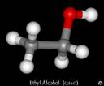

Biochemically alcohol is an extremely simple molecule. It is metabolised by two separate pathways. Its metabolism demonstrates simple enzyme systems and highlights how intermediate metabolites may result in tissue injury.

**ALCOHOL METABOLISM**

The metabolism of alcohol is affected by a large number of factors including diet, gender, body-habitus, racial and genetic influences. An appreciation of these factors can lead to a greater understanding of why some individuals are more susceptible to both the acute effects of alcohol and its long-term sequelae. How do we calculate a unit of alcohol, and what is ‘safe-drinking’?

ETHANOL

ACETALDEHYDE

CO2 + H20

CYP2E1

**ALCOHOL & PHARMACOLOGY**

Alcohol may interfere with drug metabolism, and drugs can interfere with alcohol metabolism. Which drugs are commonly implicated, and how is their metabolism affected?

**THE PHYSICAL EFFECTS OF ALCOHOL**

While the general public tend to be aware that ‘drinking damages your liver’, it is less well recognised that alcohol has a detrimental effect on a large number of other end-organs. These include:-

* CNS – Wernickes encephalopathy, Cerebral atrophy, Cerebellar syndrome, Optic Atrophy, Peripheral neuropathy
* CVS – Hypertension, Alcoholic cardiomyopathy, Stroke
* GIT – Oesophagitis, Gastritis, Oesophageal and Gastric cancer, Pancreatitis, Pancreatic cancer, Alcoholic Hepatitis, Cirrhosis, Liver Cancer
* GUT – Glomerulonephritis, Renal failure
* LMS – Gout, Fractures, Myopathies,
* Endocrine& Reproduction – Pseudocushings, Impotence, Subfertility, Breast Cancer, Fetal Alcohol Syndrome

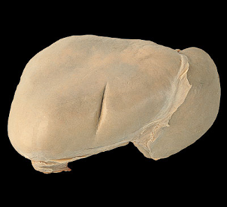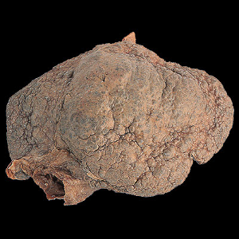

a) Normal liver b) Cirrhotic liver

**THE PSYCHOLOGICAL EFFECTS OF ALCOHOL**

What is an alcoholic? What is the difference between alcohol dependence and alcohol misuse?

Alcohol is a drug of addiction and is frequently used in conjunction with other recreational drugs of abuse. Alcohol is frequently a factor in a number of psychological conditions. While it is often seen by sufferers of mental illness as a way of dealing with the problem, the effect is frequently the opposite.

|  |  |
| --- | --- |
| Alcohol Abuse | Alcohol Dependence |
| •–failure to carry out major obligations at work, home, or school because of repeated alcohol use,  –repeated use of alcohol even when it is physically dangerous to do so,  –repeated experience of legal problems, or  –continued use of alcohol despite knowing that it has caused or worsened social or interpersonal problems | - tolerance;  – withdrawal;  – amount or duration of use often greater than intended;  – repeatedly trying without success to control or reduce alcohol use;  – spending much time using alcohol, recovering from effects, or trying to obtain it;  – reducing or abandoning important work, social, or leisure activities because of alcohol use; or  – continuing to use alcohol, despite knowing that it has probably caused ongoing physical or psychological problems. |

**THE COST OF ALCOHOL TO SOCIETY**

The consequences of alcohol cost society dearly. In monetary terms, the revenues raised by taxes fail to compensate for the man-hours of productivity lost as a result of drinking and the damage to the fabric of society as a consequence of acute intoxication. This too does not take in to account the cost of human suffering of families of drinkers. Alcohol is an important factor in the majority of cases seen in inner city A&E departments at weekends, and plays a significant role in a large number of hospital admissions throughout the hospital, producing a major drain on NHS resources. Recently we have observed changes in drinking patterns, with binge-drinking and the ‘ladette culture’ which bring with them new problems. As Health Care Professionals we need to be aware of our role as public educators as well as managing the physical and psychological effects of alcohol.