School of Medicine

## Graduate Entry year 1, 2012/13

## REGULATORY SYSTEMS

Psychology

Summer term

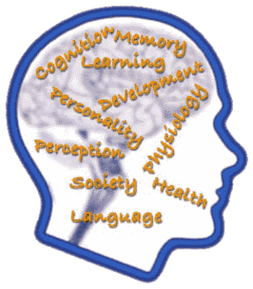

Course Leader:

**David Murphy,** Consultant Clinical Psychologist & Honorary Senior Lecturer

Tel: 020 8383 0689

email: [d.j.murphy@imperial.ac.uk](mailto:d.j.murphy@imperial.ac.uk)

<https://education.med.imperial.ac.uk/Years/GE1213/RS/index.htm>

Psychology module

Graduate Entry year 1, 2012/13 – Summer term course guide

CONTENTS

Page

SOLE

INTRODUCTION 1

READING LIST 3

ONLINE RESOURCES 4

LECTURERS 5

SESSION MATERIALS

1 Learning theory 7

2 Health beliefs and behaviour 12

3 Individual differences / personality 15

4 Developmental psychology 20

5 Coping with treatment 24

6 Attention and perception 28

7 Perception of physical symptoms 32

8 Coping with illness and disability 36

9 Memory and cognitive aspects of mental health disorders 41

10 Adherence to treatment regimes 49

11 Social psychology 53

12 Clinician decision making 57

**SOLE FEEDBACK – Psychology**

The following pages provide you with templates on which you can record your thoughts as the course proceeds. At the end of the course you can enter your views onto SOLE.

**Please answer all questions by selecting the response which best reflects your view.**

|  |  |  |  |  |  |
| --- | --- | --- | --- | --- | --- |
|  | Very Good | Good | Satisfactory | Poor | No Response |
| The support materials available for this module (e.g. handouts, web pages, problem sheets and/or notes on the board). |  |  |  |  |  |
| The organization of the module. |  |  |  |  |  |
|  | Strongly Agree | Agree | Neutral | Disagree | Strongly Disagree |
| Feedback on my work has been prompt (this refers to your work being commented upon within a specified time). |  |  |  |  |  |
| Feedback on my work has helped me clarify things I did not understand. |  |  |  |  |  |

Please use this box for constructive feedback and suggestions for improvement.

|  |
| --- |
|  |

**SOLE FEEDBACK - INDIVIDUAL LECTURERS**

Please note that for SOLE, a Lecturer’s name will only appear once. This template gives you the opportunity to record your comments about each lecture in the order of delivery. **On the following section, you have an opportunity to record any comments and constructive feedback you have for each lecturer.**

|  | **The structure and delivery of the lectures.** | | | | | **The explanation of concepts given by the lecturer.** | | | | | **The approachability of the lecturer.** | | | | | **The interest and enthusiasm generated by the lecturer.** | | | | |
| --- | --- | --- | --- | --- | --- | --- | --- | --- | --- | --- | --- | --- | --- | --- | --- | --- | --- | --- | --- | --- |
| **Lecturer and Lecture Title** | Very Good | Good | Satisfactory | Poor | Very Poor | Very Good | Good | Satisfactory | Poor | Very Poor | Very Good | Good | Satisfactory | Poor | Very Poor | Very Good | Good | Satisfactory | Poor | Very Poor |
| **Learning theory**  David Murphy |  |  |  |  |  |  |  |  |  |  |  |  |  |  |  |  |  |  |  |  |
| **Health beliefs & behaviour**  David Murphy |  |  |  |  |  |  |  |  |  |  |  |  |  |  |  |  |  |  |  |  |
| **Individual differences / Personality**  Stephen Gunning |  |  |  |  |  |  |  |  |  |  |  |  |  |  |  |  |  |  |  |  |
| **Developmental psychology**  Becky Armstrong |  |  |  |  |  |  |  |  |  |  |  |  |  |  |  |  |  |  |  |  |
| **Coping with treatment**  David Murphy |  |  |  |  |  |  |  |  |  |  |  |  |  |  |  |  |  |  |  |  |
| **Attention and Perception**  David Murphy |  |  |  |  |  |  |  |  |  |  |  |  |  |  |  |  |  |  |  |  |
| **Perception of Physical Symptoms**  David Murphy |  |  |  |  |  |  |  |  |  |  |  |  |  |  |  |  |  |  |  |  |
| **Coping with illness & disability**  Stephen Gunning |  |  |  |  |  |  |  |  |  |  |  |  |  |  |  |  |  |  |  |  |
| **Memory & cognitive aspects of mental health**  Kendra Shaw |  |  |  |  |  |  |  |  |  |  |  |  |  |  |  |  |  |  |  |  |
| **Adherence to treatment regimes**  David Murphy |  |  |  |  |  |  |  |  |  |  |  |  |  |  |  |  |  |  |  |  |
| **Social psychology**  David Murphy |  |  |  |  |  |  |  |  |  |  |  |  |  |  |  |  |  |  |  |  |
| **Clinician decision making**  David Murphy |  |  |  |  |  |  |  |  |  |  |  |  |  |  |  |  |  |  |  |  |

| **Lecturer and Lecture Title** | **Please use this box for additional constructive feedback.** |
| --- | --- |
| **Learning theory** |  |
| **Health beliefs & behaviour** |  |
| **Individual Differences** |  |
| **Developmental psychology** |  |
| **Coping with treatment** |  |
| **Attention and Perception** |  |
| **Perception of physical symptoms** |  |
| **Coping with Illness** |  |
| **Memory and cognitive aspects of mental health disorders** |  |
| **Adherence to treatment regimes** |  |
| **Social psychology** |  |
| **Clinician decision making** |  |

**Introduction to Psychology Module**

Welcome to the Psychology module of the graduate-entry medicine programme, I hope you find the module interesting and useful, however I realise you might have some questions about this module so I have attempted to answer them below.

**What is Psychology and why is it part of the graduate-entry medicine course?**

Psychology is commonly defined as “*the science of mind and behaviour*” and the “mind” is defined as “*the element or complex of elements in an individual that feels, perceives, thinks, wills, and especially reasons*”. So we can say that psychology is a scientific understanding of how individuals think, feel and behave. But why on earth would a medical student (especially a pressured GE student!) need to know anything about psychology? you might reasonably ask.

Well the answer is that in **every** branch of medicine human behaviour plays an important role. It is fairly obvious that psychology is one of the foundations for the field of psychiatry, but surgeons need to understand how psychological preparation for surgery impacts on post-operative pain and clinical outcome, a physician needs to understand how patients process information about their condition and what can be done to enhance adherence to a prescribed medication regime. Indeed, human behaviour plays a major role in the causation of many of the major diseases that are treated by modern medicine, in order to effectively prevent these diseases we need to understand why people behave in ways that may damage their health i.e. why do people continue to smoke, have an unhealthy diet even after they develop health problems? Psychology can also help us to understand how doctors make clinical decisions and why they make mistakes, it can even help you learn how to remember more from lectures.

Indeed Psychology is so central to the practice of medicine that the General Medical Council’s document; *Tomorrow’s Doctors* (2009)

(<http://www.gmc-uk.org/education/undergraduate/tomorrows_doctors_2009.asp>), which sets out what medical schools have to teach, says that all medical students should learn to “*apply psychological principles, method and knowledge to medical practice.*” And specifically be able to:

**(a)** Explain normal human behaviour at an individual level.

**(b)** Discuss psychological concepts of health, illness and disease.

**(c)** Apply theoretical frameworks of psychology to explain the varied responses of individuals, groups and societies to disease.

**(d)** Explain psychological factors that contribute to illness, the course of the disease and the success of treatment.

**(e)** Discuss psychological aspects of behavioural change and treatment compliance.

**(f)** Discuss adaptation to major life changes, such as bereavement; comparing and contrasting the abnormal adjustments that might occur in these situations.

**So what is this module going to be like?**

You will see from the timetable that some of the sessions primarily cover fundamental psychological concepts and theories whilst others focus on the application of these concepts to aspects of medicine. You might be thinking “Why can’t we just cut to the chase and focus on the medicine-specific stuff?” It’s a fair question, but I make no apology for including coverage of the fundamental concepts of psychology. It is my strong belief that if you understand where the underlying concepts come from you will be much better able to understand how they are applied within the field of healthcare and, who knows, maybe you will go on to apply them to new fields of medicine in the future. I hope you will find the entire module interesting and indeed that some of the material we cover will be relevant in other areas of your life. For instance, when we talk about memory you should learn some tips to improve your studying and when we come to talk about judgment and decision making I promise to tell you the best way to negotiate the price of a second hand car and increase your chances of winning big on the lottery!

However, although I am absolutely fascinated by the field of psychology, I don’t expect you to be (although I hope many of you will be by the end of the module). I will therefore try and make sure the module is as clear and concise as possible and that the relevance to medicine is always made clear. I have opted to do the quite a bit of the teaching myself in order to try and make the module as coherent as possible and ensure that links with other areas of the course are made clear. However, I am also very fortunate to be able to call on some excellent local psychologists to help teach some of the topics.

Finally, I realize that this module comes at the end of a very intense academic year and exams are fast approaching. Therefore, even though I’m sure you would like to spend a lot of time looking into all aspects of the module, I’ll try and make sure the most important parts in terms of the assessment are made clear (NB contrary to popular belief, although it is sometimes true that there is more than one right answer in Psychology, it doesn’t mean there are no wrong ones, so you will need to revise this stuff for the exams!). You will find that some of the lectures extend beyond the learning objectives but the exam questions will always relate directly to the learning objectives and certainly there will be nothing in the exam that isn’t covered in the lectures.

I hope this answers most of the questions you might have about the module but if you have any others please don’t be shy about talking to me or the other lecturers at the lectures or contacting me by email.

I look forward to seeing you at the teaching sessions.

Best wishes

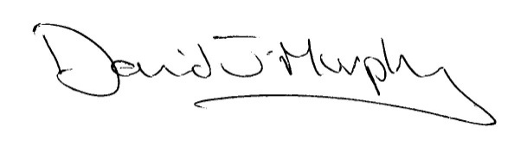

**David Murphy**

**Module Leader**

**Suggested reading**

**Introductory Psychology textbooks**:

These textbooks all offer a comprehensive overview of most areas of psychology. They all cover similar ground so any of them will be ok to use to supplement the lectures. They are prepared for the American market, apart from Passer (which is a European Edition of an American text). You do not need to buy one for this module but if you did want to, my personal recommendation would be **Holt** as it is bang up to date, engaging, very clear and not from a purely US perspective.

**1) Kowalski, Westen, *Psychology,* 6th Edition, Wiley (2011)**

ISBN:

Central Library (150 KOW) - 6 copies Short Loan

<https://unicorn.lib.ic.ac.uk/uhtbin/primo/1002873/1002873>

**2) Holt, Bremner, Sutheland, Vliek, Passer, Smith, *Psychology, The science of mind and behaviour –* 2nd Edition, McGraw Hill, (2012)**

ISBN: 0077136403

Central Library (150 PSY) Short loan –15 copies

<https://unicorn.lib.ic.ac.uk/uhtbin/primo/1042104/1042104>

**n.b.** previous edition of this book is Passer & Smith (2011)

**Textbooks on specific areas of Psychology:**

**Ogden, J., *Health psychology: a textbook***, **Open University Press (2012)**  
ISBN: 9780335243846

**Online access available via library website**

**Sarafino, E.P. & Smith. T.W.,** ***Health Psychology: biopsychosocial interactions – 7th Edition,* Wiley (2012)**

ISBN: 0470873698

Central library (616.001 SAR) – 15 copies standard loan

CX Library (WLM100 SAR) 1 copy short loan

<https://unicorn.lib.ic.ac.uk/uhtbin/primo/872743/872743>

**Eysenck, M.W.,** ***Cognitive Psychology: a student's handbook –* 4th Ed, Psychology Press,** **(2000)**CX Library(WLM400 EYS) **–** 5 copies standard loan

**SOME Online resources**

**Popular**

**American Psychological Association** – Psychology Topics (easy to use information and news articles organized under topic headings) <http://www.apa.org/topics/index.aspx>

**British Psychological Society -**  [www.bps.org.uk](http://www.bps.org.uk) (Recently redesigned to be more user-friendly, coverage of current news but not a huge amount of content)

**BBC “The Mind” website -** (some really interesting features and online tests e.g. Thinking style and memory tester) <http://www.bbc.co.uk/science/humanbody/mind/>

**Academic**

**Hanover College Online Psychology Tutorials** - <http://psych.hanover.edu/KRANTZ/tutor.html>

**The Psychology Encyclopaedia** – (Searchable but I found it a bit hit and miss) <http://www.psychology.org/>

**Simply Psychology -** (a nicely organized collection of online resources covering the main areas of Psychology)

<http://www.simplypsychology.org/>

**Psych Wiki** - <http://www.psychwiki.com/wiki/Category:Concepts> - A Pretty exhaustive list of links to explanations of the main concepts in psychology

**Module lecturers’ background information**

**David Murphy – Module Leader**

I studied Psychology at university as it seemed to be one of the most interesting and varied subjects you could take (although I wasn’t sure so I did a joint degree with Zoology). I then found I loved the subject, particularly application to healthcare, and went on to do post-graduate clinical psychology training at the Institute of Psychiatry in London. Since then I have worked in the fields of Clinical Health Psychology & Neuropsychology, firstly at The Royal National Orthopaedic Hospital and, for the past 19 years, at Charing Cross Hospital (apart from one year when I was seconded to the Healthcare Commission to do development work and be a “hospital inspector”). I have worked in a range of services including spinal cord injury, diabetes care, pain management, plastic surgery, cardiac rehabilitation and neurology. I am currently the Chair of the Professional Practice Board and a trustee of the British Psychological Society. I enjoy teaching and for many years I have been teaching undergraduate medical students at Imperial College and have been module leader for the past 5 years.

**Dr Stephen Gunning**

Following a first degree combining Psychology and Philosophy I undertook a short-lived career in journalism before embarked upon a Master’s degree which involved modelling complex human decision making, as applied to healthcare, with computational systems. Following this, I had an opportunity to work clinically using computer-assisted cognitive rehabilitation techniques with individuals with acquired brain injury. This led to a Doctorate in Clinical Psychology and I now work full-time as a Clinical Psychologist at Charing Cross Hospital. I am a member of the Cardiac Rehabilitation team for whom I am developing psychological services and I have additional interests in the diagnostic assessment of neurodegenerative disorders and the treatment of individuals with psychological disorders affecting a medical condition.

**Dr Becky Armstrong**

I completed my first degree in Psychology at Staffordshire University after really enjoying the subject at A-Level. I went on to win a place on their Master’s degree course in Health Psychology before working in research looking at Cognitive Behavioral Therapy (CBT) with people who are dependent on opiates or within a forensic setting. Whilst working in research an appetite developed to find out more about the people I was interviewing and help them develop skills to help themselves and so I pursued a career in Clinical Psychology. I graduated from Warwick University and have been working, within the NHS, with children and families from birth to 18 years ever since. I thoroughly enjoy my job and feel privileged most days to have had contact with the families I meet and work with day to day.

**Dr Kendra Shaw**

I completed my first degree in Psychology at the University of Western Ontario, Canada and then moved to Ireland to do a PhD at Trinity College Dublin where I examined the role of brain-derived neurotrophic factor in learning and memory. Following this, I spent two years working as a post-doctoral researcher at the Institute of Psychiatry, KCL and the Institute of Cognitive Neuroscience, UCL. Not being entirely content solely doing research, I decided to train as Clinical Psychologist to combine research with clinical practice. I completed my postdoctoral clinical training at the Institute of Psychiatry and have since worked for the NHS as a Clinical Psychologist in the field of Neuropsychology.

**Session 1 - Learning theory**

**Overview**

Why do people do what they do and when they do? These are fairly basic questions and ones which we could reasonably expect Psychology to be able to help us with. In the first part of the session we will look at the area of learning theory which attempts to understand and predict behaviour as a response to environmental cures and contingencies. Learning theory has been particularly built up on the basis of experiments in animal learning and has quite reasonably been criticised for not focussing on thinking and emotions. However, it is provides a foundation for much of psychological theory and also applied psychology and it is therefore a good place to start our journey into the field of Psychology.

**Learning objectives**

* Explain learning theory
* Understand and be able to explain Classical Conditioning
* Understand and be able to explain Operant Conditioning
* Differentiate between positive reinforcement, negative reinforcement and punishment.
* Define and describe the various schedules of reinforcement.
* Define observational learning, describe Bandura’s Social Learning theory, and outline the steps in the modeling process.

.

* Understand and explain approaches to increasing the likelihood of desirable behaviours and decreasing the likelihood of undesirable behaviours.

**Notes**

**Classical Conditioning**

* **Unconditioned stimulus (UCS):** a stimulus that elicits a reflexive or innate response (the UCR) without prior learning
* **Unconditioned response (UCR):** a reflexive or innate response that is elicited by a stimulus (the UCS) without prior learning
* **Conditioned stimulus (CS):** a stimulus that, through association with a UCS, comes to elicit a conditioned response similar to the original UCR
* **Conditioned response (CR):** a response elicited by a conditioned stimulus
* Conditioning typically occurs over the course of many pairings, but it can happen in a single trial in certain cases

MCFD00819_0000%5b1%5d

MCj04241140000%5b1%5dMCj04241140000%5b1%5dMCj04241140000%5b1%5dMCj02909120000%5b1%5dMCj02909120000%5b1%5d

MCj02909120000%5b1%5d

MCFD00819_0000%5b1%5d

**&**

**C**

**Classical conditioning contd:**

* Classical conditioning is strongest when:
  + There are repeated CS-UCS pairings
  + The UCS is more intense
  + The sequence involves forward pairing
  + The time interval between the CS and UCS is short
* **Extinction:** a process in which the CS is presented repeatedly in the absence of the UCS, causing the CR to weaken and eventually disappear
* **Spontaneous recovery:** the reappearance of a previously extinguished CR after a rest period and without new learning trials
* **Stimulus generalisation:** stimuli similar to the initial CS elicit a CR
  + Example: salivation may be elicited by a bell or a piano tone
* **Discrimination:** a CR occurs in the presence of one stimulus but not others
  + Example: salivation may not be elicited by a whistle
* **Higher-order conditioning:** occurs when a neutral stimulus becomes a CS after being paired with an already established CS
  + Produces a CR that is weaker and extinguishes more rapidly than the original CR

Operant Conditioning (aka Instrumental Conditioning)

Thorndike’s Law of Effect

* + - What happens as a result of a behaviour will influence the rate of occurrence of that behaviour.
    - If the consequences are positive, the behaviour is likely to be repeated, if the consequences are aversive, it is less likely to be repeated.
* **Reinforcement:** a response is strengthened by an outcome that follows it
* **Reinforcer:** the outcome (a stimulus or event) that increases the frequency of a response
* **Punishment:** a response is weakened by an outcome that follows it
* **Punisher:** a consequence that weakens (decreases) the frequency of a response
* **Differences between classical and operant conditioning:**
  + Classical: Behaviour changes are due to the association of two stimuli (CS-UCS) presented prior to the response (CR)
    - Focuses on *elicited* behaviours
  + Operant: Behaviour changes as the result of the consequences that follow it (reinforcement or punishment)
    - Focuses on *emitted* behaviours
* **Positive reinforcement:** occurs when a response is strengthened by the subsequent presentation of a stimulus
  + **Primary reinforcers:** stimuli, such as food and water, that an organism naturally finds reinforcing because they satisfy biological needs
  + **Secondary reinforcers:**stimuli that acquire reinforcing properties through their association with primary reinforcers
* **Negative reinforcement:** occurs when a response is strengthened by the removal (or avoidance) of an aversive stimulus
  + **Negative reinforcer:** the aversive stimulus that is removed or avoided
* “Positive” and “Negative” refer to presentation or removal of a stimulus, not “good” and “bad”
* **Aversive / Positive punishment:** occurs when a response is weakened by the presentation of a stimulus
* **Negative punishment / Response cost:** occurs when a response is weakened by the removal o a stimulus
* **Shaping (Method of successive approximations):** involves reinforcing successive approximations toward a final response
* **Chaining:** a technique used to develop a sequence of responses by reinforcing each response with the opportunity to perform the next response
* **Fixed schedule:** reinforcement occurs after a fixed number of responses or after a fixed time interval
* **Variable schedule:** the required number of responses or the time interval varies at random around an average
* **Escape conditioning:** the organism learns a response to terminate an aversive stimulus
  + Acquired and maintained through negative reinforcement
* **Avoidance conditioning:** the organism learns a response to avoid an aversive stimulus
* **Preparedness:** through evolution, animals are biologically predisposed to learn some associations more easily than others
  + Behaviours related to a species’ survival are learned more easily
* **Conditioned taste aversion:** a conditioned response in which the taste, sight, and/or smell of a particular food becomes disgusting and repulsive
* *Observational (vicarious) learning* - We observe the behaviours of others and the consequences of those behaviours.
* *Vicarious reinforcement* - If their behaviours are reinforced we tend to imitate the behaviours

# Exercise

###### Classical conditioning: identifying UCS, UCR, CS, and CR

\_\_\_\_\_\_\_\_\_\_\_\_\_\_\_\_\_\_\_\_\_\_\_\_\_\_\_\_\_\_\_\_\_\_\_\_\_\_\_\_\_\_\_\_\_\_\_\_\_\_\_\_\_\_\_\_\_\_\_\_\_\_\_\_\_\_\_\_\_\_\_\_\_\_\_\_\_\_

Identify the UCS, UCR, CS, and CR in the following examples:

|  |  |  |  |  |
| --- | --- | --- | --- | --- |
|  | UCS | UCR | CS | CR |
| 1. Jamie was talked into riding on the roller coaster when she was 12. The ride absolutely terrified her. Now whenever she goes to the amusement park, she breaks into a cold sweat if she even looks at the roller coaster. |  |  |  |  |
| 2. Kim was sick all night after eating a bad fried oyster. Now, she says, the smell of anything frying makes her feel nauseated. |  |  |  |  |
| 3. Sinbad was frightened when a barking spaniel lunged at the fence as he walked by. The next day, when Sinbad’s mother started to lead him by the house where the spaniel lived, Sinbad began to tremble and whimper. |  |  |  |  |
| 4. Lassie drools whenever she hears the can opener. |  |  |  |  |
| 5. Makoto was stung by a bee in the garden. Now whenever he hears a buzzing sound he starts to tremble. |  |  |  |  |
| 6. Just smelling his girlfriend’s perfume makes Romeo feel happy and relaxed. |  |  |  |  |

# *Source:* Adapted from Malley-Morrison and Yap, 2001

If you just can’t get enough of classical conditioning you can even play an online game which involves teaching Pavlov’s dog to drool (it’s bizarrely addictive!) follow the link below:

[**http://www.simplypsychology.pwp.blueyonder.co.uk/pavlov.swf**](http://www.simplypsychology.pwp.blueyonder.co.uk/pavlov.swf)

**Session 2 - Health beliefs and behaviour**

**Overview**

Human behaviour explains a significant amount of the variance in the incidence of the main causes of mortality in developed countries such as cardio-vascular disease and cancer. In other words, people who adopt certain behaviours and avoid others live longer and healthier; but if it’s so obvious why don’t people do it? In this session we will apply concepts from learning theory and some others which we will cover in subsequent sessions to try and understand why people adopt health behaviours and how to help people to change.

**Learning objectives**

* Discuss the role of behavioural factors in the aetiology of major diseases
* Define “health behaviour”
* Describe the role of health education in disease prevention
* Discuss the role of learning and habit in health behaviour
* Discuss the role of attitudes and beliefs in health behaviour
* Discuss the influence of social environment on health behaviours
* Define “self-efficacy” and the factors which influence it
* Outline the Health Beliefs Model and the Theory of Planned Behaviour
* Describe effective approaches to modifying health behaviour

**Notes**

**Health Behaviour**

“*Any activity undertaken by an individual believing himself to be healthy, for the purpose of preventing disease or detecting it at an asymptomatic stage*”

(Kasl & Cobb 1966)

**Expectancy value theory**

The potential for a behaviour to occur in any specific situation is a function of the **expectancy** that the behaviour will lead to a particular outcome and the **value** of that outcome” (Rotter 1954)

**Self-efficacy**

* Outcome efficacy - Individuals expectation that the behaviour will lead to a particular outcome
* Efficacy expectancy - Belief that one can execute the behaviour required to produce the outcome (Bandura 1977)

**Sources of Self Efficacy**

1. Mastery experience
2. Social learning
3. Verbal persuasion or encouragement
4. Physiological arousal

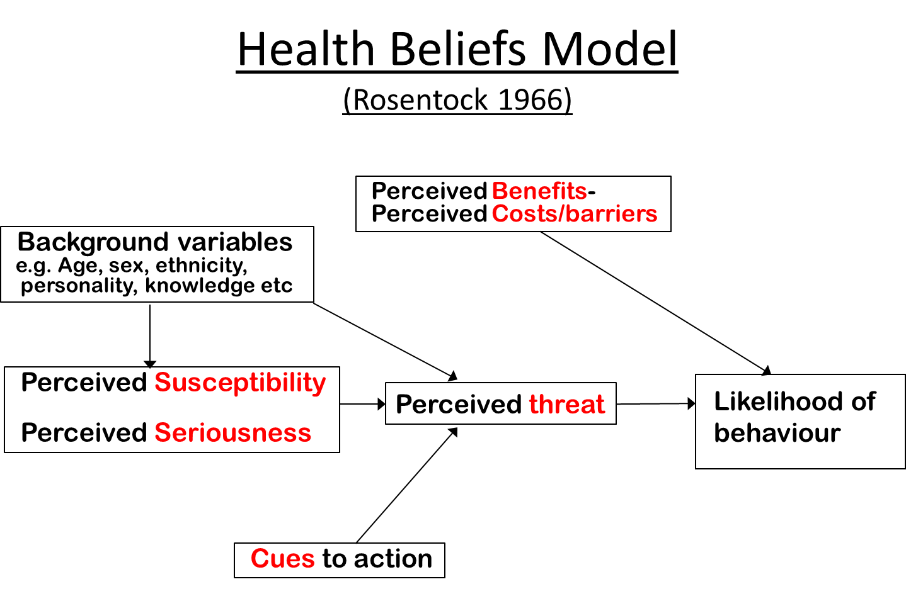

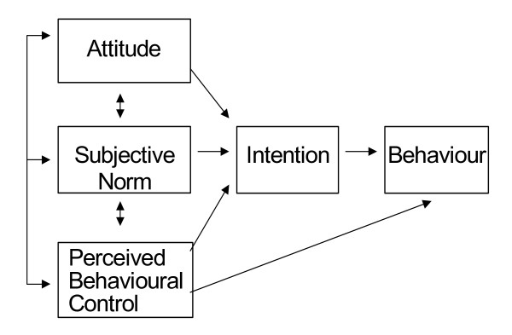**Theory of Planned Behaviour (Azjen 1991)**

**Session 3 - Individual differences/Personality**

**Overview**

One of the key differences between psychology and the natural sciences arises from the existence of *individual differences*. Two litres of hydrogen that are treated identically respond identically, but any two human beings, even identical twins, may respond quite differently to the same stimulus. Individual difference psychology examines how people are similar and how they differ in their thinking, feeling and behaviour. We will take a look at the field of personality and touch on a few of the major theories that classify personality types and some of the ways they are measured. We also look at another, more controversial, area of individual difference, intelligence. Finally, since we are being controversial, we will look at Baron-Cohen’s theory of the differences between the Male and Female brain and how this links to autism.

**Learning objectives**

* Outline psychodynamic theory of personality development.
* Describe the ‘Big Five’ trait model of personality
* Explain how psychometric testing is used in personality measurement
* Describe Spearman’s *g* factor of intelligence and cite evidence that supports it.
* Differentiate between crystallised and fluid intelligence and explain how they are affected by aging.
* Explain how psychometric tests help differentiate between normal changes in cognition through aging and those caused by disease
* Define IQ and explain why it is not always a useful concept to describe an individual’s abilities.
* Describe the findings of twin studies on the roles of heredity and environment in intelligence research
* Define Simon Baron-Cohen’s Systemising and Empathising Quotients and how they relate to autism.

**Notes**

**Freud’s Psychodynamic theory of personality**

[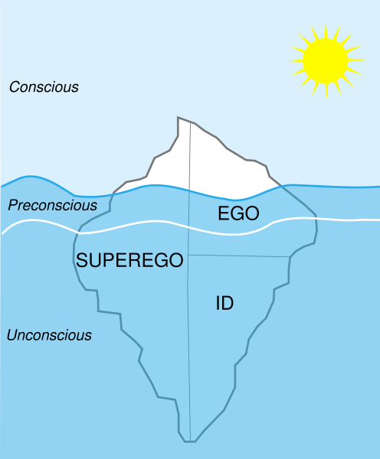](http://cccul.files.wordpress.com/2007/11/496px-structural-icebergsvg.png)

According to this model, the uncoordinated instinctual trends are the "id"; the organised realistic part of the psyche is the "ego," and the critical and moralizing function the "super-ego."

**The Big 5 Personality Factors**

The Big Five factors and their constituent traits can be summarized as follows:

* **Openness** - appreciation for art, emotion, adventure, unusual ideas, imagination, curiosity, and variety of experience.
* **Conscientiousness** - a tendency to show self-discipline, act dutifully, and aim for achievement; planned rather than spontaneous behaviour.
* **Extraversion** - energy, positive emotions, and the tendency to seek stimulation and the company of others.
* **Agreeableness** - a tendency to be compassionate and cooperative rather than suspicious and antagonistic towards others.
* **Neuroticism** - a tendency to experience unpleasant emotions easily, such as anger, anxiety, depression, or vulnerability; sometimes called emotional instability.

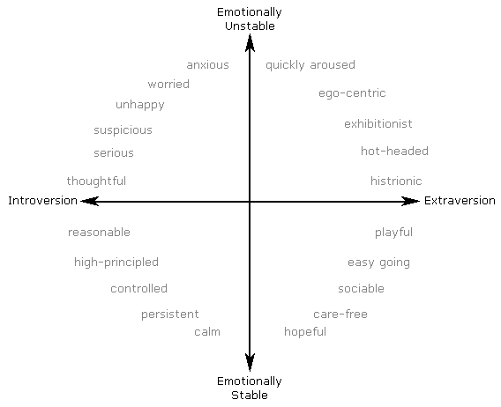**Eysenck’s Two-Factor Model**

**Intelligence**

**The normal distribution of IQ scores**

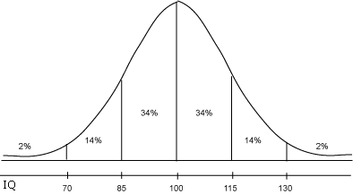

**Spearman Two-Factor Theory**

Charles Spearman (1927) analysed the relations among experimental intelligence tests using 'factor analysis'. He argued that, as a rule, people who do well on some intelligence tests also do well on a variety of intellectual tasks [vocabulary and mathematical and spatial abilities]. And if people did poorly on an intelligence test, then they also tended to do poorly on other intellectual tests. That is, he observed correlations among performance on a variety of intellectual tasks.

Thus, he proposed, a 'two-factor' theory of intelligence:

- General Ability (g): which was required for performance of mental tests of all kinds; he called this a kind of 'mental energy' that underlies the specific factors

- Special Abilities: which were required for performance on just one kind of mental test.

- e.g. Scores on a verbal comprehension test are largely determined by one’s level of general intelligence but they are also affected by one’s specific ability to perform verbal comprehension tasks.

But the main thrust of Spearman's analysis was this idea of a general intellectual capacity. This formed a major theoretical platform for many subsequent approaches to intelligence.

**Fluid & Crystallized IQ**

Raymond Cattell (1963) suggested that there are two related but distinct components of g: fluid and crystallised intelligence.

Fluid: ability to see relationships, as in analogies and letter and number series = primary reasoning ability

Crystallised: acquired knowledge and skills = factual knowledge

Fluid intelligence decreases with age and crystallised intelligence increases with age. Thus mathematicians and scientists, who need fluid intelligence, produce their best work in their 20s and 30s; whereas those in the field of history, philosophy and literature produce their best work in their 40s, 50s and beyond as they have accumulated more knowledge.

**Multiple Intelligences** (Gardener, 1983)

7 intelligences

* musical
* bodily/kinaesthetic as in athletes and dancers
* spatial as in mental maps
* linguistic or verbal
* logical/mathematical
* intrapersonal- self understanding
* interpersonal - social skills

**Empathising and Systemising**

Simon Baron-Cohen identifies two factors which represent sex differences and offer an explanation for autism:

* Empathising – the ability to identify and appropriately respond to the emotions and thoughts of others. Empathizers tend to be adept at reading non-verbal communication and judging character.
* Systemising – the ability to analyse how systems work and behave, with a final goal of predicting and controlling system behaviour or building a new system.

He postulates that there are five brain types:

* E-type – Empathising is stronger than systemising (‘female brain’)
* S-type – Systemising is stronger than empathising (‘male brain’)
* B-type – a balanced brain (equal in both traits)
* Extreme E-type – Empathising is very strong, but systemising is weak
* Extreme S-type - Systemising is very strong, but empathising is weak (‘autistic brain’)

The EQ SQ Tests that Baron-Cohen et al have developed provides an EQ score, which can be used in conjunction with an SQ score, to determine the EQ SQ brain type. An individual's sex does not necessarily determine brain type; not all men have the S-type brain and not all females have the E-type brain but, *on average*, this theory holds true. Baron-Cohen has also made a preliminary connection between EQ SQ brain types and the amount and timing of in-utero testosterone a foetus receives

The Empathizing–Systemizing theory has been criticized for minimizing environmental constructions of gender and reinforcing gender stereotypes

**Try it Yourself**

Calculate your score on the Big 5 factors:

<http://www.123test.com/personality-test/>

Test your IQ on the BBC “Test the nation” website

<http://www.bbc.co.uk/testthenation/iq/main/index.shtml>

Calculate your own systematizing and empathy quotients:

<http://www.glennrowe.net/BaronCohen/MaleFemale.asp>

**Session 4 - Developmental psychology**

**Overview**

How do we grow up to become the adults we are today? What do we bring into the world with us when we are born – in terms of physical and sensory competencies, temperament, sociability, potential? What effect does our environment and culture have on our growing up? How do we learn and what supportive input do babies, children and adolescents need from grownups as they develop? What happens if our basic emotional needs are not well enough met? How and when do we finally become an ‘adult’? These questions are of time-honoured interest to human beings as we try to make sense of ourselves as well as the world in which we live. Attempts to answer them emerge in literature (e.g. Lord of the Flies), the press (Child of our Time) and are the focus of study for developmental psychology. Remembering your own childhood, and getting in touch with children’s non-verbal language of play will help you connect with your younger patients and engage them in conversations and actions that will help them live as satisfying a life as possible whatever their health status.

**Learning objectives**

* To consider the relative influences and interaction of heredity and environment in human development
* To describe what and how babies contribute to their own development and the process of reciprocal socialization
* To describe how parents provide a supportive environment for development
* To define attachment and describe how disruptions in attachment affect psychological development
* To describe Piaget’s stage model of cognitive development.
* To describe cognitive, emotional and relationship changes during adolescence

**Notes**

**Social reciprocity**

It will take a healthy newborn about a year to be able to walk, but they are born able to interact socially with the adults on whom they will depend. In the womb, their developing senses of hearing, smell and taste are building up a memory which allows them to recognise their mother. At birth, their still-developing visual system focuses best on objects within 12 inches that are moving and are configured as faces. Babies can imitate expressions e.g. sticking out tongue. Adults respond, imitate, soothe, talk and so the social dance begins.

**Attachment** (Bowlby)

Definition: the strong emotional bond that develops between children and their primary caregivers over the first few years of life that enhances are adjustment throughout our lives

Key study: The strange situation (Mary Ainsworth and co-workers 1978)

A controlled experiment with a 12-18 month child

1. Child and mother or father plays in unfamiliar toy room.

2. A stranger enters the room and plays with the child.

3. The mother/father soon leaves the child with the stranger

4. Later the stranger departs; the child is left briefly alone

5. The caregiver returns.

The infant’s behaviour at each stage is observed and characterised.

Secure response: child uses parent as a source of safety and so seeks proximity/social reassurance from parent in presence of stranger; the child shows distress on separation; the child is able to be calmed on parent’s return.

Variations may show insecurity in the child’s attachment, reflecting different parenting styles.

**Piaget's Key Ideas**

**Adaptation:** What it says: adapting to the world through assimilation and accommodation

**Assimilation:** The process by which a person takes material into their mind from the environment, which may mean changing the evidence of their senses to make it fit.

**Accommodation:** The difference made to one's mind or concepts by the process of assimilation.

Note that assimilation and accommodation go together: you can't have one without the other.

**Classification:** The ability to group objects together on the basis of common features.

**Class Inclusion:** The understanding, more advanced than simple classification, that some classes or sets of objects are also sub-sets of a larger class. (E.g. there is a class of objects called dogs. There is also a class called animals. But all dogs are also animals, so the class of animals includes that of dogs)

**Conservation:** The realisation that objects or sets of objects stay the same even when they are changed about or made to look different.

**Decentration:** The ability to move away from one system of classification to another one as appropriate.

**Egocentrism:** The belief that you are the centre of the universe and everything revolves around you: the corresponding inability to see the world as someone else does and adapt to it. Not moral "selfishness", just an early stage of psychological development.

**Operation:** The process of working something out in your head. Young children (in the sensorimotor and pre-operational stages) have to act, and try things out in the real world, to work things out (like count on fingers): older children and adults can do more in their heads.

**Schema (or scheme):** The representation in the mind of a set of perceptions, ideas, and/or actions, which go together.

**Piaget’s Stages of Cognitive Development**

|  |  |  |
| --- | --- | --- |
| Stage | Age | Characterised by |
| **Sensori-motor** | (Birth-2 yrs | Differentiates self from objects  Recognises self as agent of action and begins to act intentionally: e.g. pulls a string to set mobile in motion or shakes a rattle to make a noise Achieves object permanence: realises that things continue to exist even when no longer present to the sense (pace Bishop Berkeley) |
| **Pre-operational** | 2-7 years | Learns to use language and to represent objects by images and words  Thinking is still egocentric: has difficulty taking the viewpoint of others Classifies objects by a single feature: e.g. groups together all the red blocks regardless of shape or all the square blocks regardless of colour |
| **Concrete operational** | 7-11 years | Can think logically about objects and events  Achieves conservation of number (age 6), mass (age 7), and weight (age 9)  Classifies objects according to several features and can order them in series along a single dimension such as size. |
| **Formal operational** | 11 years and up | Can think logically about abstract propositions and test hypotheses systematically  Becomes concerned with the hypothetical, the future, and ideological problems |

The accumulating evidence is that this scheme is too rigid: many children manage concrete operations earlier than he thought, and some people never attain formal operations (or at least are not called upon to use them).

Piaget's approach is central to the school of cognitive theory known as "cognitive constructivism": other scholars, known as "social constructivists", such as Vygotsky and Bruner, have laid more emphasis on the part played by language and other people in enabling children to learn.

**Further Reading** (optional)

Gerhardt, S. (2004) *Why Love Matters: How Affection Shapes a Baby's Brain*. Routledge

**Session 5 - Coping with treatment**

**Outline**

In this session we will focus on the distress associated with painful and intrusive medical and surgical procedures. We will look at what makes these stressful and what can be done to make them less so through the use of coping procedures. We will look at the different ways in which patients can be prepared beforehand and the effects of this. We will also look at ways of enhancing control for patients undergoing treatment and other types of coping strategies such as relaxation. Finally, we will consider how coping preparations can be used to minimize distress in child patients.

**Learning objectives**

* Describe with reference to Lazarus & Folkman’s Transactional definition of stress why some medical and surgical procedures are stressful.
* Identify strategies to prepare patients for treatment
* Describe the two different types of information which can be provided and their relative efficacy in reducing distress.
* Describe the effect of perceived control on patient distress
* Define and give examples of problem-focussed and emotion-focussed coping strategies.
* Discuss the importance of identify individual differences in preferred coping style and the importance of matching preparation to patient preferred coping style.
* Describe the specific considerations for helping children cope with treatment.
* Give examples of effective strategies to help children cope with treatment.

**Notes**

**Transactional definition of stress** (Lazarus & Folkman 1984)

“Stress is a condition that results when the person / environment transactions lead the individual to perceive a discrepancy between the demands of the situation and the coping resources available.”

**Definition applied to hospitalization for medical/surgical procedure**

Threats



Coping resources



Stress

**Effect of increasing information/predictability**

* Procedural information – Information about the procedures to be undertaken
* Sensory information – Information about the sensations that may be experienced.

**Dual-process hypothesis (Suls & Wan 1989)**

* Proposes that procedural and sensory information work in different ways.
* Procedural information works by allowing patients to match ongoing events with their expectations in a non-emotional manner.
* Sensory information works by “mapping” a non-threatening interpretation on to these expectations.

Johnson & Leventhal (1974) - Experiment to compare effects of each type of information.

What is the optimal amount of information to give? (Study by Auerbach 1983)

**Effect of increasing perceived control**

Langer & Rodin (1976) Nursing home study

Increasing control during treatment (Thrash 1982)

**Coping strategies** Lazurus & Folkman (1984)

* **Problem Focussed coping** - Efforts directed at changing the environment in some way or changing one’s own actions or attitudes
* **Emotion focussed coping** - Efforts designed to manage the stress-related emotional physical responses in order to maintain one’s own morale and allow one to function.

Which is the best coping strategy? (Martelli et al 1987)

**Helping children to cope with treatment**

1. **Tell:** Using simple language and a matter-of-fact style, the child is told what is going to happen before each procedure.
2. **Show:** The procedure is demonstrated using an inanimate object, a member of staff or the dentist him or her self.
3. **Do:** The procedure does not begin until the child understands what will be done.

**Krantz Health Opinion Survey**

**Scoring**

Items scored Agree = 1, Disagree = 0 (unless starred)

Desire for Information – 1\*,3\* ,4 ,8 ,10 ,15\*,16\*

Behavioural involvement – 2, 5\*, 6\*, 7, 9\*, 11\*, 12, 13, 14

\* -Reverse scored item

**Krantz Health Opinion Survey**

****

**Session 6 – Attention and Perception**

**Overview**

This session focuses on how the vast amount of information provided via all five of our senses is automatically processed to create our perceived view of the world around us. The fact that this process is normally so automatic and effortless can prevent us realising how fantastically complicated it actually is and how much processing is involved. This can lead us to the mistaken belief that the world as we perceive it directly accords with the objective reality which is particularly important in term of the perception of physical symptoms which we will look at in the next session. Finally, we will briefly consider visual agnosia to illustrate what can happen when these processes are impaired.

**Learning objectives**

* Define, and differentiate between, sensation and perception.
* Contrast bottom-up and top-down processing of sensory information.
* Define Attention and contrast focussed and divided attention
* Describe the biological development of perceptual skills, and explain how they are affected by cross-cultural factors, critical periods, and experience.
* Outline the stages in Humphreys & Riddoch’s hierarchical model of object recognition.
* Define Apperceptive and Associative Agnosia

**Notes**

**Perception**

* Perception is an active, creative process in which raw sensory data are organized and given meaning
* **Bottom-up Processing:** the system takes in individual elements of the stimulus and then combines them into a unified perception
* **Top-down Processing:** sensory information is interpreted in light of existing knowledge, concepts, ideas, and expectations

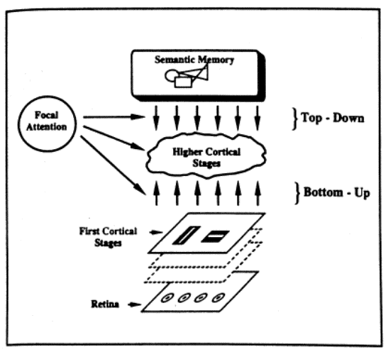

**Attention**

* Attention involves two processes:
* Focusing on certain stimuli
* Filtering out other incoming information
* Studied experimentally using *shadowing*

**Stimulus characteristics that affect attention:**

* Intensity
* Novelty
* Movement
* Contrast
* Repetition

**Personal factors that affect attention:**

* + Motives
  + Interests
  + Threats to well-being
  + Participants are faster at finding a single angry face in a happy crowd than a single happy face in an angry crowd

**Perceptual processes:**

* **Perceptual Schema:** a mental representation or image containing the critical and distinctive features of a person, object, event, or other perceptual phenomenon
  + Schemas provide mental templates that allow us to identify and classify sensory input
  + Each of our perceptions is essentially a hypothesis about the meaning of the sensory information

**Illusions:** compelling but incorrect perceptions. Most can be attributed to perceptual constancies that ordinarily help us perceive more accuratelye.g. Meyer-Lyer Illusion

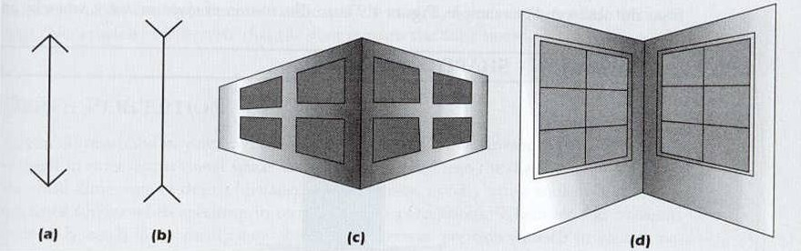

**Critical Periods:** certain kinds of experiences must occur if perceptual abilities and the brain mechanisms that underlie them are to develop normally

* + Kittens raised in completely vertical environments were unable to see horizontal objects, and vice-versa (Blakemore & Cooper, 1970)

**Hierarchical Model of Object Recognition (Riddoch & Humphreys 2001)**

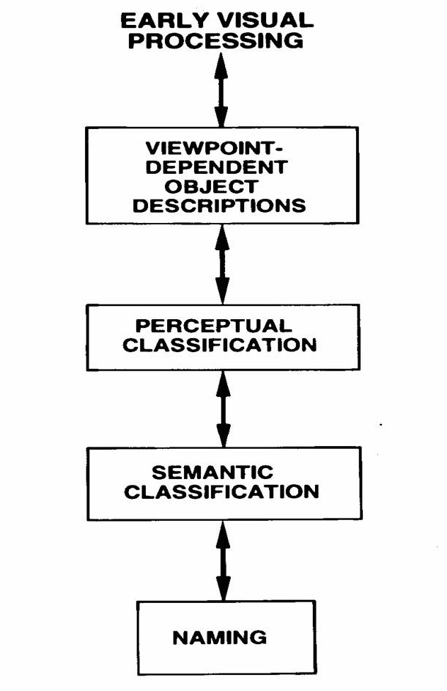

**Visual Agnosia (literally “not knowing”)**

**Apperceptive visual agnosia** is characterised by intact visual ability on a basic sensory level, but a defect in early stage visual processing that prevents a correct percept of the stimulus being formed. The patient is unable to access the structure or spatial properties of a visual stimuli and the object is not seen as a whole or in a meaningful way.

Whereas in **Associative visual agnosia**, primary sensory and early visual processing systems are preserved. The patient can perceive objects presented visually but cannot interpret, understand or assign meaning to the object, face or word.

**Session 7 - Perception of physical symptoms**

**Overview**

In this session we will take some of the basic concepts about perception and apply them to how humans perceive bodily sensations and in, particular, the experience of pain.

We will look at the discrepancy between objective measures of physiological parameters and symptom perception. We also look at the implications of this for intervention, including looking at the placebo effect. Finally, we will look briefly at chronic pain.

**Learning Objectives**

* Explain the limitations of a uni-dimensional model of pain.
* Outline the Gate Theory of Pain and explain the mechanisms through which the psychological factors influence the experience of pain.
* Discuss the lack of concordance of physiological parameters and symptom perception.
* Discuss the role of attention in symptom perception.
* Describe the role of anxiety and mood in symptom perception.
* Describe the role of culture and social environment in symptom perception and illness behaviour.
* Define the different methods of measuring pain
* Define the placebo effect and possible mechanisms of action.
* Explain the differences between acute and chronic pain.

**Symptom perception**

“*A physical symptom or sensation is a perception, feeling, or belief about the state of our body. (It)….is often-but not always – based on physiological activity. Above all, a physical symptom represents information about our internal state*.” Pennebaker 1983

“*Given an undefined state of bodily arousal, individuals will seek and labels, and given a label individuals will seek and find symptoms*” Meyer et al (1985)

**Perception**

**Representation**

**Physiological state**

**Psychological aspects of pain**

“*Pain is an unpleasant sensory and emotional experience associated with actual or potential tissue damage or described in terms of such damage*” Mersky (1986)

The Gate Theory of Pain (Melzack and Wall 1965)

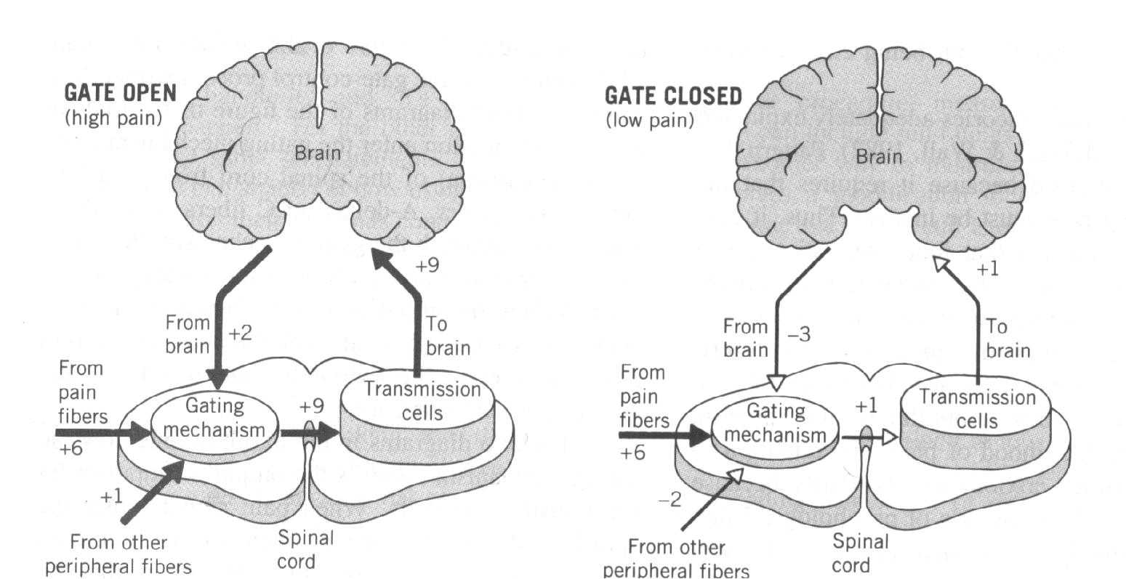

**The Placebo Effect**

“*Improvement in the condition of a sick person that occurs in response to treatment but cannot be considered due to the specific treatment used*” Webster’s Dictionary.

**Chronic Pain**

|  |  |
| --- | --- |
| Acute Pain | Chronic Pain |
| <1 month | >3-6 months |
| Usually obvious tissue damage | No clear relationship to on-going tissue damage |
| Increased nervous system activity | Degrades health and function |
| Pain resolves upon healing | Pain beyond expected period of healing |
| Serves a protective function | Usually has no protective function |

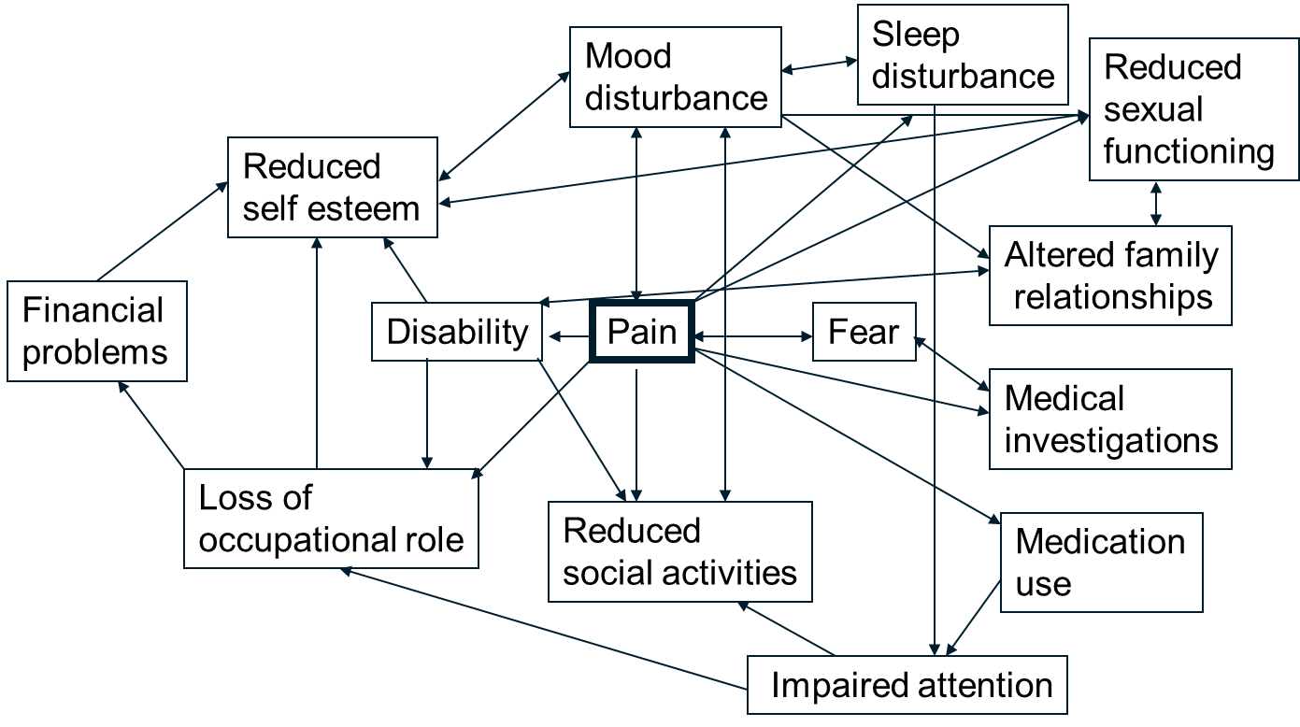

**Session 8 - Coping with illness and disability**

**Overview**

Physical signs and symptoms are poor predictors of psychological adjustment and disability. In this session we will look at some of the psycho-social factors which affect adjustment, disability and quality of life in persons with chronic illness or injury. We will also look at some psychological approaches to enhance psychological and physical functioning in chronic illness and disability; these are particularly relevant in the context of the Government’s “fit to work” initiative to support people on long term disability benefits to get back to work.

**Learning objectives**

* Describe Kubler-Ross’s Stage Theory model of adjustment to dying and Shontz’s (1975) stage theory model of adjustment to diagnosis.
* Discuss the evidence for the existence of discrete universal stages of adjustment and give examples of some limitations of stage theories.
* Outline the Crisis theory of adjustment, give examples of illness and background factors affecting adjustment and describe the role of appraisal.
* Define Leventhal’s five dimensions of illness representations.
* Describe how illness representations can influence recovery after illness or injury
* Cite evidence that demonstrates how psychological factors can affect outcome in long-term health conditions
* Give examples of how psychological interventions can improve coping behaviours and emotional adjustment to illness and disability

**Notes**

**Stage theories of adjustment to loss**

**Stage theory of adjustment to death & dying (Elizabeth Kubler-Ross 1969)**

Denial Anger Bargaining Depression Acceptance

**Shontz’s stage theory model of adjustment to diagnosis**

Shock Encounter Retreat

**Evidence base and limitations of stage theories**

**Myths of coping with loss**(Wortman and Silver 1989)

* Distress or depression is inevitable.
* Distress is necessary, and failure to experience distress is indicative of pathology.
* The importance of “working through” the loss.
* Expectations of recovery.
* Reaching a state of resolution.

Kennedy et al (2000) Followed patients with Spinal Cord Injury (SCI) prospectively over the first two years after their injury. They found that the percentage of patients scoring above threshold fluctuated throughout this period rather than showing a gradual decline. The rate did rise sharply towards the end of the first year which coincided with discharge from hospital.

**Multi-factorial models of coping**

**Crisis theory of coping with serious illness (Moos 1977)**

Illness - related factors

Physical and social

environmental

factors

Coping

Appraisal

Adaptive

Tasks

Coping

Skills

Outcome

of Crisis

Coping Process

Background and

personal factors

**Factors affecting adjustment**

**Illness related-factors:**

* Disability
* Pain
* Uncertainty/progressiveness
* Disfigurement
* Stigma

**Background/Personal factors:**

* Age of onset
* Gender
* SES & occupation
* Religious/philosophical views
* Pre-existing self esteem

**Background/Personal factors:**

* Age of onset
* Gender
* SES & occupation
* Religious/philosophical views
* Pre-existing self esteem
* Pre-existing illness beliefs
* Attribution of blame

**Physical and Social environment:**

* Accommodation and physical aids/adaptations
* Societal attitudes
* Social support

**Coping Appraisal**

**Illness representations model (Leventhal et al 1980)**

Definition: “A patients own implicit, common-sense beliefs about their illness”

Dimensions:

* Identity - can be considered the label of the illness and the symptoms the patients view as being part of the illness
* Cause - is the patients’ views about what may have caused their problem, such as genetic factors, family circumstances, trauma, etc.
* Consequences - Time-line is the clients’ view about how long their problem will last and whether it is seen as acute, chronic or episodic
* Time line - Consequences include the effects the clients are expecting from their illness and their views on the outcome
* Curability/controllability (Lau & Hartman 1983) - the patients’ expectations as they recover from or control the illness

Measured by the Illness Perception Questionnaire (IPQ) (see end of section)

**Adaptive tasks related to illness or treatment**

* Coping with symptoms or disability
* Adjusting to hospital environment and medical procedures.
* Developing and maintaining good relationships with healthcare professionals.

**Adaptive tasks related to general psychosocial functioning**

* Controlling negative feelings and retaining a positive outlook for the future
* Maintaining a satisfactory self image and sense of competence
* Preserving good relationships with family and friends

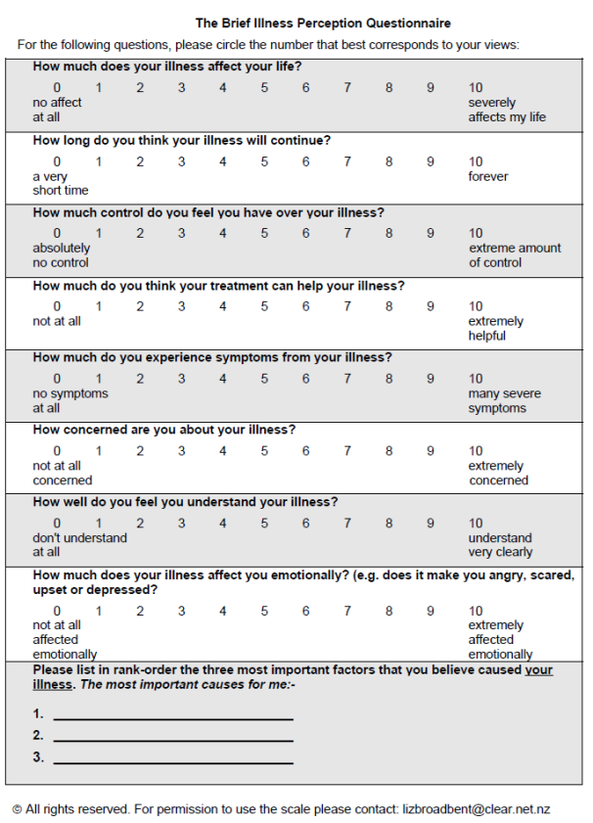

**Session 9 – Memory & cognitive aspects of mental health disorders**

**Overview**

In this session we will look in depth at the processes involved in memory. Memory is a crucial cognitive process since it allows us to bring our past knowledge to bear on present situations e.g. what day is it? Where did we agree to meet tonight? Who won X-factor? etc. You will not be surprised to learn that as with many of the other processes we have looked at, memory is not as simple as you might think, perhaps surprisingly it is not like Sky+ in that memories are not stored simply in date order and memories may be “rewritten” as they are stored and again when they are retrieved. In addition to seeing how memory works, we will also look at some techniques to improve memory. Finally we will briefly consider the role of memory and thinking processes in the development and maintenance of psychological disorders.

**Learning objectives**

* Define memory and the processes of registration, encoding, storage and retrieval
* Describe the components of working memory
* Describe the different types of long-term memory
* Differentiate between effortful and automatic processing
* Define schema and explain how schemas enhance encoding
* and influence memory construction
* Define an associative network
* Outline the role of cognitive factors in depression and anxiety

**Memory stages**

*Registration* - Input from our senses into the memory system

*Encoding* - Processing and combining of received information

*Storage* - Holding of that input in the memory system

*Retrieval* - Recovering stored information from the memory system (remembering)

Registration is necessary for storage to take place but not everything that a person registers is stored

Something has to be stored to be retrieved but the fact that it is stored does not guarantee it will be retrieved on a particular occasion

* There is more than one type of memory store
* Each has its own performance characteristics and function
* Each is the function of a different neuroanatomical system
* There are several ways of classifying them

A basic and generally accepted classification of memory is based on the duration of memory retention, and identifies three distinct types of memory: sensory memory, short term memory and long term memory

**Sensory Memory**

* Gives us an account of things that are happening around
* This allows us to understand these things
* It only lasts for a very short time (<2 s) after which the information is either forgotten or encoded into a more lasting memory
* Overwritten by subsequent perceptual information
* Contains more information than can be reported before the memory decays
  + Iconic (visual)
  + echoic (sound)
  + plus other sensory modalities

**Working Memory**

* A short-term memory store
* limited capacity in terms of information content NOT time
  + George Miller’s famously proposed that we could store 7 items ± 2
  + Most likely not that many – recent studies show it’s 7 for digits, 6 for letters, 5 for words
* Can remember more short words than long words
* Chunking allows more to be remembered
  + E.g. 9070990620 versus 007 999 2006
* Information in store can be actively manipulated, hence ‘Working Memory’
* the frontal cortex, parietal cortex, anterior cingulate, and parts of the basal ganglia are crucial for the functioning of working memory

**Components of Working Memory**

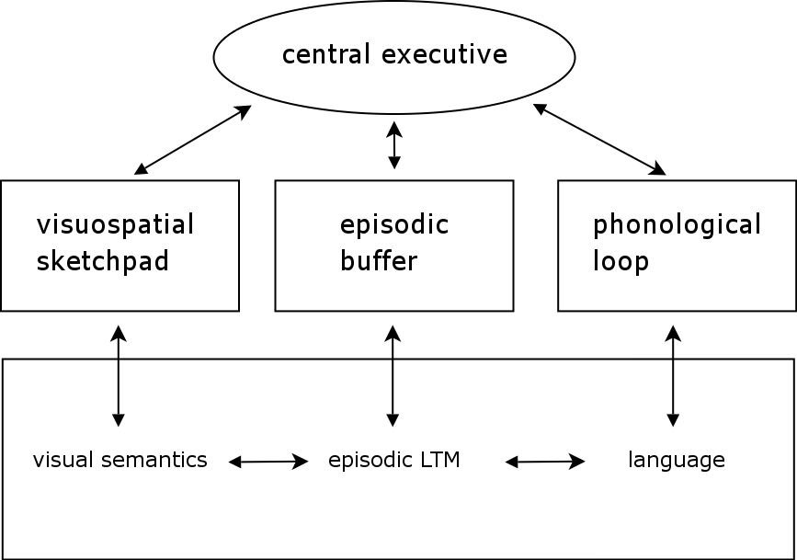

Multicomponent Model of Working Memory; from (Baddeley 2003)

The *central executive* is the main component. It is responsible for the control of executive processes, including actions; the direction of attention to relevant information, as well as the suppression of irrelevant information and undesired actions; the supervision of information integration; the coordination of multiple cognitive processes to be executed in parallel; and the coordination of the sub-systems of WM.

The *phonological loop* permits to maintain auditory/verbal information with a rehearsal mechanism that prevents its rapid decay. For example, you can maintain in memory a (short) list of words, or of numbers, as long as you continuously repeat these words or numbers to yourself.

The *visuo-spatial sketch pad* permits to maintain and manipulate visual and spatial information. For example, you can create and navigate mental maps, form mental images and rotate them, etc. It is constituted of two subsystems; the former specialized for visual information, and the latter for spatial information.

The *episodic buffer* temporarily integrates phonological, visual, and spatial information, and possibly other forms of information (e.g., semantic information, musical information) in a unitary, episodic representation. In this way it provides an interface between the subsystems of WM and the part of LTM specialized for episodic memory (EM) (Tulving, 1972) (i.e., recollection of specific events that integrate time, place, and emotions).

**Long-term Memory**

* The store of all things in memory that are not currently being used but are available for use in the future.
* It allows us to remember the past and use that information to deal with the present time.
* It can hold an unlimited amount of information
* Retrieval from long term memory may be:
  + Explicit (conscious)
  + Implicit (unconscious)

**Types of long term memory**

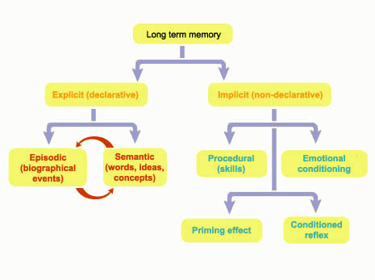

Declarative – knowing what. Fractionated into

* semantic memory
  + Memory for facts
  + It is what we think of as general knowledge
  + Knowing the capital of France or the colour of a bus
* Episodic memory
  + Memory related to our personal experience
  + It is what we generally think of as ‘memories’
  + Knowing what you did last night or where you went on holiday

Non declarative memory – knowing how.

* Most important is procedural memory (performing familiar actions or behaviours)

**Encoding**

More effective encoding into long-term memory increases the likelihood of retrieval

*Effortful Processing*: encoding that is initiated intentionally and requires conscious attention

*Automatic Processing:* encoding that occurs without intention and requiresminimal attention

**The levels of processing model of memory (Craik and Lockhart, 1972)**

We can process information in 3 ways:

## Shallow Processing – This takes two forms

**1**. **Structural processing** (appearance) which is when we encode only the physical qualities of something. E.g. the typeface of a word or how the letters look.

**2**. **Phonemic processing** – which is when we encode its sound.  
  
Shallow processing only involves **maintenance rehearsal** (repetition to help us hold something in the STM) and leads to fairly **short-term retention of information**. This is the only type of rehearsal to take place within the multi-store model.

## Deep Processing - This involves

**3**. **Semantic processing**, which happens when we encode the meaning of a word and relate it to similar words with similar meaning.   
  
Deep processing involves **elaboration rehearsal** which involves a more meaningful analysis (e.g. images, thinking, associations etc.) of information and leads to better recall. For example, giving words a meaning or linking them with previous knowledge.

**Mnemonic Device:** a memory aid that reorganises information into more meaningful units

* + Hierarchies
  + Chunking
  + Visual Imagery
  + Mnemonic Devices
  + Acronyms

**Schema:** a mental framework (an organized pattern of thought) about some aspect of the world

**Expertise:** a process of developing schemas that help encode information into meaningful patterns

**Storage**

*Associative Network*: a massive network of associated ideas and concepts e.g.

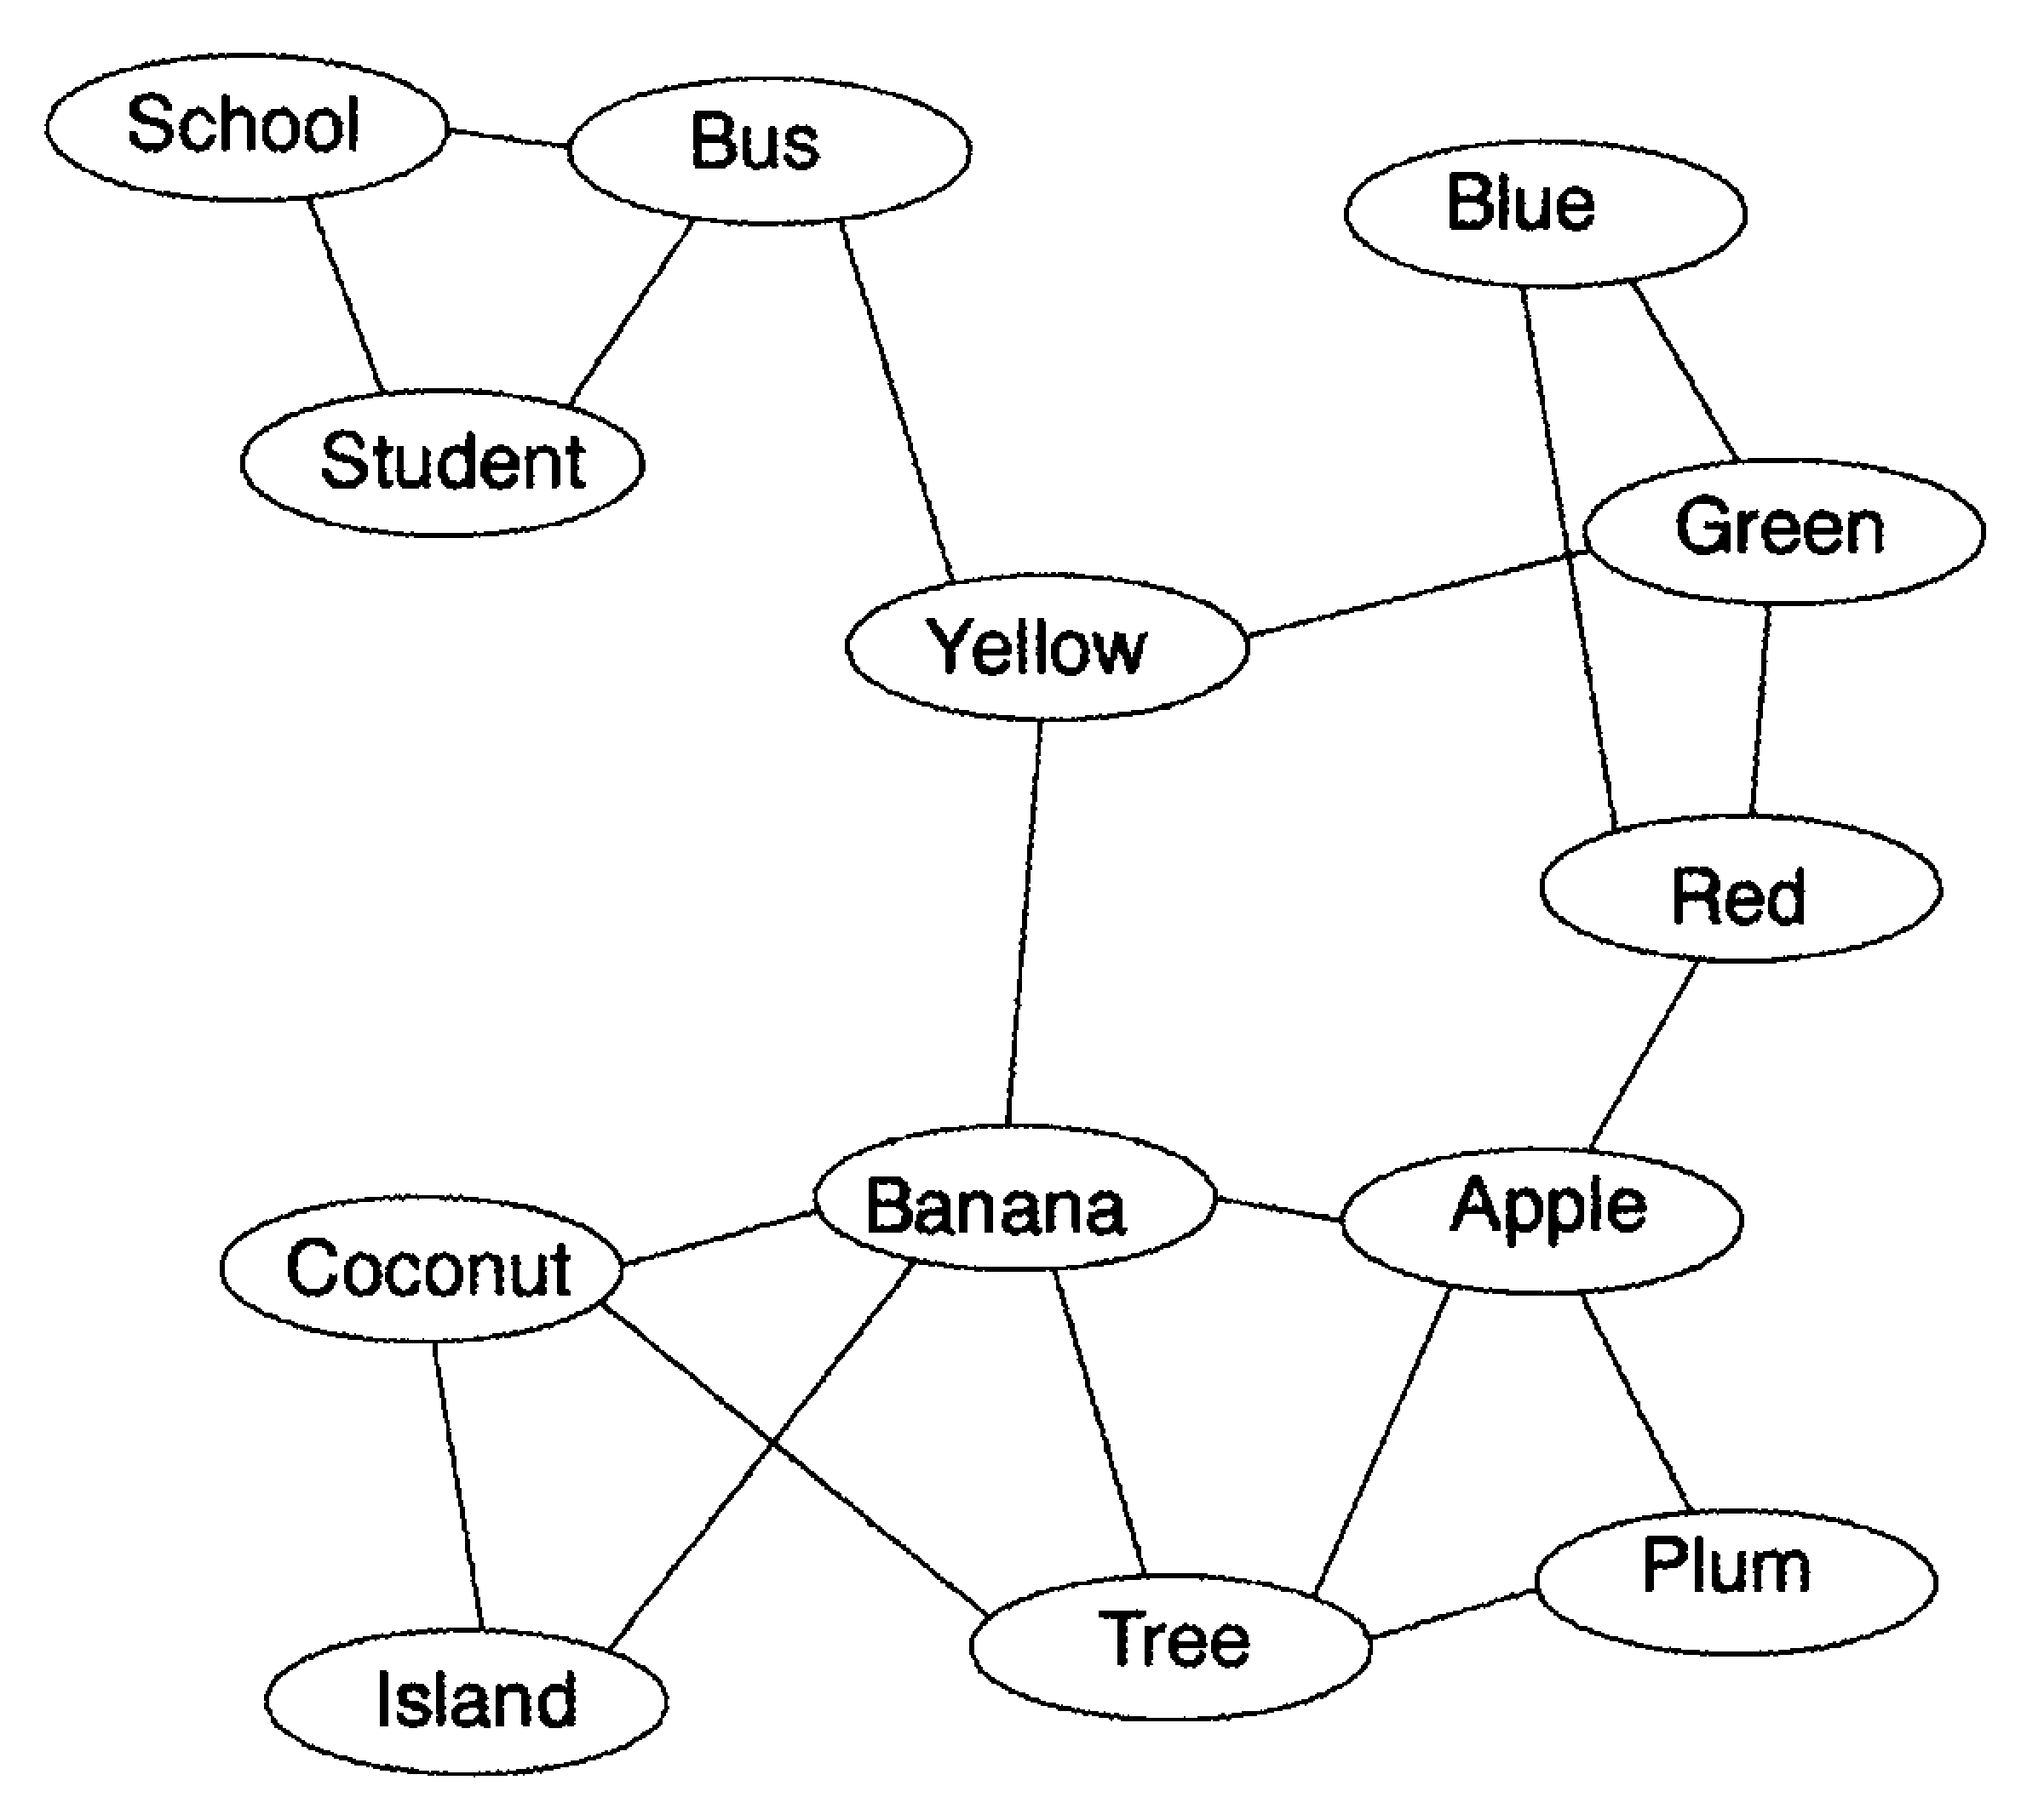

Each concept is represented by a *node*

Lines represent associations between concepts

Shorter lines indicate stronger associations

Activation of one network leads to a *spreading activation* of related concepts

*Priming:* the activation of one concept (or one unit of information) by another

**Retrieval**

**Retrieval Cue:** a stimulus, whether internal or external, that activates information stored in long-term memory

Multiple cues enhance retrieval

Generating multiple associations involves deeper processing

Self-generated associations become cues that have personal meaning

More cues = more chances of successful retrieval

**Flashbulb Memories:** recollections that seem so vivid and clear that we can picture them as if they were snapshots of moments in time

* Most likely to occur for distinctive events that evoke strong emotional reactions
* Many details may be inaccurate
* People are often overconfident in their reports

**Forgetting**

**Decay Theory:** proposed that with time and disuse the long-term physical memory trace in the nervous system fades away

Scientists have been unable to locate physical memory traces

Older memories do not always disappear first

* **Interference Theory:** we forget information because other items in long-term memory impair our ability to retrieve it
  + **Proactive Interference:** material learned in the past interferes with the recall of newer material
  + **Retroactive Interference:** recently learned material interferes with the recall of material learned in the past
* Why does interference occur?
  + Encoding time
  + Competition among retrieval cues
  + Too few or weak retrieval cues

**Memory as an active construction**

We *construct* memories by piecing together bits of stored information in ways that seem real and accurate

Schemas can distort our memories by leading us to encode or retrieve information in ways that fit in with our pre-existing assumptions

**Misinformation Effect:**  the distortion of a memory by misleading post-event information

* Can affect the accuracy of eyewitness testimony
* **Source Confusion:** our tendency to recall something or recognise it as familiar but to forget where we encountered it

**Neural correlates of memory**

The hippocampus has an important role in the formation of new episodic or autobiographical memories (e.g.: Squire, Eichenbaum, O’Keefe). Some researchers prefer to consider the hippocampus as part of a larger **medial temporal lobe** memory system responsible for general explicit (declarative) memory.

**Beck’s Schema Theory of Depression (Beck *et al* 1979)**

**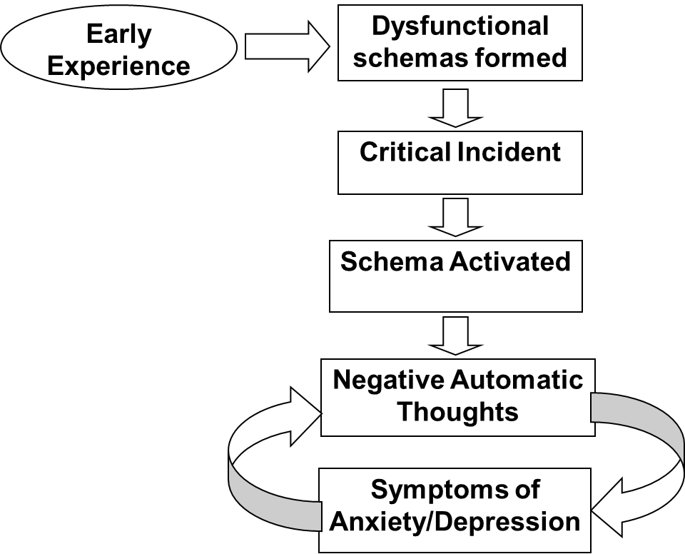**

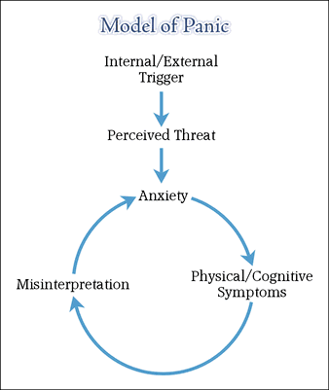**Cognitive Model of Panic (Clark 1986)Session 10 - Adherence to treatment regimes**

**Overview**

When a health professional gives a patient advice regarding their treatment e.g. to take a prescribed course of medication or to follow dietary recommendations they generally expect that the patient will follow, i.e. adhere to, this advice. However, countless studies have shown that perfect adherence is the exception rather than the rule. In this session we will look at some of the factors which influence adherence, most of which relate to how the nature of the interaction of the health professional and the patient. Many of these factors are very simple such as giving information in a way that patients are able to understand and recall. These factors are relatively easy to modify but all too often overlooked in clinical practice.

**Learning objectives**

* To define the terms “adherence” and “compliance” and describe the limitations of these terms.
* To develop an understanding of the scale of non-adherence to health care advice
* To describe the clinical and economic consequences of non-adherence
* To identify the main causes of non-adherence
* To describe the role of failure to understand and recall in non-adherence
* To describe ways of improving recall of health care information and enhancing adherence to advice

**What is adherence?**

**Definitions**

Compliance– Acting according to request or command (Oxford dictionary).

Adherence – “to stick fast to” (Oxford dictionary)

**Macintyre et al (2005)**

Limited concordance in health professionals judgements of patient adherence

**Watchdog Health/NOP Survey (2000)**

* 11% prescribed medications never started
* 34% medication courses not completed
* £37.6 Million worth of unused medication handed in to pharmacies each year in the U.K.

**Consequences of non-adherence**

* Increased hospital admissions – 20% of all hospital admissions probably due to non-adherence (Ausbern 1981)
* Rejection of transplants (Rovelli 1989)
* Occurrence of complications (Kalil et al 1991)
* Increased mortality (Robertson et al 1982)

**Causes of non-adherence**

**Treatment factors**

* Physical aspects e.g. packaging
* Complexity
* Duration
* Cost
* Side effects

**Presentation Factors**

* Amount of information
* Order
* Stressing importance
* Specificity
* Mode of presentation
* Follow up

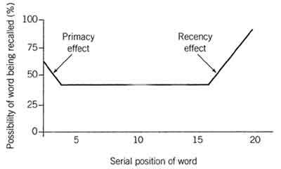

**Use of written information**

* Most patients would like to receive written information (97% in study by Gibbs et al 1990)
* The majority of patients report that they do read written information when it is given to them (88% Gibbs et al 1987)
* Written information leads to increased knowledge (in over 90% of studies) and adherence (in 60% of studies) (Ley and Morris 1984)

**Readability of written information**

* The Flesch formula is based on the average sentence length in words of any given text and the number of syllables per 100 words. The formula gives a score for reading ease on a scale from 0 (practically unreadable) to 100 (easy to read).
* The formula for the Flesch Reading Ease score is: 206.835 – (1.015 x ASL) – (84.6 x ASW)

(But most word processors can calculate it automatically e.g. in MS Word go to File>Options>proofing and tick the box which says “show readability statistics” then next time you do a spell check Flesch score will be shown, the score for this section is 54.7).

* A score of 70-80 is taken to be plain English: about 20 words per sentence and 1.5 syllables per word.

An alternative formula is the SMOG (Simple measure of Gobbledegook)


\mbox{grade} = 1.0430 \sqrt{ 30\times\frac{\mbox{number of polysyllables}}{\mbox{number of sentences}} } + 3.1291


**Psychosocial influences on adherence**

Including health beliefs, normative beliefs, self-efficacy, cultural beliefs (see Session 1b) etc

**Psychosocial influences operate at multiple levels**

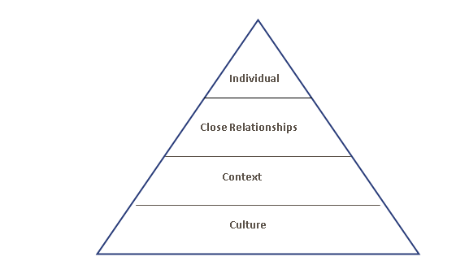

**Improving treatment adherence**

* Improve regime
* Improve interaction esp.: Communication style & presentation
* Identify & modify beliefs
* Involve sig. Others
* Wider network

**Session 11 - Social Psychology**

**Overview**

In the words of the famous saying “*No man is an Island*”, we all think, feel and behave within a social environment and this environment shapes our behaviour much more than we normally recognize. This session looks how we interpret our own and others behaviour. We also look at how strongly held views about others (prejudices) can influence how we process new information and in turn maintain these beliefs. We will look at conformity or why people follow instructions, even if they know they are wrong. We will look at why, when an individual is part of a group, they think or do things differently than if they were alone, sometimes with dangerous consequences. We will also look at what determines helping or altruistic behaviour and how it can be increased. Finally, we will look at leadership and what makes an effective leader.

**Learning objectives**

* Define Attitudes and discuss the relationship between attitudes and behaviour

(NB. This links to the Health Beliefs session esp. Theory of planned behaviour)

* Define prejudice and describe how prejudice is maintained

(NB This links with Cognitive Psychology esp. the effect of schemas)

* Define conformity and discuss the factors predicting conformity
* Define Group Processes of Social Loafing, De-individuation, Group Polarization and Group Think.
* Discuss the factors which predict helping behaviour including the “bystander effect”
* Define “Leadership” and styles of leadership
* Discuss characteristics of effective leadership

**Notes**

**Attitudes and Prejudices**

* **Attitude:** a positive or negative evaluative reaction toward a stimulus, such as a person, action, object, or concept
* Attitudes influence behaviour more strongly when situational factors that contradict our attitudes are weak

**Conformity**

* **Conformity:** the adjustment of individual behaviours, attitudes, and beliefs to a group standard
* **Factors That Predict Conformity**
  + Group Size
  + Unanimity
  + Cohesion
  + Status
  + Public Response
  + Lack of prior commitment

**Group processes**

* **Social Loafing:** the tendency for people to expend less individual effort when working in a group than when working alone
  + *Collective Effort Model:* on a collective task, people will put forth only as much effort as they expect is needed to reach their goal
  + More likely to occur when:
    - The person believes that individual performance is not being monitored
    - The task (goal) or the group has less value or meaning to the person
    - The person generally displays low motivation to strive for success
    - The person expects that other group members will display high effort
  + Depends on gender and culture
    - Occurs more strongly in all-male groups
    - Occurs more often in individualistic cultures
  + Social loafing may disappear when:
    - Individual performance is monitored
    - Members highly value their group or the task goal
* **Groupthink:** the tendency of group members to suspend critical thinking because they are striving to seek agreement
  + Most likely to occur when a group:
    - Is under high stress to reach a decision
    - Is insulated from outside input
    - Has a directive leader
    - Has high cohesiveness
  + Symptoms of Groupthink:
    - *Direct pressure* applied to people who express doubt
    - *Mind Guards:* people who prevent negative information from reaching the group
    - Members display *self-censorship* and withhold their doubts
    - An *illusion of unanimity* is created

**Helping Behaviour**

**The Bystander Effect:** presence of multiple bystanders inhibits each person’s tendency to help

* + Due to social comparison or diffusion of responsibility

**5-Step Bystander Decision Process (Latané & Darley, 1970):**

* Notice the event
* Decide if the event is really an emergency
  + *Social comparison:* look to see how others are responding
* Assuming responsibility to intervene
  + *Diffusion of Responsibility:* believing that someone else will help
* Self-efficacy in dealing with the situation
* Decision to help (based on cost-benefit analysis)

**Increasing helping behaviour**

Reducing restraints on helping

* Reduce ambiguity and increase responsibility
* Enhance guilt and concern for self image

Socialize altruism

* Teaching moral inclusion
* Modeling helping behaviour
* Attributing helpful behaviour to altruistic motives
* Education about barriers to helping

**Leadership**

Professor Kurt Lewin, widely recognized as the founder of social psychology, undertook studies on leadership and defined three distinct styles:

*Autocratic or authoritarian style*

Under the autocratic leadership style, all decision-making powers are centralized in the leader, as with dictator leaders. They do not entertain any suggestions or initiatives from subordinates.

*Participative or democratic style*

The democratic leadership style favours decision-making by the group as shown, such as leader gives instruction after consulting the group. They can win the co-operation of their group and can motivate them effectively and positively.

*Laissez-faire or “free rein” style*

A free-rein leader does not lead, but leaves the group entirely to itself as shown; such a leader allows maximum freedom to subordinates, i.e., they are given a free hand in deciding their own policies and methods.

**Medical Leadership Competency Framework – 3rd Edition (2010)**

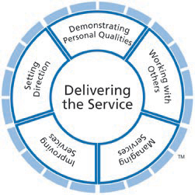

# <http://www.leadershipacademy.nhs.uk/discover/leadership-framework/>

# Session 12 - Clinical decision making

**Overview**

In this session we will look at how humans make decisions and identify some of the shortcuts we are programmed to use to ease the decision making process. However, these shortcuts make us vulnerable to predictable errors in our decision making and this potentially very dangerous for clinician’s making life or death decisions or administering dangerous treatments. We will identify the common shortcuts or “heuristics” and also look at ways of improving decision making through the use of decision making aids such as algorithms. We will also cover how to negotiate the price of a second hand car and maximize your chances of winning the lottery!

**Learning objectives**

* Describe why people are generally very poor at making probability judgments
* Contrast “hot” and “cold” systems of thinking
* Define the most common types of error made in decision making.
* Describe how these errors can affect health-related decisions by both patients and doctors
* Describe “Anchoring” and the “Framing effect”
* Define the “Availability”’ and “Representativeness” heuristics
* Describe methods to improve clinical decision making.
* Define “algorithms” and discuss their potential benefits and limitations in clinical situations

**Notes**

**Two systems of thinking i.e.“Hot” and “cold” systems of thinking (Metcalfe and Mischel 1999) / System 1 and System 2 Kahneman (2011)**

|  |  |
| --- | --- |
| **Hot system (System 1)** | **Cold system (System 2)** |
| Emotional | Cognitive |
| “Go” | “Know” |
| Simple | Complex |
| Reflexive | Reflective |
| Fast | Slow |
| Develops early | Develops late |
| Accentuated by stress | Attenuated by stress |
| “Stimulus control” | “Self-control” |

**Decision making errors**

**Sunk Cost fallacy**

Sunk costs are any costs that have been spent on a project that are irretrievable ranging including anything from money spent building a house to expensive drugs used to treat a patient with a rare disease. Rationally the only factor affecting future action should be the future costs/benefit ratio **but** humans do not always act rationallyand often the more we have invested in the past the more we are prepared to invest in a problem in the future, this is known as the Sunk Cost Fallacy or the “Concorde Effect”.

**Anchoring**

Anchoring and adjustment is a psychological heuristic that influences the way people intuitively assess probabilities. According to this heuristic, people start with an implicitly suggested reference point (the "anchor") and make adjustments to it to reach their estimate.

**Gambler’s fallacy**

The gambler's fallacy is a logical fallacy involving the mistaken belief that past events will affect future events when dealing with random activities, such as many gambling games.

**Baye’s Theorem**

**(NB You won’t be asked to recall this for this module)**

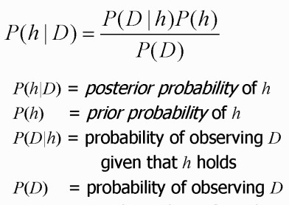

**Heuristics**

Heuristics are simple “rules of thumb” which are built on experience and are applied to simplify decision making in an ambiguous situation.

**Representativeness heuristic**

A heuristic used to estimate probability that a stimulus belongs to a particular class based on how ‘typical’ of that class it appears to be (regardless of base rate probability)

**Availability Heuristic**

A heuristic that leads people to base a judgment on the ease with which something can be brought to mind.

**Improving Decision Making**

1. Recognize that heuristics and biases may be affecting our judgement even though we may not be conscious of them
2. Counteract the effect of top-down information processing by generating alternative theories and looking for evidence to support them rather than just looking for evidence which confirms our preferred theory.
3. Understand and employ statistical principles e.g. Bayes Theorem
4. Use of Algorithms & Clinical Decision Support Systems

**Algorithm**

A logical series of steps to take in order to make a decision most effectively.