Anti-Parkinsonian Drugs and Neuroleptics

Updated learning objectives

Describe the main symptoms displayed by patients with Parkinson’s disease (PD) and their underlying pathology

Name the 3 main drug classes used to treat PD and describe their mechanisms of action

Summarise the problems with the current drug treatment for PD and the side-effects associated with levodopa in particular

Describe the major symptoms displayed by schizophrenic patients and the associated neural pathways

Name the main first-generation antipsychotic drugs in clinical use and provide details of their side-effects

Name the main second-generation antipsychotic drugs in clinical use and provide details of their side-effects

Dopamine Background
Dopamine (DA) is one of the three major monoamine neurotransmitters found within the central nervous system (CNS). The processes of DA synthesis and metabolism are shown in figure 1.
Figure 1: Dopamine synthesis and metabolism
Tyrosine (TYR) is a non-essential amino acid that is converted to L-DOPA by the enzyme tyrosine hydroxylase (TH). TH is an oxidase that catalyses the rate-limiting step in monoamine synthesis. L-DOPA is subsequently converted to dopamine (DA) by the enzyme DOPA decarboxylase (DOPA-D). DA is stored within vesicles and released following membrane excitation and Ca²⁺ entry.
DA can be removed from the synaptic cleft by the dopamine transporter (DAT) or the noradrenaline transporter (NET).
There are three enzymes involved in the metabolism of DA:
- Monoamine oxidase A (MAO-A): has a mitochondrial location and metabolises DA, noradrenaline and serotonin
- MAO-B: metabolises DA
- Catechol-O-methyl transferase (COMT) has a wide distribution, metabolises all monoamines
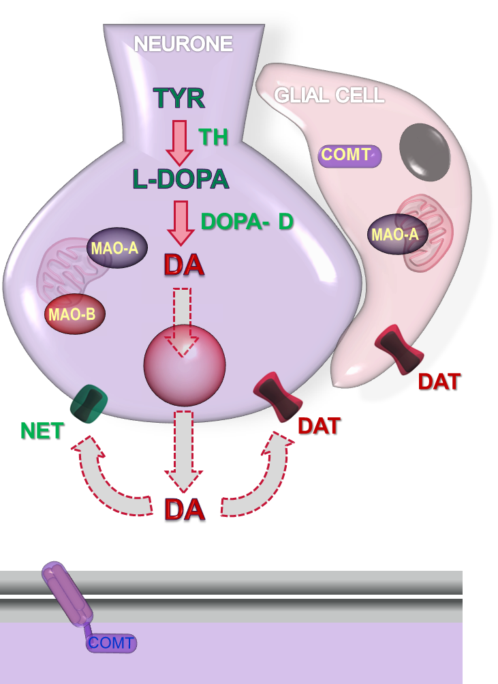

Neuronal pathways
The four main dopaminergic pathways in the brain are:
- The nigrostriatal pathway runs from the substantia nigra pars compacta (SNc) to the striatum. Inhibition of this pathway results in movement disorders
- The mesolimbic pathway runs from the ventral tegmental area (VTA) to the Nucleus Accumbens (NAcc) and is widely thought be the brain reward pathway. Inhibition of this pathway is thought to reduce positive schizophrenia symptoms (see later)
- The mesocortical pathway goes from VTA to the cerebrum and is important in executive functions and complex behavioural patterns. Inhibition of this pathway is thought to increase the negative symptoms of schizophrenia (see later)
- The tuberoinfundibular pathway runs from the arcuate nucleus to the median eminence. Inhibition results in hyperprolactinaemia

Parkinson’s disease

Epidemiology & Pathophysiology
Parkinson’s disease (PD) is thought to affect around 1-2% of the general population above the age of 60 and prevalence rates increase with advancing age. There are gender associated differences in disease prevalence and it is thought to affect men more often than women. There is also a higher prevalence in Caucasians than Afro-Caribbeans. 95% of cases are idiopathic and familial (usually early-onset) PD has been associated with mutations in a number of candidate genes, most notably LRRK2, Parkin (also known as PARK8 & PARK2, respectively), PINK1 and SNCA.
Historically, Parkinson’s disease (PD) has always been considered a neurodegenerative disorder resulting from substantial loss of the dopaminergic neurones projecting from the substantia nigra pars compacta (SNc) to the striatum (i.e. the nigrostriatal tract). Although, this neuronal loss is a key feature of PD, and responsible for the characteristic motor deficits, it is now thought that this element occurs at the later stages of the disease.
At the systems level, the loss of SNc dopaminergic neurones is a key characteristic but at the cellular level a pathognomonic feature is the presence of dense aggregates, known as Lewy bodies/ neurites. Whereas Lewy bodies are primarily found with the perikarya (cell body) of neurones, the Lewy neurites are solely present within neuronal projections (mainly the axons). The Lewy aggregates are known to contain abnormally phosphorylated neurofilaments, ubiquitin and α-synuclein.
At the sub-cellular and molecular levels, mitochondrial dysfunction (complex I deficiency); oxidative stress, L-type calcium channels and inflammation have all been linked to PD aetiology.

Symptoms
The cardinal features of PD are the motor symptoms which include:
- Resting tremor: a 4-6 Hz tremor that occurs at rest
- Bradykinesia: slow movement that is often considered to be the defining feature of PD
- Rigidity: muscular hypertonicity and resistance to movement
- Postural instability: typically occurs later in the disease and is accompanied by a shuffling gait
There are also several ‘non-motor’ symptoms that are commonly seen in PD patients and these can be broadly categorised into effects on the autonomic nervous system and neuropsychiatric changes (see table 1)

Table 1: Details of the non-motor deficits seen in Parkinson’s disease
Autonomic system disorders | Prevalence in PD
Olfactory deficits | Estimates vary between 70-98% of patients
Gastrointestinal symptoms  - Constipation  - Nausea | Estimates vary between 40-60% of patients
Urogenital dysfunction  - Bladder problems  - Sexual dysfunction | Estimates vary between 30-80% of patients
Orthostatic hypertension | Estimates vary between 30-60% of patients
Neuropsychiatric disorders | Prevalence in PD
Sleep disorders  - REM sleep disorder (RSD)  - Insomnia | Estimates vary between 60-90% of patients. RSD is considered as a good clinical marker for PD
Mood disorders  - Anxiety  - Depression | Estimates vary between 10-80% of patients
Cognition & Psychosis | Reported prevalence of 20-40%

Pharmacology
The drugs currently licensed in the UK (April 2013) for the treatment of Parkinson’s disease are shown in table 2.

Dopamine (DA) replacement
Since DA is unable to cross the blood brain barrier (BBB) it is administered in the form of the precursor L-DOPA (levodopa). Replacement with tyrosine is also not an option since tyrosine hydroxylase is the rate-limiting enzyme in the production of DA (see figure 1).
Although levodopa is able to cross the BBB, peripheral DOPA decarboxylase enzymes are able to catalyse its conversion to DA in the periphery. This has two important consequences:
- Peripheral DA production results in side-effects such as nausea & vomiting
- Higher concentrations of levodopa need to be administered to produce sufficient concentrations in the central nervous system
For these reasons levodopa is always given in combination with a DOPA decarboxylase inhibitor (carbidopa or benserazide, see table 2) that is unable to cross the BBB.
Levodopa shows greater efficacy than any of the other medications available for treating the motor symptoms of PD but it does not slow the progression of the disease and long-term use is associated with troublesome consequences such as ‘off’ periods and levodopa-induced dyskinesias (LIDs).
To reduce the emergence of ‘off’ periods sustained-release preparations of levodopa are available and supplementation with the COMT inhibitors (see table 2) are effective at reducing both ‘off’ periods and LIDs.

DA receptor stimulation
There are a number of dopamine D₂ receptor agonists licensed for the treatment of PD (see table 2). They generally fall into two categories: the ergot derivatives and the non-ergot derivatives. The former are now rarely used in PD because they are associated with dangerous cardiopulmonary fibrotic reactions.
The newer non-ergot derivatives have demonstrated inferior clinical efficacy when compared to levodopa but reduce dopaminergic neuron loss and delay the onset of motor complications. They are also available in sustained-release formulations (pramipexole & ropinirole) and as a patch (rotigotone).

Table 2: Drugs licensed in the UK for the treatment of Parkinson’s disease
Category | Licensed drugs | Additional information
DA replacement | L-DOPA (levodopa) | - Able to cross the BBB  - Is converted to DA in the periphery  - Good efficacy against motor symptoms  - Can cause LIDs and ‘off’ symptoms
DA receptor stimulation | Ergot derivative  Bromocriptine  Cabergoline  Pergolide | - Potent D₂ receptor agonists  - Associated with dangerous fibrotic reactions  - Now rarely used
 | Non-Ergot  Amantadine  Apomorphine Pramipexole  Ropinirole  Rotigotone | - Amantadine is a weak DA receptor agonist & NMDA receptor antagonist  - Apomorphine is only given under specialist supervision  - Pramipexole & ropinirole are also available as extended-release formulations  - Rotigotine is also available as a patch
Inhibition of DA metabolism | MAO_{B} inhibitors  Rasagiline  Selegiline | - Rasagiline is significantly more potent than selegiline  - Both may have disease-modifying properties  - Rasagiline is effective at treating LIDs
Adjuncts | DD inhibitors  Benserazide  Carbidopa | - Co-Beneldopa: Benserazide & L-DOPA  - Co-Careldopa: Carbidopa & L-DOPA  - Both are available as extended release formulations
 | COMT inhibitors  Entacapone  Tolcapone | - Both may have disease-modifying properties  - Entacapone is effective in treating LIDs  - Tolcapone carries a risk of hepatotoxicity

Inhibition of DA metabolism
Rasagiline and selegiline are selective and irreversible inhibitors of MAO_{B} and are both licensed for the treatment of PD. The older of the two drugs selegiline (aka deprenyl) has been shown to delay the onset of motor symptoms and is associated with a better long-term outcome than levodopa. In addition to MAO_{B} rasagiline has a number of other additional benefits such as inhibiting apoptosis and increasing neurotrophic factors.

Schizophrenia

Epidemiology & Pathophysiology
Schizophrenia is thought to affect between 0.5-1% of the population and has a non-uniform distribution across the globe, with developed countries showing higher prevalence than developing countries. There have also found to be raised levels of psychosis across several ethic minority groups (or migrants) within developed countries, particularly within the Afro-Caribbean community.
With respect to gender and age there is a similar frequency between men and women but a difference in disease progression. Whereas males show an earlier onset and peak around the twenties, females are found to have a less pronounced peak during these ages and a midlife surge (over forties). In terms of genetics there is greater gradient of risk associated with the proximity of the relationship. For example individuals who have two schizophrenic parents or a schizophrenic monozygotic twin are around 50% more likely to develop the condition themselves. Moreover, the neurodevelopment hypothesis posits that genes involved in these processes may play an aetiological role. This has been substantiated, to a certain extent, by the fact that mutations in the genes dysbindin, neuregulin and disc1 (disrupted in schizophrenia 1) are linked to a greater risk of disease.
In terms of pathophysiology there are no consistent neuroanatomical or neurophysiological changes exhibited in patients with schizophrenia. The major perturbations are seen within the neurochemistry, in particular the mesolimbic and mesocortical dopaminergic pathways. In the most simplistic terms, there is thought to be a ‘hyperdopaminergic’ state in the mesolimbic pathways (which causes the positive symptoms of schizophrenia) and a ‘hypodopaminergic’ state in the mesocortical pathways (which cause the negative symptoms).
Symptoms
Since there are no pathognomonic features of schizophrenia the diagnostic criteria vary between different governing bodies. The American Psychiatric Association’s (APA) diagnostic and statistical manual of mental disorders (DSM) and the World Health Organisation’s (WHO) international classification of diseases (ICD) are the two most prominent guidelines. NB The current DSM-IV guidelines are due to be updated to DSM-V in May 2013. However, they both require the presence of symptoms including:
- Hallucinations
- Delusions
- Disorganised speech
- Catatonic behaviour
- Primary negative symptoms
In terms of symptom classification, there are various levels of categorisation that have developed over time. Most recently, schizophrenia has been classified as having six domains (positive, negative, disorganisation, cognitive, depression and anxiety) but the most arbitrary two domain classification is possibly the most intuitive. The two domains are:
- Positive symptoms: hallucinations, delusions, thought disorder, bizarre behaviour
- Negative symptoms: affective flattening, alogia, anhedonia, avolition/apathy
The positive symptoms have been ascribed to increased dopaminergic activity in the mesolimbic pathway, whereas the negative are attributed to reduced dopaminergic activity in the mesocortical pathway.

Pharmacology
There are 20 drugs currently licensed in the UK (April 2013) for the treatment of schizophrenia, 13 of which fall into the category of first-generation (typical) antipsychotics (FGAs) and 7 that are second-generation (atypical) antipsychotics (SGAs). Some of these drugs are shown in table 3.
Historically, the SGAs were so named because they were thought to act through the serotonergic system rather than the dopaminergic system. However, this is now known not to be the case so this categorisation is essentially just based on date of discovery.

Table 3: A selection of the antipsychotic drugs licensed in the UK
 | Drug Name | Receptor effects | Side-effects | Positive attributes
FGAs | Chlorpromazine  (phenothiazine) | D(₁₋₅) antagonist  M_{1,2},α & H₁ antagonist | Anticholinergic side-effects  Marked sedation | Low potency with fewer EPS
 | Haloperidol  (butyrophenone) | D_{2,3} antagonist | High incidence of EPS | Less weight gain  Depot preparation
 | Flupentixol  (thioxanthene) | D(₁₋₅) antagonist  5-HT₂ antagonist  α₁ & H₁ antagonist | High incidence of EPS | Less sedating  Depot preparation
 | Perphenazine  (phenothiazine) | D(₁₋₅) antagonist | Dystonias | Similar side-effect profile to SGAs  antiemetic
 | Sulpiride  (benzamide) | D₂,₃ antagonist | Can aggravate agitated or aggressive patients | Fewer EPS  Less weight gain  No effect on blood pressure
SGAs | Amisulpride  (benzamide) | D₂ & D₃ receptor antagonist  5-HT₇ receptor antagonist | Hyperprolactinaemia | Minimal anticholinergic activity  Less weight gain
 | Aripiprazole  (phenylpiperazine) | D₂ & 5-HT_{1A} partial agonist  5-HT₂ antagonist | Initial akathisia  Nausea | Low incidence of Parkinsonism, hyperprolactinaemia & metabolic problems
 | Clozapine  (Dibenzodiazepine) | 5-HT_{2A} antagonist  M_{1,2} ,H₁ & α antagonist  D₄ antagonist | Agranulocytosis  Fatal myocarditis, tachycardia, hyperglycaemia | The most effective antipsychotic but only used as a last resort  Low incidence of EPS
 | Olanzapine  (Dibenzodiazepine) | 5-HT₂ antagonist  M₁ antagonist  D₁ & D₁ receptor | Significant weight & metabolic concerns | Has a low rate of discontinuation  Depot preparation
 | Quetiapine  (Dibenzodiazepine) | 5-HT (_{1, 2 & 7}) antagonist  D(₁₋₄), H₁ & α₁ antagonist | Weight gain | Wide dose range  Low EPS incidence
 | Risperidone  (Benzisoxazole) | 5-HT(_{1, 2 & 7}) antagonist  D₂, H₁ & α_{1,2} antagonist | More EPS than average SGA | Available in various preparations

In terms of prescriptions guidelines, aside from clozapine, no one antipsychotic is recommended over another. Numerous studies and meta-analyses have shown that clozapine is the most efficacious drug. Moreover, clozapine is the only currently available antipsychotic that is effective at treating the negative symptoms of schizophrenia. However, since clozapine is associated with the most dangerous side-effects it is only recommended for treatment-resistant schizophrenia.
Clinical data have also been unable to distinguish between the other FGAs & SGAs in terms of efficacy and the exhaustive (but much maligned) CATIE trial found that perphenazine (an FGA) had a similar side-effects profile to a number of SGAs.

Key points
Neuronal dopaminergic pathways
- Nigrostriatal pathway: inhibition results in movement disorders
- Mesocortical pathway: inhibition associated with positive schizophrenia symptoms
- Mesolimbic pathway: inhibition associated with negative schizophrenia symptoms
- Tuberoinfundibular pathway: inhibition results in hyperprolactinaemia

PD Symptoms & pathophysiology
- Movement disorders, autonomic dysfunction & neuropsychiatric problems
- Lewy bodies
PD Drug treatment
Receptor activation
- DA receptor agonists: ropinirole
- MAO_{B} inhibitors: selegiline
Dopamine replacement
- Levodopa
- Adjuncts: DOPA decarboxylase & COMT inhibition

Schizophrenia background
- Primarily affects people between 18-35
- Neurochemical disorder involving the mesolimbic and mesocortical dopaminergic pathways
Schizophrenia drug treatment
First generation antipsychotics
- D₂R antagonists, chlorpromazine, haloperidol
- Extrapyramidal side-effects (EPS)
Second generation antipsychotics
- Affect various receptors including D₂R
- Less EPS, more metabolic side-effects
- Clozapine is the most efficacious

Addressing David Dexter’s learning objectives
- Describe the synthetic and metabolic pathways of the neurotransmitter dopamine
Tyrosine→(TH)→L-DOPA→(DOPA decarboxylase)→Dopamine
- What are the three main dopaminergic pathways in the brain and what are their basic functions?
The nigrostriatal pathway: Inhibition of this pathway results in movement disorders
The mesolimbic & mesocortical pathways: Involved in reward & behaviour
The tuberoinfundibular pathway: regulates prolactin secretion
- What are the two main sub-groups of dopamine receptors?
D₁-like (D₁ & D₅): G_{s} linked
D₂-like (D_{2,3} & ₄): G_{i} linked
- Describe the main clinical features of Parkinson’s disease.
Motor symptoms: Resting tremor, bradykinesia, rigidity, postural instability
Non-motor symptoms: ANS effects, sleep disorders & cognitive deficits
- Which age group of the population is affected by Parkinson’s disease?
Primarily over 60s
- What are the main pathological and biochemical features of Parkinson’s disease?
Loss of the dopaminergic neurones of the substantia nigra and the presence of Lewy bodies
- Do the symptoms of Parkinson’s disease appear immediately?
No
- Can dopamine itself cross the blood brain barrier?
No
- In standard preparations what drug is combined with L-DOPA to prevent peripheral side effects?
Carbidopa OR benserazide
- What are the short and long-term side effects of L-DOPA therapy and how common are such side effects experienced.
Short-term: nausea. Long-term: dyskinesias & ‘off’ symptoms
- In the treatment of Parkinson’s disease how does the mechanism of action of bromocriptine differ from that of L-DOPA
Bromocriptine is dopamine receptor agonist
- By what mechanism can Deprenyl be utilised to reduce the dosage of L-DOPA required
Prevents dopamine breakdown (dosage can be reduced by 10-30%) but it can exacerbate side-effects and should not be used in patients with postural hypotension
- How do the COMT inhibitors and the MAO inhibitors differ in their mechanism of action?
COMT inhibitors primarily inhibit peripheral breakdown, whereas MAO inhibitors reduce neuronal breakdown
- Describe the clinical symptoms of schizophrenia. Which age group are most likely to be affected?
Symptoms: positive: delusions, hallucinations; negative: anhedonia, alogia. Peaks at around twenty.
- What is the principle neurotransmitter defect in schizophrenia?
Dopamine
- Are neuroleptic drugs selective for dopamine receptors?
No
- Apart from anti-schizophrenic actions, what are other effects produced by neuroleptic drugs that are due to antagonism at dopamine receptors.
Extra-pyramidal side-effects, hyperprolactinaemia
- What are acute and tardive dyskinesias and when do they occur in the treatment of schizophrenia?
Acute dyskinesias occur immediately and are more reversible
- What are the other unwanted side-effects of neuroleptics that are unrelated to their blockade of dopamine receptors?
Anticholinergic effects (sedation), metabolic problems

