Faculty of Medicine

Cellular and  
Molecular Science

Graduate Entry year 1

2012/13

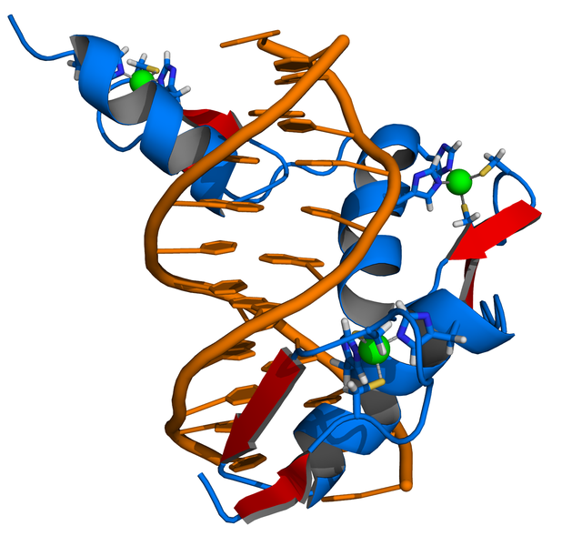

Theme Leader: Dr Charlotte Bevan

Tel: 020 7594 1685

Email: charlotte.bevan@imperial.ac.uk

# Cellular and Molecular Science

### Contents

SOLE iii

Introduction to CMS 1

CMS contacts 2

Timetable 3

Proteins, nucleic acids and gene expression 5

Cellular organization of tissues 23

Metabolism 26

Cell cycle and cancer 28

Recommended reading 32

**SOLE FEEDBACK – Cellular & Molecular Science**

The following pages provide you with templates on which you can record your thoughts as the course proceeds. At the end of the course you can enter your views onto SOLE.

**Please answer all questions by selecting the response which best reflects your view.**

|  |  |  |  |  |  |
| --- | --- | --- | --- | --- | --- |
|  | Strongly Agree | Agree | Neutral | Disagree | Strongly Disagree |
| The content of this module is useful. |  |  |  |  |  |
| The support materials available for this module (e.g. handouts, web pages, problem sheets) are helpful. |  |  |  |  |  |
| I receive sufficient feedback and guidance. |  |  |  |  |  |
| Overall, I am satisfied with this module. |  |  |  |  |  |

Please use this box for constructive feedback and suggestions for improvement.

|  |
| --- |
|  |

**SOLE FEEDBACK - INDIVIDUAL LECTURERS**

Please note that for SOLE, a Lecturer’s name will only appear once. This template gives you the opportunity to record your comments about each lecture in the order of delivery.

**On the following section, you have an opportunity to record any comments and constructive feedback you have for each lecturer.**

|  | **The lecture(s) are well structured** | | | | | **The lecturer explains concepts clearly** | | | | | **The lecturer engages well with the students** | | | | |
| --- | --- | --- | --- | --- | --- | --- | --- | --- | --- | --- | --- | --- | --- | --- | --- |
| **Lecturer and Lecture Title** | Strongly Agree | Agree | Neutral | Disagree | Strongly Disagree | Strongly Agree | Agree | Neutral | Disagree | Strongly Disagree | Strongly Agree | Agree | Neutral | Disagree | Strongly Disagree |
| Dr Charlotte Bevan, Introduction to CMS |  |  |  |  |  |  |  |  |  |  |  |  |  |  |  |
| Dr Anabel Varela Carver, Cellular Organisation of Tissues: Cell Behaviour 1 |  |  |  |  |  |  |  |  |  |  |  |  |  |  |  |
| Dr Sohag Saleh, Cellular Organisation of Tissues: Cell Behaviour 2 & 3 |  |  |  |  |  |  |  |  |  |  |  |  |  |  |  |
| Dr Mick Jones, Proteins, Nucleic acids & Gene Expression |  |  |  |  |  |  |  |  |  |  |  |  |  |  |  |
| Dr James Pease, Metabolism: ATP production, glycolysis and the TCA cycle |  |  |  |  |  |  |  |  |  |  |  |  |  |  |  |
| Dr James Pease, Metabolism: Oxidative phosphorylation |  |  |  |  |  |  |  |  |  |  |  |  |  |  |  |

|  |  |  |  |  |  |  |  |  |  |  |  |  |  |  |  |
| --- | --- | --- | --- | --- | --- | --- | --- | --- | --- | --- | --- | --- | --- | --- | --- |
| Dr Hector Keun, Metabolism: Lipid and cholesterol metabolism |  |  |  |  |  |  |  |  |  |  |  |  |  |  |  |
| Prof. Karim Meeran, Integrative Metabolism |  |  |  |  |  |  |  |  |  |  |  |  |  |  |  |
| Dr Jasmina Saric, Cellular Organisation of Tissues -Blood & Blood Cells |  |  |  |  |  |  |  |  |  |  |  |  |  |  |  |
| Dr Andy Porter, Cell Cycle and its Regulation |  |  |  |  |  |  |  |  |  |  |  |  |  |  |  |
| Dr Andy Porter, Signalling Mechanisms |  |  |  |  |  |  |  |  |  |  |  |  |  |  |  |
| Dr Radha Ramachandran, Inborn errors of Metabolism |  |  |  |  |  |  |  |  |  |  |  |  |  |  |  |
| Dr Nick Oliver, Diabetes: The archetypal Metabolic Disease |  |  |  |  |  |  |  |  |  |  |  |  |  |  |  |
| Dr James Pease/Dr Hector Keun, Metabolism Quiz & Feedback |  |  |  |  |  |  |  |  |  |  |  |  |  |  |  |
| Dr Andy Porter, DNA Damage & Repair |  |  |  |  |  |  |  |  |  |  |  |  |  |  |  |
| Dr Andy Porter, Oncogenes and Tumour Suppressors |  |  |  |  |  |  |  |  |  |  |  |  |  |  |  |
| Prof Gerry Thomas, Cellular Pathology of Cancer |  |  |  |  |  |  |  |  |  |  |  |  |  |  |  |
| Prof Gerry Thomas, Cancer as a Disease - Colorectal & Breast cancer |  |  |  |  |  |  |  |  |  |  |  |  |  |  |  |
| Prof Gerry Thomas, Cancer as a Disease - Skin Cancer |  |  |  |  |  |  |  |  |  |  |  |  |  |  |  |
| Dr James Pease & Dr Hector Keun, Revision for Metabolism |  |  |  |  |  |  |  |  |  |  |  |  |  |  |  |
| Dr Andy Porter, Revision for Cell Cycle |  |  |  |  |  |  |  |  |  |  |  |  |  |  |  |
| Prof Gerry Thomas, Revision for Cancer |  |  |  |  |  |  |  |  |  |  |  |  |  |  |  |
| Dr Mick Jones, Revision for Nucleic acids, Proteins & Gene Expression |  |  |  |  |  |  |  |  |  |  |  |  |  |  |  |
| Dr Anabel Varela-Carver, Revision session (exam questions) |  |  |  |  |  |  |  |  |  |  |  |  |  |  |  |

| **Lecturer and Lecture Title** | **Please use this box for additional constructive feedback.** |
| --- | --- |
| Dr Charlotte Bevan, Introduction to CMS |  |
| Dr Anabel Varela Carver, Cellular Organisation of Tissues: Cell Behaviour 1 |  |
| Dr Sohag Saleh, Cellular Organisation of Tissues: Cell Behaviour 2 & 3 |  |
| Dr Mick Jones, Proteins, Nucleic acids & Gene Expression |  |
| Dr James Pease, Metabolism: ATP production, glycolysis and the TCA cycle |  |
| Dr James Pease, Metabolism: Oxidative phosphorylation |  |
| Dr Hector Keun, Metabolism: Lipid and cholesterol metabolism |  |
| Prof. Karim Meeran, Integrative Metabolism |  |
| Dr Jasmina Saric, Cellular Organisation of Tissues -Blood & Blood Cells |  |
| Dr Andy Porter, Cell Cycle and its Regulation |  |
| Dr Andy Porter, Signalling Mechanisms |  |
| Dr Radha Ramachandran, Inborn errors of Metabolism |  |
| Dr Nick Oliver, Diabetes: The archetypal Metabolic Disease |  |
| Dr James Pease/Dr Hector Keun, Metabolism Quiz & Feedback |  |
| Dr Andy Porter, DNA Damage & Repair |  |
| Dr Andy Porter, Oncogenes and Tumour Suppressors |  |
| Prof Gerry Thomas, Cellular Pathology of Cancer |  |
| Prof Gerry Thomas, Cancer as a Disease - Colorectal & Breast cancer |  |
| Prof Gerry Thomas, Cancer as a Disease - Skin Cancer |  |
| Dr James Pease & Dr Hector Keun, Revision for Metabolism |  |
| Dr Andy Porter, Revision for Cell Cycle |  |
| Prof Gerry Thomas, Revision for Cancer |  |
| Dr Mick Jones, Revision for Nucleic acids, Proteins & Gene Expression |  |
| Dr Anabel Varela-Carver, Revision session (exam questions) |  |

Introduction to CMS

Welcome to the Cellular and Molecular Science (CMS) theme of the Graduate Entry course. This handbook relates to the core CMS courses, all of which cover and in some cases may extend material that you should already know from your previous degrees. Therefore, this theme is to some extent self-directed learning. We have also condensed the necessary information as far as possible into a small number of lectures, which should be largely revision.

We appreciate that, for some of you, parts of this material may be less familiar and/or you may appreciate further information and revision. As well as the pre-course reading list (reproduced here), therefore, we have additional material available to view, This and much of the study guide is available via the intranet for the School of Medicine: <https://education.med.imperial.ac.uk>. You will have to provide your Imperial username and password to gain access to it. In addition to the theme guide, the intranet provides the lecture handouts, self-directed learning material and any additional material. Various formats may be used – PDF files, Word documents or PowerPoint presentations. There is a link to Blackboard to access web-streamed audio files of additional lectures if required, drawn from the equivalent years (1 and 2) of the Undergraduate medical course. You are also encouraged to use the CMS module Discussion Board which you can access at: https://bb.imperial.ac.uk/.

We have also timetabled revision sessions in the Spring term, after the Formative and before the Summative CMS exam. The format of these revision sessions will be explained to you by the relevant Course Leader, but if there is a specific question or area you wish to go over you are encouraged to email this to the Course Leader well in advance of the session.

It is expected that students will attend all timetabled sessions.

CMS contacts

Overall Theme Leader is Dr Charlotte Bevan - [charlotte.bevan@imperial.ac.uk](mailto:charlotte.bevan@imperial.ac.uk). Lead academics for the component courses of the CMS theme and their email addresses are as follows:

**Proteins, Nucleic Acids and Gene Expression**

Dr Mick Jones – [m.d.jones@imperial.ac.uk](mailto:m.d.jones@imperial.ac.uk)

**Cellular Organisation of Tissues**

Dr Anabel Varela-Carver – a.varela@imperial.ac.uk

**Metabolism**

Dr James Pease – j.pease@imperial.ac.uk

Dr Hector Keun – h.keun@imperial.ac.uk

**Cancer and the Cell Cycle**

Dr Andy Porter – andy.porter@imperial.ac.uk

Professor Gerry Thomas – Geraldine.thomas@imperial.ac.uk

*The Genetics Module (lead – Dr Claire Shovlin) and the Haematology Module (lead – Dr Amin Rahemtulla) are part of the CMS theme and are included in the CMS examinations. Course guides for these modules will be issued during the Spring Term.*

**TIMETABLE**

|  |  |  |  |  |
| --- | --- | --- | --- | --- |
| **LECTURES** | | | | |
| **Date** | **Location** | **Time** | **Lecturer** | **Topic** |
| 23 Nov 2012  (Friday) | Hammersmith  WEC LT 3 | 2pm | Dr Charlotte Bevan | Introduction to CMS |
| 2.30 to 3pm | Dr Anabel Varela Carver | Cellular Organisation of Tissues: Cell Behaviour 1 |
| 2.30 to 5pm | Dr Sohag Saleh | Cellular Organisation of Tissues: Cell Behaviour 2 & 3 |
|  | | | | |
| 29 Nov 2012 (Thursday) | Hammersmith  WEC LT 2 | 2pm to 5pm | Dr Mick Jones | Proteins, Nucleic acids & Gene Expression |
|  | | | | |
| 30 Nov 2012  (Friday) | Hammersmith  WEC LT 3 | 2pm to 3pm | Dr James Pease | Metabolism: ATP production, glycolysis and the TCA cycle |
| 3pm to 4pm | Dr James Pease | Metabolism: Oxidative phosphorylation |
| 4pm to 5pm | Dr Hector Keun | Metabolism: Lipid and cholesterol metabolism |
|  | | | | |
| 6 Dec 2012  (Thursday) | Hammersmith  WEC LT 3 | 9 to 10 am | Prof. Karim Meeran | Integrative Metabolism |
|  | | | | |
| 11 Dec 2012  (Tuesday) | Hammersmith  WEC LT 3 | 2 to 3 pm | Dr Jasmina Saric | Cellular Organisation of Tissues -Blood & Blood Cells |
| 3 to 4pm | Dr Andy Porter | Cell Cycle and its Regulation |
| 4 to 5pm | Dr Andy Porter | Signalling Mechanisms |
|  | | | | |
| 14 Dec 2012  (Friday) | Hammersmith  WEC LT 3 | 9 to 10am | Dr Radha Ramachandran | Inborn errors of Metabolism |
| 10 to 11 am | Dr Nick Oliver | Diabetes: The archetypal Metabolic Disease |
| 11 to 12pm | Dr James Pease/Dr Hector Keun | Metabolism quiz and feedback |
| **CHRISTMAS BREAK** | | | | |
| 11 Jan 2013  (Friday) | Hammersmith  WEC LT 2 | 1 to 2 pm | Dr Andy Porter | DNA Damage & Repair |
| 2 to 3 pm | Oncogenes and Tumour Suppressors |
| 3 to 5pm | Prof Gerry Thomas | Cellular Pathology of Cancer |
|  | | | | |
| 17 Jan 2013  (Thursday) | Charing Cross  8th floor LT, Lab Block | 2 to 3 pm | Prof Gerry Thomas | Cancer as a Disease - Colorectal & Breast cancer |
| 3 to 4 pm | Cancer as a Disease - Skin Cancer |
| 4 to 5 pm | Cancer as a Disease - Leukaemia |

|  |  |  |  |  |
| --- | --- | --- | --- | --- |
| **REVISION SESSIONS** | | | | |
| **Date** | **Location** | **Time** | **Lecturer** | **Topic** |
| 7 March 2013  (Thursday) | Hammersmith  WEC LT 3 | 9am to 10.30am | Dr Andy Porter | Revision for Cell Cycle |
| 11 to 12.30 | Prof Gerry Thomas | Revision for Cancer |
| Hammersmith  WEC LT 1 | 2pm to 4pm | Dr Mick Jones | Revision for Nucleic acids, Proteins & Gene Expression |
|  | | | | |
| 14March 2013  (Friday) | Hammersmith  WEC LT 3 | 1pm to 3pm | Dr James Pease & Dr Hector Keun | Revision for Metabolism |
|  | | | | |
| 19 March 2013  (Tuesday) | Hammersmith  WEC LT 2 | 10am to 1pm | Dr Anabel Varela-Carver | Revision session (exam questions) |

**Proteins, Nucleic Acids & Gene Expression**

***Learning Objectives and Notes***

The following notes should be read in conjunction with the 3 PowerPoint presentations by Dr Mick Jones: Proteins, nucleic acids and gene expression 1 to 3.

The material covered in these presentations should be material that you will have covered in your undergraduate BSc degree.

You should go through the material in your own time. Material will be revised in Dr Jones’ lectures on Nov 29th.

If you have any queries, then please contact Dr Mick Jones, who will answer any queries, and if required will schedule group tutorial sessions to cover any points.

Lecture1: Dr Mick Jones

Protein Structure

*Learning Objectives:*

* Outline the reaction by which amino acids are joined together.
* Appreciate the different types of bond that combine to stabilise a particular protein conformation.
* Sketch a trimeric peptide, illustrating the amino -terminus, carboxyl terminus and side chains.
* Distinguish between a α-helix and a ß-pleated sheet and appreciate the bonds that stabilise their formation.
* Understand the concepts of primary structure, secondary structure, tertiary structure & quaternary structure with respect to proteins.
* Outline how warfarin works with reference to the post translational modification of glutamate.



Individual amino acids (R1 and R2) are joined in condensation reactions (i.e. water is lost) to form peptide chains.

The polypeptide chain of a protein rarely forms a disordered structure (random coil) as proteins generally have functions to fulfil, and these functions rely upon specificity. In turn, functionality requires a definite 3D structure or ***conformation***of the polypeptide chain.

Proteins generally possess a degree of flexibility necessary for function e.g. muscle fibres

Proteins are held together by:

**Covalent bonds** (in which two atoms share electrons) are the strongest bonds within protein and exist in the primary structure itself. Covalent bonds can also exist as *disulphide bridges*. These occur when cysteine side chains within a protein are oxidised resulting in a covalent link between the two amino acids.

**Hydrogen Bonds** occur when two atoms bearing partial negative charges share a partially positively charged hydrogen, the atoms are engaged in a hydrogen bond (H-bond).

**Ionic interactions** arise from the electrostatic attraction between charged side chains e.g. Glu, Asp, Lys and Arg. They are relatively strong bonds, particularly when the ion pairs are within the protein interior and excluded from water.

**Van der Waals Forces** are transient, weak electrostatic attractions between two atoms, due to the fluctuating electron cloud surrounding each atom which has a temporary electric dipole. Although relatively weak and transient in nature, because of the sheer number of these interactions within a protein, they can still have a large part to say in the overall conformation of a protein.

**Hydrophobic Interactions** are a major force driving the folding of proteins into their correct conformation. They juxtapose hydrophobic side chains by packing them into the interior of the protein. This creates a hydrophobic core and a hydrophilic surface to the majority of proteins

**Primary structure** is the linear sequence of amino acids that make up the protein.

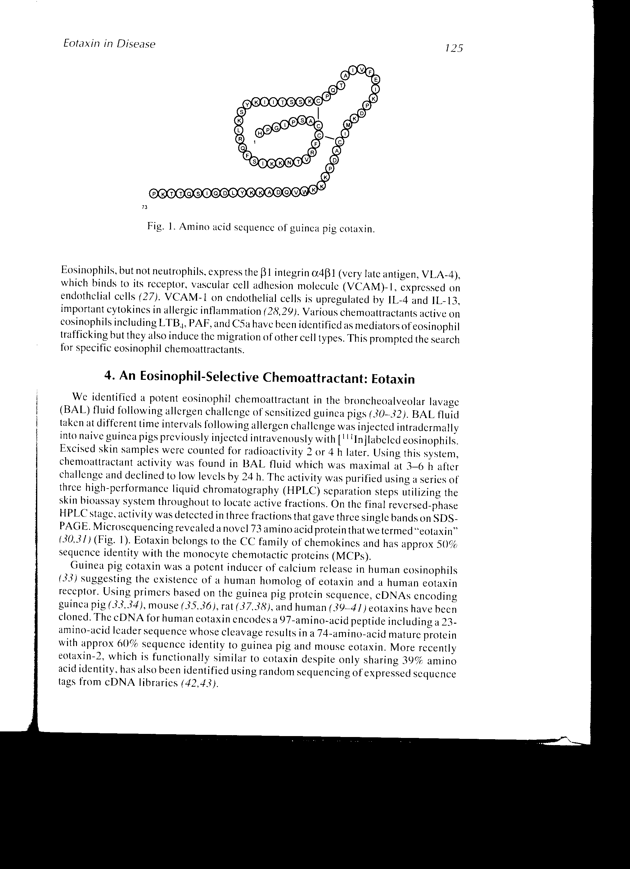

***Secondary structure*** is defined as local structural motifs within a protein, e.g. α-helices and β-pleated sheets.



***Tertiary structure*** is the arrangement of the secondary structure motifs into compact domains.

***Quaternary structure*** is the three dimensional structure of a multimeric protein composed of several subunits

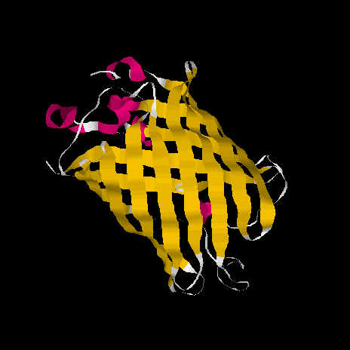 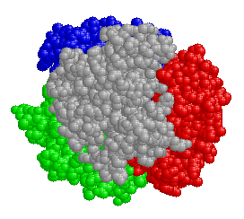

Tertiary structure Quaternary structure

Even after synthesis, **(post translation)** the starting set of 20 amino acids can be modified to create novel amino acids, enhancing the capabilities of the protein e.g. hydroxylation, glycosylation, carboxylation.

Nucleic Acids and Chromosomes

*Learning Objectives:*

* Draw the structure of a nucleotide labelling the sugar, base and phosphates and explain the difference between a nucleotide and a nucleoside.
* List the bases found in DNA and RNA and indicate which ones are purines and which ones are pyrimidines.
* Describe a single DNA chain and explain the difference between the 5’ and 3’ ends.
* Draw the structure of the double-stranded helix of DNA (not atomic structure) showing base-pairing, the major and minor grooves, and the directionality of the chains.
* Describe melting and re-annealing of complementary strands and what is meant by Watson-Crick base-pairing.
* Compare the genomes of *E.coli* and *Homo Sapiens.*
* Draw a diagram illustrating the packaging of DNA into nucleosomes and relate this to chromosome structure.
* Describe the human karyotype.

**Nucleic Acids**

* DNA and RNA are nucleic acids.
* They are macromolecules made up of a large number of nucleotides.
* A nucleotide is composed of a base, a sugar, and a phosphate group.
* A nucleoside is composed of a base and a sugar (no phosphate).
* The sugar in DNA is deoxyribose, the sugar in RNA is ribose.

**Nucleotide:** deoxyadenosine 5’-triphosphate (dATP)

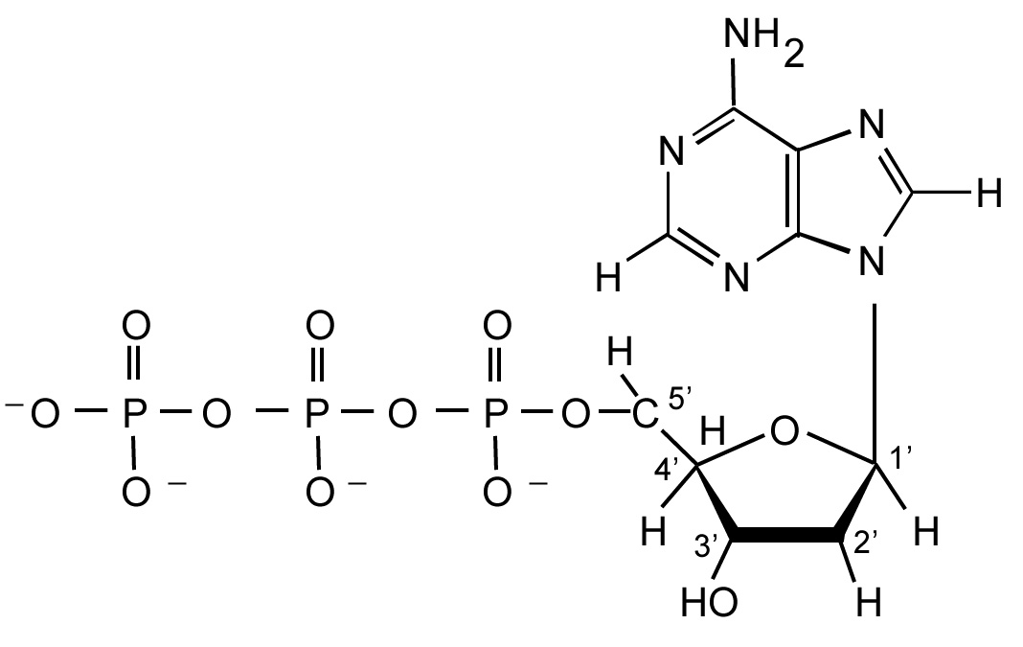

**DNA and RNA bases:**

Pyrimidines:

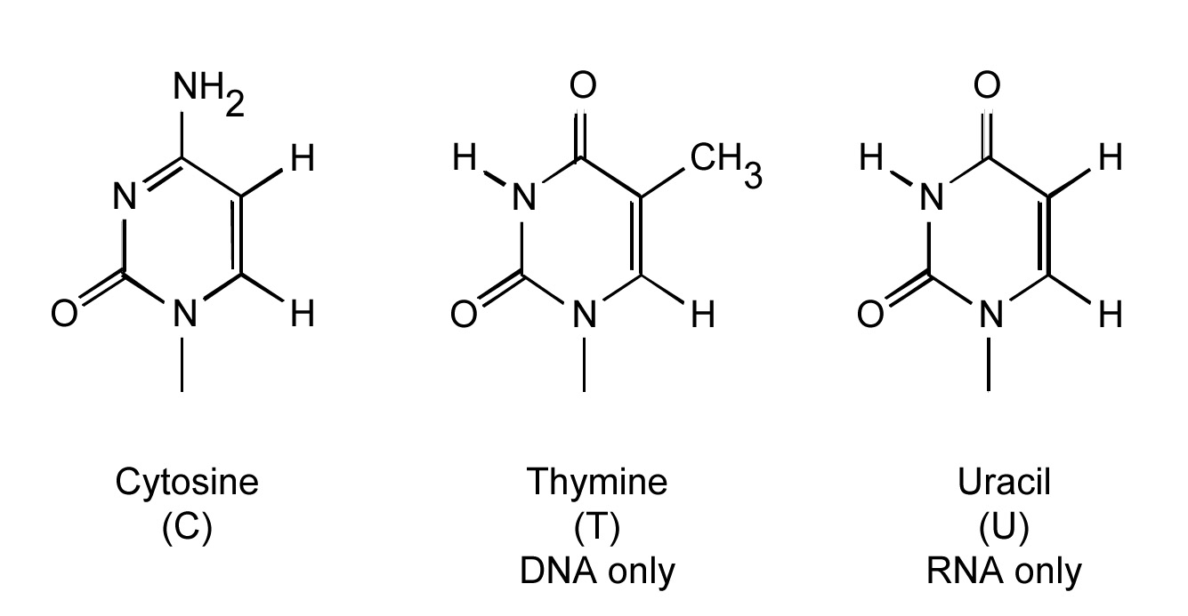

Purines:

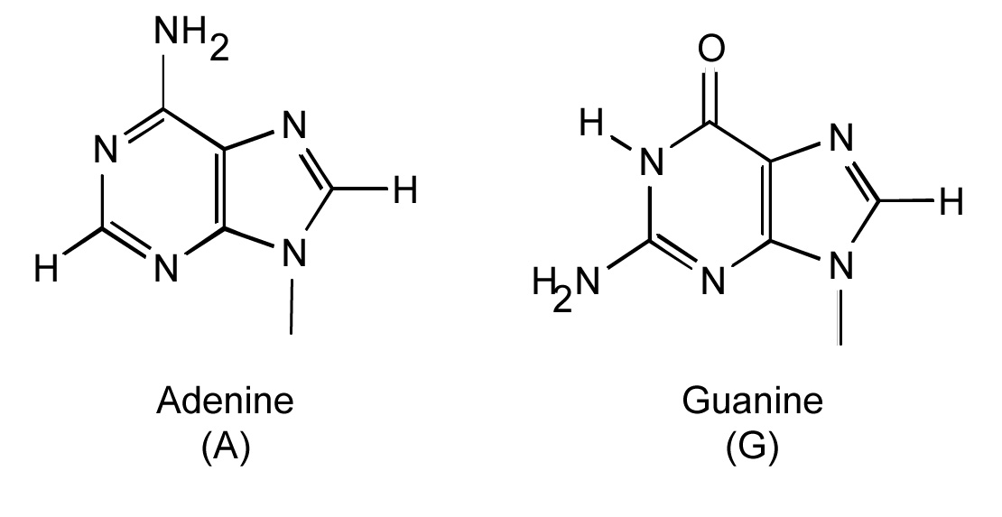

**The nucleosides:** (deoxy)cytidine, (deoxy)thymidine, (deoxy)uridine, (deoxy)adenosine, (deoxy)guanosine

**The nucleotides:** deoxyadenosine 5’-triphosphate (dATP); adenosine monophosphate (AMP) etc.

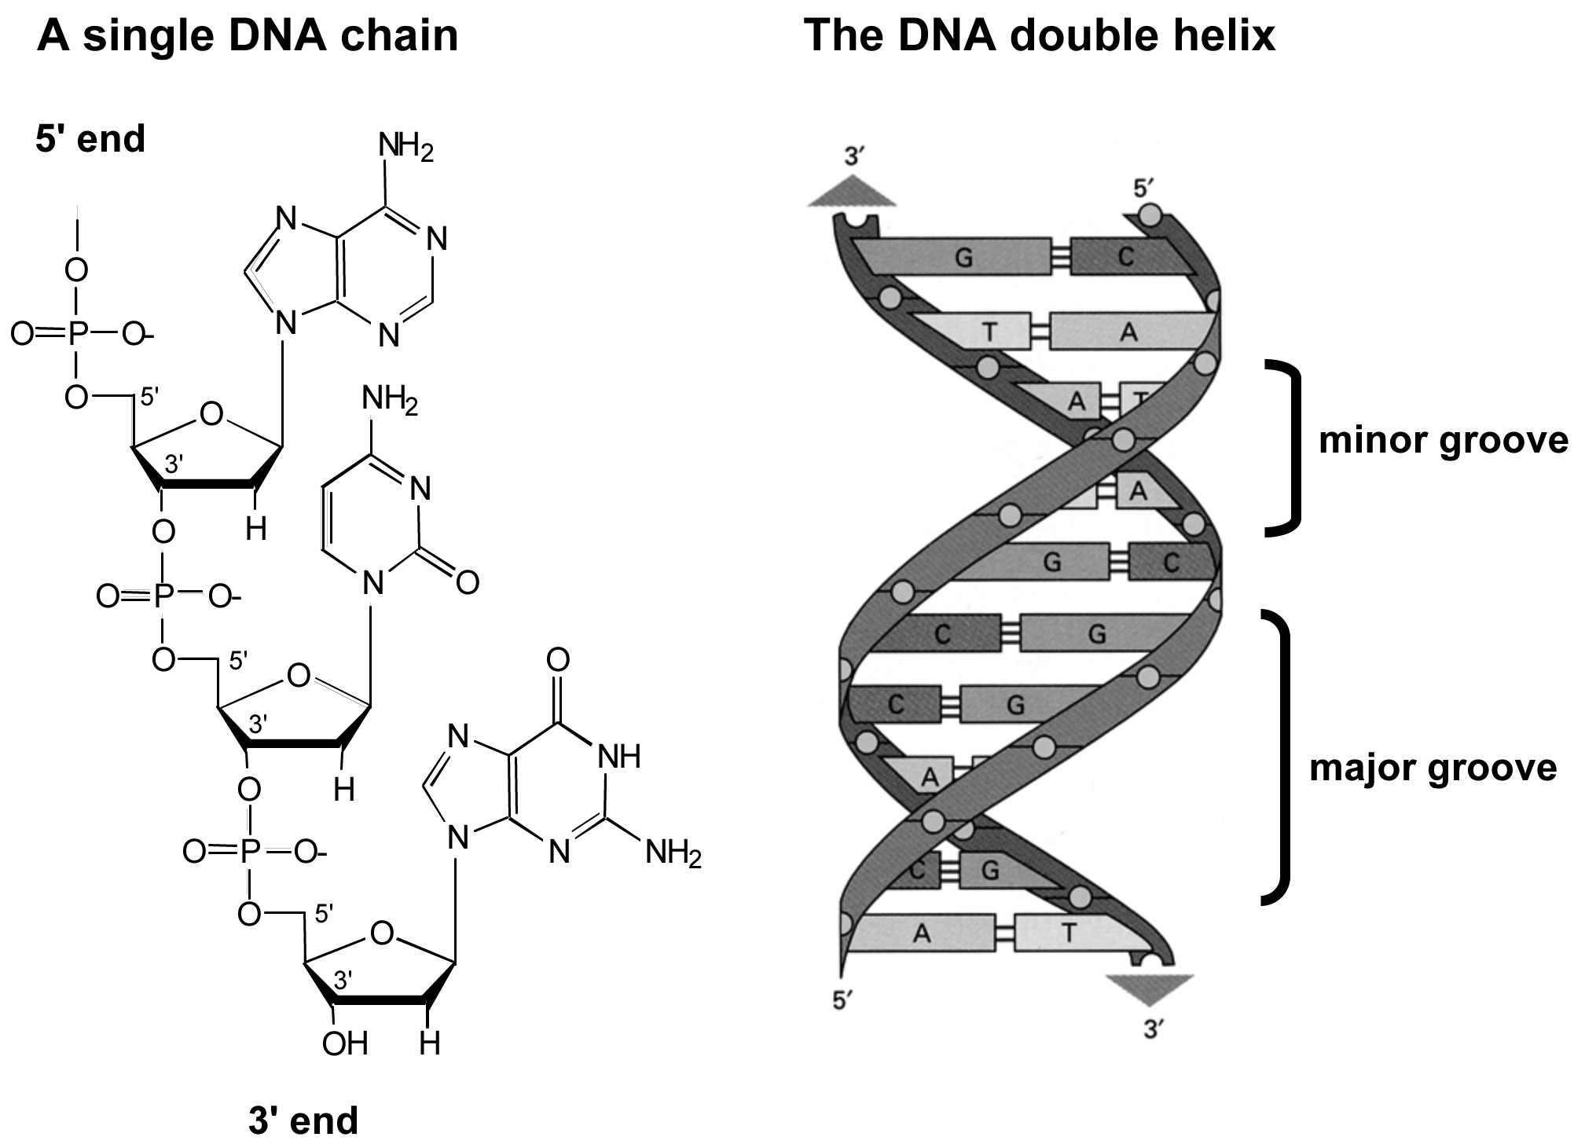

* **DNA** is a long chain of deoxyribose units linked by phosphodiester links.
* The phosphate on the 5’ carbon is linked to the –OH on the 3’ carbon along the chain.
* On each deoxyribose there is a base.
* The chain has two ends. The 5’ end and the 3’ end. It is not symmetrical.
* The primary sequence is the linear sequence of the bases. By convention, the nucleotide sequence is specified in the 5’ to 3’ direction.
* **The secondary structure** of DNA is a right-handed double helix. The two chains in the helix run in opposite directions.
* The deoxyribose and phosphate groups run along the outside of the helix, with the negative charges outside.
* The bases point inwards and the flat planes are perpendicular to the helix.
* The two chains are held together by hydrogen bonds between the bases.
* The two strands are complementary in their sequence due to the specificity of base-pairing. Adenine always pairs with Thymine; Guanine always pairs with Cytosine.

# handout5

# Melting and re-annealing

* + High temperature and/or low salt concentration causes the two strands to melt or disassociate.
  + If you then lower the temperature or increase the salt concentration, the two melted strands will re-anneal into a double helix.
  + Hybridisation: in a mixture of DNA with different sequences, the complementary strands will find each other in the mixture.

**The *E.coli* genome:**

* + *E.coli* has 4.7 x 106 base pairs in a single circular double-stranded molecule.
  + The length of the *E.coli* DNA is 1.4 mm.
  + The DNA in *E.coli* is tightly packaged – the bacterium is only 3 μm long.

**The human genome**:

* + The human genome (haploid) consists of about 3 x 109 base pairs of DNA.
  + The DNA is divided into chromosomes that each contain a linear double-helical DNA molecule of about 200 x 106 base pairs.
  + Prior to cell division, the DNA condenses into discrete chromosomes, visible by microscopy.
  + A diploid cell has 46 chromosomes; 22 pairs of ‘normal’ chromosomes and 2 sex chromosomes.

**Packaging of eukaryotic DNA:**

* + The DNA in a diploid human cell is nearly 2 m long. To fit into cells, the DNA is tightly packaged into chromatin.
  + Chromatin consists of DNA and proteins.
  + The lowest level of packaging is the nucleosome, which consists of DNA wrapped around histone proteins.
  + The nucleosomes form a chain, which pack into a helical array.

# handout6

# Packaging of DNA into a chromosome

As the DNA has already replicated, there are two identical copies and two identical chromatids (sister chromatids) for each chromosome at metaphase.

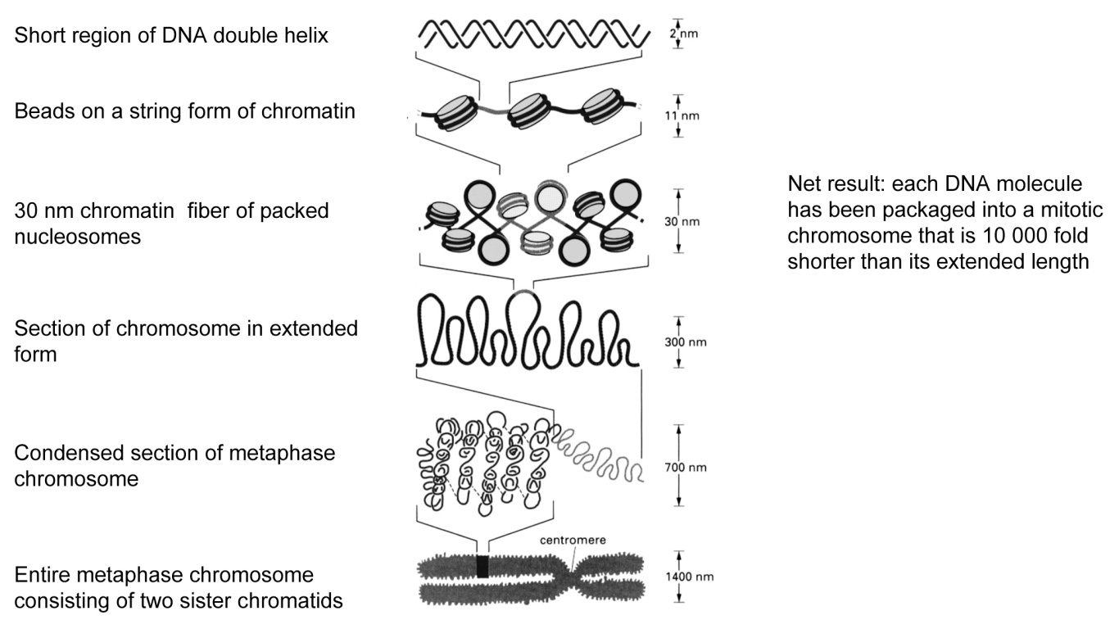

Nucleic Acids and Gene Expression

# DNA replication, the cell cycle and mitosis

*Learning Objectives:*

* Explain semi-conservative replication.
* Describe the reaction catalysed by DNA polymerases.
* Describe how nucleoside analogs can be used as drugs.
* Describe the functions of the components of the replication complex including the terms template, primer, leading strand, lagging strand, Okasaki fragment and replication fork.
* Describe how accuracy is maintained by proof-reading and the use of RNA primers.
* Draw a diagram showing replication of the *E.coli* chromosome.
* Describe the replication of mammalian chromosomes.
* Describe the different phases of the cell cycle.
* Draw a diagram showing how the chromosomes segregate at metaphase.

# DNA replication

* DNA replication is semi-conservative. Each strand forms the template for a new strand of DNA.
* DNA polymerases add deoxynucleotide tri-phosphates to the 3’ end of a DNA molecule.
* Synthesis is driven by the release of energy from the hydrolysis of the tri-phosphate.
* DNA polymerases need a template and a primer. They cannot start a new chain from scratch.

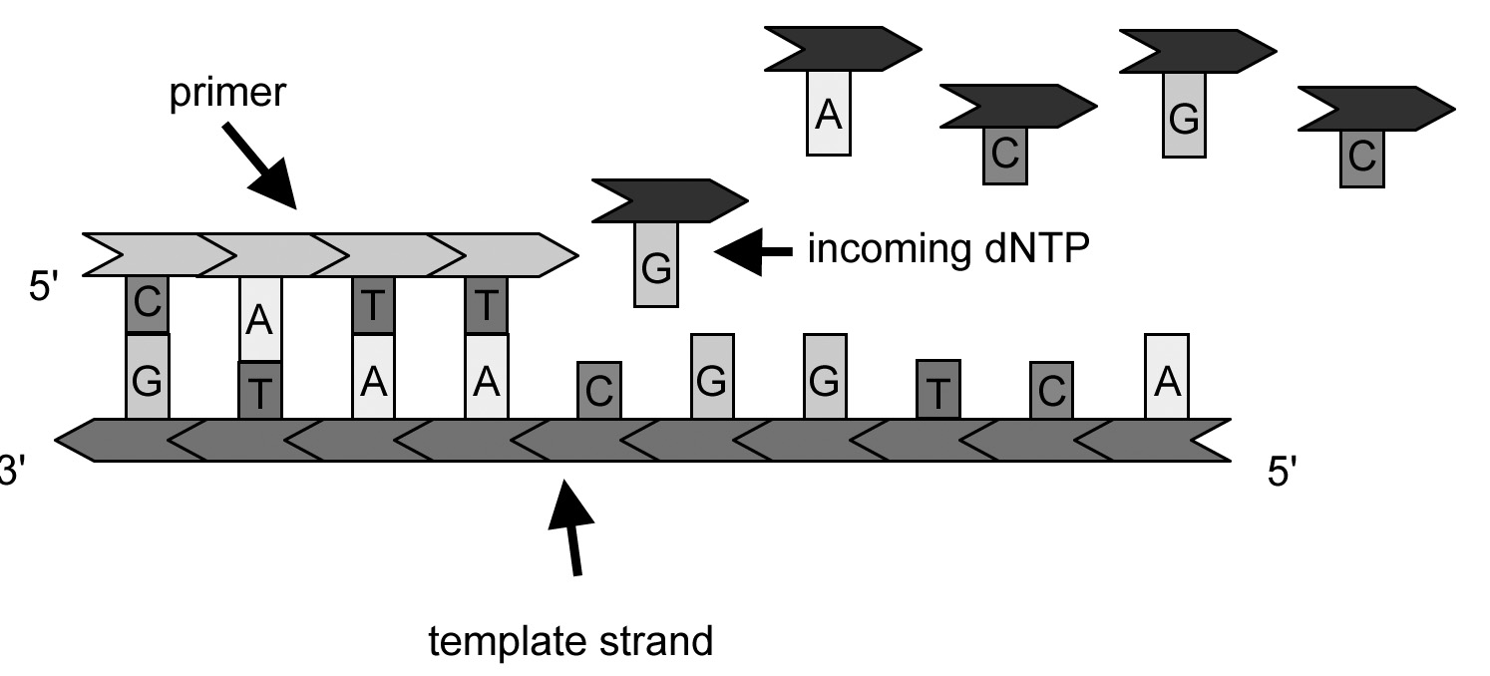

Enzyme reaction

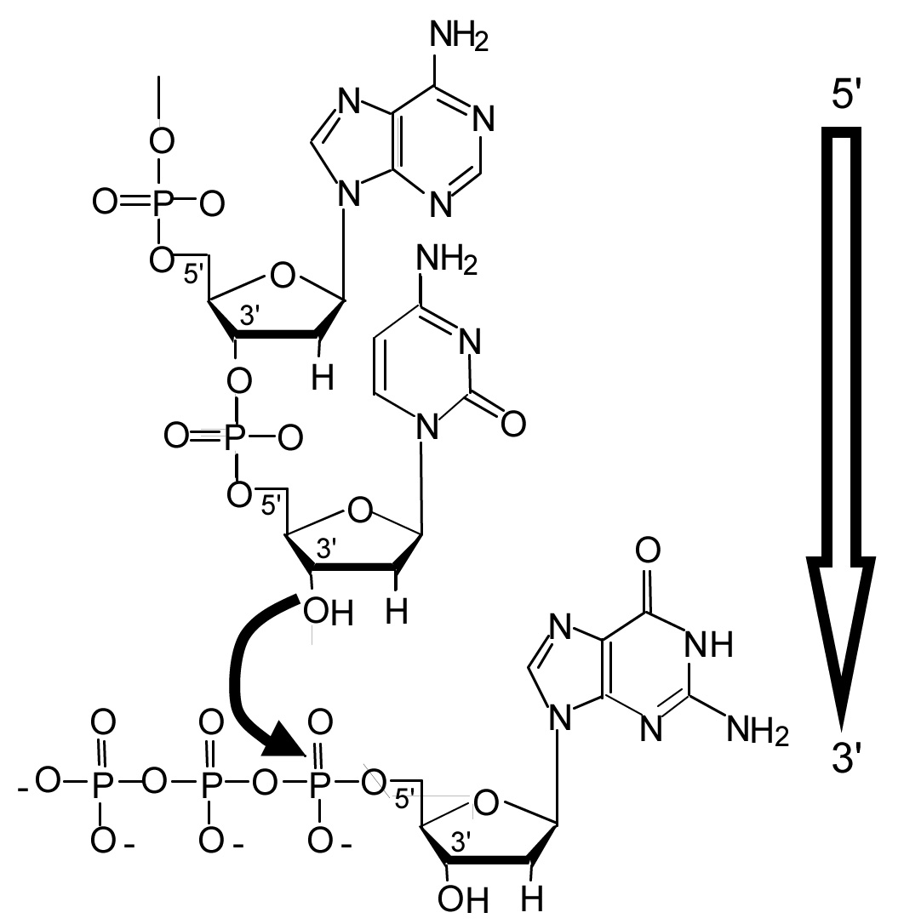

**Some nucleoside analogs used as drugs**

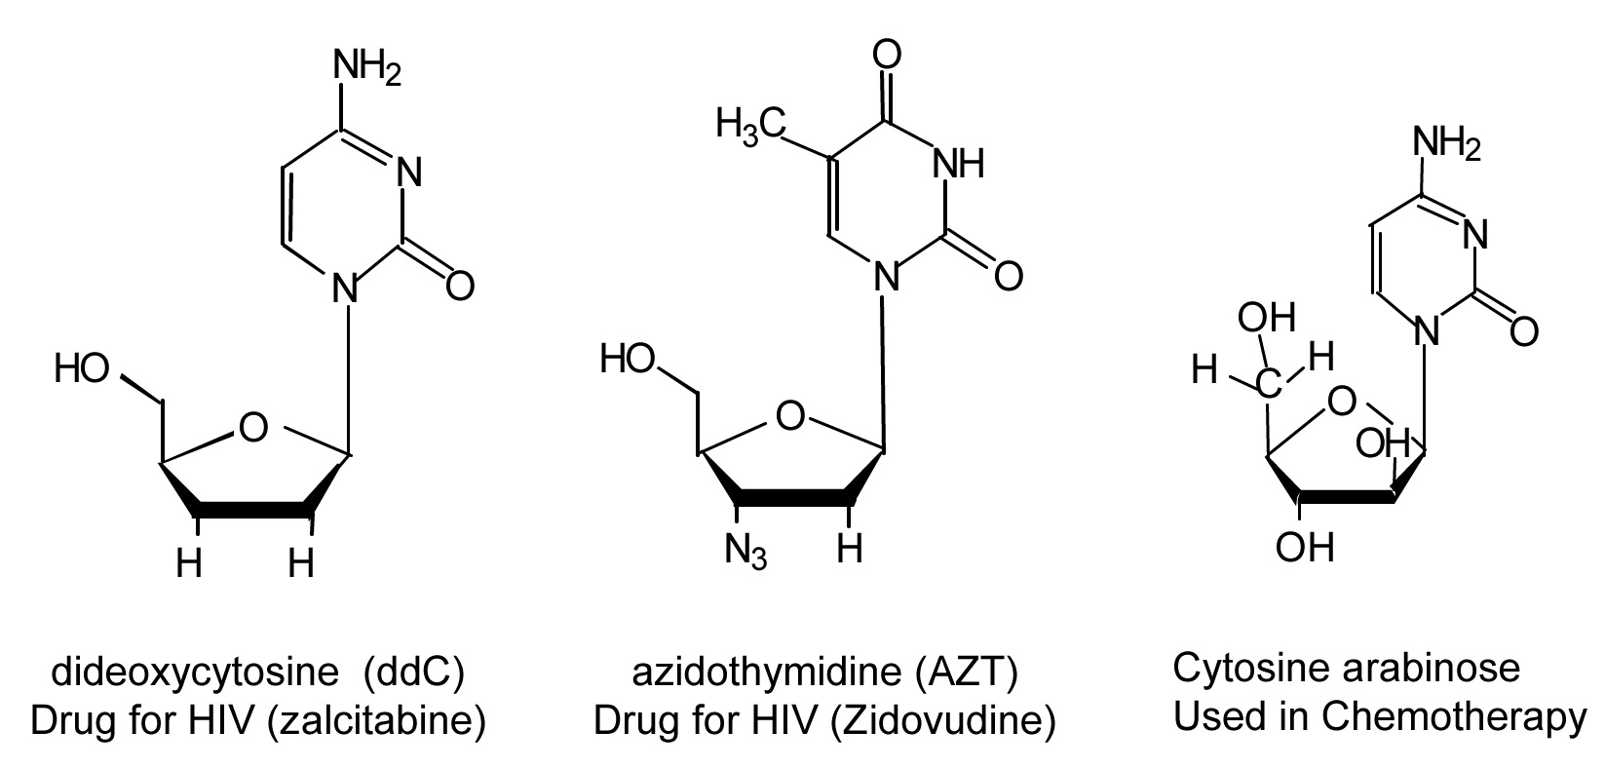

**DNA Replication**

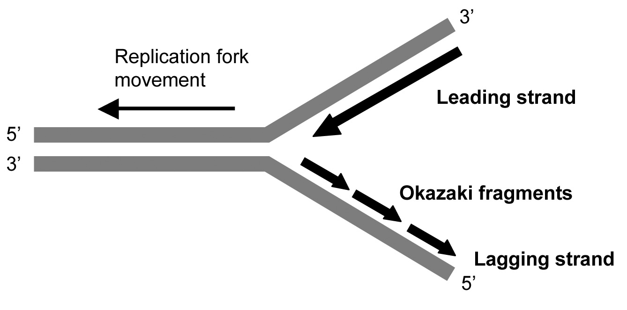

* Replication begins at discrete points on the DNA molecule and proceeds bi-directionally. The structure formed is called a replication fork.
* The replication fork is asymmetric. Both strands are synthesised in 5’ to 3’ direction.
* DNA synthesis is continuous on the leading strand
* On the lagging strand, synthesis is discontinuous.
* As the replication fork moves forward, single-stranded DNA is exposed on the lagging strand.
* When about 100-200 bases are exposed, a short RNA primer of about 5-10 bases is synthesised.
* The primer is synthesised by an RNA polymerase called primase.
* The primer is extended by a DNA Polymerase until the last RNA primer is reached.
* The stretches of DNA synthesised on the lagging strand are called Okazaki fragments.

**Joining the Okazaki fragments**

A special ribonuclease removes the RNA primer using a 5' to 3' exonuclease activity.



DNA polymerase then synthesises DNA through the RNA primer region.



DNA ligase joins the two adjacent strands of DNA together using ATP.



**Accuracy of DNA replication**

* DNA replication has an error frequency of about 1 change per 109 base pairs.
* Proof reading: DNA Polymerase has 3’ to 5’ exonuclease activities for proof reading.
* RNA Primers: Inaccurate RNA primers are replaced by accurate DNA.

**Replication of the *E. coli* chromosome**

In *E. coli* there is a single replication origin and the two forks meet on the other side of the circular chromosome.

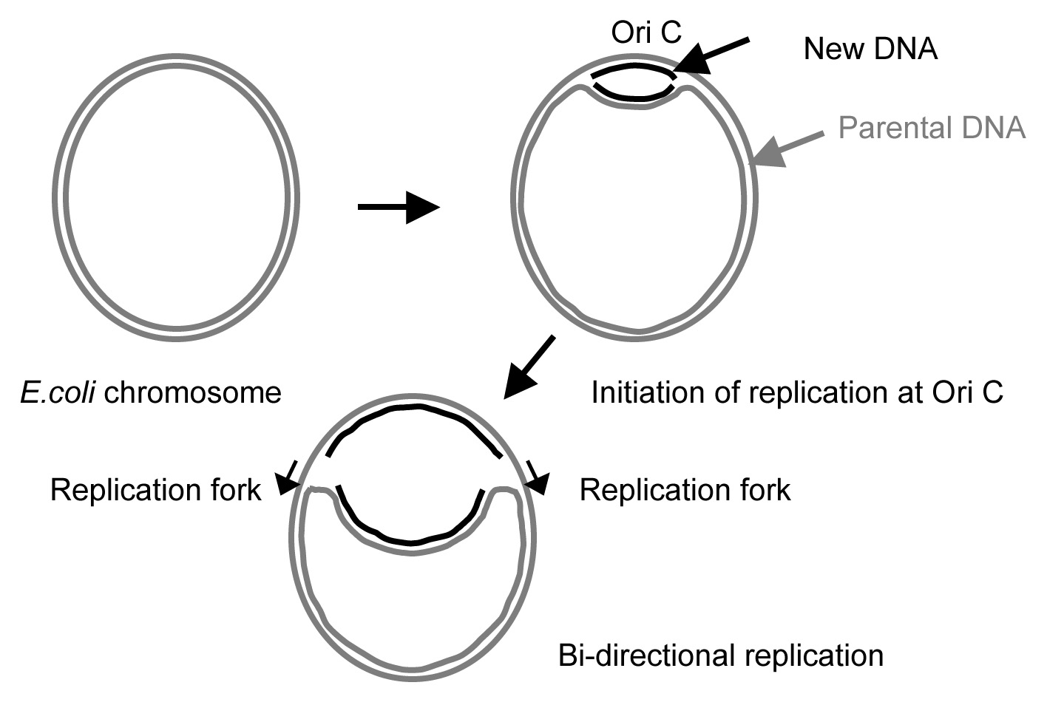

**Replication of the eukaryotic genome**

The enzymatic mechanism of replication in eukaryotes is very similar to that in *E. coli*.

There are replication forks, leading and lagging strands and enzymes which carry out all the same functions as in *E. coli*, but the actual proteins used are different.



**Multiple replication origins in eukaryotes**

* Eukaryotic chromosomes are linear and very long.
* Multiple replication origins are distributed at intervals of about 100 kb.
* Each replication origin gives bidirectional replication forks.
* Replication is finished when all the forks have met.

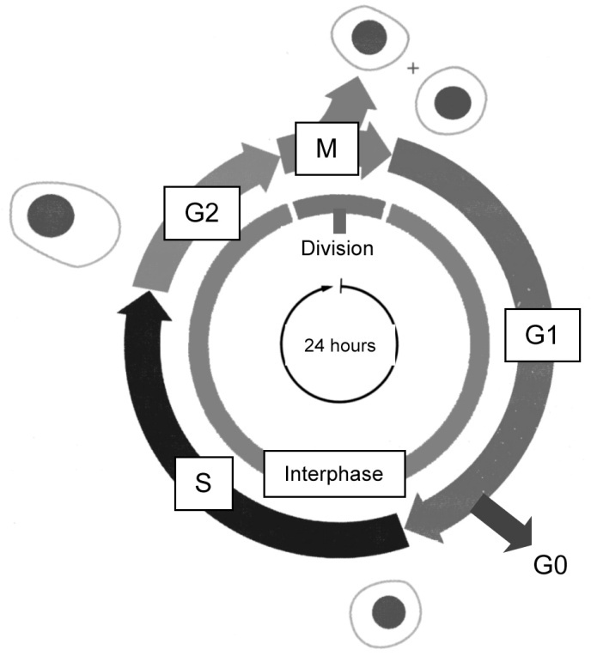

**The mammalian cell cycle**

A mammalian cell cycle takes about 24 hours in tissue culture.

M phase: Mitosis 1 hr; cell division, metaphase.

G1; gap phase 1; 10 hrs

S phase; DNA replication, 9 hrs

G2; gap phase 2; 4 hrs

G0; cells which have stopped dividing.

G1, G0, S and G2 are interphase.

**Metaphase and Anaphase of Mitosis**

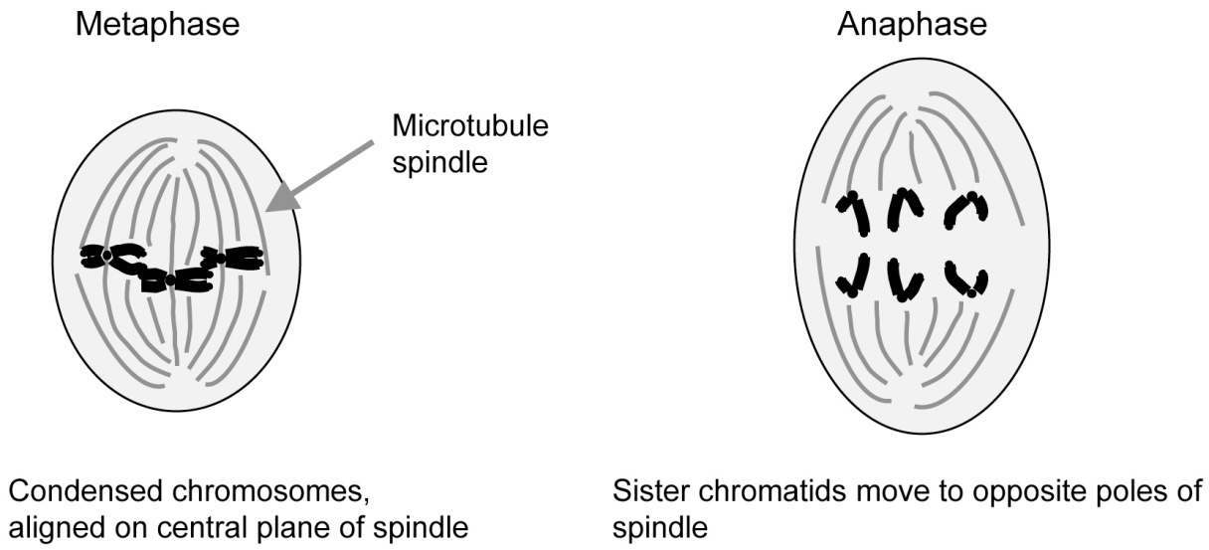

Lecture 2: Dr Mick Jones

Nucleic Acids and Gene Expression

Gene Organisation & Transcription Part 1 - Gene Transcription

*Learning Objectives:*

* Describe the basic differences between DNA and RNA
* Describe what is meant by “transcription”
* List the major functional classes of RNA and the classes of RNA polymerases involved in synthesising each of these.
* Describe what is meant by a “gene promoter”
* Describe what is meant by a “transcription factor”
* Describe, with the aid of diagrams, the processes involved in transcribing a eukaryotic gene.

**What Do We Mean By “Gene Expression”?**

DNA 🠚 RNA 🠚 (Protein)

* The initial product of gene expression is always RNA
* In some cases this RNA is functional (e.g. tRNA, rRNA, snRNA)
* In many cases this RNA is the template for protein translation (eg mRNA)
* Gene expression occurs in the cell nucleus. RNA is exported to the cell cytoplasm, to be used in “Protein Translation”

**Eukaryotic RNA Polymerases**

**Eukaryotic cells contain three types of RNA polymerases:**

* RNA Polymerase I -Transcribes rRNA genes
* RNA Polymerase III- Transcribes tRNA and 5S RNA genes
* RNA Polymerase II - Transcribes genes encoding proteins into mRNA

**Transcription: Making an RNA copy of a DNA strand**

C

T

A

T

G

T

A

C

T

T

G

A

T

A

C

T

A

G

A

A

5’

3’

3’

5’

***P G***

***A***

***U***

***A***

***C***

***U***

***A***

***G***

***A***

***AOH***

**RNA**

**Antisense DNA Strand**

**Sense DNA Strand**

3. Ribonucleotide bases are joined by phosphodiester bonds.

The RNA chain grows one base at a time in a 5’ ->3’ direction

**Components of the Basal Transcription Complex**

**RNA Pol II**

**TF IIA**

**TF IIB**

**TF IIE**

**TF II H**

**TF IID**

**TATA**

**Transcription Factor Binding Site(s)**

* The **Basal Transcription Complex** allows **RNA polymerase II** to be phosphorylated and then engage in transcription.
* In the absence of binding of other **Transcription Factors** this produces a **Basal** (low) level of transcription.
* Transcription factors “bend DNA” on binding. They can interact with each other and the Basal Transcription Complex to modulate transcription.

Nucleic Acids and Gene Expression

Gene Organisation & Transcription Part 2 - mRNA Processing

*Learning Objectives*

* Describe, with the aid of diagrams, the events that take place in pre- mRNA processing
* Define what is meant by a “splice donor site”
* Define what is meant by a “splice acceptor site”
* Describe the “lariat” intermediate in mRNA splicing
* Define the function of the “Spliceosome”
* Describe the addition of a “cap” and “poly A tail” to pre-messenger (hn-) RNA.
* With examples, describe how mutations in splice sites feature in human disease.

**The Anatomy of a Gene**



* The promoter lies at the start (5’ end) of the gene
* The sequence information contained in the final mRNA is encoded “discontinuously” in the DNA of the gene
* Segments of the gene which contain sequences that form part of the final RNA are called “**exons**”
* “**Introns**” are sequences in the gene which are transcribed but are edited out of the final mRNA

**The sequence of events in mRNA splicing**



Introns start with the sequence “GU” and end with the sequence “AG”

**The sequence of events in mRNA splicing**



Lecture 3: Dr Mick Jones

Nucleic Acids and Gene Expression:

**Protein translation & post-translational modification**

*Learning Objectives*

* Outline the mechanisms by which ribosomes can translate a mRNA sequence into a protein sequence.
* Describe the role of aminoacyl tRNAs in ensuring the fidelity of the genetic code.
* State how a ribosome recognises the start and end of a sequence to be translated.
* Explain why some antibiotics inhibit protein synthesis in prokaryotes but not eukaryotes.
* Identify the features of a newly-synthesised protein that are required for it to enter the secretory pathway.
* Give examples of the ways in which newly-synthesised proteins can be post-translationally modified.
* There is a linear relationship between the information encoded within DNA (the genetic code) and the proteins that are synthesised using that information
* Three nucleotides encode one amino acid, hence the name “triplet code”; a group of three nucleotides is called a codon
* Protein synthesis always starts with Met =AUG and finishes with a stop codon =UAA, UAG or UGA
* transfer RNAs are the transporters of amino acids (bound to the 3’ terminus) to the ribosome; they contain an anticodon loop that binds to the corresponding codon on the mRNA
* Translation initiates with:

Step 1: dissociation of ribosome subunits (40S + 60S)

Step 2: assembly of preinitiation complex containing Met-tRNA + Initiation Factors + 40S subunit

Step 3: binding of mRNA to preinitiation complex

Step 4: binding of 60S subunit

* Translation elongation proceeds with:

Step 1: binding of new tRNA to A site

Step 2: catalysis of peptide bond between two amino acids by peptidyl transferase

Step 3: translocation of tRNA to P site and dissociation of first tRNA

* Translation termination occurs by:

Step 1: recognition of stop codon

Step 2: release of peptide chain

Step 3: dissociation of release factors and ribosomes

* Antibiotics are natural products of bacteria or fungi that can selectively inhibit prokaryotic protein synthesis because the translational machinery is complex and easily disrupted
* Synthesis of proteins destined for the secretory pathway to the cell surface occurs on Rough Endoplasmic Reticulum (RER) in the following stages:

Step 1: recognition of hydrophobic N-terminal signal sequence by signal recognition particle (SRP)

Step 2: binding of SRP to a receptor at the RER surface

Step 3: translocation of the growing protein into the lumen of RER

Step 4: cleavage of signal sequence and protein folding

Transmembrane proteins have additional hydrophobic sequences that stick in the membrane of the RER

* Post-translational modification - after synthesis many proteins, e.g. insulin, are modified further before they are fully functional. Modifications include:
* Proteolytic cleavage
* Disulphide bond formation
* Addition of carbohydrate (Glycosylation)
* Addition of phosphate (Phosphorylation)
* Addition of lipid groups (Acylation, Prenylation)

Nucleic Acids and Gene Expression

Analysis of Nucleic acids

*Learning Objectives:*

* Explain the term hybridisation, used for binding of a probe to a nucleic acid.
* Explain the concept of stringency of hybridisation, and the factors that contribute to stringency.
* Explain how the polymerase chain reaction (PCR) is used to amplify small amounts of DNA for subsequent analysis.
* Describe in general terms the way in which PCR primers would be selected to amplify a given DNA sequence.
* Describe the reactions carried out by restriction enzymes (restriction endonucleases) and explain their usefulness in analysis of DNA.

**Cell-based DNA cloning**

* Construction of recombinant DNA molecules *in vitro:* cutting a target DNA and a replicon with restriction endonucleases, so that the ends of the two DNA sequences are compatible. Joining the DNA fragments by using the enzyme DNA ligase.
* Transformation of the recombinant DNA molecules into host cells (bacteria, yeast)
* Selective propagation of individual cell colonies (selectable antibiotic resistance markers).
* Expansion of the cell culture and isolation of recombinant DNA

**Restriction Endonucleases**

* Enzymes that cleave DNA at specific recognition sites, usually 4-8bp palindromic sequences - produce “blunt” or “sticky” DNA ends.
* The longer the recognition site, the less frequently it occurs in DNA.

**Separation of DNA fragments**

* Electrophoresis - DNA is negatively charged due to its phosphate backbone and moves towards the anode (+ve electrode) when an electrical force is applied to it.
* When DNA is forced to travel through a porous gel matrix (agarose / polyacrylamide gel) small fragments are retarded less than large fragments and hence travel faster.
* After resolution, DNA can be isolated from the gel or transferred to a membrane to form a replica for hybridisation.

**Nucleic Acid Hybridisation**

* A *key method* for detecting specific nucleic acid sequences in which homologous single-stranded DNA or RNA molecules combine via homologous base-pairing to form double-stranded molecules.
* Standard assay involves a labeled nucleic acid probe (DNA, RNA or oligonucleotide) to identify homologous related molecules in a mixture of target unlabeled nucleic acids.

**Hybridisation assays**

* Target DNA is immobilised on a solid support - nylon or nitrocellulose membrane - which readily binds single-stranded nucleic acid (e.g. DNA) and then hybridised with a solution of labeled probe (radioactive or fluorescent).
* Examples:

- Southern blot hybridisation (DNA target and DNA probe)

- Northern blot hybridisation (RNA target and DNA probe)

- Colony blot hybridisation (bacterial DNA target, DNA probe)

- Chromosome *in situ* hybridisation (Chromosome target and DNA probe)

- Tissue *in situ* hybridisation (RNA target and RNA probe)

- Reverse hybridisation – Microarrays (immobilised DNA or oligonucleotide probe, target DNA solution)

**Melting temperature and hybridisation stringency**

* Denaturation of a probe DNA is achieved by heating until the hydrogen bonds between the bases holding the two strands together are disrupted.
* The energy needed to do this depends on strand length (longer strand = more hydrogen bonds to break), base composition (G-C pair has one more hydrogen bond than A-T) and chemical environment (monovalent cations stabilise the DNA duplex by neutralising charge on phosphate backbone; denaturants (formamide/urea) destabilise the DNA duplex).
* Melting temperature (Tm) - measure of nucleic acid duplex stability (Hybridisation is carried out at temperatures < 25˚C below Tm).
* Hybridisation stringency (i.e. the power to distinguish between related sequences) increases with increase in temperature and decrease in salt concentration.

**Cell-free DNA cloning - Polymerase Chain Reaction (PCR)**

* *In vitro* method to allow selective amplification of a specific target DNA within a heterogeneous collection of DNA sequences (e.g. total genomic DNA or complex cDNA population).
* Some sequence information is needed to design 2 primers (15 - 25 nucleotides in length), one complimentary to each strand of the DNA to be copied.
* Primers are specifically annealed to heat-denatured DNA.
* Thermostable DNA polymerase + dNTPs extend from the primers and generate new strands.
* Denature the DNA and repeat the cycle many times -> geometric increase**.**
* Applications: typing genetic markers; Detecting or introducing point mutations; cDNA cloning; genome walking; detecting gene expression; DNA sequencing.

**DNA Sequence Analysis**

* Understand the principle of Sanger ‘dideoxy’ chain termination DNA sequencing
* Resolution of DNA fragments

**References**

* “Human Molecular Genetics” - Strachan and Read
* “Genes” - Lewin
* “Molecular Biology of the Cell” - Alberts *et al*.

**Cellular Organization of Tissues**

***Learning Objectives***

These learning objectives relate to the lectures given by Dr Sohag Saleh and Dr Jasmina Saric, and covered in the revision session given by Dr Anabel Varela-Carver. Queries should be directed to Dr Varela-Carver.

***Introduction to Cells and the Cell Membrane –Self-directed learning***

* Outline the main components of prokaryotic and eukaryotic cells.
* Understand what constitutes a cell, and the scale of cells and molecules
* Demonstrate the following on a suitable transmission electron micrograph: nucleus, nucleolus, nuclear envelope, mitochondrion, rough/smooth endoplasmatic reticulum, ribosomes, Golgi apparatus, secretory granule, plasma membrane, cytoskeletal components
* Identify the essential characteristics of prokaryotic and eukaryotic cells
* Explain the relationship of individual cells to the organization of the whole body
* Explain the formation of phospholipid bilayers in an aqueous environment

• Draw the structure of phosphatidylcholine and identify the component parts

* Describe the permeability properties of a phospholipid bilayer with respect to macromolecules, ions, water, and organic compounds (including drugs)
* distinguish simple diffusion, facilitated diffusion and active transport of ions and molecules across cell membranes
* Categorise the functions of membrane proteins
* Explain the movement of Na+ and K+ ions across the cell membrane against a concentration gradient and the consequences of failure of such a movement
* Explain how the entry of glucose and amino acids into the cell against a concentration gradient is coupled to ATP dependent Na+ transport
* Explain how external chemical signals can be sensed at the interior of a cell

***Introduction to Blood and infectious agents –Jasmina Saric***

* List the main functions and components of the blood
* Outline the differences in blood composition between male and female
* Describe the essential features of the erythrocyte and list its major functions
* Define anemia and list the major causes
* Describe the major requirements, nutritional and otherwise, of normal erythropoiesis
* List the major differences between the main hematopoietic cell populations of normal blood
* Explain simply the major functions of leukocytes and platelets
* Describe the features of the main types of infectious agents.
* Describe the constituents, properties and functions of cell membranes.
* Describe the constituents of blood and their function.
* Classify the main types of diseases and their effect on cells and tissues.

***Cellular Organisation of Tissues- self-directed learning***

* Describe the features of epithelial cells and of the extracellular matrix.
* Illustrate how epithelial cells have specialised functions, and describe their different patterns of cell division.
* Describe the structure and role of the extracellular matrix, and the structure and role of collagen in intracellular and extracellular structures.
* Describe the molecules of the extracellular matrix and the regulation of collagen assembly.
* Describe the composition of the main body fluids and the mechanisms which control their volume.
* Describe the mechanisms of signalling along, and in between, excitable cells as well as the factors which control the amount of force exerted by a muscle.
* Explain how signals are transmitted between cells, and between the cell periphery and the nucleus.

***Cell behaviour***

**Cell behaviour I**

* Describe the roles of growth factors, cell contacts and tissue boundaries in the control of division of normal and transformed cells.
* Describe the mechanisms of cell locomotion, with reference to the three filament systems that define the cytoskeleton.
* Understand the role of metastasis in the development of cancer.
* Describe the various types of molecular motors and polymerisation engines that are responsible for biological movement at the cellular level.
* Understand the molecular basis of muscle contraction.
* Describe the mechanisms that control cell locomotion.
* Describe the mechanisms that control cytoskeletal processes occurring during cell locomotion, with reference to phosphorylation, secondary messengers and G-proteins.

**Cell behaviour II**

* Highlight the major differences between the three main cytoskeletal proteins
* Understand the functional roles of microtubules and describe the drugs that target these structures
* Understand how intermediate filaments are assembled and describe their classification system
* Describe the functional roles of intermediate filaments with relation to their involvement in disease
* Describe the structure and function of actin and associated proteins

**Cell behaviour II**

* Be able to name all the major structural features of a sarcomere
* Understand the process of excitation-contraction coupling in muscle
* Understand the ‘sliding filament’ theory of muscle contraction

**Metabolism**

***Learning Objectives***

These learning objectives relate to the lectures given by Dr James Pease and Dr Hector Keun. Further lectures will be given by Prof Karim Meeran, Dr Nick Oliver and Dr Radha Ramachandran, and learning objectives for these will be given via the Intranet. All lectures will be covered in the revision session given by Drs Pease and Keun, to whom any queries should be directed in the first instance.

*METABOLISM 1:  ATP Production I - Glycolysis and the TCA Cycle*

• Sketch a cartoon of the three stages of cellular metabolism that convert food to waste products in higher organisms, illustrating the cellular location of each stage.

•Explain how ATP acts as a carrier of free energy and is used to couple energetically unfavourable reactions.

• Illustrate the role of the coenzyme NAD in the reaction catalysed by dehydrogenases.

• Outline the metabolism of glucose by the process of glycolysis, citing the key reactions that consume ATP and generate ATP and the possible fates of pyruvate.

• Describe the reactions catalysed by lactate dehydrogenase and creatine kinase.

• Outline the oxidative decarboxylation reaction catalysed by pyruvate dehydrogenase.

• Describe the Krebs or TCA (tricarboxylic acid cycle) with particular reference to the steps involved in the oxidation of acetyl Co-A and the formation of NADH and FADH2 and the cellular location of these reactions.

*METABOLISM 2: ATP production II - Oxidative phosphorylation*

• Describe the process of transamination and how it may generate glycolysis/TCA intermediates from amino acids.

• Outline the chemiosmotic theory.

• Describe the electron transport chain in mitochondria with reference to the functions of coenzyme Q (ubiquinone) and cytochrome c.

• Describe how ATP synthase is able to generate and utilise ATP respectively, with reference to its structure.

• Explain why carbon monoxide, cyanide, malonate and oligomycin are poisonous in terms of their effects on specific components of the electron transport chain.

• Outline the glycerol phosphate shuttle and the malate-aspartate shuttle, in particular stating why these mechanisms are required.

*METABOLISM 3: Lipid and Cholesterol Metabolism*

•Appreciate the chemical composition of unsaturated and saturated fatty acids.

•Describe the reactions by which the fatty acid palmitate is metabolised to give acetyl-CoA.

•Give an overview of the reactions by which fatty acids are synthesized from acetyl-CoA, contrast the pathways for synthesis with those of fatty acid metabolism.

•Outline the synthesis of cholesterol from acetyl CoA.

•Outline the synthesis of bile acids and steroid hormones from cholesterol.

•Suggest why NADPH and not NADH is used in reductive biosynthesis.

•Describe the mechanism of transport of cholesterol around the body and its uptake into cells.

•Draw a diagram of low density lipoprotein (LDL) particle and its receptor (LDLR).

•Explain how mutations of the LDLR give rise to familial hypercholesterolaemia.

• Give examples of pharmacological agents that may be used to control cholesterol metabolism.

**Cell cycle and cancer**

***Learning Objectives***

The following learning objectives relate to the lectures given by Dr Andy Porter, to whom any queries should be directed in the first instance.

*Lectures 1 & 2: The Cell Cycle and its Regulation*

* Describe the cell cycle in terms of the named phases (G0, G1, G2, S, M) and explain what these mean in terms of protein and DNA synthesis and chromosome dynamics.
* Identify (or sketch or describe) the named stages of mitosis.
* Describe how the cell cycle is regulated by interactions between cyclins, cyclin- dependent kinases, inhibitor proteins, proteosomes, other kinases and phosphatases.
* Introduce the principle of the molecular timing process which regulates the cell cycle through oscillating amounts or activities of cyclins and their kinases
* Explain the importance of checkpoints in controlling progression through the cell cycle, and give examples of external factors, which provide signals allowing cells to pass these checkpoints and enter cell division.
* Describe the way the cell cycle allows decision making about whether a cell divides, differentiates or undergoes programmed cell death (apoptosis).
* Explain in molecular terms the mechanism of action of the retinoblastoma (Rb) susceptibility tumour suppressor gene product.
* Describe the concept of a signaling pathway with examples of the kind of molecules involved, especially kinase cascades.
* Describe how signaling pathways respond to physiological signals and control cell proliferation though interactions with the cell cycle machinery
* Identify key proteins involved in each of the above processes and give examples of diagnostic/therapeutic benefits resulting form such knowledge

*Lecture 3: DNA Damage and Repair*

* Describe the ways in which DNA can be damaged by endogenous and environmental factors.
* Summarise the main natural DNA repair mechanisms: BER, NER, MMR and DSB repair (NHEJ & HR)
* Describe the DNA damage response pathways and key proteins involved
* Outline some inherited disease that result from mutations in genes involved in DNA repair or the DDR
* Identify key proteins involved in each of the above processes and give examples of diagnostic/therapeutic benefits resulting form such knowledge

*Lecture 4: Oncogenes and Tumour Suppressors .*

* Define the terms protooncogene, oncogene and tumour suppressor gene.
* Explain how a protooncogene can be activated to an oncogene.
* Explain with an example how conversion of a protooncogene to an oncogene can lead to disruption of tightly controlled pathways in the cell.
* Describe with an example how rare heritable cancers have led to an understanding of the type of cancer-causing gene called a tumour suppressor.
* Summarise the role of the tumour suppressor gene p53 in cellular decision making.
* Using colon cancer as an example, describe the way in which successive gene mutations are thought to lead to clinical cancer.

The following learning objectives relate to the lectures given by Prof Gerry Thomas, to whom any queries should be directed in the first instance.

**Cellular Pathology**

* Understand the nomenclature that differentiates malignant and benign cancers and their differentiation and development stage.
* Describe the microscopical features of carcinomas.
* Describe the mechanisms of invasion and metastasis and the factors that affect sites of metastases.
* Explain the terms 'grading' and 'staging', and how this relates to clinical outcome
* Understand the role of molecular pathology in treatment tailoring

**Breast Cancer**

* Understand the types of breast cancer and how it is treated
* The differences between hormone and chemotherapy
* The mechanisms by which oestrogen receptor signalling can be disrupted
* How biology affects prognosis

**Colon cancer**

* Understand the types of colon cancer and how it is treated
* The relationship between diet and colon cancer
* Grading of colon cancer
* Clinical presentation and factors affecting prognosis
* Treatment of colon cancer (including effect of mutations in key oncogenes e.g. BRAF, KiRas)

**Skin Cancer**

* Understand the different types of skin cancer and their causes and prognosis
* Understand risk factors for melanoma
* Understand pathological grading and staging and how this affects treatment and outcome
* Understand how and why melanoma patients may be stratified for treatment in the future

**Leukaemia and Lymphoma**

* Understand the differences between lymphoma, myeloma and leukaemia
* Understand the diagnosis and treatment of the above
* Understand the difference between acute and chronic leukaemia
* Understand how targeted therapies have made a difference to treatment of leukemia

**Recommended reading for Cancer:**

Reference text for the course (in addition to Alberts as per pre-course list)

*The Molecular Biology of Cancer – Mechanisms, Targets and Therapeutics*

Lauren Pecorino

Publication Date: 26 April 2012 | ISBN-10: 019957717X | ISBN-13: 978-0199577170 | Edition: 3

Available from Amazon:  Price £28.15

Also, a fascinating book for general background is:

[**The Emperor of All Maladies**](http://www.amazon.co.uk/Emperor-All-Maladies-Siddhartha-Mukherjee/dp/0007250924/ref=sr_1_1?s=books&ie=UTF8&qid=1350566324&sr=1-1) by Siddhartha Mukherjee

**READING LIST (as given pre-course)**

***Molecular Biology of the Cell (5th Edition)***

*Alberts, Johnson, Lewis, Raff, Roberts, Walter*

*Amazon Price: £46.77*

*Paperback - 1392 pages (January 2008)*

*Garland Science; ISBN-10: 0815341067, ISBN-13: 978-0815341062*

*4th Edition online -* [*http://www.ncbi.nlm.nih.gov/books/NBK21054/*](http://www.ncbi.nlm.nih.gov/books/NBK21054/)

*(Note: to find the section you need, enter the chapter subheading in the search function on this website)*

**Chapters relevant to each course are:**

**i. Proteins, Nucleic Acids and Gene Expression**

Chapters 3: Proteins

Chapter 4: DNA and chromosomes

Chapter 7: Control of gene expression

(If another view on DNA would be helpful, try:

*Human Molecular Genetics, 4th Edition by Tom Strachan, Andrew P. Read Amazon Price: £37.11. Paperback - 807 pages (April 2010) Garland Science; ISBN-10: 0815341490, ISBN-13: 978-0815341499*

*2nd Edition online - http://www.ncbi.nlm.nih.gov/books/NBK7580/*

*(Note: all sections can be accessed directly on web site)*

Chapter 1 : DNA structure and gene expression

**ii. Cellular Organization of Tissues**

Chapter 10: Membrane Structure

Chapter 13: Intracellular vesicular traffic

Chapter 15: Cell communication

Chapter 16: The Cytoskeleton

Chapter 19: Cell junctions, Cell Adhesion and the Extracellular Matrix

**iii. Metabolism**

For Metabolism, a more introductory book suggested is

*Alberts, Bray, Hopkin, Johnson, Lewis, Raff, Roberts, Walter “Essential Cell Biology” 3rd edition*

*ISBN-10: 081534130X | ISBN-13: 978-0815341307*

Chapter 4: Protein Structure and Function

Chapter 3: Energy. Catalysis and Biosynthesis

Chapter 13: How cells obtain energy from food

Chapter 14: Energy generation in mitochondria and chloroplast

Chapter 15: Intracellular compartments and Transport

(For more detail on some metabolism topics, dipping into the following two volumes might be helpful:

*Berg, Tymoczko and Stryer, Biochemistry, 7th edition (2011) W H Freeman, ISBN-10: 1429276355. 1026 pages.*

*Sypes, Mathews and van Holde, Biochemistry 4thedition (2010) Prentice Hall ISBN-10: 0805346090, 1280 pages.*

Also the relevant chapters in *“Molecular Biology of the Cell”* are: 2, 3, 14, 11, 12)

**iv. Cancer and the Cell Cycle**

**In 4th edition**

Chapter 5: DNA replication Repair and Recombination

Chapter 15: Cell Communication

Chapter 17: The Cell Cycle & Programmed Cell Death

Chapter 18: The Mechanics of Cell Division

Chapter 23: Cancer

**In 5th edition**

Chapter 5: DNA replication Repair and Recombination

Chapter 15: Cell Communication

Chapter 17: The Cell Cycle

Chapter 18: Apoptosis

Chapter 20: Cancer

**In both**

Chapter 5: DNA replication Repair and Recombination

Chapter 15: Cell Communication

See also further reading for Cancer, given after Learning Objectives.