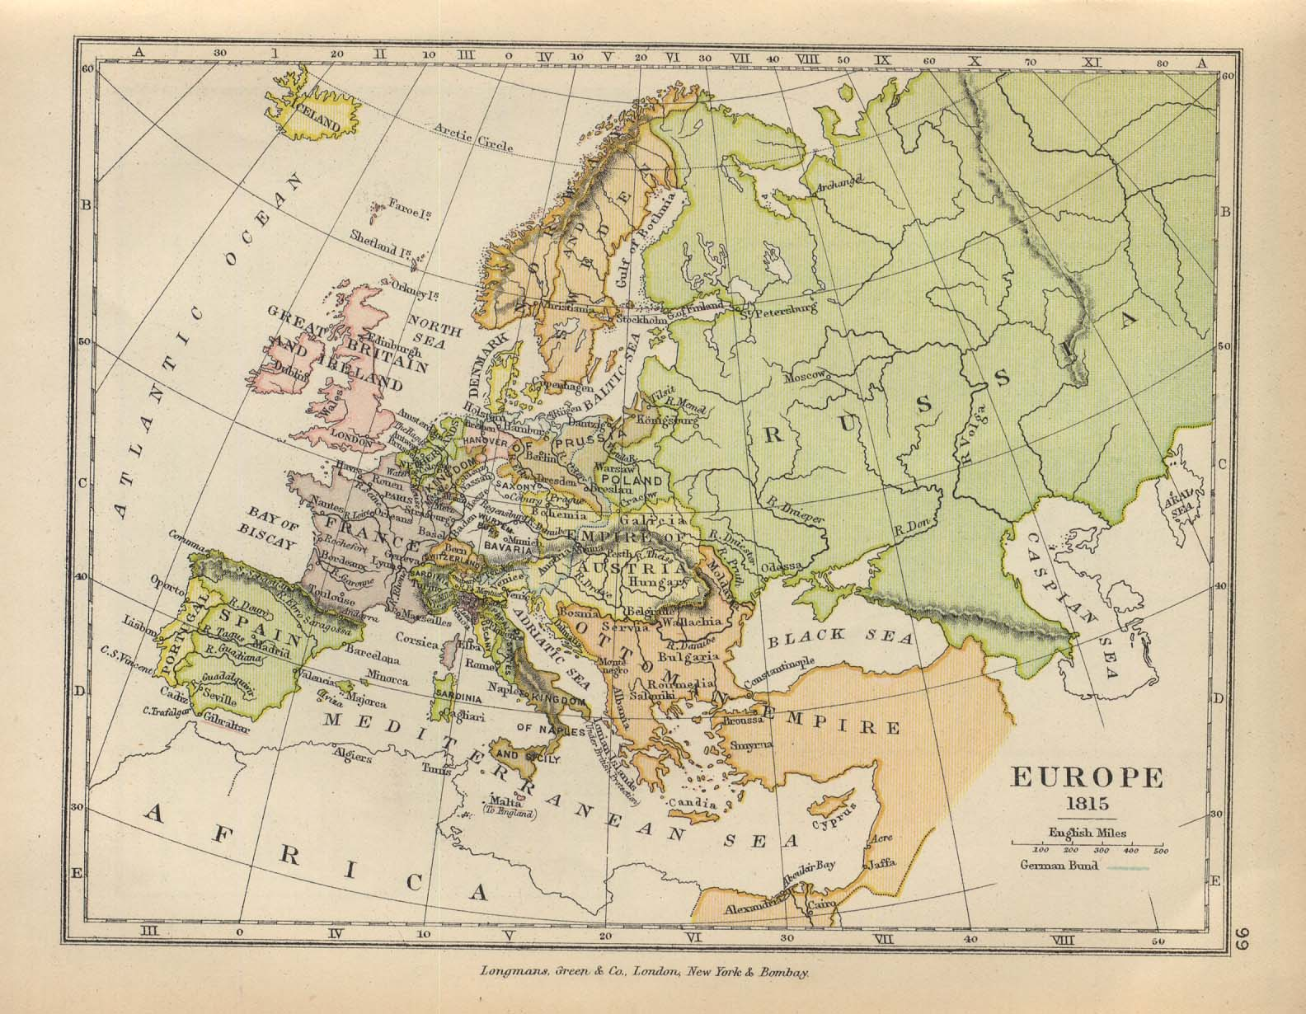
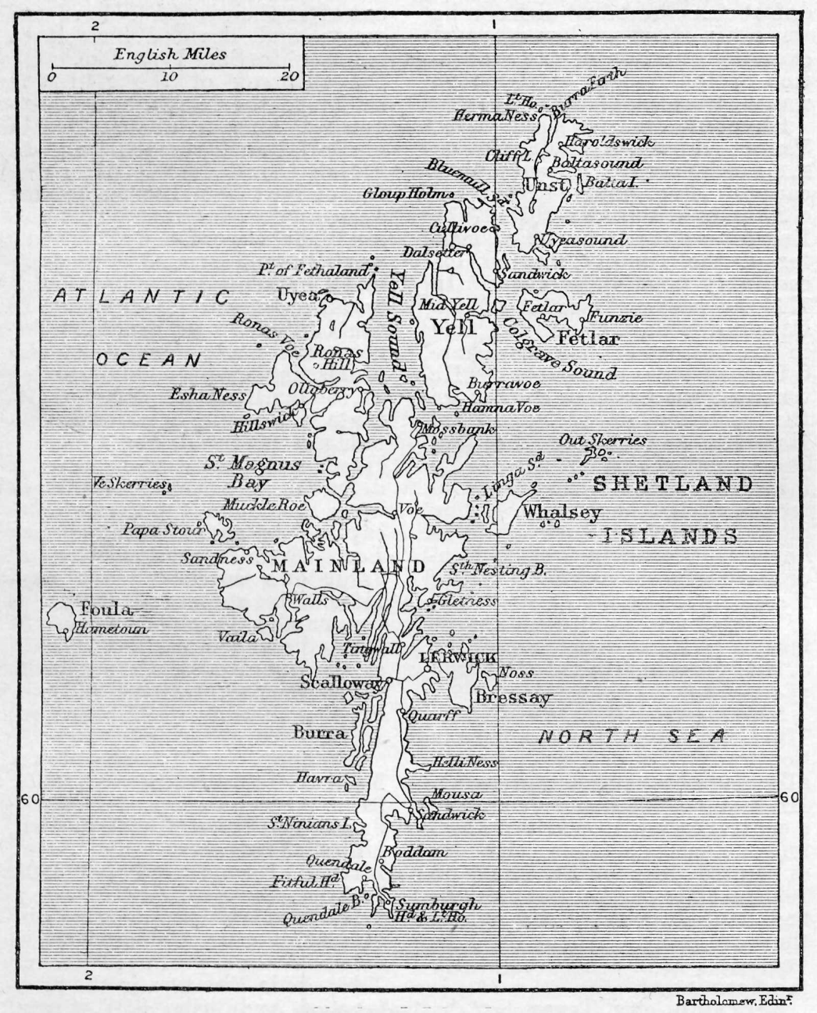

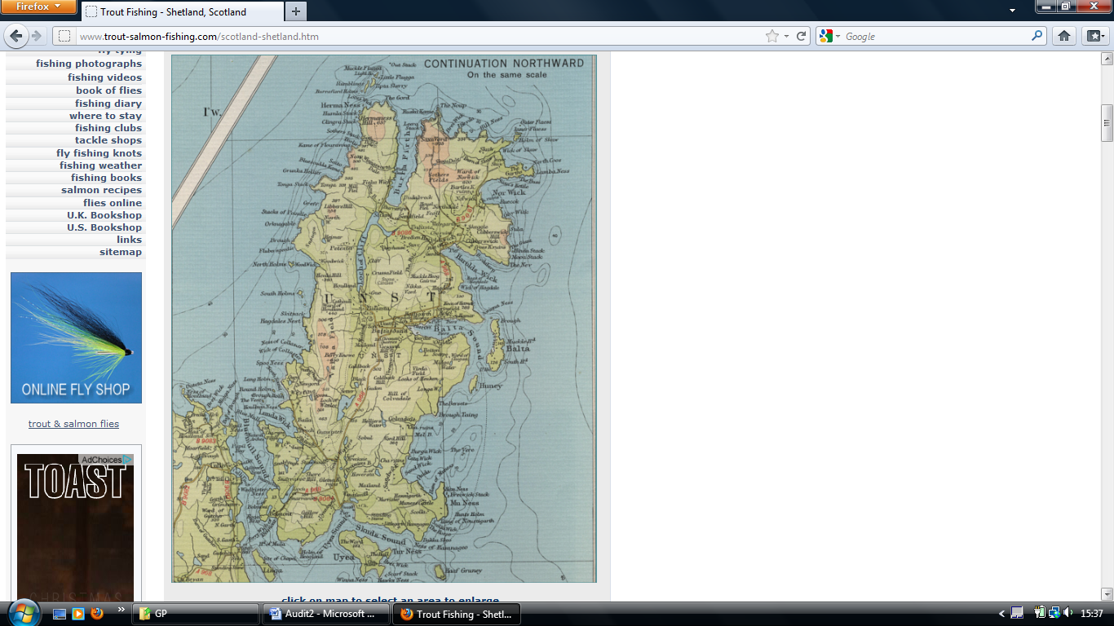

An audit of alcohol management
in Unst, Shetland

Abstract
Background: Problem drinking is a major public health issue in Scotland. Shetland is the only Health Board that has not met the national target for use of Alcohol Brief Interventions (ABIs) as part of an alcohol management strategy. It is not clear if this is due to lack of use, or lack of reporting.
Objectives:
- To determine the extent of delivery of alcohol-related consultations, screening for high risk behaviours, and use of ABIs, at a surgery in Unst, Shetland
- To determine how well these activities are recorded and coded
Methods: All GP consultations between 18th – 28th October 2011 were observed. The number of alcohol-related consultations, and use of screening tools and ABIs, were noted, as were their recording in patient notes and coding. Records from all consultations in the previous two weeks were also screened for alcohol-related data, and all existing codes pertaining to the two groups used to consider the extent of past alcohol-related consulting, screening and ABI delivery.
Results: In the observed period, alcohol was discussed twice, but this was not recorded and no associated coding was carried out. Alcohol discussions were twice recorded in the preceding two weeks, but never coded. There was no evident use of screening tools or ABIs in the reviewed consultations.
89.0 % of the included patients had existing alcohol-related codes, indicative that they had participated in alcohol-related consultations in the past. 76.4 % had alcohol-related codes entered within the past 3 years. Alcohol screening tool codes (all FAST codes) were available for very few patients (4.7 %). Only 1 patient had an ABI code, and this patient had not (ever) been coded as a hazardous/harmful drinker.
Unfortunately, none of the audit targets were met.
Conclusions: Recording of alcohol-relating consultation data is poor. This makes it difficult to determine the extent of alcohol-related consulting and use of ABIs, but potentially these too are poor. Various recommendations to optimise alcohol-relating consulting and data recording are provided. Re-auditing at an interval sufficient to allow their implementation and generation of sufficient new data – perhaps in 18 – 24 months - is suggested.

Contents

Abstract 2
Introduction 4
Aims and targets 5
Methods 6
Analysis 6
Results 8
Discussion 9
Summary 9
Limitations 10
Implications 10
Completion of audit cycle 11
Conclusions 12
References 13
Boxes 1 and 2 14
Table 1 15
Table 2 16
Table 3 17
Table 4 18

Introduction
As all over Scotland, problem drinking is a major issue in Shetland. Records from 2006 suggest 18 % of 15 year olds in Shetland consume > 5 drinks at least 4 times per month¹, and 2004 figures report that 6.4 % of male deaths were alcohol-related in that year². In 2007/2008 there were 37 drink-driving offences recorded, and 48 drunkenness offences³. The local Alcohol and Drug Development Officer⁴ suggests that these latter figures may be an underestimate – that there is a culture of acceptance, and so likely under-reporting, of offences. However, she also suggests that she has noticed a change in ideas about alcohol over the past few years, noting an incident when two 10 year olds were found collapsed due to alcohol intoxication as particularly significant in helping one community understand the problem. Other sources also suggest a possible downward trend in the number of 13 – 15 year olds who drink alcohol¹, although this is suggested with caution, as the population size is relatively low, and so fluctuations by chance relatively likely. Moreover, it is clear that alcohol consumption in children remains an important issue².
Talking to the population generally, it seems the local patterns of harmful drinking are well understood, but not always thought of as a problem. Indeed, episodes of community-inspired binge drinking are woven into the year – into weddings, which involve whole communities, and other local festivities. Alcohol is reportedly an integral part of these traditional events, and children are at least present, if not included. But despite that this behaviour is well-acknowledged, and an awareness of ‘binge drinking’ and associated problems as a phenomenon, the idea of behavioural change appears little entertained. ‘There’s nothing you can do about it’, the nurses at the Unst surgery tell me. People know or are advised about their drinking patterns, but they don’t want to change.
Despite these evident problems, in 2010/11 NHS Shetland was the only Health Board in Scotland not to meet the HEAT H4 target. This target is based on the national SIGN guidance (SIGN guideline 74)⁵, which demands screening for alcohol use/behaviours and use of alcohol brief interventions (ABIs) where appropriate. The target asked for particular numbers of ABIs to be carried out between 2008 and 2011, in primary care, antenatal and A+E environments. The numbers are based on estimated rates of alcohol-related primary and secondary care presentations amongst adults (> 16 years) in Scotland. These rates do not seem to differ between Shetland, and Scotland as a whole².
ABIs are designed for use where hazardous or harmful drinking is suspected (see Box 1 – Levels of alcohol intake), and have been shown to be effective in reducing alcohol intake in these populations^{5, 11, 12}. Hazardous/harmful drinking can be identified through the use of FAST or AUDIT screening tools^{13, 14}, or other structured or unstructured conversation. ABIs are structured conversations about alcohol consumption, and aim to motivate/support individuals to think about/plan how to change their behaviour, if desired¹⁰. They are included in the World Health Organization’s global alcohol strategy, which provides recommendations for national management programmes¹⁵.
Not only has NHS Shetland been the only Board not to meet its HEAT H4/ABI target, but it achieved a score of only 59 % - spectacularly poor compared to the rest of Scotland. Moreover, information from the local Alcohol and Drug Development Team suggests most of this failing is coming from Primary Care. More optimistically, they also feel this poor performance is a reflection of poor reporting rather than poor use of ABIs. A software change designed to facilitate reporting was introduced in spring 2011 and is expected to have increased levels of reporting. This audit was carried to investigate these possibilities. The audit was carried out at Hillsgarth Surgery, Unst. ABI data relating to this surgery alone are not available, and so how its performance compares to other surgeries in Shetland is unknown.

Aims and targets
The focus was on consultations by doctors alone, and I aimed to determine:
- How often alcohol is talked about in consultations
- Where the individual has been previously identified as a hazardous, harmful or dependant drinker (= ’high risk’ drinker)
- For all other patients
- How often alcohol screening tools and ABIs are delivered
- How often alcohol-related consultations/use of screening tools/use of ABIs are recorded in patient notes
- How often alcohol-related consultations/use of screening tools/use of ABIs are coded

Targets were as follows:
- All patients > 16 years who have completed the practice registration process should have been asked about alcohol intake, and results coded.
- Alcohol should be talked about in all GP consultations where the individual has been previously identified as a high risk drinker. It should otherwise be considered where relevant, where possible, and at least once every 3 years.
(NB. Evidence that multiple sessions are more effective than single sessions is lacking¹¹ because the studies have not been done. Such studies are, though, being encouraged¹⁶, and it is anticipated that multiple sessions may be helpful as evidence is suggestive that repeated exposure to the same messages is generally helpful in health education programmes, where aiming to facilitate long-term behavioural change ^{e.g. 17}).
- Screening (FAST, AUDIT, other) to determine applicability of ABI should be delivered where initial questions have ascertained that the individual drinks alcohol
- Alcohol-related consultations, and use and outcomes of screening tools and ABIs, should always be recorded in the patient notes
- Alcohol-related consultations, and use and outcomes of screening tools and ABIs, should always be coded

Methods
To generate data sufficient to address the above aims I observed as many GP consultations (performed by doctors) as possible for the period 18th – 28th October 2011. Where unable to attend the consultation, data relating to the missed consultation were extracted from the patient notes. The headings under which data were extracted for each consultation are listed in Box 2.
The doctors performing the consultations were aware that the audit was being performed. In consideration of the potential effects of this knowledge and the presence of the observer, data relating to the two week period before the audit was initiated/observations took place were also extracted (from patient notes). The second data set is termed Data Set 2, and that derived from the observation period Data Set 1.

Analysis
All registered patients > 16 years were included in the analysis, as the > 16 years population is that in which identification of problem drinking and use of ABIs is recommended by national guidelines. Consultations with patients who had already consulted in the same 2 week observed or unobserved period were excluded from analysis to avoid inclusion of their duplicated data in calculations relating to patients’ existing alcohol codes.
Data were summarised in tables and the following figures were calculated separately for data sets 1 and 2:
Regarding consultations:
- How often alcohol was mentioned in consultations with patients previously coded as high risk drinkers
- How often alcohol was mentioned in consultations with patients not previously coded as high risk drinkers
- How frequently alcohol screening tools were delivered to patients previously coded as high risk drinkers
- How frequently alcohol screening tools were delivered to patients not previously coded as high risk drinkers
- How frequently ABIs were used when patients were identified as hazardous or harmful drinkers
- How frequently alcohol-related information was recorded in patient notes
- How frequently alcohol-related information was coded
Regarding historical data of reviewed patients:
- How many patients had existing alcohol codes in their notes
- How many patients had alcohol codes entered in their notes within the last 3 years
- How many patients had been previously coded as high risk drinkers
- The average number of dates on which alcohol codes had been entered for each patient
- The average time-lapse between entering of alcohol codes, where more than 1 entered
- How frequently alcohol screening tool codes had been entered (ever) – for high risk (ever), and low risk, patient groups
- How frequently ABIs had been delivered to hazardous/harmful drinkers (ever)
Due to the nature of the data generated, and clear lack of significant differences between data sets 1 and 2, no statistical comparisons were required.

Results
79 consultations were performed during the ‘observed’ 2 week period, and there were 100 available for review in the 2 week ‘unobserved’ period. 25 exclusions were made from the observed data set: 9 where the patients were < 16 years, 3 non-registered patients, 4 terminal care consultations and 10 cases where the same patient had consulted previously in the 2 week period. 8 children, 2 non-registered patients, 1 terminal care consultation and 15 cases where the same patient had consulted previously were excluded from the unobserved data set. Thus there were 53 and 74 consultations for review in data sets 1 and 2 respectively. Eight of the analysed consultations from the ‘observed’ period (Data Set 1) were not observed, and the data obtained from the patient notes.
The data extracted from the consultations/notes are summarised in Tables 1 and 2 – relating to data sets 1 and 2 respectively.
Table 3 demonstrates the figures of interest produced during the analysis (see ‘Methods’).
Table 4 shows the identified targets (see ‘Introduction’) alongside the outcomes relating to the particular targets.

Discussion
Summary
I aimed here to determine how frequently alcohol was mentioned in consultation, how frequently screening tools and ABIs used, how frequently these activities were recorded in patient notes, and how frequently coded. I considered 4 weeks of consultations – 2 weeks where I observed the consultations and 2 weeks where I did not. For each patient, I reviewed the historical (coded) data relating to alcohol use, as well as the reviewed consultation, to consider the points of interest.
In the observed consultations, the frequency of alcohol consulting was low. Alcohol was mentioned in only 2/53 of the observed consultations. In addition, these discussions about alcohol were not recorded in the patient notes. This suggests that the number of alcohol related discussions in the unobserved reviewed consultations may have been more than the 2 recorded in the patient notes, but it is still likely their frequency was not high. There was no evident use of screening tools or ABIs in the reviewed consultations. None of the alcohol-related discussions was coded, although in the two cases where the alcohol-related discussion was recorded in the patient notes, the patients did have appropriate/corresponding codes already entered.
Regarding the historical data relating to the patients whose consultations were reviewed as part of this audit process, 89.0 % had existing alcohol-related codes, indicative that they had participated in alcohol-related consultations in the past. 76.4 % had alcohol-related codes entered within the past 3 years. Alcohol screening tool codes (all FAST codes) were available for very few patients (4.7 %). Only 1 patient had an ABI code, and this patient had not (ever) been coded as a hazardous/harmful drinker.
Unfortunately, none of the targets as outlined in the introduction were met.
It is hopeful though that most patients have been interviewed about alcohol at some point, and certainly the case that at least some of those without alcohol-related codes had registered with the practice relatively recently. It is also pleasing that more than ¾ of patients had had an alcohol-related consultation within the last 3 years. Although there was a high disparity in the number of years lapsed between alcohol related consultations, in the majority of cases where coding had been performed more than once, the time lapse between codings was within 3 years, and in all but two cases within 5 years. It is more concerning that the majority of patients had only one alcohol-related code entered – perhaps indicative of their having only received one alcohol-related consultation. However it is also possible that this is due to their joining the practice relatively recently, as the data were not considered against practice registration dates, and this might be usefully followed-up.
The extent to which the lack of use of screening tools and ABIs reflects a lack of need rather than lack of use is unclear, although the use of screening tools in only 6 (4.7 %) of the studied patients and apparently incorrect use of only one ABI, is indicative that they are not being employed as hoped and that re-evaluation of strategies for their use might be beneficial. Moreover, performing ABIs at the observed rate would (assuming a patient population equal to the general population of the Islands) mean that 173 ABIs have been performed (ever) in Shetland. This is well below the 622 HEAT target for 2008 – 2011. Still this does not mean that the practice is not performing a sufficient number of ABIs. It is plausible that the relatively idiosyncratic nature of the island where the practice is based (a very community-oriented place with no towns, only 3 shops, no facilities for education beyond 15/16 years and limited employment opportunities) means that the need for ABIs is relatively low. But of course this is speculative and the low level of ABIs performed should be of concern until it is demonstrated that lack of need is the only reason why.

Limitations
There are various features of this audit that limit the reliability of the above results, including:
- The nature of the used coding system is unclear, and it is possible that new codes are traditionally entered only where there is no existing code relating to alcohol, or where the existing code is found to no longer be (the most) correct. This is suggested because the same codes were not observed to have ever been entered twice for the same patient. This may be because the number of alcohol-related interactions was generally limited, but could reflect that codes are updated only when they would be changed.
- The consistency of code use was unclear. Various, but overlapping, types of code were employed for different patients, and the Practice Nurse (who seems to perform the majority of alcohol discussions) mentioned being unable to find appropriate codes for some patterns of risky behaviour (especially binge drinking). She would therefore code such drinking patterns using a ‘daily average’ system, thereby implying a lower risk
- I have only audited coding for patients that were attending the practice for reasons other than routine screening/Well Person checks (which is when (anecdotally) the majority of alcohol consulting seems to be achieved). Possibly other registered patients, who attend less/are less unwell and are therefore less inspired/encouraged to attend Well Person checks, are not so well screened with regard to alcohol.

Implications
There are various implications of this audit, and various recommendations to be made, that hold regardless of these limitations.
It would certainly be useful to:
- Audit the consultations (probably Well Person checks) held by the Practice Nurse to observe patterns of alcohol consulting and coding
- Review the frequency of Well Person checks, and attendance rates
- Understand the difficulties associated with/reasons for low rates of alcohol consulting by the doctors in the practice
- Determine whether or not alcohol codes are updated following each alcohol-related consultation, or only if the existing code no longer applies
Regardless of the outcomes of such study, it would still in the meantime be useful to:
- Have a mechanism to indicate (when consulting) where alcohol review is overdue, so that this can be carried out, or a referral made
- Aim to consider alcohol use in all consultations with patients known to be high risk drinkers
- Have a mechanism for easy identification (when consulting) of high risk drinkers, to facilitate the above aim
- Review when ABIs to be used with all who may be consulting and perform as appropriate (or refer to person trained to perform)
- Record in patient notes when alcohol discussed in consultation
- Code information gained in alcohol-related consultations
- Update coding after every consultation, even if no change in applicable code, to facilitate auditing of alcohol-related practice
- Ensure all required/relevant codes are available and easy to use so that patients can be appropriately categorised as low or high risk
It may also be desirable to screen more patients using structured tools (i.e. FAST/CAGE/AUDIT as appropriate), and thus useful to review their content and usefulness with those carrying out alcohol consultations.

Completion of audit cycle
Repeating the audit at an interval of 18 - 24 months is suggested based on predicted time requirement for implementation of changes, and to give an opportunity to generate sufficient data for comparison with the above results.

Additional notes
In addition to implementing and auditing outcomes of the suggested changes as required, it may be useful to audit outcomes of ABIs delivered. This is suggested due to the mentioned alcohol culture on the island, which seems to translate into a lack of motivation to change behaviour. It would be useful to know if this is the case, as it is very possible that ABIs are relatively ineffective in such a population, and that other strategies for changing drinking behaviours would be of more use.

Conclusions
- Alcohol issues are not commonly raised by GPs in consultations, even where of relatively high relevance. Most patients are, though, receiving alcohol-related consultations. The majority probably occur in Well Person checks carried out by the Practice Nurse.
- The current mechanism for review of alcohol use, and subsequent recording, does not seem to be rigorous/consistently applied.
- ABIs are not well delivered – both in terms of frequency, and of targeting the relevant populations. Or at least they are coded in such a way as to suggest this. This is likely to be contributing to the poor ABI use recorded in Shetland.
- Review of the practice systems currently employed to recruit patients to alcohol checks, and code the outcomes, would be useful. Review and encouragement of use of alcohol screening tools and ABIs, and determining why doctors are disinclined to consult about alcohol and facilitating changes that would encourage their involvement, would probably also be beneficial.

References
BMRB Social Research for Information Services Division (ISD)/
- BMRB Social Research for Information Services Division (ISD)/ NHS National Services Scotland on behalf of the Scottish Executive (2006) Scottish Schools Adolescent Lifestyle and Substance Use Survey (SALSUS): Smoking, Drinking and Drug Use Among 13 and 15 year olds in Shetland Islands. Scottish Executive, Edinburgh 2006. [Available at:
http://www.drugmisuse.isdscotland.org/publications/abstracts/salsus/Shetland%20Islands_2006.pdf] Accessed: October 2011
- Information and Statistics Division Scotland (2006) Alcohol Profile: Shetland. ISD Scotland, Edinburgh 2006. [Available at:www.alcoholinformation.isdscotland.org/alcohol_misuse/files/Shetland_Profile2006.pdf] Accessed: October 2011
- Northern Constabulary (2008) Public Performance Report 2007/08. Northern Constabulary, Inverness 2008. [Available at: http://files.northern.police.uk/ppr/ppr-2007-08.pdf] Accessed: October 2011
- Personal communication, October 2011
- Scottish Intercollegiate Guidelines Network (2003) Guideline 74. The management of harmful drinking and alcohol dependence in primary care: a national clinical guideline. © Scottish Intercollegiate Guidelines Network, Edinburgh 2003. [Available from: www.sign.ac.uk/pdf/sign74.pdf] Accessed: November 2011
- Department of Health (2011) Alcohol Advice. © Crown copyright 2011 [Available from: http://www.dh.gov.uk/en/Publichealth/Alcoholmisuse/DH_125368] Accessed: November 2011
- World Health Organization (2010) International statistical classification of diseases and related health problems: tenth revision [online] © WHO 2011 [Available from: www.who.int/classifications/apps/icd/icd10online/] Accessed: November 2011
- World Health Organization (1994) Lexicon of alcohol and drug terms (online). © World Health Organisation 1994 [Available from: http://whqlibdoc.who.int/publications/9241544686.pdf] Accessed: November 2011
- Alcohol Concern (2001) Factsheet 20: Binge Drinking. Alcohol Concern, London 2001 [Available from: www.alcoholconcern.org.uk%2Fassets%2Ffiles%2FWales%2520factsheets%2FBinge%2520drinking%2520-%2520Wales.pdf] Accessed: November 2011
- NHS Health Scotland (2011) Alcohol brief interventions (ABI) professional pack (Reprinted 2011); Delivering alcohol brief interventions – Briefing paper 1: What and Why? © NHS Health Scotland 2011 [Available from: http://www.healthscotland.com/uploads/documents/16514-ABIProfBriefings1.pdf] Accessed: October 2011
- Kaner EF, Dickinson HO, Beyer FR, Campbell F, Schlesinger C et al (2009) Effectiveness of Brief Alcohol Interventions in Primary Care Populations (Review). The Cochrane Library 2009, Issue 4. © 2009 The Cochrane Collaboration. JohnWiley & Sons, Ltd, Chichester.
- Raistrick D, Heather N and Godfrey C (2006) Review of the effectiveness of treatment for alcohol problems. National Treatment Agency for Substance Misuse, London 2006.
- Hodgson R, Alwyn T, John B, Thom B and Smith A (2002) The fast alcohol screening test. Alcohol and alcoholism 37: 61 – 66.
- Babor TF, Higgins-Biddle JC, Saunders JB and Monteiro MG (2001) The Alcohol Use Disorders Identification Test: Guidelines for use in primary care. © World Health Organisation 2001
- World Health Organisation (2010) Global strategy to reduce the harmful use of alcohol. © World Health Organisation 2010 [Available from: http://www.who.int/substance_abuse/msbalcstragegy.pdf] Accessed: November 2011
- Nilsen (2010) Brief alcohol intervention – where to from here? Challenges remain for research and practice. Addiction 105: 954 – 959.
- DeJong W and Winsten JA (1998) The media and the messages: lessons learned from past public service campaigns. The National Campaign to Prevent Teen Pregnancy; Arlington (VA), 1998

Box 1 – Levels of alcohol intake
Recommended limits < 3 – 4 units/day and < 21/week for men; < 2 – 3 units/day and < 14/week for females; at least 2 alcohol-free days per week. No alcohol if trying to conceive/pregnant⁶
Hazardous a pattern of alcohol use that increases the risk of harmful consequences⁷
Harmful a pattern of use that causes damage to physical and/or mental health^{1, 8}
Dependant characteristic physiological, behavioural and cognitive phenomena⁷

Binge drinking is of more varied definition (see e.g. 8), but > 6 units/day for women and > 8 units/day for men, on at least 2 days/week is suggested by Alcohol Concern⁹, and in the national information provided for those carrying out ABIs¹⁰. It is generally accepted to constitute a form of hazardous or harmful drinking. It may also be associated with dependency.

Box 2 – Data extraction
- Date
- Setting (i.e. clinic, telephone or home consultation)
- Consultation observed or not observed
- Patient age and sex
- Presentation/diagnosis/management
- Alcohol use mentioned
- Use of CAGE screening tool
- Use of FAST screening tool
- Use of AUDIT screening tool
- ABI performed
- 6 – 10 recorded in patient notes or not
- 6 – 10 coded or not and codes used
- Existing alcohol read codes for the patient (i.e. not associated with observed consultation) and date(s) entered.
- Doctor performing consultation

Table 1 Data Set 1 – Data extracted from ‘observed’ consultations. (a) Basic consultation details, (b) nature of alcohol consulting, data recording and coding in observed/reviewed consultations and (c) details of existing alcohol codes in patient notes; ENT = ear, nose and throat; MSK = musculoskeletal; CVS = cardiovascular; ‘high risk codes’ = those indicative of hazardous, harmful or dependant drinking. One of two doctors (1 and 2) performed all consultations – the number performed by each is noted (1a).
Table 1a – consultation details
Dates | Setting | Patient age and sex | Presentation/ diagnosis category | Doctor
18/10/11 – 28/10/11 | Clinic: 48  Home: 0  Tel.: 5 | Mean age + SD: 51.5 + 16.2 years  M: 22  F: 31 | 4 ENT, 12 MSK, 5 gynaecology, 2 CVS, 4 infection, 6 mental health,  2 ophthalmology, 4 rheumatology, 1 respiratory, 4 dermatology, 2 gastroenterology, 2 administrative, 1 fatigue, 2 routine screening,  2 medication review | 1: 36  2: 17

Table 1b – alcohol consulting details
Mention of alcohol use | CAGE | FAST | AUDIT | ABI | Recorded in notes | Coded
2 (1 gynaecology, 1 mental health) | 0 | 0 | 0 | 0 | 0 | 0

Table 1c – previous alcohol consulting details
Number of coded alcohol consultations | Number high risk  Codes | Number of coded alcohol consultations in patients with high risk codes | Number CAGE/ FAST/ AUDIT/ ABI codes | Time lapse between entering read codes where > 1 (to nearest year) | Time lapse between entering read codes where > 1 in patients with high risk codes (to nearest year)
0: 11  1: 30  2: 11  4: 1 | 7 | 1: 1  2: 5  4: 1 | CAGE: 0  FAST: 3  AUDIT: 0  ABI: 0 | 1 (or < 1) year: 5  2 years: 5  4 years: 1  5 years: 1 | 1 (or < 1) year: 3  2 years: 2  5 years: 1

Table 2 Data Set 2 – Data extracted from ‘unobserved’ consultations. (a) Basic consultation details, (b) nature of alcohol consulting, data recording and coding in reviewed consultations and (c) details of existing alcohol codes in patient notes; ENT = ear, nose and throat; MSK = musculoskeletal; CVS = cardiovascular; ‘high risk codes’ = those indicative of hazardous, harmful or dependant drinking. One of two doctors (1 and 2) performed all consultations – the number performed by each is noted (2a).
Table 2a – consultation details
Dates | Setting | Patient age and sex | Presentation/ diagnosis category | Doctor
3/10/11 – 17/10/11 | Clinic: 56  Home: 11  Tel.: 7 | Mean age + SD: 55.7 + 18.4 years  M: 29  F: 45 | 3 ENT, 13 MSK, 5 gynaecology, 5 CVS, 8 infection, 7 mental health, 2 ophthalmology, 2 rheumatology, 2 respiratory, 3 dermatology, 2 gastroenterology, 1 endocrinology, 3 neurology, 4 urology/renal, 2 wounds, 2 routine screening, 3 medication review, 3 administrative, 4 unclear | 1: 54  2: 20

Table 2b – alcohol consulting details
Mention of alcohol use | CAGE | FAST | AUDIT | ABI | Recorded in notes | Coded
2 (1 MSK, 1 mental health) | 0 | 0 | 0 | 0 | 2 | 0

Table 2c – previous alcohol consulting details
Number of coded alcohol consultations | Number high risk codes | Number of coded alcohol consultations in patients with high risk codes | Number CAGE/ FAST/ AUDIT/ ABI codes | Time lapse between entering read codes where > 1 (to nearest year) | Time lapse between entering read codes where > 1 in patients with high risk codes (to nearest year)
0: 4  1: 47  2: 15  3: 6  4: 1 | 6 | 2: 4  3: 2 | CAGE: 0  FAST: 3  AUDIT: 0  ABI: 1 | 1 (or < 1) year: 5  2 years: 7  3 years: 4  4 years: 5  10 years: 1  14 years: 1 | 2 years: 3  3 years: 1  4 years: 1  10 years: 1
Table 3 Data relating to targets derived from raw data sets 1/2. ‘High risk patients’ = those coded as hazardous, harmful or dependant drinkers (ever)

 | Information derived from Data Set 1 (number of patients; % all consultations in parentheses) | Information derived from Data Set 2 (number of patients; % all consultations in parentheses)
Alcohol mentioned in consultations with high risk patients | 0 (0) | 1 (16.7)
Alcohol mentioned in consultations with non-high risk patients | 2 (4.3) | 1 (1.5)
Alcohol screening tools used in reviewed consultations | 0 (0) | 0 (0)
ABI used in reviewed consultations | 0 (0 ) | 0 (0)
Alcohol-related discussion in reviewed consultation recorded in patient notes | 0 (0) | 2 (100)
Alcohol related discussion in reviewed consultation appropriately coded | n/a | 0 (0) (although in both cases already appropriately coded)
Existing alcohol code(s) | 43 (81.1) | 70 (94.6)
Alcohol related code added for patient within past 3 years | 36 (67.9) | 61 (82.4)
Patient coded as high risk (ever) | 7 (13.2) | 6 (8.1)
Alcohol screening tools delivered to high risk patients (ever) | 0 (0) | 0 (0)
Alcohol screening tools delivered to non-high risk patients (ever) | 3 (6.5) | 3 (4.4)
ABI delivered to patients identified as harmful/hazardous drinkers (ever) | 0 (0) | 0 (0) (but 1 delivered to non-high risk patient)

Table 4 Data from data sets 1/2 matched against corresponding targets. ‘High risk’ drinker = hazardous, harmful or dependant drinker
Target | Outcomes - Data Set 1 | Outcomes - Data Set 2
All patients > 16 who have completed the practice registration process should have been asked about alcohol intake, and this coded, at least once | Existing alcohol codes for 43/53 (81.1 %) patients | Existing alcohol codes for 70/74 (94.6 %) patients
Alcohol should be talked about in all GP consultations where individual has been previously identified as a high risk drinker | Alcohol mentioned in 0/7 consultations with patients previously coded as high risk drinkers | Alcohol mentioned in 1/6 consultations with patients previously coded as high risk drinkers
In all patients, alcohol should be considered:
- where relevant and where possible | Alcohol mentioned in 2 consultations | Alcohol mentioned in 2 consultations
- at least once every 3 years | Mean number of years between codings when coded > once (n = 12) = 2  Mean number of years between codings when coded > once in high risk patients (n = 6) = 2 | Mean number of years between codings when coded > once (n = 22) = 3.36  Mean number of years between codings when coded > once in high risk patients (n = 6) = 3.83
Screening (FAST, AUDIT, other) to determine applicability of ABI should be delivered where initial questions have ascertained that the individual drinks alcohol | Screening tools not used in observed consultations  Existing codes suggest FAST delivered 3 times to non-high risk patients  No ABIs delivered in observed consultations and existing codes suggest not delivered previously | No record of use of screening tools in reviewed consultations  Existing codes suggest FAST delivered 3 times to non-high risk patients  No ABIs delivered in observed consultations  Existing codes suggest ABI delivered to 1 patient (who was not categorised as high risk)
Alcohol-related consultations, use and outcomes of screening tools and ABIs should always be recorded in the patient notes | 2 consultations mentioned alcohol – neither recorded in notes | n/a (consultations not observed)
Alcohol-related consultations, use and outcomes of screening tools and ABIs should always be coded | Not achieved | Not achieved (in 2 consultations where alcohol mentioned, neither coded)

