Map and transport details for East Surrey Hospital, Redhill

Maps of area

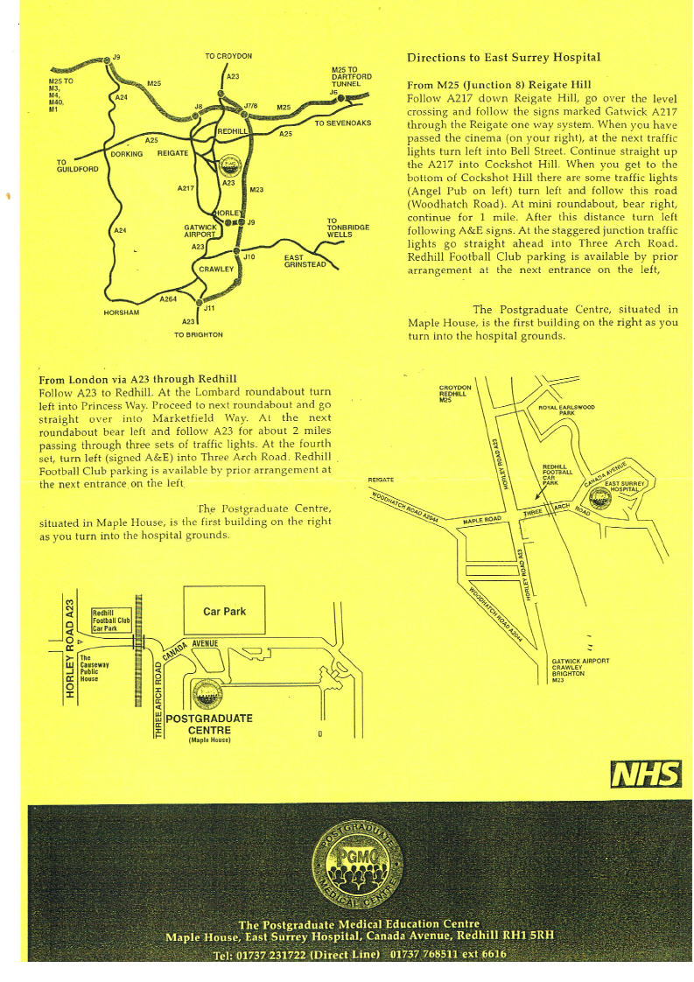

Transport / Parking

If you are not resident in the hospital and using your car to travel to the hospital the car park has a pay and display facility which costs:

Visitors Car Park

No. of Hours | Fee payable
0 - 2 | £2
2-3 | £3
3-4 | £4
4-5 | £5
5-6 | £6
6-7 | £7
7-8 | £8
8-9 | £9
10-24 | £12
over 24 | £25 per day

Over-flow car park
The Trust are using Redhill Football Club car park as an overflow car park for staff, therefore if the medical students wish to park in the Football Club they need to display some identification, a note with the following written on it for example “Medical Student – working on attachment at East Surrey Hospital” . During induction the students will be given a parking permit for their car to park in the staff car park.
However these arrangements may change in the future. The Football Club car park is located just before the entrance to East Surrey Hospital before approaching the bridge.
Please note: There must be some identification in the car windscreen that the car owner is a member of the Trust staff or a medical student on attachment at the Hospital.

