Colchester General Hospital

How to find us……

Please note you should *NOT* arrive in Colchester until early on the day your attachment begins

By Car …… If you are travelling up from London you need to get on the northbound A12 heading towards Ipswich. At Colchester, DON’T take the 1st turn off (A1124) but proceed for another mile and take the 2nd turn off to Colchester when the inside 2 lanes peel off left (Junction 27). This is sign posted as Colchester Central and has hospital signs. Follow to the roundabout and take the 2nd exit, heading down the Avenue of Remembrance until you get to another roundabout. Take the 1st exit and follow to the next roundabout, getting in the right hand lane. Take the 2nd exit from here. You are now entering a complex system including record breaking numbers of traffic lights in quick succession! Please proceed as follows:

1st Set of lights - Straight ahead in right hand lane and under railway

bridge.

2nd Set - Bearing right in right hand lane

3rd Set - Straight ahead

4th Set - Turn left, remaining in right hand lane

5th Set - Straight ahead in right hand lane then filter into new

outside third lane

6th Set - Turn Right

The hospital is 300 yards up the hill on the left hand side.

 Parking …… Enter the hospital grounds at the A & E / Main Hospital /North Entrance (this is the second entrance as you come up Turner Road). After the Kingswood Centre on your right turn right into Charter Way. This leads to parking for the accommodation blocks. There are no specifically designated spaces, so park where you can. Please notify the accommodation officer on Ext. 7508 of your vehicle details for their records.

Currently there is no need for you to apply for a parking permit, but please check with the accommodation office on arrival that no new instructions about parking have been issued.

 By Train …… Coming from London you will need to get the train from London Liverpool Street to Colchester (North) Station. You will arrive at Colchester after about 50 minutes travelling and Colchester General Hospital is a short taxi ride up the hill from the station. For the energetic, it is only about a 15 minute walk, but it is uphill.

 Accommodation … During your time here at Colchester General Hospital accommodation will be provided for you. No deposit will be required. You will find that cooking utensils are here for your use in the small kitchens which are located next to every block of five bedrooms. Bedding is provided, and two towels. The halls of residence lie at the edge of the hospital site in a quadrangle with adjacent parking. Charles Hall is devoted to student use; if you are living in other halls you will find that you have junior doctors and other healthcare professionals as your neighbours. Broadband access on a wireless installation for your laptops is provided for you in all halls of residence. There is no charge for its use. Passwords for access are available from the undergraduate office in the Postgraduate Centre, along with IT passwords for use with all other PCs in the NHS Trust.

If you have any problems or queries regarding accommodation, please advise Penny or Sandra at the Postgraduate Medical Centre. Telephone on 01206 746572 / 742140, or email [penny.west@colchesterhospital.nhs.uk](mailto:penny.west@colchesterhospital.nhs.uk) and/or sandra.khan@colchesterhospital.nhs.uk Penny works part time and is in the office on Monday, Wednesday and Friday. Sandra works full time.

We would expect you to arrive on the morning of your first day because we do not have housekeepers working over the weekend. Because of this the rooms cannot be prepared for you when previous residents leave on Fridays, and cleaning will not take place until early on Monday morning.

Please note that you may be asked to move rooms from one hall to another during the course of your stay. This is so that we can maintain best use of rooms in Charles Hall, where we have some difficulties due to the peaks and troughs in the programme of short term student placements. You must move promptly if asked to do so by the accommodation officer.

 Keys …… The keys for your accommodation will be available on your arrival at Colchester General Hospital. If you arrive on Monday to Friday between 9.30 am and 4.30 pm they will be at the Accommodation Office located at No1 Gasgoigne House in the accommodation block area. Between 4.30 and 6.00 pm Monday to Friday they will be at the reception desk inside the main entrance of the hospital. At all other times they will be at the switchboard, which is near the A and E department on the ground floor of the hospital. The accommodation officer is Ian Perry, and his assistant who works from 9.30 – 1.00 pm Monday - Friday, is Lara Rogers. They can be contacted on 01206 747508.

SECURITY…… your bedroom key also operates the lock on the main door to the building. Make a habit of ensuring that the front door is locked at all times.

On departure please take your keys to the Accommodation Office in opening hours, main reception, or switchboard (as above).

If any emergencies arise about your accommodation out of office hours when you are on site please phone 01206 74 7676 (Extn. 7676) . This is the hospital’s help line for its facility services, and they will give you advice.

IMPORTANT - Your accommodation is only booked for the duration of your stay in Colchester – TERM TIME! We will endeavour to allow you to keep your room if your placement is split by Christmas or Easter holidays, but we can’t guarantee that this will happen.

We will not be issuing you with ID badges for the duration of your stay, so please come with your Medical School photo ID badge and make sure you wear it when on the hospital site.

Reporting on your first day…….

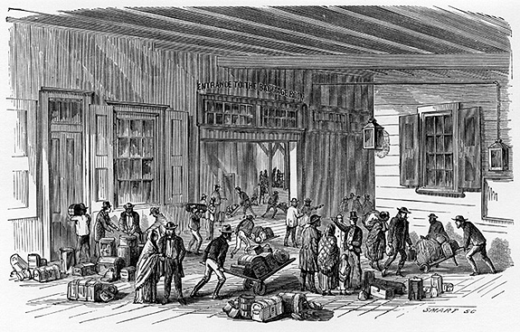

Please collect your keys at the accommodation office at 1 Gasgoigne House which is an office in one of the halls of residence at Colchester General Hospital at about 9.30 am on the first day of your placement. When you have put your luggage in your room come over to Postgrad where we will sort out your IT passwords, give you some maps of the internal structure of the hospital, tell you about your ward base, and link you with your team or F1 doctor.

Students in COTE should meet with Dr Shawis on their first day to discuss the timetable. Time and venue of the meeting will be provided when you arrive in Postgrad.

Students in Paediatrics, should make their way to the Children’s ward as soon as possible after putting their luggage in their rooms in order to meet Dr Sihra / Dr Malik at 10.00 am sharp. Come over to Postgrad later in the day.

Map of Colchester General Site………..

The Postgraduate Centre is located on the top left hand corner of the map near the staff car park.

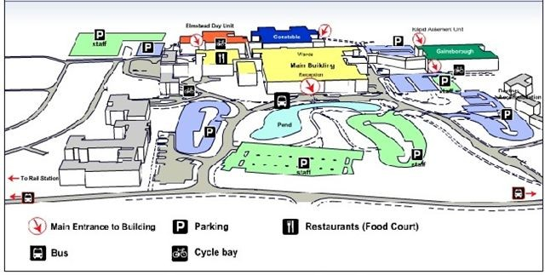



Maps of Colchester are given below………

