

**Imperial College Medical Students**

**Psychiatry Attachment**

General Information

Pastoral Care 3

Medical students in psychiatric settings - issues of capacity and consent 4

JADE read-only access 6

Process for Managing Imperial College Medical Students December 2012 7

JADE Guide for Imperial College Medical Students Rotations v9 9

Library & Knowledge Services 15

Practice Based Medicines Management Tutorials for Undergraduate Medical Students 22

Student guidance for ethics and law case discussion – psychiatry course 23

Psychiatry Ethics and Law Case Based Discussion – Formative Assessment 27

# Pastoral Care

I**MPERIAL COLEGE MEDICAL STUDENTS**

Pastoral Care at CNWL NHS Foundation Trust

To: Students on Psychiatry Attachment From: Dr James Warner

Director or Clinical Studies

Tiers of pastoral support are:

* In the first instance discuss with your consultant and/or where available, speak to the SpR mentor (a scheme that is rolling out across most Trust sites).
* The next step is to approach the Site Co-ordinator:

Claudia Wald - South Kensington & Chelsea

Ronnie Taylor - the Gordon Hospital)

Tanya Thirkell - Northwick Park

Jo Emmanuel - St Charles

Jona Lewin - Park Royal

Jeffrey Fehler - Hillingdon

I am always available, and very happy, to discuss any pastoral issues with students.

My contact details are:

Email: [j.warner@imperial.ac.uk](mailto:j.warner@imperial.ac.uk)

Tel: 07970 849818

Students can access the Imperial College Student Counseling Service and/or Head of Student Welfare, Dr Mike Schachter on [m.schachter@imperial.ac.uk](mailto:m.schachter@imperial.ac.uk) or your personal tutor.

**Incidents & Accidents in Clinical Areas – Reporting to College**

If you are subject to any accidents, assaults or any other untoward events please ensure this is reported immediately to the manager of the clinical area and direct to me: [j.warner@imperial.ac.uk](mailto:j.warner@imperial.ac.uk)

A Trust Incident Form must be completed on line and the manager should do this.

In addition the event should be reported to Imperial College using the online Accident/Incident Reporting system: <http://www3.imperial.ac.uk/safety>

# Medical students in psychiatric settings - issues of capacity and consent

**Background**

Medical undergraduates at Imperial College spend 7 weeks in psychiatric attachments during year 5. This provides valuable experience and training in the recognition and treatment of mental disorders. During the attachments, students will be exposed to patients with a variety of disorders (schizophrenia, depression, mania, anxiety, dementia etc) in a variety of settings (outpatients, wards, home visits). Some patients with mental illness are vulnerable and some will lack capacity to give informed consent. Many patients value contact with students who tend to be good, interested listeners who have more time than some clinicians.

***General principles***

* Interviewing patients remains fundamental to gaining the necessary skills in learning about psychiatric illness and the impact it has on patients and their families.
* Patients are told, as part of the information they receive about inpatient admission or outpatient attendance (or whatever appropriate), that the Trust has a major teaching function and would therefore appreciate their help by allowing students to interview them. Patients are told explicitly that the care and treatment offered will in no way be affected by the patient's participation in this, and if the patient has any objections to this, he/she should make staff aware of this.
* Students can have a valuable role in the continuing assessment of patients' mental states over the course of the attachment. Students benefit from the longitudinal perspective of seeing someone improve, possibly from an initial state where they are very unwell and lack capacity to a state where they are better and have capacity.
* Students are advised to check with an appropriate member of staff to ensure the patient is suitable to be interviewed. Members of staff may introduce students to the patient if appropriate.
* The consultant/Firm leader should advise students about which patients are likely to have capacity to consent to be interviewed.

***Patients with capacity***

* When patients are interviewed by clinical staff with students present, it is the responsibility of the clinician to seek permission for the student to be present.
* In keeping with good clinical practice, it is appropriate for unaccompanied students to seek explicit consent from patients before they interview them, explaining
  + that they are medical students
  + the reasons they wish to conduct an interview
  + the approximate length of the interview
  + that information will be shared with other members of the clinical team but is otherwise confidential
  + that the patient does not need to see the student and clinical care will not be affected by their decision
* Provided students follow this advice, verbal consent is sufficient and there is no need to document the presence or absence of capacity or the process whereby consent was obtained. Documenting such consent is unnecessarily bureaucratic and likely to deter students and patients.

***Patients without capacity***

* Capacity may be lacking if a patient is unable to
  + understand and retain;
  + believe, and;
  + weigh in the balance

Information provided to them about a course of action and its alternatives. Such information has to be given in a method suitable for the patient.

* Assessment of consent and capacity are crucial skills in medicine, and students need to gain some experience of patients whose capacity is compromised or questionable.
* For patients without capacity, the firm leader (usually the consultant) should take the decision (and accept responsibility on behalf of the Trust) on whether or not it is appropriate for a patient to be interviewed by students. This decision should take into account any advance directives from the patient and, where appropriate, the views of carers.
* Where capacity is lacking, the principle of assent should guide students about whether to continue with an interview. If a patient expresses a desire to stop an interview or appears distressed or uncomfortable with the process, then the student should discontinue.

# JADE read-only access

As a 5th year medical student completing your Psychiatry rotation, you will have the opportunity to access JADE, the main clinical electronic record system within CNWL NHS Trust.  With Jade read-only access, you will be able to search for patients, access their clinical history and their progress notes.

You must ensure that you comply with policies relating to JADE use. **In particular you must not access notes a) of patients not under the care of your supervising consultant AND b) patients you are not seeing as part of your psychiatric placement. Also, you must not give your username/password to any student (or other individual) and you must not print anything from JADE.**

Inappropriate use of JADE may result in you being disciplined by the medical school and may result in referral to the GMC for breach of patient confidentiality.

You will be issued with two usernames and passwords.

The first username and password will give you access to the CNWL IT Network.

The second username and password will give you access to JADE itself.

Please see below instructions on how to access JADE. Please read them thoroughly.  If you require further help please use the Quick Reference Guides available on Trustnet.

1. You will receive a call log reference number in an email from the CNWL Undergraduate Teaching Coordinator.
2. You need to call the IT Helpdesk and quote your call log reference number, in order to obtain your network login details. Their number is **0203 214 5900** - option 2 or ‘hold the line for the general IT Helpdesk’.
3. Access the following link:

<http://trustnet/sorce/apps/sorce_doc_manager/Actions/view_doc.aspx?docid=3783&revid=3863>

(must be accessed via a CNWL PC)

1. You need to accept the JADE Acceptable Use Policy by replying to my email (the one I sent you with your call log reference number) and state: **I have read and understood the JADE Acceptable Use Policy and agree to comply with all its terms in my use of JADE.**
2. You will receive a call from the JADE Clinical Systems Support Team. You need to quote them your call log reference number to obtain your JADE login details.

For any issues or delay in obtaining your JADE login details, contact the JADE Clinical Systems Support Team on 0203 214 5900 - option 1 or via email css.cnwl@nhs.net (quoting your call log reference number).

1. You can then access the JADE read-only electronic database.

**ACCESS TO THE TRUST SYSTEM WILL ALSO ENABLE YOU TO HAVE AUTOMATIC ACCESS TO THE INTERNET, FROM WHICH YOU CAN ACCESS THE IMPERIAL COLLEGE STUDENT INTRANET.**

# Process for Managing Imperial College Medical Students December 2012

Below the system for managing the login process for medical students

|  |  |  |  |  |
| --- | --- | --- | --- | --- |
|  | **Process** | **Escalation Type** | **Timescale** | **Actioned By** |
| 1 | Student call log reference numbers are created |  |  | IT Helpdesk  (and shared with the CSS team) |
| 2 | IT Helpdesk email Undergraduate Teaching Coordinator the student call log reference numbers | Email to Undergraduate Teaching Coordinator | A week before students start attachment |  |
| 3 | Teaching Coordinator to email each student their unique call log reference number with instruction to call the IT Helpdesk to arrange their network login. | Undergraduate Teaching Coordinator emails undergraduate students | First Monday when Students attending IC Induction lectures | Undergraduate Teaching Coordinator for CNWL |
| 4 | Student to call IT Helpdesk [**0203 214 5900** - option 2 or ‘hold the line for the general IT Helpdesk’], quoting their unique call log reference number. IT Helpdesk then provides the student (over the phone) with their network login details to access the CNWL network. | Student calls IT Helpdesk |  | Student |
| 5 | Student to log into the CNWL network: Click Ctrl+Alt+Delete- a pop up window appears and login details should be entered. | Student to log into the CNWL network |  | Student |
| 6 | Any issues relating to network login to be reported by student to IT Helpdesk [itservicedesk.cnwl@nhs.net](mailto:itservicedesk.cnwl@nhs.net) |  | As soon as possible | IT Helpdesk |
| 7 | JADE Acceptable Use:  Student to access the following link:  <http://trustnet/sorce/apps/sorce_doc_manager/Actions/view_doc.aspx?docid=3783&revid=3863>  (must be accessed via a CNWL PC) | Student reads the JADE Acceptable Policy document |  | Students |
| 8 | Student to reply to the email received from the Undergraduate Teaching Coordinator with their call log reference number stating the text: **I have read and understood the JADE Acceptable Use Policy and agree to comply with all its terms in my use of JADE.** | Student emails Undergraduate Teaching Coordinator |  | Student |
| 9 | Teaching Coordinator emails Information Governance (IG) and cc student, advising that the student has complied with IG requirements. In the email to Information Governance, Teaching Coordinator advises the student that Clinical Systems Support (CSS) team will provide them with their JADE read-only login details. | Teaching Coordinator |  | Undergraduate Teaching Coordinator |
| 10 | CSS Team to call the student and provide the student (over the phone) with their JADE read-only login details. The student will need to quote their call log reference number. | CSS team |  | CSS Team |
| 11 | Any issues relating to JADE login to be reported to css.cnwl@nhs.net | CSS team | As soon as possible | CSS Team |

# JADE Guide for Imperial College Medical Students Rotations v9

**Introduction**

The objective of this guide is to assist you in the read only access use of the main functionality in JADE relating to your clinical roles and to make you aware of the Information Governance and Security issues when using the system.

The topics covered are:

* Information Governance
* Security
* Searching for Persons / Clients
* Reading Alerts
* Accessing the Clinical Summary
* Searching Progress Notes
* Accessing Documents (correspondence)
* Accessing Assessments
* Further Help

**Information Governance**

* JADE contains lots of information about service users, their carers, families and others. The data is **personal, sensitive and confidential**
* JADE information is accessed and shared on a ‘need to know’ basis
* Directly providing or supporting healthcare is a good reason for access. Other reasons need to be justified
* Make sure that your use of JADE is compliant by following the *JADE Acceptable Use Policy* on Trustnet. You will only be given access to JADE when you have read this document together with the *Access to JADE*form, the latter of which will also need to be signed off as indicated
* Non Trust staff are required to sign the *Acceptable Use Policy*. Trust staff will find that the requirements are incorporated into their contracts
* JADE is a secure system, so remember:
  + Your use of JADE may be monitored
  + Service users have the right to request a full copy of their JADE record plus details of everyone who has accessed it. In the event of your being asked by a patient to supply such information, please refer them to your CNWL Team Manager
  + Keep your password secret. It is for your exclusive use

**Security**

* Never leave JADE unattended when logged in. Exit the system by clicking on the ‘X ‘ button in the top right hand corner of the screen
* Never share your password/login details with anyone
* Never share client information from JADE with any unauthorised person
* Do not access clients’ data on JADE inappropriately

Password

* Expires every 30 days
* 5 grace logins
* 5 – 10 characters
* Must include at least 1 numeral
* Times out after 10 minutes of inactivity then exits JADE after another 100 minutes

You will need a JADE login id and password, which will be given to you by a member of the JADE team by phone. Log in by double clicking the JADE icon on the desktop. When the login window appears type in your User id and password and click the OK button.

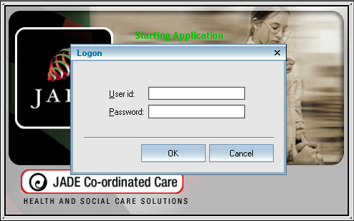

The first time you log in, you will be forced to change your password; when the *Change Password* window opens, update your password and click OK.

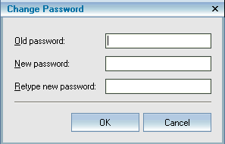

The JADE front screen will then appear.

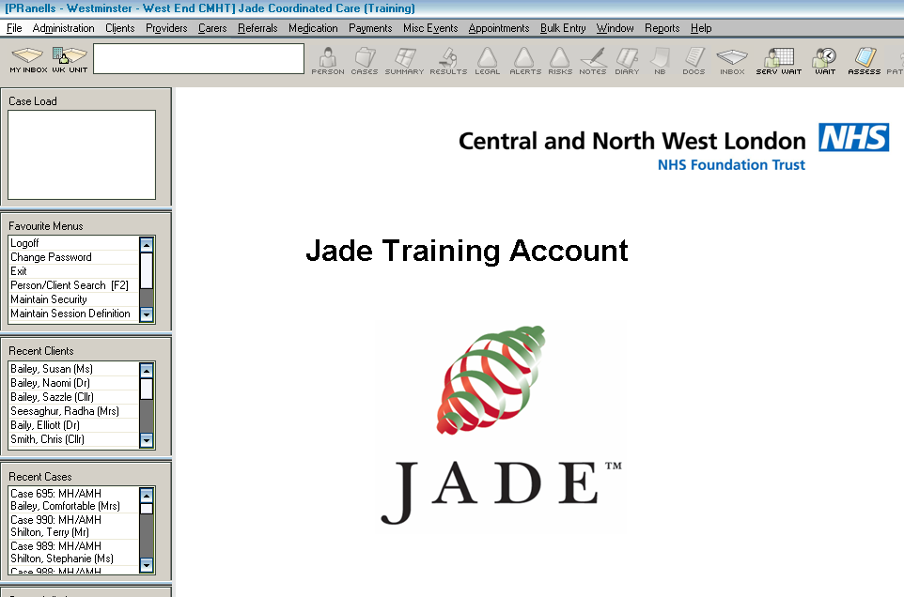

**Searching for Persons / Clients**

You will now need to search for the patient on JADE. The quickest way to get to the search screen is to press the F2 function button on the keyboard and the search window below will appear.

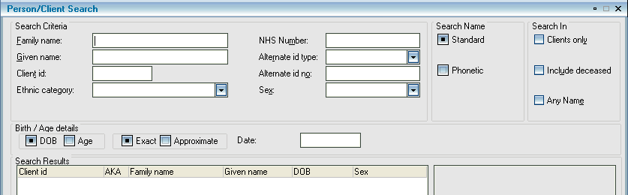

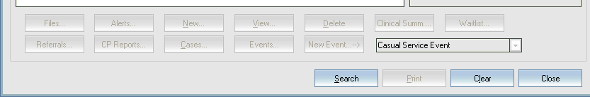

If you have a client’s NHS Number or JADE id, use those as they are unique, to search for the patient.

If you do not have a JADE Client id, type the patient’s name into the appropriate box(es) in the search window. **Less is more**. Search using the *Family name* first then use a **combination** of different parameters to break your search down, i.e. *Family/Surname*, *Given/First name*. **Do not rely on just one** **search parameter**. If you are not sure of the spelling include the *Phonetic* (sound like) search. If you are not sure of which is the first name or surname or the patient uses their middle name, use the *Any Name* search to help.

When you have found the patient, double click on their name to open the *Clinical Summary*.

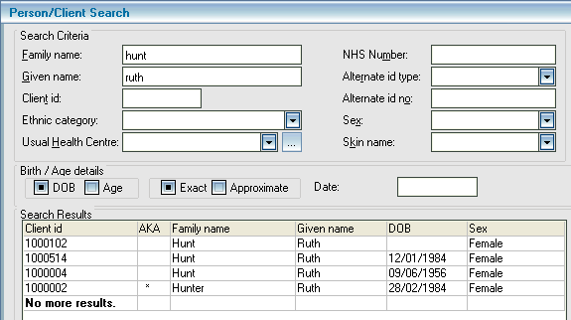

You will be asked to add a reason why you need access to the patient’s record

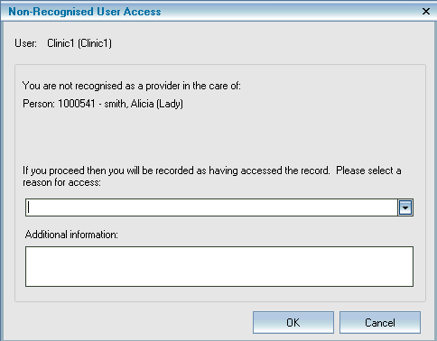

From the pick list select Duty / A&E Liaison service click on Medical Student

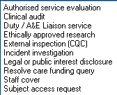

Add additional information to give specific reason(s) why you are accessing the record then click OK.

**Reading Alerts**

The *Clinical Summary* form will appear unless the patient has any alerts, in which case you will see the *Alerts and NBs* window first. Read the alerts then click OK.

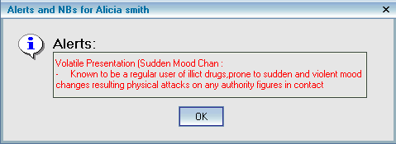

**Accessing the Clinical Summary**

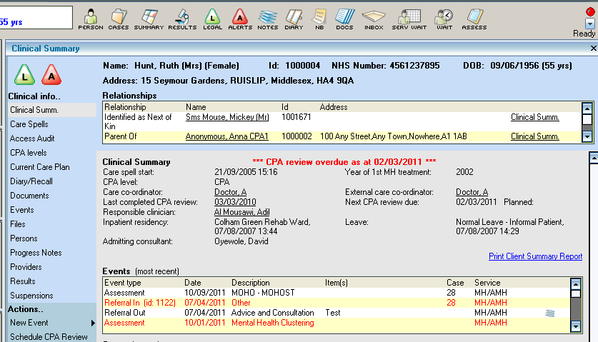

**Searching Progress Notes**

You can access a patient’s Progress Notes in two ways, either by clicking on the  icon at the top of the window, or by clicking on the  button on the left hand side of the screen.

You will also see individual notes attached to events in the *Events (most recent*) list; they will have a picture of a stack of paper next to them.

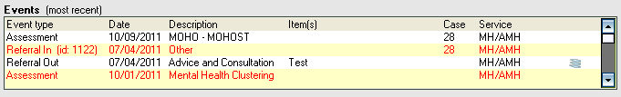

When the *Progress Notes Search* window appears you will be able to scroll through all the entries if you wish. Information in the **BOLD** headings on the right hand side of the windowwill include the date and time the note was written and who typed the note. If the note was written against an event you will see the event details.

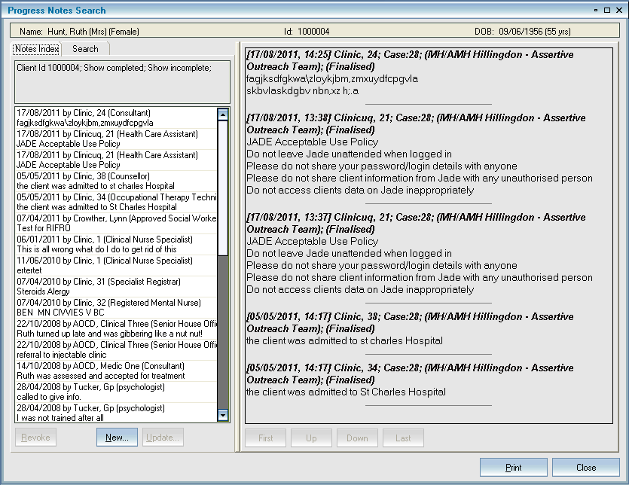

Use the search parameters to look for notes within a specific date range or by author or using key words in the *Containing text* box or notes written against events using the *Relating to* pick list box.

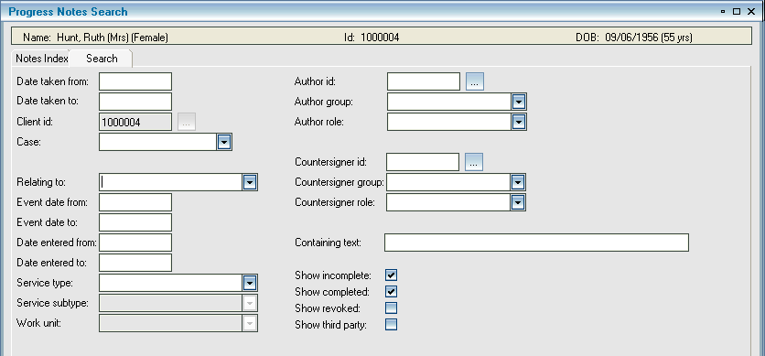

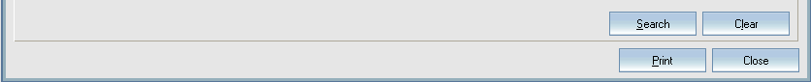

**Accessing Documents (correspondence)**

To access documents in a patient’s record, click on the  icon on the toolbar at the top of the window or on the left hand list of the clinical summary click  and the *Document Search Form* window will appear.

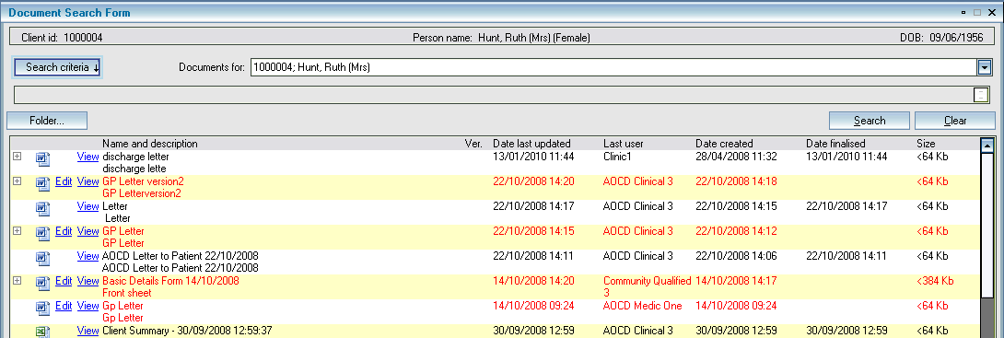

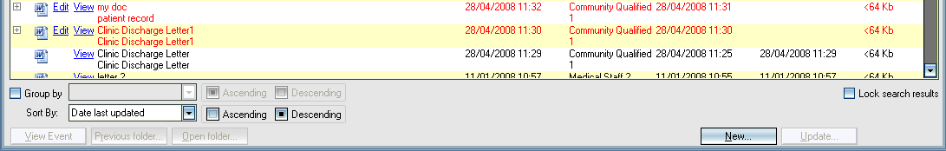

You will see all the documents attached to the patient’s record including any scanned &/or imported documents. The name and description should help you find the appropriate document you need to view. To view the document click on the  button for it to open.

**Accessing Assessments**

If you want to see any assessments attached to a patient’s record click on the  button on the toolbar at the top of the window of the patient’s *Clinical Summary* for the *Assessment Search* window to appear.

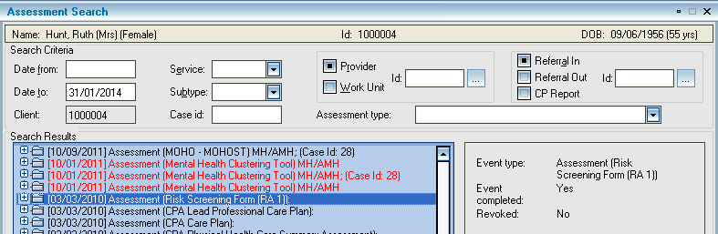

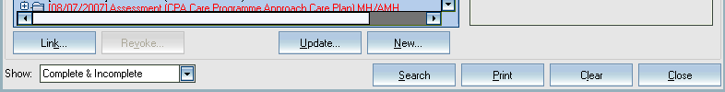

Double click on the assessment you want to view.

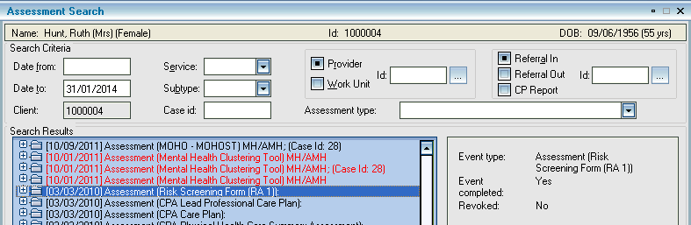

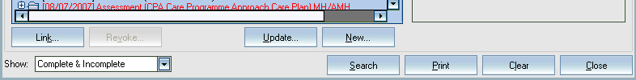

You can search for specific assessments using the *Assessment type* pick list and *Date from* and *Date to* boxes to search for a specific period of time.

**Further Help**

If you require further guidance please refer to the Quick Reference Guides available on Trustnet. [Trustnet\I Want to\Find a JADE QRG]

JADE training, if required, can be arranged with the IT Training Department, by contacting them by email [ittraining.cnwl@nhs.net](mailto:ittraining.cnwl@nhs.net).

For any IT or JADE issues please telephone 020 3214 5900 and select the appropriate option

# Library & Knowledge Services

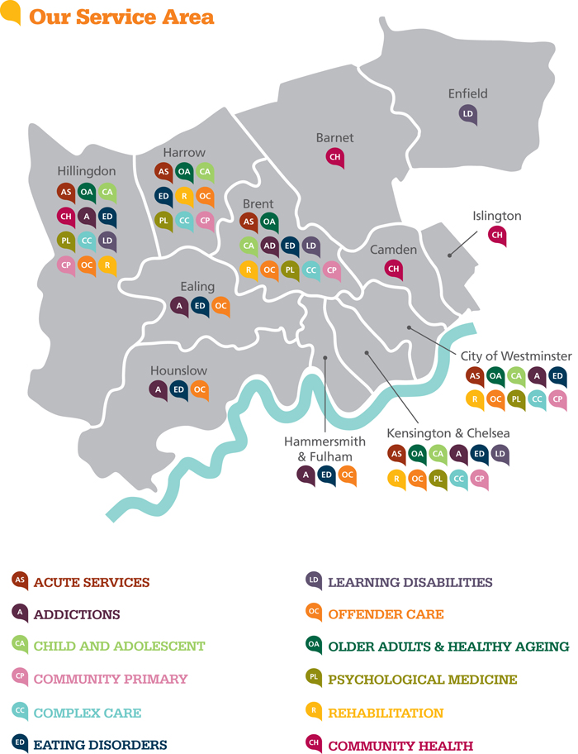

**Marco Isetta**

**Library & Knowledge Services Manager.**

**Also: Kingswood LD Resource Centre (Monday only 020 8238 0950)**

**Trust HQ, Stephenson House, 75 Hampstead Road NW1 2PL**

**Tel 020 3214 5881**

[**marco.isetta@nhs.net**](mailto:marco.isetta@nhs.net)

**Access – Membership**

All staff categories from the following agencies have full membership rights to CNWL-owned libraries:

* CNWL NHS Foundation Trust
* Medical and nursing students on placement
* Locum and bank staff

Full access is also offered by all sites at Imperial College and by the following NHS libraries:

* Northwick Park Hospital
* Central Middlesex Hospital
* Hillingdon Hospital
* Ealing Hospital
* Bloomsbury Healthcare

For opening hours and full details check Library pages on Trustnet

**Core Services**

1. Access to a wide range of **electronic information resources** (Health Sciences Databases, E-journals and E-books)
2. Access to local multi-disciplinary books and journals collections
3. Book loans
4. Enquiry and information searching service.
5. Free photocopying, printing and electronic delivery facilities.
6. Inter-regional and nationwide library arrangements. Locally unavailable references can be obtained via inter-library loan and photocopying schemes.
7. IT facilities at all sites (PCs and Internet access)
8. One-to-one or small group training in the use of electronic resources.

Training sessions should be booked in advance.

**We are happy to visit staff at their workplaces by arrangement.**

* Study and research support

1. Tailored current awareness bulletin
2. Quiet reading and study areas
3. **Helpful and friendly library and information professionals!!!**

***Please check out the Library & Knowledge Services pages on Trustnet (Resources section) for full details of access points, opening hours, range of services, training, leaflets, help sheets, etc***

**Useful websites**

**Athens logon (NHS Evidence, healthcare databases, e-journals and e-books)**

[**www.athensams.net/myathens/**](http://www.athensams.net/myathens/)

**Athens self-registration**

[**https://register.athensams.net/nhs/nhseng/**](https://register.athensams.net/nhs/nhseng/)

**NHS Evidence**

<http://www.evidence.nhs.uk/>

**Book catalogues**

**CNWL**

<http://www.librarything.com/catalog/cnwllibraries>

**NHS London Libraries**

<http://www.lhlcatalogue.nhs.uk/>

## CNWL Libraries

CNWL provides access to libraries at the following locations:

**GORDON HOSPITAL LIBRARY**

6th Floor, Gordon Hospital, Bloomburg Street, London SW1V 2RH  
Tel: 020 8237 2281  
Staffed: Monday 09:15-17:15

* Only staffed on Mondays
* Access at other times available by signing out a key from reception (24/7)
* Stock for loan and reference use
* Internet access available
* User training provided by the Librarian
* Literature searches provided by the Librarian
* Items available through inter-library loans.  Cost: free to CNWL staff

**ST. CHARLES HOSPITAL LIBRARY**

Kelfield House, St Charles Hospital, Exmoor Street, London W10 6DZ  
Tel: 020 8206 7362  
Staffed: Mon, Tues, Thurs, Fri 09:30-17:00  
Librarian: Mike Taylor

[**michael.taylor2@nhs.net**](mailto:michael.taylor2@nhs.net)

* Out of hours key code access to psychiatric staff – please see the LibrarianMajor mental health, nursing, and medical journals are taken and back files maintained
* About 600 books for loan or reference
* Internet access available
* User training provided by the Librarian
* Literature searches provided by the Librarian
* Items available through inter-library loans.  Cost: free to CNWL staff

**KINGSWOOD CENTRE LIBRARY**

134 Honeypot Lane, Kingsbury, London NW9 9QY  
Tel: 020 8238 0950  
Staffed: Monday 09.00-17.00  
Librarian: Marco Isetta

[**marco.isetta@nhs.net**](mailto:marco.isetta@nhs.net)

## ****NHS Libraries****

**NHS Libraries that CNWL staff and CNWL-placed students can use**

**CENTRAL MIDDLESEX HOSPITAL**

Library

ACAD Centre

Central Middlesex Hospital

Acton Lane

Park Royal

London

NW10 7NS

Tel: 020 8453 2504

Web: [http://www.cmhlib.demon.co.uk](http://www.cmhlib.demon.co.uk/)

Opening Times:

Monday-Friday 09:00-17:00

* CNWL staff may join as full members on production of ID badges.
* Stock of 4500 books and 130 journal titles (with back-files).
* Internet access available.
* User training provided by Library staff.
* Database searches provided by Library staff.
* Items available through inter-library loans.  Cost: free to CNWL staff on production of ID badges.
* The Library has special collections on psychiatry, child and adolescent psychiatry and psychotherapy.

**NORTHWICK PARK**

John Squire Library

Northwick Park and St Mark’s Hospitals

Watford Road

Harrow

Middlesex

HA1 3UJ

Tel: 020 8869 3322

Web: <http://www.johnsquirelibrary.org.uk/>

Opening Times:

Monday-Friday 09:00-18:00

* Multidisciplinary healthcare library, which provides services to all staff employed by CNWL.
* Houses a large range of books and journals covering biomedical sciences, clinical medicine, nursing and related subjects.
* Internet access is available.
* User training provided by Library staff.
* Database searches provided by Library staff.
* Items available through inter-library loans.  Cost: £1.50 an item.

**HILLINGDON HOSPITAL TRUST**

Library

Education Centre

Hillingdon Hospital

Pield Heath Road

Uxbridge

Middlesex

UB8 3NN

Tel: 01895 279250

Web: <http://www.thh.nhs.uk/Departments/Library/library.htm>

Opening Times:

Monday-Friday 09:00-17:00

24-hour entry codes available to registered users

* CNWL staff may join as full members on production of ID badges.
* Approximately 3400 books and 140 current journal titles.
* Subject coverage is multidisciplinary, including mental health material.
* Internet access available to all CNWL staff with IT accounts provided by Hillingdon Hospital.
* User training provided by Library staff.
* Database searches provided by Library staff.
* Items available through inter-library loans.  Cost: £1.00 an item.

**WEST LONDON MENTAL HEALTH TRUST**

Coombs Library

West London Mental Health Trust

Trust Headquarters

St. Bernard’s Wing

Uxbridge Road

Southall

Middlesex

UB1 3EU

Tel: 020 8354 8009

Opening times:

Monday-Friday 09:00-18:00

* CNWL SMS staff based in Ealing may join as full members upon production of ID badges
* Stock is multidisciplinary and includes approximately 2500 books and 75 current journal titles in mental health, substance misuse, nursing, allied health care and management, together with back runs of varying lengths
* Internet access is available via library log-ons
* Assistance with database searching is available from library staff
* Items available through interlibrary loans.  Cost: free to CNWL staff

**WEST MIDDLESEX UNIVERSITY HOSPITAL NHS TRUST**

Patricia Bowen, Library & Knowledge Service

West Middlesex University Hospital NHS Trust

Isleworth TW7 6AF

Tel: 020 8321 5968

Web: [http://www.wmuhnhst.demon.co.uk](http://www.wmuhnhst.demon.co.uk/)

Opening times:

Monday, Thursday, Friday 09:30-17:00; Tuesday, Wednesday 08:15-18:00

* Stock of 8000 books and 121 journal titles (with back-files).
* 24 hour access to the reference library.
* Internet access available.
* User training provided by Library staff.
* Database searches provided by Library staff.
* Items available through inter-library loans.  Cost: £2.00 for articles, £3.50 for books borrowed from the British Library, £2.00 for books borrowed from other libraries.

# Practice Based Medicines Management Tutorials for Undergraduate Medical Students

The CNWL clinical pharmacists will provide a practice based tutorial about common aspects of managing medicines to all Imperial undergraduate medical students on psychiatry placements in CNWL firms.

Each multidisciplinary team has a pharmacist. Students should identify the pharmacist working with their allocated firm and arrange a tutorial session.

**When the training occurs:**

The student and pharmacist need to agree a specified “ward round” during which the training begins.

**Duration of training:**

The pharmacist will use this identified ward show and explain to the student what their role is, and what aspects of patient care the pharmacist is considering as the prescribing is reviewed and planned.

Following the ward round the pharmacist will offer a further an informal tutorial covering the topics listed below, linking these to the patients that have just been reviewed.

**Topics to be covered during the tutorial** (in no specific order):

* how to use a BNF
* role of pharmacist in a multidisciplinary team
* how to write on a prescription chart and how to avoid prescribing errors
* importance of timely prescribing on the drug chart
* medicines reconciliation – how & why
* awareness of drug interactions (including with non-prescribed substances)
* medicine information sources available
* medicine related stages in the discharge process (including communication with GPs)

**How do I contact the pharmacist?**

The consultant will know who their pharmacist is.

If there is any doubt, contact the lead pharmacist for that borough/site. All pharmacists’ contact details are listed on trustnet.

# Student guidance for ethics and law case discussion – psychiatry course

**FAQs**

**What do we have to do?**

During your attachmentyou will be divided into **groups,** and in **week 6** will be required to deliver a **15 minute group presentation on a clinical case that you have identified.** A register will be taken, and the course organisers informed of any non-attendees**.**

You will be expected to **identify and analyse the ethical and legal aspects of the case, and to incorporate this analysis into a management plan.** Each presentation will be followed by a facilitated discussion. **You should then record details of your presentation, as well as the feedback you receive, in your logbook.**

**What are our learning outcomes?**

The handbook contains the full set of objectives for the psychiatry course. Below is a selection of the ones that have particular bearing on this assignment.

***General Adult Psychiatry***

* Identify and critically reflect on the ethical issues of individual cases, and incorporate these into a management plan.
* Assess capacity in a range of common clinical scenarios, making reference to the Mental Capacity Act.
* Describe the provision for assessment and treatment of psychiatric conditions under the Mental Health Act.
* Discuss the ethical issues raised by compulsory detention and treatment.

***Older Adult Psychiatry***

* Understand the ethical and legal issues relevant to old age psychiatry including capacity, driving and use of lasting power of attorney and court of protection.

***Learning Disability Psychiatry***

* Demonstrate an understanding of assessment of capacity in relation to clinical situations and ways of managing communication difficulties in the doctor-patient relationship.

**Why are we doing this?**

There had been concern that students received comprehensive teaching on ethics and law in Year 2, but didn’t have timetabled activities to apply their new skills to real clinical situations. This assignment redresses that imbalance, and helps in preparation for the F1 year. As junior doctors you will be dealing with issues such as capacity and confidentiality every day.

**When is the assignment due?**

The presentations normally happen on the Wednesday morning in Week 6 (final week). Students at Northwick Park will attend on Tuesday morning in Week 6.

**How do I know which group I’m in?**

Your induction pack may tell you which group you are in, but you will always receive an email with this information as well. You need to identify your other group members as you will be working with them on the group presentation.

**How do we find a case?**

As with the rest of your logbook, you need to be filling it in sooner rather than later! You may ask your firm leader ***early*** for help in identifying suitable cases or issues. As a group, it might be a good idea to have a meeting halfway through the rotation to see where you’ve got to. The case can come from **any setting**, not just the wards.

**What sort of case should we choose?**

Students from the last year addressed everything from lying to patients, to the question of anti-smoking legislation in locked wards. **Don’t feel restricted to issues such as compulsory treatment and detention under the Mental Health Act.** Some other examples are:

* Gaining collateral history about a psychotic patient who believes that people are conspiring against him.
* Prescribing medication for Alzheimer’s disease in the context of NICE’s restrictive guidance.
* Obtaining paracetamol levels in a patient who’s taken an overdose, but declining treatment.

The most important thing is that it must be a ***real*** case, with all the complexity that this entails!

**What should our presentation cover?**

Have a look at the assessment tool at the end of this FAQ. You don’t have to stick to the same order, but you should, in a logical fashion:

* identify one central question, and any relevant information
* conduct a legal and ethical analysis, and use this to
* construct a management plan

|  |
| --- |
| * + Be **precise** in your analysis   + Be **creative**!   + **Avoid too much information** (especially clinical)   + Keep your audience **awake**! |

There are two sample PowerPoint presentations (provided by previous groups) on the intranet, along with the actual mark sheets. The common pitfalls are to address too many questions, and not to link the analysis with management. Remember that **a significant part of the assignment is the discussion**, so think about how to get this going (the facilitator will help).

**What is the timing?**

Maximum 15 minutes for the group presentation, 20 minutes for the discussion, and then 5 minutes for feedback.

**What resources are available to use?**

You receive **a lecture on ethics and law in Week 1**, and this is available for review on the intranet (under introductory week and course material).

There are also **ethics and law modules available through webCT.** These e-modules are based on your year 2 teaching material, so the content should be familiar to you.

The modules on autonomy, confidentiality and the Mental Capacity Act are likely to be helpful with this assignment. Each module has a self–assessment section for you to review your learning and understanding. **During this rotation the self-assessment section of the Mental Capacity Act module is part of your compulsory formative assessment.**

**The student** intranet **also has some useful resources:**

**A Mental Health Act algorithm**

**A guide to Mental Capacity Act assessments**

Some useful weblinks are included below, but remember to be critical of all sources:

[www.gmc-uk.org/guidance/index.asp](http://www.gmc-uk.org/guidance/index.asp) - GMC guidance on medical ethics

[www.uq.edu.au/oppe/PDFS/Ethics_primer.pdf](http://www.uq.edu.au/oppe/PDFS/Ethics_primer.pdf) - a two page summary of ethical analysis

[www.dca.gov.uk/legal-policy/mental-capacity/mca-summary.pdf](http://www.dca.gov.uk/legal-policy/mental-capacity/mca-summary.pdf) - summary of Mental Capacity Act 2005

<http://www.dh.gov.uk/en/Healthcare/NationalServiceFrameworks/Mentalhealth/DH_078743> - summary of Mental Health Act 2007

<http://www.mind.org.uk> - mental health charity

**Don’t forget to** use your clinical team, and each other**!**

**Where should we go for our presentations?**

These details can be found in your induction pack. If in doubt please ask your peers and contact your undergraduate teaching coordinator (WLMHT: Annette.Mcmayo@wlmht.nhs.uk 0207 386 1305, CNWL: constanza.martinez@nhs.net 0203 214 5884). **Note that the venue for your presentations may be different from your attachment site**, so make sure you leave enough time to find it. **You will receive email directions on exactly where to go closer to the time of the presentation.**

**How will we be assessed?**

The ethics and law case presentation is mandatory. You must turn up in good time, and you must attend for your peers’ presentations as well. A register will be taken, and the names of those not attending will be passed to the course organisers for action. If you cannot attend, you must complete the absence form, complete with your peers’ signatures (copy on intranet).

Your presentation will be graded using the formative assessment tool found at the end of this FAQ. The group may choose to make photocopies of the completed form for everyone in the group. **The assessment sheet must be handed to the UMO at the end of the firm.**

**Do I have to record the case in my logbook?**

Yes! There is a specific section in the logbook for recording a brief description of your case, the analysis, and the conclusions. You should also transcribe some feedback from the assessment sheet into your logbook so you know what action to take.

Sharmini Rajenthran, v5, 29/09/11

# Psychiatry Ethics and Law Case Based Discussion – Formative Assessment

Group Name **.......................................................................** Centre **............................................**

Please grade the following areas, ticking the appropriate box. The standard expected is that of a thoughtful, reflective and competent doctor at the start of the Foundation programme.

|  |  |  |  |  |
| --- | --- | --- | --- | --- |
|  | Below  Expectations | Borderline | Meets  Expectations | Above  Expectations |
| **1. Defining the problem**  What is the clinical problem / key clinical features?  What are the ethical and/or legal issues raised?  What are the conflicts/dilemmas? |  |  |  |  |
| **2. Identifying additional information**  What are the perspectives of the patient and parents/family?  What are the relevant psychological and social aspects?  What is the empirical evidence relevant to decision making in this case? |  |  |  |  |
| **3. Reflection and analysis**  What are the different perspectives on the ethical and legal issues raised?  What are the strengths and weaknesses of these arguments?  How does the information/evidence available affect your ethical and legal assessment of the case? |  |  |  |  |
| **4. Integrating information and analysis – a holistic management plan**  How did you propose to move forward?  How do you explain this proposal in terms of your ethics/legal assessment and the available information/evidence? |  |  |  |  |
| **5. Involving other parties**  Which colleagues did you suggest involving?  Who else could you have involved?  What use have you made of the network of services and resources available? |  |  |  |  |
| **6. Group participation**  Have the students:  Shown evidence of team working in the presentation?  Contributed constructively to the facilitated discussion?  Responded to questions / feedback from their peers? |  |  |  |  |

|  |  |
| --- | --- |
| **Particular Strengths** | **Suggestions for development** |
| 1.  2. | 1.  2. |

Facilitator Name (please print and sign) **.....................................................................................**

Facilitator Grade: Consultant / SAS / SpR Date: **................................................................**