JADE read-only access

As a 5th year medical student completing your Psychiatry rotation, you will have the opportunity to access JADE, the main clinical electronic record system within CNWL NHS Trust. With Jade read-only access, you will be able to search for patients, access their clinical history and their progress notes.

You must ensure that you comply with policies relating to JADE use. In particular you must not access notes a) of patients not under the care of your supervising consultant AND b) patients you are not seeing as part of your psychiatric placement. Also, you must not give your username/password to any student (or other individual) and you must not print anything from JADE.

Inappropriate use of JADE may result in you being disciplined by the medical school and may result in referral to the GMC for breach of patient confidentiality.

You will be issued with two usernames and passwords.
The first username and password will give you access to the CNWL IT Network.
The second username and password will give you access to JADE itself.

Please see below instructions on how to access JADE. Please read them thoroughly. If you require further help please use the Quick Reference Guides available on Trustnet.

- You will receive a call log reference number in an email from the CNWL Undergraduate Teaching Coordinator.

- You need to call the IT Helpdesk and quote your call log reference number, in order to obtain your network login details. Their number is 0203 214 5900 - option 2 or ‘hold the line for the general IT Helpdesk’.

- Access the following link:
http://trustnet/sorce/apps/sorce_doc_manager/Actions/view_doc.aspx?docid=3783&revid=3863
(must be accessed via a CNWL PC)

- You need to accept the JADE Acceptable Use Policy by replying to my email (the one I sent you with your call log reference number) and state: I have read and understood the JADE Acceptable Use Policy and agree to comply with all its terms in my use of JADE.

- You will receive a call from the JADE Clinical Systems Support Team. You need to quote them your call log reference number to obtain your JADE login details.

For any issues or delay in obtaining your JADE login details, contact the JADE Clinical Systems Support Team on 0203 214 5900 - option 1 or via email css.cnwl@nhs.net (quoting your call log reference number).

- You can then access the JADE read-only electronic database.

ACCESS TO THE TRUST SYSTEM WILL ALSO ENABLE YOU TO HAVE AUTOMATIC ACCESS TO THE INTERNET, FROM WHICH YOU CAN ACCESS THE IMPERIAL COLLEGE STUDENT INTRANET.

Process for Managing Imperial College Medical Students December 2012

Below the system for managing the login process for medical students
 | Process | Escalation Type | Timescale | Actioned By
1 | Student call log reference numbers are created |  |  | IT Helpdesk  (and shared with the CSS Team)
2 | IT Helpdesk email Undergraduate Teaching Coordinator the student call log reference numbers | Email to Undergraduate Teaching Coordinator | A week before students start attachment
3 | Teaching Coordinator to email each student their unique call log reference number with instruction to call the IT Helpdesk to arrange their network login. | Undergraduate Teaching Coordinator emails undergraduate students | First Monday when Students attending IC Induction lectures | Undergraduate Teaching Coordinator for CNWL
4 | Student to call IT Helpdesk [0203 214 5900 - option 2 or ‘hold the line for the general IT Helpdesk’], quoting their unique call log reference number. IT Helpdesk then provides the student (over the phone) with their network login details to access the CNWL network. | Student calls IT Helpdesk |  | Student
5 | Student to log into the CNWL network: Click Ctrl+Alt+Delete- a pop up window appears and login details should be entered. | Student to log into the CNWL network |  | Student
6 | Any issues relating to network login to be reported by student to IT Helpdesk itservicedesk.cnwl@nhs.net |  | As soon as possible | IT Helpdesk
7 | JADE Acceptable Use:  Student to access the following link:  http://trustnet/sorce/apps/sorce_doc_manager/Actions/view_doc.aspx?docid=3783&revid=3863  (must be accessed via a CNWL PC) | Student reads the JADE Acceptable Policy document |  | Students
8 | Student to reply to the email received from the Undergraduate Teaching Coordinator with their call log reference number stating the text: I have read and understood the JADE Acceptable Use Policy and agree to comply with all its terms in my use of JADE. | Student emails Undergraduate Teaching Coordinator |  | Student
9 | Teaching Coordinator emails Information Governance (IG) and cc student, advising that the student has complied with IG requirements. In the email to Information Governance, Teaching Coordinator advises the student that Clinical Systems Support (CSS) team will provide them with their JADE read-only login details. | Teaching Coordinator |  | Undergraduate Teaching Coordinator
10 | CSS Team to call the student and provide the student (over the phone) with their JADE read-only login details. The student will need to quote their call log reference number. | CSS team |  | CSS Team
11 | Any issues relating to JADE login to be reported to css.cnwl@nhs.net | CSS team | As soon as possible | CSS Team

JADE Guide for Imperial College Medical Students Rotations v9

Introduction
The objective of this guide is to assist you in the read only access use of the main functionality in JADE relating to your clinical roles and to make you aware of the Information Governance and Security issues when using the system.
The topics covered are:
- Information Governance
- Security
- Searching for Persons / Clients
- Reading Alerts
- Accessing the Clinical Summary
- Searching Progress Notes
- Accessing Documents (correspondence)
- Accessing Assessments
- Further Help

Information Governance

- JADE contains lots of information about service users, their carers, families and others. The data is personal, sensitive and confidential
- JADE information is accessed and shared on a ‘need to know’ basis
- Directly providing or supporting healthcare is a good reason for access. Other reasons need to be justified
- Make sure that your use of JADE is compliant by following the JADE Acceptable Use Policy on Trustnet. You will only be given access to JADE when you have read this document together with the Access to JADE form, the latter of which will also need to be signed off as indicated
- Non Trust staff are required to sign the Acceptable Use Policy. Trust staff will find that the requirements are incorporated into their contracts
- JADE is a secure system, so remember:
  - Your use of JADE may be monitored
  - Service users have the right to request a full copy of their JADE record plus details of everyone who has accessed it. In the event of your being asked by a patient to supply such information, please refer them to your CNWL Team Manager
  - Keep your password secret. It is for your exclusive use

Security

- Never leave JADE unattended when logged in. Exit the system by clicking on the ‘X ‘ button in the top right hand corner of the screen
- Never share your password/login details with anyone
- Never share client information from JADE with any unauthorised person
- Do not access clients’ data on JADE inappropriately

Password
- Expires every 30 days
- 5 grace logins
- 5 – 10 characters
- Must include at least 1 numeral
- Times out after 10 minutes of inactivity then exits JADE after another 100 minutes

You will need a JADE login id and password, which will be given to you by a member of the JADE team by phone. Log in by double clicking the JADE icon on the desktop. When the login window appears type in your User id and password and click the OK button.
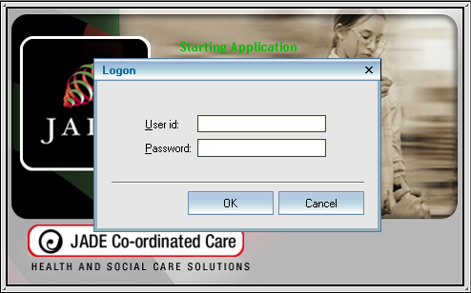

The first time you log in, you will be forced to change your password; when the Change Password window opens, update your password and click OK.
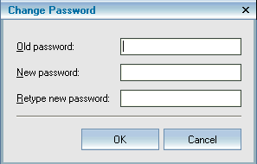

The JADE front screen will then appear.

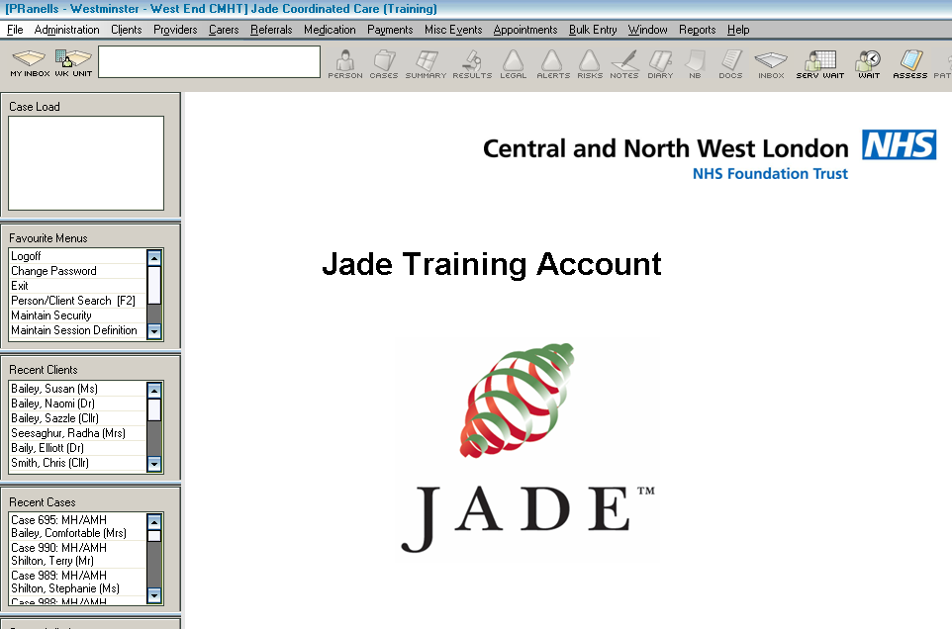

Searching for Persons / Clients

You will now need to search for the patient on JADE. The quickest way to get to the search screen is to press the F2 function button on the keyboard and the search window below will appear.

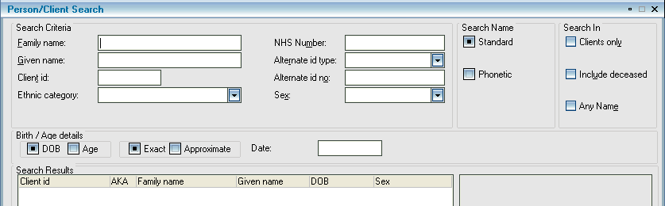

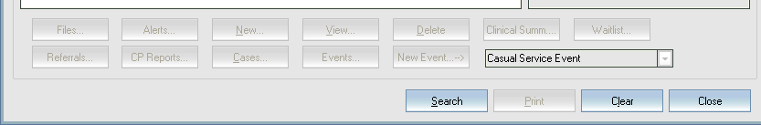

If you have a client’s NHS Number or JADE id, use those as they are unique, to search for the patient.
If you do not have a JADE Client id, type the patient’s name into the appropriate box(es) in the search window. Less is more. Search using the Family name first then use a combination of different parameters to break your search down, i.e. Family/Surname, Given/First name. Do not rely on just one search parameter. If you are not sure of the spelling include the Phonetic (sound like) search. If you are not sure of which is the first name or surname or the patient uses their middle name, use the Any Name search to help.
When you have found the patient, double click on their name to open the Clinical Summary.

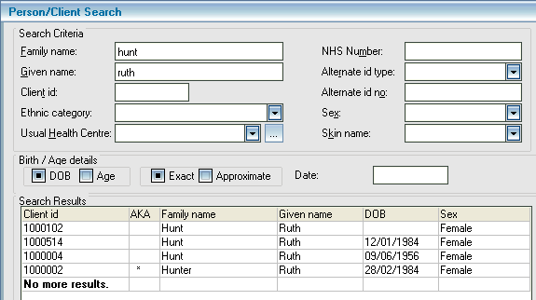

You will be asked to add a reason why you need access to the patient’s record

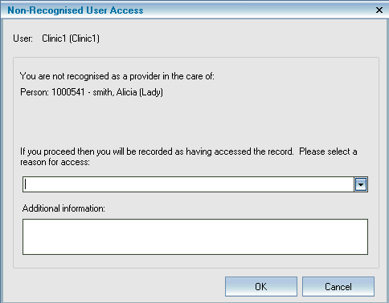

From the pick list select Duty / A&E Liaison service click on Medical Student
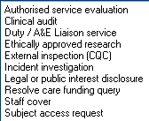

Add additional information to give specific reason(s) why you are accessing the record then click OK.

Reading Alerts

The Clinical Summary form will appear unless the patient has any alerts, in which case you will see the Alerts and NBs window first. Read the alerts then click OK.

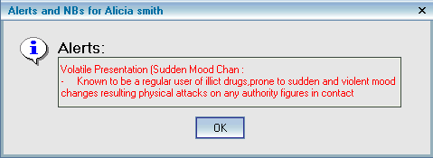

Accessing the Clinical Summary
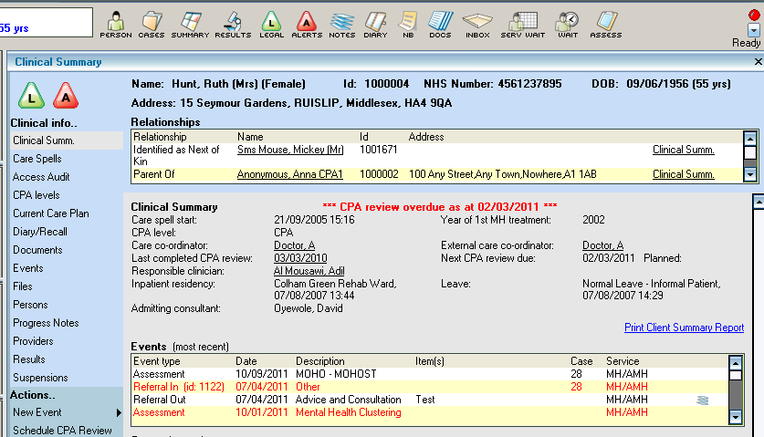

Searching Progress Notes
You can access a patient’s Progress Notes in two ways, either by clicking on the icon at the top of the window, or by clicking on the button on the left hand side of the screen.
You will also see individual notes attached to events in the Events (most recent) list; they will have a picture of a stack of paper next to them.
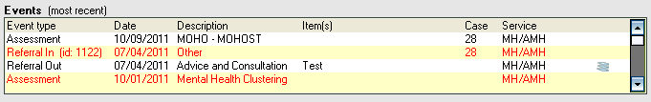

When the Progress Notes Search window appears you will be able to scroll through all the entries if you wish. Information in the BOLD headings on the right hand side of the window will include the date and time the note was written and who typed the note. If the note was written against an event you will see the event details.

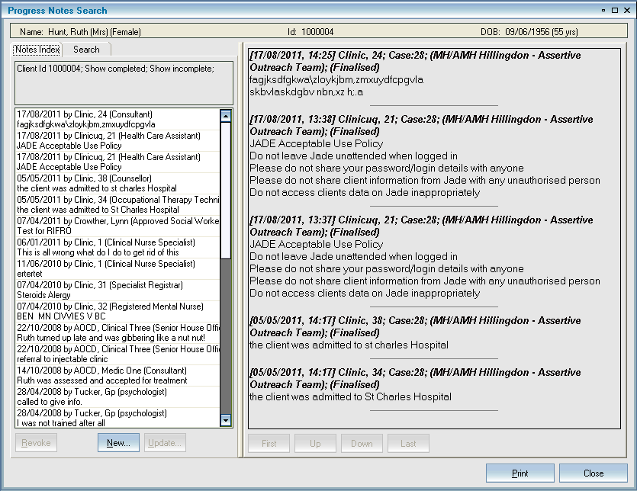

Use the search parameters to look for notes within a specific date range or by author or using key words in the Containing text box or notes written against events using the Relating to pick list box.

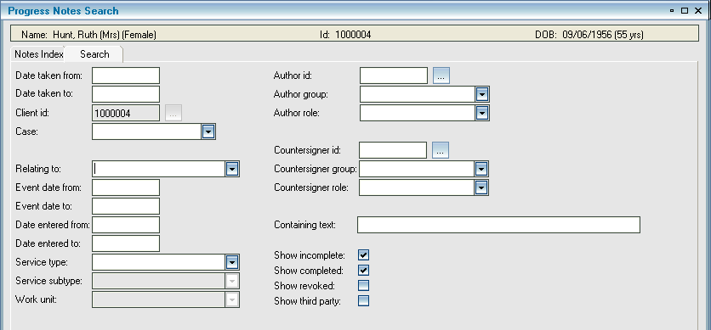

Accessing Documents (correspondence)
To access documents in a patient’s record, click on the icon on the toolbar at the top of the window or on the left hand list of the clinical summary click and the Document Search Form window will appear.
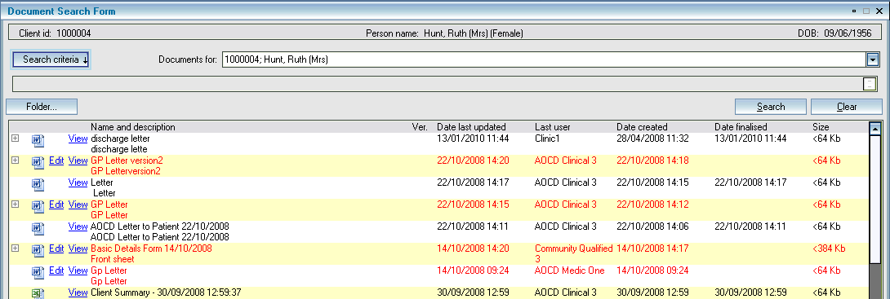

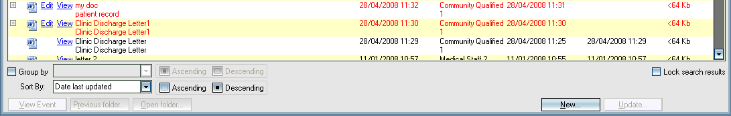

You will see all the documents attached to the patient’s record including any scanned &/or imported documents. The name and description should help you find the appropriate document you need to view. To view the document click on the button for it to open.

Accessing Assessments

If you want to see any assessments attached to a patient’s record click on the button on the toolbar at the top of the window of the patient’s Clinical Summary for the Assessment Search window to appear.
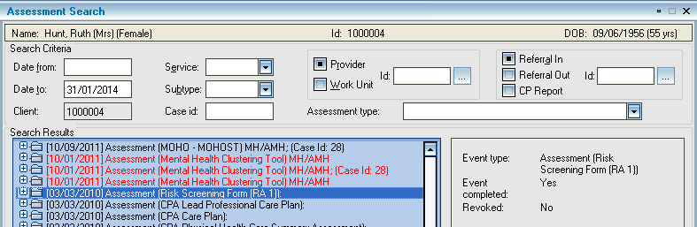

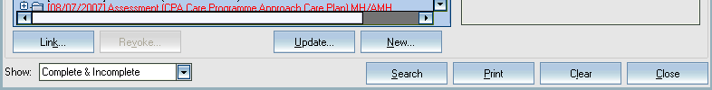

Double click on the assessment you want to view.

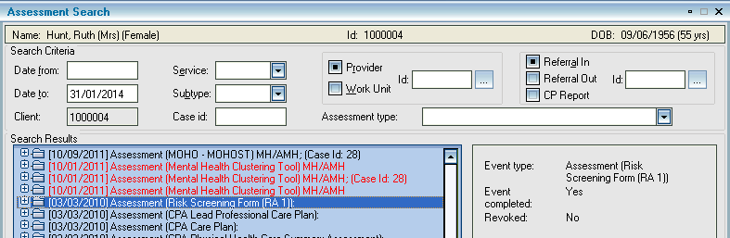

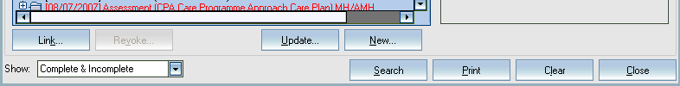

You can search for specific assessments using the Assessment type pick list and Date from and Date to boxes to search for a specific period of time.

Further Help

If you require further guidance please refer to the Quick Reference Guides available on Trustnet. [Trustnet\I Want to\Find a JADE QRG]

JADE training, if required, can be arranged with the IT Training Department, by contacting them by email ittraining.cnwl@nhs.net.

For any IT or JADE issues please telephone 020 3214 5900 and select the appropriate option

