­­­

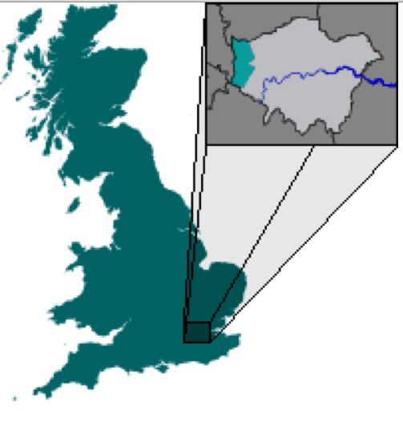

**Central and North West London NHS Foundation Trust**

**Mental Health Services in Hillingdon­­­**

**Sites attended by medical students with maps**

[How to get to Hillingdon Hospital 3](#_Toc338670185)

[Buses from Hillingdon 4](#_Toc338670186)

[Hillingdon Hospital - site 5](#_Toc338670187)

[HDAS, CFACS, MILL HOUSE, MEAD HOUSE & HILLINGDON HOSPITAL 6](#_Toc338670188)

[HDAS & CFACS on the map 7](#_Toc338670189)

[Hillingdon Drug & Alcohol Services (HDAS) 7](#_Toc338670190)

[CFACS 8](#_Toc338670192)

[Mill House, Hillingdon Assessment & Brief Treatment Service Team 9](#_Toc338670194)

[Mead House - Community Recovery Team (South) 10](#_Toc338670196)

[Pembroke Centre - Community Recovery Team (North) 11](#_Toc338670198)

# How to get to Hillingdon Hospital



# Buses from Hillingdon

|  |
| --- |
| **C:\Documents and Settings\martinec\Desktop\buses from Hillingdon Hospital.jpg** |

# Hillingdon Hospital - site

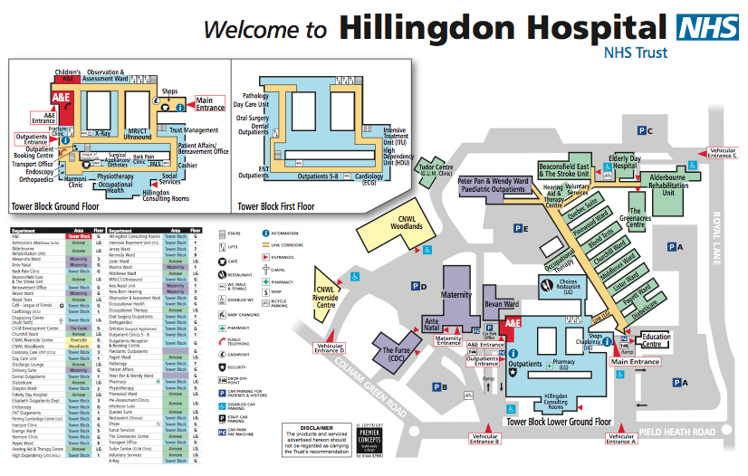

# 1 HDAS, 2 CFACS, 3 MILL HOUSE, 4 MEAD HOUSE & 5 HILLINGDON HOSPITAL

|  |
| --- |
|  |

|  |
| --- |
| HDAS & CFACS on the map |
| C:\Documents and Settings\martinec\Desktop\HDAS & CFACS.jpg |
| Hillingdon Drug & Alcohol Services (HDAS) Old Bank House, 64 High Street, Uxbridge UB8 1JP |
| HDAS-Old Bank Hse |
| Hillingdon Drug & Alcohol Services are a combined health and social care service providing treatment for individuals with drug and alcohol problems and their carers.  This multi-disciplinary team provides a comprehensive specialist addictions service to Hillingdon residents. |
| CFACS1 Redford Way, Uxbridge UB8 1SZ |
| C:\Documents and Settings\martinec\Desktop\CFACS-street view copy.jpg |
| The **Child, Family and Adolescent Consultation Service (CFACS)** offers services for young persons from the ages of 0-18 presenting with emotional, behavioural and other mental health problems. The service offers a variety of treatments, including family therapy, individual therapy, group therapy and parent/infant therapy. |

|  |
| --- |
| **Mill House, Hillingdon Assessment & Brief Treatment Service Team**  **38 Riverside Way, Uxbridge UB8 2YF** |
| **Mill House** |
| The Assessment and Brief Treatment Team is the single point of planned referral to Mental Health Services in Hillingdon for adults of working age.  The Team provides multidisciplinary assessment of individuals referred; short term, evidence-based interventions and advice and support to GPs.  The team comprises a mix of mental health practitioners including psychiatrists, approved social workers, nurses, occupational therapists and psychologists. |

|  |
| --- |
| **Mead House - Community Recovery Team (South)**  **Hayes End Road, Hayes UB4 8EW** |
| Mead House_2 |
| **Mead House_1** |
| The Community Recovery Team based at Mead House provides longer term focused support (care coordination) to those with severe and enduring mental health difficulties, who live in South Hillingdon. Service users are primarily supported through the mechanism of the Care Programme Approach (CPA).  The team comprises a mix of mental health practitioners including psychiatrists, nurses, social workers, occupational therapists and psychologists. |
| **Pembroke Centre - Community Recovery Team (North) –**  **90 Pembroke Rd, Ruislip HA4 8NQ** |
| Pembroke Centre |
| **C:\Documents and Settings\martinec\Desktop\Pembroke Centre.jpg** |
| The Community Recovery Team based at the Pembroke Centre provides longer term focused support (care coordination) to those with severe and enduring mental health difficulties, who live in North Hillingdon. Service users are primarily supported through the mechanism of the Care Programme Approach (CPA).  The team comprises a mix of mental health practitioners including psychiatrists, nurses, social workers, occupational therapists and psychologists. |