Examination of the knee

LOOK
1) Deformities
eg genu valgum, genu varum, genu recurvatum
2) Position of the patella
3) Swellings – where, for how long, how does it feel
4) Muscle wasting – which muscles
5) Redness

FEEL
- Fluid
- Thickening
- Warmth
- Crepitus
- Palpate joint line…..NB Knee should be in flexed position
- Clicking
- Tenderness over ligament and ligaments, tendon insertions, bursas etc

Tests for swelling

- Patella tap test

First you must compress the synovial fluid from the suprapatellar pouch into the knee joint. Then sharply tap the lower pole of the patella against the underlying femur with the index finger. When sufficient fluid is present within the joint the patella can be felt to tap against the femur and then float free.
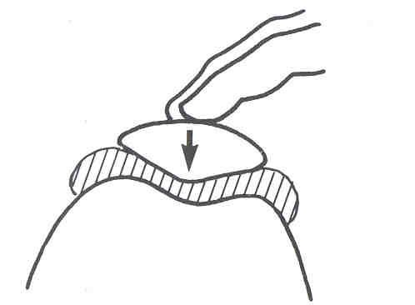

- Patella bulge sign

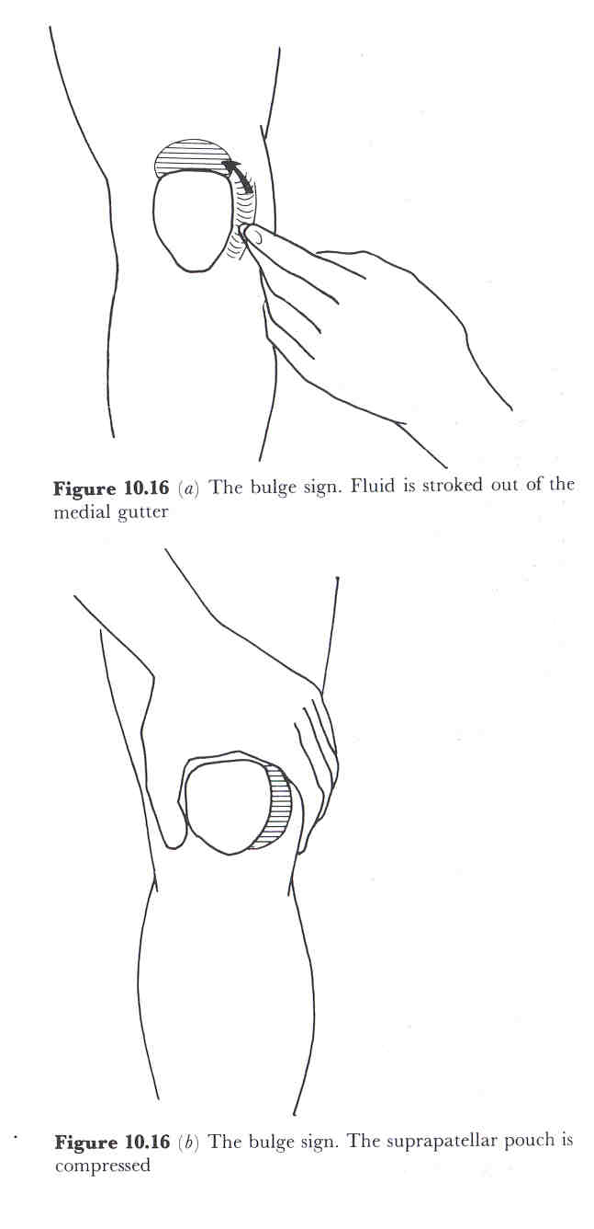
Palpate the medial compartment of the knee joint just under the medial border of the patella and stroke any fluid upwards into the suprapatellar pouch a). Then with the other hand compress the suprapatellar pouch which will force any fluid present distally where it can be seen to bulge outwards in a wave like motion b). Repeat with hand over both side of patella, see diag c)
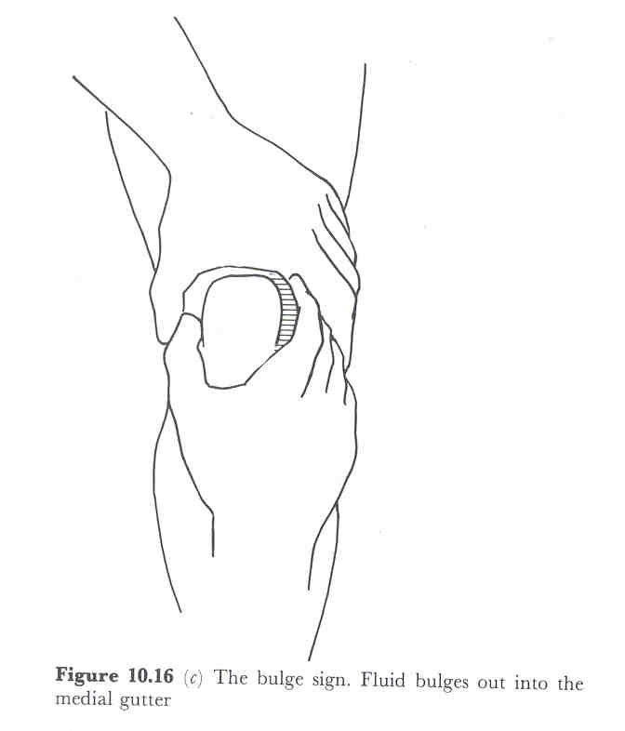

MOVE

- Movements
a) active how far, any pain etc, any quads lag
b) passive as above, any flexibility problems
- isometric tests on quads and hams

SPECIAL TESTS

Anterior Draw Test
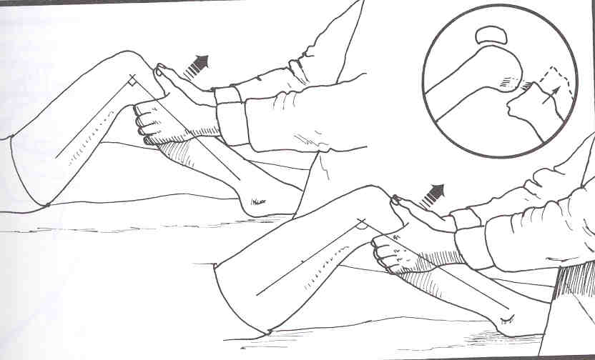
Traditionally used to investigate rupture of the anterior cruciate ligament. To perform the test flex the knee to 90 degrees, with the foot pointing straight forwards and steady the foot by sitting on it. Grasp the leg firmly with your thumbs on the tibial tubercle, check hamstrings are relaxed and jerk the leg towards you. Note degree of displacement of the tibia moving anterior on the femur, if this is excessive the ACL is likely to be damaged.

Posterior Draw Test/ Tests for PCL deficiency

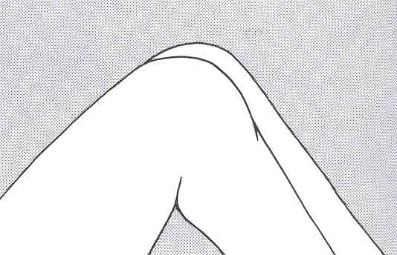
Initially observe position of the two knees at rest. A posterior cruciate deficient knee tends to be held in this rest position with the knee subluxed posteriorly.

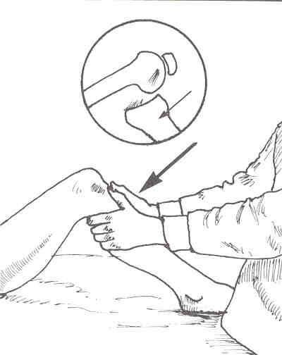

For the posterior draw test, again position the knee in approximately 80-90 degrees flexion and sit on the foot to steady it. Attempt to jerk the tibia backwards. Greater displacement of one side relative to the other is indicative of PCL deficiency.

Collateral Ligaments

- Medial Tibiofemoral compartment (predominately MCL)

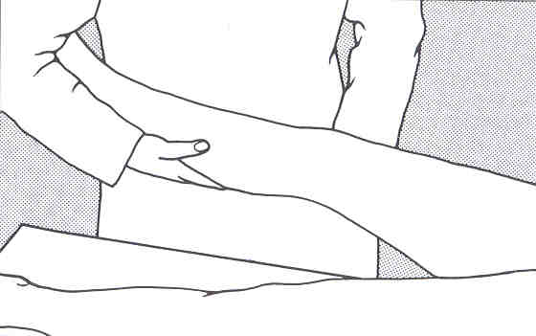
The patient should be in supine lying with the hip slightly abducted. Flex the knee to 30 degrees, place the patient’s lower leg under your right arm and use right hand to steady low leg. Place left hand over lateral aspect of the knee. Move knee gently into abduction until pain is produced over the medial compartment or subluxation and gapping of the medial joint line is shown. Repeat the test with the knee straight.

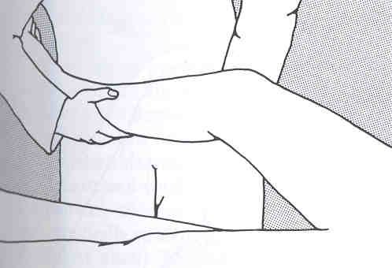

It the test is positive with the knee flexed to 30 degrees but negative with the knee fully extended it implies that the medial collateral ligament has been damaged. If it is positive in both positions it indicates that the cruciate and medial capsular ligaments have been damaged.

- Lateral Tibiofemoral compartment (predominately LCL)

Similar to medial compartment test but the hands are changed over to apply an adduction stress to the knee.

If the test is positive with the knee flexed to 30 degrees but negative with the knee fully extended it implies that the lateral collateral ligament has been damaged. If it is also positive in extension it implies damage has also occurred to the cruciate and LCL.

McMurray’s Test (Mensici posterior or middle thirds)

With the patient supine and the hip and knee flexed. If a medial meniscus tear is suspected externally rotate and abduct the lower leg, maintain this position of the lower leg and slowly extend the knee. A painful click indicates a positive test. In cases of suspected lateral meniscus tear the knee is internally rotated and slowly extended whilst the examiner palpates over the joint line.
This test identifies tears in the posterior or middle thirds of the meniscus.

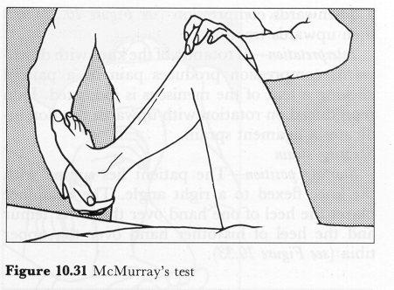

Apley’s grind test

With the patient in prone with the hip extended and the knee flexed to 90°, the examiner may need to place his knee across the back of the patient’s thigh to stabilise it, the lower leg is internally and externally rotated while at the same time applying first a downwards compression and then an upwards traction.

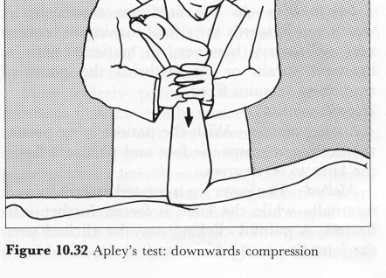

If rotation with downwards compression produces pain or a painful clicking a tear of the meniscus is indicated. Pain on an upwards rotation suggests a ligament injury.

Lachman’s test

With the knee flexed at 30° and the patient relaxed, the lower leg may be drawn forward on the upper leg by firmly stabilising the femur and drawing the tibia forward on the femur. Increased excursion on this test is pathognomonic of a torn ACL. The end point should be graded as hard or soft. The end point is said to be hard when the ACL abruptly halts the forward motion of the tibia on the femur. It is soft when there is no ACL, and the restraints are the more elastic secondary stabilisers.

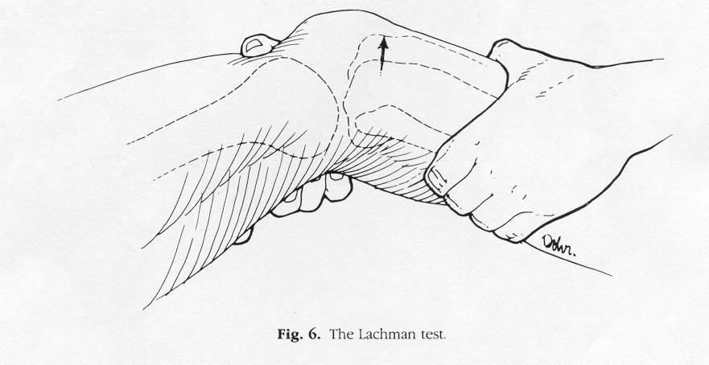

Pivot shift test

Helps to determine if there is abnormal translation and rotation of the medial and lateral compartments of the knee.
Various forms ~ Commonest Losee test
The patient should be completely relaxed with no tension in the hamstrings. Apply a valgus force to the knee and at the same time push the fibular head anteriorly. The knee should be partly flexed. Now extend the joint. As full extension is reached a dramatic clunk will occur as the lateral tibial condyle subluxes forwards (if rotatory instability is present).

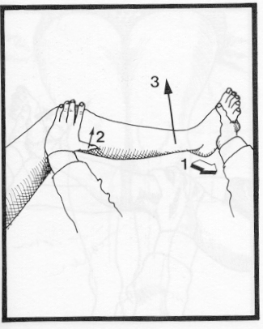

The apprehension test

The examiner pushes outwards against the medial border of the patella while flexing the knee with his other hand. As the patella begins to subluxate laterally, the patient feels pain and becomes acutely aware that the patella is about to dislocate. He/she actively resists any further attempt to move the patella by contracting the quadriceps.



