BSc Pharmacology – Module 1
Principles of Pharmacodynamics and Pharmacokinetics
Drug Metabolism Tutorial

Q1 – Answer the following general questions on drug metabolism:
- List three consequences of metabolism.
- Where in the cell is CYP450 located?
- Give two examples of phase 1 and 2 transformations and name the co-factors/enzymes required.
- Which of following are required by CYP450 – NADPH/O₂/Zinc/H₂O/NADH-CYP450- reductase?
- Is N-demethylation a result of C-oxidation or N-oxidation?
- Is glutathione conjugation the result of a chemical reaction or an enzyme mediated reaction?
- Which amino acid is commonly used in amino acid conjugation reactions?
- What biotransformation might inorganic mercury undergo in a biological system?

Multiple choice; Choose the most appropriate answer:
Q2 – The phenomenon of enterohepatic recirculation of a chemical causes:
- a decrease in the volume of distribution
- an increase in the whole body half-life of a chemical
- a decrease in the metabolism of the compound
- a decrease in the whole body half-life
- zero order elimination of the chemical
Q3 – the term ‘first-pass effect’ means which of the following:
- the drug is excreted unchanged
- the drug is mostly metabolised by the GI tract and/or liver before reaching the systemic circulation
- the drug is completely absorbed from the GI tract
- the drug is excreted completely and very quickly by the kidneys
- none of the above

Q4 - Write notes on the following:
- Glutathione
- Biliary Excretion
- Gut Bacteria and Drug metabolism

Q5 – The structures of aspirin, isoniazid and paracetamol are shown below – show the likely Phase 1 and 2 biotransformations of each drug and name the enzymes/co-factors required for each reaction. Where would you expect the metabolites you identify to be excreted.

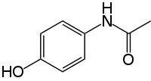
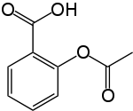
Aspirin

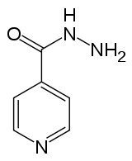
Paracetamol

Isoniazid

