BSc Pharmacology – Module 1
Principles of Pharmacodynamics and Pharmacokinetics
Drug Metabolism Tutorial

Q1 – Answer the following general questions on drug metabolism:
- List three consequences of metabolism: accumulation avoided, biological half-life decreased, duration of exposure is reduced and duration of biological activity is affected.
- Where in the cell is CYP450 located? Smooth Endoplasmic Reticulum (SER), microsomes.
- Give two examples of phase 1 and 2 transformations and name the co-factors/enzymes required. E.g. 1: aromatic hydroxylation, aliphatic hydroxylation, ester and amide hydrolysis, N-oxidation etc. 2: glucuronidation, sulphation, acetylation, amino acid conjugation, GSH conjugation
- Which of following are required by CYP450 – NADPH/O₂/Zinc/H₂O/NADH-CYP450- reductase? NADPH and O₂ and NADH-CYP450- reductase
- Is N-demethylation a result of C-oxidation or N-oxidation? C-oxidation, generally proceeds via hydroxyalkyl intermediate that is unstable and spontaneously rearranges with loss of corresponding aldehyde.
- Is glutathione conjugation the result of a chemical reaction or an enzyme mediated reaction? Either
- Which amino acid is commonly used in amino acid conjugation reactions? Glycine
- What biotransformation might inorganic mercury undergo in a biological system? Typically methylated.

Multiple choice; Choose the most appropriate answer:

Q2 – The phenomenon of enterohepatic recirculation of a chemical causes:
- a decrease in the volume of distribution
- an increase in the whole body half-life of a chemical
- a decrease in the metabolism of the compound
- a decrease in the whole body half-life
- zero order elimination of the chemical

- an increase in the whole body half-life of a chemical
Enterohepatic recirculation involves the excretion of a drug or its metabolites into the bile followed by reabsorption from the intestine. This may occur several times. Therefore the overall elimination of the drug from the body is decreased because of this recycling between liver and intestine. Hence the whole body half-life is increased.

Q3 – the term ‘first-pass effect’ means which of the following:
- the drug is excreted unchanged
- the drug is mostly metabolised by the GI tract and/or liver before reaching the systemic circulation
- the drug is completely absorbed from the GI tract
- the drug is excreted completely and very quickly by the kidneys
- none of the above

- the drug is mostly metabolised by the GI tract and/or liver before reaching the systemic circulation
The first-pass effect is where a drug is removed by metabolism in the organ/tissues through which it passes during absorption and before reaching the systemic circulation. This is commonly the GI tract and liver but could also be the lungs or skin.
Q4 - Write notes on the following:
- Glutathione
- Biliary Excretion
- Gut Bacteria and Drug metabolism
(a) Glutathione is a tripeptide (Glu, Gly, Cys) found in most mammalian tissues but especially the liver (conc > 5 mM). Cystine has a free –SH (sulphydryl) group which is crucial in function of glutathione, it can exist in reduced (GSH) or oxidised (GSSG) forms. Important toxicologically as (a) reacts with and detoxifies reactive electrophilic chemical intermediates (b) conjugated enzymatically with many chemicals which are excreted into bile or as mercapturates into urine (c) it can act as an antioxidant and reduce/detoxify free radicals and similar reactive intermediates and becomes itself GSSG.
(b) Excretion of chemicals from the body via the bile. The secretion of bile from the liver involves active transport of substances from the hepatocyte. Therefore the excretion of foreign chemicals may be saturated by high concentrations or affected by hepatic metabolic dysfunction. Excretion of chemicals into the bile is affected by the molecular weight of the chemical, its charge and the species of animal. Thus there is a MW cut-off or threshold which varies between species (eg 300 rat 400-500 human).
(c) The gut bacteria are important with respect to drug metabolism/toxicology because of their ability to metabolise xenobiotics. This may be important when a compound is administered orally and the bacteria of the GI tract convert the compound into metabolites that may be toxic or may alter the bioavailability of the compound. The gut bacteria are also important in metabolising compounds secreted into the bile and eliminated by the GI tract. This may result in cleavage of conjugates such as glucuronides and reabsorption of the original compound.
Q5 – The structures of aspirin, isoniazid and paracetamol are shown below – show the likely Phase 1 and 2 biotransformations of each drug and name the enzymes/co-factors required for each reaction.
Aspirin: Important reactions we discussed are ester hydrolysis to salicylic acid, conjugation with gucuronic acid and glycine. Also further hydroxylation to gentisic acid.
Remember to list all enzymes and co-factors.
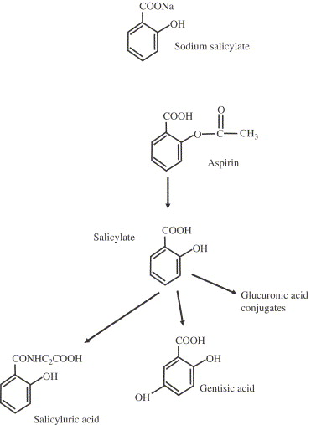

Paracetamol: We discussed the glucuronidation (ca 50% metabolism), sulphation (ca. 40% metabolism) and very minor methylation reaction of catechol (hydroxylation of paracetamol and formation of OMe, not shown in scheme below). Also, toxic, electrophilic reactive metabolite, NAPQI and how this is detoxified with GSH.
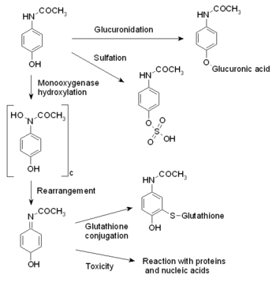

Isoniazid: We discussed acetylation as an important reaction (see AcINH in scheme below, link to polymorphism lecture) and also hydrolysis to isonicotinic acid (INA) and conjugation with glycine. The other conjugation reactions where hydrazones are formed (eg with pyruvate, ketoglutarate) you do not need to know but shown for completeness.

