# global health studies logo-3.jpgglobal health studies logo-2.jpgglobal health studies logo-1.jpg

# BSc in Medical Sciences with Global Health, 2012-2013

# Introductory Module (Part A)

Module director: Helen Ward ([h.ward@imperial.ac.uk](mailto:h.ward@imperial.ac.uk) )

Administrator: Helen King [Helen.king@imperial.ac.uk](mailto:Helen.king@imperial.ac.uk)

Teaching Fellow: Mariam Sbaiti [m.sbaiti@imperial.ac.uk](mailto:m.sbaiti@imperial.ac.uk)

Contents: This module will provide a broad overview including the scope of global health, the range of disciplines contributing to global health scholarship, and an introduction to globalization and health. We will also begin the research methods theme which will continue through each of the modules. There will be group presentations on the Millennium Development Goals. The module also contains the introductory session of the Humanities in Global Health stream.

Lecturers: Helen Ward (HW), Mariam Sbaiti (MS), Teresa Norat (TN), Doris Chan (DC) and Jackie Cousins (JC).

## Intended Learning Outcomes

At the end of this module, students will be able to:

* Be aware of your roles and responsibilities on the course and of the learning support available during your studies
* Outline the differences between the main definitions of global health and identify a working definition of the field
* list the major disciplines used in global health research and practice
* describe the key measures of mortality and morbidity and how they can be used to compare the disease burden between regions
* outline the main epidemiological study designs and their uses in investigation
* describe the leading causes of death and disability at the global level
* describe basic epidemiological study designs
* interpret evidence including applying concepts of association and causality
* critically appraise articles and reports on global health
* list the Millennium Development Goals and outline how they are measured and progress towards them
* Discuss in more detail the measures and progress on one particular MDG
* work effectively and collaboratively in small groups
* discuss the relevance of Humanities in Global Health

## Tutor Groups

Students will each be assigned to a tutor group and should expect to meet in their tutor groups twice during the Introductory module. Tutors will contact their students directly to arrange these meetings. If you have not heard from your tutor by the start of the Module, please contact Helen King ([Helen.King@imperial.ac.uk](mailto:Helen.King@imperial.ac.uk) ).

## Assessment

This will be assessed by a single piece of in-course assessment, which consists of a group work task on one of the Millennium Development Goals (see below). Failure to contribute to or to complete this can result in you being withdrawn from the BSc. While the mark for this in-course assessment will not contribute to your BSc mark, the material taught in the course may be included in the Part B examinations. In addition, the in-course assessment mark can be used in your allocation to a BSc project.

## In-course assessment on Millennium Development Goals (MDGs)

Students will be divided into five groups of 6 (see Intranet). Each group will be allocated one of the first 5 MDGs and asked to study them over the two weeks. Groups should:

* Describe the goal and any specific targets
* Find out how these are measured, and assess whether these measurements are valid and comparable
* Describe the global variation in the baseline for the goal/targets and the progress towards them
* Identify a case study where major progress has been made
* Discuss obstacles to achievement of the goal at a global level

At the end of the introductory course, on Thursday 4 October, you will give a group presentation on the MDG to the rest of the class. This should last 15 minutes (with an additional 5 minutes for questions and discussion). You should consider using media to best illustrates the issues – power point, video clips, drama, stories, vignettes, case studies. You should also produce a short handout (see below).

Although this work is not part of your summative assessment, we will provide feedback on the presentation and the handout.

**Protocols for working in groups**

One of the learning outcomes for this exercise is to understand how to work effectively in groups. Students often complain about unfair distribution of work in groups, with some enthusiasts feeling that they “carry” other students who are less engaged. Learning how to overcome this is a key part of group work and we propose to test out a way to tackle this.

Each group will be asked to produce a short handout to accompany their presentation. This should be no more than two sides of A4 and include a few key facts and examples to help other students, and also include the names and contributions of each member of the group. This is now the standard in any academic publication and is good practice. All members have to agree the wording of that section.

For example (fictitious of course!):

*Contributors to introductory module:*

* *Helen Ward (produced first draft timetable and learning outcomes and prepared material for the group work)*
* *Paolo Vineis (developed proposals for teaching in research methods and developed the practicals)*
* *Alex Bond (handbook, room bookings and communication)*

**The five MDGs to be covered by the groups (see allocations on intranet)**

* Goal 1 Eradicate extreme poverty and hunger
* Goal 2 Achieve universal primary education
* Goal 3 Promote gender equality and empower women
* Goal 4 Reduce child mortality
* Goal 5 Improve maternal health

**Further guidance on preparation for the ICA**

The recently published 2012 report on MDGs progress summarises progress for each Goal by world region.

<http://mdgs.un.org/unsd/mdg/Resources/Static/Products/Progress2012/Progress_E.pdf>

We encourage you to consider the current debates about UN Development Goals and to adopt a critical approach to the MDG initiative with specific reference to the MDG allocated to your group.

Below are some texts which introduce you to the critique of MDGs.

The MDGs have been praised and criticised at length. The UN strategy for the next decade was defined at the UN Conference on Sustainable Development (Rio+20) in June 2012. For the new set of UN development goals, named the SDGs, the focus has been largely moved away from *health*, and towards *sustainability*. Some critics question the validity and utility of the MDG measurements for monitoring specific countries’ progress (see Vandemoortele 2009).

Do you think the MDGs initiative is valid and useful? The MDG you are studying may be a useful illustration for these questions.

Some questions you may wish to think about in your group work include:

* What lessons can be learnt from the MDGs initiative? What successes and shortfalls can inform future initiatives? (see Sachs 2012).
* Was the goal you considered and appropriate goal in the current global context?
* Were the measures and targets chosen to monitor this goal suitable?

*Readings for the ICA*

Hulme, D. (2010). IDS Bulletin, Volume 41. Number 1. Lessons from the Making of the MDGs: Human Development Meets Results-based Management in an Unfair World. Blackwell Publishing Limited. Accessible at: <http://onlinelibrary.wiley.com/doi/10.1111/j.1759-5436.2010.00099.x/pdf>

Sachs JD (2012). From Millennium Development Goals to Sustainable Development Goals, The Lancet 379(9832): 2206-2211. Accessible at: (http://www.sciencedirect.com/science/article/pii/S0140673612606850)

Vandemoortele, J. (2009). Development Policy Review. 27 (4): 355-371. The MDG Conundrum: Meeting the Targets Without Missing the Point. Blackwell Publishing. Accessible from: [http://www.chagghana.org/chag/assets/files/Vandermoortele_2009_MDGs[1].pdf](http://www.chagghana.org/chag/assets/files/Vandermoortele_2009_MDGs%5b1%5d.pdf)

**Prerequisite skills**

In order to complete this module, you will be expected to have a prior basic understanding of statistical methods. Depending on your background, you may have covered this at different times in your previous undergraduate years.

What will we expect you to be familiar with by the end of the Introductory Module?

Can you explain what a p-value is? Can you calculate and interpret a Confidence Interval? Are you familiar with significance testing? Can you explain the difference between significance and power?

If you are not feeling entirely clear on any of these concepts, then we advise you to use the Self Directed Learning time in the Introductory Module to review these. You will find plenty of basic textbooks on Basic Statistics for Epidemiology. One of these is the free online text by Neil Pearce:

Neil Pearce, Handbook of Epidemiology - can be downloaded free <http://publichealth.massey.ac.nz/publications/introepi.pdf>

We also recommend the online Blackboard Module called *Introduction to Medical Statistics* by Karim Meeran and Tom Sensky. You should be able to access this via the old Blackboard portal: <https://vle.imperial.ac.uk/webct/logonDisplay.dowebct>

If the module does not appear on your module list, please contact Helen King to arrange access.

This should enable you to gain the most out of the Crash Course on Methodology which will run in the Introductory Module:

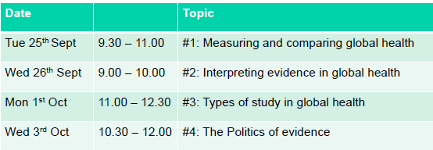

## Reference readings for the Module

Kelley Lee and Jeff Collin. *Global Change and Health*, OUP, 2005

Neil Pearce, Handbook of Epidemiology - can be downloaded free <http://publichealth.massey.ac.nz/publications/introepi.pdf>

People's Health Movement. Global health watch 2. Zed Books: London, 2008 (6 copies available at St.Mary's Library)

People's Health Movement. Global health watch 2005-2006: an alternative world health report, 2005. Zed Books: London (5 copies available at St.Mary's Library)

People's Health Movement. Global health watch 3 : an alternative world health report, 2011. Zed Books: London (4 copies available at St.Mary's Library)

Sen A. Development as Freedom. Oxford, Oxford University Press, 1999.

Skolnik R. *Essentials of Global Health*, Jones and Bartlett, 2007, & accompanying set of case studies. Levine R. *Case Studies in Global Health: Millions Saved* Jones and Bartlett, 2007. The case studies are available at [www.cgdev.org/section/initiatives/_active/millionssaved](http://www.cgdev.org/section/initiatives/_active/millionssaved)

# Part A: Introductory Module

### 24 September– 5 October 2012

|  |  |  |  |  |
| --- | --- | --- | --- | --- |
| **Date** | **Time** | **Speaker** | **Session** | **Location** |
| **Week 1** | | | | |
| Mon 24 Sept | 9.30-11.00 | Helen Ward  Mariam Sbaiti | Welcome and introductions  Discussion What Is Global Health? | Roger Bannister |
| 11.30-12.30 | Mariam Sbaiti | Introduction to the structure of the course and housekeeping  Q&As | Roger Bannister |
| 14.00-3.30 | Jackie Cousins | Plagiarism | Roger Bannister |
| Tues 25 Sept | 9.30-11.00 | Helen Ward | Crash course in methods #1: Measuring and comparing global health | Roger Bannister |
| 11.00-12.00 | Mariam Sbaiti | The Millennium Development Goals and introduction to group work | Roger Bannister |
| 14.00-16.00 | Kelley Swain | Why Humanities in Global Health? | Roger Bannister |
| Wed 26 Sept | 09.00-10.00 | Helen Ward | Crash course in methods #2: Interpreting evidence in global health | Roger Bannister |
| 11.00-12.30 | Tutors | Private Study or Tutorial group meetings | Roger Bannister |
| Thurs 27 Sept | 10.00-12.00 | Teresa Norat | Lecture: Systematic Reviews | Roger Bannister |
| 2.00-3.30 | Reviewing the literature with Jackie Cousins | | Hynds Lab |
| Fri 28 Sept | 09.30 – 11.00 | Teresa Norat and Doris Chan | Practical: Planning and Conducting a Systematic Review | Roger Bannister  And MSc room |

|  |  |  |  |  |
| --- | --- | --- | --- | --- |
| **Date** | **Time** | **Speaker** | | **Session** |
| **Week 2** | | | | |
| Monday 1 October | 10.00 – 10.15 | DVD | Health and Welfare at Imperial College | Roger Bannister |
| 10.30-11.15 | Helen Ward | Lecture : Globalisation | Roger Bannister |
| 11.30-12.30 | Helen Ward | Crash course in methods #3: Types of study in global health | Roger Bannister |
| Tues 2 Oct | 9.30-12.00 | **Freshers’ Fair day** | | Rothschild LT |
| 13.00-15.00 | Rothschild LT |
| Wed 3 Oct | 9.30- 10.30 | Mariam Sbaiti | Lecture: ABC of Health Policy | Cockburn Lecture Theatre |
| 11.00 – 12.00 | Helen Ward | Crash Course in methods #4: Politics of evidence | Cockburn Lecture Theatre |
| 13.30-  16.30 | Freshers’ Fair | |  |
| Thurs 4 Oct | 9.30-12.30 | Students | ICA: Group presentations on the  *MDGs* | Roger Bannister |
| 14.00-17.00 | Private Study or Tutorial group meetings | | Roger Bannister |
| Friday 5 Oct | 9.30-12.30 | Private Study or Tutorial group meetings | | Roger Bannister |
| From 5pm | Drinks and nibbles | | Fountains Abbey |

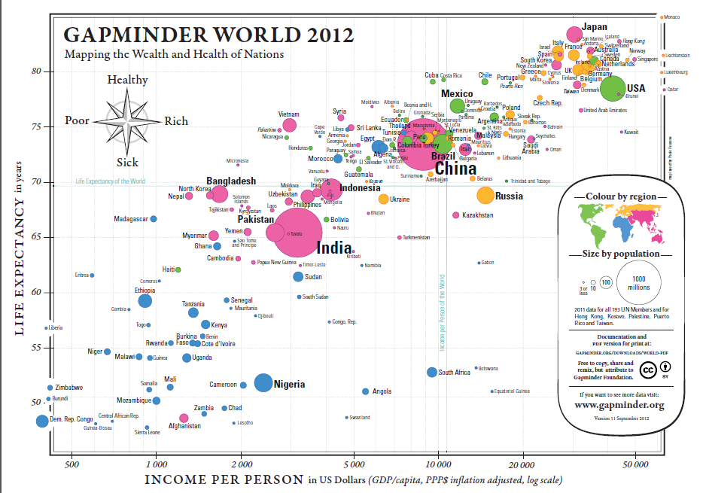

# Week 1

## Seminar: What is Global Health?

By the end of this session you should be able to:

* Describe the differences between existing definitions of Global health and the implications of these.
* Discuss the relevance of a global health perspective in explaining global health inequalities

#### Essential Reading:

Ruiz Cantero MT et al. The myopia of governments contributes to maternal mortality: dying from socioeconomic and physical distances. J Epidemiol Community Health 2007;61:370–371.

#### Further reading

Beaglehole R and Bonita R. What is Global Health? Glob Health Action. 2010; 3: 10.

Bozorgmehr (2010). Rethinking the “global” in Global Health: a dialectic approach”. Globalization and Health 6:19

Fried LP, Bentley ME, Buekens P, Burke DS, Frenk JJ, KlagMJ, et al. Global health is public health. Lancet 2010; 375: 535-7.

Kickbush, I. (2006). The need for a European strategy on global health. Scandinavian Journal of Public Health, 34(6), 34(6), 561–565.

Koplan JP, Bond TC, Merson MH, et al (2009). Towards a common definition of global health. Lancet 373:1993-1995.

Piot P, Garnett G. Health is global. Lancet 2009,374:1122-1123

Rowson M, Hughes R, Smith A, Maini A, Martin S, Miranda JJ, Pollit V, Wake R, Willott C, Yudkin JS (2007). Global Health and medical education - definitions, rationale and practice. Unpublished Work

| **The lecture(s) are well structured** | | | | | **The lecturer explains concepts clearly** | | | | | **The lecturer engages well with the students** | | | | | | | | |
| --- | --- | --- | --- | --- | --- | --- | --- | --- | --- | --- | --- | --- | --- | --- | --- | --- | --- | --- |
| Strongly Agree | Agree | Neutral | Disagree | Strongly Disagree | Strongly Agree | Agree | Neutral | Disagree | Strongly Disagree | Strongly Agree | Agree | | Neutral | | Disagree | | Strongly Disagree | |
|  |  |  |  |  |  |  |  |  |  |  | |  | |  | |  | |  |

**One useful learning point I would like to remember from this session:**

|  |
| --- |
|  |

## Seminar: Introduction to the Global Health BSc – Q&As

This session will introduce the structure of the course, including contents and basic advice on learning strategies and accessing learning resources. It also covers your roles and responsibilities as a BSc student. This includes essential information on the support available to you through your degree, academic integrity, plagiarism and attendance.

| **The lecture(s) are well structured** | | | | | **The lecturer explains concepts clearly** | | | | | **The lecturer engages well with the students** | | | | | | | | |
| --- | --- | --- | --- | --- | --- | --- | --- | --- | --- | --- | --- | --- | --- | --- | --- | --- | --- | --- |
| Strongly Agree | Agree | Neutral | Disagree | Strongly Disagree | Strongly Agree | Agree | Neutral | Disagree | Strongly Disagree | Strongly Agree | Agree | | Neutral | | Disagree | | Strongly Disagree | |
|  |  |  |  |  |  |  |  |  |  |  | |  | |  | |  | |  |

**One useful learning point I would like to remember from this session:**

|  |
| --- |
|  |

## Practical on Plagiarism Training

This practical is compulsory. If you are not able to attend you are required to contact the main tutor as soon as possible to rearrange this session. All students are required to complete the relative online assessment.

| **The lecture(s) are well structured** | | | | | **The lecturer explains concepts clearly** | | | | | **The lecturer engages well with the students** | | | | | | | | |
| --- | --- | --- | --- | --- | --- | --- | --- | --- | --- | --- | --- | --- | --- | --- | --- | --- | --- | --- |
| Strongly Agree | Agree | Neutral | Disagree | Strongly Disagree | Strongly Agree | Agree | Neutral | Disagree | Strongly Disagree | Strongly Agree | Agree | | Neutral | | Disagree | | Strongly Disagree | |
|  |  |  |  |  |  |  |  |  |  |  | |  | |  | |  | |  |

**One useful learning point I would like to remember from this session:**

|  |
| --- |
|  |

## The Millennium Development Goals and introduction to group work

By the end of this session you should be able to:

* Describe the origins of the UN MDGs
* List each goal, and access information on each target and indicator
* Outline how progress toward the MDGs is measured
* Critically discuss the UN MDGs initiative
* Understand the aim of the In-Course Assessment

#### Reference Reading

Hulme, D. (2010). IDS Bulletin, Volume 41. Number 1. Lessons from the Making of the MDGs: Human Development Meets Results-based Management in an Unfair World. Blackwell Publishing Limited. Accessible at: <http://onlinelibrary.wiley.com/doi/10.1111/j.1759-5436.2010.00099.x/pdf>

Sachs JD (2012). From Millennium Development Goals to Sustainable Development Goals, The Lancet 379(9832): 2206-2211. Accessible at: (http://www.sciencedirect.com/science/article/pii/S0140673612606850)

Vandemoortele, J. (2009). Development Policy Review. 27 (4): 355-371. The MDG Conundrum: Meeting the Targets Without Missing the Point. Blackwell Publishing. Accessible from: [http://www.chagghana.org/chag/assets/files/Vandermoortele_2009_MDGs[1].pdf](http://www.chagghana.org/chag/assets/files/Vandermoortele_2009_MDGs%5b1%5d.pdf)

| **The lecture(s) are well structured** | | | | | **The lecturer explains concepts clearly** | | | | | **The lecturer engages well with the students** | | | | | | | | |
| --- | --- | --- | --- | --- | --- | --- | --- | --- | --- | --- | --- | --- | --- | --- | --- | --- | --- | --- |
| Strongly Agree | Agree | Neutral | Disagree | Strongly Disagree | Strongly Agree | Agree | Neutral | Disagree | Strongly Disagree | Strongly Agree | Agree | | Neutral | | Disagree | | Strongly Disagree | |
|  |  |  |  |  |  |  |  |  |  |  | |  | |  | |  | |  |

**One useful learning point I would like to remember from this session:**

|  |
| --- |
|  |

## Introduction to the Humanities in Global Health stream

Speakers: Kelley Swain with guest Matt Rinaldi

Please see Appendix for lecture notes.

Outline

This session will introduce the stream of HGH and explore why humanities is relevant to Global Health studies. It includes a performance by Global Health alumnus Matthew Rinaldi.

Essential Reading

Holt T. Freeman J. 'The Perfect Code' Granta magazine, The Magazine of New Writing - Medicine edition: 120. Freeman J (ed). Granta Publications Ltd August 2012.

Susan Sontag, Illness as Metaphor. In: Sontag S (2002). Sontag, Susan. Illness as metaphor and AIDS and its metaphors. London : Penguin (5 copies available at the Central Library, South Kensington and more copies to be delivered in September at St Mary’s library).

#### Recommended Reading

Reference Reading:

Susan Sontag, Illness as Metaphor

Any/all of Granta 'Medicine' edition

| **The lecture(s) are well structured** | | | | | **The lecturer explains concepts clearly** | | | | | **The lecturer engages well with the students** | | | | | | | | |
| --- | --- | --- | --- | --- | --- | --- | --- | --- | --- | --- | --- | --- | --- | --- | --- | --- | --- | --- |
| Strongly Agree | Agree | Neutral | Disagree | Strongly Disagree | Strongly Agree | Agree | Neutral | Disagree | Strongly Disagree | Strongly Agree | Agree | | Neutral | | Disagree | | Strongly Disagree | |
|  |  |  |  |  |  |  |  |  |  |  | |  | |  | |  | |  |

**One useful learning point I would like to remember from this session:.**

|  |
| --- |
|  |

## Lecture: Systematic Reviews and Meta-analysis and

## Practical: Planning and Conducting a Systematic Review

Dr Teresa Norat

**Intended** **Learning Objectives: by the end of this session you should be able to:**

• evaluate the need for conducting systematic reviews and meta-analyses

• assess the potential biases and limitations of systematic reviews and meta-analyses

• interpret the findings presented in published systematic reviews and meta-analyses in the context of Global Health

• develop a protocol for undertaking a systematic review and access resources to conduct systematic reviews

***Basic Background to the Lecture and Practical***

**Why undertake a systematic review?**

Because of the high volume of data that need to be considered by practitioners and researchers, it has become impossible for the individual to critically evaluate and synthesise the state current knowledge in many areas. Single studies are often insufficient to universally answer a research question. In order to provide more generalisable conclusions, researchers can conduct a s*ystematic review* of the primary studies on a particular research question.

A systematic review is „a review of a clearly formulated question that uses systematic and explicit methods to identify, select, and critically appraise relevant research, and to collect and analyse data from the studies that are included in the review.‟

The advantages of a systematic approach include:

* Transparent process because of the explicit methods in identifying and rejecting studies.
* Meta-analysis, if appropriate, will enhance the precision of estimates of treatment effects.
* Systematic reviews may demonstrate the lack of adequate evidence and thus identify areas where further studies are needed.

***What is involved in a systematic review?***

There are several stages to undertaking a systematic review:

*Stage I*

Planning the review - Need to clearly define the research question to be addressed. This question is usually framed around the definition of study participants, intervention (exposure), outcomes and study designs of interest.

*Stage II*

Identification of research - Requires clearly defined search criteria and a thorough search of all published literature (including exhaustive searches of reference lists, conference proceedings and contact with researchers in the field).

Selection of studies – Inclusion and exclusion criteria should be defined a priori; these are likely to be based on factors such as study design, year, sample size, completeness of information, study quality etc.

Study quality assessment – Study quality can be assessed against recognized or user-defined criteria, usually to establish whether various biases are likely to exist in the in study (e.g. selection bias, measurement bias, attrition bias/loss to follow-up).

*Stage III*

Reporting and dissemination – Study details need to be abstracted from each eligible study along with the effect estimate (or details that allow an effect estimate to be calculated). These details need to be tabulated in a meaningful way, including, where appropriate, details of populations, interventions/exposure, outcomes and study design, and a summary of the findings. The last step consists in estimating an overall effect by combining the data, if a metanalysis is deemed appropriate.

**What is a meta-analysis?**

Meta-analysis refers to „the use of statistical techniques in a systematic review to integrate the results of included studies‟. The studies themselves are the primary units of analysis.

Meta-analyses combine the published estimates of effect from each study to generate a pooled risk estimate. This approach means that:

* More subjects can be included than any single constituent study, producing a more reliable and precise estimate of effect
* Differences (heterogeneity) between published studies can be identified and explored.

*However…*

* If the studies are too heterogeneous, it may be inappropriate, even misleading to statistically pool the results from separate studies

***What is involved in a meta-analysis?***

As in a systematic review, effect estimates are abstracted (or calculated) from the selected studies; in a meta-analysis, these individual study effect estimates are then pooled to produce a weighted average effect across all studies.

A **Forest plot** is the most common way of presenting the results from a meta-analysis. This is a graphical representation of the results from each study included in a meta-analysis, together with the combined meta-analysis result.



Each study is represented by a box and line – the size of the box corresponds to the weight given to that individual study; the horizontal lines correspond to the 95% confidence interval.

The overall estimate from the meta-analysis is usually shown as a diamond at the bottom of the plot. The centre of the diamond and dashed line corresponds to the summary effect estimate; the width of the diamond represents the confidence interval around this estimate.

***Publication bias***

Publication bias refers to the greater likelihood of research with statistically significant results to be published in the peer-reviewed literature in comparison to those with null or non-significant results. Failure to include all relevant data in a meta-analysis may mean the effect of an intervention/exposure is over (or under) estimated.

Publication bias in meta-analyses can be explored using **Funnel plots**, which show whether there is a link between study size (or precision) and the effect estimate.



***Heterogeneity***

Studies that are trying to answer the same question may still differ with respect to the exact population, interventions/exposure, outcomes and designs used. Even where these factors are homogeneous, heterogeneity may still exist because of clinical differences, methodological differences or unknown study characteristics.

Heterogeneity can be explored using **Galbraith (radial) plots**. But remember, if too much heterogeneity exists, it might not be appropriate to pool the studies.

**Limitations in conducting systematic reviews**

If the methodological quality of studies is inadequate then the findings of reviews of this material may also be compromised.

Publication bias can distort findings because studies with statistically significant results are more likely to get published.

#### Further reading

Centre for Reviews and Dissemination. *Undertaking Systematic Reviews of Research on Effectiveness*. CRD Report Number 4, March 2001 (available from <http://www.york.ac.uk/inst/crd/report4.htm> )

Egger, M, Davey Smith, G, Altman, eds. DG. *Systematic Reviews in Health Care*, BMJ Publishing Group, 2001.

Greenhalgh, T. *How to read a paper: Papers that summarise other papers (systematic reviews and meta-analyses).* BMJ 1997;315:672-675.

Khan, KS, Kunz, R, Kleijnen, J & Antes, G. *Systematic Reviews to support Evidence-based Medicine.* The Royal Soceity of Medicine Press Ltd. 2003.

The Cochrane Collaboration: <http://www.cochrane.org>

| **The lecture(s) are well structured** | | | | | **The lecturer explains concepts clearly** | | | | | **The lecturer engages well with the students** | | | | | | | | |
| --- | --- | --- | --- | --- | --- | --- | --- | --- | --- | --- | --- | --- | --- | --- | --- | --- | --- | --- |
| Strongly Agree | Agree | Neutral | Disagree | Strongly Disagree | Strongly Agree | Agree | Neutral | Disagree | Strongly Disagree | Strongly Agree | Agree | | Neutral | | Disagree | | Strongly Disagree | |
|  |  |  |  |  |  |  |  |  |  |  | |  | |  | |  | |  |

**One useful learning point I would like to remember from this session:.**

|  |
| --- |
|  |

# Week 2: lecture outlines, objectives and reading

## Lecture: Globalisation and Health

Intended learning outcomes: by the end of this session you should be able to:

* have a working definition of globalization
* outline and discuss the major links between globalisation and health

#### Essential reading

Benatar SR (2009). Global Health: Where to Now?, Global Health Governance, Volume II, Number 2 .

Woodward et al (2005). Globalization and health: a framework for analysis and action. Bull World Health Organ. 2001;79(9):875-81.

#### Reference Reading

BMA (2007) Improving health for the world's poor : what can health professionals do?, London, BMA. http://www.bma.org.uk/ap.nsf/AttachmentsByTitle/PDFImprovinghealth/$FILE/improvinghealth.pdf

Diderichsen, F., Evans, T. Whitehead, M. The Social Basis of Disparities in Health. From Challenging inequities in health: From Ethics to action. Edited by Evans, T., Whitehead, M., Diderichsen, F. Bhuiya, A., Wirth, M. Oxford University Press. New York, 2001.

Fidler D P, Drager N, Lee K (2009) Managing the pursuit of health and wealth: key challenges. Lancet, 373(9660): 325-331.

Huynen M, Martens P and Hilderink HBM (2005). The health impacts of globalisation: a conceptual framework. Globalization & Health., 1:14

Medact (2005). The Global Health Curriculum: Unit 5: Globalisation and health . Online, available at: http://www.medact.org/ (accessed 1 Sept 2012)

Navarro, V. (2004) The world health situation. International Journal of Health Services 34, 1, 1-10

Rowson M 2007. Globalization, Debt and Poverty Reduction Strategies WHO Commission on Social Determinants of Health. Globalization and Health Knowledge Network: Research Papers. Available at: http://www.who.int/social_determinants/resources/gkn_rowson.pdf (accessed 02.08.2011)

Woodward et al (2005). Globalization and health: a framework for analysis and action. Bull World Health Organ. 2001;79(9):875-81.

World Health Organisation (2005). Commission on Social Determinants of Health - final report. Available at : http://www.who.int/social_determinants/thecommission/finalreport/en/index.html

Xu K, Evans DB, Carrin G, Aguilar-Rivera AM (2005) Designing health financing systems to reduce catastrophic health expenditure. Technical brief for policy-makers

| **The lecture(s) are well structured** | | | | | **The lecturer explains concepts clearly** | | | | | **The lecturer engages well with the students** | | | | | | | | |
| --- | --- | --- | --- | --- | --- | --- | --- | --- | --- | --- | --- | --- | --- | --- | --- | --- | --- | --- |
| Strongly Agree | Agree | Neutral | Disagree | Strongly Disagree | Strongly Agree | Agree | Neutral | Disagree | Strongly Disagree | Strongly Agree | Agree | | Neutral | | Disagree | | Strongly Disagree | |
|  |  |  |  |  |  |  |  |  |  |  | |  | |  | |  | |  |

**One useful learning point I would like to remember from this session:.**

|  |
| --- |
|  |

## Lecture: ABC of health policy for Global health

Intended learning Outcomes: by the end of this session you will be able to:

* discuss the relevance of health policy in Global Health studies
* describe the main actors in political processes: the state, the private sector and civil society
* be familiar with one of the common frameworks for health policy analysis

**Essential Reading**

Buse K and Dickinson C (2007). How can the analysis of power and process in policy-making improve health outcomes? Moving the agenda forward. ODI Briefing Paper 25.

Available at:

<http://www.odi.org.uk/resources/docs/478.pdf>

**Further Reading**

Buse K, Mays N, Walt G. Chapter 1: The Health Policy Framework: context, process and actors. .In: Making health policy. Maidenhead: McGraw-Hill/Oxford University Press; 2005

| **The lecture(s) are well structured** | | | | | **The lecturer explains concepts clearly** | | | | | **The lecturer engages well with the students** | | | | | | | | |
| --- | --- | --- | --- | --- | --- | --- | --- | --- | --- | --- | --- | --- | --- | --- | --- | --- | --- | --- |
| Strongly Agree | Agree | Neutral | Disagree | Strongly Disagree | Strongly Agree | Agree | Neutral | Disagree | Strongly Disagree | Strongly Agree | Agree | | Neutral | | Disagree | | Strongly Disagree | |
|  |  |  |  |  |  |  |  |  |  |  | |  | |  | |  | |  |

**The most important thing I’ve learnt today is.............**

|  |
| --- |
|  |

## Lecture: Crash Course in Methods # 4: The Politics of Evidence

Essential Reading

McKee M, Stuckler D, Basu S (2012) Where There Is No Health Research: What Can Be Done to Fill the Global Gaps in Health Research? PLoS Med 9(4): e1001209. doi:10.1371/journal.pmed.1001209

| **The lecture(s) are well structured** | | | | | **The lecturer explains concepts clearly** | | | | | **The lecturer engages well with the students** | | | | | | | | |
| --- | --- | --- | --- | --- | --- | --- | --- | --- | --- | --- | --- | --- | --- | --- | --- | --- | --- | --- |
| Strongly Agree | Agree | Neutral | Disagree | Strongly Disagree | Strongly Agree | Agree | Neutral | Disagree | Strongly Disagree | Strongly Agree | Agree | | Neutral | | Disagree | | Strongly Disagree | |
|  |  |  |  |  |  |  |  |  |  |  | |  | |  | |  | |  |

**The most important thing I’ve learnt today is.............**

|  |
| --- |
|  |

Humanities in Global Health Introduction:

Considering Medical Humanities

Tuesday 25 September 2012

Kelley Swain

www.kelleyswain.com

kelley.k.swain@gmail.com

Hippocrates:

* ‘I swear…to consider dear to me, as my parents, him who taught me this art; to live in common with him and, if necessary, to share my goods with him; to look upon his children as my own brothers, to teach them this art; and that by my teaching, I will impart a knowledge of this art to my own sons, and to my teacher’s sons, and to disciples bound by an indenture and oath according to the medical laws, and no others.’

‘Medicine’ comes from Latin *ars medicina:* ‘the art of healing’.

## ‘Unlimited’ Festival at the Southbank Centre, 2012 (Photos, SBC)



Above: ‘Parallel Lines’ performance.

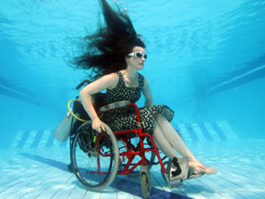

Above: Sue Austin in her self-propelled underwater wheelchair.

## From Berlin Conference on Medical Objects (Photo, K.S.)

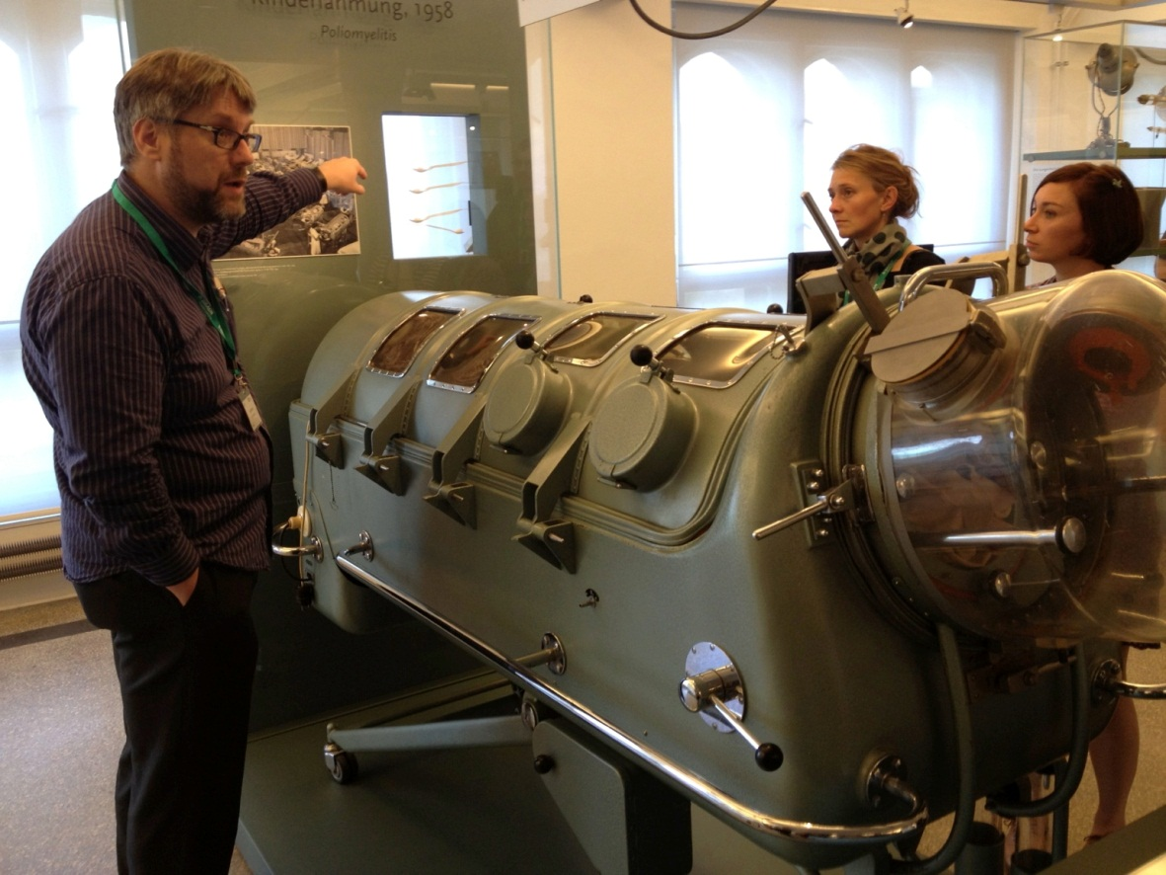

AnanaGram (adj):

Original, Constantly Evolving

* Matt Rinaldi: performance
* Q&A with Matt

Twitter: @thenanagram

Facebook: ananagram

ananagram.blogspot.com

ILLNESS AS METAPHOR:

## What, according to Sontag, did TB come to represent in the 19th century?

Come up with a list from the reading:

‘With the new mobility (social and geographical) made possible in the eighteenth century, worth and station are not given; they must be asserted. They were asserted through new notions about clothes (‘fashion’) and new attitudes toward illness. Both clothes (the outer garment of the body) and illness (a kind of interior décor of the body) became tropes for new attitudes toward the self.’

## Metaphor examples:

* The interior drapery of tuberculosis.
* Tuberculosis is like a fine cloth draping my lungs.
* I am as ghostly as one with TB.
* I am draped with the spectre of tuberculosis.

## ‘The Perfect Code’

There is a great deal of mess in hospital medicine, literal and figurative, and the code bunches it all into a dense mass that on some days seems to represent everything wrong with the world. (p. 139)

‘He needs a halo.’

A halo is one of those excruciating-looking devices you may have seen somebody wearting: a ring of shiny metal that encircles the head (hence the name), supported by a cage that rests on a harness braced on the shoulders. Four large bolts run through the halo and into the patient’s skull, gripping the head rigidly in place like a Christmas tree in its stand. A little crust of blood where the bolts penetrate the skin completes the picture. They look terrible, but patients tell me that after the first day or so they don’t really hurt. Getting one put on, however: that hurts. (p. 144-5)

I…saw through the open door of Mr Mongay’s room a strange tableau: two tall men in green scrubs wielding socket wrenches around the patient’s head, a tangle of chrome, and the patient’s hands quivering in the air, fingers spread as if calling on the seas to part. Sometime later I looked up again and the green scrubs were gone. Mr Mongay lay propped up in his bed, his head in a halo. From the side, his nose was a hawk’s beak, the rest of his face sunk in drugged sleep, but his mouth still snarled as if it remembered recent pain. He looked like a strange, sad bird in a very small cage. (p. 146)

This, I thought as we left the room (the lines on the monitor dancing their steady dance, the ventilator measuring breath and time to its own slower rhythm), this is what a code should be. A clean thing. A beautiful thing. The patient hadn’t died. (p. 149)

He had become something unreal to me – something beautiful, like a work of art, but unreal. Amid all the mess and squalor of the hospital, with its blind random unravelling of lives, in their patient dignity and kindness he and his family stood apart. In his case, for a little while at least, everything had gone exactly as it should have. The perfect code. (p.151)

## Metaphor-Making

‘Metaphor usually involves talking about one thing in terms of something else. Good metaphors often surprise us, making connections we don’t expect. We recognise in them a rich and profound truth – one we can’t always put our finger on; can’t always put into straightforward explanation. A metaphor’s deepest effects might occur because we can’t explain it in a straightforward way.’

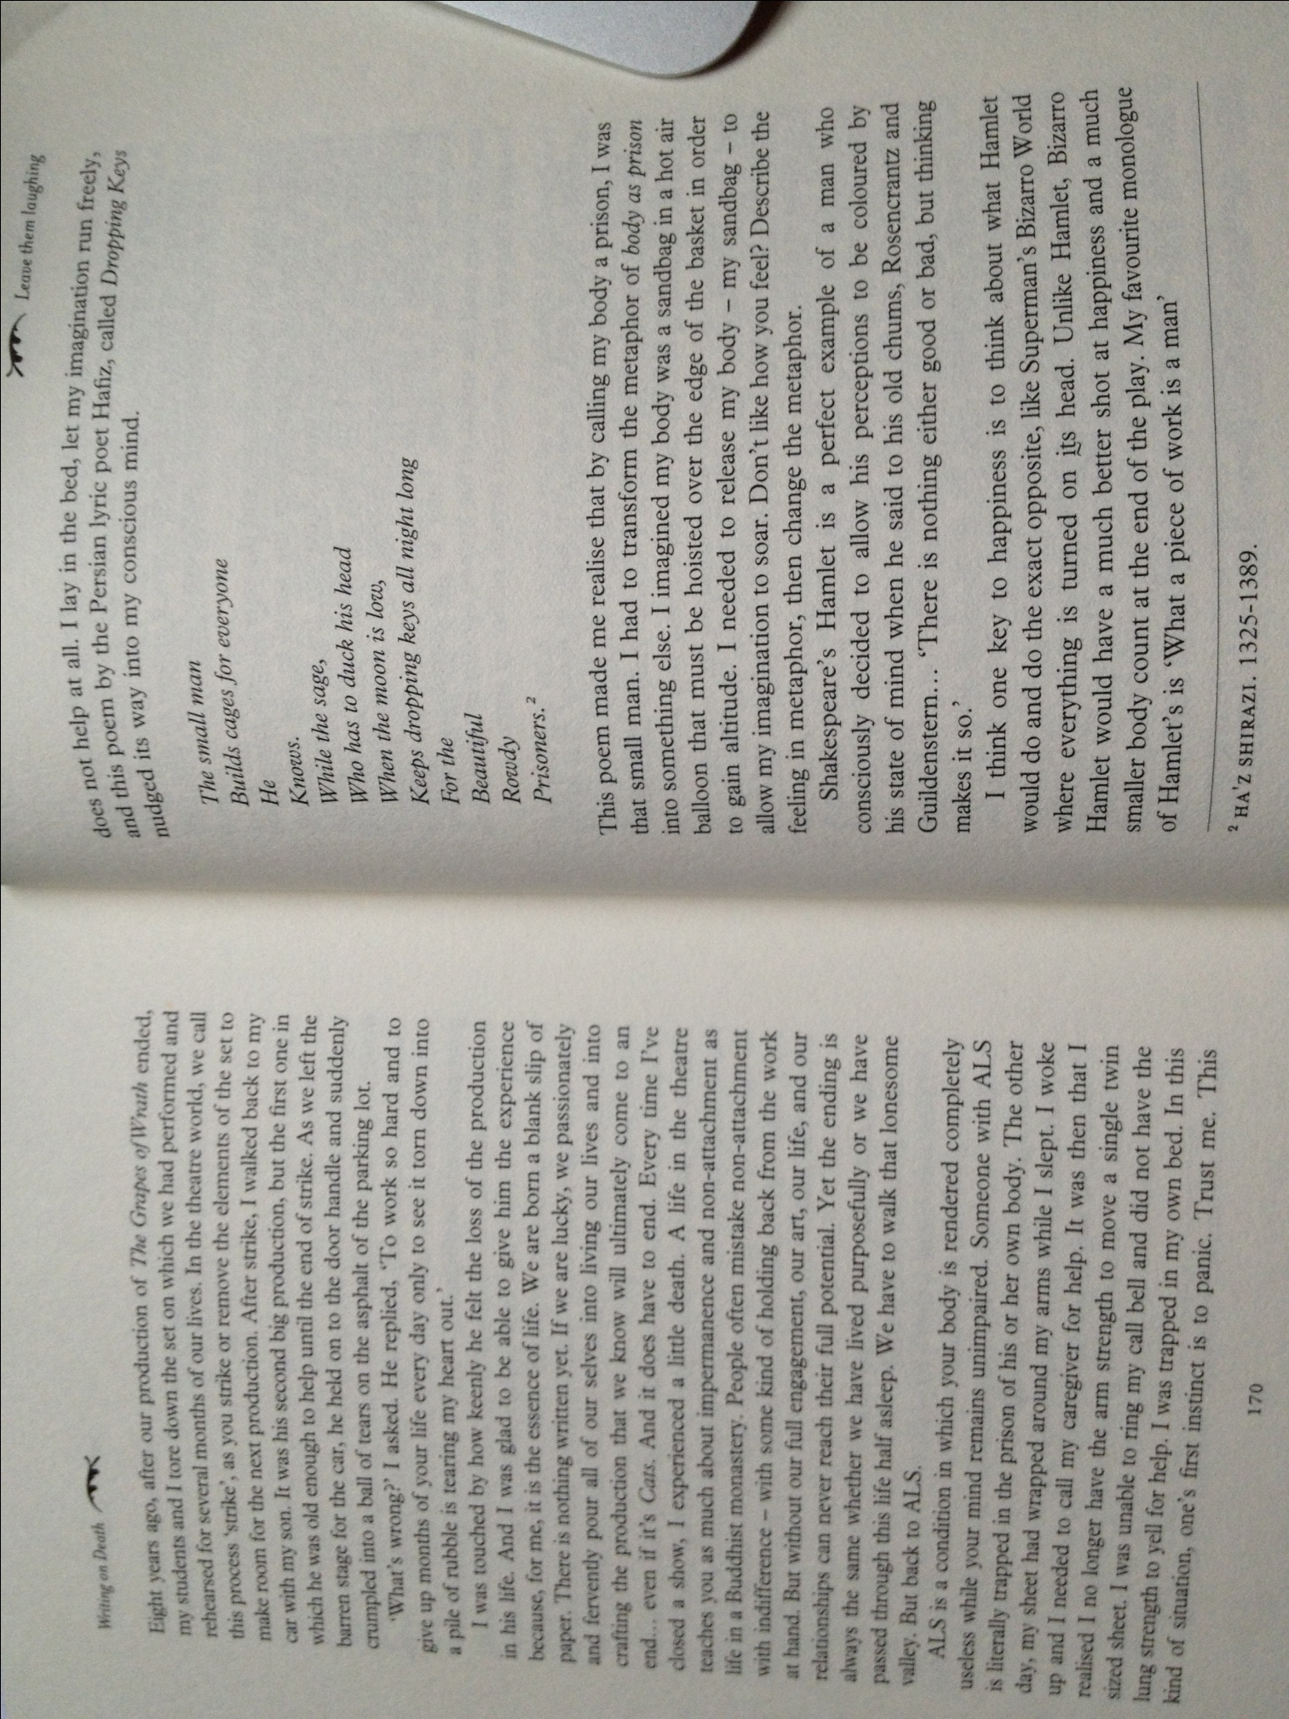From ‘Leave them laughing,’ by Carla Zilbersmith

*Writing on Death: The Natural Death Handbook*, 5th Ed.

## Changing the Metaphor

* Gather into groups
* Make a list of medically-related objects/things that you have encountered in your studies, ie: stethoscope, gurney, stitches, blood pressure – feel free to use your expertise and go beyond the obvious!
* Write in the form: ‘A _____ of _____’
* ‘A gurney of steel’ ‘Stitches of thread’
* Focus on at least five examples
* Then take the second word (‘steel or ‘thread’) and replace with an emotion.
* ‘A gurney of sorrow’ ‘Stitches of laughter’ – some will make more sense than others. Be creative and change words if you think they’ll fit better. ‘Stitches of laughter’ is cliché; what about ‘stitches of anger’?

NEXT TIME: TUESDAY 9 OCTOBER

* Meet outside John Snow Pub, Soho at 2:55 for 3pm sharp!
* Be prepared for a guided walk lasting about 2 hours: wear comfortable shoes, warm clothes, bring a brolly, etc.

# Appendix

Group Allocations for ICA

|  |  |  |  |
| --- | --- | --- | --- |
| **MDG** | **Surname** | **First name** | **Email** |
| 1 | Boussabaine | Emaan | emaan.boussabaine09@imperial.ac.uk |
| Chong | Amelia | amelia.chong10@imperial.ac.uk |
| de Rosa | Eleanor Jane | eleanor.de-rosa11@imperial.ac.uk |
| Emanuwa | Emudiaga Jonathan Ewan | emudiaga.emanuwa12@imperial.ac.uk |
| Feyereisen | Laura | laura.feyereisen10@imperial.ac.uk |
| Wynberg | Elke | elke.wynberg09@imperial.ac.uk |
| 2 | Forshaw | Jennifer Anne | jennifer.forshaw12@imperial.ac.uk |
| Grahame | Emma | emma.grahame12@imperial.ac.uk |
| Johari | Nur | nur.johari10@imperial.ac.uk |
| Karnani | Nisha | nisha.karnani08@imperial.ac.uk |
| Arnold | Thomas | thomas.arnold09@imperial.ac.uk |
| 3 | Keech | Maximillian Morgan Kinder | maximillian.keech09@imperial.ac.uk |
| Kim | Sung-Hee | sung-hee.kim08@imperial.ac.uk |
| Lee | Samuel | samuel.lee09@imperial.ac.uk |
| Lee | Yin Yin | yin.lee09@imperial.ac.uk |
| Lewis | Marissa | marissa.lewis09@imperial.ac.uk |
| 4 | Low | Jen Mae | jen.low09@imperial.ac.uk |
| McGown | Patrick James | patrick.mcgown09@imperial.ac.uk |
| Ologunde | Rele Matthew Adedeji | rele.ologunde09@imperial.ac.uk |
| Patel | Purvi Nimishkumar | purvi.patel09@imperial.ac.uk |
| Prager | Latreille Gabrielle Mary | latreille.prager09@imperial.ac.uk |
| Zahid | Shereen Sanaa | shereen.zahid09@imperial.ac.uk |
| 5 | Rae | Sophie | sophie.rae10@imperial.ac.uk |
| Ramjan | Rubeena | rubeena.ramjan09@imperial.ac.uk |
| Sadasivan | Luvarnia | luvarnia.sadasivan09@imperial.ac.uk |
| Stewart | Eleanor Margaret | eleanor.stewart09@imperial.ac.uk |
| Yasin | Maryiam | maryiam.yasin09@imperial.ac.uk |
| Yeats | James | james.yeats12@imperial.ac.uk |