BSc Global Health: introductory module crash course in methods

Session 1: Measuring and comparing global health

Exercise 1
In groups of 2 or 3, rank the following in order of importance for global health, and discuss why.

- Cardiovascular disease
- Neglected tropical diseases
- All infectious disease
- Neuropsychiatric disorders
- HIV/AIDS
- Cancers

Exercise 2
In each of the following examples, decide what type of measure is being presented, how you think the data were obtained, what questions you have about the validity of the data.

(a) This map shows the physical inactivity of adults across different regions of the world (Hallal et al, Lancet 2012)
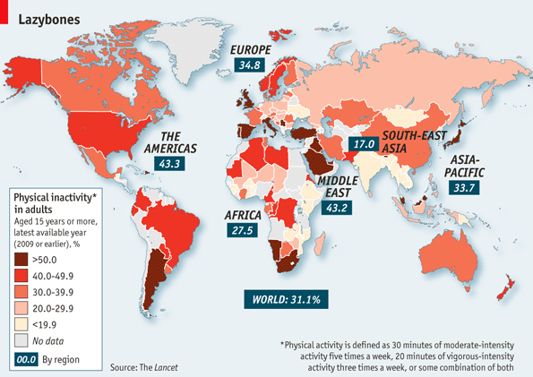
The data on the map show
☐ Incidence ☐ Prevalence ☐ Risk ☐ Rate ☐ p value

The data were probably obtained from
☐ GP data
☐ hospital episode statistics
☐ national registry
☐ cross sectional survey
☐ gym membership records
☐ mathematical models
☐ lots of different methods
☐ made up

How valid do you think these data and the comparisons likely to be?

(b) The data in the table are for TB in the world in 2005 (data source: WHO, cited in Ward et al Oxford Handbook Epidemiology for Clinicians, 2012)

WHO region | Number of new cases of TB per 100 000 population
Africa | 343
The Americas | 39
Eastern Med | 104
Europe | 50
South-East Asia | 181
Western Pacific | 110
Global | 136

The data in the table show
☐ Incidence ☐ Prevalence ☐ Risk ☐ Rate ☐ p value

The data were probably obtained from
☐ GP data
☐ hospital episode statistics
☐ national registry
☐ cross sectional survey
☐ infectious disease notifications
☐ prescribing data
☐ mathematical models
☐ lots of different methods
☐ made up

How valid do you think these data and the comparisons likely to be?

(c) Globally there were 139,300 measles deaths in 2010 compared with 424,000 in 2004. These data report
☐ Incidence ☐ Prevalence ☐ Risk ☐ Rate ☐ mortality

The data were probably obtained from
☐ hospital episode statistics
☐ national registry
☐ cross sectional survey
☐ infectious disease notifications
☐ verbal autopsies
☐ mathematical models
☐ lots of different methods
☐ made up

