School of Medicine

TMDU Exchange Programme

2011/2012



Photos.com

IT facilities

Dr Michael Barrett  
Head of Learning Resources:  
email: [mike.barrett@imperial.ac.uk](mailto:mike.barrett@imperial.ac.uk)

<https://education.med.imperial.ac.uk>

**IT facilities**

## Contents

#### IT Facilities -Questions & Answers

**PC facilities** **2**

**Headphones** **2**

**Availability of access to clusters** **2**

**Connecting personal device to College network, Wi-Fi, VPN** **3**

**Using PC in Hall of Residence** **3**

**Buying a laptop**  **3**

**College software on personal PC**   **3**

**Protecting personal PC (antivirus and security patching)** **3**

**Software shop** **4**

**Personal storage space (H: drive)** **5**

**Encryption of files** **5**

**Storing Patient data on College network** **5**

**Sharing very large files; passwords; Roaming profiles** **6**

**Disc space quota** **7**

**Getting Help** **8**

**Reporting faults** **8**

**Printing, scanning and photocopying** **9**

**Email *(*in College, remote, etiquette***)* **12**

**Staying healthy** **15**

**College Conditions for Use of IT facilities** **22**

**College Information Systems Security Policy** **24**

**Data protection; handling patient Data Policy** **25**

**Advice on Internet Privacy, Use of Social Networking  
use of Copyright material**  **27**

**Food and Drink Policy** **(for PC labs)** **28**

**Teaching Intranet** **29**

**Guide to Virtual Learning Environment, Blackboard**  **30**

This booklet includes components that will be given to first year medicine undergraduates on their arrival next month. You may still find some of the detail of value.

**Learning Styles Interactive Diagnostic Screening tool**

There are a number of online tools that can assist you in deciding how you learn best.

You will have developed excellent learning skills already. Nonetheless, you could take a few minutes to try this out as an opportunity to think about whether you need to change how you are going to plan your studies and perhaps identify what type of learner you are. It will also provide guidance on tools and techniques you can use to support your learning processes more effectively.

The tool can be accessed at: <http://learningstylesid.co.uk/tryout/>

Try it out!

# IT Facilities - Questions and Answers

#### What PC facilities are available?

The PC facilities in clusters for the Faculty of Medicine use multimedia PCs running   
Windows 7 and, currently, Office 2010. On the following campuses the main clusters are managed for the Faculty but there are also PCs managed by the Library:-

* South Kensington campus - Sir Alexander Fleming Building: there is a cluster of 130 machines in two labs (100 + 30).
* Charing Cross campus: the PC clusters are situated within the Library (2nd floor, Reynolds Building). A smaller cluster is also available at CX during normal working hours in the ICT basement office area.
* St Mary’s: the cluster is in the Hynds Computer Lab, 1st Floor Medical School building.
* Chelsea & Westminster: the cluster is within the Library (Lower ground floor). There are also a limited number of PC’s in the Student Common room (Lower Ground Floor).
* Hammersmith: there is a cluster of 36 machines on the 3rd floor, Commonwealth Building and a small number of PC’s in the Student Common room (Wolfson Education Centre).
* There are other machines elsewhere in the College that you may also use, e.g. Main Library, as well as machines on the other clinical campuses, including District General Hospitals (Associated University Hospitals). You are able to**logon** at any of these College machines and see exactly the same thing, and have access to all of your files.

These facilities are provided primarily to support your studies. They are not intended to be social/recreational areas but a reasonable amount of “personal” use is permitted, within College Regulations. Please consider those around you when using the cluster PCs.

**Listening to sounds**

Some software that you may be required to use during your studies will include sound clips and commentary. When using any of the cluster computers in the School of Medicine or in the libraries you will need to bring your own earpiece or headphones. The phones socket is on the front panel of the computer.

**Can I use the PC cluster at any time?**

* There will be times when the School of Medicine cluster machines will be booked for specific teaching classes and so will not be available for general use during these periods. All our clusters are equipped with printers for your use. All of the software that you will need is supplied and it will not be possible for you to load your own favourite programs (see later).
* Charing Cross, the cluster is available all week up to around 10.15 at night except on nights when there are special functions in the building – see local notices. Outside of normal Library opening hours, access is via the lift lobby foyer on the 2nd floor of the Reynolds Building – you will need your ID swipe/proximity card at all times.
* SAFB clusters may be used up to around 10.45pm each night, all week.
* Hammersmith CWB 3rd floor cluster is available 24/7.
* Chelsea & Westminster cluster is available during library opening hours only.
* Other clusters may have differing closing times.

#### Can I use my home PC for course work?

Certainly, but note that if you are not using the same version of the software at home which is used in College, work produced at home may not run properly on the College network and *vice versa*. You can link in to the College network from home using broadband/modem/phone line connection. Advice on this can be obtained from the Information and Communications Technologies Division – ICT – see below.

#### Can I plug my PC directly into the network in College?

You must register your personal PC with ICT if you wish to connect it to the College network. If you wish to connect your own PC to the College network, you will be required to ensure that it has been updated with the latest security systems patches and has had the antiviral software configured and updated. The local ICT Help Desk team can assist you with this. The MS Vista Home operating system does not include authentication procedures for institutional networks and so cannot be used directly on the College network via a wired connection.

In some areas a wireless network will be available. For connections in Halls of Residence, details are provided locally. Further details are available at:

<http://www3.imperial.ac.uk/ict/services/securitynetworkdatacentreandtelephonyservices/collegenetwork/networkconnections>

#### Can I connect via Wi-Fi?

An increasing number of areas in College are wireless-enabled. See the above link for details of Wireless Connections.

#### What configuration settings do I need for a VPN connection?

These are also available at the ICT Networks link, as above.

#### What about using my PC in Halls?

See the local Halls of Residence documentation about connecting your PC in Halls.

#### Can I buy my own College-specification PC or laptop?

ICT provide guidance about purchasing a laptop for personal use. See the ICT New Students web page <http://www3.imperial.ac.uk/ict/services/newstudents> Please note that some deals exclude software.

If you are planning to buy a portable with a view to using it on the College network you can also get advice from ICT via the manned Help Desks, or the Service Desk. Other information on personal purchases from the preferred College suppliers may, from time to time, be found on the College Administration’s purchasing website but please note that details are constantly changing. See… <http://www.purchasing.ad.ic.ac.uk/Product%20Areas/Computers/index.htm>

#### Am I allowed to use College software on my own computer?

In general the answer will be **NO**! Most of the programs come from commercial software companies and the College has appropriate licences for use of them but the licences are unlikely to allow students to install the programs on home machines.  
The good news is that many of the programs are available for purchase at student discount rates through the College’s **ICT Software Shop** on 4th floor Sherfield Building, South Ken <http://www3.imperial.ac.uk/ict/services/personalcomputersupportandmobileservices/softwarepurchase>

For some software used in the course, e.g. some e-learning material, you may install copies on your own machines. Details of these will be available on the School of Medicine Teaching Intranet <https://education.med.imperial.ac.uk> . You are also entitled to the College’s anti-viral software free of charge (see **Essential Information** section, below) and you are strongly urged to take advantage of this offer if you do not already subscribe to antiviral software.

#### How can I protect my PC? Computer Viruses & Security patching

Computer viruses can wreak havoc and can rapidly spread through a large computer network like that at Imperial. Many of these viruses are blocked upon entry into the College networks by the vigilance of ICT-Security services. As an added precaution, College machines have anti-viral software installed which is automatically updated to deal with new virus as they appear. The licence for this software allows all members of College to install this software on their own home machine.

Whilst you are a student of Imperial College London, you may install a copy of Symantec Antivirus (for Windows and Mac). All members of College have the right to use this software and can install it free of charge on their personal systems e.g. in Halls and at home.   
The software can be obtained from the Software Shop at <http://www3.imperial.ac.uk/ict/services/personalcomputersupportandmobileservices/softwarepurchase/softwareshop/priceindex/studentpricelist>

If you install this software on your personal machine, please ensure you configure it to check regularly for the latest virus signature file on the server. Disk sets can also be generated or obtained in other formats from the ICT Shop for a small fee. You are also advised to install anti-malware software onto your own machine and you can download a personal copy of **Malwarebytes**, free of charge.

Further details may be obtained from the ICT Software Shop website. See ICT’s Information for New Students at <http://www3.imperial.ac.uk/ict/services/newstudents>

Security patches for operating systems and common applications are usually available online and you should ensure your system is loaded with the latest systems patches so as to avoid security breaches. The ICT help Desk teams can advise and assist you.

**Where is the ICT Software Shop and can I get other software through ICT?**

The ICT Software Shop is in the Sherfield Building 4th Floor [west end], South Kensington campus and their opening hours are 9.30am-5.00pm but all software sales have to be completed by 4.30pm. The web site is <http://www3.imperial.ac.uk/ict/services/personalcomputersupportandmobileservices/softwarepurchase>

#### Can I load my favourite programs onto the College network?

**NO!** The smooth functioning of the College network depends upon regular behind-the-scenes maintenance by the IT support staff. If all the students were able to load programs then there would be chaos and the network would fail.

#### What else is not allowed?

It will not surprise you that the use of College computing facilities is governed by a number of rules and regulations to which you must conform. Some of these are legal requirements (Data Protection Act, Race Relations Act, *etc*) whilst others are local, College requirements. Details of these have been given to you in the Student Handbook and you must read these before you use the facilities. Misuse of the facilities will be taken very seriously by the College and severe penalties will be imposed on anyone caught. These rules also apply to the College staff in exactly the same ways as to students. Ignorance of the rules will not be accepted as an excuse for misuse. It is your responsibility to ensure that you conform to the requirements in force at the time. Don't be deterred by the **rules** for using the computers. When you read through them you will see that most are just a matter of common sense and politeness. Perhaps the greatest danger lies in the speed of electronic communication. It is so very easy to fire off a reply to a message that is either inappropriate or ill-considered. **Think before you send!**

#### How secure are the IT facilities?

In order to use the computer facilities you will need to **"logon"** which involves entering your personal username and your personal password. **This is your main source of security and you must not reveal these details to anyone else**. If you do, others can use the computers in your name and you will be held responsible for anything that they do. When you have finished your session you must also **logoff** otherwise the machine remains active when you leave and someone else could use your “active” account and **appear to be you!**

**Do I get a personal storage space on the network?**

**Yes**. You have a personal space (**Personal Directory**) on the network, showing as **your “H:” drive**. Undergraduate (non-research or taught masters courses) student H: drive quotas are 1Gb. This network space is private to you and can only be accessed via your password. You can also access this directory remotely by means of a VPN connection – see <http://www3.imperial.ac.uk/ict/services/securitynetworkdatacentreandtelephonyservices/collegenetwork/networkconnections/vpnconnection> which also gives details of how to view   
your H: drive

**Remember that no security system can guarantee absolute security of information**.   
If you want to save personal information that you would not want others to see, think where to store it. **Note:** when storing personal details about others your use of the computer facilities must be in accordance with legal and College requirements described above.

**Where can I save documents?**

Work which you produce or files that you download can be “permanently” saved (see below) for later use. You are likely to want to save it to a **USB device** that you insert in the machine you are using, write to a CD/DVD and then subsequently take away with you; or you can save it onto a networked **hard disk**. This is not removable and is **not physically located on the machine you are using**. In some cases you may want to save copies by several methods.

**Do not try to save files on the PC’s local hard disk C.** Any files saved to **C:** are only accessible on that specific machine at that logon session and would not be available if you were then to logon to a different machine.

**How do I obtain removable storage media?**

Try the Union Shop on the walkway, South Kensington campus.

**Should I encrypt my files?**

The recommendation is that you do so that if any storage media is lost, any private details about yourself or mail list, for example, will be incapable of being high-jacked. However, do remember that if you forget the password for your encrypted files, College ICT may be unlikely to help. See the ICT Security pages for helpful advice about encryption.

**Are there restrictions about storing Patient data?**

Information through which patients can be readily identified, must NOT be stored on the College systems, including email. More information on the Guidelines for handling patient data are to be on the teaching Intranet at <https://education.med.imperial.ac.uk/policies/policies.htm>. We urge you to be especially careful that any patient descriptors stored on personal file space/media are encrypted.

**Is the network traffic monitored?**

You should also be aware that for network management and maintenance purposes, all activity on the network is automatically recorded in a log. This is not as menacing as it may sound: there is no “Big Brother” looking over your shoulder. No one has the time to routinely examine the huge number of transactions taking place on the College network each day. However, if a question of possible misuse of the facilities arises, that activity will be traceable even if the user has deleted all of the relevant files.

#### How can I share very large files?

Often there is the need to share files with colleagues, and the usual way of doing this might be by email. Unfortunately there are limits to many email systems as to the file size they can cope with. You can share very large files within College using a secure File Exchange server system. These notes are just to make you aware of this service which you can also access remotely.

<https://fileexchange.imperial.ac.uk>

Try it out before you need to use it, so you are confident in using the service. Logon and upload a file. Unfortunately you can only upload one file per “job” but you can create a .zip file of many individual documents and upload that as a single “job”. The system will show you a location for the saved file and offer you the option of emailing that link to you. You then share that link information with colleagues by email and they then have 14 days in which to retrieve the file. You can use this to share files with others in College, or externally.

The system deletes all saved files after 14 days of upload so there are no file management issues for the end user. There is an upper limit on the file size that can be saved per job, but it’s REALLY big – 1 Gb – but it is not recommend that you ever create documents that large as most users just will not be able to handle them, and the upload and download times will be considerable, especially via a home connection.

Currently, there are two versions of the system. If you select the “New Service” the system emails to you when the recipient of the attachment has picked it up.

**Can I change my password without being on a College machine?**

Yes - More information about passwords can be seen at <https://www.imperial.ac.uk/ict/Security/>   
Follow the hot topic link to “Changing your password”. The College’s Code of Practice on passwords, and further information about how to set a “strong” password, may be found at [http://www3.imperial.ac.uk/secretariat/policiesandpublications/informationsystemssecurity/  
codesofpractice/cop12](http://www3.imperial.ac.uk/secretariat/policiesandpublications/informationsystemssecurity/codesofpractice/cop12)

##### Roaming Profile

Windows 7 allows you to logon to any machine in the Faculty of Medicine clusters together with general access machines in the College Library. You will have access to the same software on all machines in the Faculty of Medicine. The personal profile allows your own ‘personal’ default settings to be used for Outlook, Word, Excel, screen savers, *et*c. which travel with you as you log on and off of different machines. This information is stored in your ‘Roaming Profile’. At the end of any session, when you logoff, your profile information is loaded from the machine you are using to specific areas on a profile server. The next time you login, this latest profile information is loaded back to the machine you are now using, and all the local software is then configured to your settings. Additionally, this means that your web cache (copies of web pages previously visited) is also copied so you have a quicker access the next time you wish to view those pages. These files are therefore also part of your profile quota (see below). Since the profile is important to you, *i.e.* it contains your set-up preferences, it is critical that you do not do anything yourself that may cause it to become corrupted. One way by which you can cause your profile to become corrupted is to go over-quota on your disk space usage (see below).

Additionally, overnight ICT deletes files stored on the C: drives of cluster machines as part of their continual systems housekeeping. Some applications, *e.g.* MS Office applications, will try to save files into your ‘Desktop’ area by default. Avoid using the Desktop to save files because it is part of your roaming profile which is copied back to a fileserver when you log out and then copied back to the PC’s local disk when you log in. If any changes are made to your as to increase the profile size, e.g. by adding large files, this will drastically slow down the logout and subsequent login processes. You are advised therefore to use your home directory on the H: drive for storing files, or to store then direct to removal media. Files stored on the H: drive are only accessed when you need them and are not part of your profile. You can access your H: drive remotely, via a VPN connection.

##### Disc Space Quota

Many of the problems experienced by users finding that they can no longer perform certain tasks on the College computers are due to the allocation of filing space on the network servers—the quotas—being exceeded. If you exceed your quota, your roaming profile may become corrupted (see above) and may need to be reset with assistance at ICT Help Desk walk-in sessions. A fixed amount of storage space (1Gb) is assigned to your login name. When this quota is used up, you will not be able to store any more files unless you first delete other files. You may therefore wish to transfer them elsewhere, *e.g.* to removal media, for safe keeping.

If you attempt to exceed your **H: drive** quota, you will receive a warning message box on-screen showing how much of your quota on the H: drive has been used and you will not be able to logoff until the quota limit is no longer exceeded. You will also receive an email message giving more details, including names of largest files.

Email messages, including any attachments, that you receive (**Inbox**) and send (**Sent Items**), are charged against a **different** quota on the Exchange email server. Your Exchange quota is 1Gb but fortunately Outlook heavily compresses messages and calenders in its database, so this represents a considerable amount of message storage unless you also store attachments within messages. Your usage may therefore be substantial especially if you receive/send multimedia email messages! You should, therefore, ‘purge’ your email folders regularly since going over quota will prevent you from sending any messages. When you delete an email in *Outloo*k, it is transferred to the **Deleted Items** folder and so will remain part of your mail quota. You must empty the **Deleted Items** folder to permanently remove these messages and any attachments (see Workbook). As you approach your quota limit, you will receive an automatic email telling you this is the case. If you go well over your email quota, you will still receive incoming mail but you will not be able to send messages.

If you have any difficulties with these housekeeping issues, attend one of the ICT Helpdesk walk-in sessions for assistance. If problems prove not to be readily resolved by the help desk teams, please send a full description of the problem, and all attempted remedial action taken, to   
Dr Mike Barrett, Head of Learning Resources, School of Medicine,   
email: mike.barrett@imperial.ac.uk

##### How can I get help with IT?

* College ICT have a webpage with useful details of the services on offer  
  <http://www3.imperial.ac.uk/ict/services/newstudents>
* Check any on-line Help menu associated with the program you are using.
* Ask a fellow student - most are happy to share their knowledge.
* Consult documentation available from the ICT Service Desks or on-line via the Web at <http://www.imperial.ac.uk/ict/services/documents> or ask for their assistance at walk-in Help Desk sessions (see details elsewhere in this guide for times/places).
* Email the query to the Service Desk ([service.desk@imperial.ac.uk](mailto:service.desk@imperial.ac.uk)) or phone them on 020 7594 0000 or use their On-line self-service facility (see [www.imperial.ac.uk/ict](http://www.imperial.ac.uk/ict) )

The Service Desk also deals with all faults (hardware and software).

# REPORTING FAULTS

Please report all software and hardware faults to the ICT Service Desk as soon as you discover them. Please ensure you have the identified the problem machine in your message.

If you think you have a problem with computer account, please contact the Service Desk teams as soon as possible.

You can report faults and put queries online by following the link to the Self-help Service Desk at <http://www.imperial.ac.uk/ict/>

Alternatively, email **service.desk@imperial.ac.uk**, or phone 020 7594 9000

#### Immediate help for students

The main ICT Service Desk area, 4th floor, Sherfield Building (South Kensington campus), also provides a weekday service from 10AM to 6PM each day. Help will be available to configure student laptops for use with the College network (e.g. in the Library) and also wireless connections if required. The campus ICT support teams also provide drop-in clinics at the times stated in the link above, or by arrangement.

#### Help Desks at Faculty of Medicine sites

Helpdesk staff are located on the following campuses:

Charing Cross Chelsea and Westminster Hammersmith

Northwick Park Royal Brompton St Mary's

South Kensington, Sir Alexander Fleming Building

Further details about these Help Desks can be found at <https://www.imperial.ac.uk/ict/servicedesk/locationsandopeningtimes/icsmlocalhelp>/

The Help Desks at the various campuses normally operate every weekday lunchtime during term, from 12.30 p.m. to 1.30 p.m. when a member of ICT-IT services staff will be available to deal with queries and to give advice. Timings may vary on different days so look out for local notices. Outside of these times, the ICT staff may be available but this cannot be guaranteed. See the URL above for opening times of Help Desk at the campuses.

**PRINTING**

**School of Medicine Computer Labs**

The PrintService for the PC clusters is managed by the ICT. Printing is available from any PC in the PC labs, via a managed printing system operated via a virtual credit account for which your College ID Swipe card is your personal key. Your account has been credited with **£5.00** from the FEO to get you started and this allows you to print about 170 sides of A4. Alongside this, departments are making their own arrangements to provide you with printing credits or hard copies. You cannot draw this credit out as cash! Your account may be “recharged” with cash credits at any time using the money loader situated in or near the main PC clusters and in the Sherfield Building, South Kensington campus, or online by credit or debit card at <http://www.imperial.ac.uk/ict/printservice> - login and select the “**ePay**” option. Please ensure that you have enough credits in your account if you intend to be using the cluster outside of staffed periods. The service also provides for **photocopying** and for **scanning** to your email address. The College Libraries also have printers, some colour, and their charging policy may be different to that applying in the School of Medicine cluster.   
We encourage you to use the Faculty of Medicine Printers if at all possible.

**Charges**

On Faculty of Medicine printers, all monochrome printing is currently charged at 3p per printed side and colour at 12p per printed side. You can also specify how you wish a PC print job to be printed. The default is full size and double-sided. Within the print job at the PC, you can also specify printing 2-per-page, 4-per-page, *etc*. “Scan to email” is free.

Many students print out all the material that is made available electronically. Needless to say this will be expensive. Having a paper copy does not automatically mean it is read and understood! Do make decisions about what you need to print out. Many lectures contain images, *etc*. that are purely illustrative and do not need to be printed – remember all the material will remain available for you to access online, so you don’t need to print everything out. If you wish to print out material not otherwise provided as hard copy, carefully review what you need to print, and how. See below printing multiple pages per sheet more clearly.

**How to print**

Print from your PC in the normal way from within the software application that you are using. The print job is written to a special area and does not appear in your own directory. The cost of your print job therefore depends upon whether you selected the monochrome or the colour printer driver from within the print command on the PC. If you use a colour printer for a mono job it will be charged at mono print rates.

(i) Go to the printer in the computer lab; (ii) Swipe your ID card; (iii) Use the touch-screen display panel to select the function required (print from PC, Copy, (scan) to email. Note: FAX facilities are not provided) A directory listing of recent print files belonging to you will be displayed; (iv) Select the file to be printed; (v) Always protect the printer credits on your account by logging off the printer after use; (vi) Collect your pages from the printer.

**SCAN to email**

You can vary the scanning settings to give you different scanning densities and types of output files (PDF, JPEG, TIFF, *etc*.), colour or greyscale. Note that mono printers will scan in colour. You can also configure the scanner to email other email recipients, including external.

### What to do if the printer runs out of paper/jams

See local notices or contact ICT staff or email [Service Desk@imperial.ac.uk](mailto:Service%20Desk@imperial.ac.uk) or telephone on 020 7594 9000. Note that at weekends, evenings, bank holidays and other College closure days, immediate local support is not normally available.

**Printing Acetates**

Under NO circumstances print to acetate sheets as these damage the laser fuser engine.

**How to print presentations more effectively & cheaply**

You might consider printing multiple pages of the original on each sheet. Within all software applications, there is usually a software-specific set of printer controls. You should use these in conjunction with the printer driver configurations to make your printed output clearer to read and allow you to better organise how it appears when printing multiple pages per sheet.

For example, from PowerPoint you can choose to print the slides as multiple handouts per page. Here are 2 screen shots of the printer dialogue box as viewed from PowerPoint:

Selecting to print slides Selecting to print slides as handouts 3 per page

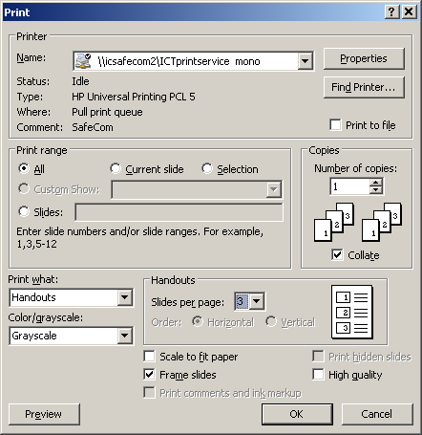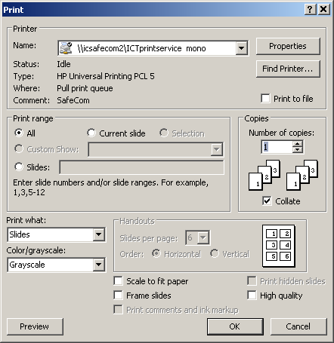

However, if you control how you print using the printer drivers, you can print the same content but it can be made to appear larger on the sheet and so be more legible.   
Thus… at the Printer dialogue window, select “Slides” as what is to be printed, and then on the “Finishing” tab, you can select how many pages to print per sheet, orientation. This example shows “6 pages per sheet” as being selected.

See over page the ways the output is improved.

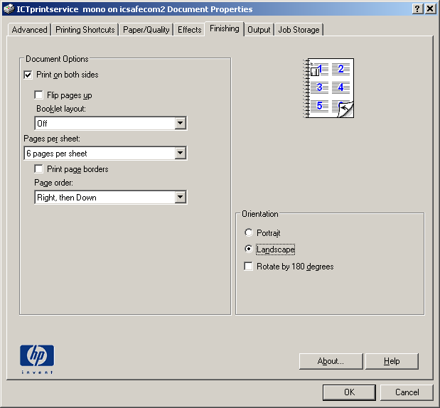

|  |  |
| --- | --- |
| This is what you get from the printer having selected 6 **handouts** per page using the PowerPoint printer driver. | This is what you get from the printer having selected 6 **pages per sheet** using the printer properties driver. |
| 6handouts | 6pages |

As you can see immediately, the second option on the right gives a much clearer view of the content of the presentation. If you choose to print 4 per page on the printer driver controls, this will usually give a sufficiently large image per page to make even diagrams legible, and still give you enough white space to write notes.

### Printing & cluster facilities at College sites

Printing facilities managed by ICT are provided in the computer clusters in the Sir Alexander Fleming Building, South Kensington campus; at main clinical sites (Hammersmith, St Mary's, Charing Cross and Chelsea & Westminster). At St Mary’s the cluster is in the Hynds Computer Lab, 1st Floor Medical School Building. At Chelsea & Westminster the cluster is in the Library. At Charing Cross the main cluster is within the Library (2nd floor) with a small cluster in the basement; at Hammersmith the cluster is on the 3rd floor of the Commonwealth Building and a small cluster in the Common room, Wolfson Education Centre and there Library PC facilities also available on site. All College site PC clusters require swipe cards for access. District General Hospitals with College PC clusters have local arrangements for printing and you will get details of these when you are attachment at these hospitals.

**Further details about Printing/Scanning**The ICT website has lots of information about using the system.

See [www.imperial.ac.uk/ICT/printservice](http://www.imperial.ac.uk/ICT/printservice)

# Using your Email account

You will already be using personal and institutional email accounts which you can continue to use this whilst at Imperial College. However, you **must** regularly check your Imperial email account as well. This is the main means of contacting you for teachers, tutors and admin staff located at the various sites that make up the School of Medicine. It is School of Medicine Policy that information relating to your course, including official examination information, will **ONLY** be sent to your Imperial email account. Usually, when critical documents become available they will be placed on the Teaching Intranet and you will be emailed about them. You will **NOT** be emailed when each new item of lecture support material becomes available as we expect you to regularly visit each course’s web page for new or updated files. On College PCs you are advised to use Microsoft Outlook and on logon you will see a desktop shortcut to it. Please note that all students have a quota of storage in Outlook. If your Outlook folder size goes over 500Mb you will not be permitted to send messages.

## Getting access to your email when you are away from College

##### Direct Connections in Halls of Residence

##### Many of the Halls of Residence are networked. See local documentation in your Hall for details of how you may make use of this.

##### Remote connection through ISP

You can access your College email using any web-browser from anywhere in the World. See the **Workbook for Email** for more details about how to use the web access to College email.

There are two recommended methods for use with a dial-up /broadband connection and ISP account

* **Low usage users,** **or if accessing email from many different offsite locations**, use the **Outlook Web Access** at <https://exchange.imperial.ac.uk>

You will be asked to state whether the machine being used is a public or private PC. enter your **login name** and **password**. You will be able to send and receive email, view your calendar and contacts lists, *etc*.

* **High usage users** or those who regularly wish to connect from a personal machine, should consider using an Outlook client via a VPN connection, or an IMAP or POP3 client such as Outlook Express, as an alternative to the web access. A VPN connection is NOT required for use of an IMAP or POP client, these still work using a VPN connection.

Useful information on how to set this up at home is available at:

<http://www.imperial.ac.uk/ict/services/email>

scroll down the page to the section titled “**Email Application Setup Information**”.

Consult your ISP for details on how to configure their settings. There are too many ISP’s for us to give you specific information, such as what the outgoing SMTP server settings should be. The local ICT Help Desks can offer some assistance, but cannot guarantee a solution.

###### NOTE The College is striving to improve security and intends to phase out the POP3 and IMAP protocols in favour of secure versions (POPS and IMAPS). If your email client supports these secure versions, and many new products do, then you are recommended to use them.

##### Broadband or other fast internet access

You can use Outlook as an Exchange client for your College email with fast connections. Please note that to use Outlook, the College VPN service is required and for which you need to register. Details of how to set this up may be found at: <https://www.imperial.ac.uk/ICT/> via Services/Network Installation/Network Connection/Virtual Private Network, or go to this link <https://www.imperial.ac.uk/ict/services/networkservices/networkconnections/VPNconnection>

***E-Mail Etiquette***

*This section has been modified for local use from an article by L.Rawlinson (Open University) and presented to the Association of University Administrators Forum March 2000. Nearly twelve years on, it is still relevant.*

Electronic mail is a primary means of communication but because it is still a relatively new communications medium, conventions as to how it is used are not well developed. On the one hand an e-mail message is the modern equivalent of an office memo; on the other, it replaces some telephone conversation. Although e-mail is more flexible, easier and quicker to use than a traditional memo, it has its own limitations. The following notes set down some points of good practice for both senders and receivers of e-mail to help us make more effective use of this medium.

## Some characteristics of e-mail

In considering e-mail, it’s worth noting some of its characteristics, which should influence how we use it.

* E-mail cannot be regarded as secure. Avoid sending confidential information via e-mail unless an encryption tool is available.
* Messages cannot be totally erased; even when deleted they can be retrieved from back-ups and usually traced back to their origin.
* Messages can be stored; unlike telephone conversations they are not ephemeral.
* Messages can be printed, so cannot be regarded as purely electronic.
* Messages can be readily sent to a large number of recipients and forwarded many times.
* Forwarded messages can be invisibly edited, unlike a printed memo which is fairly obvious if altered.
* Depending on the way in which the message was sent, recipients who are on a distribution list may be unaware that they are not the only ones to receive the message. They also may not know who the other recipients are.

## Sending e-mail

* Messages should be short and to the point. A message that makes its point and fits on one screen does its job best.
* Clearly identify the topic in the **Subject** box.
* A message should be about a single topic. If you want to raise a second topic, send another message to avoid having content unrelated to the message heading.
* If you need to cover several related topics, try to make the subject label broad enough to cover the whole. Multiple topics are confusing and frustrating for someone trying to follow a thread through e-mail correspondence.
* Is e-mail really the most appropriate medium? If you are composing a message that is long or requires some care in its construction, language and presentation, ask yourself whether a letter or memo might be more appropriate.
* You can never be sure what system your recipients will use to view your message. Although e-mail systems like Outlook encourage you to format your messages, this formatting may not survive to your recipient. For this reason it is a good idea to treat all messages as plain text (and avoid using £ signs – use GBP instead).
* Use proper spelling, grammar and punctuation. Always proof read and use the spell checker if necessary. Messages are frequently printed and errors that may be overlooked or excused when read on screen are likely to be judged more harshly when seen on paper.
* Choose words carefully, sometimes hastily produced messages can be misinterpreted. Avoid slang and don’t include anything that you would have reservations about appearing in print above your written signature.
* Be careful of your ‘tone of voice’. Because your facial expressions and verbal tone are missing from electronic correspondence, what you write is open to misinterpretation.
* Avoid sarcasm or other forms of dry humour to minimise the risk of misinterpretation.
* Do not use all capitals, which may be interpreted as shouting.
* You should make it clear if you wish your message to be forwarded by its first recipients, or is only for the person (or people) to whom it has been sent.
* Think carefully about sending confidential information about yourself or others. If your message refers to a colleague or their work, make sure you include that colleague in the circulation of the message.

## Replying to e-mail

* Reply as soon as possible, at least within 24 hours. If you cannot answer a message within this time, send a message saying when you will be able to respond.
* Make use of the “Out of Office Assistant” when on leave or out of the office for any period of time making sure you give a contact name for urgent messages.
* Change the subject line if the topic changes in your reply.
* Use a signature that gives contact information i.e. extension/fax number and department.
* Do not include the original message automatically. Consider whether it is necessary e.g. where the recipients of your reply include people who did not receive the original.
* Without sacrificing brevity unduly, try to make your reply intelligible on its own, without requiring reference back to the original message.
* When responding to a message to several colleagues, check whether others have already responded.
* When replying to a message that has been sent to a list of recipients, only reply to the whole list if your answer is of interest to them all. If you are taking up specific points with the sender of the original message, send your response only to that person.
* Watch **cc’s** when replying to make sure you reach your intended audience.

## Forwarding e-mail

* Take care in forwarding a message: would the original sender wish you to do so?  
  You may need to seek their permission first.
* It may be a good idea to remove a lengthy distribution list from the head of a message before forwarding it. If you do this (or make other changes), it would be appropriate to write a note, perhaps in square brackets, indicating what you have done.
* If, instead of forwarding a message, you extract a chunk from it and send that as a new message, or as part of a new message, make sure it is clear what you have done.

## E-mail addresses

* Where there is more than one user with similar names, check that you have chosen the right one.
* Users’ internal e-mail addresses do change from time to time, e.g. when a new mailbox is established for the user on a different e-mail system. The global address list is updated (usually nightly), but until the old mailbox has been removed, two separate addresses will appear in the list.

## E-mail attachments

* E-mail can be an extremely convenient way to send files: Word documents, templates, style sheets, spreadsheets and graphics can all be sent as e-mail attachments. However, these files may be large and take up a lot of room on mail servers; this can seriously impair the performance of the e-mail system (and can lead to you exceeding your own Exchange quota when you try to send or receive large files).
* Think carefully before sending any message with an attachment to a large distribution list. Place it instead in a shared area and e-mail people with the file name and its location.
* When you receive an e-mail message with an attachment, save the attachment to your own H: drive folder as soon as possible, and remove the message and attachment from your mail box.

## Unwanted e-mail

* Because the Internet is largely unregulated, it is difficult to prevent unsolicited messages reaching you. You can limit who gets hold of your e-mail address by being circumspect when visiting web sites and by thinking carefully before subscribing to any mail service. However, lists of e-mail addresses are bought and sold in the same way as lists of postal addresses are (but with less scope for regulation).
* Just as the best way to deal with ‘junk’ postal mail is to put it in the bin unopened, the best way to deal with ‘junk’ e-mail is to delete it.

## Think before you send

* E-mail is a fast and effective way of communicating and sharing information but should not be used as a substitute for other forms of communication, for example where face-to-face contact, phone or memo would be more appropriate. It is easy to be overloaded with e-mails in which case the benefits will be lost.
* E-mail communications can be presented as evidence in court and are legally binding.

## These Guidance Notes provide important information for anyone who works with computers. They:

* Give a brief summary of Regulations explaining how they are applied at College and how they may affect you;
* Suggest some simple adjustments that can be made to your workstation and screen to make them more comfortable and easy to use;
* Answer the questions that are most commonly asked about Computers and health.

### WHY IS COLLEGE CONCERNED?

More and more people are using computers and inevitably we are seeing people in college who are experiencing health problems, notably affecting the hands and arms. This is usually caused by prolonged use of the keyboard and mouse coupled with unsatisfactory workstation layout and/or poor keyboard or mouse technique.

### What has College done to ensure your health is protected?

The College has developed a specific policy on work with computers. You can see a copy of the [Policy](http://www3.imperial.ac.uk/portal/page?_pageid=44,395019&_dad=portallive&_schema=PORTALLIVE) and its [Code of Practice](http://www3.imperial.ac.uk/portal/page?_pageid=44,461946&_dad=portallive&_schema=PORTALLIVE) on the [Occupational Health (OH) web page](http://www3.imperial.ac.uk/portal/page?_pageid=44,1&_dad=portallive&_schema=PORTALLIVE) on the College intranet system. These documents outline responsibilities, standards and procedures to maintain healthy working conditions. To assist you, as a computer user, the College has implemented a number of things pertaining to training and general computer health and safety.

### The following applies to everyone using a computer at College:

* **Workstation assessments** - Everyone should do an assessment of their own workstation and to assist you there is a checklist for you to work through which can be printed off the OH page on the College intranet system. Each Department has at least one person trained to assess computer workstations and equipment and they will help you sort out what measures are necessary to reduce any risks that you may have identified in the assessment of your workstation.
* **Minimum workstation requirements** - These are mainly features to ensure that individuals can adjust and organise their workstations to suit their particular needs. Details of the requirements are given in the College's computer [Code of Practice](http://www3.imperial.ac.uk/portal/page?_pageid=44,461946&_dad=portallive&_schema=PORTALLIVE).
* **Provide information** - This should cover what an employer has done to comply with the Regulations, such as the action taken to reduce the risks and arrangements for breaks. These Guidance Notes and the College's computer Policy and Code of Practice provide this information.
* **Eyesight Screening** - Everyone at College can have eyesight screening at their local OH clinic. See the information on eligibility for eyesight tests on the OH web page.

If you are a member of staff at Imperial and use a computer for a significant amount of time for work purposes, then you may be classed as a significant user. The full definition of a significant user can be found in the Computer Health and Safety Handbook or by clicking here. If you are classed as a significant user then you will also be entitled to the following:

* **Eye and eyesight tests** - Everyone at College can have eyesight screening at their local OH clinic. Specified users are also entitled to an eye test by one of the appointed opticians. For more information, contact your local OH Service or view the eye-test information on the intranet system.
* **Provide health and safety training** - This is to make sure 'Users' can use all aspects of their workstation equipment safely, and know how to make best use of it to avoid health problems. The College's Safety and OH Advisors run one or two 'micro-workshops' around the College every term. There are also training courses for specific software packages and there use. Details of workshops can be found in the College Training Programme.

### What about work at home?

Provided that it is an agreed part of your usual work, periods of computer work at home should be taken into account when deciding if you are a 'specified user'. If your computer equipment used at home is supplied by College, it is required that a workstation assessment be carried out. It is also recommended that where possible, your personal computer equipment be set up to similar standards as that of your work equipment, to prevent you developing any health problems.

## DON'T IGNORE THE SYMPTOMS

If your arms or shoulders start aching/tingling, take a break and then reorganise your work to give yourself more breaks in the future and reorganise your workstation to ensure that your equipment is correctly set-up for you. If symptoms persist or keep occurring then you should contact the experts.

### Who are the experts:

1. Your department will have a DSE Assessor who knows about computer ergonomics & can help you check your workstation. They'll help you with the computer checklist if you do not feel confident enough to complete it yourself. They will also assist you if you identify problems through the checklist which you can't solve yourself or which may affect your or others safety.
2. The College Safety Unit holds regular health & safety training sessions for computer users. Contact your DSE assessor or the Safety Unit for details.
3. If you are unable to solve the problem by re-organising your workstation and are experiencing difficulties, your local Occupational Health Service can assess and advise on how to overcome them.

## ADJUSTING YOUR WORKSTATION TO SUIT YOU

You should make full use of the adjustment facilities for your computer and work environment to get the best from them and avoid potential health problems. Here are some useful tips:

### A. Workstation Set-up:

**Tip A1:** Adjust your chair and computer to find the most comfortable position for your work. As a broad guide, your arms should be approximately horizontal and your eyes at the same height as the top of the computer casing.

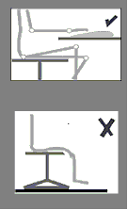

**One:** Adjust seat height to ensure hands are perpendicular to keyboard (height adjustment is usually achieved by a handle to the left underside of the chair).

**Two:** If, with the chair set at the correct height feet cannot be placed flat on the floor, ask for a footrest. A footrest will be provided for you if required.

**Tip A2:** Make sure there is enough space underneath your desk to move your legs freely. Move any obstacles such as boxes or equipment.

**Tip A3:** Position your screen at a comfortable viewing position, height and distance. As a general rule, the top of the screen should be roughly at eye level. The screen should be positioned at about 350 - 600 mm away from you. Adjusting the swivel and tilt mechanism will allow a comfortable viewing angle and will help avoid neck muscles becoming fatigued.

**Tip A4:** Adjust your keyboard and screen to get a good keying and viewing position. A space in front of the keyboard is sometimes helpful for resting the hands and wrists while not keying.

**Tip A5:** You should ensure that you sit 'face on' to your computer screen. This will avoid you twisting your body and placing unnecessary strain on muscles and tendons.

**Tip A6:** Arrange your desk and screen so that bright lights are not reflected in the screen. You shouldn't be directly facing windows or bright lights. Adjust curtains or blinds to prevent unwanted light. Ideally your screen should be at 90 degrees to the source of the reflection / glare. Screens that use dark characters on a light background are less prone to glare and reflection. If these 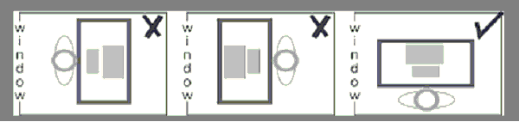measures do not work then you should consider anti-glare screen filters.

### B. Workstation use:

**Tip B1:** Don't sit in the same position for long periods. Make sure you change your posture as often as practicable. Some movement is desirable, but avoid repeated stretching movements.

**Tip B2:** Screen-based work should be broken up by other tasks such as filing, photocopying, etc. Computer work should be organised so that you do not work for periods of one hour or more on a computer without a change to some other work or a 5 minute rest break. This is especially important if the computer work is particularly intensive or requires a high degree of concentration. It is recommended that you should have a break of at least 5 minutes for every hour spent doing screen-based work.

**Tip B3:** With the chair set to the correct height it should not be too high to create pressure under your thighs nor too low to give no thigh support. As a rough guide, your knees should be at right angles. Remember about a footrest if you cannot touch the floor.

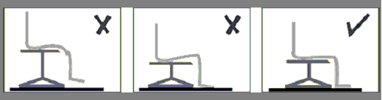

|  |  |
| --- | --- |
| **Tip B4:** The seat back height should be adjusted to provide support for the small of your back when you are sitting erect but comfortable.   Seat back height adjustment should be independent of chair height adjustment and is often adjusted by loosening control to rear of chair.   Adjust to correct height and then re-tighten control. | Image showing proper lower back support |

**Tip B5:** Be aware of your posture at all times.   
Don't slouch as this could lead to back problems.

**Tip B6:** Make sure the characters on your screen are sharply focused and can be read easily. They shouldn't flicker or move. If they do then you should get your screen serviced or replace it.

**Tip B7:** Make sure there are no layers of dirt, grime or finger marks on the screen (or your glasses, if you wear them.)

**Tip B8:** Use the brightness control on the screen to suit the lighting conditions in the room. These controls can be found on the lower front side of the monitor itself.

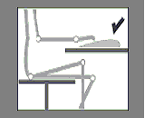

**Tip B9:** Don't bend your hands up at the wrist when keying. Try to keep a soft touch on the keys and don't overstretch your fingers.

Good keyboard technique is important.

Don't rest your forearms on the edge of your desk as this can lead to health problems in the forearms.

**Tip B10:** Ensure that you use your mouse correctly. The mouse should be positioned close to your body to avoid excessive reaching to operate it. Your fingers should be placed down the body of the mouse to reduce movement at the knuckles and operation should be from the elbow to limit bending and twisting at the wrist.

**Tip B11:** Try different layouts of keyboard, screen and document holder to find the best arrangement for you. **Tip B12:** Make sure you have enough workspace to take whatever documents you need.   
A document holder may help you to avoid awkward neck movements.

## C. Office Environment

### C1. Temperature, Ventilation and Humidity

Individuals will have different tolerances for these environmental factors. However, task, work volume, clothing and your health all affect the temperature at which you feel comfortable. Office environments should not be lower than 16 degrees Centigrade. You should avoid locating a workstation where temperature problems are foreseeable. Consider local variations e.g. a workstation adjacent to a south facing window may be much warmer than the same set-up located in an area away from the window or a self closing mechanism on a door next to a workstation may prevent the DSE user suffering from unpleasant draughts.  
Extremely dry air can cause discomfort to the eyes of DSE users. Excessive humidity is also unpleasant. Build up of static electricity is also more likely in areas of low humidity.

**Tip C1:** Temperature, air flow and humidity are environmental factors that require particular attention when planning computer clusters. Additional environmental control in the form of a potable fan or air conditioning may be required. One or two potted houseplants may help to control low humidity, in addition to making the room seem pleasant.

### C2. Noise

In open plan/shared offices background noise may be distracting to DSE users and may contribute to reduced efficiency or errors. Noise levels experienced at a work station should not be sufficiently high as to cause unreasonable distraction. This will again be subject to individual tolerances.

**Tip C2:** Noisy equipment (i.e.: dot matrix printers, photocopy machines, etc.) may need to be placed behind screens to limit noise or placed further away from occupants. During refurbishments and/or building projects local noise levels may increase. If these levels become problematic you should consult your line manager.

### C3. Lighting

Office lighting should allow you to read documents and your keyboard without visual discomfort. A desk lamp may be required if the lighting in the office is insufficient for the tasks you are performing. If your office environment is too bright there are a number of things you can do, namely:

* Repositioning your desk to avoid glare is important as reflections off one screen can cause discomfort and may even cause headaches. This has already been discussed earlier in Tip A6.
* Blinds can be installed to allow you to regulate the amount of light entering your work environment locally. This is effective as it will allow you to vary it according to the change in season (i.e.: In winter you may require more light in the late afternoon).
* Dimmer switches can also be installed if required.

### C4. Layout of Office Area

The layout of your office area should not interfere with your health and safety. If you find that you frequently bump into certain items they should be repositioned so this does not occur. There should be no trip hazards (i.e.: trailing wires; piles of documents; etc) that someone may encounter as these have the potential to cause serious injury.

## EXAMPLE OF WORKSTATION SET-UP

The following checklists should help you determine the ideal workstation set up and seating arrangement.

### Figure 1: Workstation Layout

1. 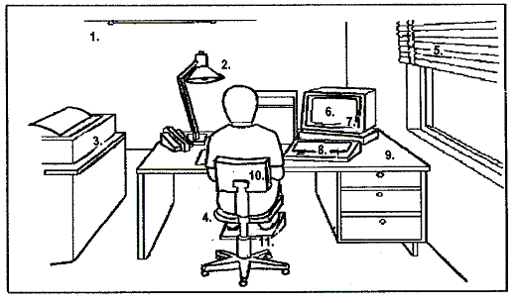Adequate Lighting
2. Adequate contrast - no glare or distracting reflections
3. Distracting noise decreased to a minimum
4. Leg room and clearances to allow postural changes
5. Window covering
6. Appropriate software
7. Screen: stable image, adjustable, readable, glare/reflection free
8. Keyboard: usable, adjustable, detachable, legible
9. Work surface: allow flexible arrangements, spacious, glare free
10. Work chair: Adjustable Footrest

### Seating arrangementsFigure 2: Seating Arrangement

## FURTHER INFORMATION

For further information visit the Health & Safety Executive web site <http://www.hse.gov.uk/>   
  
Direct link to HSE- VDU Guidance <http://www.hse.gov.uk/pubns/indg36.pdf>

#### 

# College Information Systems Security Policy - Supporting Policy 2: Conditions of Use of IT Facilities

The User agrees and accepts that:

1. Use of College IT facilities, and their use to access non-College IT facilities, must be for the purpose of University research, teaching, coursework, associated administration or other authorised use. No 'private/commercial' work is permitted without prior authorisation. College IT facilities include the network, the virtual private network (VPN), computers, printers and the associated services e.g. software, data, email, Web, E-journals, bulletin boards, data bases but do not exclude any other part of the College IT facilities.

Occasional personal use of the Desk top computer, e-mail and web access is permitted provided such use does not disrupt the conduct of College business or other Users.  Recreational use of the Halls of Residence network is also permitted, subject to these conditions.

2. When using College IT facilities the user must comply with the College Information Systems Security Policy and all relevant statutory and other provisions, regulations, rules and codes of practice. Specifically, but not exclusively, the User must:

2.1 Not disclose to others her/his College login name/password combination(s) or access or attempt to access IT facilities at College or elsewhere for which permission has not been granted or facilitate such unauthorised access by others.

2.2 Not use or produce materials or resources to facilitate unauthorised corruption, changes, malfunction or access to any IT facilities at the College or elsewhere. Attempted access to IT facilities includes scanning activities (e.g. port scanning).

2.3 Not display, store, receive or transmit images or text which could be considered offensive e.g. material of a sexual, pornographic, paedophilic, sexist, racist, libellous, threatening, defamatory, of a terrorist nature or likely to bring the College into disrepute.

2.4 Not forge email signatures and/or headers, initiate and/or forward 'chain' or 'junk' or 'harassing' email.

2.5 Not play unauthorised games.

2.6 Respect the copyright of all material and software made available by the College and third parties and not use, download, copy, store or supply copyright materials including software and retrieved data other than with the permission of the Copyright holder or under the terms of the license held by the College.

2.7 When holding data about living individuals, covered by the College Data Protection Policy, register that data and its uses, and treat it in accordance with the Principles, as required by the Data Protection Act. Student users must not construct or maintain computer files of personal data for use in connection with their academic studies/research without the express authority of the Departmental/Divisional Data Protection Co-ordinator.

2.8 When responsible for Information Servers or the information held thereon abide by the College Code of Practice for Information Servers and be aware that a User may be considered in law to be a Publisher in certain circumstances.

3. All data/programs created/owned/stored by the user on or connected to College IT facilities may, in the instance of suspected wrong doing, be subjected to inspection by College or by statutory authorities. Should the data/programs be encrypted the User shall be required to provide the decryption key to facilitate decryption of the data/programs.

4. Other than any statutory obligation, the College will not be liable for any loss, damage or inconvenience arising directly or indirectly from the use of, or prevention of use of, any IT facility provided and/or managed by the College.

5. Whilst the College takes appropriate security measures against unauthorised access to, alteration, disclosure, destruction or accidental loss of personal and other data it cannot and does not give any warranties or undertakings to the USER about security, confidentiality or integrity of data, personal or other. The same applies to other IT material submitted to or processed on facilities provided or managed by the College or otherwise deposited at or left on its premises.

6. His/her name, address, photograph, status, e-mail name, login name, alias, College Identifier (CID) and other related information will be stored in computerised form for use for administrative and other purposes e.g. monitoring system usage.

7. As provided by the Telecommunications (Lawful Business Practice) (Interception of Communications) Regulations 2000, made under the Regulation of Investigatory Powers Act 2000 the College will intercept and monitor electronic communications for the purposes permitted under those Regulations in accordance with the Code of Practice on Monitoring Electronic communications in the College Information Systems Security Policy.

8. These conditions apply to non-College owned equipment e.g. personal Laptops, home PCs when connected to the College network, directly and/or via the VPN, for the duration that the equipment is using the College network.

**Breach of these conditions may lead to College disciplinary procedures being invoked, with penalties which could include suspension from the use of all College computing facilities for extended periods and/or fines. Serious cases may lead to expulsion or dismissal from the College and may involve civil or criminal action being taken against the User.**

If you have any difficulty, please contact your Departmental/Divisional Computing Representative or the ICT Service Desk (Ext. 49000) or the ICT User Registration Office (Ext. 49008).

You can also see this information at

<http://www3.imperial.ac.uk/secretariat/policiesandpublications/informationsystemssecurity/policy/policy2>

**College Information Systems Security Policy**

Your attention is also drawn to this Policy which may be viewed online on the ICT website <http://www3.imperial.ac.uk/ict/services/securitynetworkdatacentreandtelephonyservices/security/securitypolicies>

This page links to the different sections of the Policy, the Codes of Practice, and a set of Guidelines. In summary, the Policy reveals the extent to which the College acts in order to keep safe all critical College information and information systems.

You should note **Guideline 5** which deals with *Misuse of College IT Systems by Students* and provides a list of the Summary Punishments.

It is known that the student-community share “recreational” files such as music and video clips. Often this material is obtained by looking for “open shares” on the network. This activity is contrary to College Policy. You are also reminded that acquisition of such material should be in an authorised manner as much of it is copyright. Re-use of material provided to you is also copyright and you should respect it and not re-distribute in any way except with express and prior permission of the copyright holder.

**Peer-to-Peer software**

Whilst the use of Peer-to-Peer file transfer software on the campus network is not explicitly forbidden, since it can have some legitimate uses, such software must never be used to transfer copyrighted materials without the permission of the copyright holder.

College reserves the right to investigate and close down any systems which:

* Use Peer-to-Peer software to transfer copyrighted materials without the permission of the copyright holder
* Make excessive demands on College network bandwidth
* Are suspected of being involved in a security breach

The owners and/or users of such systems could face disciplinary action.

This also applies to personal computers in Halls, at home or elsewhere and which are connected to the College network remotely by VPN, and by wireless or wired-connections in College.

# Data Protection Policy - Code of Practice 2: Handling of Patient Data

## Processing Patient Data on Computers Attached to the College Network

The Faculty of Medicine’s position on this is that no student should store patient-identifiable information on their College systems, and also they should not do so on any private systems. In working in NHS Trust or General Practice environments, you should not attempt to export such information as this will be contrary to their local policies. Here is the College Policy on Handling Patient Data taken from <http://www3.imperial.ac.uk/secretariat/policiesandpublications/dataprotection/codesofpractice/cop2-handlingofpatientdata> .

1. It is recognised that some research, particularly clinical, requires the processing and/or storage of personal and sensitive information relating to living individuals e.g. patients. All such activity is governed by the Data Protection Act 1998 and members of College must comply with the Act and process/store all personal information in accordance with the eight Data Protection Principles shown at the end of this note.

2. It is a condition of Use of Information Technology (IT) Facilities at Imperial College that members of College may only process and/or store information relevant to their College work on computers, portables, desk-top or servers, attached, permanently or temporarily, to the College network. Examples of processing and/or storage include e-mail messages (whether stored locally, or on a College server), word processed documents, medical images, databases and Web pages. Processing of data for patient management purposes is not permitted on the College network or equipment connected to it.

3. With respect to the security of personal data (Principle 7 below) it must be noted that the College network is widely and legitimately accessible across the campus and from the internet via its connection to JANET. In terms of the processing and storage of personal data, the network must be regarded as being insecure, having no access restrictions. Consequently, any identifiable patient data stored on any computer connected to the academic network must be encrypted and/or secured behind an appropriate firewall. It is not sufficient to rely on normal system passwords. It is also not acceptable for unencrypted personal data to pass across the College network.

4. Information relating to the clinical management of patients under the care of an NHS Trust typically belongs to that Trust (and not to the individual clinician), irrespective of the usage to which the data is being put, i.e. clinical diagnosis or research purposes. However, in the latter case, the data may well be transferred to a third party, such as the sponsor of a study. Information obtained on patients and healthy volunteers specifically for the purpose of a research study, i.e. beyond normal clinical care, will belong either to the study sponsor or the investigator.

5. In all cases, it is a requirement of the Data Protection Act that the explicit consent of the Data Subject be obtained, by the Data Owner, before any such sensitive data are stored or processed. The Data Owner may be a Trust, a sponsor or the investigator. When seeking consent, Data subjects should be informed of the purposes for which it will be used, in accordance with the first principle, and the likely recipients to whom their information could be disclosed (e.g. the College if the data has been collected by the Trust). Where such data are to be processed on a computer connected to the College network, or passed across that network, a separate registration of the data must be made with the College Data Protection Officer through your Departmental/Divisional Data Protection Co-ordinator.

6. To summarise, data on living individuals e.g. clinical data, collected for whatever purpose, must not be stored or transmitted on the College network unless both registered and adequately protected to prevent disclosure of that data to unauthorised persons. This requires either that adequate security measures are in place or that the data are adequately anonymised. It should be noted that where the data has been codified there exist separate records, electronic or paper, which enable the individual to be ultimately identified, then that data is not fully anonymised and falls under the Act. Thus it must be registered, properly processed in accordance with the Act and adequately protected.

7. The Eight Data Protection Principles.

When processing personal information data must:

1. be obtained and processed fairly and lawfully and shall not be processed unless certain conditions are met
2. be obtained for a specified and lawful purpose and shall not be processed in any manner incompatible with that purpose
3. be adequate, relevant and not excessive for those purposes
4. be accurate and kept up to date
5. not be kept for longer than is necessary for that purpose
6. be processed in accordance with the data subject's rights
7. be kept safe from unauthorised access, accidental loss or destruction
8. not be transferred to a country outside the European Economic Area, unless that country has equivalent levels of protection for personal data

Further details can be found on these Data Protection Pages. If in doubt about security measures required/available, contact ICT.

For more information concerning the Data Protection Act contact your Departmental/Divisional Data Protection Co-ordinator.

This information may also be viewed at

<http://www3.imperial.ac.uk/secretariat/policiesandpublications/dataprotection/codesofpractice/cop2-handlingofpatientdata>

**Internet privacy**

Alongside the College policies, ICT also provides more guidance on.

Email, Backing up data, Computer security basics, Copyright, How not to respond to “phishing”, Internet privacy, Keeping your password safe, and Protecting sensitive data  
  
See <http://www3.imperial.ac.uk/ict/secureaware/internetprivacy>

# BMA Guidance

# Using social media: practical and ethical guidance for doctors and medical students

Many health professionals use websites such as Facebook, Twitter and various different internet forums. While the use of social media can bring both personal and professional benefits, it can also present a number of risks to doctors and medical students.   
  
This guidance provides a brief overview of the challenges and potential pitfalls that health professionals may encounter when using social media.

It gives practical and ethical guidance on a range of subjects including, protecting patient confidentiality, defamation, the public-private boundary and the potential impact of social media use on medical education and employment.   
<http://www.bma.org.uk/images/socialmediaguidancemay2011_tcm41-206859.pdf>

Taken from <http://www.bma.org.uk/press_centre/video_social_media/socialmediaguidance2011.jsp>

Your Ethics course will also make reference to this topic.

# Illegal Transfer or use of Copyright Material

This ICT website <http://www3.imperial.ac.uk/ict/services/securitynetworkdatacentreandtelephonyservices/security/securitypolicies/copyrightmaterial>   
provides further information about copyright for music, movie and images files. Teaching materials, novels etc., are also copyright. There are regulations covering what you are permitted to do with material where others own the Copyright and Intellectual Property Rights. The teaching intranet (see below) has Conditions of Use concerning reuse of teaching materials provided for your person use.

****Faculty of Medicine

Faculty of Natural Sciences

**Computer Laboratory   
Food and Drink Policy**

The “misuse of computer facilities or activities” is a disciplinary offence, as defined in paragraph A. 1(vi) of the College Procedures[1] for dealing student disciplinary offences.   
The action described below is in accordance with and subject to the College Procedures.

1. **Any student found to be visibly in possession of food or drink in a student computer laboratory will, on the first offence, have his/her password removed by the ICT Support staff.** It will not be reinstated until the student has seen a senior member of staff* to request reinstatement of the account, but loss of access to the account will normally be for less than seven days. At the time of interview, the student will be reprimanded, fined **£10** (to go to the Student Hardship Fund) and informed of his/her right of appeal.

*

for Medicine undergraduate students – the Head of Learning Resources or chairman of a campus IT committee

for Medicine postgraduate students – the chairman of a campus IT committee or the Departmental Administrator

for Life Sciences undergraduate students – the Director of undergraduate Studies or Senior Tutor

for Life Sciences postgraduate students – the Divisional Administrator

1. **The exception will be that drinking from a container with a non-spill cap will be permitted.**
2. **Loss of access to a computer account will not be regarded as an extenuating circumstance** in the event that either (i) deadlines are missed, *e.g.* for submission of coursework and completion of on-line assessments, or (ii) that senior staff are not immediately available to interview the student.
3. **A repeat offence will again lead to immediate removal of password.**   
   The student will be called before the Director or Education (Medicine) or delegate, or the Director of Undergraduate Studies for Life Sciences or delegate, as appropriate.   
   The student will be reprimanded, informed that the password will be removed for seven days, fined **£100** and informed of his/her right of appeal.
4. **A further offence will precipitate a full College Discipline Committee hearing.**   
   The student will have his/her password removed until such time as the Committee has come to a decision.

|  |  |
| --- | --- |
| **Professor Jenny Higham**  Director of Education  Faculty of Medicine | **Dr Stephen Curry**  Director of Undergraduate Studies (Life Sciences)  Faculty of Natural Sciences |

September 2011

**Undergraduate Medicine Teaching Intranet and   
Blackboard resources**

The majority of your course materials will be found online at the Teaching intranet

<https://education.med.imperial.ac.uk> where you will also find the conditions of use.

Authentication is required using your College username and password.

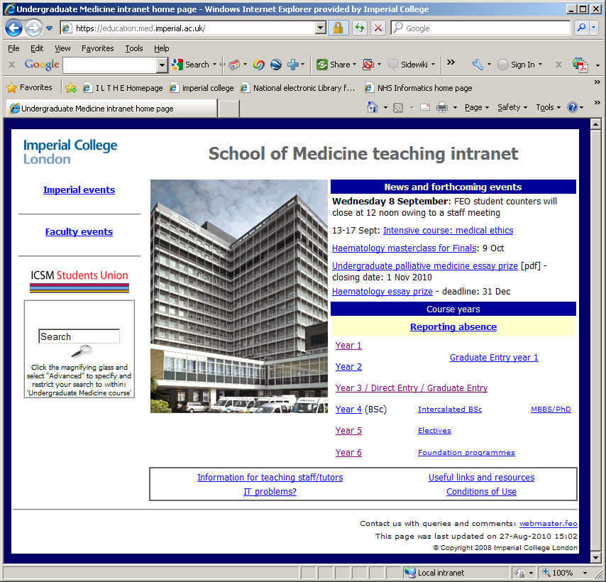

You have access to all areas of the intranet and so can revise topics currently taught to year 1 & 2 students, or look at those taught in the clinical years of the MBBS course here at Imperial. There are also a number of other e-learning resources you will find useful.

Please explore.

If you have any queries about links, or comments, please email [webmaster.feo@imperial.ac.uk](mailto:webmaster.feo@imperial.ac.uk)

The Year 4 page obviously is the most important for you at this stage.

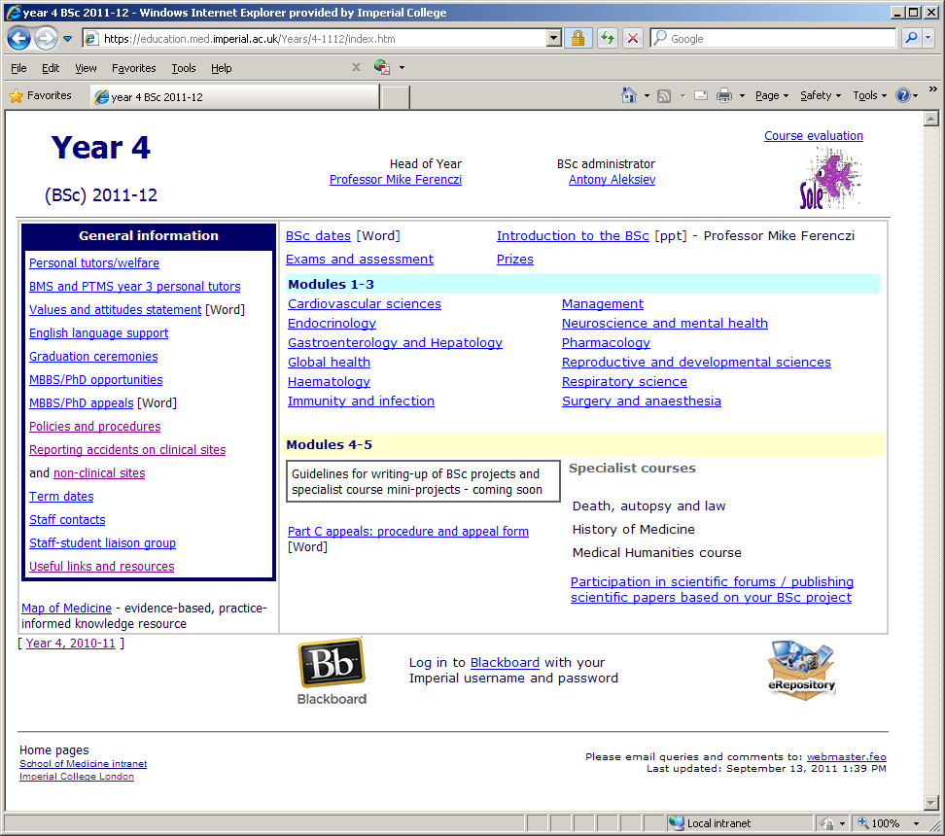

**BlackBoard** <http://learn.imperial.ac.uk>

This is the College VLE (Virtual learning Environment) and some of the components of the course are delivered through Blackboard, for example   
e-lectures, online quizzes, discussion boards, and so on. The following pages introduce the navigational elements to you. Some of your assignments may require to be submitted through BlackBoard.

**Introduction**

Blackboard is the College’s Virtual Learning Environment; <http://learn.imperial.ac.uk> and will be used alongside the School of Medicine Teaching Intranet for various components of your teaching and   
self directed learning.

**Customize My Blackboard Page**

When you first log into Blackboard the **My Blackboard** portal page appears, showing the Course List. There are different ways you can customize the look of this page.

The **Layouts** link allows users to change the order and location of the Channels. For example, you could move the Course List from the middle column to the left column.

The **Channels** link is where you can show or hide other channels from appearing on this page.

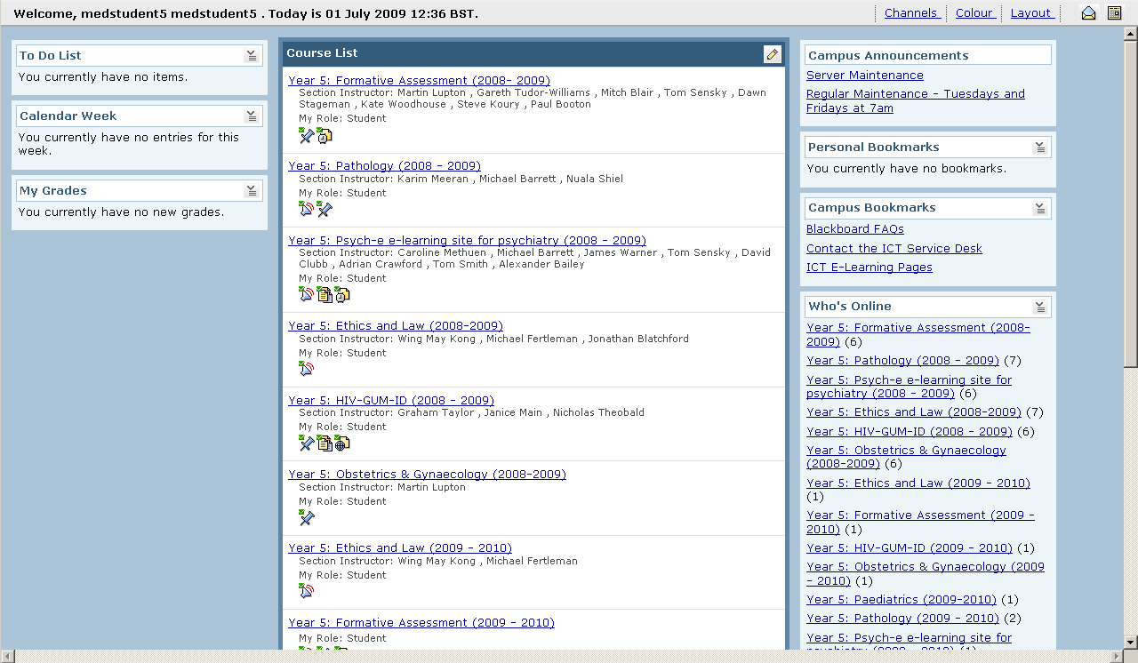**Fig. 1**

The **Pencil Icon Pencil Tool.bmp**  allows users to show/hide courses from appearing in the course list.

**Contacts/Trouble-shooting**

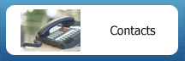Within each Blackboard course, there is an icon entitled **‘Contacts’**, as shown in Figure 2. which provides contact details of the Course Leaders, Administrators, etc.   
  
 **Fig 2.**

There is also a link from the Contacts folder to the **IT Problems** page on the Intranet (<https://education.med.imperial.ac.uk/ITprobs.html>) for students who are experiencing technical difficulties with Blackboard.

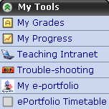You can also access the IT Problems web page from the **‘My Tools’** tab within each Blackboard course.  
  
There is also useful links to addtional resources:

* Teaching Intranet
* ePortfolio (If applicable)
* Trouble-shooting

**Fig 3.**

**Tip:** If you are unable to access any content and/or unable to access tools inside a Blackboard course you are advised to run a ‘**Browser Check’**. Please note that if you are accessing Blackboard from home, you will need to have **Flash Player** installed and you will need to **TURN OFF your popup blocker** to view multimedia content.

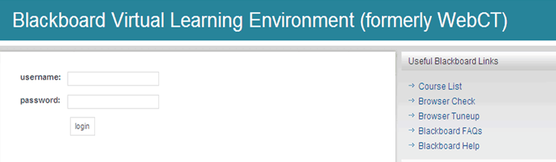

You can run a ‘**Browser Check**’ (from the Blackboard login page) to ensure that the browser you are using to access Blackboard is configured correctly, so the complete functionality of the application is available to you.

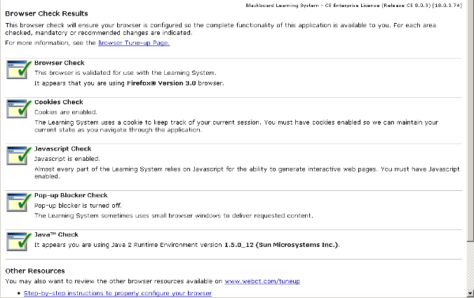

If the browser is configured correctly then the user will have ticks, however if there is a problem then instead of ticks there would be a red cross.

To rectify any errors, scroll down and click on the relevant link under **‘Other Resources’** and follow the instructions.

**Please note** that some browsers (i.e. Chrome) and operating systems are **NOT** **compatible with Blackboard**. You can view a list of supported browsers and operating systems from this link:

<http://kb.blackboard.com/pages/viewpage.action?pageId=75071574>

**Navigation**

Blackboard uses virtual breadcrumbs to show the path you have taken, which appears directly under the title of the course, as shown in Figure 4. You can use the breadcrumbs to navigate through the course.

Breadcrumbs.bmp

**Fig. 4**

Course Tools.bmp

Alternatively, you can click on one of the Course Tools, as shown in Figure 5, to navigate within the course.  
  
**DO** **NOT** use the ‘Back & ‘Forward’ buttons on your browser as this will cause errors.

**Fig. 5**

**Tip:** New items are available when a white star in a green box appears next to a Course Tool.

New Items.bmp

**Fig. 6**

**Course List – New Content Available**

If there is any new content within a Blackboard course since you last logged in, icon(s) will appear under the course titles as shown in Figure 7.

Hover your mouse over the icon to reveal what type of content is available or click on an icon to access the new content.

In the example, the following icons are shown (from left to right) to highlight new content.

• Announcements

• Discussion Board

• Assessment

**Fig. 7**

**Co**

**Experiencing Problems Uploading Files Using Windows 7**

****Some people have reported problems when uploading files in Blackboard. This may also affect some other areas of functionality in Blackboard too.

When you log in to Blackboard with the new system **(Windows 7)** you will see a dialog box asking if it is ok to run Java from the college server. You must click **“Always trust content from this publisher”** and **"Run"** to enable My Computer in the upload dialog.

Once you have clicked on this once, the permission should be stored in your profile, so you won’t have to do this again.

**Training Materials**

There are some tutorial videos and supporting .pdf documents on how to use various tools inside Blackboard: <https://education.med.imperial.ac.uk/BB/train/student/train.htm>

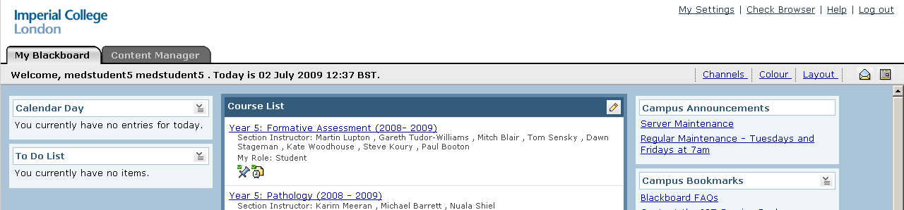

**Tip:** You can also access the online ‘**Help’**, which can be located on the top right of the window, once you have logged into Blackboard.

1. <http://www3.imperial.ac.uk/registry/information/formsproceduresandregulations>