Total Word Count: 4458
Antibiotic Use
Beyond Severe Cholera:
A Systematic Review
and Meta-Analysis

Samuel S O’Neill
CID – 00513091
Department: Imperial College,
Médecins Sans Frontières

ABSTRACT
Introduction: Current guidelines recommend antibiotic use for the treatment of severe cholera, but there is uncertainty and conflicting guidelines regarding antibiotic use in patients suffering less severe cholera. A systematic review and meta-analysis was conducted to investigate antibiotic use in mixed and undefined cases of cholera.
Methods: Medline, Embase, Cochrane Central, Cochrane Infectious Disease Group Specialised Register and bibliographies were searched to identify randomised and quasi-randomised trials comparing antibiotic treatment groups to control (placebo, or nothing). The primary outcome was clinical success; secondary outcomes included bacteriological success, duration of diarrhoea, clinical relapse and bacteriological relapse. A random effects meta-analysis was done to provide pooled estimates of effect, and subgroup analyses ran to explore potential sources of heterogeneity.
Results: 21 studies met the inclusion criteria, comprising 16 randomised controlled trials and 5 quasi randomised trials. 5 studies comparing 13 antibiotic treatment arms to controls measured clinical success in mixed cholera cases, with a pooled relative risk of 1.85 (95%CI 1.57-2.17; I² 52.5%, p=0.014). Bacteriological success was measured by 9 studies comparing 15 antibiotic treatment arms with controls, with a pooled relative risk of 4.99 (95% CI 1.27-19.61; I² 97.8%, p=0.000). 10 studies comparing 17 antibiotic treatment arms to controls measured duration of diarrhoea with a pooled relative risk of duration of diarrhoea was markedly reduced among patients receiving antibiotic compared to control, with a weighted mean difference 36.8 hours, 95% CI 29.85-43.74 hours; I² 97.1, p<0.001). 3 studies comparing 10 antibiotic treatment arms to controls measured clinical relapse, with a pooled relative risk was 1.59 (95% CI 0.67-3.76; I² 0.0% P=0.505). 5 studies comparing 13 antibiotic treatment arms to controls measured bacteriological relapse, with a pooled relative risk of 1.63 (95%CI 1.16-2.30; I² 43.9%, p=0.035).
Conclusions: The use of antibiotics for the treatment of cholera of undefined or mixed severity is beneficial. The results demonstrated increased clinical success, bacteriological success, and reduced duration of diarrhoea in patients treated with antibiotics compared to controls. While further research is needed to provide definitive evidence, this study supports the view that antibiotics should be used in the management of all cases of cholera presenting to hospital, regardless of whether they are involve severe or mild-moderate dehydration, including in emergency settings where cholera status may be difficult to define for all cases.

INTRODUCTION
Cholera is an acute diarrhoeal disease caused by the bacterium Vibrio cholerae, which in the worst cases can trigger massive fluid loss from the gastrointestinal tract, leading to severe dehydration and death. Two main serogroups, O1 and the more recently discovered O139, cause these effects [1,2]. There have been seven recorded cholera pandemics in the past two centuries; the most recent, which began in Indonesia in 1961 and is still on-going, is the only one caused by the El Tor biotype which has been associated which associated with increased virulence and ability to survive [3,4].
Cholera is transmitted primarily by contaminated water, but also food [4,5], and over one billion people are at risk of cholera epidemics due to lack of access to safe drinking water [6,7]. It particularly affects the poorest, began in Indonesia in 1961 and is still on-going, is the only one caused by the El Tor biotype which has been accounting for 76% of the total disease burden in 2008, compared to a negligible 0.014% made up by the high income group [7]. This makes it all the more important that cost-effective management strategies are defined.
Cholera is still considered a major global health problem, the WHO estimates there are 3–5 million cases and 100 000–120 000 deaths each year [8]. The number of cases reported increased by 24% comparing the period 2000-2004 with the subsequent period 2004- 2008. High profile outbreaks in Zimbabwe epidemic and in particular the on-going Haiti crisis have helped draw attention to this serious disease. These outbreaks have affected large numbers of people, with over 98,000 cases in Zimbabwe and over 209,000 reported in Haiti so far [9,10]. They have also been associated with relatively high mortality rates. The Zimbabwe outbreak had a case-fatality rate of 4.3% and in Haiti the case fatality rate was 2.3%. According to WHO guidelines and studies dating as far back as the 1960s, adequate management should allow for a rate below 1% [8,10,11,12,13].
One question that has come to the fore in managing these emergencies is the place of antibiotics, particularly in the management of mild and moderate cases [3,6,14,15]. If demonstrated to be effective, then antibiotic therapy could be a cost-effective addition to the overall package of patient management, as it would reduce the amount of sterile fluids required, staff time needed and bed space necessitated for the treatment of a patient [16,17].These savings may have particular benefit in the emergency epidemic situation by enabling greater patient turnover and thus increasing the number of cases treated. This can save lives and potentially allow the health services of a country to more effectively tackle a rapid explosion of cases.
There is a general acceptance that antibiotics should be used in the management of severe cholera. However there is less clear consensus on the use of antibiotics in moderate or mild cases. This is demonstrated by the variation between various guidelines, the WHO recommends antibiotics in severe cases only [18,19], MSF recommends antibiotics in “serious cases” whereas the International Centre for Diarrhoeal Disease Research, Bangladesh (ICDDR,B) and the recent Ministry of Health and Population in Haiti/ U.S. Centres for Disease Control and Prevention (CDC) guidelines recommend antibiotic use in both moderate and severe cases [14, 20, 21, 22]. Recent articles have argued for the more widespread use of antibiotics for mild-moderate diarrhoea, particularly in emergency settings, where determination of cholera status is a challenge [6,14,15, 23].
This debate began half a century ago. The main aspect of management was (and remains) fluid replacement, but it was postulated that concomitant administration of antibiotics would increase the rate of recovery. Authors have stated cholera is an ideal disease for assessment of antibiotic efficacy, because objective measurements of the course of the disease are possible [24]. In the late 1960s Hirschhorn suggested that by showing in controlled studies, that antibiotic use in patients can reduce stool output, fluid requirement, duration of illness, duration of bacterial excretion, and spread of infection as well as demonstrating that benefits justify the risks of antimicrobial therapy we can indicate whether antibiotics should be used [25]. Studies by Greenough, Carpenter and Wallace in the mid-1960s achieved these goals favourably and thus demonstrated antibiotic effectiveness [26, 27, 28]. Since then there have been a large number of controlled trials to study whether antibiotics should be used and which are most effective.
- Despite the large number of trials conducted to date, no systematic review of antibiotic use for cholera has been conducted to date. This study aims to summarize the evidence from available comparative trials to elucidate whether or not antibiotics are appropriate for cases of non-severe cholera.

METHODS

Selection Criteria
This review aimed to identify all trials that assessed the use of antibiotics for the treatment of cholera. Studies included were randomised controlled trials (RCT) and quasi-randomised controlled trials, where treatment allocation groups were decided by alternating treatment on consecutive patient arrival or days. Studies had to include a microbiological diagnosis of cholera caused by V. cholerae; those analysing other forms of acute diarrhoea were included, provided results specifically for cholera could be disaggregated. Age, setting (endemic or epidemic; hospital or not) and degree of cholera severity were not defined as initial exclusion criteria, in order to be able to assess as many trends as possible. Further, in order to review the evidence as comprehensively as possible, trials were sought irrespective of comparison group, although the final analysis aimed to assess antibiotic use against non-antibiotic use (placebo or nothing). Outcomes were not initially used as selection criteria, to allow inclusion of as many potentially useful studies. However, after data collection any studies not analysing at least one of the primary or secondary outcomes were rejected, because they could not be adequately compared to the remaining studies. Non-comparative articles, studies and those with no attempt at randomisation and non-English language papers were excluded.

Outcomes
The primary outcome of interest was Clinical success, defined as cessation of watery stools (diarrhoea) within 72 hours, without recurrence in the subsequent follow up period. Secondary outcomes of interest included Bacteriological Success (defined as the inability to isolate V. cholerae from stool or rectal-swab within 72 hours, without recurrence positive samples returning before the end of follow up), duration of diarrhoea (mean number of hours from administration of the intervention until resolution of diarrhoea, clinical relapse (return of watery stools after a period of passing formed or soft stool) and bacteriological relapse (return of stools positive for V. cholerae after a period of being negative). Other outcomes reported by studies were included in summary tables, but were not statistically analysed.

Where outcome definitions were different, outcomes were reported according to the definition applied by the study authors (i.e. no additional definition was applied), unless further results were provided that were synonymous with this studies definition. Where different time frames were reported (e.g. 48 hours until clinical success) these were all recorded in the outcomes tables (Tables 3 and 4).

Search Methods
The Medline and Embase databases were searched for relevant publications using a highly sensitive search strategy (see Annex A1). The Cochrane Central Register of Controlled Trials and the Cochrane Infectious Disease Group Specialised Register where searched using the term “cholera” in order to minimise any risk of missing any key studies by restricting the search. The more limited amount of results made this feasible. Bibliographies of all included studies, as well as relevant studies cited by this review, were thoroughly searched for relevant terms used in the highly sensitive search strategy, as well as any study analysing compounds that could have been antibiotics. The full text for each of these papers was retrieved, at this point non-English language papers were excluded and the remainder reviewed. Articles were not excluded on the basis publication date and searches looked at the maximum possible date range each database allowed.

Data Collection
Articles were scanned by title and abstract by one author (SO), and irrelevant articles and those not meeting the inclusion or exclusion criteria were rejected (see Figure 1). The full text of all potentially relevant articles was retrieved and each was reviewed and analysed according to the selection criteria, those not meeting requirements were rejected. Where relevance for inclusion was unclear a second author (NF) independently reviewed the article.

Data extraction
The study aimed to assess the effect of antibiotics against no antibiotics (placebo or control) among patients whose cholera status was not defined (either because patients had a range of severity, or because status was not ascertained). These effects were compared against studies that assessed the effect of antibiotics compared to no antibiotics for severe cholera patients. For studies in which multiple doses of antibiotic were given, the highest dose was used for analysis; where multiple durations of follow up were reported, the follow up nearest to this studies definition time was considered.
According to WHO [29] severe cholera is defined by finding 2 or more of the following signs on clinical examination: (1) lethargic, unconsciousness, floppy; (2) eyes very sunken; (3) unable to drink or drinks poorly; (4) mouth very dry; (5) skin pinch goes back very slowly; or (6) (In children only – no tears). Mild-Moderate cholera is defined as no more than one of than one of the above signs; instead less stark clinical features can be noted including being restless and irritable, sunken eyes, dry mouth, thirsty, drinks eagerly, skin pinch goes back slowly. In this review, severity status was defined as reported by the original studies, but studies were assessed according to whether or not they stated using the WHO definitions.

Data on study characteristics was collected, including the severity of dehydration (defined as severe or mild-moderate), whether the study compared adults, or children (adults defined as ≥15 years old, children <15), the setting, whether or not supportive care was given in terms or oral rehydration or intravenous fluids (these remain the most important aspects of cholera management). The types of antibiotic regimen used in each study were also recorded.

- The following information was extracted in order to assess the methodological quality of included studies: assessment for potential confounding by assessment of baseline differences between groups; reporting of method of randomisation; reporting of blinding; clear reporting of exclusion criteria; reporting of method of allocation of concealment; application of intent-to-treat analysis; and proportion of patients lost to follow-up.

- Data analysis
The relative risk and 95% confidence intervals (RR, 95% CI) were calculated for the primary and secondary outcomes according to the number of events reported in the original studies. Study outcomes were pooled with the DerSimonian-Laird random-effects method, which recognises and anchors studies as a sample of all potential studies, and incorporates an additional between-study component to the estimate of variability. We calculated the I² statistic (95% CI) for each analysis as a measure of the proportion of the overall variation that is attributable to between study heterogeneity. The following subgroup analyses were run, to determine the potential effect of study characteristics on our primary outcome measure: age (adults vs. children), control (placebo vs. nothing), and disease severity ascertainment (mixed vs. unknown). Finally, a funnel plot was generated for the primary outcome of clinical success in order to assess the likelihood of publication bias. All p values are two-sided; we judged the threshold of significance to be α=0·05. Analyses were done with StatsDirect (version 2.5.2) and Stata (version 11.0).

RESULTS
Figure 1 (see end of review) shows the flow diagram of study selection. Following the database and bibliography search of titles and potentially relevant abstracts of 5378 papers, 135 potentially relevant articles were obtained. Following full text review 99 articles were excluded for not meeting the inclusion criteria. Of the remaining 36 articles, 15 were excluded because they did not include a control group (Involving either a placebo or no medication at all). At final inclusion there were 21 articles, 16 randomised controlled trials (as numbered in tables 1-4: 1-12, 14, 16, 17, 21) and five quasi-randomised trials (as numbered in Tables 1-4: 13, 15, 18-20). All 21 studies took place in a hospital setting, 11 in Bangladesh (3 whilst still known as East Pakistan), six in India and one Turkey, Somalia, Burma and Iran respectively Three studies looked exclusively at severely dehydrated cholera patients, 10 at both mild/moderate and severe cases and in 8 studies severity was not defined. Ten studies involved adults only (≥15), five included adults and children, five included children only, while for one study age was not defined (Table 1).
The methodological quality of studies was rated overall as moderate. Three studies reported differences in baseline characteristics of treatment and control groups demonstrating the possibility of a confounded result, but this was not adjusted for statistically. In seven studies the method of randomisation was not defined and allocation of concealment was only stated in five studies. An intention to treat analysis was not used in seven studies; in a single case it was not clear if an intention to treat analysis was applied. However in 13 studies it was not applicable as all patients completed the study, and only one study had a follow up of under ≤20%. Only five studies stated that they used the WHO criteria to define dehydration and only four defined a different definition. In the remaining 13 a definition of the dehydration severity was not defined, even if it was included as an inclusion criterion (Table 2).
The results for primary and secondary outcomes are presented in Table 3.
Primary Outcome: Clinical Success
There were 13 antibiotic treatment arms in five studies that assessed antibiotic use against non-antibiotic use (control) in mixed (severe and mild-moderate) cases of cholera. Every study has demonstrated greater proportion of patients achieving clinical success in at least one antibiotic group compared to the control (no antibiotic or placebo). The relative risk of clinical success comparing antibiotics to control ranged from 0.98 to 4.42, with an overall pooled relative risk of 1.85 (95%CI 1.57-2.17; I² 52.5%, p=0.014) (Figure 2).

Only three antibiotic treatment groups found no significant benefit of antibiotics over control. Two of these reports were from a single in a study in 1967 that used antibiotics that were never used again (streptomycin and paramomycin). The third study used single dose furazolidone; however, a subsequent study done by the same investigators using a larger dose of the same antibiotic demonstrated the greatest clinical success when compared to a control group with a relative risk of 4.42 (95% confidence intervals 1.77, 11.05) and a difference of 60% (77% clinical success in antibiotic group, compared to 17% in the control group [39]. The greatest clinical success achieved by an antibiotic was 97%, which compared to 39% success in the control group [12].
The I² value for clinical success for mixed cases of cholera was 52.5% (p=0.014) which represents a moderate degree of statistical heterogeneity [30]. The potential reasons for heterogeneity were explored through a series of subgroup analyses defined a priori. These analyses found that studies that used a placebo did not differ from studies that provided nothing (p=0.61), studies that included only adults did not differ from studies that included a mix of adults and children (p=0.76), and studies in which disease severity was defined a mix of moderate and severe did not differ from studies in which disease status was undefined (p=0.76)
Bacteriological Success
Out of 15 different antibiotic treatment arms, across 9 different studies analysing mixed cholera, the relative risk in favour of antibiotic used ranged from 1.06 to 50.91, with an overall pooled relative risk of 4.99 (95% CI 1.27-19.61; I² 97.8%, p=0.000 ) (Figure 3). This suggests a significantly higher proportion of patients achieving bacteriological success in the antibiotic treatment groups compared to the controls. However the I² suggests there may be substantial heterogeneity.

Only two antibiotic groups found no significant difference compared to a control. In one instance [42], this finding was due to high proportion of bacteriological success in the two placebo groups (94% and 89%). The second study compared [44]) had a relative risk of 2.15, but the 95% confidence intervals were 0.59-7.91 indicating a non-significant result.
The amount of antibiotic treatment arms achieving ≥80% bacteriological success was 19/25 studies compared to 2/13 control arms and the next highest proportion by a control group was just 36%, suggesting that antibiotics are very effective in reducing the length of time a patient excretes Vibrio cholerae for.
Duration of Diarrhoea
Results with a mean and standard deviation were used in the meta-analysis, 17 antibiotic treatment arms were compared to control groups over 10 studies with mixed cases of cholera. Duration of diarrhoea was markedly reduced among patients receiving antibiotics, with a weighted mean difference of 36.8 hours (95% CI 29.85-43.74 hours; I² 97.1, p<0.001) (Figure 4). This was greater than that seen in severe cases of cholera only, which demonstrated a weighted mean difference of 8.5 hours (95% CI 2.41-14.65 hours; I² 79.6% p=0.002), although this was influenced by duration in the control groups. Again, the I² value suggests there may be substantial heterogeneity.

In total 45 antibiotic treatment arms were compared with control groups (Table 3), in all 45 the duration of diarrhoea was less in the antibiotic treatment arm, with a range of differences spanning 1.8 - 58.4 hours. In 43 out of 45 antibiotic treatment arms the duration was more than ten hours shorter than that of the control group and in 38 out of 45 the difference was in excess of 24.0 hours. Also, in 36 out of 45 comparisons the placebo group had duration >1.5 longer than antibiotic treated arms (Range 1.07-2.92). Overall this suggests antibiotics are effective in reducing diarrhoea duration.
Clinical Relapse
10 antibiotics treatment arms were compared across three different studies in mixed cases of cholera, the relative risk of clinical relapse in the antibiotic group ranged from 0.15-5.00 with a pooled non-significant relative risk of 1.59 (95% CI 0.67-3.76; I² 0.0% P=0.505). (Figure 5) This suggests a trend towards more clinical relapses in antibiotic-treated group, but results are not statistically significant. This trend is not surprising given that in order to relapse, patients first have to recover. Of note, many relapses in antibiotic groups appeared to be within the initial clinical recovery time of patients in control groups.
Bacteriological Relapse
Across 15 treatment arms compared in 6 studies involving mixed cases of cholera, the relative risk of bacteriological relapse in the antibiotic treated groups had a range of 0.09-4.27 with a pooled relative risk of 1.63 (95%CI 1.16-2.30; I² 43.9%, p=0.035. (Figure 6) This suggests a small, but significantly higher number of bacteriological relapses in the antibiotic treated groups, with moderate heterogeneity.
Other outcomes
Data on other outcomes are presented in Table 4.
- The total fluid requirement was recorded in 13 studies; in 11 of these each antibiotic treatment arm required less fluid than the control group. Control groups frequently required as much as 50-75% more fluid. Eight studies measured the length of time V.cholerae was excreted, with duration generally less in the antibiotic group than the control groups, with mean differences of up to 4 days. In the control groups it usually took 4-5 days until negative stool samples were obtained, whereas in the antibiotic groups this rarely exceeded 2 days.
In 45 out of 48 antibiotics treatment arms compared to controls across 19 studies the total volume of stool was less in the antibiotic treatment arm. 7 studies commented on adverse effects and only one of these demonstrated any, with 16% of patients (4/25) receiving furazolidone experiencing vomiting [46]).

Publication bias
A funnel plot was calculated based on the primary outcome, clinical success, (Figure 7). This showed a reasonably high degree of symmetry, suggesting a relatively low risk of publication bias.

DISCUSSION
It is already known that antibiotics are useful and recommended for severe cases of cholera [8], but debate exists over their wider use [3,6,14,15,23]. This study contributes to this by reviewing the current evidence, which shows that antibiotics are effective in managing cases where cholera status is mixed or unknown. There was significantly more clinical success in the antibiotic treatment arms than the control arms of analysed studies. This result was supported by the pooled relative risks for bacteriological success and duration of diarrhoea as well as the positive outcomes from all of the secondary outcomes assessed. In addition, this analysis suggest antibiotics can be recommended in all cholera cases in order to reduce duration and volume of diarrhoea, the length of Vibrio cholerae excretion and reduce fluid requirements. In addition, the limited report of adverse events is of particular note considering that cholera can be associated with severe vomiting, particularly in the early hours before rehydration and acidosis are corrected [4,14]. The trend towards greater bacterial relapse, while partly a result of greater bacteriological success, could be of concern, because a higher rate could promote resistance.
Antibiotics have not been shown to reduce mortality, because in well-controlled study settings mortality rate is already very low, often below 1% as previously described [8,12,13]. However, they still have the potential to save lives and reduce transmission, particularly in the emergency setting. In dramatic outbreaks there are often not enough hospital staff and facilities to cope with the sheer number of patients [48], but by increasing the clinical success and reducing diarrhoea duration, patients can have shorter hospital stays, often by a day or more according to the results of this study. This liberates hospital beds faster, allowing a greater total number of patients to be treated in a given time frame. This potentially saves the lives of the extra patients that gain hospital access, because they can now be offered more aggressive management (including oral and intravenous rehydration) that is not possible outside the hospital setting. In addition, by reducing the length of time a person excretes V. cholerae, the infectious period can be decreased, in turn reducing the number of secondary cases [23].
Strengths of this study include the selection of randomised (and quasi-randomised) controlled trials, which reduces the likelihood of bias and confounding associated with weaker study designs. In addition the outcomes assessed were objective, allowing clear comparisons. While there was a moderate degree of heterogeneity across studies, the meta-analytical approach taken attempted to account for this by using a random effects model, in addition to subgroup analyses that explored potential sources of heterogeneity.
Limitations include the potential for publication bias, as it is known that positive studies are more likely to be submitted and subsequently published [49]. This was assessed by funnel plot and found to be limited, though it should be noted that this result was obtained using just 14 results, so should be interpreted with caution. This study did not search grey literature such as conference abstracts and could have used a wider selection of databases to enhance the search which may have reduced this issue. However this trial was limited to randomised trials, which reduces the likelihood of unpublished data. In addition the search was restricted to papers in English only.
There are several limitations inherent to the evidence base. First, studies frequently had small sample sizes, leading to wide confidence intervals, seen most clearly in the studies recording clinical relapse (Figure 5). Second, studies sometimes used different outcome definitions, for the primary outcome, one study defined clinical success as recovery in four days, and for bacteriological relapse three out of 11 studies used a different definition to ours, either recovery in 24 hours, 48 hours or by day four. Also different definitions of diarrhoea were used, these varied from the “passage of at least one liquid stool per day” [32], to “The presence of four or more watery stools within a 12 hour period” [38]. The latter definition could lead to quicker treatment outcomes, because this definition of diarrhoea is stricter. Such variance in definitions could limit the comparability between studies to an extent. Third, only nine studies had stated a definition for cholera severity and these were often inconsistent. In addition there was variable reporting of severity. As a result studies may have different criteria for what constitutes severe diarrhoea. Many studies failed to identify severe or moderate cholera and most did not record how many patients were afflicted with each. This means it is hard to know how many mild-moderate cases were involved in this study and to understand the true effect of antibiotics in mild-moderate cholera. In addition the WHO criteria are subjective, what is seen as “very sunken eyes” and what is simply “sunken eyes” is likely to vary between different hospitals and medical practitioners, again decreasing the accuracy of differentiating between severe and mild-moderate cholera. However, a change in the guidelines, recommending antibiotics in all hospitalised cases would remove this as an issue as differentiation becomes a less important factor as the management will be the same.
Following this review several directions for future study can be recommended to strengthen the evidence base. First, no studies reported to date have taken place in an emergency epidemic setting and almost all have taken place in countries where cholera is endemic such as Bangladesh and India. The recent literature calling for antibiotic wider use have an emphasis on Haiti, [3,6,14,15,23] where the dramatic epidemic has a recorded much higher case-fatality rates and strain on resources [48] than exist in the endemic situation. Although a study in this setting would be more difficult, it could provide more information on the effectiveness of antibiotics in more resource constrained environments. Similarly the studies involved in this review have only looked at the patients in the hospital setting where patients have access to the highest standard of care. It would be useful to look at cases outside this setting, for example where there is no access to hospitals. Here antibiotics could have a greater effect, because in resource scarce environments, the fact antibiotics reduce fluid requirements may be a more critical factor in patient survival or recovery. One reason cited by the WHO for not recommending antibiotics for non-severe cases is the increased risk of resistance [8]; therefore further study in reducing relapse rates could make the wider use of antibiotics more amenable. Finally, in order to definitively assess the benefit of antibiotic use for mild/moderate patients, a trial involving an appropriately large sample size of exclusively moderate/mild cholera patients would be required.
In conclusion, the findings of this review supports the use of antibiotics in the management of all cases of cholera presenting to hospital, regardless of whether they involve severe or mild-moderate dehydration.

ACKNOWLEDGEMENTS
- Thank you to Dr Nathan Ford for invaluable help supervising this project, and in particular for help producing the meta-analysis results. Also thank you to Dr Graham Cooke for feedback and reviews of earlier parts of the project and data collection.

Figure 1: Identification of Studies for Inclusion:
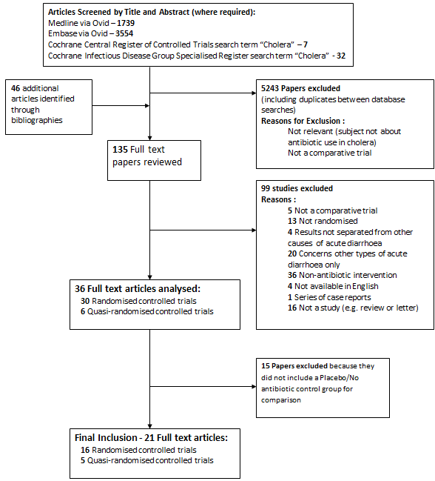

Table 1: Study Characteristics:
 | Author, Year | Country | Dehydration Status Severe /Mild-Moderate / Both / Undefined (S/M/B/U) | Adults/ Children/ Both (A/C/B) | Age Range | Number of participants (that completed) | Setting | Supportive Care with IV Polyelectolyte solution/ ORS/ Both approximate to WHO guidelines | Antibiotic Regimens †
1 | Hossain, 2002 | Bangladesh | S (With one exception) | A | 18-60 | 43 | Clinical Research and Service Centre (CRSC) of ICDDR,B: Centre for Health and Population Research | Both | Tetracycline (500mg capsules every 6h for 3 consecutive days [total of 12 doses]). | Placebo (every 6h for 3 consecutive days [total of 12 doses]).
2 | Roy, 1998 | Bangladesh | B | C | 1-5 | 184 | International Centre for Diarrhoeal Disease Research,  Bangladesh hospital in Dhaka | Both | Erythromycin 50 mg/kg/d every 6 h for 3 d | Tetracycline 25 mg/kg/d every 6 h for 3 d | Ampicillin 50 mg/kg/d every 6 h for 3 d | Placebo every 6 h for 3 d
3 | Usubutun, 1997 | Turkey | B | A | 15+ | 74 | Social Securtiy Hospital, Ankara | IV | Ciprofloxacin 1g single dose | Ciprofloxacin 500mg bd for 1 day | Doxycycline 100mg bd for 3 days | No Antibiotic (control)
4 | Kabir, 1996 | Bangladesh | B | C | 1-8 | 48 | Clinical Research Centre of the ICDDR,B | Mild to moderate dehydration - ORS Severe dehydration - IV | Erythromycin given at 50 mg/kg per day in 4 equally divided doses | Trimethoprim at 10 mg/kg per day and sulphamethoxazole 50 mg/kg per day in 2 equally divided doses for 5 days | Control group No antibiotics
5 | Dutta, 1996 | India | S | A | 18-55 | 111 | Infectious Diseases Hospital, Calcutta | Both | No Antibiotic (control) | Doxycycline 300mg given on admission | Norfloxacin 400 mg bd for three days | Norfloxacin 800 mg given on admission
6 | Rabbani, 1991 | Bangladesh | B | C | 1 month - 14 years | 118 | International Centre for Diarrhoeal Disease Research, Dacca | IV | Furazolidone (7 mg/kg/day) liquid suspension given as a single dose on day 1 | Placebo liquid suspension given as a single dose on day 1 | Furazolidone (7 mg/kg/day) liquid suspension given in four equal daily doses on days 1, 2, and 3 | Placebo liquid suspension given in four equal daily doses on days 1, 2, and 3.
7 | Bhattacharya, 1990 | India | S | A | 18+ | 37 | diarrhea ward of the Infectious Diseases Hospital, Calcutta | Both | Norfloxacin (400 mg) twice daily | Trimethoprim(160 mg) Sulphamethoxazole (800 mg) twice daily | Placebo twice daily
8 | Burans, 1990 | Somalia | U | B | 6 months+ | 47 | Forlanini fever hosoital in Moaadishu | Both | Erythromycin - Adults 800mg bd; Children oral suspension at a dose of 40 mgikg d in 2 divided doses | Trimethoprim 160 mg and Sulphamethoxazole 800 mg twice daily; Children - 8 mg/kg trimethoprim and 40 mg/kg sulphamethoxazole in 2 divided doses per 24-h | Placebo (5-10ml [corresponding to erythromysin dose] of a dextrose cherry-flavoured suspension, twice daily)
9 | Rabbani, 1989 | Bangladesh | U | A | 15+ | 87 | Dhaka Hospital of the International Centre for Diarrhoeal Disease  Research, Dhaka, Bangladesh. | IV | Furazolidone single Dose 400 mg (two capsules of 200 mg each) | Tetracycline single dose of 1 g (2 capsules of 500mg each) | Placebo (No antibiotics)
10 | Islam, 1987 | Bangladesh | B | A |  | 118 | International Centre for. Diarrhoeal Disease Research, Dhaka, | IV | Tetracycline 1g single dose | Tetracycline 2g single dose | Tetracycline mutliple dose (500 mg six hourly for four doses). | No Antibiotic (control)
11 | Rabbani, 1987 | Bangladesh | B | A | Undefined | 102 | International Centre for Diarrhoeal Disease Research | IV | Berberine Sulphate (400mg) | No Antibiotic (control) | Berberine Sulphate (1200mg) AND 1 g of tetracycline (1g) | Tetracycline (1g) (control)
12 | Khin-Maung-U, 1985 | Burma | B | A | Undefined | 185 | Infectious Diseases Hospital, Rangoon, Burma | Both | Placebo groups 1 (one placebo tablet and one placebo capsule given four times a day) | Placebo groups 2-one placebo tablet and one placebo capsule given four times a day | Berberine (one berberine hydrochloride tablet (100 mg) and one placebo capsule given four times a day) | Tetracycline (1 placebo tablet and 1 tetra- cycline capsule (500 mg) given 4/day) | Berberine and tetracycline (one berberine hydrochloride tablet (100 mg) and one tetracycline capsule (500 mg) given four times a day).
13 | Rahaman, 1976 | Bangladesh | U | Undefined | Undefined | 51 | Cholera Research Laboratory, Dacca | IV | Doxycycline 2mg/kg at start and 12 hours then once daily | Tetracycline Hydrochloride at 6h intervals | Placebo
14 | Gharagozloo, 1970 | Iran | U | B | Undefined | 42 | Pahlavi University Hospital in Teheran | Undefined | Chloramphenicol (dose of 50mg/kg. body weight to a maximum of 2 g./day in four equally divided doses) | Tetracycline (dose of 40mg/kg. body weight to a maximum of 2 g./day in four equally divided doses) | Trimethoprim Sulphamethoxazole (10 mg trimethoprim and 50 mg sulphamethoxazole /kg body weight to a daily maximum of 390 mg. and 1.6 g. respectively (4 tablets) in 2 equal doses) | Placebo (dextrose)
15 | Karchmer, 1970 | East Pakistan (Now Bangladesh) | B | C | 2-10 | 78 | Pakistan-SEATO Cholera Research Laboratory hospital (now the Cholera Research Laboratory, Dacca, Bangladesh) | IV | No Antibiotic, IV fluids only | Furazolidone, 5 mg/kg/day; given 6 hours for 7 days | Tetracycline " low dose regimen ", 10 mg/kg/day; every 6 hours for 7 days (total of 28 doses). | Tetracycline, 31 mg/kg/day-62 mg/kg/day; every 6 hours for 7 days (total of 28 doses).
16 | Pierce, 1968 | India | U | B | >10 | 49 | Infectious Diseases Hospital and the School of Tropical Medicine, Calcutta | IV | Tetracycline 500 mg. every 6h for 48 hours (8 doses, 4 g.) | Furazolidone 200 mg. every six hours for 72 h (12 doses,2.4 g.), | Furazolidone 400 mg. daily for three days (3 doses, 1.2g) | No Antibiotics (control)
17* | Wallace, 1968 | India | U | A | 15+ | 66 | Infectious Disease Hospital, Calcutta | IV | 1965 Tetracycline 500 mg every 6 h for 8 doses (total - 4 g) | 1965 Tetracycline 250 mg every 6 h for 12 doses (total 3 g) | 1965 No Antibiotic (control)
 |  |  |  |  |  |  |  |  | 1966 Tetracycline 2 g after rehydration and 2 g 24 hours later (total 4g) | 1966 Chloramphenicol 500 mg every 6 h for 12 doses (total 6g) | 1966 Sulfaguanidine 2 g every 4 h for 6 doses, and then 2 g every 8h for 15 doses (total of 42g) | 1966 No Antibiotic (control)
18 | Lindenbaum, 1967a | East Pakistan (Now Bangladesh) | B | B (but had to be ≥15kg) | Jun-70 | 313 | Pakistan-SEATO Cholera Research Laboratory hospital (now the Cholera Research Laboratory, Dacca, Bangladesh) | IV | No Antibiotic (control) | Tetracycline: 500mg or 750 mg every 6h for 48 hours; 250mg or 500mg every 6h for 72 hours; 250mg every 6h for 96 hours | Chloramphenicol: 250 mg or 500 mg or 750 mg 6-hourly for 48 hours; or 250 mg or 500 mg 6-hourly for 72 hours | Streptomycin: 1000 mg 6-hourly for 48 hours or 72 hours. | Paromomycin: 250 mg 6-hourly for 48 hours or 72 hours; or 500 mg 6-hourly for 72 hours.
19 | Lindenbaum, 1967b (children) | East Pakistan (Now Bangladesh) | B | C | 6 weeks- 10 years | 238 | Pakistan-SEATO Cholera Research Laboratory hospital (now the Cholera Research Laboratory, Dacca, Bangladesh) | IV | No Antibiotic (control) | Tetracycline in 4 regimens: 125mg every 6h for 72h; 250mg every 6h for 72 h; 250mg every6h for 48h; 125mg every 6h for 96h | Chloramphenicol (125mg or 250mg or 500mg every 6h for 48h or 72h) | Streptomycin (500mg every 6h for 48h or 72h) | Paromomycin (125mg every 6h for 48h or 73 h or 250mg every 6h for 72 h)
20 | Carpenter, 1965 | India | U | A | Undefined | 20 | Calcutta Infectious Diseases Hospital | IV | No Antibiotic (control) | Tetracycline: 100mg IV every 6h for 4 doses and 500mg orally every 6h for the first 3 days in hospital
21 | Wallace, 1965 | India | U | B | 10+ | 42 | Calcutta Infectious Diseases Hospital | IV | No Antibiotic (control) | Tetracycline - 500mg orally every 6 hours for 4 doses | Tetracycline - 250mg every 6 hours for 8 doses
*Study 17 [47] involved trials over two years, those completed in 1966 entered on the line below those in 1965
† The use of a placebo is explicitly mentioned, in cases reading “No antibiotic (control)” no placebo or alternative medication was used. Two trials use berberine, a non-antibiotic intervention (12 Khin-Maung-U, 1985 and 11 Rabbani, 1987) [41,42], these were included as they contain a non-antibiotic control involving no intervention or placebo to compare to an antibiotic.
Table 2: Assessment of Methodological Quality
 | Study | Formation of Groups (Randomised; Quasi-randomised) | Experimental Confounders (Baseline differences between groups potentially related to outcome) | Method of Randomisation Adequately Defined | Blinding (Double-blind; Single-blind; Open Label; Undefined) | Exclusion Criteria | Intention to Treat Analysis † | Follow Up > 20% (of those positive for V. cholerae) | Adequate Random Allocation of Concealment Method stated | Stated that Cholera Severity assessed by WHO criteria | Other definition of severity given for selection ‡
1 | Hossain, 2002 | Randomised | No | Yes | Double-blind | Females; patients already receiving any antimicrobial therapy; concurrent illness | No | Yes | Yes | Yes | No
2 | Roy, 1998 | Randomised | No | No | Double-blind | Patients already received an antimicrobial; concurrent systemic illness; malnourishment | N/A | Yes | No | No | Yes
3 | Usubutun, 1997 | Randomised | No | No | Open Label | V. cholerae negative; inability to tolerate oral medication due to of excess vomiting; underlying severe disease, age < 15 and breast feeding | N/A | Yes | No | No | No
4 | Kabir, 1996 | Randomised | No | Yes | Undefined | Females; Patients who had taken antibiotics before hospital admission; concurrent systemic infections | N/A | Yes | No | Yes | N/A
5 | Dutta, 1996 | Randomised | No | Yes | Open Label | Females; patients who had received any drug or iv fluid before admission; any concurrent systemic illness | N/A | Yes | No | Yes | N/A
6 | Rabbani, 1991 | Randomised | No | Yes | Double-blind | Patients passing < 20ml/kg stool during initial 4 h observation; breast feeding; allergic history to furazolidone; inability to tolerate oral medication due to vomiting; underlying diseases that would interfere with evaluation; severe malnutrition | No | Yes | No | No | No
7 | Bhattacharya, 1990 | Randomised | No | Yes | Double-blind | Females; patients who received any drug/ IV fluid before admission; any systemic illness | N/A | Yes | Yes | No | No
8 | Burans, 1990 | Randomised | Undefined | No | Single-blind | prior antibiotic therapy | N/A | Yes | No | No | No
9 | Rabbani, 1989 | Randomised | No | Yes | Double-blind | Patients who had antibiotics within 1 week of admission; severely malnourished; pregnant | No | Yes | Yes | No | Yes
10 | Islam, 1987 | Randomised | No | Yes |  | antibiotic use within seven days before admission were selected for the study. | N/A | Yes | No | Yes | N/A
11 | Rabbani, 1987 | Randomised | No | Yes | Double-blind | current treatment with antimicrobial/ antidiarrheal drugs | N/A | Yes | Yes | Yes | N/A
12 | Khin-Maung-U, 1985 | Randomised | No | No | Double-blind | Prior antibiotic ingestion; coexisting illness within two weeks prior to study entry; Pregnancy; known history of glucose-6-phosphate dehydrogenase deficiency | N/A | Yes | No | No | No
13 | Rahaman, 1976 | Quasi-randomised | No | Yes (but Quasi-randomised) | Double-blind | None selected if they had been treated outside with antimicrobial agents. | N/A | Yes | Yes | No | No
 | Study | Formation of Groups (Randomised; Quasi-randomised) | Experimental Confounders (Baseline differences between groups potentially related to outcome) | Method of Randomisation Adequately Defined | Blinding (Double-blind; Single-blind; Open Label; Undefined) | Exclusion Criteria | Intention to Treat Analysis | Follow Up > 20% (of those positive for V. cholerae) | Adequate Random Allocation of Concealment Method stated | Stated that Cholera Severity assessed by WHO criteria | Other definition of severity given for selection
14 | Gharagozloo, 1970 | Randomised | Undefined | No | Undefined | None stated | No | No | No | No | No
15 | Karchmer, 1970 | Quasi Randomised Trial | No | Yes (but Quasi-randomised) | Open Label | Undefined | N/A | Yes | No | No | No*
16 | Pierce, 1968 | Randomised | No | No | Undefined | Females; previous antibiotic treatment | No | Yes | No | No | No
17 | Wallace, 1968 | Randomised | No | No | Undefined | Females; ≤25kg; Patients who received antibiotics in week prior to admission | N/A | Yes | No | No | No
18 | Lindenbaum, 1967a | Quasi-randomised | Yes | Yes (but Quasi-randomised) | Open Label | Patients weighing <15kg | No | Yes | No | No | Yes
19 | Lindenbaum, 1967b (children) | Quasi-randomised | Yes | Yes (but Quasi-randomised) | Open Label | Patients weighing ≥15kg | No | Yes | No | No | Yes
20 | Carpenter, 1965 | Quasi-randomised | No | Yes (but Quasi-randomised) | Open Label | Undefined | Undefined | Yes | No | No | No
21 | Wallace, 1965 | Randomised | Yes | Undefined | Open Label | Antibiotic therapy prior to admission, females. Age below 10 and weight below 20kg. | N/A | Yes | No | No | No

† For Intention to treat analysis, N/A is used when all the patients mentioned in the methods completed the study
‡ Other definitions for determining Cholera severity included: “a stool output was at least 4 ml/kg/h during the 6 h initial rehydration phase” (Article 2) [32], “clinical evidence of loss of body weight (5% or more) due to dehydration” (article 8)[38], according to volume of diarrhoea:” mild (200-450 ml/hr), moderate (451-700 ml/hr), or severe >700 ml/hr)” (article 11) [41 ]and articles 18 and 19 described severe dehydration as having the clinical sign of being “pulseless” [12,13]
*Table for comparison of treatment groups’ gives figures for severity of dehydration on admission using plasma protein levels and the proportion that were pulseless

Table 3: Primary and Secondary Outcomes:
 |  | Clinical Success*† | Bacteriological success*† | Duration of Diarrhoea*‡ | Clinical Relapse*† | Bacteriological Relapse*†
1 | Hossain, 2002 |  |  | Median (IQR)‡
n=21 | Tetracycline | 17/21 (81%) | 19/21 (90%) | 32 (24-48) |  | 0/21 (0%)
n=22 | Placebo | 6/22 (27%) | 8/22 (36%) | 80 (48-104) |  | 0/22 (0%)
2 | Roy, 1998 |  | 48 hours*
n=48 | Placebo |  | 6/48 (12%)
n=46 | Erythromycin |  | 39/46 (85%)
n=47 | Ampicillin |  | 16/47 (34%)
n=43 | Tetracycline |  | 39/43 (91%)
3 | Usubutun, 1997 |  | By day 4*
n=21 | Ciprofloxacin 1g |  | 20/21 (95%) | 45.6 (± 14)
n=19 | Ciprofloxacin 500mg bd for 1 day |  | 17/19 (90%) | 60.0 (± 17)
n=21 | Doxycycline 100mg bd for 3 days |  | 19/21 (91%) | 43.2 (± 22)
n=13 | Control |  | 2/13 (15%) | 96.0 (± 14)
4 | Kabir, 1996
n=15 | Erythromycin | 10/15 (67%) | 12/15 (80%) | 54 (± 26)
n=18 | Trimethoprim Sulphamethoxazole | 15/18 (82%) | 15/18 (82%) | 53 (± 21)
n=15 | Control (No Antibiotic) | 5/15 (33%) | 4/15 (27%) | 80 (± 35)
5 | Dutta, 1996
n=29 | Control |  | 7/29 (24%) | 55 (± 24)
n=28 | Doxycycline 300mg |  | 26/28 (93%) | 42.4 (± 15.2)
n=26 | Norfloxacin 400mg bd 3 days |  | 26/26 (100%) | 34.8 (± 9.4)
n=28 | Norfloxacin 800mg |  | 28/28 (100%) | 41.4 (± 12.1)
6 | Rabbani, 1991
n=27 | Furazolidone (1 day) | 13/27 (48%) | 14/27 (52%) | 73 (± 10)
n=26 | Furazolidone (3 days) | 20/26 (77%) | 16/26 (62%) | 56 (± 7)
n=30 | Placebo (1 day) | 3/30 (10%) | 2/30 (7%) | 114 (± 5)
n=23 | Placebo (3 days) | 4/23 (17%) | 2/23 (9%) | 98 (± 8)
7 | Bhattacharya,1990
n=13 | Norfloxacin |  |  | 19.2 (± 4.4)
n=12 | Trimethoprim Sulphamethoxazole |  |  | 27.5 (± 4.0)
n=12 | Placebo |  |  | 29.3 (± 4.5)
8 | Burans, 1990
n=18 | Erythromycin |  |  | 67.9 (± 17)
n=17 | Trimethoprim Sulphamethoxazole |  |  | 80.4 (± 32.9)
n=12 | Placebo |  |  | 114 (± 44.9)
9 | Rabbani, 1989
n=30 | Tetracycline | 26/30 (83%) |  | 40.9 (± 32.7) | 2 (7%) | 18/30 (61%)
n=27 | Furazolidone | 15/27 (56%) |  | 73.9 (± 33.3) | 1/27 (4%) | 11/27 (40%)
n=30 | Placebo | 17/30 (57%) |  | 80.7 (± 30.9) | 0/30 (0%) | 10/30 (33%)
10 | Islam, 1987 |  |  | (SEM)‡
n=45 | Single 1g Tetracycline |  | 31/45 (69%) | 35.2 (± 2.8) | 3/45 (7%) | 7/45 (16%)
n=23 | Single 2g Tetracycline |  | 18/23 (78%) | 42.8 (± 6.7) | 2/23 (87%) | 2/23 (9%)
n=25 | Multiple dose Tetracycline |  | 22/25 (88%) | 37.4 (± 3.4) | 0/25 (0%) | 3/25 (12%)
n=25 | Control (No antibiotic) |  | 2/25 (8%) | 85.4 (± 5.6) | 0/25 (0%) | 5/25 (20%)
11 | Rabbani, 1987 |  | 24 hours*
n=30 | 400mg Berberine Sulphate (BS) |  | 1/30 (3%)
n=31 | Control (No antibiotic) |  | 0/31 (0%)
n=21 | 1,200 mg BS plus 1 g of tetracycline |  | 17/21 (80%)
n=20 | 1 g of tetracycline (control) |  | 17/20 (86%)
12 | Khin-Maung-U, 1985
n=43 | Berberine |  | 42/43 (98%) | 60.7 (± 3.6)
n=36 | Placebo Group 1 |  | 34/36 (94%) | 65.0 (± 4.1)
n=35 | Tetracycline |  | 35/35 (100%) | 35.0 (± 2.7)
n=35 | Placebo Group 2 |  | 31/35 (89%) | 65.0 (± 4.3)
n=36 | Berberine and Tetracycline |  | 36/36 (100%) | 41.3 (± 2.7)
13 | Rahaman, 1976
n=17 | Doxycycline |  |  | 28.7 (± 16.8)
n=15 | Tetracycline |  |  | 33.5 (± 16.8)
n=19 | Placebo |  |  | 64.0 (± 25.6)
 |  | Clinical Success*† | Bacteriological success*† | Duration of Diarrhoea*‡ | Clinical Relapse*† | Bacteriological Relapse*†
14 | Gharagozloo, 1970
n=13 | Chloramphenicol |  | 7/13 (54%) |  |  | 0/13 (0%)
n=8 | Tetracycline |  | 7/8 (88%) |  |  | 1/8 (13%)
n=13 | Trimethoprim Sulphamethoxazole |  | 11/13 (85%) |  |  | 1/11 (9%)
n=8 | Placebo |  | 2/8 (25%) |  |  | 3/8 (38%)
15 | Karchmer, 1970
n=22 | Furazolidone 5 mg/kg/day |  |  | 34.4 (± 3.2 )
n=18 | Tetracycline 10 mg/kg/day |  |  | 32.0 (± 2.4)
n=17 | Tetracycline |  |  | 30.4 (± 4.0)
n=21 | Control |  |  | 88.8 (± 4.8)
16 | Pierce, 1968
n=12 | Tetracycline |  |  | 31.6 (± 2.7)
n=13 | Furozolidone, 2.4g |  |  | 46.1 (± 6.1)
n=12 | Furozolidone, 1.2g |  |  | 49.2 (± 5.4)
n=12 | No Antibiotic |  |  | 75.5 (± 8.8)
17 | Wallace, 1968 |  |  | (Range)‡
n=8 | 1965 Control |  |  | 80 (15-170) | 0/8 (0%) | 0/8 (0%)
n=11 | 1965 Tetracycline 4g |  |  | 40 (20-70) | 0/11 (0%) | 0/11 (0%)
n=14 | 1965 Tetracycline 3g |  |  | 45(10-85) | 0/14 (0%) | 0/14 (0%)
n=9 | 1966 Control |  |  | 85(50-120) | 0/9 (0%) | 0/9 (0%)
n=9 | 1966 Tetracycline 4g |  |  | 40(30-55) | 0/9 (0%) | 0/9 (0%)
n=7 | 1966 Chloramphenicol 6g |  |  | 45(10-65) | 0/7 (0%) | 0/7 (0%)
n=8 | 1966 Sulphaguanide 42g |  |  | 55(30-95) | 0/8 (0%) | 0/8 (0%)
18 | Lindenbaum, 1967a |  |  | (Range)‡
n=94 | No Antibiotic | 37/94 (39%) |  | 96.0 (0-184) | 2/94 (2%) | 8/94 (8.5%)
n=124 | Tetracycline (all groups) | 120/124 (97%) |  | 47.2 (0-176) | 0/124 (0%) | 25/124 (20.2%)
n=66 | Chloramphenicol (all groups) | 63/66 (95%) |  | 52.0 (0-128) | 0/66 (0%) | 14/66 (21.2%)
n=11 | Streptomycin (all groups) | 8/11 (73%) |  | 70.4 (32-120) | 1/11 (9%) | 4/11 (36%)
n=18 | Paromomycin (all groups) | 12/18 (67%) |  | 85.6 (0-184) | 1/18 (6%) | 6/18 (33%)
n=37 | Tetracycline (500mg every6h for48h) | - |  | 48.8 | 0/37 (0%) | 11/37 (29.7)
n=12 | Tetracycline (750mg every6h for 48h) | - |  | 52.8 | 0/12 (0%) | 3/12 (25%)
n=13 | Tetracycline (500mg every6h for 72h) | - |  | 53.6 | 0/13 (0%) | 3/13 (23%)
n=46 | Tetracycline (250mg every6h for 72h) | - |  | 41.6 | 0/46 (0%) | 4/46 (8.7%)
n=16 | Tetracycline (250mg every6h for 96h) | - |  | 48.8 | 0/16 (0%) | 4/16 (25%)
19 | Lindenbaum, 1967b | 4 days* |  | (Range)‡
n=50 | No Antibiotic | 24/50 (48%) |  | 90.4 (0-144) | 1/50 (2%) | 8/50 (16%)
n=103 | Tetracycline (all groups) | 98/103 (95%) |  | 40.0 (0-104) | 0/103 (0%) | 19/103 (18%)
n=47 | Chloramphenicol | 42/47 (90%) |  | 67.2 (16-184) | 1/47 (2%) | 11/47 (26%)
n=23 | Streptomycin | 16/23 (70%) |  | 75.2 (16-184) | 2/23 (9%) | 10/23 (44%)
n=15 | Paromomycin | 10/15 (67%) |  | 80.0 (0-184) | 1/15 (7%) | 5/15 (33%)
n=39 | Tetracycline (125mg every 6h for 72h) | - |  | 40.8 | - | 9/39 (23.1%)
n=19 | Tetracycline (250mg every 6h for 72 h) | - |  | 45.6 | - | 2/19 (10.5%)
n=35 | Tetracycline (250mg every6h for 48h) | - |  | 38.8 | - | 7/35 (20%)
n=10 | Tetracycline (125mg every 6h for 96h) | - |  | 33.6 | - | 1/10 (10%)
20 | Carpenter, 1965
n=10 | No Antibiotic |  | 0/10 (0%)
n=10 | Tetracycline |  | 10/10 (100%)
21 | Wallace, 1965 |  |  | (Range)‡
n=11 | Control |  |  | 103.2 (48-144) |  | 0/11 (0%)
n=17 | Tetracycline (500mg every 6 h for 24h) |  |  | 57.6 (0-120) |  | 1/17 (6%)
n=14 | Tetracycline (250mg every 6 h for 48h) |  |  | 55.2 (24-96) |  | 1/14 (7%)

*For definition, see methods section, where studies that use a different time frame in their definition and results it is noted in bold in the relevant results cell.
† Expressed as actual number of clinical/bacteriological successes/relapses per total number in intervention or control arm with percentage in brackets.
‡ Expressed as the mean total duration of diarrhoea in hours ± standard deviation in brackets, it is noted in the relevant cells where the result is a median or if the range or standard error of the mean (SEM) is given instead.

Table 4: Other Outcomes
 |  | Duration of excretion of V. cholerae in stool (hours)* | Fluid requirement (ml) – ORS*‡ | Fluid requirement (ml) - IV Fluid*‡ | Total Fluid Requirement (ml) – (IV + ORS)*‡ | Volume of watery stool (l)† | Adverse Effects
1 | Hossain, 2002 | Median (IQR) | Total 0-72h (ml/kg) Median (IQR) |  |  | Up to 72h (ml/kg body weight) Median (IQR)
n=21 | Tetracycline | 1 (1-2) | 209.93 (119.92-272.93) |  |  | 216.48 (90.18-325.22)
n=22 | Placebo | 5 (3-6) | 311.90 (245.54 - 405.63) |  |  | 334.25 (215.2-537.64)
2 | Roy, 1998 |  | Total 0-96h (± SEM) | Total 0-96h (± SEM) | Total 0-96h | Up to 96h (± SEM)
n=48 | Placebo |  | 3918 (± 229) | 2722 (± 460) | 6640 | 6034 (± 481)
n=46 | Erythromycin |  | 3186 (± 190) | 1551 (± 330) | 4737 | 3664 (± 481)
n=47 | Ampicillin |  | 3122 (± 180) | 1193 (± 237) | 4315 | 3467 (± 305)
n=43 | Tetracycline |  | 3035 (± 208) | 670 (± 113) | 3705 | 3335 (± 553)
3 | Usubutun, 1997 |  |  |  |  | ml/kg body weight | No observed adverse drug reactions from either drug
n=21 | Ciprofloxacin 1g |  |  |  |  | 69.7 (2.9-197)
n=19 | Ciprofloxacin 500mg BD for 1 day |  |  |  |  | 75.9 (25.7-162.1)
n=21 | Doxycycline 100mg BD for 3 days |  |  |  |  | 79.5 (13.8-146.6)
n=13 | Control |  |  |  |  | 172.3 (65.5-530)
4 | Kabir, 1996 |  | ml/kg |  |  | Total after 5 days [ml/kg body weight]
n=15 | Erythromycin |  | 418 (± 319) |  |  | 389 (± 249)
n=18 | Trimethoprim Sulphamethoxazole |  | 379 (± 261) |  |  | 358 (± 279)
n=15 | Control (No Antibiotic) |  | 435 (± 537) |  |  | 403 (± 314)
5 | Dutta, 1996 |  |  |  |  | (± standard deviation)
n=29 | Control |  |  |  | 23800 (± 5300) | 8.6 (± 3.2)
n=28 | Doxycycline 300mg |  |  |  | 19800 (± 6000) | 6.1 (± 2.4)
n=26 | Norfloxacin 400mg bd 3 days |  |  |  | 16700 (± 3900) | 4.7 (± 2.0)
n=28 | Norfloxacin 800mg |  |  |  | 19900 (± 6300) | 6.2 (± 2.8)
6 | Rabbani, 1991 |  |  |  |  | (± standard errors) | None reported or developed signs of drug reactions in hospital
n=27 | Furazolidone (1 day) | 2.1 (± 0.4) |  |  |  | 6.1 (± 1.0)
n=26 | Furazolidone (3 days) | 1.5 (± 0.2) |  |  |  | 5.2 (± 0.9)
n=30 | Placebo (1 day) | 4.3 (± 0.3) |  |  |  | 16.2 (± 1.9)
n=23 | Placebo (3 days) | 4.1 (± 0.38) |  |  |  | 13.5 (± 2.0)
7 | Bhattacharya, 1990 |  |  |  |  |  | None with norfloxacin
n=13 | Norfloxacin |  |  |  | 4195 (± 1667) | 1.9 (± 1.0)
n=12 | Trimethoprim Sulphamethoxazole |  |  |  | 6660 (± 1945) | 3.5 (± 1.4)
n=12 | Placebo |  |  |  | 7290 (± 2777) | 3.5 (± 1.6)
8 | Burans, 1990
n=18 | Erythromycin
n=17 | Trimethoprim Sulphamethoxazole
n=12 | Placebo
9 | Rabbani, 1989 |  |  |  | Only IV Fluid given | Recorded for 6 days after treatment | No side effects detected by daily history and examination
n=30 | Tetracycline |  |  | 11600 (± 9600) | 11600 (± 9600) | 10.5 (± 8.6)
n=27 | Furazolidone |  |  | 22100 (± 16500) | 22100 (± 16500) | 20.9 (± 15.9)
n=30 | Placebo |  |  | 19900 (± 11400) | 19900 (± 11400) | 19.1 (± 10.5)
10 | Islam, 1987 |  |  | ml/kg (± SEM) | Only IV Fluid given ml/kg (± SEM) | ml/kg (± SEM)
n=45 | Single 1g Tetracycline |  |  | 202.9 (± 23.6) | 202.9 (± 23.6) | 168.0 (± 20.9)
n=23 | Single 2g Tetracycline |  |  | 260.7 (± 48.9) | 260.7 (± 48.9) | 229.5 (± 45.6)
n=25 | Multiple dose Tetracycline |  |  | 258.3 (± 29.3) | 258.3 (± 29.3) | 214.5 (± 28.5)
n=25 | Control (No antibiotic) |  |  | 526.8 (± 63.8) | 526.8 (± 63.8) | 499.1 (± 56.5)
11 | Rabbani, 1987 |  |  | Total 0-24h after treatment | Total 0-24h after treatment | First 24 hours of treatment
n=30 | 400mg Berberine Sulphate (BS) |  |  | 6544 (± 1901) | 6544 (± 1901) | -
n=31 | Control (No antibiotic) |  |  | 9876 (± 2002) | 9876 (± 2002) | 8.19
n=21 | 1,200 mg BS plus 1 g of tetracycline |  |  | 7923 (± 1624) | 7923 (± 1624) | 7.1
n=20 | 1 g of tetracycline (control) |  |  | 7546 (± 1881) | 7546 (± 1881) | 7.0
12 | Khin-Maung-U, 1985 |  | (± Standard Error) | (± Standard Error) |  | (Standard error)
n=43 | Berberine |  | 9000 (± 800) | 11300 (± 1100) | 20300 | 8.2 (± 1.0)
n=36 | Placebo Group 1 |  | 7800 (± 700) | 9800 (± 1200) | 17600 | 9.0 (± 1.2)
n=35 | Tetracycline |  | 4500 (± 400) | 5400 (± 600) | 9900 | 7.1 (± 2.7)
n=35 | Placebo Group 2 |  | 11600 (± 2600) | 10000 (± 1200) | 21600 | 9.2 (± 1.3)
n=36 | Berberine and Tetracycline |  | 6300 (± 700) | 12300 (± 5100) | 18600 | 6.2 (± 0.7)
 |  | Duration of excretion of V. cholerae in stool (hours)* | Fluid requirement (ml) - ORS*‡ | Fluid requirement(ml) - IV Fluid*‡ | Total Fluid Requirement (ml) – (IV + ORS)*‡ | Volume of watery stool (l)† | Adverse Effects
13 | Rahaman, 1976 |  |  |  | Only IV Fluid given | (± Standard Deviation) | None of the patients developed complications.
n=17 | Doxycycline |  |  | 5700 (± 4900) | 5700 (± 4900) | 5.2 (± 4.0)
n=15 | Tetracycline |  |  | 5500 (± 3900) | 5500 (± 3900) | 4.8 (± 3.1)
n=19 | Placebo |  |  | 9700 (± 4800) | 9700 (± 4800) | 10.0 (± 6.0)
14 | Gharagozloo, 1970
n=13 | Chloramphenicol
n=8 | Tetracycline
n=13 | Trimethoprim Sulphamethoxazole
n=8 | Placebo
15 | Karchmer, 1970 |  |  |  |  | (± standard error)
n=22 | Furazolidone 5 mg/kg/day | 0.6 (± 0.2) |  |  |  | 3.4 (± 0.6)
n=18 | Tetracycline 10 mg/kg/day | 0.1 (± 0.0) |  |  |  | 3.0 (± 0.7)
n=17 | Tetracycline | 0.2 (± 0.1) |  |  |  | 3.0 (± 0.8)
n=21 | Control | 3.4 (± 0.2) |  |  |  | 10.0 (± 1.1)
16 | Pierce, 1968 |  |  | (± standard error) | Only IV Fluid given (± standard error) | (± standard error) | 4 patients receiving furazoli-done vomited.
n=12 | Tetracycline | 0.6 (± 0.1) |  | 8600 (± 1000) | 8600 (± 1000) | 3.9 (± 0.6)
n=13 | Furozolidine, 2.4g | 2.2 (± 0.5) |  | 11800 (± 1600) | 11800 (± 1600) | 6.8 (± 1.3)
n=12 | Furozolidine, 1.2g | 1.7 (± 0.3) |  | 12500 (± 1100) | 12500 (± 1100) | 7.4 (± 1.2)
n=12 | No Antibiotic | 3.0 (± 0.3) |  | 17800 (± 2800) | 17800 (± 2800) | 13.5 (± 2.8)
17 | Wallace, 1968 | (Range)
n=8 | 1965 Control | 4 (1-7) |  |  |  | 15 (1-45)
n=11 | 1965 Tetracycline 4g | 1 (1-2) |  |  |  | 6 (1-12)
n=14 | 1965 Tetracycline 3g | 1 (1-2) |  |  |  | 7 (1-15)
n=9 | 1966 Control | 5 (2-7) |  |  |  | 13 (4-30)
n=9 | 1966 Tetracycline 4g | 1 (1-3) |  |  |  | 5 (2-10)
n=7 | 1966 Chloramphenicol 6g | 2.5 (1-4) |  |  |  | 9 (2-18)
n=8 | 1966 Sulphaguanide 42g | 3 (1-6) |  |  |  | 11 (1-31)
18 | Lindenbaum, 1967a | (Range) |  | (Range) | Only IV Fluid given (Range)
n=94 | No Antibiotic | 5.8 (1-13) |  | 27000 (200-10800) | 27000 (200-10800) | 21.5 (0-100.1)
n=124 | Tetracycline (all groups) | 2.7 (1-10) |  | 12200 (0-10500) | 12200 (0-10500) | 8.1 (0-84.3)
n=66 | Chloramphenicol (all groups) | 3.2 (1-10) |  | 12300 (2500-32900) | 12300 (2500-32900) | 7.8 (0-23.7)
n=11 | Streptomycin (all groups) | 3.5 (1-8) |  | 15100 (0-30000) | 15100 (0-30000) | 10.6 (1.2-22.0)
n=18 | Paromomycin (all groups) | 4.8 (1-9) |  | 19500 (4000-61500) | 19500 (4000-61500) | 16.0 (0-53.5)
n=37 | Tetracycline (500mg every6h for48h) | 2.7 |  |  |  | 8.5
n=12 | Tetracycline (750mg every6h for 48h) | 2.7 |  |  |  | 10.7
n=13 | Tetracycline (500mg every6h for 72h) | 2.7 |  |  |  | 10.7
n=46 | Tetracycline (250mg every6h for 72h) | 2.3 |  |  |  | 6.0
n=16 | Tetracycline (250mg every6h for 96h) | 3.4 |  |  |  | 8.9
19 | Lindenbaum, 1967b (children) | (Range) |  | (Range) | Only IV Fluid given (Range)
n=50 | No Antibiotic | 5.7 (2-13) |  | 7900 (0-33800) | 7900 (0-33800) | 7.3 (0-33.1)
n=103 | Tetracycline (all groups) | 2.6 (1-14) |  | 3800 (0-14300 | 3800 (0-14300 | 2.6 (0-14.1)
n=47 | Chloramphenicol | 3.8 (1-9) |  | 5900 (900-29900) | 5900 (900-29900) | 5.2 (0.5-22.7)
n=23 | Streptomycin | 4.9 (1-8) |  | 6600 (1800-18900) | 6600 (1800-18900) | 4.8 (0.5-17.8)
n=15 | Paromomycin | 4.6 (1-9) |  | 9400 (0-24700) | 9400 (0-24700) | 8.1 (0-24.7)
n=39 | Tetracycline (125mg every 6h for 72h) | 3.1 |  |  |  | 2.6
n=19 | Tetracycline (250mg every 6h for 72 h) | 1.8 |  |  |  | 2.9
n=35 | Tetracycline (250mg every6h for 48h) | 2.7 |  |  |  | 2.4
n=10 | Tetracycline (125mg every 6h for 96h) | 1.7 |  |  |  | 2.3
20 | Carpenter, 1965 |  |  |  | Only IV Fluid given | (± Standard Deviation)
n=10 | No Antibiotic |  |  | 24000 (± 17800) | 24000 (± 17800) | 24.0 (± 17.8)
n=10 | Tetracycline |  |  | 12400 (± 4400) | 12400 (± 4400) | 10.6 (± 4.9)
21 | Wallace, 1965 |  |  | (Range) | Only IV Fluid given (Range) |  | No vomiting after initial rehydration and correction of the acidosis
n=11 | Control | 6.5 |  | 17000 (5000-30500) | 17000 (5000-30500) | 16.0 (4.3-32.0)
n=17 | Tetracycline (500mg every 6 h for 24h) | 3.9 |  | 6300 (3000-19000) | 6300 (3000-19000) | 5.8 (0-15.0)
n=14 | Tetracycline (250mg every 6 h for 48h) | 3.4 |  | 10800 (4000-20000) | 10800 (4000-20000) | 6.8 (0.6-17.4)
*expressed as mean ± standard deviation unless noted otherwise
†Volume of diarroea expressed as mean (range), unless stated otherwise
‡ Includes fluid requirement in rehydration period before antibiotic administration

Figure 2: Clinical Success in Mixed and Severe Cholera Cases*
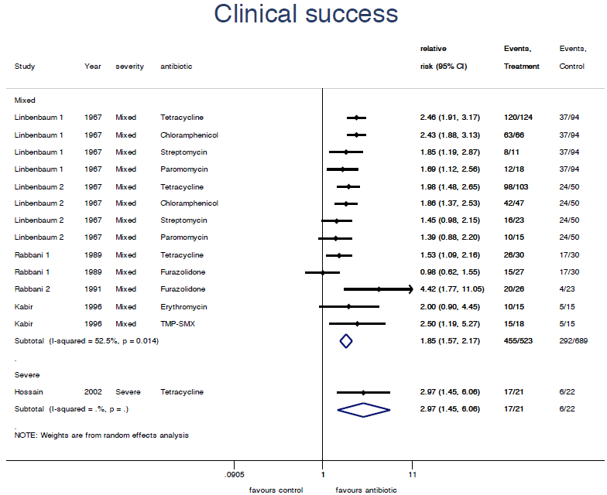
* For studies in which multiple doses of antibiotic were given, the highest dose was used for analysis

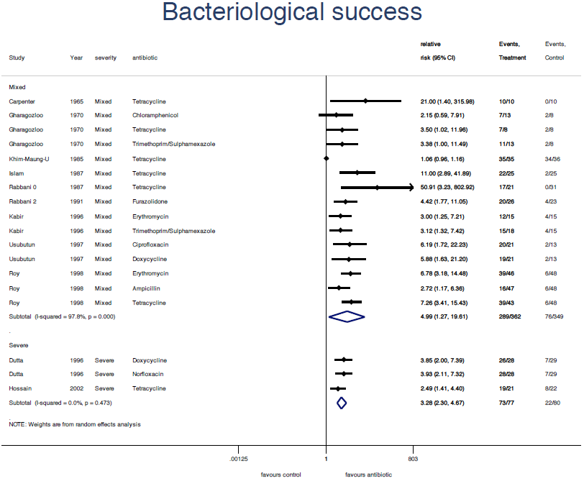
Figure 3: Bacteriological Success in Mixed and Severe Cholera Cases*

* For studies in which multiple doses of antibiotic were given, the highest dose was used for analysis

Figure 4: Duration of Diarrhoea in Mixed and Severe Cholera Cases*
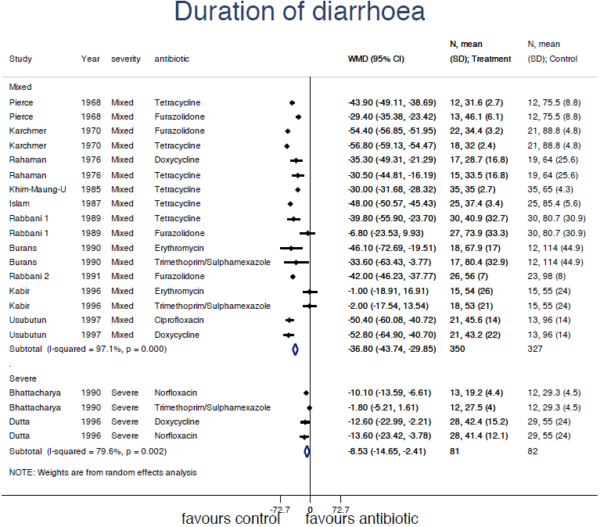
* For studies in which multiple doses of antibiotic were given, the highest dose was used for analysis

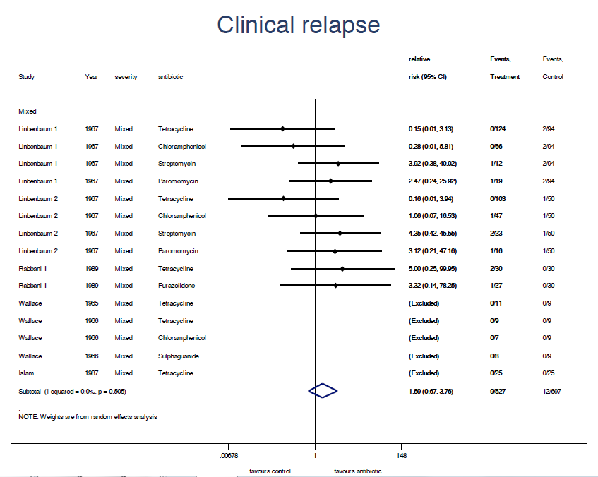
Figure 5: Clinical Relapse in Mixed Cholera Cases*

* For studies in which multiple doses of antibiotic were given, the highest dose was used for analysis

Figure 5: Bacteriological Relapse in Mixed Cholera Cases*
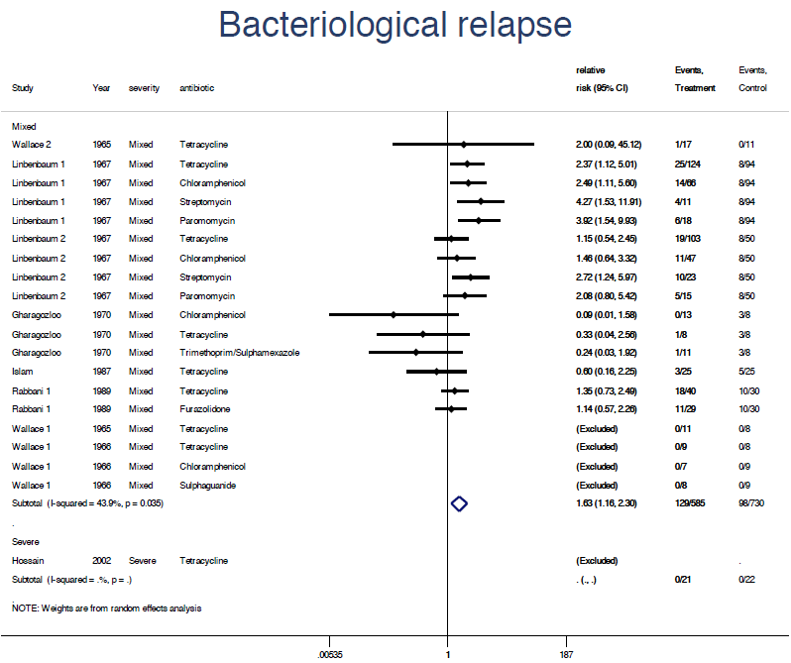

* For studies in which multiple doses of antibiotic were given, the highest dose was used for analysis

Figure 7: A Funnel Plot to Demonstrate Risk of Publication Bias

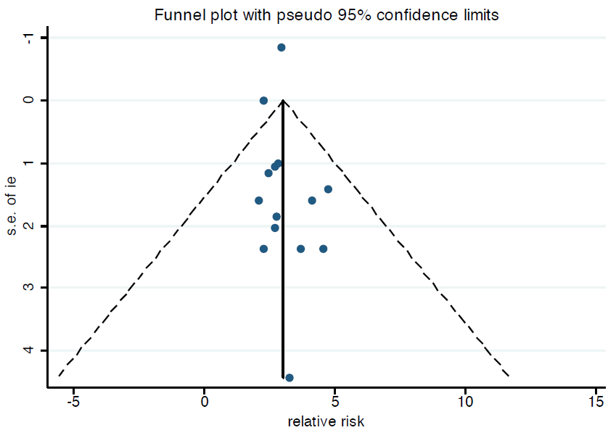

Annex A1: Highly Sensitive Search Strategy
Used for Medline, Embase Classic + Embase search via Ovid
Maximum Date range searched:
For Medline: 1948 to 3rd week May 2011
For Embase Classic + Embase: 1947 to 3rd week May 2011
(search repeated at end of study, to check for any new studies)

1. exp Cholera/ (exploded MeSH term)†
2. Cholera Morbus/ (MeSH term)†
3. exp Cholera Toxin/ (exploded MeSH term)†
4. exp Vibrio cholerae/ (exploded MeSH term)†
5. cholera.mp. (Keyword*)
6. vibrio cholerae.mp. (Keyword)
7. V cholerae.mp. (Keyword)
8. kommabacillus.mp. (Keyword)

9. 1 OR 2 OR 3 OR 4 OR 5 OR 6 OR 7 OR 8 (To generate thorough list of all studies that involve cholera)

10. Anti-Bacterial Agents/ (MeSH term) ‡
11. exp Antimicrobial Cationic Peptides/ (exploded MeSH term) ‡
12. antibiotic$1.mp. (Keyword)
13. antimicrobial$1.mp. (Keyword)
14. anti-bacterial.mp. (Keyword)
15. antibacterial.mp (Keyword)
All the antibacterial agents found in studies in cholera (including rejected articles) searched as keywords, in case other studies used these antibiotics and they weren’t listed under the MeSH terms or the specific antibacterial synonyms weren’t used in the study.
16. Azithromycin.mp (Keyword)
17. Ciprofloxacin.mp (Keyword)
18. Erythromycin.mp (Keyword)
19. Tetracycline.mp (Keyword)
20. Ampicillin.mp (Keyword)
21. Doxycycline.mp (Keyword)
22. Trimethoprim Sulphamethoxazole.mp (Keyword)
23. Trimethoprim Sulfamethoxazole.mp (Keyword)
24. Co-trimoxazole.mp (Keyword)
25. Norfloxacin.mp (Keyword)
26. Paramomycin.mp (Keyword)
27. Steptomycin.mp (Keyword)
28. Chloramphenicol.mp (Keyword)
29. Aminosidine.mp (Keyword)
30. Monomycin.mp (Keyword)
31. Fleroxacin.mp (Keyword)
32. Prulifloxacin.mp (Keyword)
33. Furazolidine.mp (Keyword)
34. Mecillinam.mp (Keyword)
35. Pivmecillinam.mp (Keyword)

36. 10 OR 11 OR 12 OR 13 OR 14 OR 15 OR 16 OR 17 OR 18 OR 19 OR 20 OR 21 OR 22 OR 23 OR 24 OR 25 OR 26 OR 27 OR 28 OR 29 OR 30 OR 31 OR 32 OR 33 OR 34 OR 35 (To generate complete search of antibacterial agents that could potentially be relevant)
37. 9AND 36 (To produce final search combining Cholera and antibacterial topics.
† These MeSH terms relate to the Medline database, these are slightly different in Embase and were replaced by the exploded MeSH terms “anti-biotic agent/” and “antiinfective agent/”
‡ These MeSH terms relate to the Medline database, these are slightly different in Embase and were replaced by the exploded MeSH terms “Cholera/”, “Cholera toxin/” and “Vibrio cholerae/”
* Medline database searched for “Keywords” in the “protocol supplementary concept, rare disease supplementary concept, title, original title, abstract, name of substance word, subject heading word, unique identifier” whereas Embase Classic + Embase searched for “keywords” in the “title, abstract, subject headings, heading word, drug trade name, original title, device manufacturer, drug manufacturer, device trade name, keyword”
Search Produced:
Medline: 1739
Embase: 3554
Each title or title and abstract was searched to ascertain potential relevance, no further restriction criteria applied, to minimise risk of missing an important study.

