School of Medicine

Year 2 - Autumn term 2012
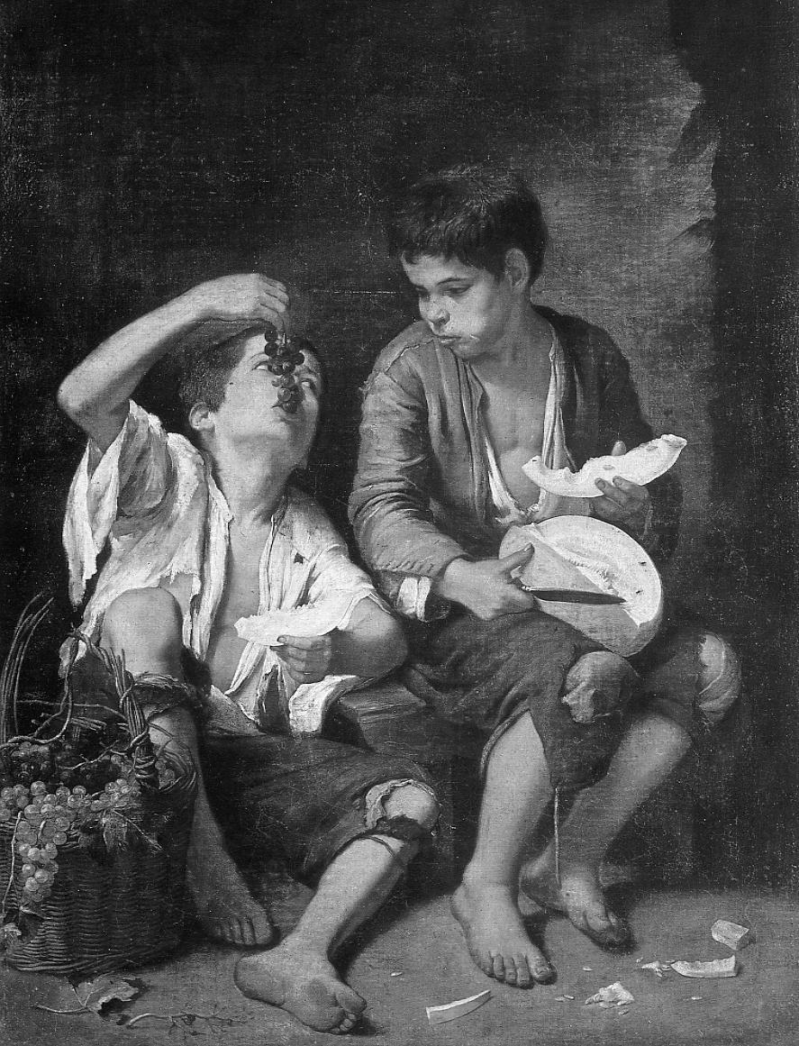
Science and Patient

Theme leaders: Dr Gareth Barnes and Dr Michael Wilson
Course leaders: all can be contacted via Blackboard:
http://learn.imperial.ac.uk

Critical appraisal of science and patient data - Professor Karim Meeran

https://education.med.imperial.ac.uk

Year 2 Science and Patient 2012-13

CONTENTS

SOLE
Introduction 1
Learning outcomes 2
Assessment 3
Appendix 1 - Use of Refworks 4
Appendix 2 - Accessing feedback via Blackboard 6
Appendix 3 - Academic honesty & writing task 7
Appendix 4 - ‘Understanding The Scientific Literature’ 9
Appendix 5 - Critical appraisal: clues and prompts 17

Articles + worksheets for tutorial sessions 19

Vidt et al - for discussion 23 October pm
Richter et al - for discussion 15 November am
Abraham et al - for discussion 15 November pm
Madrid et al - for discussion 17 January am

SOLE Feedback – Science and Patient

We cannot stress the importance of doing your SOLE feedback – we can only respond and change if we hear your views. This year we have changed the order, content, and lecturers within the module based on last year’s feedback. These changes are designed to improve student experience, but of course we will only know if we have been successful, and what still needs changing, if you take the time to let us know through SOLE.

The following two pages provide you with templates on which you can record your thoughts as the course proceeds. At the end of the course you can enter your views onto SOLE.

Gareth Barnes & Michael Wilson

Please answer all questions by selecting the response which best reflects your view. After the questions there is an opportunity to comment on any aspects about which you feel strongly.

N/A Strongly Agree Neutral Disagree Strongly
agree disagree

1. By the end of the course, I think the aims and objectives □ □ □ □ □ □
will have been met.

2. Teaching and learning opportunities (e.g. lectures, □ □ □ □ □ □
small groups, practicals) for this course are suitable.

3. Appropriate resources (e.g. books, computers, □ □ □ □ □ □
lab equipment etc.) are available for this course.

4. Appropriate support materials (e.g. handouts, □ □ □ □ □ □
web pages, problem sheets) are available for this course.

5. I receive sufficient guidance and feedback. □ □ □ □ □ □

6. The workload on this course is manageable. □ □ □ □ □ □

7. Overall I am satisfied with this course. □ □ □ □ □ □

8. If you wish to make further comments about this course, please use the space below.

Science and Patient course

Introduction

Science and Patient has 14 sessions in the Autumn term, one session in the Spring term, and then occupies seven weeks in the Summer in May and June. During the Summer term there will be an in-course assessment exercise and an exam at the end. The main purposes of this course are to prepare you for clinical work in year 3, and to foster critical appraisal skills, which we hope you will use in your everyday learning, but will be particularly important as you move into the BSc in year 4.

Critical appraisal applies both to basic science and clinical medicine. Students need to decide for themselves whether the conclusions drawn from evidence that may be presented in a publication are acceptable. This course will both enable students to review clinical data and science with a critical eye, but will also be the beginning of encouraging some of you to become clinical scientists of the future.

The final term integrates clinical topics with literature review, but you will receive more information about that later. This term will focus on being able to review the literature and interpret data and statistics that appear in papers. You have a series of journal clubs to discuss the papers included in this guide. Each of the worksheets associated with these papers should be completed before the session, and you should be able to give a brief summary of the paper at the beginning of the tutorial so you are fully prepared – this will facilitate discussion and ensure that you get the most out of the journal clubs. So, by the end of the course, you will be able to review literature with confidence, and you will also have written up a practical in the form of a publication, and hence will have some experience of actually writing a manuscript.
Learning outcomes; Autumn and Spring Term

- Demonstrate an in depth knowledge of each of the areas covered in the course.

- Critically appraise scientific literature and discuss your thoughts in small groups.

- Demonstrate the ability to add to the taught material of the course through self directed learning.
- Demonstrate the ability to summarise material and write persuasively.

Mapping and learning objectives:

Learning Objectives with 14 sessions in October and November 2012, 1 in January 2013, and then a 7 week course from May to June 2013.
By the end of the science and patient course students should:
1. Analyse and interpret data, using relevant statistics where appropriate
- ‘Statistics – a survival guide’ (Tom Sensky)
- ‘Introduction to survival analysis’ (Jane Warwick)
- Analysis of data from practical in May 2013
2. Understand the principles of experimental design
- Tutorial and publication review sessions and journal clubs
- Design of practical May 2013
- ‘Measurement in science’ (Karim Meeran)
3. Understand the concept of plagiarism and how to avoid it
- ‘Academic honesty’ (Alison McGregor)

4. Understand how to present effectively
- ‘Presentation skills’ (John Laycock and Pat Cover)

5. Have had experience of written scientific communication
  - Practical write up (summative)
  - Practice essays June 2013
6. Understand the fundamental principles and practice of scientific research
- Many sessions throughout the course
7. Be able to critically review scientific literature
  - ‘Evidence-based medicine’ (Stephen Robinson)
  - ‘Scientific publications’ (Paul Matthews)
  - ‘Understanding the scientific literature’ (David Lane)
  - ‘Misleading literature’ (Karim Meeran)
  - Journal tutorial reviews Autumn 2012 / January 2013

Assessment

In course assessment (20%):

For summative in course assessment, there will be one practical write up. You will be involved in the design of an experiment, as well as carrying it out and writing it up in the form of a publication, including abstract, introduction, methods summary, conclusion and references. Planning occurs in early May 2013, the actual practical in late May.

Main exam assessment (80%):

This course is examined in Paper 1, in June 2013. You will already have sat Papers 2, 3 and 4 of Part 2 at the beginning of the summer term in other subjects. The only exam at the end of the summer term is Paper 1, a written exam covering Science and the Patient.

Additionally, there is a strong focus through the modules on discussing cases and small group learning.

The exam paper consists of two sections. Section A comprises of compulsory short answer questions (SAQs) and Section B consists of a single essay from a choice of two. Any part of the course can be examined in the summer.

In the essay we will test the ability to think across everything you have learned in the last two years, and are looking for integration of your knowledge.

Note: there will be a 5% contribution from the Year 2 Science & Patient assessment score to your BSc degree classification in Year 4.

Finally please note that we expect all students to behave in a professional manner during sessions of all types, including lectures and tutorials. Some of you have complained that small minorities of students are spoiling the learning experience, by talking during sessions. Students who do this are at risk of having such unprofessional behavior recorded. You are being prepared for a professional career.

Appendix 1 – Use of Refworks

During this course you will need to write your own essays and papers. For this it is vital that you have access to the Imperial College Virtual Private Networking (VPN) so that you can access all the journals that Imperial has paid a subscription for on your behalf from home. In addition, correct referencing is crucial to essay writing. You will be shown how to use the referencing software Refworks, and there is a downloadable guide available from the library:
http://www3.imperial.ac.uk/library/subjectsandsupport/referencemanagement/refworks.

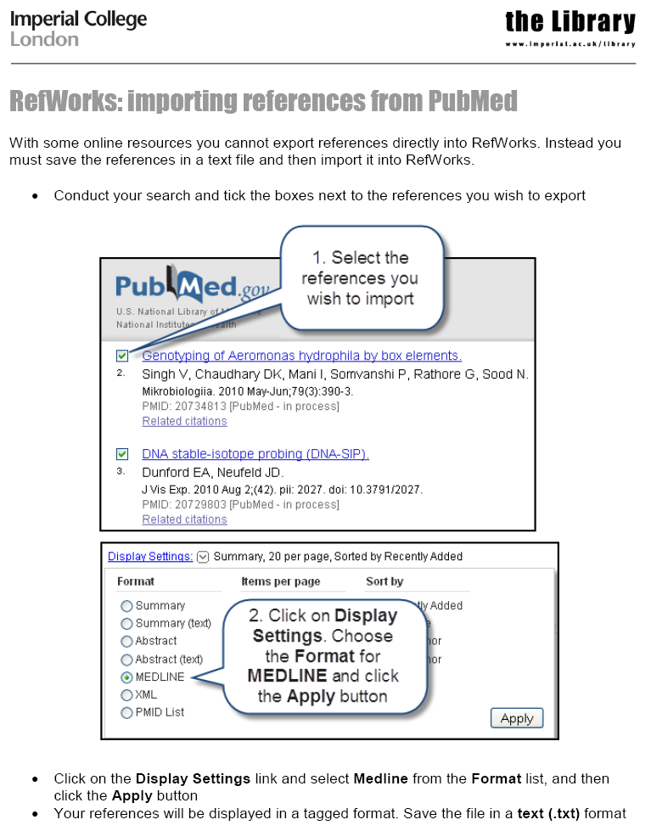

Continued/…
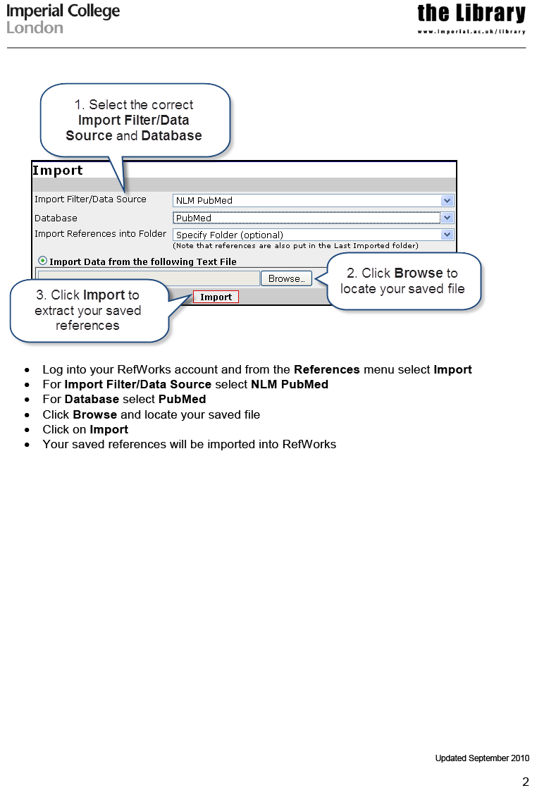
Appendix 2 – Accessing feedback via Blackboard

During the course you will be required to submit various pieces of work though Blackboard, both formative (e.g. abstract writing) and summative (in-course assessment). You will be given information on how to do this. Work that we ask you to submit via Blackboard will be marked and you will receive feedback to enable you to learn from the process. Feedback will be accessible in the following way –

    - Login to Blackboard Learn and access your assignment

- Click the View button

- A window will open with your original submission showing any feedback and/or grade
- To view feedback, hover over any of the QuickMark icons -

- You may also view general comments, if there are any, by clicking the second icon in the bottom right of the window.

Appendix 3 - Academic honesty & writing

Academic writing is a difficult skill and takes time to develop. There are two main areas that need careful consideration. Firstly, there is a challenge to present your work in a clear, concise style that is engaging to read, whilst placing your findings in the context of current knowledge. Style is important and you need to guide the reader through your paper. Whilst the scientific findings are undoubtedly the most important aspect of any paper, and no amount of writing skill will ever propel a poorly designed and executed study into a high ranking journal, some authors are able to convey their findings with clarity maximising the impact and publication potential of their work.

Secondly, academic honesty is essential and the work you present as your own must be your own. Appropriate referencing is necessary, and again is a skill that takes time to refine. There are well-publicised examples of plagiarised work, and for that there is no defence. The College views plagiarism very seriously and offers the following definition and advice.

The College defines plagiarism as
"the presentation of another person's thoughts or words as though they were your own" (http://www3.imperial.ac.uk/registry/exams/examoffences)
You will receive training on plagiarism at different stages of the undergraduate curriculum, but the website above provides a useful link on what to consider when you are submitting any coursework, either summative or formative.

Most cases of plagiarism, or what we prefer to call academic dishonesty, are due to 'poor scholarship' by inexperienced students and are not carried out with deliberate intent to cheat. Forms of poor scholarship can include: -

- unsophisticated or thoughtless use of electronic sources, text books and lecture notes
- misunderstanding of the conventions governing individual written work based on group exercises
- poor or inappropriate note taking techniques carried through to written work
- poor time management
- reluctance, or lack of confidence to reword the work of authoritative authors
- diversity of experiences in the practice and conventions of education before coming to university

Unfortunately deliberate cheating involving work maliciously copied from a fellow student or the deliberate exchange of work between students with the intent to cheat can occur and is usually referred to the College rather than the Faculty.

Minor plagiarism
Poor referencing
Paraphrasing
Failure to reference figure, or table
Failure to attribute reference to direct quote and to use inverted commas

Major plagiarism
Extensive poor referencing or paraphrasing
Use of others phrases, concepts or arguments without due acknowledgement
Use of the work of another student, past or present
Direct and unacknowledged repetition of your own work that has already been submitted for assessment is self plagiarism
Providing incorrect information about the source of a quotation
Extensively copying text or ideas such that it makes up the majority of your work with little of your own thoughts, critique or understanding apparent.

Scientific writing task (based on 23rd October tutorial)
To date you are unlikely to have much practice at academic writing and we aim to address this, in part, throughout Science and the Patient. As your career progresses your writing skills will also progress and this is very much an on-going process. The skills you need to develop are essential - every piece of information you receive needs to be assessed and critiqued. Beyond the ability to appraise work that other researchers produce, you will need to develop skills that will allow you to present your own research and communicate effectively.

One of the main aspects of the Science and Patient Summer term is a practical, which you will plan and write up as a paper. In order to prepare you for this we have planned writing tasks that will give you the opportunity to learn from published authors and receive feedback on your own efforts.

In the Summer term you will write an abstract to a published article, but in the Autumn term you will be writing a ‘Letter’ about one of the research articles that you have appraised during the tutorial sessions. Your work should be submitted via Blackboard (deadline for submissions 1st Dec, midnight), and you will receive individual feedback through the system. In addition, we will go through some of the common issues and give more feedback during the session on 17th January. Letters should be written using the following guidance -

The aim of this task is to write a letter to the editor of the highly acclaimed “Science and Patient Journal”. You should put yourself in the shoes of a scientist/clinician, writing to this journal, to express your views on the paper by Vidt et al that you discussed in your groups on the 23rd October. The aim of this would be to inform the scientific community at large about this paper, either how ground-breaking it is, or how misleading it is, in your opinion. You may support your opinion by referring to other work in the scientific literature, but this must be properly referenced if you do. The aim of this exercise is to give you experience of writing scientifically and presenting a persuasive and well-structured argument. Remember that the editor of the “Science and Patient Journal” is unlikely to publish your letter if it is either boring or libelous!

When any piece of work is submitted to a journal there are clear instructions that must be followed. Failure to do so will often result in work being rejected without consideration or review. Clearly, if your work falls into this category, your efforts have been a waste of time. When composing this letter the instructions are as follows:

-identifier CID number
-word limit 300
-maximum number of references 3
-style of references Vancouver style, following BMJ bibliography format (authors, article title, journal, year, volume, pages)
-disclosures/conflict of interest

This work will be electronically submitted and feedback will be provided. The deadline for submission is Dec 1st 2012. Submissions exceeding the word limit or late will not be assessed. You MUST be very careful to properly cite any references used, or any paraphrasing, as this work WILL be evaluated for potential plagiarism!

Appendix 4 – ‘Understanding The Scientific Literature’

This paper on “Risk Factors for Thrombosis” is for you to discuss during the session on ‘Understanding The Scientific Literature’ with Professor David Lane.

INTRODUCTION
Upper-extremity deep vein thrombosis (DVT) is a rare manifestation of venous thromboembolic disease, accounting for 4% of all cases.¹ In the past few decades, the clinical importance of upper-extremity DVT has increased because of the wider use of central venous catheters and the development of ultrasonography as a simple and accurate objective diagnostic method.² In addition to indwelling catheters, another common risk factor for upper-extremity DVT is cancer.³ Primary upper-extremity DVT, i.e., that which occurs in the absence of the aforementioned risk factors, is recognized in 30% of cases.⁴ Because of the relative rarity of the disease, only studies with small sample sizes are available, and therefore, at variance with lower-extremity DVT, knowledge on risk factors for this thrombotic manifestation is limited. Whether thrombophilia due to deficiencies of the natural anticoagulant proteins antithrombin, protein C, and protein S; gain-of-function mutations in coagulation factor V and the prothrombin gene; or the metabolic abnormality hyperhomocysteinemia is associated with an increased risk of primary upper-extremity DVT remains a matter of debate. ^{2,5–11} In addition, data on oral contraceptives as risk factor for primary upper-extremity DVT are scanty and controversial,^{2,5,7–9,11} whereas their role in lower-limb DVT¹² and cerebral vein thrombosis¹³ is well established. Moreover, the rate of recurrence of upper-extremity DVT is unknown. The aim of this case-control study was to investigate the role of potential risk factors and to evaluate the recurrence rate after a period of anticoagulant therapy in a large series of patients with primary upper-extremity DVT.

METHODS
Patients
One hundred sixty-seven patients referred between January 1994 and February 2003 to the Thrombosis Center of the Ospedale Maggiore Policlinico of Milan for a thrombophilia screening after a first episode of upper-extremity DVT were considered for the study.
Patients were asked to bring to the center the diagnostic documentation of their thrombotic episodes. Eighteen patients were subsequently excluded because thrombosis was related to central venouscatheters (n 12) or cancer (n 6: 3 lymphoma with mediastinal involvement, 1 breast, 1 lung, and 1 liver cancer); 17 were excluded because of incomplete thrombophilia screening, 12 because of previous DVT of the lower extremity, 3 because the diagnosis was uncertain, and 2 because they were relatives of patients previously diagnosed as having an inherited thrombophilic abnormality. In 5 patients, more than 1 exclusion criterion was present. Therefore, 115 patients with a first, objectively confirmed episode of primary upper-extremity DVT were included in the study; 26 of them had been part of a previous study of thrombosis risk factors in primary upper-extremity DVT,⁵ which was limited by the small sample size.

Diagnosis was made in 90 cases by Doppler ultrasound examination, in 22 by contrast venography, and in 3 by computed tomography venography. Upper-extremity DVT involved the axillary and/or subclavian veins in 91 patients, the axillary and/or subclavian veins and the brachial vein in 20, and the brachial vein only in 4. Thrombosis occurred in the dominant arm in 64 patients (56%). Symptomatic pulmonary embolism as an early complication of upper-extremity DVT occurred in 2 (1.7%) of the 115 patients and was diagnosed by ventilation/perfusion lung scan in 1 patient and computed tomography in the other.

Controls
The population of controls included 797 healthy individuals who were partners or friends of the whole population of patients, who agreed to accompany them and to be investigated at the Thrombosis Center. Previous thrombosis was excluded in these individuals by use of a structured questionnaire validated for the retrospective diagnosis of thrombosis.¹⁴ Information on transient risk factors for thrombosis, such as oral contraceptive intake and trauma of the upper extremities, was obtained for both patients and controls. A positive family history of venous thrombosis was considered when at least 1 first- or second degree relative had had objectively documented episodes. Patients were also interviewed about strenuous muscular efforts with the arms in the week preceding symptoms of thrombosis. The same information was not obtained from controls. Women were considered to be taking oral contraceptives if they had taken them until 2 weeks or less before thrombosis for patients or at the time of blood sampling for controls. No subject had abnormal liver or renal function or overt autoimmune or neoplastic diseases when they first visited the Thrombosis Center. All subjects were white and gave their informed consent to the study, which was approved by the Institutional Review Board of the University of Milan.

Laboratory Tests
DNA analysis for the 1691 guanine-to-adenine substitution in coagulation factor V gene (factor V Leiden) and for the 20210 guanine-to-adenine substitution in the 3-untranslated region of the prothrombin gene was performed as described previously.^{15,16} Functional and/or antigenic assays for antithrombin, protein C, and protein S were performed on plasma samples obtained from blood anticoagulated with sodium citrate (3.8% wt/vol), as described previously.¹³ Antiphospholipid antibodies (lupus anticoagulant and anticardiolipin antibodies) were diagnosed according to previously described methods¹⁷ and were looked for only in patients, because these tests are not part of the laboratory workup of our control population. Total plasma homocysteine was measured in blood samples anticoagulated with EDTA after overnight fasting and 4 hours after an oral methionine load (3.8 g/m² body surface area), according to previously described methods.¹³ Hyperhomocysteinemia was diagnosed when plasma levels of fasting total homocysteine or their post–methionine-load increments above fasting levels exceeded the 95th percentile of the values obtained in the control group (in men 19.25 and 24.04 nm/mL; in women 14.88 and 24.5 nm/mL, respectively).

Patient Follow-Up
To minimize selection bias, we chose to limit the follow-up analysis only to patients who had the first primary upper-extremity DVT after January 1991, a time when our Thrombosis Center became fully active and started to assist a similar yearly number of patients. The median time elapsed from the first primary upper-extremity DVT to the visit was 6 months (range 1 month to 5 years). For patients who received oral anticoagulant therapy, the follow-up started after its discontinuation, whereas for those who did not receive this therapy, it started after the event. Patients who were still taking oral anticoagulant therapy at the end of the study were not included in the analysis. The end of follow-up was July 1, 2003, or the date of the recurrent upper-extremity DVT. Patients underwent duplex color ultrasonography when first referred to the Thrombosis Center and, if thrombosis was still present, after 6 months and then annually.

Subclavian, axillary, and brachial veins were investigated as described previously.2,10 Recanalization was judged complete if a previously abnormal venous segment was normally compressible or for the subclavian vein, which is not easily compressible in the subclavicular fossa, if a normal flow pattern (compared with the contralateral vein) was recorded. In case of symptoms suggestive of recurrence of upper-extremity DVT, patients were instructed to return to the Thrombosis Center for objective examination. Recurrent upper-extremity DVT was diagnosed if a previously compressible venous segment could no longer be compressed or if, in the presence of symptoms of recurrence, a previously nonocclusive thrombus had changed into an occlusive one at ultrasound examination.

Statistical Analysis
Continuous variables are presented as median and range. The age difference between patients and controls was calculated by the Mann-Whitney U test. ORs and 95% CIs were used as a measure of the association between primary upper-extremity DVT and various types of thrombophilia. An unconditional logistic regression analysis was used to adjust ORs for possible confounders, such as age (continuous variable), gender, and the presence of other causes of thrombophilia (categorical variables). Interaction between inherited thrombophilia and oral contraceptive intake or hyperhomocysteinemia and between oral contraceptive intake and hyperhomocysteinemia was evaluated by stratification of patients and controls into 4 groups, according to the presence or absence of the specific risk factors and using the group without specific risk factors as the reference. The incidence of recurrent upper-extremity DVT was calculated by dividing the number of events by the sum of patient years of observation. To estimate the cumulative probability of recurrent upper-extremity DVT in patients with and without thrombophilia, a survival analysis was performed by the Kaplan-Meier method and with a Cox proportional hazards model, which allows adjustment for confounding variables, such as age at first event, gender, length of follow-up, and presence or absence of recanalization after the first event. The final hazard ratio (and its 95% CI), adjusted for the other variables in the model, expresses the risk of recurrent upper-extremity DVT in patients with thrombophilia compared with those without.

RESULTS
Risk Factors
The main characteristics of the study population and the prevalence of thrombophilia are shown in Table 1. The median age at first visit to the Thrombosis Center was 35 years (range 14 to 61 years) in patients and 44 years (range 12 to 73 years) in controls (P 0.001). Heterozygosity for factor V Leiden and prothrombin G20210A increased the risk for upper-extremity DVT by factors of 6 and 5, respectively. No homozygous carrier of either mutation was found in patients or controls.

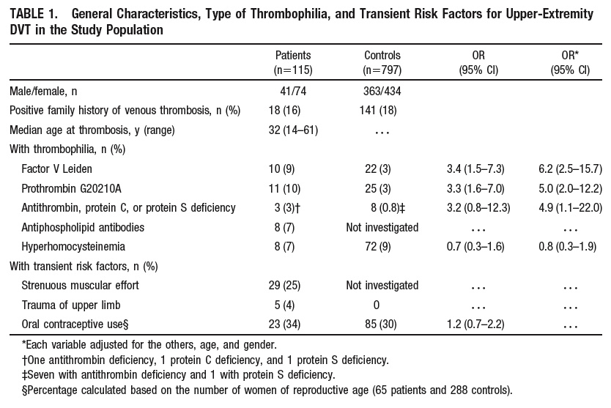

The presence of antithrombin, protein C, or protein S deficiency (considered together) was associated with a 5-fold increase in the risk of the disease, whereas no association was found for hyperhomocysteinemia (Table1). Because homocysteine plasma levels may be influenced by gender and age, we performed separate analyses for men and women and for 2 age categories (below and above the median age of the study population [43 years]), without finding a significant association (data not shown). The OR for thrombophilia and hyperhomocysteinemia did not change after the exclusion of the 26 patients who were part of our previous study.⁵ In terms of transient risk factors, strenuous muscular efforts with the arms were recorded in one fourth of patients and the use of oral contraceptives in one third. Efforts were sports related in 15 patients (8 weightlifting, 3 rowing, 2 tennis, and 2 volley) and related to unusual strenuous exercise in another 14 (7 lifting heavy weights, 4 prolonged above-shoulders extension, 3 repeated abduction). The overall prevalence of thrombophilia was similar in patients who did or did not undergo strenuous muscular efforts, being 31% and 33%, respectively. The prevalence of oral contraceptive users was similar in patients and controls (34% and 30%, respectively), with no association between this transient risk factor and upper-extremity DVT (Table 1). Such risk factors as surgery, pregnancy or puerperium, and prolonged immobilization, frequently found in patients with lower-extremity DVT, were never recorded in our patients.

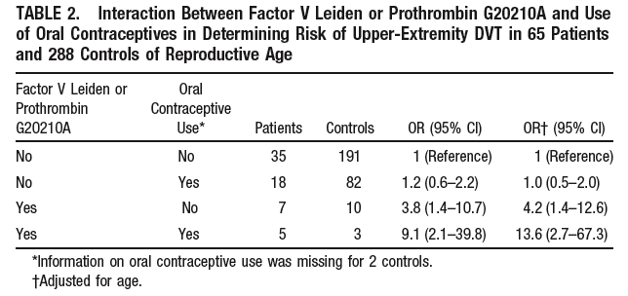

Table 2 shows that when women were stratified according to the presence of the most common causes of thrombophilia, ie, factor V Leiden or prothrombin G20210A, and the use of oral contraceptives, the OR for upper-extremity DVT increased nearly 14-fold in the group sharing both the genetic and transient risk factors compared with the group with neither risk factor. This figure was similar for the interaction of the separate mutations and oral contraceptive use (not shown). The OR (adjusted for age and gender) for the combination of factor V Leiden or prothrombin G20210A and hyperhomocysteinemia (1.7 [95% CI 0.2 to 14.5]) and the OR (adjusted for age and the presence of factor V Leiden or prothrombin G20210A) for the combination of hyperhomocysteinemia and oral contraceptives (1.8 [95% CI 0.3 to 9.7]) were not statistically significant.

Recurrence Rate

The incidence of recurrent symptomatic upper-extremity DVT was calculated for 98 patients who had the first event after January 1991. Seventy-seven patients received oral anticoagulant therapy for a mean of 6 months (median 5 months), whereas 14 received subcutaneous heparin and 7 took antiplatelet agents for no longer than 3 months. Eight additional patients were not included because they were still taking oral anticoagulant therapy at the end of the study. A complete recanalization of the first DVT was observed in 65 patients (66%), whereas in the remaining 33 (34%), a residual vein thrombosis was detected. On the whole, there were 12 symptomatic, objectively documented episodes of recurrence (12%), 9 ipsilateral and 3 contralateral, over the median period of follow-up of 5.1 years (range 2 months to 12.5 years). Six of these episodes occurred in patients with thrombophilia and 6 in those without. Seven patients with ipsilateral recurrence had previously shown a complete recanalization of the first event. No patient experienced a recurrence during the oral anticoagulant period and made a strenuous muscular effort before the second event. One patient developed breast cancer during the follow-up period.

The overall annual incidence of recurrence of upper extremity DVT was 2.4% (95% CI 1.2% to 4.0%). In patients with and without thrombophilia, it was 4.4% (95% CI 1.5% to 8.8%) and 1.6% (95% CI 0.6% to 3.2%), respectively. The Figure shows the breakdown of recurrence rate in patients with and without thrombophilia. Overall, the cumulative probability of recurrence-free survival was 95% at 1 year and 89% at 5 years of follow-up. In patients with thrombophilia, such probability was 89% at 1 year and 80% at 5 years, and in those without thrombophilia, it was 97% and 93%, respectively.

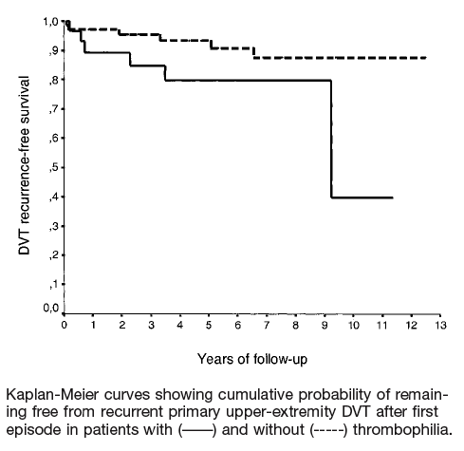

The hazard ratio for recurrent upper-extremity DVT, adjusted for age at the first event, length of follow-up, gender, and recanalization, in patients with thrombophilia compared with those without was not statistically significant (2.7 [95% CI 0.7 to 9.8]). The hazard ratio for recurrence in patients with lack of recanalization versus those with recanalization was also not statistically significant (0.8 [95% CI 0.2 to 3.3]). These results did not change substantially if thrombophilia was restricted to inherited coagulation abnormalities only, ie, if the metabolic disorder hyperhomocysteinemia was excluded.

DISCUSSION
The study of this large series of patients with primary upper-extremity DVT, which investigated the prevalence of underlying risk factors and the rate of recurrent events, shows that inherited thrombophilia is associated with an increased risk of primary upper-extremity DVT. A 5- to 6-fold increased risk was found in carriers of thrombophilia due to deficiencies of the naturally occurring anticoagulant proteins antithrombin, protein C, or protein S and to the gain-of function factor V Leiden or prothrombin mutations. In contrast, the metabolic abnormality hyperhomocysteinemia and the use of oral contraceptives, known to be associated with an increased risk of DVT of the lower extremities and of cerebral vein thrombosis,¹⁸ were not associated with primary upper-limb DVT. However, a multiplicative interaction between the use of oral contraceptives and the most common inherited thrombophilic abnormalities, factor V Leiden or prothrombin mutation, was observed, with an increased risk for the disease up to 14-fold. Patients with thrombophilia were more likely to have symptomatic recurrence than those without, for an incidence of 4.4% and 1.6% per year, respectively.

Strenuous muscular effort with the arms was a common predisposing condition, present in one fourth of the patients. This is in agreement with what was reported in the largest series to date of 51 patients with primary upper-extremity DVT.⁷ We could not calculate the risk associated with strenuous muscular effort in the present study because the corresponding information was not included among those the data we routinely collect in individuals who make up our control population. However, at variance with the study by Héron et al,⁷ thrombophilia was equally distributed among patients with and without a history of strenuous muscular effort. Data on thrombophilia in the literature are conflicting, perhaps because of different selection criteria for patients and the limited sample size of most studies.^{2,5–11} In a previous study of only 36 patients with primary upper-extremity DVT,⁵ we reported a statistically nonsignificant trend toward an association between the disease and all the inherited thrombophilic abnormalities taken together (factor V Leiden and antithrombin, protein C, and protein S deficiency). To date, the role of hyperhomocysteinemia has been investigated only in that study,⁵ and the role of the prothrombin mutation has only been investigated in 2 additional case-control studies, which showed an association with primary upper extremity DVT in 48 patients¹¹ and with primary or secondary upper-extremity DVT in 55 patients.¹⁹ The prevalence of antiphospholipid antibodies in patients with upper-limb DVT varies from 3.7% to 26.8%.^{2,7,9,11} Although we could not calculate the risk associated with this acquired thrombophilic condition because it was not investigated in control subjects, we found a prevalence similar to that reported in patients with upper-limb11 or lower-limb^{20,21} DVT. Recently, an OR of 6 in favor of an association between oral contraceptive intake and primary upper-extremity DVT has been reported.¹¹ The data from the present study failed to confirm such an association and are in agreement with the low prevalence of oral contraceptive use reported by others.^{2,9} However, a synergistic effect was found between oral contraceptive intake and thrombophilia in increasing the risk of upper extremity DVT. A similar interaction is already well established for patients with lower-extremity DVT, although in these patients, oral contraceptives alone are associated with an increased risk. Compared with DVT of the lower extremities, upper-extremity DVT recurs less frequently. A study of patients with a first, idiopathic episode of lower-extremity DVT estimated a 5.0% annual incidence of recurrence after discontinuation of anticoagulant therapy,²² whereas in the present study, it was 2.4%.

One of the limitations of the present study is that patients referred for thrombophilia screening to a specialized center are selected. We believe we minimized such bias by excluding from the follow-up analysis patients who had the first event before the Thrombosis Center had become a national referral for thrombosis patients. The average yearly number of patients referred to the center after 1991 was similar, and there is no reason to think that patients with a higher probability to have thrombophilia were preferentially referred to us. In addition, a positive family history for venous thrombosis was not a selection bias, because this was similar among patients and controls. Diagnostic bias should have been limited by review of the diagnostic documentation of thrombotic episodes and the adoption of strict criteria for diagnosis of recurrent upper-extremity DVT. In particular, a recurrent event at the same venous segment only partially obstructed by thrombus occurred in 2 patients only.

In conclusion, the present study provides evidence that the risk of first primary upper-extremity DVT is higher in individuals with inherited thrombophilia than in those without. The risk of recurrent events appears to be higher in such individuals, but not so high as to suggest the extension of anticoagulant treatment, which in the present series had a mean duration of 6 months. The metabolic abnormality hyperhomocysteinemia and the use of oral contraceptives per se are not associated with an increased risk for this site of DVT, which strengthens the concept that risk factors may play a different role in determining venous thrombosis in different sites.²³ However, women with inherited thrombophilia have a much greater risk of upper-extremity DVT if they also use oral contraceptives. Therefore, discontinuation of oral contraceptives after a first episode of upper-extremity DVT should be recommended in women with inherited thrombophilia.

REFERENCES

1. Bolgiano EB, Foxwell MM, Browne BJ, et al. Deep venous thrombosis of the upper extremity: diagnosis and treatment. J Emerg Med. 1990;8: 85–91.
2. Prandoni P, Polistena P, Bernardi E, et al. Upper-extremity deep vein thrombosis. Arch Intern Med. 1997;157:57–62.
3. Joffe HV, Goldhaber SZ. Upper-extremity deep vein thrombosis. Circulation. 2002;106:1874–1880.
4. Mustafa S, Stein PD, Patel KC, et al. Upper extremity deep venous thrombosis. Chest. 2003;123:1953–1956.
5. Martinelli I, Cattaneo M, Panzeri D, et al. Risk factors for deep venous thrombosis of the upper extremities. Ann Intern Med. 1997;126:707–711.
6. Ruggeri M, Castaman G, Tosetto A, et al. Low prevalence of thrombophilic coagulation defects in patients with deep vein thrombosis of the upper limbs. Blood Coagul Fibrinolysis. 1997;8:191–194.
7. Héron E, Lozinguez O, Alhenc-Gelas M, et al. Hypercoagulable states in primary upper-extremity deep vein thrombosis. Arch Intern Med. 2000; 160:382–386.
8. Ellis M, Manor Y, Witz M. Risk factors and management of patients with upper limb deep vein thrombosis. Chest. 2000;117:43–46.
9. Leebeek FWG, Stadhouders NAM, van Stein D, et al. Hypercoagulability states in upper-extremity deep venous thrombosis. Am J Hematol. 2001; 67:15–19.
10. Baarslag HJ, van Beek EJR, Koopman MMW, et al. Prospective study of color duplex ultrasonography compared with contrast venography in patients suspected of having deep venous thrombosis of the upper extremities. Ann Intern Med. 2002;136:865–872.
11. Vayá A, Mira Y, Mateo J, et al. Prothrombin G20210A and oral contraceptive use increase upper-extremity deep vein thrombotic risk. Thromb Haemost. 2003;89:452–458.
12. Rosendaal FR, Van Hylckama Vlieg A, Tanis BC, et al. Estrogens, progestogens and thrombosis. J Thromb Haemost. 2003;1:1371–1380.
13. Martinelli I, Sacchi E, Landi G, et al. High risk of cerebral-vein thrombosis in carriers of a prothrombin-gene mutation and in users of oral contraceptives. N Engl J Med. 1998;338:1793–1797.
14. Frezzato M, Tosetto A, Rodeghiero F. Validated questionnaire for the dentification of previous personal or familial venous thromboembolism. Am J Epidemiol. 1996;143:1257–1265.
15. Bertina RM, Koeleman BPC, Koster T, et al. Mutation in blood coagulation factor V associated with resistance to activated protein C. Nature. 1994;369:64–67.
16. Poort SR, Rosendaal FR, Reitsma PH, et al. A common genetic variation in the 3 -untranslated region of the prothrombin gene is associated with elevated plasma prothrombin levels and an increase in venous thrombosis. Blood. 1996;88:3698–3703.
17. Brandt JT, Triplett DA, Alving B, et al. Criteria for the diagnosis of lupus anticoagulants: an update. Thromb Haemost. 1995;74:1185–1190.
18. Martinelli I, Battaglioli T, Pedotti P, et al. Hyperhomocysteinemia in cerebral vein thrombosis. Blood. 2003;102:1363–1366.
19. Bombeli T, Basic A, Fehr J. Prevalence of hereditary thrombophilia in patients with thrombosis in different venous systems. Am J Hematol. 2002;70:126–132.
20. Martinelli I, Taioli E, Battaglioli T, et al. Risk of venous thromboembolism after air travel. Arch Intern Med. 2003;163:2771–2774.
21. Mateo J, Oliver A, Borrell M, et al. Laboratory evaluation and clinical characteristics of 2132 consecutive unselected patients with venous thromboembolism: results of the Spanish Multicentric Study on Thrombophilia (EMET-Study). Thromb Haemost. 1997;77:444–451.
22. Agnelli G, Prandoni P, Santamaria MG, et al, and the WODIT Investigators. Three months versus one year of oral anticoagulant therapy for idiopathic deep venous thrombosis. N Engl J Med. 2001;345:165–169.
23. Rosenberg RD, Aird WC. Vascular-bed-specific hemostasis and hypercoagulable states. N Engl J Med. 1999;340:1555–1564.

Appendix 5 – Critical appraisal of an article on therapy: clues and prompts

This table (produced by Dr James Warner) provides some useful guidance for you to consider when appraising research articles. It is based mainly on clinical therapeutic trials, but many of the questions are equally useful when considering pre-clinical studies. You may want to use this when evaluating your articles before the tutorial sessions.

Are the results valid ?
Was assignment of patients randomised? | Look for an explicit statement about the method of randomisation. Was the method open to bias? Computer-generated independent randomisation methods are best
Were all patients who entered the trial accounted for at the conclusion? | How did the authors deal with missing data. All trials have subjects who drop out. If these subjects are ignored, the distillate of completers may be very atypical. Trials should be reported on an Intention-to-treat basis, where everyone who was randomised are included in the final analysis. Look for methods such as last observation carried forward.
Were patients, clinicians and study personnel blind to treatment allocation, and was blinding assessed? | If subjects are not blind to their treatment they may (unintentionally) give misleading answers to outcome questionnaires. Likewise, study personnel and clinicians may influence outcome if they are aware of treatment allocation. It is not enough to assume that initial blinding will be preserved. Subjects and clinicians alike can be de-blinded by adverse effects. One way to assess this is to ask all involved in the study to rate their allocation on a visual analogue scale.
Were the groups similar at the start of the trial? | Often now there are no statistical comparisons on tables of baseline data. However differences between groups at baseline can occur by chance or may indicate non-random allocation to groups. If differences are present, think how they may influence the results.
Apart from the intervention, were groups treated equally? | Apart from the intervention being assessed, subjects should have similar treatment. Look especially for different adjunctive treatments between groups, as well as different management or investigations by the study personnel
Did the study have adequate power? | Was there a pre-trial power calculation? This is especially important if the study did not show significant differences between groups. You need to be able to judge whether no difference was found because there truly is no difference, or whether the study was too small (type II error).

What are the results?
How large is the treatment effect? | What is the ‘number needed to treat’ (NNT)? This is a simple 4 stage process  - calculate the proportion of subjects improving in the experimental group (the experimental event rate or EER). This may be given or you may have to work it out.  - calculate the proportion of subjects improving in the control group (control event rate or CER)  - subtract (1) from (2) to give the net effect that treatment confers over the control (Absolute risk reduction, ARR)  - divide 1 by the ARR (the reciprocal) to give you the NNT – the higher this is, the less effective the treatment
How precise is the treatment effect? | What are the confidence intervals? The following equation will give you the 95% confidence limits of the ARR.  ^{ARR} 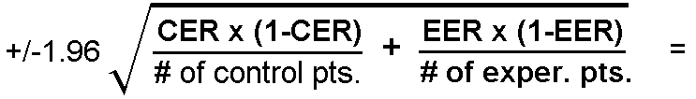  Taking the reciprocal of these numbers gives you the confidence limits of the NNT

Will the results help me in caring for my patient?
Are my patients similar to those in the trial? | Consider exclusion factors of the study being appraised (medication, general health etc) and the population from which the sample was drawn. For example, are they the same age, ethnicity etc as your patient.
Were all clinically relevant outcomes considered? | Do the authors report adverse events as well as benefits.
Are the benefits worth the harms and costs? | This is a matter of judgement. Think, not only of monetary cost, but the risk-benefit ratio of the intervention.
What does my patient think? | A most important question. You are now in a position to take the results to your patient and discuss the evidence.

Decide on the usefulness of the evidence on a continuum:
very good ____________________________________________________ very poor

Articles and worksheets for tutorial sessions
(full articles have been removed from the electronic version of the guide for copyright reasons)

Questions for Vidt et al paper, to be discussed 23rd October

Vidt DG, White WB, Ridley E et al.
A forced titration study of antihypertensive efficacy of candesartan cilexetil in comparison to losartan: CLAIM Study II.
J Hum Hypertens. 2001 Jul;15(7):475-80.

Please note: this worksheet should be completed in advance and handed in to your tutors on the 23rd October.

What was the aim of this study?

Explain the terms “trough” and “peak” as used in table 1.

How many similar studies have been done before?

According to the discussion in this paper, what was the finding of reference 12, the meta-analysis?

How do the findings in this (CLAIM II) study compare with the meta-analysis in reference 12?

Please note; after this session you will need to complete the ‘Scientific writing’ task following the guidelines in appendix 3. The hand in date is the 1st Dec; feedback will be given for this task both electronically and at the session on 17th January.

Questions for Richter et al paper, to be discussed 15th November

Richter JE, Kahliras PJ, Johanson J et al.
Efficacy and safety of esomeprazole compared with omeprazole in GERD patients with erosive esophagitis: a randomized controlled trial.
Am. J. Gastroenterol. 2001 Mar.;96(3):656–65.

What were the aims of this study?

Do you think that the study is well designed?

What were the outcome measures of the study and do you think these are fair?

What were the main findings of this study and do you agree with the conclusions in this paper?

How could this have been improved?

Questions for Abraham et al paper, to be discussed 15th November

Abraham E, Laterre P-F, Garbino J et al.
Lenercept (p55 tumor necrosis factor receptor fusion protein) in severe sepsis and early septic shock: A randomized, double-blind, placebo-controlled, multicenter phase III trial with 1,342 patients
Crit Care Med 2001; 29:503–510

How ‘clinically important’ is the problem being addressed?

What is the background for the hypothesis?

Were there any potential ‘conflicts of interest’?

Were the two intervention groups similar at baseline?

Was the primary outcome variable appropriate, and did the treatment have any effect on this?

Was the study large enough?

What did the authors conclude about the different ‘lots’ of drug?

Questions for Madrid et al paper, to be discussed 17th January

Madrid AH, Marin IM, Cervantes CE, et al.
Prevention of recurrences in patients with lone atrial fibrillation. The dose-dependent effect of angiotensin II receptor blockers.
Journal of the renin-angiotensin-aldosterone system : JRAAS. 2004 Sep.;5(3):114.

What were the aims of this study?

Do you think that the study is well designed?

What were the outcome measures of the study and do you think these are fair?

Do you think that the study population is representative of “real life patients”?

To what extent does irbesartan improve the outcome of cardioversion?

How does irbesartan reduce the recurrence rate of atrial fibrillation and do you agree with the explanation given? Is this supported by other literature?

