Introduction to Refworks
- Set up your RefWorks account
- Go to the library homepage: http://www3.imperial.ac.uk/library
- Select ‘Reference Management’ under the ‘Find Out About’ column
- Once you’re on the Reference Management page, select ‘RefWorks’ from the column on the right
- Select ‘Log in to RefWorks’ at the bottom of the RefWorks page
- Login with your College username and password.

- RefWorks registration:
The first time you’ll be asked to enter your email address twice. From now on you can login to RefWorks via Shibboleth using your College username and password. Always use the Shibboleth link, including when logging in to Write-n-Cite.

Adding references to your RefWorks account
- Manually
Click on Add New from the References menu and the below box should appear.
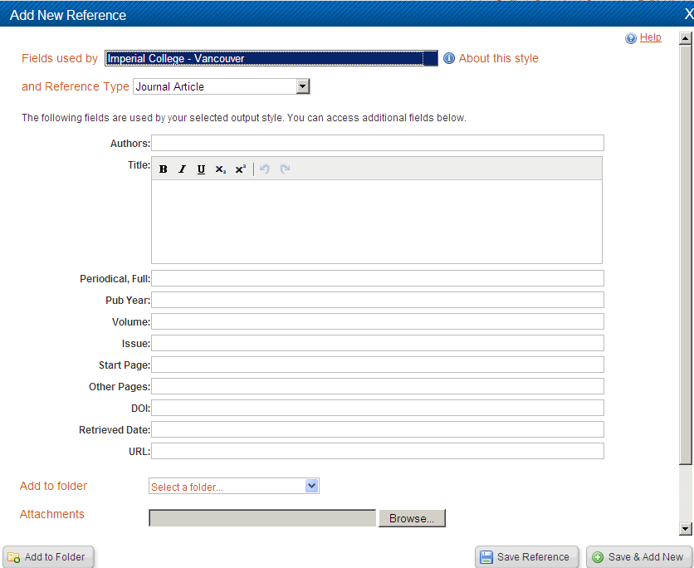
3. Fill in as many fields as possible (details below), scrolling down
2. Select the Ref Type – Journal Article
1. View fields used by - select Imperial College London –Vancouver
4. Choose Save Reference or Save & Add New to continue adding references

Add the following journal article:
Weatherall, D. J. (2008) Hemoglobinopathies worldwide: present and future. Current Molecular Medicine. 8 (7), 592-599. Note that you put the article title in the Title field and the journal title in Periodical, Full and the first page number in Start Page and the last page number in Other Pages. The volume is 8 and the issue number is 7.

- Direct export (example: Medline)
Direct export is available from a number of database providers including OvidSP, hosts of Medline. Leave RefWorks open throughout.
- Open OVID Medline (instructions follow):
- Go to the library homepage (http://www3.imperial.ac.uk/library)
- Click on Databases and e-books list (under Search)
- Click on A-Z list, O
- Scroll down and click on OVIDSP
- Click on one of the Medline links (different year ranges are available)
  - Search Medline for myocardial infarction (you will need to click on the Continue box twice)
  - Mark the first 5 references by clicking in the box beside the references
  - Scroll up to this toolbar
  - Click on Export
  - Choose RefWorks from the Export To drop down box
- Select Complete Reference in the Fields section
  - Click Export Citation(s)(You may need to turn off pop up blockers)
  - Your references will now appear in RefWorks – click on View Last Imported Folder to view (you may need to maximise the window to see the View Last Imported Folder box).

- Import from text file (example: Pubmed)
Some database providers require you to export your results to a text file which can then be uploaded to RefWorks; these include Cochrane Library, Pubmed, Web of Knowledge.
- Open Pubmed via the Databases and e-books list
- Search for public health
- Select the references you want to save by clicking in the checkbox to the left of the references
- Click on the Send to arrow and select File
- Change Format to MEDLINE and save to your H drive (or somewhere you can find it) as pubmed_result.txt
- Go to RefWorks
- Click Import under the References menu
- Under Import Filter/Data Source select NLM PubMed and Pubmed from the drop-down menus if not already selected
- Browse for the file citations and open it
- Click Import. See Last Imported Folder for your references

- Import a single reference (example: Google Scholar)
- Open Google Scholar (http://scholar.google.co.uk/)
- Click on Settings in the top right hand corner of the screen
- Click on Show links to import citations into and select RefWorks
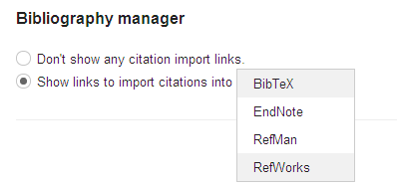
- Click on Save
- Do a search in Google Scholar – you will now see Import into RefWorks under each reference. Click on this to import a reference into RefWorks. You can view it in the Last Imported Folder. Note that you can only import single references via Google Scholar and if you wish to import multiple references you need to use a database as above.

- Organising your references in RefWorks

- View your references
RefWorks opens showing you All References by default. Select options from the View menu to change this. You can view the references you last imported, all references which don’t belong to a folder (see point III.5. on how to create/organise folders) or your deleted references. You can also identify duplicate records from the View menu.

- Deleting references
When you delete a reference it moves into the Deleted References folder. They remain there for 30 days before they get automatically and permanently deleted. You are able to restore deleted references during those 30 days.

- Sorting references
There are different options to sort your references, e.g. by title or publication year. The Sort by option displays to the right at the top and bottom of a reference list.
- Sort all references by descending publication year
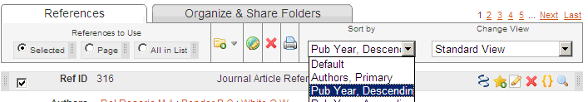

- Viewing options
Standard View (default) includes author, title and source information.
One Line/Cite View (used to insert citations in a document, see below) has a Cite and View link along with Author, Year and Title only.
Full View displays all fields in a record, including an abstract when imported/available.
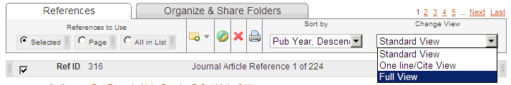

- Organising references using folders
You can create folders to organise your references. You can think of them also as tags. You can tag references more than once. One example of setting up folders is according to the chapters of your work.
Create folders
- Click on the New Folder button under References on the main menu
- Name your first folder Public Health
- Create another folder called Myocardial infarction
- Folders will now appear in the Organize & Share Folders tab

Putting references into folders (tagging references)
- Select All References from the View menu
- Choose 2 references you want to put in your Public Health folder by selecting their tick box
- Select public health under the Folder icon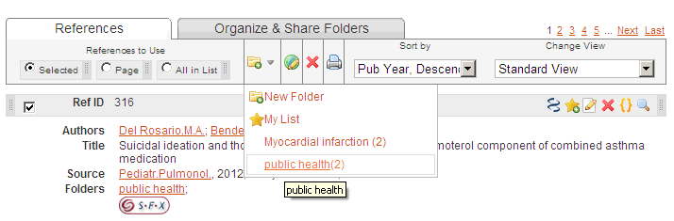
Organising folders
- Click on the Organize & Share Folders tab
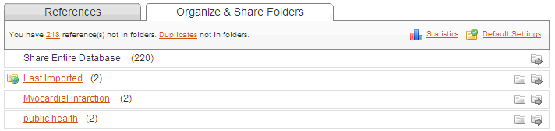
- From here you can see how many references are in each folder, create new folders and rename existing folders
- Click on the folder name to view the references in that folder

- Searching for references
You can search for references using the search function at the top right of the screen.
- Do a quick search for myocardial infarction
- You can now easily move these references into your Myocardial infarction folder by selecting All in List and selecting Myocardial infarction from the list of folders under the folder icon

Formatting your imported references for your written work
Before you create bibliographies or reference lists for the references you refer to in your written work. References that have been imported from databases will require some more editing, to ensure all required information is included in your final references. This is because databases don’t necessarily include all the information required by the referencing style. If you edit them now, it will save you time later when writing up. (This is for future reference and you don’t have to amend any references right now).
- To make it easier it is suggested that you first sort into a folder references that you are going to use for your written work.
- Click on the edit icon (pencil and paper icon in Standard View) on the right hand side of the reference you are going to edit.
- From the drop down menu View fields used by
- Select the referencing style you are going to use, e.g. Imperial College London - Vancouver
- Scroll down a little and you will see the fields that need to be filled in for that particular reference style. Most should be filled in already.
1. In the retrieved date field add the date you accessed the article e.g. 20th October 2011

2. Add either the DOI number of URL of the article, depending on what you prefer. (A DOI or digital object identifier is a permanent way of identifying electronic documents). A quick way of getting one of these is following the sfx button which appears in the Refworks reference if available.

3. Click Save Reference to save the changes.

Create a bibliography from a list of references
Click on the Create Bibliography button, or Create under the Bibliography tab
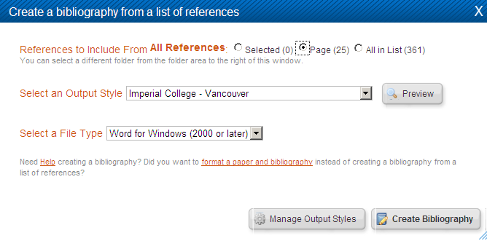
1. Select the output style you want: e.g. Imperial College -Vancouver
3. Select which references you want to create a reference list with – e.g. all
2. Select the File Type you want to create, e.g. Word document
4. Click on Create Bibliography – this opens a new window displaying your bibliography
Write-n-Cite III for Windows
- Introduction
Write-N-Cite is a small program which enables you to put citations in your Word document and create a reference list at the end applying the referencing style you’ve chosen.
It’s readily available on College PCs and there should be a shortcut on the desktop. If not, you’ll find it under Start – Programs – RefWorks. In either case you are asked to login again.

If you are using RefWorks off campus, you’ll need to download Write-N-Cite III. Using Write-N-Cite IV is not recommended at present. There are different versions available (including one for Mac). For more information see http://www.refworks.com/Refworks/WNCDownload.asp. To download Write-N-Cite to your own computer, click on Write-N-Cite under the Tools menu within RefWorks.

- Adding citations to your Word document
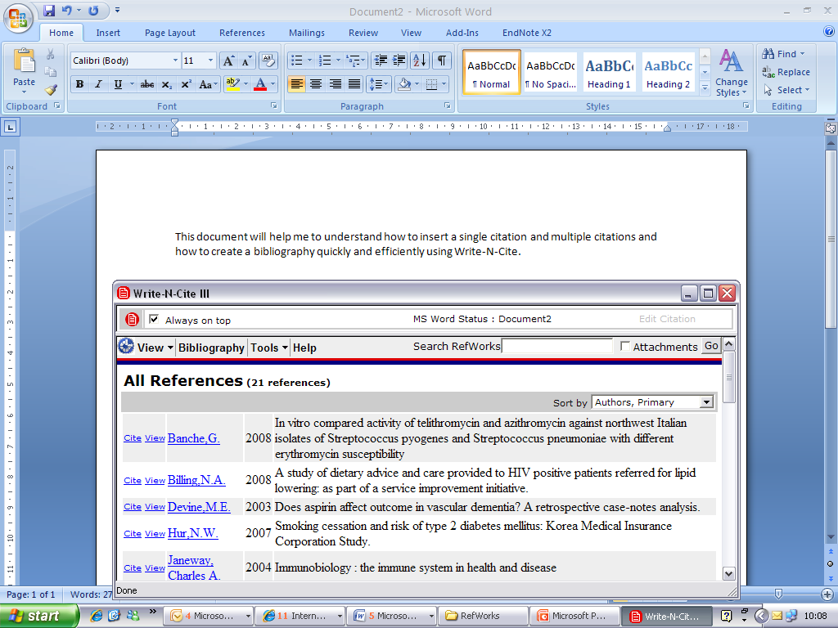

- Open Word and type the following text: This document will help me to understand how to insert a single citation and multiple citations and how to create a bibliography quickly and efficiently using Write-N-Cite.
- Click on the Write-N-Cite icon on your desktop. 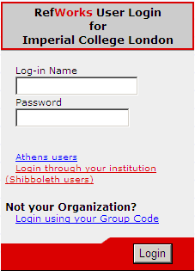
- Login using the Login through your institution (Shibboleth users) link.
- Tick the Always on Top radio button
- Default view is All References. You can change this to a folder using the View menu.
- Place your cursor in your Word document exactly where you want to put a citation.
- Find any reference in Write-N-Cite.
- Click on Cite next to the reference.
- Repeat this in two more locations, one of which should be a multiple citation – with the cursor in one place, click on Cite for three references.
- This creates temporary placeholders. The right format will be applied when creating the bibliography (see next section)
- Save your document to the desktop as RWcite.

- Creating a reference list from citations in your Word document
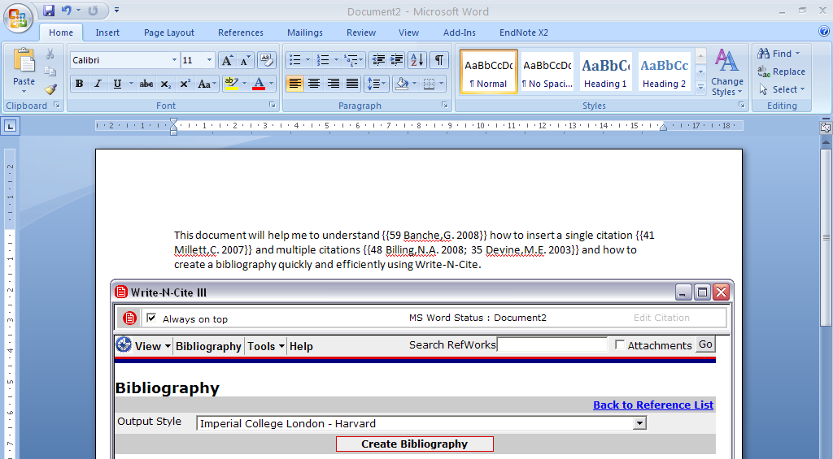
- To finalise your document’s citations and to include a reference list, click on Bibliography in the Write-N-Cite window.
- Choose the referencing style you want, e.g. Imperial College London – Vancouver.
- Click on Create Bibliography. This will put the citations in the right style and puts a bibliography at the end.

