Exercise on somatosensory pathways
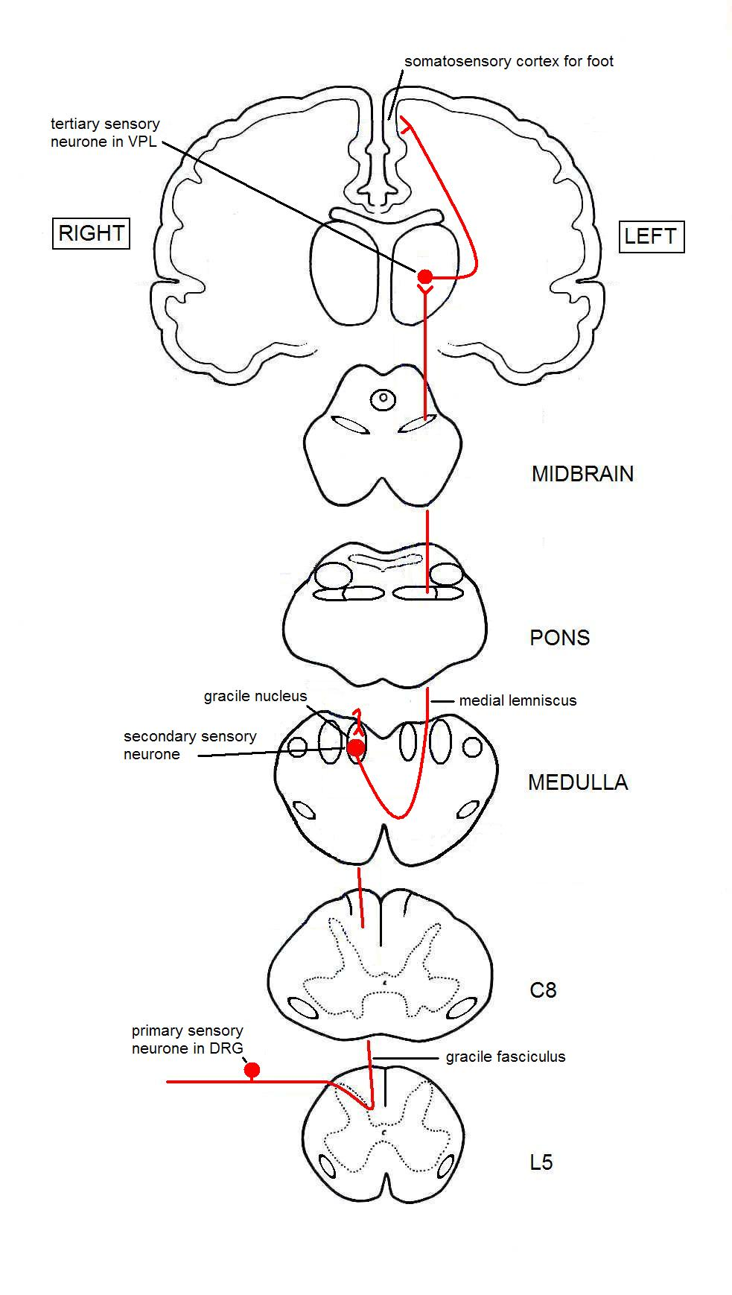
- Touch on the right big toe
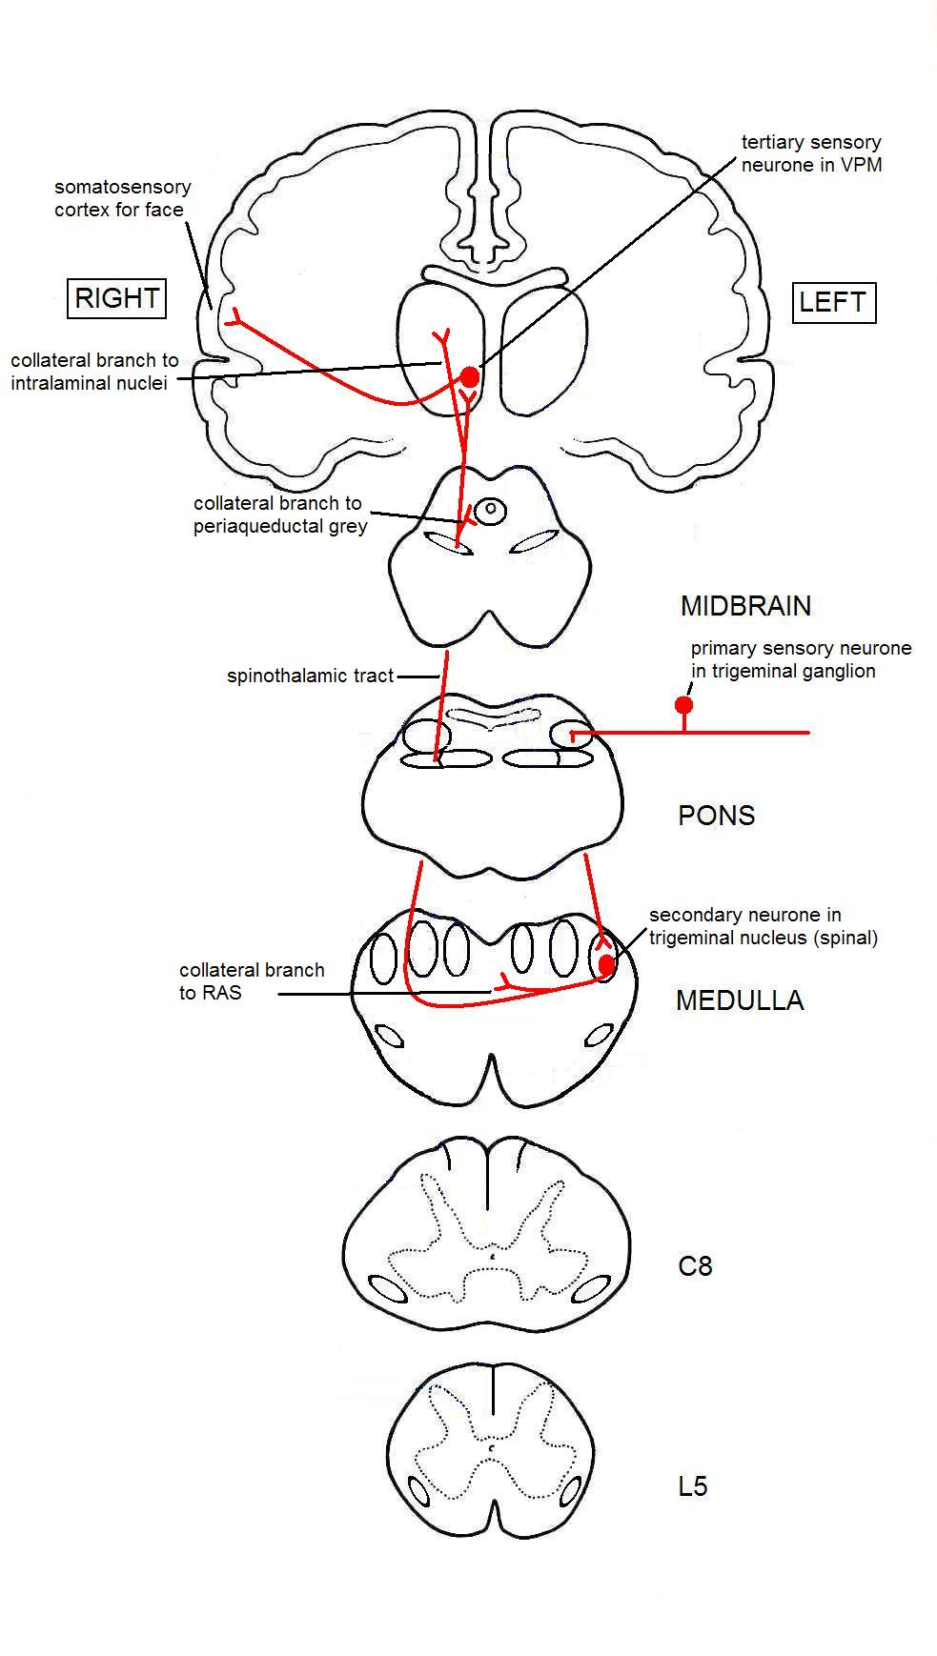
2. Pain in the left side of the face
- Pain in the left hand
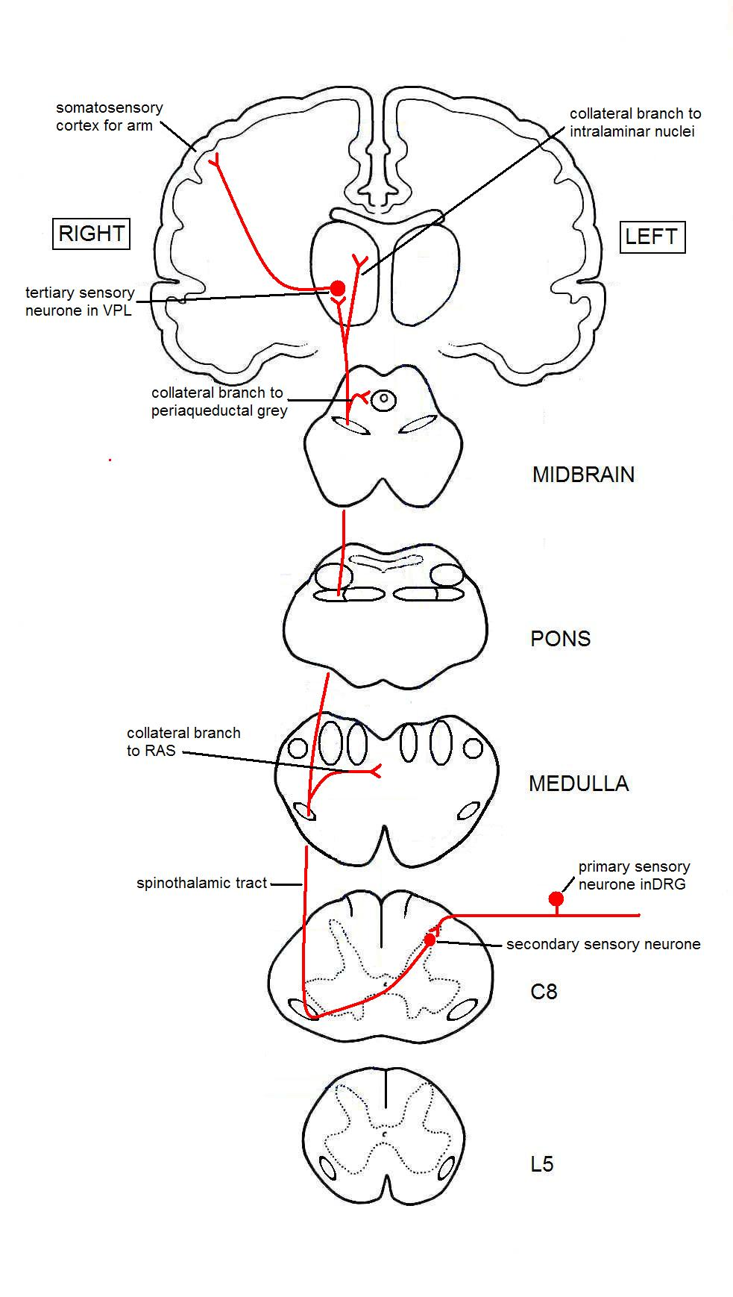
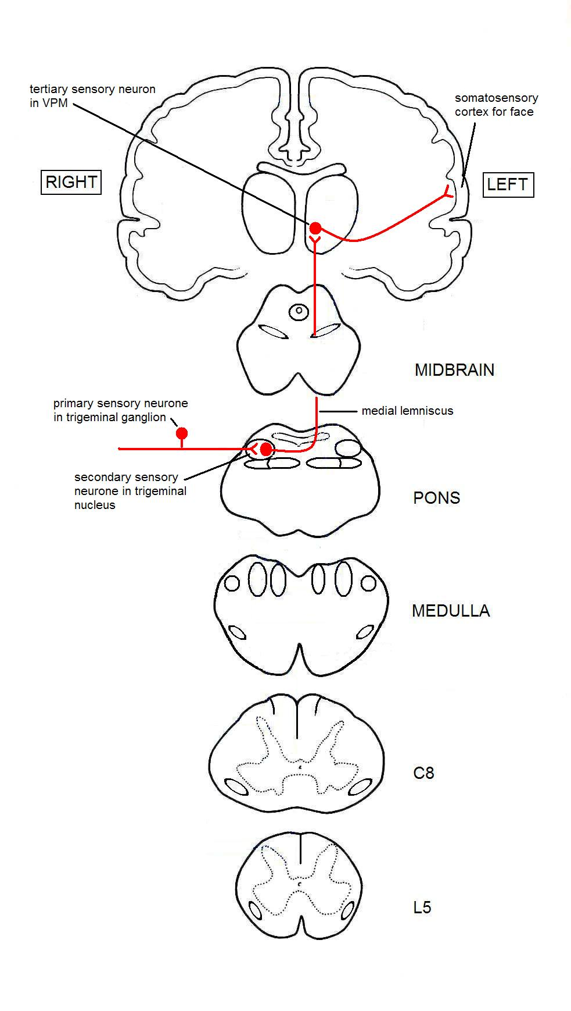
- Touch on the right side of the face

