
School of Medicine

Year 2 – 2012/13

Musculoskeletal System
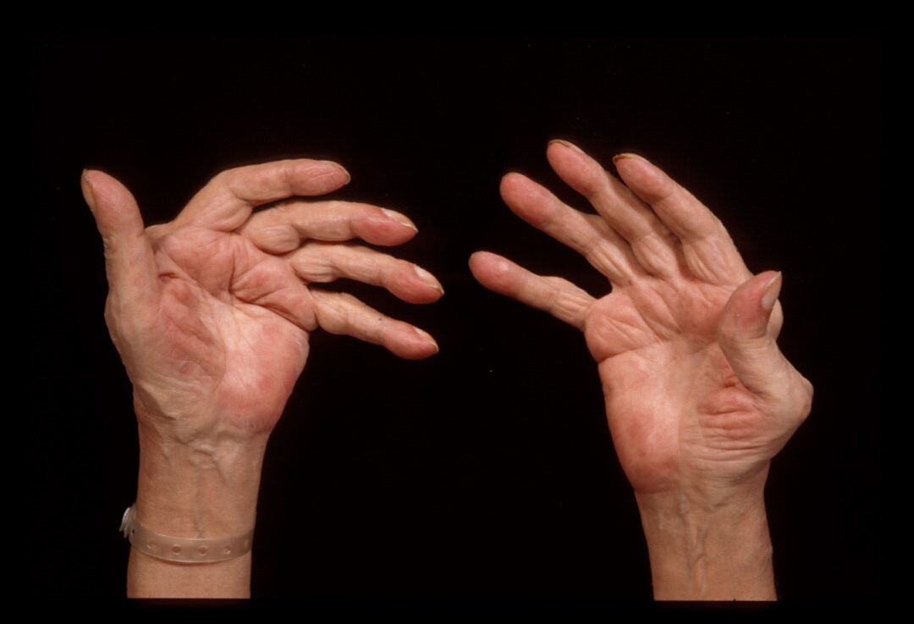

Spring term course guide

Course leader: Professor Matthew Pickering PhD MRCP(UK)
Professor of Rheumatology and Wellcome Trust Senior Fellow in Clinical Science
Centre for Complement & Inflammation Research (CCIR)
Division of Immunology and Inflammation
Department of Medicine, Imperial College London
Hammersmith Campus, Du Cane Road
London W12 ONN

matthew.pickering@imperial.ac.uk
http://www1.imperial.ac.uk/medicine/people/matthew.pickering/
CCIR weblink:
http://www1.imperial.ac.uk/medicine/about/divisions/departmentofmedicine/immunologyandinflammation/ccir/

https://education.med.imperial.ac.uk

Musculoskeletal course

Year 2 – Spring term course guide

CONTENTS
Page
SOLE and feedback documents iii
Introduction 2
Assessment 3
Timetable 4
Learning objectives – Overview 5
Learning objectives – Metabolic medicine 5
Learning objectives – Orthopaedics 6
Learning objectives – Rheumatology 7
Rheumatology worksheet 10
Recommended reading 11

https://education.med.imperial.ac.uk

SOLE FEEDBACK – Musculoskeletal year 2

The following pages provide you with templates on which you can record your thoughts as the course proceeds. At the end of the course you can enter your views onto SOLE.

Please answer all questions by selecting the response which best reflects your view.

 | Strongly Agree | Agree | Neutral | Disagree | Strongly Disagree
The content of this module is useful.
The support materials available for this module (e.g. handouts, web pages, problem sheets) are helpful.
I receive sufficient feedback and guidance.
Overall, I am satisfied with this module.

Please use this box for constructive feedback and suggestions for improvement.

SOLE FEEDBACK - INDIVIDUAL LECTURERS

Please note that for SOLE, a Lecturer’s name will only appear once. This template gives you the opportunity to record your comments about each lecture in the order of delivery.

On the following section, you have an opportunity to record any comments and constructive feedback you have for each lecturer.

 | The lecture(s) are well structured |  |  |  |  | The lecturer explains concepts clearly |  |  |  |  | The lecturer engages well with the students
Lecturer and Lecture Title | Strongly Agree | Agree | Neutral | Disagree | Strongly Disagree | Strongly Agree | Agree | Neutral | Disagree | Strongly Disagree | Strongly Agree | Agree | Neutral | Disagree | Strongly Disagree
Metabolic bone disease - Pathology
Dr Ann Sandison
Metabolic bone disease – Biochemistry
Dr Jeremy Cox
Metabolic bone disease – Radiology
Dr Ranju Dhawan
Bone: structure, function and healing
Mr Barry Andrews
Articular cartilage: structure, function and healing
Mr Vipin Asopa
Ligament, tendon and muscle: structure, function and healing
Mr Chinmay Gupte

Pathogenesis of autoimmune disease
Professor Matthew Pickering
Systemic lupus erythematosus
Professor Justin Mason
Rheumatoid arthritis
Professor Matthew Pickering
Osteoarthritis and Reactive arthritis
Professor Matthew Pickering
The GALS screen
Professor Matthew Pickering
Revision Lecture
Professor Matthew Pickering

Lecturer and Lecture Title | Please use this box for additional constructive feedback.
Metabolic bone disease - pathology
Dr Ann Sandison
Metabolic bone disease – biochemistry
Dr Jeremy Cox
Metabolic bone disease – Radiology
Dr Ranju Dhawan
Bone: structure, function and healing
Mr Barry Andrews
Articular cartilage: structure, function and healing
Mr Vipin Asopa
Ligament, tendon and muscle: structure, function and healing
Mr Chinmay Guptee
Pathogenesis of autoimmune disease
Professor Matthew Pickering
Systemic lupus erythematosus
Professor Justin Mason
Rheumatoid arthritis
Professor Matthew Pickering
Osteoarthritis and Reactive arthritis
Professor Matthew Pickering
The GALS screen
Professor Matthew Pickering
Revision Lecture
Professor Matthew Pickering

Musculoskeletal System

INTRODUCTION

The Musculoskeletal System teaching comprises:

Year 1 Spring Term

‘Molecular motors’ and how muscle works

Format: 2 lectures, 1 video demonstration of electromyography (electrical recording of muscle activity)

Year 2 Autumn Term

Muscle disease and muscle contraction in vivo

Format: 3 lectures

Year 2 Spring Term

Metabolic Bone Disease

Orthopaedics

Rheumatology

COURSE STRUCTURE – SPRING TERM – YEAR 2

METABOLIC BONE DISEASE – 3 lectures

- Pathology of metabolic bone disease
- Biochemical aspects
- Radiology

RHEUMATOLOGY – 6 lectures

- Pathogenesis of autoimmune disease
- Systemic lupus erythematosus (SLE)
- Rheumatoid arthritis
- Osteoarthritis and Reactive arthritis
- The GALS screen
- Revision lecture

ORTHOPAEDICS – 4 lectures

- Bone: structure, function and healing
- Articular cartilage: structure, function and healing
- Ligament, tendon and muscle: structure, function and healing
- Biomechanics for medical students
ASSESSMENT

Summative Assessment
The course will be examined in a single examination:
- LCRS — Part 2 Paper 2 (3hrs) in April 2009

The questions may be SAQ, SBA, EMQ, and TF-MCQs.

Examples of specimen questions

SAQ (10 marks)

Rheumatology

Part A. A 26 year-old man presents with pain and swelling in the knee. Four weeks previously he was treated for urethritis in the Sexual Health Clinic. Based on the investigations (below) a definite diagnosis of reactive arthritis was made. Describe in one word what the most likely result of each of the following investigations. (7 marks)

- Previously isolated from urethral swab
- Erythrocyte sedimentation rate
- C-reactive protein
- Rheumatoid factor
- Antinuclear antibodies
- HLA B27
- X-ray of the affected knee

Model answers
- Chlamydia
- Raised
- Raised
- Negative
- Negative
- Positive
- Normal (soft tissue swelling)

Part B. List, in one sentence each, 3 independent pieces of evidence that apoptosis is important in the pathogenesis of SLE. (3 marks and more difficult)

Possible model answers
- The rash of SLE is exacerbated by UV light (UV light induces apoptosis)
- Nuclear antigens are expressed on the surface of apoptotic cells and antinuclear antibodies are a feature of SLE.
- Deficiency of complement (which clears apoptotic material) is a strong risk factor for the development of SLE
- Apoptotic cells are frequently seen at the sites of inflammation

Further details and the most up-to-date information about examinations are provided on the intranet.

TIMETABLE 2013 – Spring term

Details are correct at the time of printing. Amendments will be shown on the intranet.

Date/campus | Time | Lecture topic | Lecturer
Metabolic Bone Disease
Monday  14/01/2013  Charing Cross campus  Brian Drewe  Lecture theatre | 09.30 – 09.45 am | Metabolic bone disease – introduction and overview | Dr Jeremy Cox
 | 09.45 – 10.30 am | Metabolic bone disease – histopathology | Dr Ann Sandison
 | 10.30 – 11.15 am | Metabolic bone disease – biochemistry | Dr Jeremy Cox
 | 11.15 – 12.00 am | Metabolic bone disease – radiology | Dr Ranju Dhawan
Orthopaedics
Wednesday  30/01/2013  Charing Cross campus  Brian Drewe  Lecture theatre | 09.00 – 09.45 | Bone: structure, function & healing | Mr Barry Andrews  Confirmed – 19/9
 | 09.45 – 10.30 | Articular cartilage: structure, function & healing | Mr Vipin Asopa  Confirmed – 26/10
 | 10.30 – 11.00 | Break
 | 11.00-11.45 | Muscle, ligament and tendon: structure, function & healing | Mr Chinmay Guptee
Rheumatology
Wednesday  13/02/2013  Charing Cross campus  Brian Drewe  Lecture theatre | 09.30 – 10.15 am | Pathogenesis of autoimmune disease | Prof Matthew Pickering
 | 10.15 – 11.00 am | Rheumatoid arthritis | Prof Matthew Pickering
 | 11.00 – 11.30 am | Break
 | 11.30 – 12.15 am | Osteoarthritis & Reactive arthritis | Prof Matthew Pickering
Monday  11/03/2013  Charing Cross campus  Brian Drewe  Lecture theatre | 09.00 – 10.00 am | Systemic lupus erythematosus | Prof Justin Mason
 | 10.00 – 10.45 am | The GALS screen | Prof Matthew Pickering
 | 10.45 – 11.00 am | Break
 | 11.00 – 12.00 am | Revision lecture | Prof Matthew Pickering
Learning objectives – Year 2 (2013) Spring term

These session objectives include tasks you should be able to carry out after you have completed the relevant activity. They provide you with a way to assess how well you are keeping up with the material. Note that they are also provided to the external examiners as a guide to what you should know at the end of the course.

METABOLIC BONE DISEASE

Leader: Dr. Jeremy Cox jeremy.cox@imperial.ac.uk

Lecture 1. Metabolic Bone Disease – Pathology
Dr. Ann Sandison ann.sandison@imperial.nhs.uk

Learning Outcomes: Students will be able to:
- Describe the composition of bone (cell types, inorganic matrix) and the classification of bone (trabecular, compact, lamellar and woven).
- Describe the key pathology of Osteoporosis, Osteomalacia, Paget’s disease and Hyperparathyroidism

Lecture 2. Metabolic Bone Disease – Biochemistry
Dr. Jeremy Cox jeremy.cox@imperial.ac.uk

Learning Outcomes: Students will be able to:
- Explain how basic biochemical tests can be used to assess mineral metabolism and bone turnover.
- Describe the biochemical features of Osteoporosis, Osteomalacia, Paget’s disease and Hyperparathyroidism.

Lecture 3. Metabolic Bone Disease – Radiology
Dr. Ranju Dhawan Ranju.Dhawan@imperial.nhs.uk

Learning Outcomes: Students will be able to:
- Describe the key radiological features of Osteoporosis, Osteomalacia, Paget’s disease and Hyperparathyroidism.

ORTHOPAEDICS

Leader: Professor Justin Cobb j.cobb@imperial.ac.uk

Lecture 1. Bones: structure, function and healing
Mr. Barry Andrews
Learning Outcomes: Students will be able to:

- Describe the structures of long and short bones including cancellous and trabecular bone
- Describe the mechanical properties of bone and mechanisms of bone failure
- List the stages of fracture healing including mal union and non union

Lecture 2. Articular cartilage: structure, function and healing
Mr. Vipin Asopa
Learning Outcomes: Students will be able to:

- Describe the structure and function of articular cartilage
- Describe the mechanisms of cartilage failure and repair

Lecture 3. Ligament, tendon and muscle: structure, function and healing
Mr. Chinmay Gupte
Learning Outcomes: Students will be able to:

- Describe the structure and function of ligament, tendon and muscle
- Describe the mechanisms of failure of these tissues and their mechanism of repair

RHEUMATOLOGY

Leader: Prof. Matthew Pickering matthew.pickering@imperial.ac.uk

In most cases, rheumatological diseases are disorders of the immune system. Consequently, the basic science underlying these diseases not only involves understanding the basic anatomy and physiology of the joint, but also an understanding of the basic concepts of autoimmunity. In this module we therefore devote a lecture to the pathogenesis of autoimmune disease (lecture 1)

We then select four common types of rheumatological disease: Rheumatoid arthritis, Systemic lupus erythematosus, Osteoarthritis and Reactive arthritis (lectures 2, 3 and 4). These represent common conditions a hospital rheumatologist would encounter.

The GALS and revision lecture (lectures 5 and 6) will describe ways in which these disorders are differentiated either clinically (this means ‘at the bed-side’ so relies on recognizing the conditions by history taking and clinical examination) or through investigations (radiology and blood tests such as testing for autoantibodies).

We want to emphasise the key aspects of these conditions. Therefore a worksheet (see below) has been developed which will allow you to achieve this aim. After these lectures you should be able to complete the worksheet for these four important rheumatic diseases.

There are many other conditions that are treated by rheumatologists but these are much less common and not relevant at this stage of training. However, important examples of these will be covered later during your clinical attachments.

Lecture 1. Pathogenesis of autoimmune rheumatic diseases.
Prof. Matthew Pickering matthew.pickering@imperial.ac.uk

The role of HLA, autoimmunity, cytokines, prostaglandins and metalloproteinases in rheumatological disorders. Basic science of rheumatology with an emphasis on how this science is applied to clinical aspects, i.e. clinical features, pathology, diagnosis and treatment.

Learning Outcomes: Students will be able to:

- Describe the role of HLA molecules in antigen recognition and the immune response.
- List 3 major HLA tissue types which represent risk factors for rheumatic disease
- Outline the mechanisms of autoimmunity and how they apply to different autoimmune rheumatic diseases.
- Name at least 5 major autoantibody systems which are used in diagnosis and management.
- Describe the role of the cytokines, gamma-interferon, IL-1, IL-2, IL-6 and TNF-alpha in mediating inflammation and tissue damage and outline the scientific basis for the use of TNF-alpha  inhibitors in rheumatoid arthritis
- Outline the role of prostaglandins in inflammation and how their blockade is exploited in therapy

Lecture 2. Systemic Lupus Erythematosus.
Prof. Justin Mason justin.mason@imperial.ac.uk

An overview of systemic lupus erythematosus (SLE) which is the major example of human systemic autoimmune disease.

Learning Outcomes: Students will be able to:

- To describe the pathogenesis, clinical features and management of SLE

Lecture 3. Rheumatoid arthritis.
Prof. Matthew Pickering matthew.pickering@imperial.ac.uk

An overview of rheumatoid arthritis the commonest chronic inflammatory joint disease.

Learning Outcomes: Students will be able to:

- To describe the pathogenesis, clinical features and management of rheumatoid arthritis

Lecture 4. Osteoarthritis and Reactive Arthritis.
Prof. Matthew Pickering matthew.pickering@imperial.ac.uk

An overview of osteoarthritis, a major cause of joint disability in the ageing population.

An overview of reactive arthritis, an infection-induced systemic illness characterized by sterile joint inflammation.

Learning Outcomes: Students will be able to:

- To describe the pathogenesis, clinical features and management of osteoarthritis
- To describe the pathogenesis, clinical features and management of reactive arthritis

Lecture 5. The GALS screen.
Prof. Matthew Pickering matthew.pickering@imperial.ac.uk

The GALS screen (G gait, A arms, L legs, S – Spine) is a validated examination technique to screen for the presence of musculoskeletal disease. In other words it is a rapid examination technique that will detect the presence of joint problems. Once identified more detailed examination of the affected joint is performed. Conversely, if the GALS examination is normal there is no need to perform detailed examination of individual joints or the spine.

Learning Outcomes: Students will be able to:

- To describe and perform the GALS examination
- Define the following commonly used rheumatological terms: arthritis, arthralgia, subluxation, synovitis
- Describe the pattern of joint disease in rheumatoid arthritis, osteoarthritis and reactive arthritis
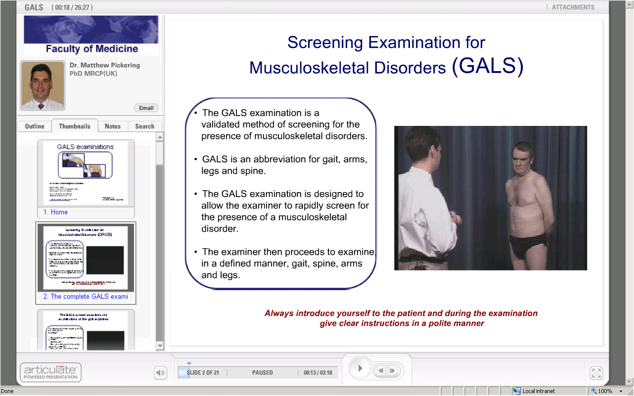
The GALS examination is demonstrated in a video teaching module on the intranet – see https://education.med.ic.ac.uk/Skills/Examinations-KM/index.html

Lecture 6. Revision lecture.
Prof. Matthew Pickering matthew.pickering@imperial.ac.uk

This lecture aims to consolidate the teaching points covered in lectures 1 to 5.

Learning Outcomes: Students will be able to:

- To outline the key features of rheumatoid arthritis, SLE, osteoarthritis and reactive arthritis.
- Understand how autoantibodies are useful in rheumatology practice

Worksheet for Rheumatology

It is anticipated that each cell of the table should contain between 1 to 5 essential facts. Example: Pathogenesis of rheumatoid arthritis could be - (1) activation of macrophages within the joint, (2) production of TNF and IL-1, (3) inflammation and (4) destruction of bone and cartilage by metalloproteinases”.

 | Rheumatoid arthritis | Osteoarthritis | Reactive arthritis | SLE
Aetiology (including genetics)

Demography (age, sex)

Pathogenesis

History

Examination

Blood investigations

Radiology

Treatment

Recommended reading

Textbook of Orthopaedics, Trauma and Rheumatology
Edited by Rashid Luqmani, James Robb, Daniel Porter, John Keating
Mosby Elsevier
ISBN: 978-0-7234-3389-7

Hyperlink: http://www.elsevier.com/wps/find/bookdescription.cws_home/714456/description#description



