Tutorial: Exploitation of the actin cytoskeleton by *Listeria*

**Take home messages**

The mechanism of *Listeria* motility is summarised in the diagram. New actin filaments are constantly being produced adjacent to one pole of the bacterium to form the "comet tail" structure. The actin filaments of the comet tail stay stationary within the cell, probably because they are crosslinked to each other and to cellular filaments with α-actinin and other crosslinking proteins. Thus as new filaments continue to be created the bacterium is pushed forwards. At the same time the filaments at the distal end of the tail tend to depolymerise.

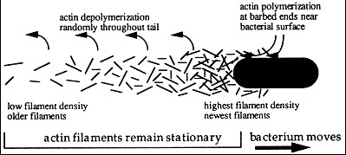

*Listeria* expresses ActA at one pole only of the bacterium. ActA can itself bind actin in the host cell cytoplasm, and this is sufficient to allow limited motility. However full motility at up to 10 μm/min also requires VASP binding by the proline-rich region of the protein. This recruits Arp complexes which acts as nuclei for new actin filaments, increasing greatly the rate of comet tail formation. The preferred ends of the new filaments are oriented towards the bacterium. VASP also binds profilin to this part of the cell, ensuring a good supply of ATP-containing G-actin molecules for polymerisation. The molecular arrangement is illustrated schematically below.

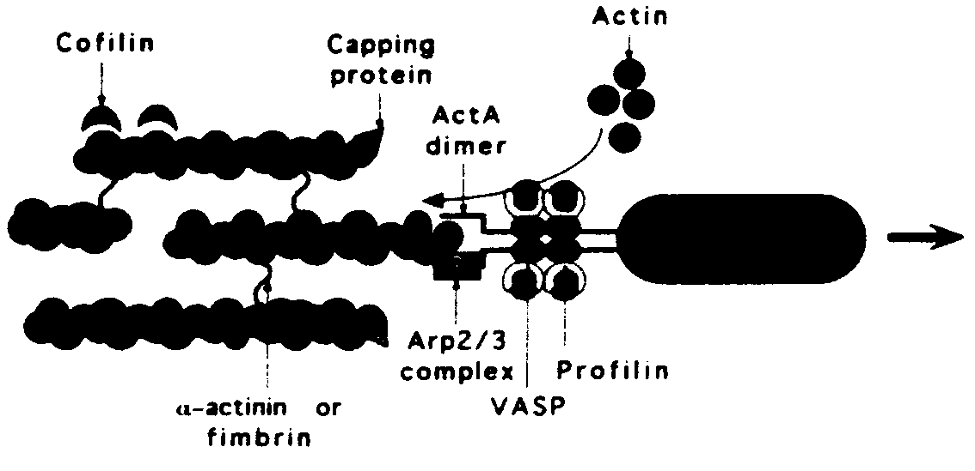

**Role of intracellular motility in the pathogenesis of *Listeria***

*Listeria* bind to the outside of cells, via one of the cell surface adhesion molecules (E-cadherin). This triggers internalisation by normal endocytosis or phagocytosis mechanisms. Once the bacterium is in an acidic compartment within the cell a special lysin protein is produced which breaks down the membrane of the organelle and allows *Listeria* access to the cytoplasm. It then spreads throughout the cell by the mechanism summarised above.

Intracellular motility allows *Listeria* to move through the cell (in its absence the rate of cell division is reduced) and to migrate from cell to cell or to exit the cell, as shown below.

Having this mechanism of moving and reproducing within host cells gives *Listeria* some unusual properties. It can cross between different compartments of the body without having to use a pre-existing wound or other lesion. There is some controversy as to whether the route of entry from the gut interior to the body is via intestinal epithelial cells or antigen presenting M cells, but it is clear that *Listeria* end up within macrophages and blood monocytes which carry the bacteria to other tissue cells around the body. The main site of bacterial division is in hepatocytes of the liver, but *Listeria* can also invade the syncytiotrophoblast lining the maternal blood spaces in the placenta and exit to infect the fetus. They can also cross the blood-brain barrier and cause a form of meningitis.



**Epidemiological consequences**

During an infection the vast majority of *Listeria* will be within host cells, where they are not accessible to antibodies or complement. The main form of immune defence will therefore be by cell-mediated responses. Any individual with a poor cell-mediated immune response is thus particularly susceptible to *Listeria* infection. This includes the very young and very old, the pregnant, those undergoing immunosuppression drug therapy and those suffering from diseases such as AIDS which target the immune system.

*Listeria* is common in soil and thus small numbers will normally contaminate the outsides of uncooked fruit and vegetables. It is destroyed by cooking or pasteurisation, but unusually for bacteria it can continue to divide at normal domestic fridge temperatures (3-5°C) in certain foods and potentially build up to infective concentrations. This is the basis for the strict hygiene regulations in commercial food production where utensils used for uncooked fruit and vegetables must be kept separate from those used for other foods. It is behind the advice for at-risk groups to avoid dairy products made from unpasteurised milk such as certain soft cheeses, to avoid refrigerated products particularly likely to culture *Listeria* such as meat patés, and not to eat food past the "use by" date.

**Further reading**: F.S. Southwick & D.L. Purich (1996). Intracellular pathogenesis of Listeriosis. *New Eng. J. Med*. **334**, 770-776; P. Cossart & M. Lecuit (1998). Interactions of *Listeria monocytogenes* with mammalian cells during entry and actin-based movement: bacterial factors, cellular ligands and signaling. *EMBO J.* **17**, 3797-3806.