MICROBIOLOGY 3

IMMUNITY TO FUNGAL INFECTIONS
Dr Elaine Bignell

Learning objectives:

Following this lecture you should be able to:

- Name the major antifungal immune effector cells
- Describe 2 mechanisms of cell-mediated antifungal defence
- Summarise the sequence of events leading to effective clearance of infectious fungal cells
- Understand how immune status determines risk of fungal infection

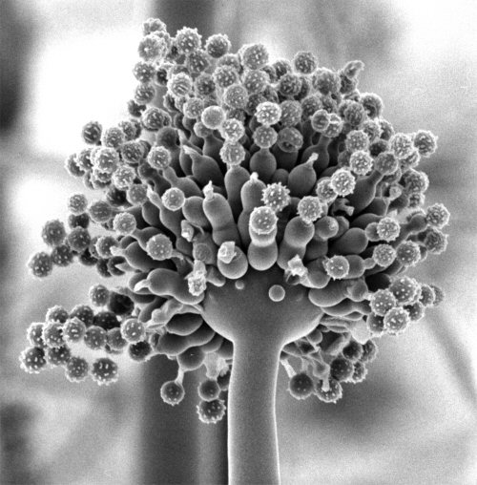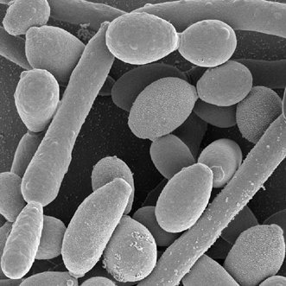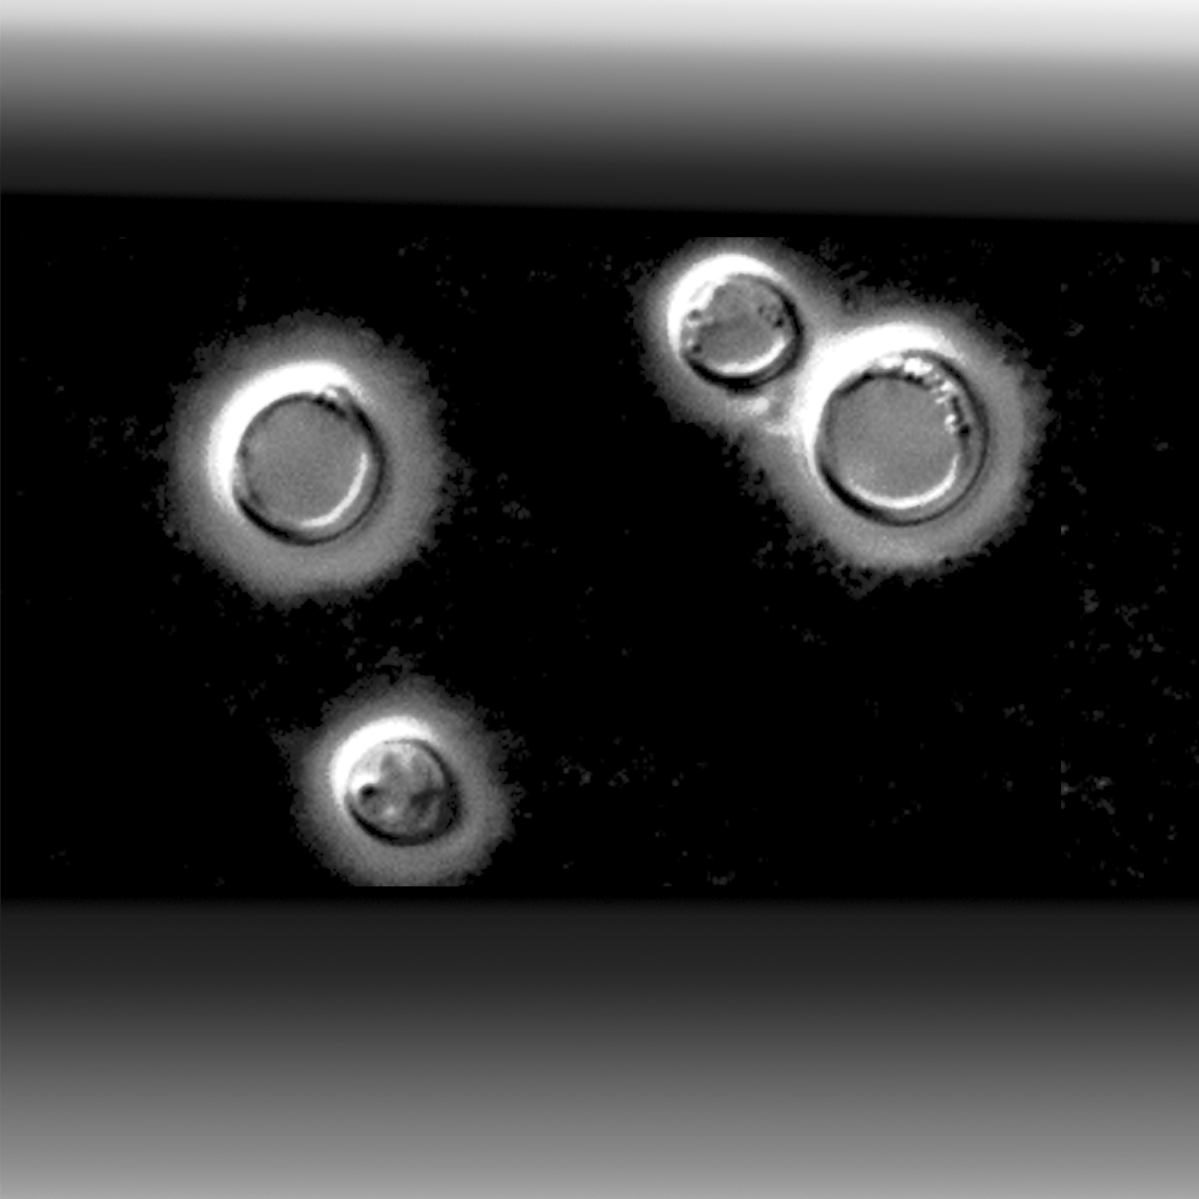

Questions to consider:

How does the healthy host defend against:

- Airborne fungal pathogens?
- Fungal commensals?

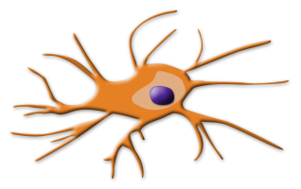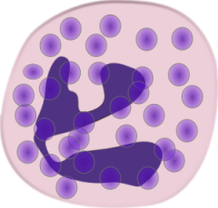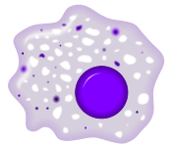

Which host cells are important for defence against fungal infection?

How do innate immune responses protect against Aspergillus fumigatus infection?

How do innate immune responses protect against Candida albicans infection?

How do innate immune responses protect against Cryptococcus neoformans infection?

How do the following risk factors promote susceptibility to infection:
- Immunocompromise
- Surgery
- Hereditary defects

What antifungal functions are performed by:

- Macrophages
- Neutrophils
- Dendritic cells

How is adaptive immunity to fungal pathogens orchestrated?

How does adaptive immunity impact the host-commensal relationship?

