MICROBIOLOGY 2
HOSPITAL infections
Dr Angelika Gründling

In this lecture we will cover hospital acquired bacterial infections and define what is considered as hospital acquired infection

We will specifically cover the following bacteria and infections caused by them

  - Staphylococcus aureus
  - Klebsiella pneumonia
  - Pseudomonas aeruginosa
  - Enterococcus
  - Escherichia coli
  - Clostridium difficile
  - Acinetobacter baumanii

We will cover antimicrobial resistance in health care associated infection

Infection in Hospital with resistant organisms is associated with:
- longer hospital stays
- increased healthcare costs
- increased mortality

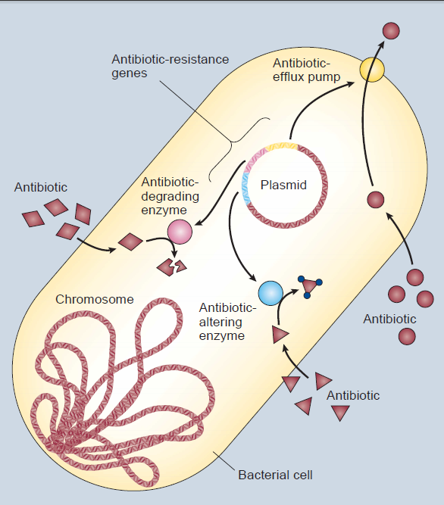

The Infamous Five for antibiotic resistant infections in the UK

Gram negative
……………………….Hospital acquired pneumonia, UTI, particularly affects immune compromised hosts (e.g. chemotherapy, individuals with cystic fibrosis). Survives on abiotic surfaces
………………………..Extended spectrum b-lactamase producers. E. coli, Klebsiella
………………………... ITU infections, Survives on abiotic surfaces

Gram positive
……………………… colonises skin and nasopharynx, Causes line associated sepsis, urinary tract infections, bloodstream infections, disseminated spread
………………………commensal of gastrointestinal tract. Causes line and urinary tract infection

Insert: Enterococcus faecium, Methicillin Resistant Staphylococcus aureus, ESBL, Pseudomonas aeruginosa, Acinetobacter baumanii)

