HAEMATOLOGY 9
THE HAEMOGLOBIN MOLECULE AND THALASSEMIA

Dr Nina Salooja

Learning Objectives
- Describe the structure and function of the haemoglobin molecule and list the normal haemoglobins in the fetal, neonatal and adult periods.
- Describe the genes controlling haemoglobin synthesis and explain how genetic defects lead to α and β thalassaemias.
- Describe briefly the clinical and haematological features of β thalassaemia major and the principles of management.
- Describe the haematological features of β thalassaemia trait, how it is diagnosed and why this is important.
- Describe how β thalassaemia trait can be differentiated from iron deficiency anaemia and the anaemia of chronic disease.

Haemoglobin (Hb) is a protein molecule found in red blood cells. Each molecule of haemoglobin consists of 2 pairs of globin protein chains together with 4 haem groups. Each haem group consists of a protoporphyrin ring with an iron atom at its centre and a single haem group sits in a pocket formed by a single globin chain.

Several different types of globin proteins exist each encoded by their own gene (s). The globin genes are located in two clusters. The alpha cluster is found on chromosome 16 and contains the genes for α globin (adult variety) and
ζ globin (zeta globin - an embryonic variant). The alpha genes are duplicated so that there are two functional alpha genes within an alpha cluster. The beta cluster is found on chromosome 11 and contains the genes for β globin, and δ globin (adult varieties), γ globin and ε globin (fetal and embryonic variants respectively).

There are 6 common variants of Hb. Three are transient embryonic haemoglobins. Hb F (α₂γ₂) is the predominant haemoglobin of fetal life and is also found in large amounts at birth. Hb A (α₂β₂) is quantitatively the major Hb (>95%) in adults and is found together with some HbA₂ (α₂δ₂) (2-3.5%) and traces of HbF (α₂γ₂).

The main function of Hb is the carriage of oxygen from the lungs to the tissues. To facilitate this the Hb molecule can exist in two spatial configurations. Deoxy haemoglobin exists in a tight (T) configuration and has a relatively low affinity for oxygen. Oxygen molecules are taken up sequentially by the 4 haem groups and at some point the partially liganded Hb molecule switches to a relaxed (R) configuration which has a markedly higher affinity for oxygen.

This can be represented diagramatically by the oxygen dissociation curve.
On the Y axis is the oxygen saturation which is defined as the fractional occupancy of the oxygen binding sites, and on the X axis is concentration of oxygen which is expressed as its partial pressure.

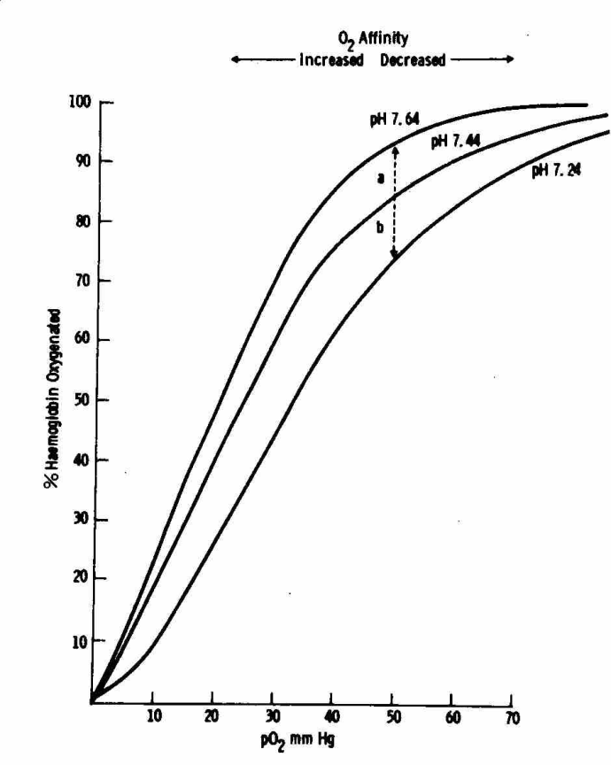
The binding of oxygen by haemoglobin is regulated by specific molecules in its environment. H+ ions, CO₂ and 2,3-DPG (an organic phosphate compound) all stabilise the T form of the oxygen molecule by forming H bonds and thus decrease the oxygen affinity of the molecule. This is represented on the oxygen dissociation curve as a shift to the right i.e a higher concentration of O₂ is needed for maximum O₂ saturation if the concentration of CO₂, H⁺ ions or 2,3-DPG are high. Thus in metabolically active tissues where the concentration of H ions and CO₂ are high, oxyhaemoglobin will assume the T configuration and give up oxygen readily. Conversely in the lungs where CO₂ is exhaled, oxygen affinity is higher. This effect of CO₂ on the affinity of Hb for oxygen is called the Bohr effect.

The thalassaemias are disorders in which there is underproduction of one of the types of globin chains of adult haemoglobin and are called alpha or beta thalassaemia according to the chains affected. Globin genes are transcribed into messenger RNA which is processed before translation into protein. Underproduction of a globin chain may therefore result from deletion of part (or all) of the gene, or else genetic mutations which lead to defects in transcription, mRNA processing, translation or stability of the final protein product. Different sets of mutations develop in different parts of the world. They probably arose independently and were expanded by selection possibly in relation to malaria

Alpha thalassaemia
Alpha chains are found in HbA and HbF so alpha thalassaemia may present clinically in utero. Alpha thalassaemia is usually (>80% cases) due to a deletion of one or more alpha genes and since each alpha cluster (one on each chromosome) has two alpha genes, four syndromes are possible as follows each with an increasing degree of anaemia and associated morbidity: α⁺ trait where one locus fails to function, α⁰ trait where two loci on the same chromosome are dysfunctional, Hb H disease with three loci affected and Hb Bart’s hydrops fetalis where all four loci are defective and death in utero is the norm. α⁺ thalassaemia is particularly common in Africa and in those of African descent and α⁰ thalassaemia is particularly common in SE Asia.

Beta thalassaemia
Most types of β thalassaemia are due to point mutations and over 100 different mutations have been described. In the absence of beta chains, alpha chains accumulate and precipitate in the bone marrow causing cell death; this is called ineffective erythropoiesis.

Cells which do manage to mature and enter the circulation contain β-chain inclusions and are removed by the spleen which subsequently enlarges. The anaemia stimulates erythropoietin production and this causes expansion of the bone marrow in the skull and long bones.

A simple clinical classification of β thalassaemia takes into account the severity of anaemia and need for regular transfusions and is not dependent on the underlying genetic changes. Thus, a patient with thalassaemia major has profound anaemia and requires regular blood transfusions to survive. A patient with thalassaemia intermedia, has anaemia but does not require regular blood transfusions.

Patients with thalassaemia major usually present within the first year of life with failure to thrive, and general malaise. Splenomegaly and bony deformities of the skull are characteristic and bone changes in the long bones may be associated with recurrent fractures. Without transfusion the children usually die by the age of 7. If blood transfusions are commenced in infancy, however, then early growth and development may be normal. The blood transfusions are themselves associated with considerable morbidity due predominantly to iron overload but also as a result of the transmission of blood borne viruses (e.g. hepatitis B and C and HIV). Each unit of blood contains 200mg iron and this accumulates in the liver, heart and endocrine glands. The effects of this start to appear by the end of the first decade. Secondary sexual development may be delayed or absent, the normal adolescent growth spurt fails to occur and diabetes, hypoparathyroidism and adrenal insufficiency may become apparent. In addition, progressive liver and cardiac damage occur and liver damage from the iron overload may be exacerbated further by infectious hepatitis. Death usually occurs before the age of 25. Removal of iron is difficult. Currently the most successful drug is an iron-chelating agent called desferrioxamine. This is not an ideal medication since it is not orally active and must be administered by a subcutaneous infusion over several hours on several occasions a week. Furthermore, it is expensive. Iron chelation does improve the outcome of thalassaemia, however, and in the transfused and chelated patient, survival into the 4th decade is possible. Death is usually (60%) a result of cardiac failure secondary to iron overload.

Bone marrow transplantation has the potential to cure thalassaemia major and should be considered in transfusion-dependent thalassaemics under the age of 16 years who have an HLA-identical sibling greater than 18 months of age

Beta thalassaemia trait
Heterozygotes for a beta thalassaemia gene are said to have β-thalassaemia trait. These carrier states are usually clinically silent, and can be referred to as thalassaemia minor. They can, however, be identified in the laboratory on the basis of abnormal red cell indices. Typically, patients with β-thalassaemia trait have smaller red cells than usual (microcytosis) and a reduced mean cell haemoglobin (MCH) with a normal mean cell haemoglobin concentration (MCHC). The red cell count is usually raised and the haemoglobin level is normal or slightly reduced. If β thalassaemia trait is suspected then the level of HbA₂ should be measured and is typically raised. If levels are equivocal even on repeat testing, and there is no evidence for coexisting iron deficiency then DNA analysis could be considered. There are two situations in which identifying patients as having β thalassaemia trait is of value. Firstly, the microcytosis may be misinterpreted as iron deficiency if the raised red cell count and normal MCHC are not noted. If these patients are then put on long term iron they can become iron overloaded. Secondly, it is important to identify pregnant patients with
thalassaemia trait so that their partners can be tested and the couple can be counselled about their chance of having a baby with clinically significant thalassaemia and can be offered further testing.

n.salooja@imperial.ac.uk

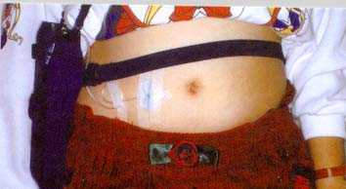
Subcutaneous infusion of desferrioxamine in beta thalassaemia major

