HAEMATOLOGY 2
MECHANISMS OF ANAEMIA AND POLYCYTHAEMIA
Prof. Barbara Bain (b.bain@imperial.ac.uk)

Learning objectives – you should be able to:
- Explain the term anaemia
- Describe the mechanisms underlying the development of anaemia
- Describe the classification of anaemia on the basis of red cell size
- List the common causes of microcytic, normocytic and macrocytic anaemia
- List causes of haemolytic anaemia and describe how you would recognise a haemolytic anaemia
- Explain the possible mechanisms underlying polycythaemia

Blood count interpretation
To understand blood counts you need to know the meaning of various terms and abbreviations:
WBC white cell count, the number of white cells in a given volume of blood
RBC red cell count, the number of white cells in a given volume of blood
Hb haemoglobin concentration
PCV packed cell volume, the proportion of a column of centrifuged blood occupied by red cells
Hct haematocrit, equivalent to the PCV
MCV mean cell volume, i.e. the average size of the red cells
MCH mean cell haemoglobin, i.e. the average amount of haemoglobin in a red cell
MCHC mean cell haemoglobin concentration, i.e. the average concentration of haemoglobin red cell
Platelet count the number of platelets in a given volume of blood

Anaemia is a reduction in the concentration of haemoglobin (Hb) in the circulating blood below what is normal for a healthy individual of the same age and gender as the individual. Anaemia is usually associated with a reduction in the red blood cell count (RBC) and the haemocrit (Hct) or packed cell volume (PCV).

Anaemia can be caused by:
- Reduced production of red cells by the bone marrow
- Loss of blood from the body
- Reduced survival of red cells in the circulation (called haemolysis)
- Increased pooling of red cells in an enlarged spleen

Anaemia can be classified not only by mechanism but also by the size of the red cells. This has the advantage that cell size gives important clues to the likely cause of the anaemia. Anaemia can be classified on the basis of cell size as
- Microcytic
- Macrocytic
- Normocytic

In a microcytic anaemia red cells are small. They are referred to as microcytes. The size of red cells can be judged by looking at a blood film with a microscope or by measuring the mean cell volume (MCV) on an automated blood cell counter. Microcytic cells are usually also hypochromic, i.e. they appear pale when looked at with a microscope. The anaemia is therefore described as hypochromic microcytic. The common causes of microcytosis are
- Iron deficiency anaemia
- Anaemia of chronic disease
- Thalassaemia
Microcytosis is a result of reduced synthesis of haemoglobin. This can be caused by reduced synthesis of haem (iron deficiency or anaemia of chronic disease) or reduced synthesis of globin (thalassaemia).

In a macrocytic anaemia red cells are larger than normal. They are referred to as macrocytes. The size of red cells can be assessed by examining a blood film or by noting an elevated MCV.
Important causes of macrocytosis include
- Megaloblastic anaemia resulting from a deficiency of vitamin B₁₂ or folic acid
- Liver disease
- Excess alcohol intake
- An increased proportion of young red cells newly released from the bone marrow

In normocytic anaemia the red cells are usually normally staining as well as normal in size so the anaemia is referred to as normochromic normocytic. Important causes include:
- The early stages of iron deficiency and the anaemia of chronic disease
- Renal failure
- Recent blood loss
- Bone marrow failure or infiltration

A haemolytic anaemia may be inherited or acquired. It may be caused by defective red cells (e.g. hereditary spherocytosis) or by a defect outside the red cells (e.g. fragmentation by fibrin strands deposited in capillaries, referred to as a micro-angiopathic haemolytic anaemia). Haemolysis may be mainly extravascular (e.g. increased removal of defective red cells by splenic macrophages in hereditary spherocytosis) or mainly intravascular (e.g. incompatible blood transfusion in which antibody destroys cells in the circulation). The following diagram summarises the causes of haemolytic anaemia.

CAUSES OF HAEMOLYTIC ANAEMIA

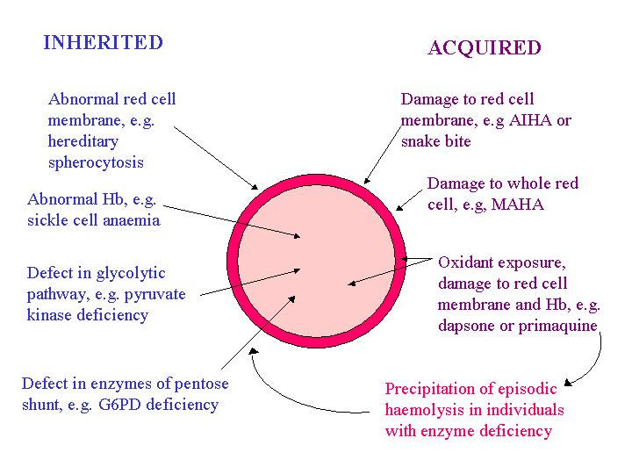
In macrocytic and normochromic normocytic anaemias it is often necessary to think about the mechanism of anaemia as it may not be immediately obvious from the patient’s history and blood film. The reticulocyte count is very important in this. It involves exposing living red cells to a dye that is taken up by young red cells so that they can be counted. An approximately equivalent observation on a routine blood film would be polychromasia. Polychromasia means that cells have a blue tinge, caused by ribosomal RNA in young red cells, in addition to the pink colour of the haemoglobin – hence ‘polychromasia’ - ‘many colours’. An increased reticulocyte count is seen as a response to haemolytic anaemia and recent blood loss and also as a response to treatment with iron, vitamin B12 or folic acid. A reduced reticulocyte count is seen when there is reduced output of red cells from the bone marrow.

If haemolytic anaemia is suspected, diagnosis is aided by
The detection of morphologically abnormal red cells, e.g. spherocytes, elliptocytes, fragments.
Evidence of increased red cell breakdown, e.g. increased serum bilirubin (unconjugated) and lactate dehydrogenase (LDH)
Evidence of an increased bone marrow response, e.g. polychromasia and an increased reticulocyte count

The following diagram summarises what happens in haemolysis and shows you the tests (in bold) that can be used if you suspect haemolysis.

Stimulation of bone marrow, polychromasia and reticulocytosis
INTRAVASCULAR HAEMOLYSIS

Anaemia
Red cell destroyed in circulation

Haemoglobin in plasma
Haemoglobin released from red cells

When all haptoglobin is saturated, free haemoglobin is filtered by the kidney

Haemoglobin binds to haptoglobin and the complex is cleared by liver

Haemoglobin and, later, haemosiderin in the urine

Low serum haptoglobin

EXTRAVASCULAR HAEMOLYSIS

Anaemia
Stimulation of bone marrow, polychromasia and reticulocytosis
Red cells phagocytosed by macrophages and destroyed

Red cell destruction leads to increased serum bilirubin and LDH and faecal and urinary bile pigments

Don’t worry if, at this stage, this seems all very complex. Further half days of Blood course will deal with microcytic and macrocytic anaemias.
POLYCYTHAEMIA
Polycythaemia is the opposite of anaemia. There are too many red cells produced and the Hb is too high. You can classify polycythaemia as follows:

Type of polycythaemia | Example
Physiological | Newborn baby
Appropriate erythropoietin secretion | Residence in Himalayas or Andes  Hypoxia due to cyanotic heart disease or severe chronic lung disease
Inappropriate erythropoietin secretion | Erythropoietin abuse by athletes  Erythropoietin secreted by renal cysts or tumours or other tumours
Not mediated by erythropoietin but due to intrinsic bone marrow disease | Polycythaemia vera

