**CANCER 4**

**APOPTOSIS**

Professor Tony Magee

**Learning Objectives**

1. Explain the difference between necrosis and apoptosis; describe how they may be distinguished.
2. Discuss whether necrosis and apoptosis are the only forms of cell death.
3. Describe the proteolytic caspase cascades which execute the apoptotic response.
4. Discuss how apoptosis may be mediated through death receptors and/or mitochondria.
5. Discuss how Bcl-2 family proteins may modulate apoptosis.

**Programmed cell death – why?**

1. Harmful cells (e.g. cells with viral infection, DNA damage)

2. Developmentally defective cells (e.g. B lymphocytes expressing antibodies against self antigens)

3. Excess/unnecessary cells:

(embryonic development – e.g. brain to eliminate

excess neurons; sculpting of digits and organs)

4. Obsolete cells (e.g. mammary epithelium at the end of lactation)

5. Chemotherapeutic killing of cells

**Programmed cell death in an embryonic mouse paw**

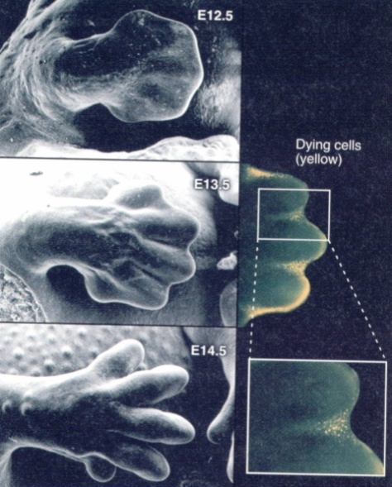

**Cell death: necrosis vs. apoptosis?**

* Necrosis - unregulated cell death associated with cellular disruption and an inflammatory response
* Apoptosis (programmed cell death) - Regulated cell death; controlled disassembly of cellular contents; no inflammatory response (e.g. haematopoietic cells)

2 ways to die?

**Apoptosis**

**Necrosis**

**Necrosis**

* Plasma membrane becomes permeable
* Cell swelling and rupture of cellular membranes
* Release of proteases leading to autodigestion and dissolution of the cell
* Localized inflammation

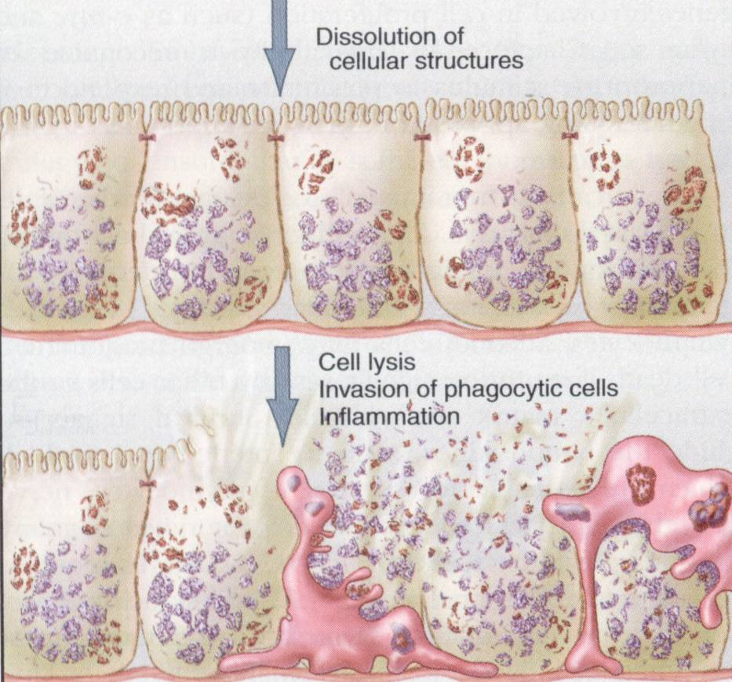

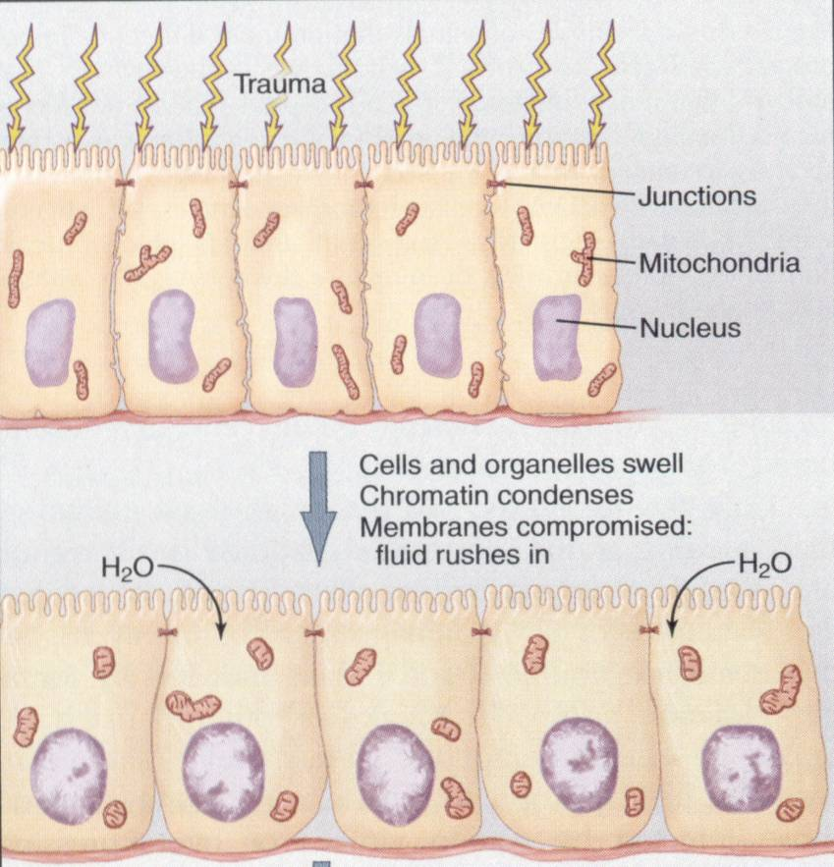

**Apoptosis**

Latent phase – death pathways are activated, but cells

appear morphologically the same

Execution phase –

Loss of microvilli and intercellular junctions

Cell shrinkage

Loss of plasma membrane asymmetry

(phosphatidylserine appears in outer membrane)

Chromatin and nuclear condensation

DNA fragmentation

Formation of membrane blebs

Fragmentation into membrane-enclosed apoptotic bodies

**Plasma membrane remains intact**

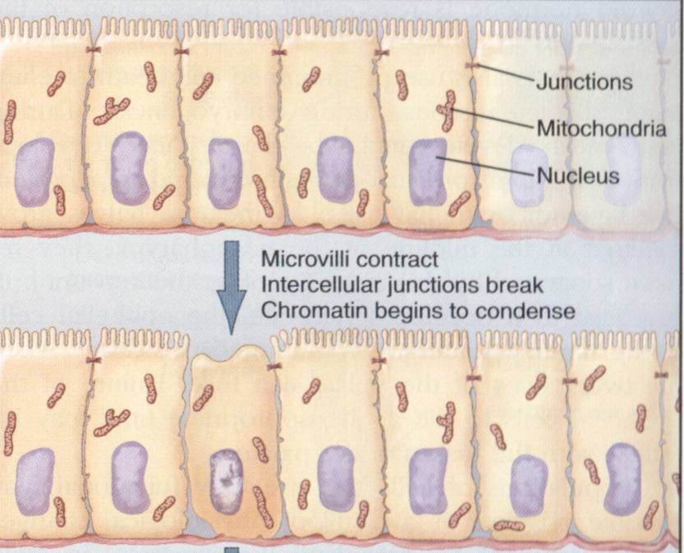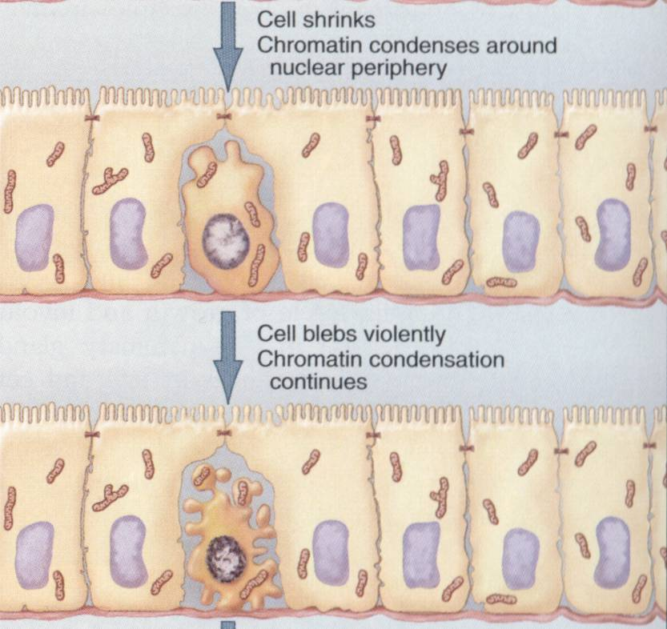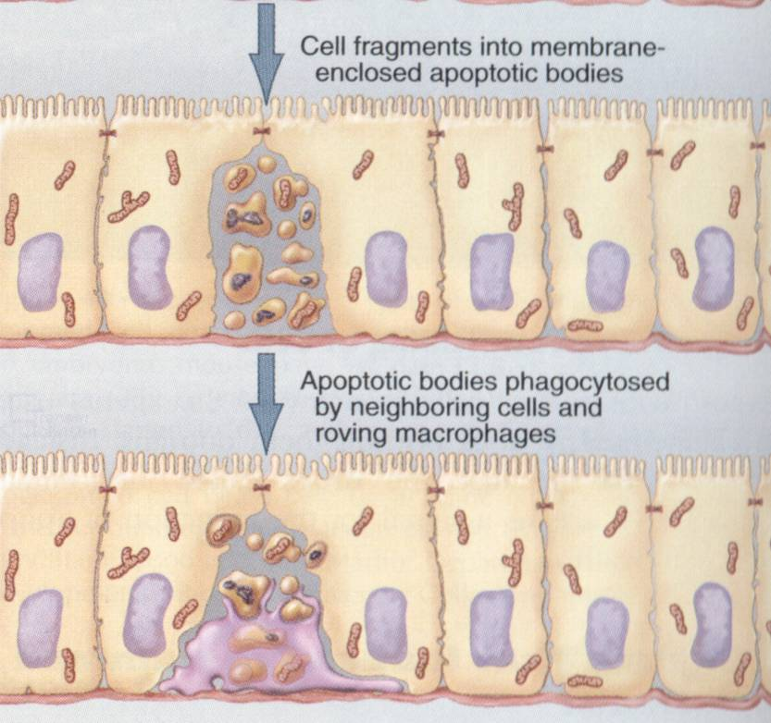

**DNA fragmentation in apoptosis**

DNA ladders TUNEL assay

(agarose gel) (**T**erminal deoxynucleotidyl Transferase

Biotin-d**U**TP **N**ick **E**nd **L**abelling)

 

* DNA fragmentation leads to more “ends” which are labelled by transferring a biotinylated U onto the end by TdT
* this is stained with fluorescent avidin that recognises biotin

**Loss of microvilli, cell shrinkage and cell blebbing**

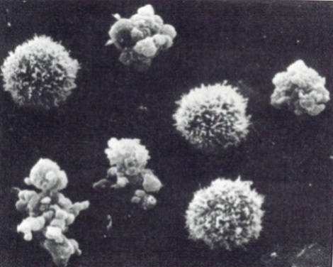

Normal and apoptotic mouse sarcoma cells

**Phagocytosis of apoptotic body by surrounding cells. e.g. macrophages**

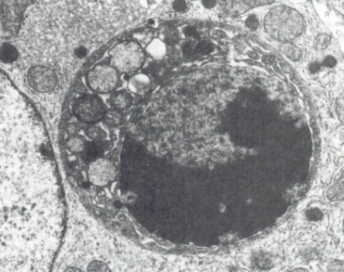

**Cell death: Four deaths and a funeral?**(Nature Reviews: Molecular Cell Biology 2001 2: 1 - 10)

* **Necrosis** - Unregulated cell death associated with cellular disruption and an inflammatory response
* **Apoptosis** (programmed cell death, PCD) - Regulated cell death; controlled disassembly of cellular contents; no inflammatory response (e.g. haematopoietic cells)
* **Apoptosis-like PCD** - some, but not all, features of apoptosis. Display of phagocytic recognition molecules before plasma membrane lysis
* **Necrosis-like PCD** - Variable features of apoptosis before cell lysis; “Aborted apoptosis”

**Is there a graded response?**



**Mechanisms of cell death**

1. The executioners – Caspases
2. Initiating the death programme  
   Death receptors  
   Mitochondria
3. The Bcl-2 family

**The executioners - Caspases**

**C**ysteine-dependent **asp**artate-directed prote**ases**

* + - * + Executioners of apoptosis
        + Activated by proteolysis
        + Cascade of activation

(Other proteases may be involved – calpains, cathepsins)





**Caspase cascades**

* amplification
* divergent responses
* regulation

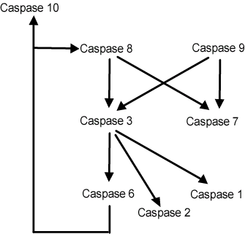

**Mechanisms of Caspase activation**

* Death by design – Receptor-mediated (extrinsic) pathways
* Death by default – Mitochondrial (intrinsic) death pathway

**The Death Receptors**



**Adapter proteins in receptor-mediated apoptosis**



**Signalling through Death Receptors, e.g. Fas/Fas-ligand**



**Initiator caspase oligomerisation results in cleavage and activation**



**Death Receptor activation of caspase 8 is inhibited by FLIP**



**FLIP inhibits caspase 8 activation**



**Caspase 8 activates downstream effector caspases**



**Effector caspases execute the apoptotic programme**



**Mitochondrial regulation of apoptosis**





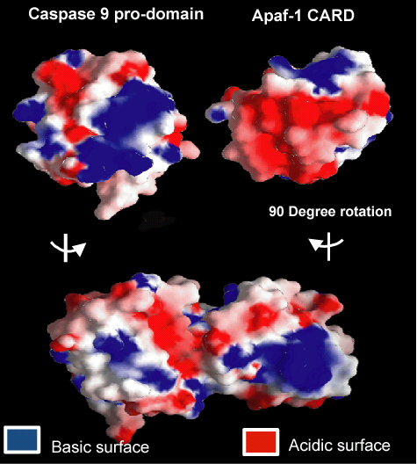





**Apoptosis requires energy**

The apoptosome requires ATP

Energy levels in the cell may determine whether death is by necrosis or apoptosis



**Inhibitor of Apoptosis Proteins (IAPs) regulate PCD**

* Bind to procaspases and prevent activation
* Bind to active caspases and inhibit their activity
* mitochondrial leakage also releases an inhibitor of IAPs (DIABLO) that potentiates cell death

**Modulators of apoptosis: Bcl-2 family proteins**

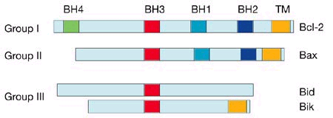

**Bcl-2 family proteins**

Anti-apoptotic Pro-apoptotic

Bcl-2 Bad

Bcl-xL Bax

Bcl-xS

(Mitochondrial) (Cytosolic/Mitochondrial)

**A model for the regulation of apoptosis by Bcl-2   
family proteins by heterodimerization**

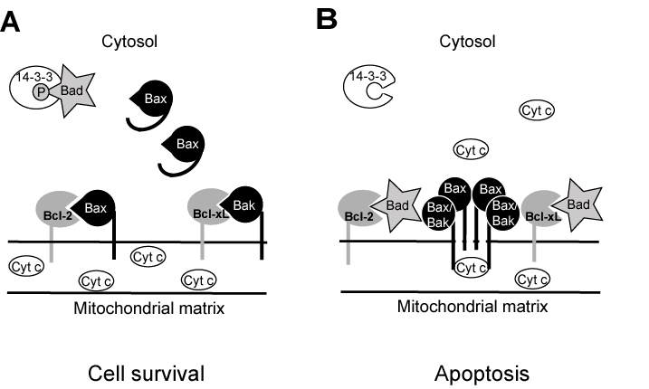

**Cytoprotective pathways**

* Bcl-2, Bcl-xL: intrinsic pathway
* FLIP, IAPs: extrinsic pathway
* Phosphatidylinositol 3’-kinase and protein kinase B (Akt)

**P13K and PKB (Akt)**



**PKB and cell survival**

1. Phosphorylates and inactivates Bad
2. Inactivates FOXO transcription factors (FOXOs promote expression of apoptosis-promoting genes)
3. Phosphorylates and inactivates caspase 9
4. Other?

**PTEN (lipid phosphatase) inhibits PI3K signalling**



**Apoptosis and cancer:  
Programmed cell death – why?**

1. Harmful cells (e.g. cells with viral infection, DNA damage)
2. Developmentally defective cells (e.g. B lymphocytes expressing antibodies against self antigens)
3. Excess/unnecessary cells:   
   (embryonic development – brain to eliminate excess neurons; sculpting of digits and organs)
4. Obsolete cells (e.g. mammary epithelium at the end of lactation)
5. Chemotherapeutic killing of cells, e.g. Dexamethasone

**Proto-oncogenes/tumour suppressors associated with apoptosis**

Bcl-2

PKB/Akt

PTEN

**References**

* Alberts *et al*., *Mol. Biol. of the Cell*, 4th edn., Chapter 17
* Leist and Jaattela, 2001, *Nature Reviews: Mol. Cell Biol*. **2**: 1 – 10
* Clerk *et al*., 2003, *Pharmacology and Therapeutics* **97**: 223-261
* Riedl and Shi, 2004, *Nature Reviews: Mol. Cell Biol.* **5**: 897-907