**CANCER 14**

**Cancer as a disease – Breast cancer**

**Dr Laki Buluwela**

**Schematic diagram of the progression of normal to malignant breast**

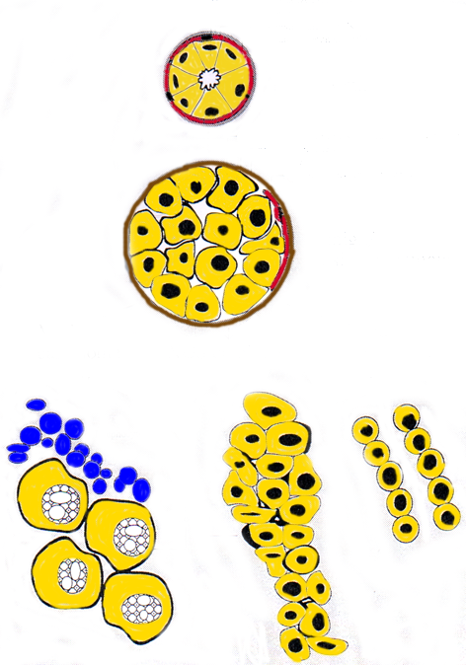

Basement Membrane

Normal

Benign/In situ carcinoma

Lymphocytes

Luminal epithelial cell

Tumour cell

Myoepithelial cells

Residual

myoepithelial cells

Lobular

carcinoma

Medullary carcinoma

Carcinoma

**Breast Cancer Growth is Estrogen-Regulated**

1870s: A. Schinzinger noted that atrophy of the breast follows cessation of ovarian function and proposed ovariectomy as a treatment for breast cancer

1886: George Beatson demonstrated that ovariectomy in pre-menopausal women resulted in disease regression and improved prognosis.

Subsequent studies confirmed that ovarian hormones stimulate breast cancer development and identified estrogen as the hormone responsible.

Important risk factors include

* lifetime of exposure to estrogens:
* age of onset of menarche,
* age to first full-term pregnancy,
* some contraceptive pills,
* some hormone-replacement therapies

Further studies have elucidated the mechanisms by which estrogen synthesis is regulated.

**Oestrogen and Receptor (ER) in Breast Cancer**

Some breast cancers like normal breast, are sensitive to the effects of oestrogen.

Approximately one-third of premenopausal women with advanced breast cancer will respond to oophorectomy. Paradoxically, breast cancer in postmenopausal women responds to high-dose therapy with synthetic estrogens *ie* causes breast tumour regression,

ER is over expressed in around 50% of breast cancers. Presence is indicative of a better prognosis.

In ER-positive case,oestrogen regulates the expression of genes involved in cellular

proliferation leading to breast cancer.

Oestrogen withdrawal or competition for binding to the ER using anti-oestrogens results in a response in about 70% of ER-positive cancers, 5-10% of ER-negative cancers also respond.

An increased level of expression of ER indicates a good prognosis in female breast

cancer but a worse prognosis in male breast cancer

**Oestrogen receptor**

|  |  |
| --- | --- |
| * The Oestrogen Receptor is Activated upon binding Oestrogen * Gene Expression is Induced by Binding to Specific DNA Sequences called Oestrogen Response Elements * The Oestrogen-Induced Gene Products Increase Cell Proliferation, Resulting in Breast Cancer |  |

**Targets for Breast Cancer Treatment**

**Aromatase  
inhibitors**



**Hypothalamus**

*Pre/post-  
menopausal*

*Premenopausal*

Gonadotrophins

(FSH + LH)

Adrenocorticotrophic  
hormone

(ACTH)

**Adrenal  
glands**

**Pituitary gland**

Prolactin

Growth hormone

Oestrogens

Progesterone

Corticosteroids

Progesterone

Oestrogens

Peripheral conversion

**Ovary**

LHRH

Androgens

**X**

**LHRH agonists**

**X**

**Antiestrogens**

**Aromatase inhibitors**

**X**

**X**

**Estrogen Target Tissues & Tamoxifen**

|  |  |  |  |
| --- | --- | --- | --- |
| **TAMOXIFEN** | **ESTROGEN’S DESIRABLE EFFECTS** | **ESTROGEN’S NEGATIVE EFFECTS** | **TAMOXIFEN** |
| **BREAST** Reduces breast cancer  **LIVER & HEART** Lowers cholesterol, reduces atherosclerosis and heart attacks  **BONE** Maintains density to help prevent bone loss | **BRAIN** Improves cognitive function  **BREAST** Programs glands to produce milk  **LIVER & HEART** Lowers cholesterol, reduces atherosclerosis and heart attacks  **UTERUS** Programs uterus to nourish a foetus  **BONE** Maintains density to help prevent bone loss | **BREAST** Promotes breast cancer  **LIVER** Increases thromboembolism  **UTERUS** Promotes endometrial cancer | **HYPOTHALAMUS** Increases vasomotor symptoms  **EYE** Increases cataracts  **LIVER** Increases thromboembolism  **UTERUS** Promotes endometrial cancer, fibroids, polyps & vaginal discharge |

**Aromatase Inhibitors in Breast Carcinoma**

* In postmenopausal women, the major source of estrogen derives not from the ovaries but from the conversion of the adrenal hormones androstenedione and, to a lesser extent, testosterone to estrone.
* This enzymatic conversion occurs at extra-adrenal or peripheral sites such as fat, liver, and muscle.
* This conversion is catalyzed by the aromatase enzyme complex.

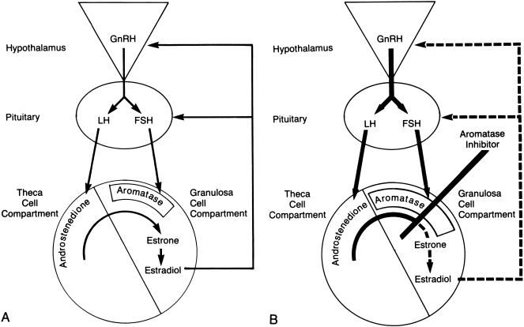

**Progestins in Breast Cancer**

* Progesterone is the dominant naturally occurring progestin
* Progestin response in the human breast is complex and influences both proliferation and differentiated function.
* Progestins are used in the endocrine treatment of uterine and breast cancer with clinically proven antineoplastic properties.
* The poor absorption of progesterone has been overcome with some of the synthetic derivative progestins.
* Progestin therapy for metastatic breast cancer has been used principally as a second- or third-line therapy following selective estrogen.
* The principal progestin used for metastatic breast cancer has been megestrol acetate

**Breast Cancer – Risks and Causes**

|  |  |
| --- | --- |
| Established risks include:   * + - * + Age         + Family History         + Early age of menarche         + Late Menopause         + Having no children, or children late in life         + A history of benign disease         + Lobular Carcinoma in-situ | Possible risks include:   * + - * + Contraceptive pill         + HRT         + Diet         + Weight         + Alcohol         + Being tall |

**Patient History of Breast Cancer**

* “Lump” detected by Self Examination or GP
* Referred to Hospital
* Examined by surgical team (mammogram, FNA)
* Surgery performed (lumpectomy/mastectomy)
* Tumour examined pathologically (ER/PR)
* ER+ (90%) or ER-
* See Physician for first time
* ER+ Tamoxifen (5 years) or ER- Chemotherapy (6 months)
* Disease-free period
* Patient returns with secondary tumour (no cure)

**References**

<http://www.cancerresearchuk.org/>

<http://www.cancer.gov/cancer_information/>

An introduction to the Cellular and Molecular Basis of Cancer - 3rd Edition.   
Edited by L.M. Franks and N.M Teich. Oxford Medical Publications

l.buluwela@imperial.ac.uk