CANCER 11

Cancer as a disease -Colorectal Cancer
Dr Michael Osborn
St Mary’s campus
(handout prepared by Professor Gordon Stamp)

LEARNING OBJECTIVES:
- Describe the different modes of clinical presentation of colorectal carcinoma
- List the principles of the adenoma-carcinoma sequence
- Define the Duke’s and TNM staging systems
- Develop an understanding of molecular pathogenesis of colorectal carcinoma
- Describe the major pathological features which are associated with aggressive malignant behaviour of colorectal carcinoma

Colonic Function (what is it there for?)
The colon has evolved to serve not only as a reservoir but to compact faecal residues, reducing frequency of defaecation which would have obvious evolutionary advantages. The large intestine is also very efficient at water and electrolyte resorption.

Colonic Anatomy
The colon is divided into:
- the caecum which includes the ileocaecal valve and appendix
- ascending (“right”) colon
- the transverse colon
- descending (left) colon
- sigmoid colon and
- rectum

The hepatic flexure is at the junction of the ascending and transverse colon while the splenic flexure is at the junction of transverse and descending colon. The rectum is below the level of the peritoneum surface ranging between 8-15 cm. in length.

The anatomy is important as the blood supply to these areas differs and also that colon cancers present in different ways when they arise in different parts of the colon. There is also evidence that there are some differences in molecular genetic abnormalities and behaviours in tumours arising in right side versus left side of the colon.

The colonic mucosal epithelium, from which carcinomas arise, consists of tubular crypts (of Lieberkuhn) lined by predominantly mucin secreting cells with intervening surface cells which are mainly absorptive cells. The absorptive cells have basally located nuclei and do not secret mucin, whereas in the crypts goblet cells synthesise and secrete mucin. Each crypt has 5-10 enteroendocrine cells (neuroendocrine cells) and a few stem cells. Occasional Paneth cells are seen in the base of the crypts of the caecum and ascending colon.

Adenomas
Colonic adenomas are very common lesions and increase with age. Most adenomas present in the 30-60 year age group and may be incidental findings at colonoscopy or cause symptoms by bleeding. They range in size from very tiny to large masses which can obstruct the colon.
Sometimes gastroenterologists see colonic lesions and describe them as polyps, but the term polyp is just applied to a mass lesion in the bowel which may or may not have a stalk. There are many different types of polyp, most of which are benign, and most are not adenomas. The majority of small colonic polyps are benign so called hyperplastic polyps.
A minority are adenomas which are true neoplasms with genetic abnormalities.

Up to the age of 60 almost half of the population may be harbouring a small adenomatous polyp. There is a greater risk of developing polyps if you have first-degree relatives with colorectal carcinoma or adenomas, particularly if they are multiple.

There are 4 main morphological patterns of adenomas:
- tubular
- villous
- tubulovillous (a mixture of the two)
- serrated (a more recently recognised category)

The important features are that tubular adenomas are often well defined and pedundulated and whereas villous adenomas are often larger, more diffuse (‘carpet papillomas’) and difficult to sample in the centre where carcinomas develop.
Some very large villous adenomas more than 5cms in diameter have a high risk of harbouring a cancer (more likely than not).

Dysplasia in adenomas
Dysplasia is a term often used by pathologists and literally means “bad moulding”.
In the context of neoplasia, it indicates cells show features associated with precancerous change, such as enlarged nuclei with more heavily staining chromatin (hyper chromasia) and a coarser chromatin pattern, often accompanied by large nucleoli.

In the tubular adenomas nuclei are often enlarged and elongated (cigar shaped).
In higher grades of dysplasia the nuclei enlarge to an irregular ovoid pattern with thick, irregular nuclear membranes and increased numbers of mitotic figures.
Along with this the glandular structure tends to become more complicated with buds and branches and a greater degree of irregularity in the architecture. The changes are accompanied by an increasing number of genetic abnormalities. It is the excess and irregularly distributed chromosomes and DNA that gives the cells their features.

Pathologists often divide adenomas into low-grade and high-grade dysplasia and there is a much greater risk of invasive cancer developing with the high-grade dysplasia.

The essential difference between an adenoma and a carcinoma is an absence or presence of invasion, which in most circumstances implies that the malignant epithelial cells have acquired 3 abilities
- Extracellular (stromal) matrix degradation (especially basement membranes)
- Adhesion to degraded or new extracellular matrix (ECM)
- Ability to move into the newly degraded ECM

The hallmark of invasion in adenomas is penetration of the thin layer of muscle (the muscularis mucosae) that separates the epithelial containing compartment (lamina propria) from the underlying submucosa which lies above the thicker muscle layer, the muscularis propria.

Once the tumour cells have got beyond the muscularis mucosae they then have access to the vascular system (lymphatic and capillaries) and thus potentially can spread further.

The distinction between and adenoma and carcinoma is very difficult using radiology and endoscopy, but generally speaking the larger the lesion the higher the risk that malignancy has developed.

On rare occasions there may be small early carcinomas encountered without any obvious adenoma. Generally speaking most cancers will develop in a setting of an adenoma.

Progression of colonic cancer - Paradigm for molecular cancer genetics
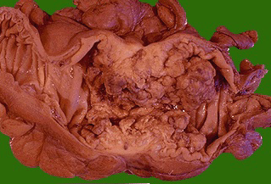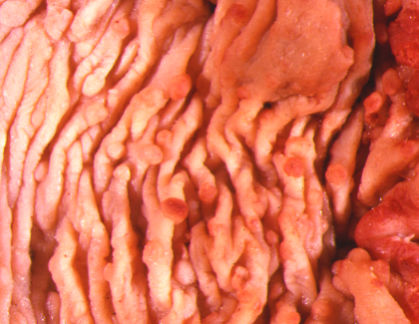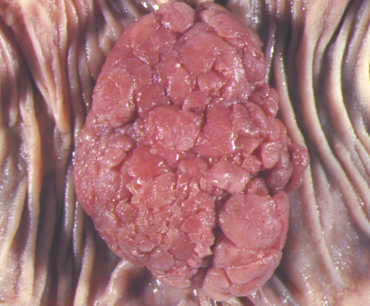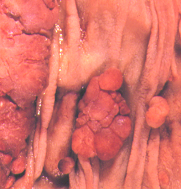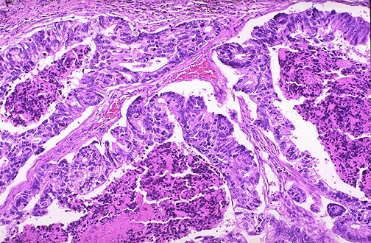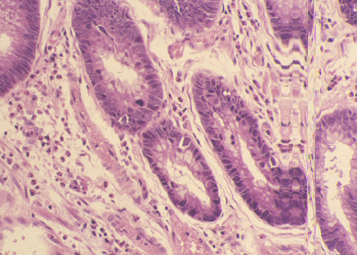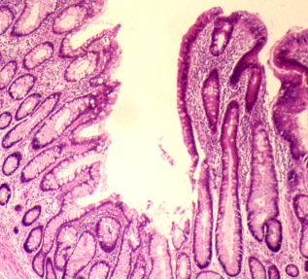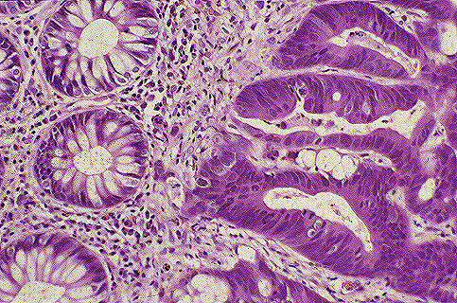

APC Hypomethylation ras mutation p53 others
18q tsg mutation
Normal colon Hyperplasia Early Late Carcinoma Metastasis
crypt cell Adenoma Ademoma

A ‘Vogelgram’
Each stage accumulates a new set of molecular genetic abnormalities.

The adenocarcinoma sequence
The progression of adenomas to carcinomas is accompanied by an increasing degree of genetic abnormalities. Clues to the progression of colorectal carcinoma came from careful study of patients with hereditary colorectal cancers and comparing them to the patients with sporadic colorectal carcinomas. It is also known that there are some early and some later events. In general the accumulation of mutations is more important than any specific order in which order they occur. The main genes affected are listed in table 3 but include APC, mismatch repair genes, P53, K-RAS, DCC (deleted in colorectal cancer), SMAD (loss) and E cadherin mutation.

Molecular pathogenesis of colorectal carcinoma
There are relatively rare families that have a greatly increased risk of developing colonic adenocarcinoma. The best known is familial adenomatous polyposis FAP) syndrome, due to a mutation of the APC gene on chromosome 5q21. Depending where the mutation is in the gene, you can see different variants of this condition including Gardner and Turcot syndromes.

In the classical FAP syndrome, patients may have up to 2500 adenomas over the whole colon although predominantly in the left colon. If left unmanaged, almost all patients will develop cancer by the age of 30 years. There are some mutation variants where the risk is less and patients have relatively few polyps. Generally speaking if a patient has more than adenomatous polyps in their colon they are almost certain to have an hereditary syndrome. Always think of possible hereditable tendencies when people<30 develop cancers that usually affect older generations.

Hereditary Nonpolyposis Colorectal Cancer (HNPCC) Syndrome is a different autosomal dominant familial syndrome where there are fewer numbers of adenomas, usually on the right side of the colon. Here the mutation lies in DNA repair genes leading to micro satellite instability.
There are a few other familial syndromes which may predispose to colorectal cancer but these are far less common (Multiple Juvenile Polyposis, Peutz-Jeghers syndrome and Cowden’s syndrome)

Colorectal Cancer
Most colorectal cancers occur sporadically and the risk increases with age.
The patients usually present with:
- altered bowel habit (constipation or diarrhoea or a mixture of the two)
- rectal bleeding (fresh blood or altered blood)
- discharge of mucus
- intermittent (colicky) abdominal pain
- intermittent obstruction leading to swelling of the abdomen
- tiredness and malaise due to and unexplained iron deficiency anaemia

There is often a considerable delay in the diagnosis of colorectal cancer and General Practitioners have to be alert to the possibility of colorectal cancer in any middle aged to elderly patient who presents with vague abdominal symptoms and especially rectal bleeding. Occasionally patients will present with acute intestinal obstruction or with due to the blockage of the lumen of the colon by an advanced cancer, or with peritonitis due to perforation of the centre of an ulcerated carcinoma and rarely with bowel fistula’s due to the carcinoma invading other organs such as bladder or small bowel.

Half of all cancers will occur in the rectosigmoid area, the remainder are distributed throughout the colon. Minority of patients (5%) will have more than one carcinoma developing. It should also be remembered that patients who have been treated for colonic carcinoma are at risk of developing others.

Tumours occurring in the caecum and right colon often present later and with vaguer symptoms, partly due to the capacity of the caecum to expand before getting blocked, and also they more often mucinous and soft in nature so obstruction occurs later.

Diagnosis is usually by a combination of radiology (plain abdominal x-ray, barium enema and CT scan, but particularly endoscopy using a sigmotoscope or colonoscope.) As yet, there are no reliable markers of colorectal cancer than can be measured in the blood although carcinoembryonic antigen has been used as a response marker in advanced colorectal carcinoma. However it is elevated in many other conditions.

Types of Colorectal Cancer
Pathologists usually assess colorectal carcinomas by their resemblance to the normal cells in the crypts and how abnormal the glands and cells are arranged, and describe this as differentiation.

Usually carcinomas are assessed as well, moderately or poorly differentiated but this is a relatively subjective assessment. In addition, some cancers may secrete a large amount of mucin (so called mucoid/colloid carcinomas). Others may rarely have a high content of endocrine cells and there are very rare pure endocrine carcinomas (carcinoids and high grade neuroendocrine cancers).
Staging
Aside from assessing differentiation, the most important clinical indicator is the extent to which the tumour has progressed.

There are two main systems that pathologists use to describe this progression.
The classical Dukes staging was described by Cuthbert Dukes from St Marks Hospital in the 1937 and is elegantly simple, describing whether the tumour is
- Dukes’ A - confined within the bowel wall (including the muscle)
- Dukes’ B - extended beyond the muscle into fat or serosa (peritoneal surface)
- Dukes’ C - metastasis in lymph nodes

If the tumour is still confined within the wall and involves lymph nodes it is nevertheless classified as Dukes’ C.

At a later stage some authorities have recommended a Dukes’ D classification for liver metastasis.

More recently the TNM classification has been used (see Table 1).

Table 1 - TNM Classification of Carcinoma of the Colon and Rectum

Tumour Stage | Histologic Features of the Neoplasm
Tis | Carcinoma in situ (high grade dysplasia) or  intramucosal carcinoma (lamina propria invasion)
T1 | Tumour invades submucosa
T2 | Extending into the muscularis propria but nor penetrating through it
T3 | Penetrating through the muscularis propria into subserosa
T4 | Tumour directly invades other organs or structures
Nx | Regional lymph nodes cannot be assessed
N0 | No regional lymph node metastasis
N1 | Metastasis in 1 to 3 lymph nodes
N2 | Metastasis in 4 or more lymph nodes
Mx | Distant metastasis cannot be assessed
M0 | No distant metastasis
M1 | Distant Metastasis

Table 2 -
Dukes’  Stage | TNM  Stage | Extent of  Invasion | 5-yr  Survival
A | T1N0M0 or  T2N0M0 | Mucosa | 100%
B1 | T3N0M0 | Muscularis propia | 65%
B2 | T4N0M0 | Serosa | 50%
C1 | Any TN1M0 | Muscularis propia +  lymph nodes | 40%
C2 | Any TN2, N3M0 | Serosa +  lymph nodes | 25%
D | Any T, NM1 | Distant metastases | 5%
Spread and metastasis
Colorectal carcinomas go to the regional lymph nodes and liver in the first instance and subsequently may spread to the lungs and elsewhere. Most surgeons aim to clear the local lymph nodes in order to stage the tumours. The Dukes’ system was also adapted to try and asses whether lymph nodes near the tumour were involved (C1) or more distant nodes at the point of the mesenteric blood vessel ligature which represented more distant spread (C2). These seem to have some prognostic value.

In the past, involvement of the liver was very difficult to treat, but with modern surgical techniques including so called bloodless surgery with radio frequency ablation or laser techniques, it is possible to resect colorectal cancer metastases and allow the liver to regenerate hopefully to affect a cure or allow a greater window for chemotherapeutic effect.

On occasion colorectal cancers will spread across the abdominal cavity to the small bowel or the ovaries/uterus, particularly if they are of the mucinous type.

Prognostic features
After curative resection for colorectal carcinoma about half of the patients will survive 5 years. Survival is increasing with advances in surgery and chemotherapy and more recently there have been promising developments in new drugs which target rogue factors best on colorectal cancer cells. It is a little early to see what impact these will have but early results are promising.

Apart from stage and type, the factors which affect how a colorectal carcinoma will develop and behave include:

- Age extremes – some very young patients (20-30 years old) present with colorectal carcinoma although it is extremely rare. In a few of these this is in a background of a pre-malignant condition such as ulcerative colitis or Crohn’s disease and many of these tumours are aggressive mucinous types. Added to this is the difficulty in making the diagnosis in such a young patient with what is effectively a rare tumour in that age group. Similarly in the very elderly patient, the vagueness of the presenting symptoms means the tumours often present at an extremely advanced or untreatable stage.
- Sex – the prognosis is better for females than males. There is a slight female preponderance of the less common right-sided colorectal carcinomas which paradoxically have a worse prognosis. There is a good correlation between tumour size and extent which is reflected in the staging and outcome

- Obstruction and perforation – These complications are often accompanied by advanced tumour and access to the vascular system and peritoneum and therefore not surprisingly associated with worse prognosis.
- Inflammatory reaction – A host immune response consisting of lymphocytes and plasma cells is associated with a better prognosis.
- Tumour type – Mucinous and very undifferentiated carcinomas have a worst outlook.
- Angioinvasion – penetration of muscular walled blood vessels carries a worse prognosis

Screening for colorectal cancer
The government has recently proposed a new screening programme using the
Fecal Occult Blood Test. The disadvantage is that this is relatively insensitive and produces some false positives but in pilot studies it has been shown to produce some benefit in picking up asymptomatic cancers. Many other molecular genetic tests have been proposed including screening for mutations by PCR-based techniques on fecal samples but many of these mutations are encountered in other carcinomas and may occasionally occur in the absence of a cancer. So, a robust technique has not yet been developed. Screening by sigmoidoscopy or colonoscopy is usually reserved for those with a significant family history (usually in a first degree relative) and obviously for those with known hereditary bowel cancer in the family.

Table 3 Major molecular genetic abnormalities in colorectal cancer

1 APC gene (5q)
2 DNA hypomethylation
3 K-RAS mutation (12p)
4 Deleted in DCC (18q loss)
5 P53 (17p)
6 Mismatch repair (HMSH2 {2p}HMLH {3p})
7 TGF beta (receptor 2 mutation ) (3p)
8 Beta catenin mutation (3p)

