CANCER 10

Invasion: regulation of cell mIGRATION
Dr Vania Braga

- How does detachment from primary tumour and migration occur?
2) What are the molecular mechanisms that regulate motility?
- microfilaments
- regulation of actin dynamics
- cytoskeletal proteins
- signalling proteins

Migration of primary glial cells
Scratch wound assay
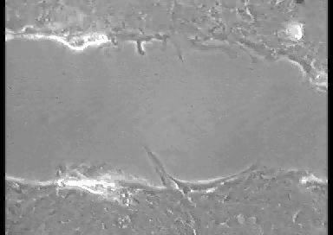
Migration of a glial tumour cell line
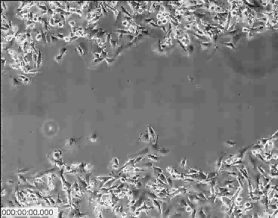

Filopodia
Finger-like protusions rich in actin filaments
actin vinculin
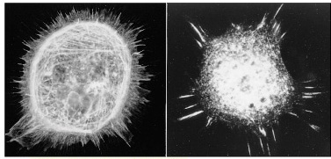Molecular Biology of the Cell
Lamellipodia
Sheet-like protusions rich is actin filaments
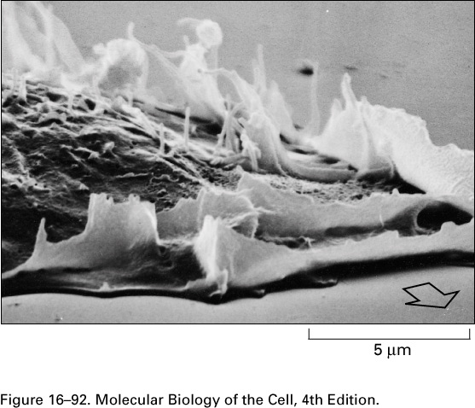
Cell Movement
Control is needed:
- within a cell to coordinate what is happening in different parts
- regulate adhesion/release of cell-extracellular matrix receptors
- from outside to respond to external influences –
sensors
directionality

Motility: hapoptatic versus chemotatic

Cell movement = changing cell shape
Why is it important to learn about cytoskeletal proteins?
Which one of these diseases is not caused by deregulation of actin cytoskeleton?

- High blood pressure
- Wiskott-Aldrich Syndrome – WAS (immunodeficiency, eczma, autoimmunity)
- Epidermolysis Bullosa (hereditary blistering diseases)
- Bullous Pemphigoid (autoimmune disease)
- Alzheimer (neurodegenerative)
Signalling mechanisms that regulate the actin cytoskeleton:
1 - ion flux changes (i.e. intracellular calcium)
2 – control by phosphoinositide signalling
3 - signalling cascades via small GTPases

Control of actin filament networks by Ca²⁺

Gelsolin
- Ca²⁺ dependent severing
- exposes - (fast depolymerising) end
α-actinin
- Crosslinks actin filaments
- binding decreased at high Ca²⁺

Further reading:

1) Molecular Biology of the Cell
2) Cell Biology. 2002. T.Pollard & W.Earnshaw. pg 551-670, Elsevier Science
3) Condeelis J, Singer RH, Segall JE. THE GREAT ESCAPE: When Cancer Cells Hijack the Genes for Chemotaxis and Motility. Ann Rev Cell Dev Biol. 2005;21:695-718.
4) Jaffe AB, Hall A. RHO GTPASES: Biochemistry and Biology.
Ann Rev Cell Dev Biol. 2005, 21:247-269.
5) Sahai E. Mechanisms of cancer cell invasion. Curr Opin Genet Dev. 2005, 15(1):87-96.

