CANCER 1

EPIDEMIOLOGY OF CANCER
Professor Paolo Vineis
Leading causes of death in 2003: US

Cause of death Number Percent
1 Heart disease 685,089 28.0
2 Malignant neoplasm 556,902 22.7
3 Cerebrovascular disease 157,689 6.4
4 Chronic lower resp. tract dis. 126,382 5.2
5 Accidents 109,227 4.5
6 Diabetes mellitus 74,219 3.0
7 Influenza and pneumonia 65,163 2.7
8 Alzheimer’s disease 63,457 2.6
9 Nephritis, nephrotic syndrome 42,453 1.7
10 Septicemia 34,069 1.4
Total 2,448,288 100

(CDC/NCHS, 2005)

Global burden of cancer (2002)

- 10.9 million new cases of cancer worldwide (excluding non-melanoma skin cancer)
- 6.7 million deaths
- 24.6 million persons alive with cancer (within 5 years of diagnosis)
- Cancer mortality
  - 1985 50/50 (%) developing/developed countries
  - 2002 61/39 (%) developing/developed countries

MIGRANT STUDIES

- Offer insights into the relative importance of environment and genetic make-up in cancer etiology
- Strengths
  - Data from cancer registry or death certificates is easily accessible and convenient
  - Large numbers, population-based
  - Migrant status defined by birth place (high accuracy)
- Weaknesses
  - Useful only if genetically different populations
  - Bias can exist in many forms: confounding, data quality (e.g. ‘overshoot’), selection bias
Common reasons for secular trends in cancer rates

- Changes in completeness of the sources of data
- Changes in diagnostic abilities
- Changes of practice in data classification
- Demographic changes in the population in which the trend is being observed
- Changes in screening practices
- Changes in treatment practices
- Change in risk factor distribution

Sources of cancer data

- Cancer Research UK
http://info.cancerresearchuk.org/cancerstats/types/

- National Statistics (deaths)
http://www.statistics.gov.uk/CCI/nscl.asp?ID=6444

Cancer Etiology
- What do we know?
- What can we do to prevent cancer?
- What remains unexplained?

What are the main risk factors for cancer?
The causes of cancer: quantitative estimates of avoidable risks of cancer in the United States today. Doll R, Peto R. J Natl Cancer Inst. 1981; 66(6):1191-308

Population attributable risks percent:
Smoking 29-31
Diet 20-50
Alcohol 4-6
Infection 10-20
Occupation 2-4
Reproductive hormone 10-20

These estimates are probably not too far from reality but have several limitations.
- published in 1981
- for US only
- based essentially on case-control studies
- ignore gene-environment interactions
- ignore molecular and biochemical evidence

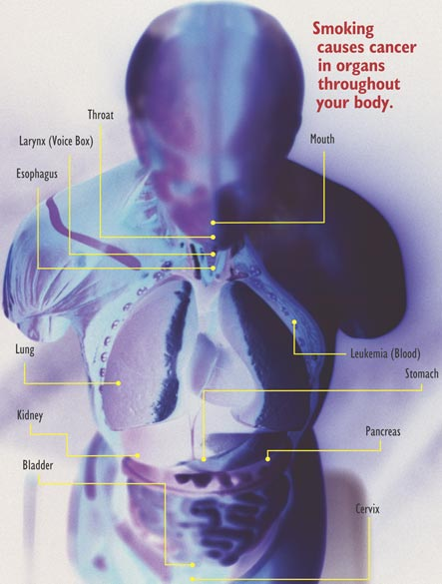

SMOKING
Smoking accounts for at least 30% of all cancer deaths

- Smoking is associated with increased risk for at least 15 types of cancers
- Smoking causes 90% of lung cancer deaths in men and
80% in women

Association between conclusions of the papers on ETS and cancer vs. relationship of the authors with the tobacco industry

Relationship with the tobacco industry

yes no
yes 2 65
Association
no 29 10

odds ratio 88.4; 95% confidence interval 16.4-476.5; P<.001
Barnes & Bero, JAMA 1998; 279: 1566-70

DIET

ALCOHOL
- Oral cavity, pharynx, larynx, oesophagus, liver
- all types of alcohol
- mechanisms poorly understood
- synergism with tobacco
- balance with preventive effect for CHD

ANTHROPOMETRY

Breast Cancer:
Exogenous & Endogenous
Hormones
WESTERNIZATION OF LIFESTYLE AND CANCER
Western Lifestyle:
- Energy dense diet, rich in
- fat,
- refined carbohydrates
- animal protein

- Low physical activity
- Smoking and drinking

Consequences:
- Greater adult body height
- Early menarche
- Obesity
- Diabetes
- Cardiovascular disease
- Hypertension
…and Cancer

H pylori and gastric cancer
- In a pooled analysis of the three cohort studies, the relative risk was 3.8, which was significant. In these cohort studies, potential confounding by dietary and other factors that have previously been associated with gastric cancer was not assessed.
- Nine retrospective case-control studies have addressed the association between sero-prevalence for H. pylori infection and incidence of gastric cancer. The estimated relative risks for gastric cancer were elevated in six studies, ranging from 1.2 to 4.2, and were significant in three studies. In a number of studies, the control series may not have been representative of the population that gave rise to the cases.
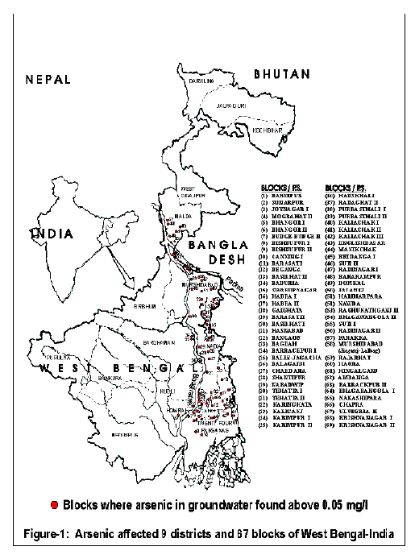
Arsenic-associated cancer epidemic in West Bengal

- West Bengal:
978 villages/wards in 67 blocks are affected in 9 districts (including southern part of Calcutta)
- Total population in these 9 districts is 42.8 million
- Those having severe keratosis will get cancer in the long run

Arsenic-associated cancer epidemic in Bangladesh

Recent field survey in Bangladesh:

  - people suffering from arsenical skin lesions were identified in 75 of 91 villages surveyed
  - 2000 water samples were collected
  - 60% had increased levels of arsenic above 50 microgram/l

