Introduction to Pubmed

Pubmed is a free US based database which provides access to 22 million references, mainly journal articles.

- Accessing PubMed
- Go to the library web pages using the following URL: www.imperial.ac.uk/library
- Type PubMed into the search box in the middle of the page (Books & more)

- Click on the first tab under the Pubmed record (Online access)
- Click on Open source in a new window

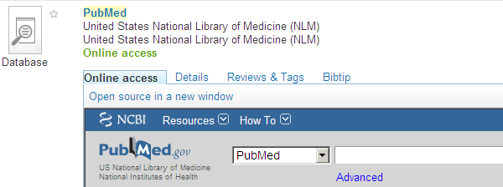

This will take you to the database and allow you to access the SFX feature, which is only available if you access PubMed via the library's webpage – you can bookmark the page for future reference.

- Basic searching
Firstly, we will do a very quick search so that you get an idea of how to search on and navigate your way around PubMed. In the search box in the main window type the acronym MRSA. As soon as you start typing, a box opens with auto suggestions of keywords.

- Click on the Search button.

The results (hits) of your search will now be displayed underneath the search box.

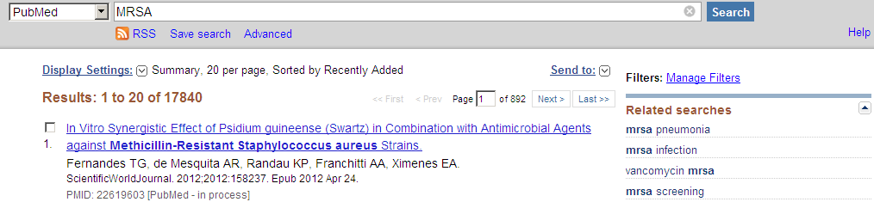

- Displaying results
The results you have found appear below the search box. PubMed gives a full citation for each result. The citation consists of the author(s), article title, and the source - the source is the journal title, the month & year of publication, volume and issue number, and page numbers.

- Click on the drop down arrow next to the Display Settings link and change the format from Summary to Abstract.
- Click on Apply

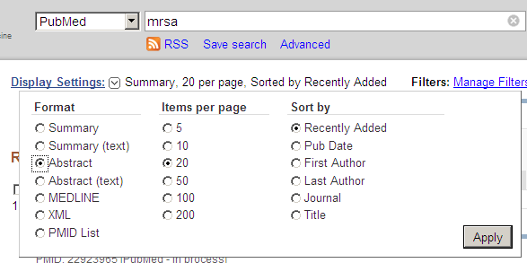

You will now see that most of the results you have found have an abstract as well as a full citation. An abstract can help you decide if the article is going to provide you with the information you are looking for.

- Marking results

You can mark results to print, save or email.

- To mark results for printing, click on the drop down box next to the Display Settings button and change the format from Abstract back to Summary.
- Select results 2, 3 and 9 from your set. To select a record you need to tick the box beside that record, so tick results 2, 3 and 9.
- Once you have selected all the results you want to keep, click in the drop arrow beside Send to and select Clipboard. Click on the Add to Clipboard button.

A message will appear under the search box to say "... items were added to Clipboard". The Clipboard is cleared after eight hours of inactivity and it will hold 500 items.

Click on the link beside the Clipboard tab to see what is on the Clipboard. You can change the format of the results on the Clipboard by using the drop down box next to Display Settings.
Access to Clipboard

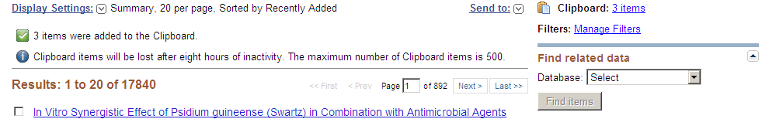

- Emailing results

You will now email the references you have just put on the clipboard.

- Access your Clipboard, if you have not done so already.
- Click on the arrow beside the Send to button and select Email.
- Fill in the form: choose the email format (e.g. Summary, Abstract), and fill in your email address.
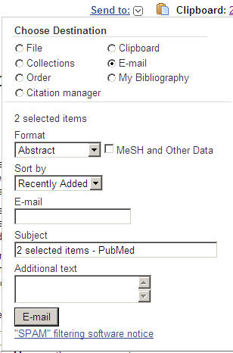
- Click on the E-Mail button. You get a message, below the search box, indicating that the email has been sent to the address you gave.

- Printing results
- Display the results in your desired format (eg Abstract) by using the drop-down menu beside the Display Settings button. Make sure that all the results you wish to print are on the same page.
- Use the print function of the Web Browser (e.g. Print from the File menu).
- Normally you then Click on Print this page. To avoid spending money on printing, you don’t have to print during this tutorial.

- Saving results
- Select File from the Send To menu. Chose the format, eg summary or abstract, and click on Create File. Click on Save in the window which opens. Select the drive you want to save your results in.
- If a yellow strip with the message: To help your security, Internet Explorer blocked this site from downloading files to your computer. Click here for options appears this is a pop up blocker, and you will need to click on it, select Download File and repeat the above action.

- Search strategies
Before you start searching any database you should plan your search strategy in advance to save time.

  - Keywords

Before you start searching, think about keywords for your given subject.

You may find it useful to do some preliminary reading in textbooks and encyclopaedias which will help you identify some keywords, and perhaps also key authors.

If your topic is the use of aspirin in patients who have suffered from heart attacks

Your keywords would be:
- aspirin
- heart attack

Authors use many different terms which mean the same thing. Remember, PubMed will only search for what you tell it to search for. If there are synonyms for your search terms, you must search for these too. Think about alternatives.

For example:
myocardial infarction
cardiovascular disease
analgesic
non-steroidal anti-inflammatory agent

  - Boolean searching
If you use only one phrase in your search such as heart attack the results you will retrieve will be about or may mention heart attacks, but will cover a very broad spectrum. You therefore need to be more specific about the subject you are looking for. To do this you can use Boolean search techniques – the words AND and OR. (You can also use NOT to exclude results but you need to be careful in the use of NOT to avoid eliminating potentially useful results).

The term AND will narrow your search.

Example: heart attack and aspirin
- In the search box type heart attack and click on Search. Make a note of the number of results that you retrieve. The number of results retrieved is indicated underneath the search box.
- Now delete heart attack and type in aspirin in the search box and make a note of the number of results you retrieve.
- Now in the search box type heart attack AND aspirin and make a note of your results.

Items containing both words will now be searched for. Using AND will usually result in fewer but more relevant hits. Have a look at the result numbers you wrote down and see how the number of results changed.

The term OR will broaden a search.

Example: cardiovascular disease OR myocardial infarction
- In the search box type cardiovascular disease and make a note of the results.
- Now delete cardiovascular disease and type in myocardial infarction and make a note of the results.
- In the search box type cardiovascular disease OR myocardial infarction and make a note of your results.

Items containing either word will now be searched for and you will see that the number of items on your results list is very high.

  - Parentheses

Using brackets helps structure your search by breaking it down into sections.

Example: heart attack and (aspirin or analgesic)

The following will now be searched for:
heart attack and aspirin
heart attack and analgesic

- In the search box type heart attack AND aspirin and make a note of the results.
- Now type heart attack AND analgesic and make a note of the results.
- In the search box type heart attack AND (aspirin OR analgesic) and make a note of the results.

Add up the results of the first and second search. The combined results of the 2 searches should be similar to the result of the third search. You can see by using parentheses that you only need to do one search rather than two.

  - Truncation
Using truncation allows you to manipulate your keywords even further by searching for the different endings of a word. To truncate a word you need to use the * symbol.
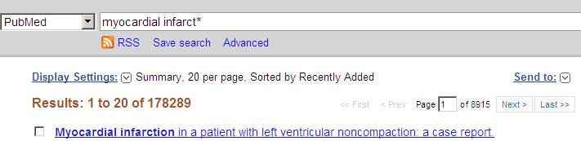

Example: myocardial infarct* = myocardial infarct, myocardial infarction, myocardial infarctions
Example: myocardial infarct* and (aspirin or analgesic*)

- Click on the PubMed icon near the top of the screen. This will bring up a fresh search screen.

For the purposes of this search you will be looking for information on the use of oxygen therapy in patients with chronic obstructive pulmonary disease (COPD), published in the last 5 years. You will see that you can use OR to combine synonyms, alternative spellings or related terms.
In this search there are two sets of search terms:
Set 1: COPD, chronic obstructive pulmonary disease
Set 2: oxygen therapy

Searching for the first set of search terms
- Check that the box next to the Search toggle says PubMed. In the search box, type: COPD OR chronic obstructive pulmonary disease
- Click on the Search button.

Your search results are displayed. You should retrieve around 36,500 results. You now need to search for the second set of keywords.

- Click on Clear.
- In the search box, type oxygen therapy and click on Search.

For this second search you should retrieve around 65,000 results.

  - Combining your searches

You have now completed two separate searches.
- Go to Advanced Search to see the search history.

You need to combine them together with the Boolean AND. AND will retrieve results containing all of the terms we have chosen (narrowing the search).

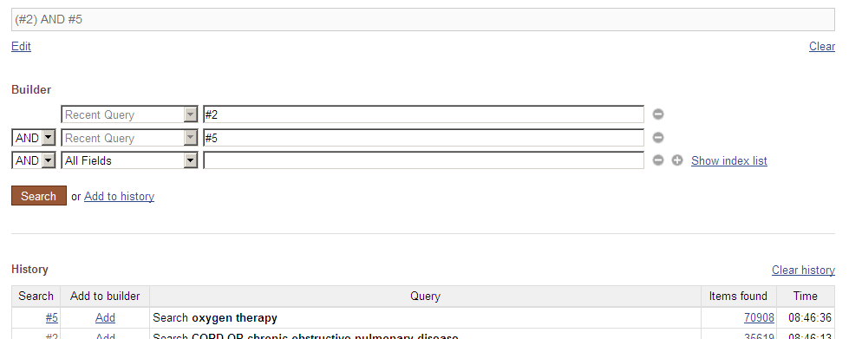

- Click on the numbers to the left of the two searches you have just completed.
- Click on the brown Search box.

  - Why can’t I enter the whole search at once?
In PubMed it is much more effective to search in stages, searching only for related terms. Searching in stages, as we will show you here, is better because some databases will treat a string of words as one phrase, so you may find nothing or very little. Searching in stages allows you to build up a much more complex and specific search. In addition, searching in stages makes it easier to correct mistakes.

  - Filtering your search
You now need to limit your search so that it retrieves articles published in the last 5 years.

- Select 5 years from the Publication Dates box to the left of the results to limit your results to the last 5 years.
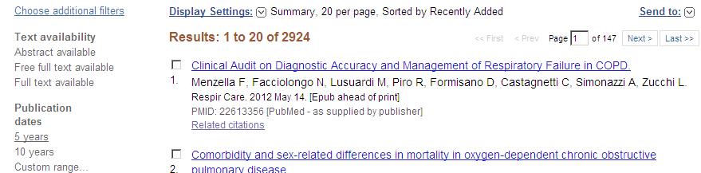

You have retrieved a new set of results, filtered in the way you selected.

Other filters, like publication type or language are available in Filters also.

Note: The filters you select will apply to any search you do from now on – in PubMed you need to uncheck the filters when you no longer wish to apply them.

- Accessing full-text

We will now try and access the full-text to some of the results you have found. Click on the drop down box next to the Display Settings link and change the format from Summary to Abstract. In some of your results (you may have to scroll down some way) you will see that there is an SFX toggle. This normally means that you can access the full text of the article.

- Click on the SFX toggle.

At this point you may be given a choice of electronic journal providers who host the full text article.
- Click on the GO button and follow the instructions to access the full text. You may need to login to access some journals, especially if you are not using a College PC or one using VPN (Virtual Private Networking).

If there is no SFX link it means there is no electronic access for the article. You can check the library catalogue to see if the College has the paper version of the journal article.

- Using MeSH headings and subheadings
MeSH headings are another way to search PubMed. Indexers look at all the articles in PubMed and index them according to MeSH headings which are PubMed’s preferred term for describing a condition, drug etc. MeSH headings allow you to find articles on a topic which may have been described in different ways or with different spellings by different authors.

- Change the drop down search box from PubMed to MeSH
- Type in sleep apnoea

- Click on the first result Sleep Apnea Syndromes (PubMed uses American spellings)

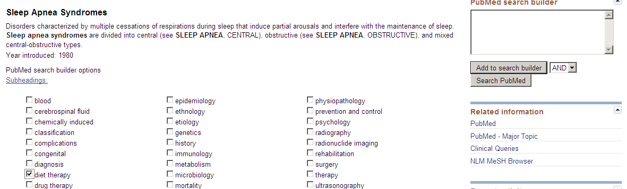

- You will see that many different terms are classed under Sleep Apnea Syndromes
- Tick the subheading diet therapy
- Click on the Add to search builder box to the right
- Click on Search PubMed

PubMed will now find articles classified as being about diet therapy for sleep apnoea. You should find about 30 articles (if fewer you may need to clear the limit you just set). Using subheadings with MeSH headings allows you to find articles only on one or more aspects of a condition.

- My NCBI

If you sign up for an account with My NCBI you can have results emailed to you and save your searches and results. Click on My NCBI in the top right corner if you wish to set up an account.

You have reached the end of this tutorial. If you need more advice about constructing your search, such as choosing keywords, or how to combine searches, or if you need help with any other database, please contact library staff at: library@imperial.ac.uk

