School of Medicine
Year 1
2012-13
Foundation Course

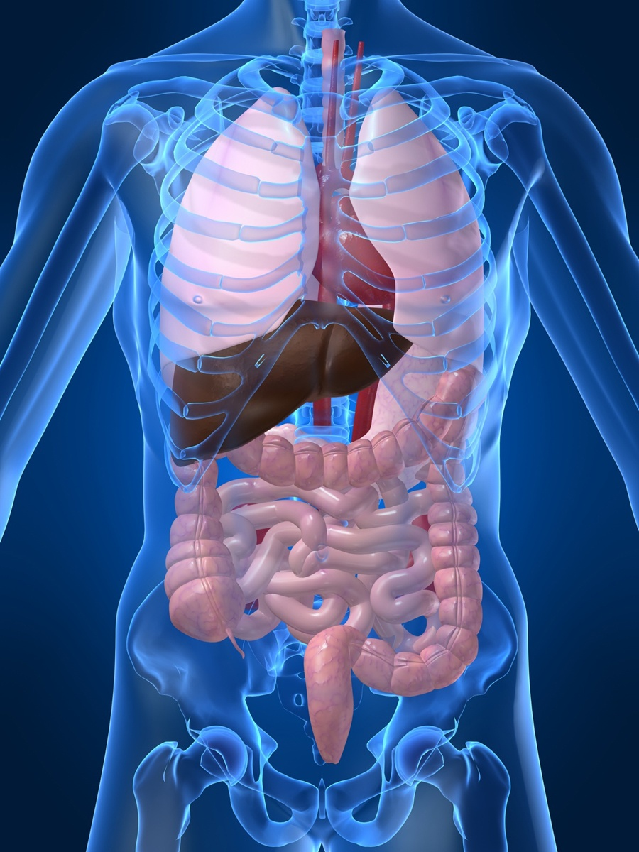

Introducing the Human Body

Charing Cross campus
Friday 5 October 2012

SOLE Feedback – Introducing the Human Body

The following two pages provide you with templates on which you can record your thoughts as the course proceeds. At the end of the course you can enter your views onto SOLE.

Please answer all questions by selecting the response which best reflects your view. After the questions there is an opportunity to comment on any aspects about which you feel strongly.

N/A Strongly Agree Neutral Disagree Strongly
agree disagree

1. By the end of the course, I think the aims and objectives □ □ □ □ □ □
will have been met.

2. Teaching and learning opportunities (e.g. lectures, □ □ □ □ □ □
small groups, practicals) for this course are suitable.

3. Appropriate resources (e.g. books, computers, □ □ □ □ □ □
lab equipment etc.) are available for this course.

4. Appropriate support materials (e.g. handouts, □ □ □ □ □ □
web pages, problem sheets) are available for this course.

5. I receive sufficient guidance and feedback. □ □ □ □ □ □

6. The workload on this course is manageable. □ □ □ □ □ □

7. Overall I am satisfied with this course. □ □ □ □ □ □

8. If you wish to make further comments about this course, please use the space below.

SOLE feedback - individual lecturers

For each of the lecturers below, let us know whether or not you agree with the statement “OVERALL I AM SATISFIED WITH THIS LECTURER. In particular, we want to know whether the lectures were well structured and whether concepts were explained clearly.

Although this template provides you the opportunity to record your comments about each lecture, in SOLE a lecturer’s name will only appear once.

At the bottom of this page, you will have an opportunity to comment on any aspects about which you feel strongly.

Lecturer | Lectures | N/A | Strongly  agree | Agree | Neutral | Disagree | Strongly  disagree
Prof D Ceri Davies | Introducing Anatomy | □ | □ | □ | □ | □ | □
Dr Wing May Kong | Ethically speaking – whose body is it anyway? | □ | □ | □ | □ | □ | □

If you wish to make further comments, particularly on the practical sessions, please use the space below.

Contact Details

Anatomy Teaching Staff

Professor D Ceri Davies CX 0203 311 7026 d.ceri.davies@imperial.ac.uk

Dr Maniccam Thavarajah CX 0203 311 7321 m.thavarajah@imperial.ac.uk

Dr Peter Clark p.clark@imperial.ac.uk

Dr Paul Strutton p.strutton@imperial.ac.uk

Anatomy Support Staff

HAU Manager Ms Rachael Waddington r.waddington@imperial.ac.uk

Embalmer Mr Lee Dennis l.dennis@imperial.ac.uk

Technician Ms Laura McMinn l.mcminn@imperial.ac.uk

CX 0203 311 7027 or 7039

Important Information for student teaching sessions in the Human Anatomy Unit

Failure to comply with Human Anatomy Unit Policies and Dissecting Room Rules will result in exclusion from the Dissecting Room until appropriate disciplinary action has been taken

The Human Anatomy Unit
The HAU teaching facilities are restricted areas, these areas and the use of its resources must comply with the provisions of the Human Tissue Act 2004.
Only anatomy academic staff, support staff, appointed demonstrators, Imperial College medical students and authorised visitors are allowed entry and must comply with the Unit rules.

Attitudes and conduct
Human cadaveric material must be treated and handled with the respect and dignity befitting the dead and the expectations of the donor. Unprofessional behaviour will not be tolerated in the DR.

Dissecting Room Rules
- The DR is a restricted area and not open to friends or the public.
- All persons must wear appropriate College ID badges or relevant ID and sign the attendance register.
- Bags, personal items, and non study materials are not allowed in the DR. Lockers are provided in room 14L12.
- Mobile phones, cameras, iPods and MP3 players are not allowed to be used or taken into the DR.
- Eating, drinking, chewing gum and applying makeup are forbidden.
- All workers in the DR must wear the appropriate PPE provided (i.e. Gowns, Gloves & Safety Goggles).
- Loose hair must be tied back
- Appropriate footwear must be worn and must be fully closed and cover the upper surface of the foot.
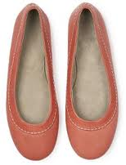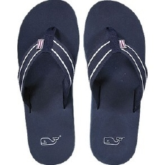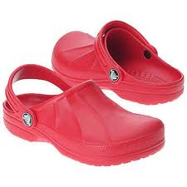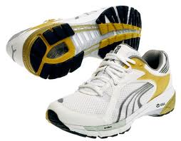

Full HAU health and safety and regulations are available on all academic year intranet pages, please ensure you read all documents before attending any session held within the HAU.

Please see Miss Rachael Waddington, HAU Manager and Safety Coordinator, or a member of HAU staff if you require any assistance.

Foundation Course 2012
Introducing the Human Body
Right from the beginning of the medical course you will be expected to have a basic understanding of how the human body is organised. You will also need to be able to use and understand the descriptive terminology used in human anatomy. If you can achieve the objectives listed below and on page 20 on the basis of today’s classes and your own further study, you should be able to cope with issues of body structure arising before you have detailed knowledge of the region in question. During Term 2 you will study the regional anatomy of the thorax in parallel with the respiratory and cardiovascular systems. In Term 3 you will study the regional anatomy of the abdomen and pelvis in parallel with the alimentary and urinary systems. The head, neck, spine and limbs will be studied in Year 2. Each Anatomy session in years 1 and 2 will comprise Dissecting Room and Living Anatomy Classes. It is ESSENTIAL that you read the module handbook before classes and DRESS APPROPRIATELY to enable you to participate in both Dissecting Room and Living Anatomy classes.

Important notes:
- Keep this guide with you, not on your bookshelf. At the back of the guide there is an explanation of positional terms and a glossary of anatomical terms you are likely to meet. When you encounter an unfamiliar anatomical term, look it up at once.
2 Right from the start you will need an anatomy textbook. See the guidance on page 9.

Objectives
- Demonstrate and explain the usefulness of the ‘anatomical position’.
- Use correctly the following positional terms: superior, inferior, anterior (ventral), posterior (dorsal), medial, lateral, median, sagittal, coronal, horizontal (axial, transverse), superficial, deep, cranial (rostral) and caudal.
- Recognise and explain the functions of the skull, vertebrae, ribs, manubrium and sternum.
- Demonstrate the meanings of the words thorax, abdomen, pelvis and perineum.
- Identify in diagrams and specimens, the mediastinum, trachea, bronchi, pleural cavities and lungs.
- Identify in diagrams and specimens, the heart, pericardial cavity, ascending aorta, aortic arch, descending aorta (and their coronary, subclavian and common carotid branches) and the superior and inferior venae cavae.
- Demonstrate the carotid, brachial, radial, popliteal and posterior tibial pulses in a living subject.
- Name the branches of the abdominal aorta supplying the gastro-intestinal tract and the kidneys.
- Define the peritoneal cavity and outline the nature of mesenteries.
- Differentiate the functions of the stomach, small intestine and large intestine.
- Outline the positions and digestive functions of the liver and pancreas.
- Explain the importance of the portal vein.
- Outline the positions and functions of the kidneys, ureters, urinary bladder and urethra (male and female).

Morning Programme
Drewe Lecture Theatre:

0900 – 09.35 Introducing Anatomy Part 1 Professor D. Ceri Davies

- What is Human Anatomy? What is its importance to doctors?
- Do we need to know Latin?
- How was anatomy traditionally taught? Why have we changed it?
- How does anatomy fit with the rest of the course?
- Living Anatomy and Imaging
- What is special about human anatomy? (a short look at what doctors need to understand about human evolution)

09.45 – 10.15 Part 2

- How are the human trunk and its main organs arranged?
- The law and where bodies come from?
- Health and Safety in the Dissecting Room

Break

Divide into groups A, B, C and D

Group A:

1025 - 1125: Anatomy Skills Laboratory (Lab Block 13th Floor)

Bones and pulses Professor D. Ceri Davies, Dr M. Thavarajah and Demonstrators

- Practical on the human skeleton and arterial pulses working in pairs – handout-led tasks

Group D:

1025 –1125: Dissecting Room (Lab Block 14th Floor)

The Trunk Dr Peter Clark, Dr Paul Strutton and Demonstrators

- Exploration of the thoracic, abdominal and pelvic cavities and their contents

Group A:

1130 – 1230: Dissecting Room (Lab Block 14th Floor)

The Trunk Dr Peter Clark, Dr Paul Strutton and Demonstrators

- Exploration of the thoracic, abdominal and pelvic cavities and their contents

Group D:

1130 –1230: Anatomy Skills Laboratory (Lab Block 13th Floor)

Bones and pulses Professor D. Ceri Davies, Dr M. Thavarajah and Demonstrators

- Practical on the human skeleton and arterial pulses working in pairs – handout-led tasks

1025 – 1355: Groups B & C Private Study & Lunch break

1230 – 1615: Groups A & D Lunch break & Private Study

Afternoon Programme

Group B:

1355 - 1455: Dissecting Room (Lab Block 14th Floor)

The Trunk Dr Peter Clark, Dr Paul Strutton and Demonstrators

- Exploration of the thoracic abdominal and pelvic cavities and their contents

Group C:

1355 - 1455: Anatomy Skills Laboratory (Lab Block 13th Floor)

Bones and pulses Professor D. Ceri Davies, Dr M. Thavarajah and Demonstrators

- Practical on the human skeleton and arterial pulses working in pairs – handout-led tasks

Group B:

1500 - 1600: Anatomy Skills Laboratory (Lab Block 13th Floor)

Bones and pulses Professor D. Ceri Davies, Dr M. Thavarajah and Demonstrators

- Practical on the human skeleton and arterial pulses working in pairs – handout-led tasks

Group C:

1500 - 1600: Dissecting Room (Lab Block 14th Floor)

The Trunk Dr Peter Clark, Dr Paul Strutton and Demonstrators

- Exploration of the thoracic, abdominal and pelvic cavities and their contents

Whole Class

1615 - 1715: Drewe Lecture Theatre

Ethically speaking – whose body is it anyway? Dr Wing May Kong

Information resources

You will need an anatomy textbook next term. The following titles are recommended for our course; you should buy a copy as soon as you are able.

Moore, Keith L., Dalley, Arthur R. and Agur, Anne M. R.
Clinically Oriented Anatomy
6th Edition: 2009: Wolters Kluwer/Lippincott Williams & Wilkins
or
Drake, Richard L., Vogl, Wayne, Mitchell, Adam W. M
Gray’s Anatomy for Students
2nd Edition: 2009: Elsevier Churchill Livingstone

In addition an anatomy atlas is extremely useful; the following atlas is available at a reduced price bundled with Moore et al.’s textbook.
Rohen J. W., Yokochi, C., Lütjen-Drecoll, E.
Colour Atlas of Anatomy
11th Edition: 2011: Wolters Kluwer/Lippincott Williams & Wilkins

For the Living Anatomy Sessions, you will also find the following useful:

Lumley, John S. P.
Surface Anatomy: The Anatomical Basis of Clinical Examination.
4th Edition: 2008: Churchill, Livingstone, Elsevier

Harris, Philip and Ranson, Craig
Atlas of Living Anatomy for Sports Medicine
2008: Churchill, Livingstone, Elsevier

These books are available in the College Library for you to look at. Spend some time with them and see which you prefer. They all come with free online resources.

IT resources
Two packages of computer software entitled Human Anatomy and Radiologic Anatomy are available on all teaching sites through the network. There are also excellent packages on human embryonic development named Embryonic Disc and Simbryo. You can access these (and many other useful packages covering other subjects) by clicking the desktop shortcut icon named Teaching Software.

Another resource, Anatomy TV (http://www.anatomy.tv/new_home.aspx), based on resources developed by Primal Pictures Ltd, provides range of anatomical pictures on which features can be identified and layers stripped away. It relates each region to radiology (MRI), and is supported by a rather easy and clunky quiz and some more difficult MCQs.

Other anatomy resources can also be accessed by either searching the library catalogue, or through the FEO (Faculty of Medicine Education Office) webpage: https://education.med.imperial.ac.uk/Years/1-0910/LsS/index.htm

Learning the Language

This subject has a very large specialist vocabulary. This explanation of positional terms and glossary are to help you pick up the essentials. Please ask if you do not understand the meaning of any term used (but check the glossary below first). The names of body structures may derive from a variety of languages (mainly Latin and Greek) with use of English for obvious structures that have common names in English. For example, the stomach is a well-known part of the gut tube, but structures associated with it are described as gastric (gastric gland, gastric artery) because gaster is the Latin word for the stomach. In English speaking countries it is normal to use anglicised forms of Latin terms, whereas many non-English speaking countries use the Latin forms more rigidly. Thus one of the arteries supplying the stomach is known in Britain and the USA as the left gastric artery, but in Germany is usually called Arteria gastrica sinistra. The currently approved terms, both in Latin and English, are defined in a handbook called Terminologia Anatomica published in 1998. Remember that the main purpose of the terminology is to allow accurate communication, so don’t worry if you stumble over pronunciation or word-endings provided you are understood.

Positional Terms and the Anatomical Position:

In everyday speech we use position terms like front, below and outside in a fairly loose way. However, doctors need to describe body positions and relations with complete clarity. The system of terminology used is based on the Anatomical Position. The body is always described as if it were in this position regardless of its actual position.

The Anatomical Position (shown in the figure on the following page) is standing upright, feet slightly apart, arms hanging by the sides and palms facing anteriorly (forwards). The following descriptive terms are based on this position:

- Anterior (ventral) means towards the front. Thus, the sternum is anterior to the heart and the toes are anterior to the heels.

- Posterior (dorsal) means towards the back; the heart is posterior to the sternum.

- Superior means above, so the head is superior to the neck.

- Inferior means below, so the neck is inferior to the head.

- Midline (median) means the mid-sagittal plane dividing the body into two (approximately) equal halves. The nose, the pituitary gland and the vertebral column are midline structures, (Note that this is an absolute term – structures are either median or not, and cannot be more or less median than something else.)

- Medial means closer to the median plane than something else. The little finger is medial to the other fingers.

- Lateral means further from the median plane than something else. The thumb is lateral to the fingers.

- Proximal means closer to the beginning than something else. The elbow is proximal to the forearm, the thigh is proximal to the knee, and the stomach is proximal to the intestine.

- Distal means further from the beginning than something else. The hand is distal to the wrist, and the rectum is distal to the colon.

The growth of tomographic imaging means that understanding body sections is of ever-increasing importance. In addition to the midline plane just described above, you should understand the following planes:

- Sagittal: A family of planes parallel to and including the midline plane (the mid-sagittal plane) that divides the body into two equal halves.

- Frontal (coronal): A family of planes slicing the body vertically from side to side, thus forming a stack of slices progressing from the anterior to the posterior surface.

- Horizontal (transverse or axial): A family of planes slicing the body in the horizontal plane, forming a stack progressing from the top of the head to the soles of the feet. These are the most commonly used planes in CT and MRI imaging. Note that the imaging convention is to display tomography as if seen from the inferior aspect.
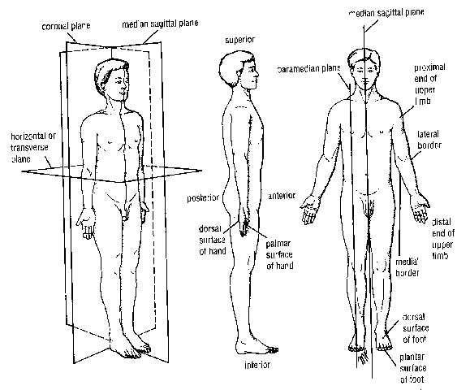
Alphabetical Glossary (L: glossa = tongue, language)

This does not set out to be a dictionary of all the anatomical terms you will meet. However, reference to this when you don’t understand a new word will often save a question or prevent confusion. Don’t try to memorise these words; learn them one at a time when they come up in a context. If you come across any mysterious terms during the year please tell Professor Davies so that he can add any important ones to the glossary. Most of these are derived from Latin or Greek (or Sanskrit, the parent language of both) – meanings of the root words are given in the hope that this will make the terms themselves easier to remember.

Abducens 6th pair of cranial nerves, involved in lateral eye movements (L: guiding away)
Abduction Movement of part of a limb away from the mid-line of the body or of the limb (L: guiding away)
Accessory 11th pair of cranial nerves; involved in swallowing
Adduction Movement of part of a limb towards the mid-line of the body (L: guiding towards)
Adhesion Pathological attachment between two organs following inflammation
Adrenal Endocrine glands at superior poles of kidneys: medulla is part of sympathetic nervous system secreting adrenaline and noradrenaline; cortex secretes steroid hormones regulating stress responses and salt retention (L: by the kidney)
Adventitia Connective tissue surrounding a tube such as blood vessel or oesophagus (L: foreign)
Alveolus Socket (e.g. of tooth); large space surrounded by cells in a gland (e.g. in the mammary glands) or in the lungs (L: socket)
Anastomosis Rejoining, usually of arterial branches to form a network or by-pass channel (G: joining through a mouth or opening)
Anatomist Morphologist who can see the big picture! (G: cutting apart)
Aneurysm Weakening and stretching of an arterial wall threatening rupture (G: dilation)
Annulus (= Anulus) Ring-shaped structure (e.g. intervertebral disc) (L: ring)
Aponeurosis Flattened, sheet-like tendon (G: from tendon)
Appendicular skeleton Skeleton of limbs & limb girdles
Appendix Short, blind-ended diverticulum of beginning of large intestine (L: hang from)
Arcuate Arched (L; bow, arch)
Arm Limb segment between the shoulder and the elbow
Arteriole Microscopic artery – main site of peripheral resistance to blood flow (L: small artery)
Artery Vessel conducting blood away from the heart (G: air pipe – classical anatomists thought that arteries contained air)
Articular Relating to joints e.g. articular disc – fibrous disc within a joint (L: separation of meat into joints)
Ascites Accumulation of fluid in peritoneal cavity (G: belly, wineskin)
Auscultation Listening to body sounds e.g. heart or breathing sounds. (L: listening)
Autonomic Motor nerves to cardiac or smooth muscle and glands & sensory nerves from viscera (G: self law)
Avulsion Tearing of a ligament or tendon from a bone. (L: tear off)
Axial skeleton Skull, vertebral column, ribs & sternum (Sanskrit: axle)
Axilla Region superior to armpit containing major nerves, vessels and lymph nodes. (L: armpit)
Azygos Unpaired, usually the azygos vein draining the posterior chest wall (G: unpaired)
Bifid Forked (e.g. spines of typical cervical vertebrae) (L: split in two)
Body Main part of a structure or organ e.g. vertebra, pancreas
Brachial Relating to the arm (e.g. brachial artery and brachial plexus) (L: arm)
Bronchus Lung airway visible with the naked eye (G: windpipe)
Bronchiole Microscopic lung airway
Buccal Relating to the cavity of the mouth (L: cheek)
Bursa Protective pouch containing synovial fluid to lubricate sites of pressure (L: purse)
Capsule Tough fibrous covering of organ such as kidney or spleen, or surrounding a joint (L: little box)
Cardiac Relating to the heart e.g. cardiac muscle (G: heart)
Carpal Related to the wrist; the small bones of the wrist (L: wrist)
Caudal Relating to the tail end of the body, often of the embryo (L: tail)
Cephalic Relating to the head-end of the body, often of the embryo (G: head)
Caecum Initial, sac-shaped segment of large intestine (L: blind)
Cartilage Gristle forming flexible part of developing or mature skeleton (L: gristle)
Cervical Relating to neck region, 7 cervical vertebrae, 8 cervical spinal nerves or to cervix of uterus (L: neck)
Cervix Fibro-muscular neck of the uterus.
Chondral Related to cartilage e.g. costo-chondral joints between ribs and their cartilages. (G: gristle)
Clitoris Area of erectile tissue rich in sensory nerves supero-anterior to the female urethral opening; has structural similarities to the penis, important in sexual arousal. (probably G: key, latch, hook)
Coeliac Artery of foregut and derivatives; sympathetic nerve plexus of same area (G: cavity)
Coelom Cavity in embryo from which pleural, peritoneal & pericardial cavities develop (G: cavity)
Collateral Arterial circulation by-passing a main artery through an anastomosis (L: alongside)
Colon Main part of large intestine with alternating retroperitoneal and mesentery-supported segments (ascending, transverse, descending, sigmoid) (G: food, meat)
Condyle Large, roller-shaped end of bone forming part of a synovial joint (G: knuckle)
Contralateral On the opposite side of the body (L: opposite side)
Coronary Arteries supplying heart; peritoneal ligament attaching liver to diaphragm (L: crown)
Cortex Outer layer of organs such as the cerebrum, kidney and adrenal; dense outer layer of a bone (L: bark, rind)
Costal Related to the ribs e.g. intercostal = between the ribs (L: rib)
Costal margin Lower border of rib cage from 7th costal cartilages anteriorly to 12th ribs posteriorly
Cranial Relating to the skull; towards the head end (esp. in embryol & zool) (G: skull)
Cranial nerve One of 12 pairs of nerves entering or leaving the brain
Cuneiform Wedge-shaped; group of 3 tarsal bones named after their shape (L: wedge-shaped)
Cystic Relating to the gall bladder e.g. cystic duct (G: sack, bladder)
Diaphragm Domed respiratory muscle separating thorax from abdomen (G: barricade)
Diaphysis Shaft of long bone acting as primary centre of bone formation in development (G: grow between)
Dorsal Relating to the posterior surface of the body (L: back)
Ductus deferens Thin, muscular tube carrying sperm from testis to urethra (L: carrying away tube)
Duodenum First, G-shaped segment of small intestine: retroperitoneal, entry point for bile duct and pancreatic ducts (L: twelve [length in finger-breadths])
Embolism Blocking of an artery by an object such as a clot travelling in the circulation (G: insertion)
Endocardium Inner, endothelial surface of heart (G: inside heart)
Endothelium Layer of flattened cells lining heart, blood and lymph vessels (G: upon nipple)
Epicardium External, pericardium-coated surface layer of heart (G: upon heart)
Epiphysis Ends of long bones acting as secondary centres of bone formation in development (G: growth upon)
Erectile tissue Tissue in penis, clitoris and vestibular bulbs which swells as a result of increased blood inflow during sexual arousal
Extension Most straightened position of a joint; moving to this position
Facial Nerves 7th pair of cranial nerves: involved in movement of muscles of facial expression, salivation, tear secretion, taste
Falciform Sickle-shaped e.g. falciform ligament of liver (L: sickle)
Fascia Layer of connective tissue connecting or binding other structures (L: band)
Fetus Human developmental stage between 3 months and birth (L: offspring) - note that foetus is an incorrect spelling
Flexion Most folded-up position of a joint; moving to this position
Foramen Natural hole, often in bone and usually acting as pathway for a vessel or nerve (L: opening, bored hole)
Forearm Limb segment between elbow and wrist
Fossa Shallow pit or hollow in a bone or other organ (L: ditch)
Ganglion Small swelling on a peripheral nerve containing nerve cell bodies (G: swelling)
Gastric Relating to the stomach e.g. gastric ulcer (G: stomach)
Glossopharyngeal Nerves 9th pair of cranial nerves: involved in taste, swallowing, salivation, BP monitoring (G: tongue & throat)
Gluteal Relating to the buttock area or its muscles (G: buttocks)
Head Expanded end of a bone
Hepatic Relating to the liver (G: liver)
Hilum Site on organ such a lung, kidney or spleen where vessels and nerves enter (L: small thing)
Hypoglossal Nerves 12th pair of cranial nerves: controlling tongue movement (G: below tongue)
Ileum Third, mesentery-supported part of small intestine; joins large intestine at ileo-caecal valve (L: flank)
Inguinal Groin area, especially inguinal canal through lower abdominal wall to scrotum (sac of skin containing testes) (L: groin)
Insertion Attachment of the distal end (usually) of a muscle. Safer to refer to attachments. See also Origin. (L: put in)
Intervertebral Between vertebrae, e.g. IV discs and IV foramina for spinal nerves
Ipsilateral On the same side of the body (L: same side)
Jejunum Second, mesentery-supported part of small intestine (L: empty, fasting)
Kidneys Paired retroperitoneal organs on posterior wall of upper abdomen: produce urine from filtered blood plasma
Labium Lip, either of mouth or female external genitalia (outer labia majora and inner labia minora) (L: lip)
Labrum Lip of cartilage deepening a joint socket e.g. glenoid labrum of shoulder joint (L: lip)
Lamina Bony plate forming posterior part of spinal canal of vertebra (L: sheet, layer)
Larynx Valve preventing entry of liquids or solids into trachea; also involved in speech (G: throat)
Leg Limb segment between knee and ankle
Lesser sac Pocket of peritoneal cavity posterior to the stomach
Ligament Fibrous band connecting bones across a joint; also used for some peritoneal folds (L: binding)
Limb girdle Skeleton attaching limb to trunk (clavicle + scapula, pelvic bone)
Lingual Relating to the tongue (L: tongue)
Lumbar Relating to lower back, 5 lumbar vertebrae or 5 lumbar nerves (L: loin)
Mediastinum Block of organs separating L & R pleural cavities )Mediaeval L: intermediate)
Medulla Part of kidney, adrenal etc inside the cortex (L: marrow of bone)
Mesenteric Arteries of midgut (superior mesenteric) and hindgut (inferior mesenteric) (G: middle of gut)
Mesentery Fold of peritoneum suspending an organ in the peritoneal cavity
Metastasis Spread of cancer to distant sites through blood or lymph circulation (G: change of place)
Myocardium Muscular part of heart (G: muscle & heart)
Neck Part of bone or organ adjoining head (e.g. humerus, rib, pancreas)
Neural Relating to nerves (G: nerve)
Oculomotor Nerves 3rd pair of cranial nerves: controlling most extraocular muscles, pupil and lens focal length (L: eye & move)
Oesophagus Gullet; segment of gut through which swallowed material passes from the pharynx to the stomach (G: gullet)
Olfactory Nerves 1st pair of cranial nerves: mediating sense of smell (L: smell)
Omentum Fold of mesentery attached to the stomach (L: obscure meaning but often quoted as ‘apron’)
Optic 2nd pair of cranial nerves; mediate vision
Oral Relating to the aperture of the mouth (L: mouth)
Origin Attachment of the proximal end (usually!) of a muscle. (L: starting point) Attachment is a better term. See also Insertion.
Ossification Formation of bone, usually during development (L: bone)
Pancreas Gland extending from duodenum across L kidney to spleen; secretes digestive juice; also contains islet tissue which secretes hormones (insulin and glucagon) regulating blood glucose (G: all flesh)
Parasympathetic Autonomic nerves (visceral) from cranial (III, VII, IX, X) and sacral nerves
Parietal Relating to walls of a body cavity e.g. the parietal peritoneum or pleura lining them (L: wall)
Parturition Childbirth (L: be in labour)
Percussion Eliciting sounds by tapping on the body surface
Perineum Region in which the urinary, reproductive and anal openings are found (G: dwell around)
Periosteum Fibro-cellular layer on outside of bone at which bone growth may occur (G: around bone)
Peritoneum Connective tissue layer lining the peritoneal cavity surrounding the abdominal organs (G: stretch around)
Pharynx Funnel-like tube (basically the throat) linking back of nose and mouth to larynx and oesophagus (G: throat)
Phrenic Nerves Nerves to the diaphragm (G: diaphragm)
Piriform Pear-shaped (name of a laryngeal fossa and a muscle of the hip) (L: pear-shaped)
Pisiform A small carpal bone (L: pea-shaped)
Pituitary Small endocrine gland attached to brain and regulated by it; secretes multiple hormones, many regulating other endocrine glands (L: mucus)
Pleura Connective tissue layer lining the pleural cavity surrounding each lung (parietal pleura) or covering the lung surface itself (visceral pleura) (G: side, rib)
Pleurisy Accumulation of fluid in pleural cavity
Plexus A branching and rejoining pattern of nerves or blood vessels (L: braid)
Process Projection from a bone, as olecranon process of ulna (L: develop, advance)
Pronation Turning the hands to the palms-posterior position (L: palm or face down)
Prostate Gland surrounding beginning of male urethra; secretes components of semen (G: stand before, guard)
Pulmonary Relating to lungs e.g. pulmonary arteries (L: lung)
Pylorus The pyloric sphincter controls movements of gut contents from stomach to duodenum (G: gatekeeper)
Quadrate Square or rectangular (L: square)
Ramus Branch, especially main (anterior and posterior) branches of a spinal nerve (L: branch)

Ramus communicans Bundle of sympathetic fibres passing between sympathetic chain and spinal nerve
Rectum Last portion of large intestine, extending from sigmoid colon to anal canal (L: straight)
Retinaculum Ligament-like band strapping tendons to bones near wrist or ankle (L: small net)
Retroperitoneal Any organ plastered to the abdominal wall by peritoneum (L: retro- - behind)
Root value e.g. C3,4,5, means a muscle supplied by cervical spinal nerves 3, 4 & 5
Roots Anterior (motor) and posterior (sensory) roots of spinal and some cranial nerves
Rotation Movement of certain joints so that a bone spins on its long axis
Sacral Relating to 5 fused vertebrae of sacrum or the 5 sacral spinal nerves (L: sacred)
Semen Fluid expelled in ejaculation; contains sperm and secretions of prostate and seminal vesicles (L: seed)
Seminal vesicles Glands secreting components of semen, which lie posterior to the bladder and open via ejaculatory ducts into the urethra
Septum Partition between two spaces e.g. nasal septum (L: partition).
Sesamoid Bone developed within a tendon e.g. the patella, the pisiform (G: resembling herb – specifically seeds of the herb sesame)
Sinus Air-filled space in skull connecting to the nose; also non-collapsible venous channel within the cranium (L: bay, hollow)
Sphincter Muscular ring surrounding a tube and capable of closing it (G: band)
Spinal cord Part of central nervous system extending from foramen magnum of skull to 1st/2nd lumbar vertebra
Spinal nerve One of (usually) 31 pairs of nerves leaving the spinal cord
Spine Supporting column formed by vertebrae and their intervertebral discs
Supination Turning the hands to the palms-anterior position (L: palm up, on back)
Suture Interlocked fibrous joint between skull bones; also thread for surgical stitching (L: seam)
Sympathetic Autonomic nerves (visceral and somatic motor and visceral sensory) from thoracic and upper lumbar roots
Sympathetic chain Cord of sympathetic ganglia and connections each side of vertebral column
Symphysis Mid-line attachment of two bones e.g. pubic symphysis at front of pelvis (G: growing together)
Synovial Class of joints lubricated by viscous synovial fluid (L: body fluid)
Tamponade Effect of accumulation of blood or other fluid in the pericardial cavity (Fr: padding, buffering).
Tendon Cord of fibrous connective tissue joining a muscle to a bone (L: stretcher, tendon).
Teres e.g. Ligamentum teres, Teres major (L: round, smooth)
Testis Testicle: contains sperm-producing tubules and endocrine tissue secreting the male sex hormone testosterone (L: witness).
Thigh Limb segment between hip and knee.
Thoracic Relating to chest region, 12 thoracic vertebrae or 12 thoracic spinal nerves (L: breastplate)
Thrombosis Clot formation within a vessel, partly of completely blocking it
Thrombus Blood clot (G: clot)
Thyroid Endocrine gland in lower neck secreting thyroxin and tri-iodothyronin; regulates metabolic rate and important in growth. Also the main cartilage of the larynx forming the Adam’s apple (G: door, rectangular shield)
Trachea Windpipe – airway joining larynx (voice-box) to bronchi (G: rough – Greek scholars thought that both arteries and the trachea contained air – the trachea is less smooth than arteries)
Trigeminal 5th pair of cranial nerves; three major divisions sensory to face, nose & mouth, motor for mastication (chewing) (L: triplets).
Trochanter Prominent bony lumps for muscle attachment on the femur (G: runner – in the sense of a sledge runner).
Trochlea L: pulley – the extraocular muscle (superior oblique) supplied by the trochlear (4th cranial) nerve passes round a pulley-like sling of tissue.
Tubercle Small elevation on a bone (L: small swelling).
Tuberosity As Tubercle, but usually larger.
Ureters Tubes descending from kidneys to enter bladder in posterolateral corners (G: urine).
Urethra Single tube through which urine is expelled from bladder (G: urine)
Vagina Distensible canal extending from cervix to open into the vestibule of the vulva; lower part rich in sensory nerves (L: sheath)
Vagus Nerves 10th pair of cranial nerves: involved in swallowing and speech and parasympathetic functions in the chest & abdomen (L: wandering).
Vascular Relating to blood or lymph vessels (L: small vessel)
Vein Vessel conducting blood towards the heart
Ventral Relating to the anterior surface of the body (L: belly)
Venule Microscopic vein
Vertebra Bony unit of vertebral (spinal) column (L: turning)
Vestibule Space between the labia minora; vestibular bulbs are adjacent pads of erectile tissue (postero-inferior continuations of erectile tissue of the clitoris) surrounding the lower vagina (L: porch, lobby)
Vestibulocochlear Nerves 8th pair of cranial nerves: involved in hearing, balance, acceleration.
Visceral Relating to internal organs e.g. visceral layer of peritoneum (L: internal organ)
Vulva External genitalia of female (G via L: wrapping)

Dissecting Room 14th Floor

The Trunk

An exploration of the trunk and its contents

Worksheets will be provided during the session

Anatomy Skills Laboratory 13th Floor

The Basics of Bones

Objectives

- Distinguish between axial, limb girdle and limb regions of the skeleton

Axial skeleton:

- Demonstrate the correct use of the terms neurocranium, cranial base and facial skeleton
- Identify the following major skull features: orbit, zygomatic arch, external auditory meatus, mastoid process, temporo-mandibular joint, foramen magnum
- List four major functions of vertebrae
- Identify the following features of a typical vertebra: body, pedicles, laminae, neural arch, spinal canal, transverse and spinous processes
- Outline the structure and functions of intervertebral discs
- Identify the ribs, manubrium and sternum and outline the main functions of the rib cage.

Limb girdles:

- Name the bones of the pectoral girdle and outline their functions in support and mobility of the upper limb
- Name the main regions of the pelvis; explain the main functional differences between the pelvic and pectoral girdles

Limbs:

- Name the bones of the upper and lower limbs (names of individual carpals and tarsals not required yet)

Joints:

- Explain how different ways of attaching bones affect the strength and mobility of the joint, making correct use of the term ‘synovial joint’.
- Demonstrate the differing ranges of movement of plane, hinge, condylar and ball-and-socket joints.

Class activities

- Follow the live video tutorial on the axial skeleton, filling the gaps in the text as you go: (Time – 15 min)

The main elements of the axial skeleton are the skull, vertebrae, ……………. and ribs. The skull consists of a bony box called the ……………….. which protects the brain, to which are attached the bones supporting the structures of the face. The cranial base includes four large bones (sphenoid, occipital and a pair of ……………..bones) perforated by numerous holes called …………… which transmit cranial nerves and ……………………. Among the important bones of the face are those carrying the teeth: the ……………… forming the upper jaw and the mandible forming the lower.

Other obvious bony features of the head are the rim of the ………… containing the eye, the ……………………….. meatus conducting sound to the eardrum, and a prominent bony mass called the …………. process immediately behind the ear.

The large hole in the cranial base, called the ………………….., marks the level at which the brain becomes continuous with the …………………. running through the neural arches of the vertebrae as far as the first /second lumbar vertebra (abbreviated to L1 /L2). There are …… cervical (neck) vertebrae, ….. thoracic vertebrae each articulating (forming a joint) with a pair of ribs, ….. lumbar vertebrae and a group of five vertebrae fused into a single bone called the ………… Below this is the ……, usually comprising … vertebrae.

Each vertebra consists of a cylindrical, load-bearing part called the ………, a ring called the neural arch surrounding the …………………… and projecting processes, which provide attachment for …………… (One of the vertebrae doesn’t meet one of these criteria – which one? …………….). Between the bodies of adjacent vertebrae is a fibrous disc, the intervertebral disc. This is tightly fused to the vertebrae and, as well as providing a slightly flexible coupling, absorbs ………………… forces very effectively and so acts as a shock absorber.

Each thoracic vertebra forms mobile joints with a pair of ribs. These pass postero-laterally then turn forward; the upper 7 pairs attach via a cartilage rod (the ………. cartilage) to the sternum, pairs 8-10 have cartilages joining to the cartilage of the rib above, while pairs 11-12 terminate in the muscles of the lateral body wall. Apart from protecting the heart and lungs, the ribs are struts, which can be moved ……….. by chest muscles to expand the chest volume and so suck air into the lungs. The lower border of the rib cage is formed (from anterior to posterior) by cartilages 7-10 and by the 11th and 12th ribs to form an easily felt landmark called the costal …………..

The sternum has two main bony parts: a superior part called the ……..…………. and a Larger part called the body of the sternum. These parts are joined by a secondary cartilaginous joint called the …………………… joint, allowing the body of the sternum to hinge …………… to increase the antero-posterior chest diameter on inspiration.

Label the bones on these drawings (do this as homework)
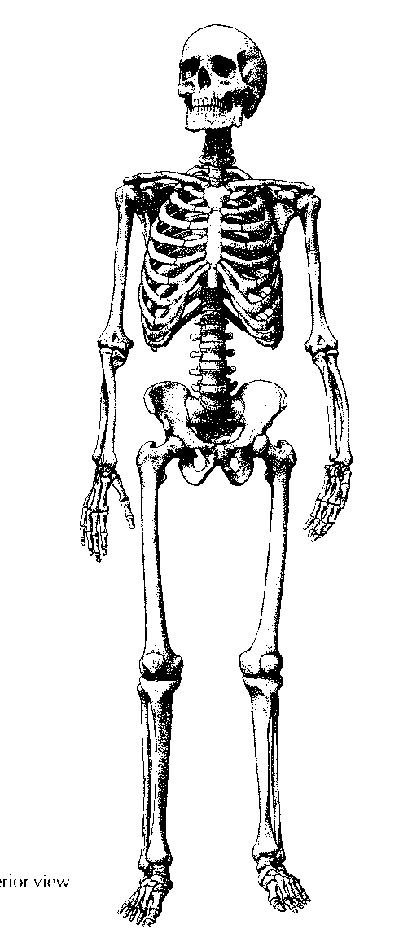
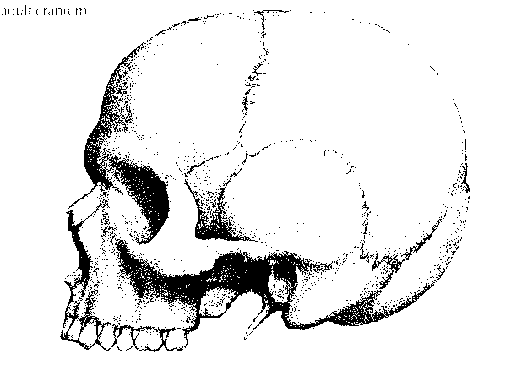
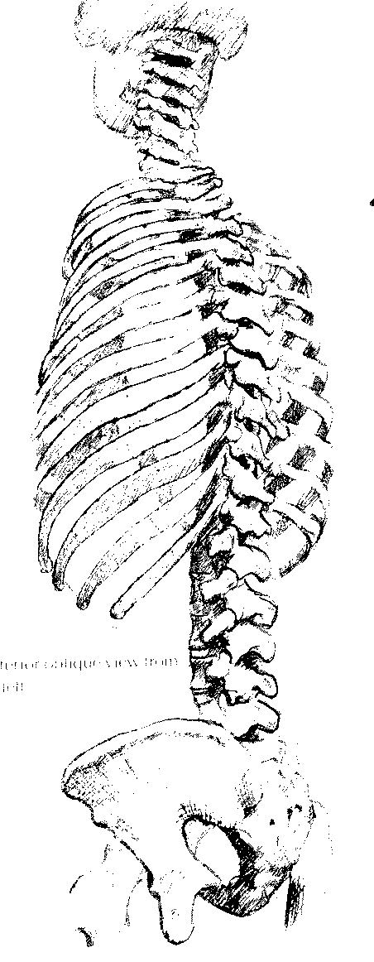
- Organise yourselves into groups of 4 students for the following exercise, making notes on your findings: (Time – 20 min)

This is an introduction to physical examination of a patient.
Remember that whenever you examine a patient you must:
- Show respect for patients by introducing yourself, establishing that they consent to being examined and making sure that they are as comfortable as possible
- Behave in a way that establishes confidence and trust
- Understand and respect the patient’s anxiety and any cultural limitations on body exposure

Your aim is to find major pulses in the neck and limbs. Patients should be seated (neck and upper limbs) or lying on an examination couch (lower limbs).

Pulses can be palpated wherever an artery intervenes between a solid structure (bone) and the body surface. Large artery pulses, such as the abdominal aorta and the popliteal artery, can be palpated even though deeply placed, whereas small artery (and therefore weaker) pulses are only palpable when they are superficial. Always feel pulses using the middle three fingers, held together and placed flat on the skin.

When you have satisfactorily found each pulse, you must demonstrate it to a member of staff. If you cannot find a particular pulse, ask for help.

The neck (work in pairs)

The only important pulse is the carotid, found by placing the fingers in the groove between the larynx and the large diagonal muscle (sternocleidomastoid) and pressing gently backwards. This is the only important central pulse of the body. For what purposes is it commonly used?

The upper limb (work in pairs)

Palpate the medial surface of the arm to find the brachial pulse in the groove between biceps and the muscle lying deep to it (brachialis).

Identify the radial pulse at the wrist. What can you use as a landmark for finding this pulse?

The lower limb

Work in groups of 4, taking turns to act as examiner and subject. Trousers should be pulled up above the knee and socks should be removed.

Popliteal artery:
The subject should lie supine with knees raised. The examiner should face the subject and support the knee with one hand. Place the fingers of the other hand in the popliteal fossa (the hollow at the back of the knee) and pull them towards you against the posterior surface of the tibia. The pulse is large but deeply placed and can only be felt properly with the muscles of the popliteal fossa relaxed by passive flexion of the knee.

Posterior tibial artery:
This artery emerges from its position deep to the large calf muscles (gastrocnemius and soleus) to pass into the sole of the foot posteriorly to the bony projection on the medial side of the ankle (the medial malleolus) and its associated tendons. Palpate the soft tissue immediately posterior to the tendons.

Now try to answer the following questions:

- What does it mean if you cannot feel the carotid pulse?

- What does it mean if you can feel the popliteal but not the posterior tibial pulse?

- Why is the radial pulse the most commonly used peripheral pulse?

- Watch the live video tutorial on joints, then answer the following questions: (Time – 10 min)

What is the term for a lubricated joint?

What prevents these joints from dislocating?

Give three examples in the upper limb, one belonging to each of the following types:

Ball-and-socket:

Condylar:

Hinge:

