SAQ 1 | Examiner Use Only
A. List 2 principal target organs for parathormone (PTH) and identify one action at each site.
(4 marks)

Kidney (1 mark); either increased PO4 excretion, increased Ca reabsorption, stimulation of 1α-hydroxylase activity. (1 mark for any one)
Bone (1 mark); stimulation of osteoclast activity (1 mark)

B. Draw a labelled flow diagram illustrating the synthesis of the hormone calciferol
(dihydroxycholecalciferol) from its initial precursor 7-cholesterol. [students: apologies, for
clarity this should have read 7-dehydrocholesterol] Identify relevant catalytic agents, molecules
and organs/tissues. (4 marks)

7-dehydrocholesterol
UV light, in skin (1/2 mark each)

Cholecalciferol (1/2 mark)

25 (OH) D3 (1/2 mark 25-hydroxlase, in liver (1/2 mark each)

1,25 (OH)₂D3 1a-hydroxylase, kidney (1/2 mark each)
(calciferol)

C. Identify the major target organ/tissue for calciferol and list its 2 principal effects here.
(1½ marks)

The small intestine; stimulation of Ca and PO4 absorption (1/2 mark each)

D. Name the polypeptide hormone from the thyroid which stimulates renal calcium excretion.
(½ mark)

calcitonin

 | TOTAL MARK

SAQ 2 | Examiner Use Only
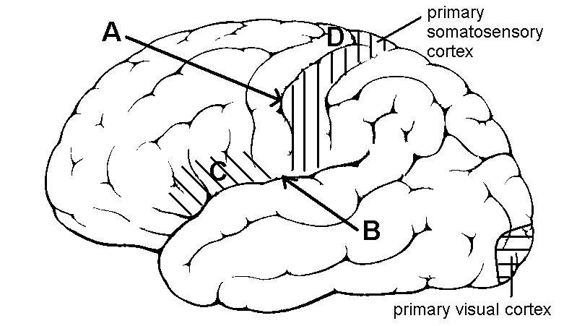

This is a diagram of the lateral surface of the left cerebral hemisphere.

(i). Name the labelled sulci. (2 marks)

A: central sulcus

B: lateral sulcus/lateral fissure/Sylvian fissure

(ii). Draw and label the position of the primary somatosensory cortex and primary visual cortex on the diagram. (2 marks)

(iii). Name cortical area C and briefly explain the effect of a lesion here. (2 marks)

Broca’s area – impaired speech/loss of speech/ aphasia

(iv). A patient has an epileptic focus located in the cortex at D. What behavioural change would you expect to observe during a complex partial seizure? (4 marks)

Jerking/clonic movements of the right leg with associated impaired consciousness

 | TOTAL MARK

SBAs select the single best answer for each numbered item 1 to 8 below

1. | Androgens:
 | a) | Are produced by the adrenal medulla
 | b) | May be converted into oestrogens in certain tissues
 | c) | Has glucocorticoid actions
 | d) | Acts via G-protein coupled receptors
 | e) | Have catabolic effects on protein

2. | Angiotensin II:
 | a) | Is converted from angiotensin I by renin
 | b) | Is a precursor of angiotensinogen
 | c) | Stimulates cortisol release from the adrenal cortex
 | d) | Acts directly on the zona fasciculata
 | e) | Is a powerful vasoconstrictor

3. | Which of the following suppresses somatotrophin (growth hormone) secretion?
 | a) | Somatostatin
 | b) | Hypoglycaemia
 | c) | Ghrelin
 | d) | Oestrogen
 | e) | Amino acids

4. | Tri-iodothyronine:
 | a) | Is the main product of the thyroid gland
 | b) | Inhibits the actions of catecholamines
 | c) | Inhibits thyrotrophin release
 | d) | Has a half life of greater than 7 days
 | e) | Inhibits vitamin A synthesis

5. | Which of the following statements about the PNS is correct?
 | a) | The limbs are innervated by dorsal rami of spinal nerves
 | b) | The brachial plexus supplies the lower limb
 | c) | The nerves are surrounded by endoneurium
 | d) | The axons are myelinated by oligodendroglia
 | e) | The area of skin innervated by a single spinal nerve is called a dermatome

6. | The basal ganglia are located in the:
 | a) | Brainstem
 | b) | Cerebral hemispheres
 | c) | Diencephalon
 | d) | Peripheral nervous system
 | e) | Midbrain

7. | In the ANS:
 | a) | Sympathetic activity dilates the pupil of the eye
 | b) | Preganglionic sympathetic motoneurones use the neurotransmitter noradrenaline
 | c) | Sympathetic activity constricts the bronchioles of the lungs
 | d) | Parasympathetic activity causes ejaculation
 | e) | Parasympathetic activity increases total peripheral resistance

8. | Astrocytes:
 | a) | Strip synapses from neurons
 | b) | Take up glutamate
 | c) | Line the ventricles of the brain
 | d) | Are involved in antigen presentation
 | e) | Support the metabolism of dorsal root ganglion cells

