MCD Tutorial 1 - Acyclovir, an antiviral agent

Take home messages

The main aims of this tutorial are:
- To address the main questions in the student guide notes  - To discuss the essential biology of viruses and the important ways in which they differ from animal cells. Namely, they are obligate parasites, they have their genetic material in the form of DNA or RNA. They have no organelles and are not cells. They cannot reproduce outside of a host cell. Plus anything else you can think of.  - Whilst we do not intend that you give understand details of virus classification, we do want you to appreciate that there are small and large viruses. The small ones have less nucleic acid material and hence code themselves for fewer virus-specific genes and the larger viruses code have more nucleic acids hence code for many more virus-specific genes. Thus, the bigger the virus the more proteins that differ from the host and the more potential targets for drug intervention and hence therapy against infection by that virus.  - Using the example of an archetypal large DNA virus (Herpes simplex) you must be able to describe the major features of the life-cycle (see attached figure 1).  - The aim here is think about the possible places in the life cycle and hence the biochemical processes that might feasibly lend themselves to drug interaction. For example, can we prevent infection of a cell, can we prevent incorporation into the genome, can we prevent viral DNA replication, can we prevent viral protein production and packaging?  - You might venture your own suggestions as to why some are viable avenues and others are not. | 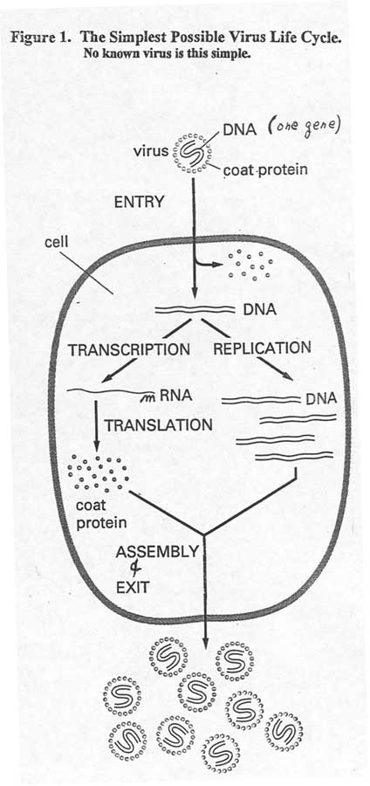  Figure 1

- You must appreciate the concept of drugs that are structural analogues of naturally-occurring molecules in cells and how these drugs may work against the virus but not so much against the host.
- The basis of this strategy is back to good old protein “structure and function”. In other words how we can take advantage of differences in the structure of a viral isoform of a protein from the cell’s own isoform, in order to perturb key processes in the viral life cycle and not to affect the cell’s systems.
- So, for example, the Herpes family of viruses code for their own thymidine kinase and DNA polymerase. Both these enzymes have host versions but there are sufficient differences between their substrate specificities and activities. These differences can be taken advantage of for the prevention of viral DNA replication without jeopardising cellular DNA synthesis greatly.
- You will need to be able to explain (with the aid of diagrams if needed) the basics of DNA replication in the absence and presence of acyclovir. This is the biochemical crux of the problem.
- Acyclovir and related nucleotide and nucleoside analogues are in effect “Biochemical Confidence tricks” whereby the viral thymidine kinase has a high affinity for acycloGMP (Acyclovir) and hence generates large amounts of acycloGTP in infected cells. This in turn is an excellent substrate for the viral DNA polymerase and so is incorporated into the growing DNA strand of viral DNA. Unfortunately for the virus acyclocGTP blocks further polymerisation of DNA as no 3’OH group is available for the production of the next phosphate bond. Thus, viral DNA replication is blocked and hence generation of new virus prevented. On the other hand acycloGTP is a poor substrate for the host cell DNA polymerase and so is less often incorporated into the cell’s replicating DNA. Thus, the cell is spared from the most potent effects of the drug.
- It should be stressed that acyclovir in itself does not “cure” the infection but greatly suppresses it by reducing the overall viral load. The host’s immune system can then work to eradicate the infection completely. Of course there are situations where this does not occur such as in immuosuppressed and HIV infected patients. Here antiviral treatment is continuous and obligatory. Such individuals are commonly infected by Herpes and cytomegalovirus also treatable using nucleoside analogues.
Finally, it will be worth noting that acyclovir has other uses apart from treatment of the immunosuppressed. For example, preparations of acyclovir are sold over the counter as Zovirax for the treatment of Herpes cold sores and on prescription for treatment of infection by Varicella zoster (Chicken pox).

The structure of Acyclovir:
