
School of Medicine

Year 1

LIFE SUPPORT SYSTEMS

2012/2013

The Skin

Course leader:
Prof Tony Chu - a.chu@imperial.ac.uk

https://education.med.imperial.ac.uk

List of Contents

PAGE

3 Timetable
4 Learning outcomes
5 Teaching sites – main teaching staff
6 About the skin course
7 Introduction
8 Structure of epidermis and Adnexal structures
16 Structure of the dermis and dermo-epidermal junction
22 Pigmentation of the skin
29 Organisation of the skin immune system
35 Function of the skin
37 Blood vessels and nerves
40 Wound Healing
47 Control of body temperature with particular emphasis on the role of the skin
50 Skin in innate and acquired immunity
54 Hair and Nails
60 Skin Organ Failure
62 Sample MCQs
64 Recommended book reading

Year 1 Skin Course 2012/13

Timetable

Friday 17th May 2013

- Introduction to the skin - Prof Tony Chu 09.00 – 09.15

- Structure of the epidermis and adrexal structures 09.15 – 09.45

- Dr Fernanda Texiera

- Structure of the dermis and Dermo-epidermal
junction - Prof Tony Chu 09.45 – 10.15

4 Pigmentation of the skin - Dr Fernanda Texiera 10.15 – 10.45

BREAK: 10.45 – 11.15

5 Organisation of the Skin Immune System – Prof Tony Chu 11.15 – 11.45

6 Function of the Skin – Prof Tony Chu 11.45 – 12.15

Friday 24th May 2013

7 Blood vessels and nerves – Dr Sue May Ang 09.00-0-9.30

8 Wound Healing – Dr Fernanda Teixeira 09.30 – 10.00

9 Control of body temperature – Dr Sangeeta Puinjabi 10.00 – 10.30

BREAK 10.30 – 11.00

10 Skin in innate and acquired immunity – Dr Bernadetta Brazzini 11.00 – 11.30

11 Hair and nails – Dr Sue May Ang 11.3 0 – 12.00

12 Skin organ failure – Dr Fernanda Teixeira 12.00 – 12.30

Skin: Learning outcomes

- Explain the concept of the skin as a single organ of the body with its complex intra-relationships with other organ systems of the body.

- Describe the basic anatomical structure of the skin and the intra-relationships between the epidermis, dermis and subcutis.

- Describe the structure of the epidermis and associated adnexal structures its foetal development and regulation of growth.

- Outline the mechanisms by which the integrity of the dermoepidermal junction is maintained and the results of failures of these mechanisms.

- Describe the migrant cell populations within the epidermis and detail their origins.

- Describe the structure of the dermis including the vascular and nerve supply to the skin, the development of the dermis, regulation of collagen formation and events that occur in senescence.

- Describe skin pigmentation, the development, function and control of melanocytes and the principals of immediate and delayed tanning.

- Describe the development and maturation of acquired melanocytic naevi and the features of carcinogenic change within these lesions.

- Describe the development of the hair follicle, its anatomy and regulation of growth through life including the effect of sex hormones and age on hair growth.

- Describe the principles of barrier function of the skin and its role in controlling percutaneous water loss and absorption and defence against microbial invasion.

- Explain the control of body temperature and the role of the cutaneous vasculature in maintaining body temperature.

- Explain the importance of the skin as an immunological organ and describe the role of individual cell types in the cutaneous immune system.
- Explain the mechanism of skin wound healing

- Describe the consequence of skin organ failure and give examples of the impact of this on the body and other organ systems.

Teaching sites

All lectures will be given in lecture theatre 1, Sir Alexander Fleming Building, South Kensington Campus.

Main teaching staff

Dr Tony Chu, Consultant Dermatologist, Hammersmith Campus
Dr Fernanda Teixeira, Consultant Dermatologist, Hammersmith Campus
Dr Sue May Ang, SpR Dermatology, Hammersmith Campus
Dr Sangeeta Punjabi, Associate Specialist in Dermatology, Hammersmith campus
Dr Bernadetta Brazzini, Associate Specialist in Dermatology

About the Skin Course

Tony Chu

Dermatology is the study of the skin, which represents the largest organ of the human body. In this part of the course the emphasis will be on the normal structure, function and development of the skin and recognition of the skin as a single organ of the body. The skin interacts with most other organs of the body in both physiological and pathological states. A good working knowledge of the normal structure and function of the skin is, therefore, important. In the course we will detail the various functions of the skin as well as its pivotal role as the outermost outpost of the immune system. This will explain why the skin is essential to life and skin organ failure may result in death.

Introduction

Tony Chu, Hammersmith Campus

The skin is the largest organ of the body. It must be regarded as an individual organ rather than merely a wrapper for the body, which keeps the outside out and the inside in. The skin is an essential organ of the body, loss of skin is incompatible with life as seen in severe burn patients.

The skin is essentially composed of three components, the upper stratified epithelium, consisting mainly of keratinocytes, the structural dermis, which supports the epidermis and the deeper subcutaneous tissue. As well as the true resident skin cells, a large variety of different cell types migrate through the different layers of the skin. The skin has important functional activity in providing barrier function to the body and in providing one of the most peripheral outposts to the immune system in preventing infection and in its role as an organ of sexual attraction.

Through a persons life any individual may develop several different skin problems. These range enormously in severity from trivial cosmetic problems to acute and chronic diseases, which may be disfiguring, itchy, painful and may even prove fatal. Skin diseases can affect any age group from the neonate to the very old. Over 2000 different skin conditions may present to the dermatologist and pattern recognition is central to the diagnostic acumen of the dermatologist.

In this series of lectures we will cover the basic development, structure and function of the skin culminating in the concept of skin organ failure.

Structure of the epidermis and adnexal structures

Fernanda Teixeira, Hammersmith Campus

The skin arises by juxtaposition of the ectoderm, that will give origin to the epidermis and adnexae, and the mesoderm, which will form the dermis, and is also essential for inducing the differentiation of some epidermal structures, as the hair follicles. The neural crest also derives from the ectoderm; melanocytes originate from the neural crest and migrate to the epidermis by the 10th to 11th week of embryonal life.

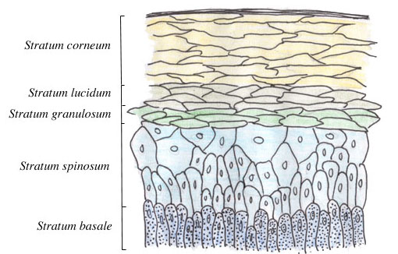

By the third week of gestation, the epidermis consists of a single layer of glycogen-filled cells. By the sixth week, two layers can be distinguished; the outer layer, or periderm, and the inner layer, or basal layer. The periderm will disappear by the 21st week, whereas the basal layer will form the epidermal cells during all of the individual’s life.
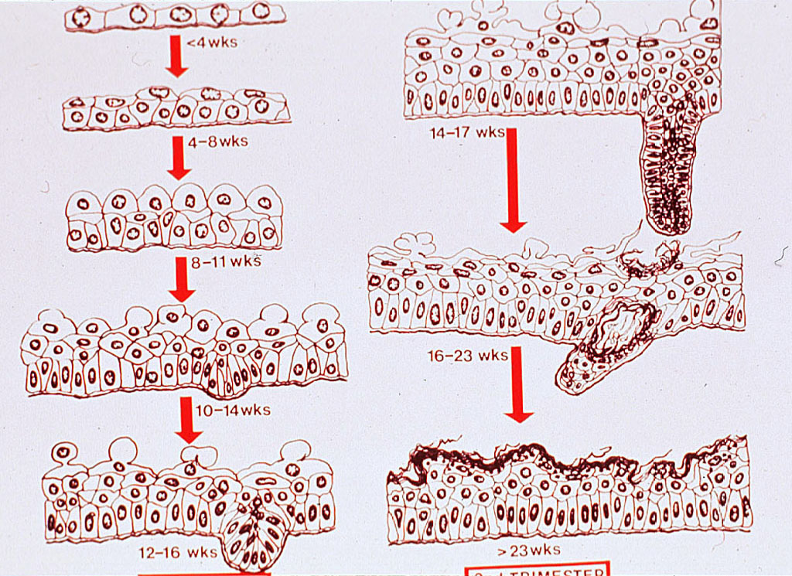

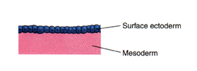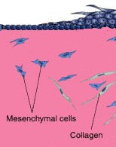

The hair follicles are first distinguished by the 9th week, in the regions of the eyebrows, upper lip and chin. The primordia of hairs appear as a cluster of cells in the basal layer of the epidermis, which begin to grow downwards into the dermis (“hair pegs”), at the same time that they are associated with fibroblasts and other mesenchymal cells, which are going to form the hair papilla. The tip of the hair peg becomes progressively bulbous and surrounds the dermal papilla. At this point, three bulges appear on the posterior wall of the follicle: the lower one, to which the arrector pili muscle will be attached; the middle one, which soon lose their glycogen and accumulate intra-cytoplasmic fat, becoming large and functional sebaceous glands by the 16th week of gestation, and finally the upper one, which gives origin to apocrine glands and ducts. These glands will be numerous in the whole body surface of the foetus, but most will disappear during the third trimester, persisting only in some areas as the axillae, perineum and genitalia.

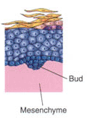 | 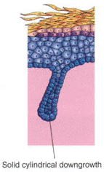 | 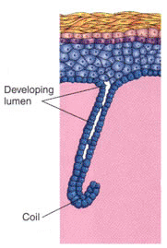

The dermis is formed by the proliferation of mesodermal cells that will give rise to a whole range of vessel- and connective elements, including several types of collagen and elastic fibres. Before the end of the third month, all the elements of the mature dermoepidermal junction will be recognizable.

THE EPIDERMIS

The epidermis is constituted by keratinizing, stratified squamous epithelium. Keratinocytes form 95% of the epidermal cells; the other 5% includes the melanocytes, the Langerhans cells and the Merkel cells.
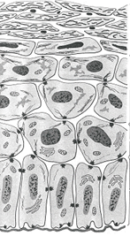 | Stratum corneum  Stratum granulosum  Stratum spinosum  Stratum basale

Keratinocytes are located on the basal lamina, where they divide; the daughter cells migrate upwards, acquiring a large amount of cytoplasm and many desmosomes.

Keratinocytes can be divided into four layers:
- the basal layer, or stratum basale;
- the prickle cell layer, or stratum spinosum,
- the granular layer, or stratum granulosum
- and the cornified layer or stratum corneum.

The stratum basale is a continuous layer, one- to three cells thick, of small cells (around 12 micrometers in diameter), cuboidal in shape, with large nuclei and dense cytoplasm. In the stratum spinosum, the cells enlarge and acquire numerous desmosomal connection plaques, that will stabilize the network of cells. Prickle cells are rich in tonofilaments, that are constituted by intermediate filaments of keratin that attach themselves to the desmosomes. Diseases that affect the desmosomes can lead to breaks in the fabric of keratinocytes, with the formation of vesicles; for example, in pemphigus, autoantibodies are directed against desmosomal proteins, leading to their destruction, and lack of cellular adhesion.

The next layer is the stratum granulosum, so called because the cells become flat and accumulate dense, basophilic granules in the cytoplasm, called keratohyalin granules. These granules contain filaggrin, a protein so called because it promotes the aggregation of filaments of keratin. By the influence of filaggrin, the keratin filaments align into disulphide cross-linked macrofibres. At the same time, the nucleus and cytoplasmic organelles disappear, and the keratinocyte is reduced to a flat squame of keratin- the corneocyte, that will be shed on the surface of the skin.

Keratinocytes are labile cells; i.e., basal cells are continuously dividing, to replace the corneocytes that are shed, so that the thickness of the epidermis can be maintained. The mechanisms that control the cell division in the basal layer are the result of the balance between stimulatory (or growth) factors and inhibitory factors. Among the stimulatory signals are epidermal growth factors, transforming growth factor alpha, interleukin 1, interleukin 6 and granulocyte-macrophage colony-stimulating factor; basal keratinocytes possess receptors for all these cytokines. In contrast, the transforming growth factor beta will inhibit the division of basal cells, although it stimulates the fibroblasts’ growth and collagen production. Interferons alpha and gamma also are inhibitors, as is tumour necrosis factor alpha. Cytokines and growth factors are produced by keratinocytes, Langerhans cells (see below) and lymphocytes within the dermis and epidermis.

As keratinocytes move upwards in the epidermis, they undergo a complex process of differentiation to produce the stratum corneum. First, they lose their ability to divide; also, the types of keratin change as the cells evolve into corneocytes.

The cytoskeleton of all mammalian cells comprise microfilaments, measuring approximately 7 nm in diameter, that are composed of actin, and microtubules, that are composed of tubulin and measure 20 to 25 nm in diameter. Between these two sizes are the intermediate filaments, that measure between 7 and 10 nm in diameter. There are six types of intermediate filaments: vimentin (in mesenchymal cells), glial fibrillary acidic protein (in astrocytes), neurofilaments (in nerve cells), desmin (in muscle), lamins A, B, and C (in the nuclear matrix) and keratins. Keratins are present in all epithelial cells, from many different organs, including the epidermis, the pancreatic ducts, the cells that line the intestinal lumen, the hepatocytes, etc. They are a family of approximately 20 members, weighing between 40 and 70 kD, each one the product of a different gene. Keratins are divided into two groups: the basic keratins (numbered 1 to 8) and the acidic keratins (number 9 to 19). At each layer of the skin, keratinocytes express one pair of keratins, that includes one acidic and one basic member in equimolar amounts; each one stabilize each other. Specific keratin pairs are synthesized in microscopically distinct epidermal cell layers. Keratins 5 and 14 are synthesized in the basal layer, whereas keratins 1 and 10 are found in the more differentiated spinous and granular layers. Each keratin pair assembles to form intermediate filaments,that, with tubulin and actin, form the cytoskeleton of keratinocytes. The main function of the keratin seems to be to maintain the three-dimensional architecture of the epidermis.

The epidermis has many functions. Its main duty is to serve as a barrier to harmful exogenous substances, chemicals and pathogens. It is also fundamental as a retainer of tissue proteins and fluids. There are diseases, as toxic epidermal necrolysis, in which the epidermis is detached in large sheets from the body as the result of a cell-mediated immune response after, for example, the administration of some drugs. These patients have to be treated in a burn unit, to decrease the risk of sepsis, to correct the fluid loss and to avoid the loss of body heat. Details about the functions of the epidermis will be discussed later in this programme.

OTHER EPIDERMAL CELLS

The Langerhans cell

The Langerhans cell is a highly specialized macrophage, originated from the bone marrow. It settles in the epidermis, working as an antigen-presenting cell with a branched (“dendritic”) morphology that forms a horizontal network of approximately 300 to 800 cells per square millimeter in the middle layers of the epidermis. They are mobile cells, and therefore, lack desmosomes and tonofibrils. Details of Langerhans’ cells morphology and their role in the immunosurveillance in the skin will be given later today.

The melanocyte

Melanocytes originate from the neural crest, and migrate into the lower epidermis, where they will synthesize melanin. Their biology, and some examples of diseases that affect them will be discussed later today.

The Merkel cell

These cells are located in the basal layer of the epidermis, in close proximity to axonal processes, and are believed to be involved in sensory perception. Although they can be found on the whole surface of the skin, they are more numerous on more sensitive areas, as the tip of the nose, the lips, around hair follicles or the fingertips.

Langerhans cell
✵
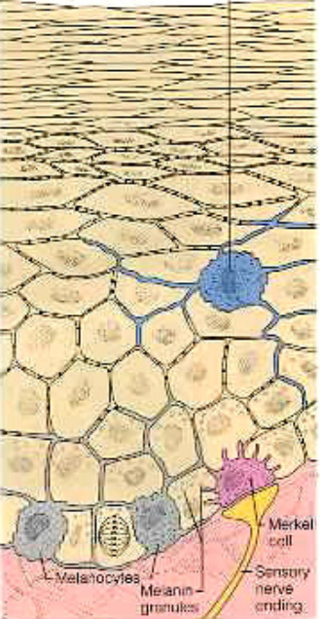

Merkel cells are not seen in routine histologic preparations, and electron microscopy and immunostaining are required for their identification. Under transmission electron microscopy, Merkel cells are seen to contain dense granules that are morphologically identical to the chromaffin granules found in the adrenal medulla. Although they do not contain catecholamines, other substances, as metencephalin, ACTH, substance P, bombesin and vasoactive intestinal polypeptide have been found in Merkel cells. Neurofilaments can be found as perinuclear balls.

In spite of the controversy regarding the origin of Merkel cells- neuroectodermal versus ectodermal- they are seen to contain keratin filaments and desmosomes, and very probably are of epithelial derivation. It is believed that traction on the epidermis is transmitted to Merkel cells, which stimulate the nearby axons, so contributing to local sensation.

Adnexal Structures
The dermis contains mostly extracellular matrix, providing support for nerves, vasculature, and adnexal structures such as the hair follicles, the sebaceous glands, and sweat glands. These adnexal structures, which are in continuity with the epidermis and develop during embryonic life through complex epithelio–mesenchymal interactions.

Different areas of the body have different proportions of the adnexal and hair follicle structures present. For example:
- Dense hair on the scalp and none on the palms
- Intense sweating from armpits, palms and soles compared with elsewhere.
Hair and nails are ‘epidermal appendages’, i.e. they are specialised structures formed by direct extension of the epidermis. The hair follicles are associated with sebaceous (oil) glands and arrector pili smooth muscle. This muscle is responsible for goose bumps appearing on the skin in response to cold.
• Hair follicles will be dealt with in a later lecture.
Sebaceous glands
The sebaceous glands are holocrine glands, i.e., their secretions are produced by disintegration of cells. They are found on the whole body surface, except the palms and soles.
Sebaceous glands are lobulated and contain small, germinative basophilic cells at the periphery. The daughter cells migrate into the centre of the gland, and accumulate lipid droplets in the cytoplasm, until they disintegrate, discharging cellular debris into the sebaceous duct at the lower portion of the infundibulum
Sebum production is at its greatest in early adulthood and decreases with age.
Sweat glands
There are three types of sweat glands distributed throughout the body:
• eccrine
• apocrine
• apoeccrine.
Eccrine glands are found over the whole skin, but are more numerous on the soles, forehead and axillae. Their secretory portion is a convoluted tube located at the junction between the dermis and subcutaneous fat. There are three types of cells in this tube: dark cells, clear cells and myoepithelial cells. The excretion of sweat is accomplished through a straight duct that crosses the dermis, continued by an intraepidermal portion, called the acrosyringium, that opens on the surface of the skin.
The eccrine sweat glands have three main functions:
• The most important function is that of thermoregulation, through evaporation of superficial moisture. Eccrine sweat is colourless and odourless, and is composed of water and electrolytes. The precursor of sweat is produced in the coil, an isotonic solution; however, in the duct there is reabsorption of sodium chloride, producing the final, hypotonic sweat.
• Ingested drugs can also be delivered to the skin through the eccrine sweat glands
• The ductal epithelium contributes to wound healing.
Apocrine glands are more numerous in some locations, such as the axillae, anogenital skin and around the umbilicus. Their secretory coil is up to ten times bigger than the eccrine gland and may reach up to 5 mm in diameter. The secretory glands are located in the deep dermis or subcutaneous fat, and are lined by large cells, shedding part of their apical cytoplasm into the lumen. They are also surrounded by myoepithelial cells. The apocrine duct does not open onto the surface of the skin, instead it ends in hair follicle, above the sebaceous duct.
The apocrine secretion is milky-white, sterile and odourless; its distinctive smell is due to the action of bacteria present on the surface of the skin. Its function is believed to be a leftover from nonhuman mammals, in which it has identifying or sexual roles.
Axillary apocrine glands regress with age and produce less odour.

Finally, the apoeccrine glands, present in the human axillae, have a secretory portion indistinguishable from that of apocrine glands, but their duct opens on the surface of the skin. These glands develop from eccrine glands during puberty, and account for approximately half of all axillary sweat glands.

Structure of the Dermis and Dermo-epidermal Junction
Tony Chu, Hammersmith Campus

The dermis is the structural ‘foundation’ to the epidermis, bound externally by the junction with the epidermis and internally by the subcutaneous fat. It contributes 15-20% of the total weight of the human body. It varies in thickness from about 5 mm on the back and thighs to 1 mm on the eyelids.

The skin arises by the juxta position of the prospective epidermis, which originates from a surface area of the early gastrula and the prospective mesoderm which is brought in to contact with inner surface of the epidermis during gastrulation. The mesoderm not only provides a dermis but is also essential for inducing differentiation of epidermal structures such as the hair follicle.

The embryonic dermis is at first very cellular and in the second month the dermis and subcutis are not distinguishable. After this time fibrillar components and regular bands of collagen fibres are evident. Later the papillary and reticular layers become distinct. At the fifth month connective tissue sheets are formed around the hair follicles. Elastic fibres are first detectable at twenty two weeks. At first the under surface of the epidermis is smooth but during the fourth month at the same time as hair follicles start to develop it becomes irregular developing into the rete ridge pattern. Touch pads become recognisable on the hands and fingers and on the toes and feet by the sixth week and reach their greatest development at the fifteenth week. These areas subsequently determine the pattern of dermoglyphics, which take their place.

The dermis consists of a supporting matrix of ground substance in which polysaccharides and proteins co-exist and interact to produce hydroscopic proteoglycan macromolecules. Running through and attached to this matrix are several kinds of protein fibres, such as, collagen and elastin. Collagen represents 75% of the dry weight of the dermis. Collagen provides the tensile strength of the dermis whereas elastin conveys considerable elasticity to the dermis. The dermis is divided into the superficial thin papillary dermis which inter-digitates with the ridged underside of the epidermis and the larger underlying reticular dermis, which blends with the subcutaneous fat. In specialised regions, such as, the nipples, penis, scrotum and perineum there are also smooth muscle fibres within the reticular dermis. The predominant cellular elements of the dermis are fibroblast. Others include mast cells, histiocytes, macrophages, lymphocytes and other leukocytes and melanocytes. The dermis also contains capillaries, arterioles, venules and lymphatics as well as peripheral and sensory motor nerve endings.

Fibroblasts
Fibroblasts are the most numerous cell of the dermis. They arise from pluripotent mesenchymal cells and are able to differentiate to myofibroblasts, smooth muscle cells, chondrocytes and osteoclasts. They are the main source of ground substance and collagen in the dermis and it is possible that these cells also synthesise elastin. Dermal fibroblasts synthesize prostaglandins, leukotrienes and a number of cytokine and release pro-inflammatory mediators as early response to skin injury and growth factors to promote subsequent healing. Fibroblast proliferation is mainly stimulated by platelet derived growth factor, transforming growth factor beta and fibroblast growth factor. Synthesis of collagen is induced by platelet derived growth factor and transforming growth factor beta.

After skin damage, fibroblasts are activated and migrate onto fibronectin and fibrin, synthesise new collagen and induce healing tissue formation. As collagen matures the wound contracts.
Mast cells
Mast cells are of bone marrow origin. These cells contain multiple granules containing a large number of chemicals including histamine. They are naturally found in connective tissue and within the dermis as ovoid or spindle shaped cells.

Ageing of skin
Senescent in the skin is a gradual process, which has input from intrinsic ageing as well as the effects of a number of environmental insults particularly ultraviolet radiation and in women the additional hormonal changes at the menopause. Environmental factors, such as, UV radiation are of obvious importance in certain communities living in particular parts of the world. In Caucasian populations living near the equator the effects of UV radiation are much greater tan in Afro-Caribbean populations living in the same geographical area.
Intrinsic ageing falls into two categories, those engendered within the skin itself and those that result as alterations caused by senile changes in other organs. An example of the former is greying of hair and of the latter the lowering of sebaceous gland activity consequent on a reduction of androgen secretion. It has been suggested that 90% of age associated cosmetic problems on exposed skin are caused by UV radiation rather than intrinsic ageing of the skin.

Dermis
Wrinkling of senescent skin is almost entirely the result of changes in the dermis. Collagen decreases with age and there is also a steady decrease in the number and size of fibroblasts. Elastic fibres gradually disintegrate with age and after the age of seventy most fibres appear abnormal. Collagen bundles become fragmented and disorientated leading to progressive loss of tensile strength and elasticity in the skin, sagging of the dermis and wrinkle formation

Epidermis
With age the rete ridge pattern of the derma-epidermal junction becomes flattened and in general the epidermis becomes thinner with age. Permeability of the skin also changes with age. This does not seem to affect the capacity of isolated horny layer in vitro to a straight water loss but does alter percutaneous absorption through the skin. With age the skin progressively dryer and flakier and this is partly due to a reduced water binding capacity of the corneum but also a reduction in function of the sebaceous glands.

Pigmentation
An obvious change in old skin is irregular pigmentation. Melanocytes undergo localised proliferation at the derma-epidermal junction, giving rise to yellow or brown spots, know as liver spots or senile lentigines.

Greying of hair
Greying of hair becomes evident at about the age of fifty by which time half the population has about 50% grey or white body hairs. The bulbs of grey hairs lack tyrosinase activity, which is the enzyme necessary for the first stages of melanin synthesis. Fully white hairs complete lack melanocytes. It is unknown why grey hairs tend to be thicker and longer than pigmented ones.

Hair follicles
With age the density of hair follicles steadily reduces in the scalp. This is most marked on the vertex and least marked on the occiput. Scalp hair also becomes visibly finer with age.
Sebaceous and apocrine glands
Sebum production is at its greatest in early adulthood and decreases with old age. Studies have suggested that sebum excretion declines steadily through each decade by about 23% in men and 32% in woman. Axillary apocrine glands also regress with age and produce less odour.

Eccrine glands
Spontaneous sweating on the fingertips declines in old age due to a combination of a reduction in the number of glands and reduction in output per gland.

Nail growth
The rate of linear nail growth increases progressively until about the age of twenty five and then progressively decreases. Nail growth in men is greater than in women until the age of seventy but thereafter is greater in women than in men.

Dermo-epidermal junction
This transition between the stratified squamous cells of the epidermis and the dermis is called the dermo-epidermal junction. There are a number of important structural proteins at this site. The main adhesion unit between the basal layer of the epidermis and the dermis is called a hemidesmosome.
Their main function is to keep the epidermis attached to the dermis, but they have an important role in the control of the permeability across the dermis. The study of a number of inherited diseases (e.g. epidermolysis bullosa (EB)) and acquired diseases (bullous pemphigoid) illustrate how important these proteins are and what occurs when they do not work.

Keratin Intermediate Filaments
Hemidesmosomes
Anchoring Filaments
Anchoring Fibrils
Epidermis
Lamina Densa
Dermis
Lamina Lucida

Structure
Just underneath the plasma membrane of the basal keratinocyte there is the first layer of the basement membrane, called the lamina lucida; this is composed of laminins, glycosaminoglycans and proteoglycans. The lamina densa lies under this and mainly consists of Type IV collagen and heparin sulphate proteoglycan.

Underneath the lamina densa there are the anchoring fibrils, which are composed of collagen type VII, and are attached to structures called anchoring plaques, located in the superficial dermis.

Hemidesmosomes
Hemidesmosomes are specialized complexes that contribute to the attachment of epithelial cells to the underlying basement membrane in stratified and other complex epithelia. In the skin, they act as the major adhesion units at the dermal–epidermal junction. Ultrastructurally, they are composed of electron-dense inner and outer plaques that bind to intracellular keratin intermediate filaments and also connect to the epidermal basement membrane via anchoring filaments, which in turn bind to the lamina densa and anchoring fibrils in the superficial dermis. Keratin intermediate filaments are made up of keratins 5 and 14, and are found within the keratinocyte cytoplasm. They are capable of binding both plectin and the 230-kDa bullous pemphigoid (BP) antigen within the hemidesmosomal inner plaque. These two plakin family members interact with the two major transmembrane
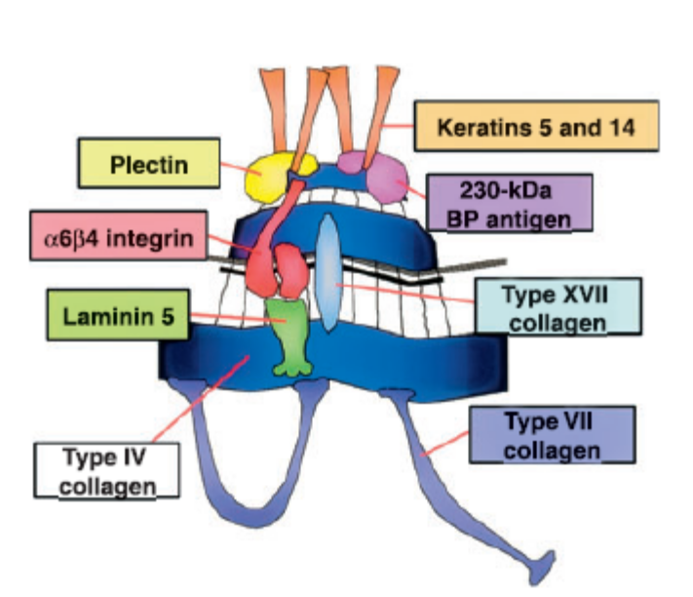
molecules, integrin a6b4 and type XVII collagen (also known as the 180-kDa BP antigen). Integrin a6b4 is the receptor for the extracellular ligand, laminin 5, which in turn binds to type VII collagen, the major component of anchoring fibrils. Type IV collagen forms a network in the lamina densa and is linked to laminin 5.

In addition, it has recently been shown that certain protein components of hemidesmosomes have more than just a structural role. Integrin a6b4 is able to transduce signals from the extracellular matrix to the interior of basal cells, modulating the organization of their cytoskeleton, and their proliferation, apoptosis and differentiation. Furthermore, interactions between type VII collagen and laminin 5 have been shown to play a role in tumour cell invasion in epidermal neoplasia.

Clinical
All the above information was acquired through the advances in the areas of electron microscopy, biochemistry, molecular biology and medical genetics, with the study of diseases that result in specific defects of components of the DEJ.

Inherited disorders
Mutations in the genes encoding proteins associated with hemidesmosomes result in the group of inherited skin fragility disorders known as epidermolysis bullosa (EB) Thus far, mutations in 10 different genes have been identified in different subtypes of EB. Targeted proteins include keratins 5 and 14, plectin, collagen types VII and XVII, a6b4 integrin, and laminin 5. The level of blister formation occurs close to the dermal–epidermal junction, but the exact plane of cleavage depends on precisely which gene ⁄ protein is mutated. In addition to skin blistering, several forms of EB have extracutaneous features, reflecting the tissue distribution of the abnormal protein. For example, plectin is present in skin and skeletal muscle and therefore plectin gene mutations result in EB associated with muscular dystrophy. There are no known inherited skin conditions with type IV collagen as the targeted protein; however, mutations in genes encoding for certain subtypes of type IV collagen result in Alport’s syndrome (haematuria, proteinuria and progressive renal failure), demonstrating the consequences of abnormal type IV collagen in the glomerular basement membrane of the kidney.

Acquired disorders
Many of the structural components serve as target autoantigens in the acquired autoimmune blistering skin diseases . For example, specific epitopes within the type XVII collagen protein are recognized by autoantibodies in BP. Type XVII collagen antibodies may also be found in mucous membrane pemphigoid, pemphigoid gestationis and linear IgA disease. Other proteins targeted by autoantibodies include laminin 5 in mucous membrane pemphigoid, and type VII collagen in epidermolysis bullosa acquisita or bullous systemic lupus erythematosus. Passive-transfer studies have shown that several of these autoantibodies may be directly pathogenic (i.e. cause blisters). However, data from animal models demonstrate that in BP the blister formation is dependent upon the activation of complement and generation of neutrophil-rich infiltrates, and it is the activity of neutrophil elastase that degrades type XVII collagen, producing subepidermal blisters. There are no known acquired skin conditions with antibodies targeting type IV collagen at the cutaneous basement membrane; however, in Goodpasture’s syndrome, lung haemorrhage and glomerulonephritis are caused by antibodies to type IV collagen in the basement membrane of the lungs and kidney, respectively
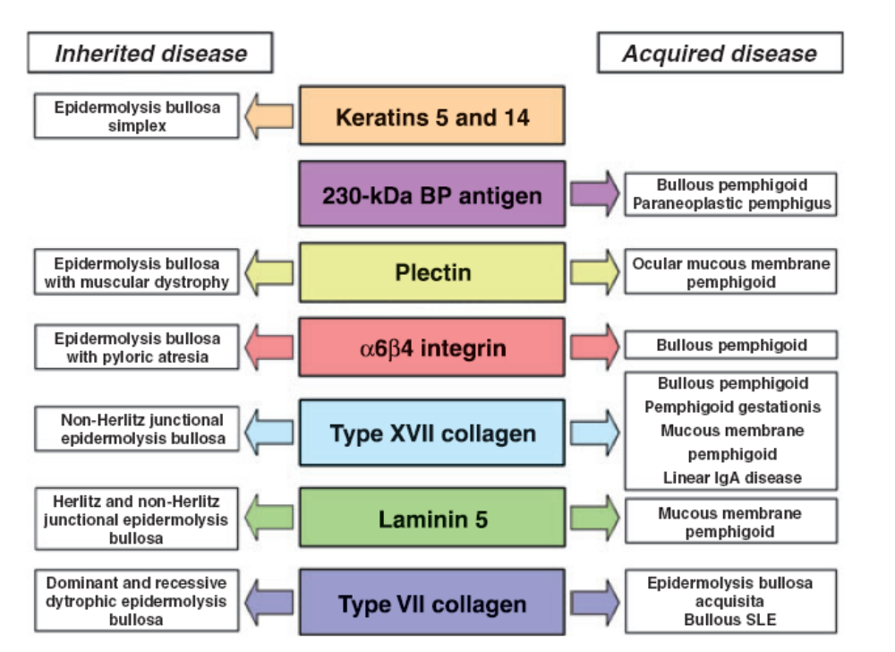
Reference
H. Fassihi, T. Wong, V. Wessagowit, J. A. McGrath and J. E. Mellerio. Target proteins in inherited and acquired blistering skin disorders. Clinical and Experimental Dermatology 2006;31: 252–259

Pigmentation of the skin
Fernanda Teixeira, Hammersmith Campus

Normal skin colour depends on several types of pigment, including:
- Haemoglobin, inside blood vessels in the dermis, and
- Melanin in the epidermis.

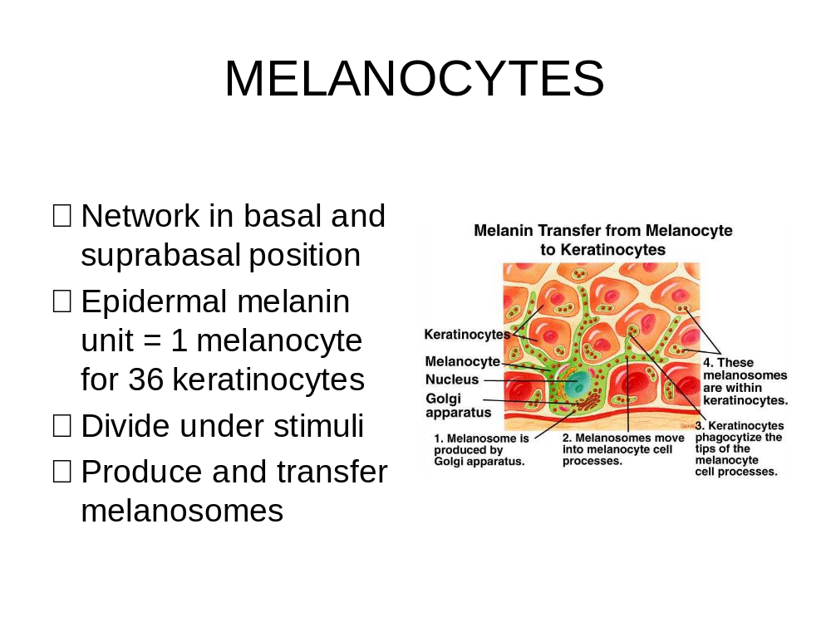

Melanin is produced by melanocytes, cells that originate in the neural crest of the embryo and migrate into the skin by the 8th week of gestation. By the 10th week, production of melanin is already evident. Melanocytes can be found in many tissues, but in the epidermis they are located among basal keratinocytes and in suprabasal position, where they form a network. Melanocytes can undergo cell division within the epidermis, although the mitotic rate is much lower than that of keratinocytes. One of the most important stimuli for melanocyte division is the exposure to ultraviolet radiation.

The melanin pigment can be of two main types:
- Eumelanin, which is black or brown and is insoluble, and
- Phaeomelanin, which is yellow or reddish-brown and is soluble in alkalis. It is found in human red hair, and in the feathers of red hens.
Both are derived from tyrosine, and share the same initial steps.
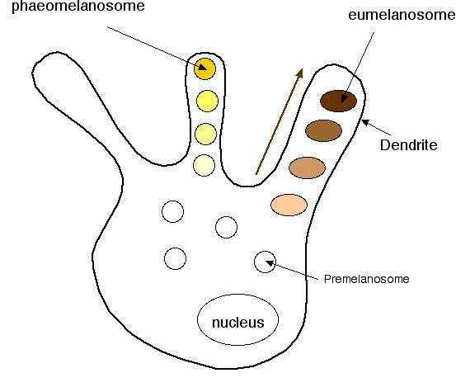

Tyrosine is oxidized to DOPA (3,4, dihydroxyphenylalanine) by the enzyme tyrosinase, which also catalyses the next step, in which DOPA is further oxidised to dopaquinone. From dopaquinone, the pathways to the formation of eumelanin and pheomelanin diverge. For eumelanin synthesis, dopaquinone is oxidized to dopachrome and then is rearranged to form DICA (5,6-dihydroxyindole-2-carboxylic acid), in the presence of zinc, copper, cobalt and nickel as catalysts. The synthesis of phaeomelanin involves the addition of the SH group of cysteine or glutathione to dopaquinone, to form cysteinyldopa or glutathionedopa.

Melanin synthesis is regulated by melanocyte-stimulating hormone (alpha MSH), a peptide derived from a pituitary protein called pro-opiocortin. MSH is uptaken by receptors on the surface of melanocytes, and proceeds to stimulate the cell’s cAMP activity and increase its tyrosinase activity. Darkening of the skin is observed in patients who have increased levels of MSH, as in Addison’s disease- an entity in which the adrenal glands are damaged either by infection or by auto-immune destruction. MSH is also produced by keratinocytes and melanocytes in the skin; this peptide can function, therefore, in a paracrine or autocrine manner.

Melanin is packaged in the cytoplasm of melanocytes, within granules called melanosomes. These organelles are classified into four stages, according to their activity of tyrosinase and their amount of pigment; tyrosinase activity decreases progressively, whereas the amount of melanin increases progressively from stages 1 to 4. Under the transmission electron microscope, stage 1 melanosomes are membrane-bound, spherical vesicles derived from the Golgi apparatus, that contain filaments with a periodicity of 7 nm (the melanofilaments). Stage 2 melanosomes are oval in shape and show numerous melanofilaments, with and without cross-linking. In stage 3, the internal structure of the melanosome is partially obscured by dense deposition of melanin, and by stage 4, the mature melanosome is an electron-dense particle.

Melanin is found in melanocytes and also in keratinocytes, particularly those in the basal layer. The transfer of pigment from the former to the latter has been studied by electron microscopy, and has been shown to involve the participation of both cell types. Melanocytes contain fine cytoplasmic filaments, which seem to be concerned with the movement of melanosomes inside their cytoplasm. The melanocyte embeds the tip of one of its cell processes inside the cytoplasm of a keratinocyte, and transfers melanosomes to its tip. This is pinched off by the keratinocyte, which will have the melanosomes incorporated into a cytoplasmic phagosome. Each melanocyte is in contact with about 36 keratinocytes, and each such group of cells is termed an epidermal melanin unit.

Melanin is fundamental for health, as it protects the lower layers of the skin against ultraviolet radiation, which produces changes in the DNA of keratinocytes and induces the formation of several types of skin cancer. Melanin absorbs ultraviolet radiation and is also activated to a free radical by light, so that it may serve to eliminate genetically damaged cells by a phototoxic mechanism. Black skin has an inherent sun protection factor of about 5, and absorbs and disperses ultraviolet radiation more effectively than fair skins, so that it prevents the ageing of the skin and the generation of cutaneous tumours. On the other hand, it has been proposed that the synthesis of vitamin D is less effective in darker skins – an idea that still has to be confirmed.

Tanning

Our normal skin colour, also called constitutive skin colour, is determined genetically by polyallely, and three to four gene pairs are involved in determining the hue of a person’s skin. The constitutive skin colour depends on the amount of melanin present in the skin, and also on the way in which it is distributed. Although the concentration of melanocytes per unit surface area varies markedly in different areas of the body, there are no significant differences among races in the number of distribution of melanocytes in the skin. In persons with darker skin, there is increased production, distribution and retention of melanin, but the number of melanocytes is the same as in a very fair individual. Melanosomes in black skin are large, dense, numerous, and distributed singly to epidermal cells. The relative size of the melanosomes correlates with tone in black skin, darker skin having larger melanosomes. In the skin of fair individuals, melanosomes are smaller, less dense, fewer in number and distributed in clusters enclosed in lysosomes, that will degrade them.
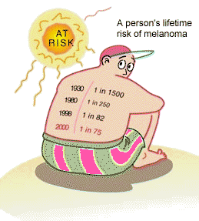

Under the sun, many individuals will develop a tan- this is their inducible skin colour. Others, however, will always burn and will be unable to tan. Based on the sensitivity to the sun, the American dermatologist Thomas Fitzpatrick proposed a classification of six skin phototypes:

Skin Type | Sun sensitivity | Tanning
I | Burns easily | Never tans
II | Always burns | Minimal tan
III | Burns moderately | Trans gradually (light brown)
IV | Burns minimally | Tans easily (brown)
V | Rarely burns | Tans easily (dark brown)
VI | Never burns | Tans easily (black)

There are two types of tanning: immediate pigment darkening, and delayed tanning reaction. The former happens within five minutes of exposure to long-wave ultraviolet radiation (UVA, 320 – 400 nm) and seems to be due to oxidation of pre-formed melanin. This reaction is short-lived. In contrast, in the delayed tanning reaction there is production of new pigment, a phenomenon that will take about 24 hours to occur. It is produced by exposure to UVA and medium-wave ultraviolet radiation (UVB, 290 – 320 nm), and results from the proliferation of melanocytes, increase in their tyrosinase activity, intense production of new melanosomes and enhanced transfer of melanosomes to keratinocytes. The delayed tanning reaction is long-lived.

The solar spectrum. Effects of ultraviolet light on the skin.

Electromagnetic waves are capable of traveling through a vacuum. Electromagnetic waves exist with an enormous range of frequencies, known as the electromagnetic spectrum. The entire range of the spectrum is often broken into specific regions. The diagram below depicts the electromagnetic spectrum and its various regions. The longer wavelength, lower frequency regions are located on the upper part of the spectrum and the shorter wavelength, higher frequency regions are on the lower part. Two very narrow regions with the spectrum are the visible light region and the X-ray region

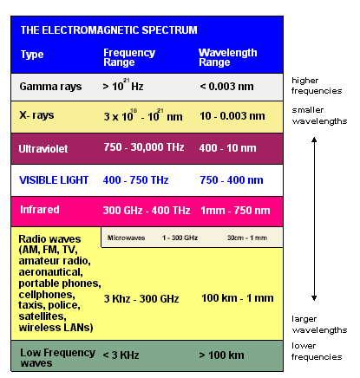

Ultraviolet radiation (UVR) is a very important area of the spectrum in Dermatology, because it is the most important preventable risk factor for skin cancer.

UVR:
• Damages skin (sunburn, premature aging and cancer)
• Damages eyes (keratitis and cataracts)
• Suppresses immunity in the skin and internally
• Predisposes to bacterial and viral skin infection
• Exacerbates pre-existing solar keratoses
• Prevents innate immunity from rejecting skin tumours

UVR levels are affected by:
• The angle of the sun: the higher the sun in the sky, the higher the UVR level. This
means UVR levels vary with the time of the day and the time of year.
• Latitude: the closer to equatorial regions, the higher the UVR levels.
• Cloud cover: UVR levels are highest on a clear day, but even with cloud cover,
UVR can be high. And with scattered cloud it can be even higher because of
reflection.
• Altitude: the thinner atmosphere at higher altitudes means less UVR is absorbed.
UV increases by four percent for each 300m increase in altitude.
• Ozone: ozone absorbs some UVR that would otherwise reach the Earth's surface.
Ozone levels vary over the year and even across the day.
• Reflection: UVR is reflected by different surfaces e.g. fresh snow can reflect as
much as 80 percent of UVR, sand about 15 percent and sea foam about 25
percent.

UVR that reaches the Earth's surface can be divided into UV-B (290-320 nm) and UV-A (320-400 nm). UV-A can be further subdivided into UV-A I, or far UV-A (340-400 nm), and UV-A II, or near UV-A (320-340 nm). UVC radiation (10 – 290 nm) is absorbed by atmosphere and does not reach the Earth’s surface.

The US Food and Drug Administration (FDA) regulates sunscreen products as over-the-counter drugs. The sun protection factor (SPF) is defined as the dose of UVR required to produce minimal erythema (that is, a mild blush) on the skin protected with 2 mg/cm2 of sunscreen, divided by the UVR required to produce a faint blush on unprotected skin. A water-resistant product is defined as the one that can maintain the SPF level after 40 minutes of water immersion, whereas a very water-resistant (formerly waterproof) product maintains the SPF level after 80 minutes of water immersion. A broad-spectrum or full-spectrum sunscreen provides both UV-B and UV-A protection, ideally through the entire UV-A I and UV-A II range.

Although sunscreens provide excellent UV-B protection, they lack in UV-A protection, particularly UV-A I. With the availability of higher SPF products allowing individuals to spend greater amounts of time in the sun without burning, concerns have been raised about the adequacy of the UV-A protection of these products. In fact, individuals relying on sunscreens as their sole form of photoprotection may now be subject to greater cumulative sun exposure, including UV-A radiation. Sun avoidance remains the most desirable form of sun protection. Sunscreen should be applied 15-30 minutes prior to sun exposure to allow sufficient time for a protective film to develop. Sunscreen should be reapplied after prolonged swimming or vigorous activity. Sunscreen needs to be applied liberally. As much as 1 oz may be needed to cover the entire body. Particular attention needs to be paid to the back of the neck, the ears, and the areas of the scalp with thin hair

Simply staying indoors is obviously the best way of avoiding the sun. However, encouraging individuals to time outdoor exposure to avoid the hours when the sun is at its zenith is more practical. Trying to schedule activities before 10 am and after 4 pm avoids solar exposure at times of peak intensity. Individuals need to be reminded that on cloudy days as much as 80% of UVR may still penetrate the cloud cover. Shade availability in recreational areas is also desirable despite difficulty in accurately estimating the protective effects with varying reflection and penetration in different environments. Window glass absorbs most of the radiation below 320 nm; however, considerable amounts of UV-A radiation may still pass through glass. Special plastic films containing UV-A shields as an interleaf or overlay are available.

Clothing can be an excellent form of sun protection. The most important determinant is tightness of the weave. Fabric type is less important. Thickness is also less important than regular weave. Protection drops significantly when the fabric becomes wet. Color plays a minor role, with dark colors protecting better than light colors. A crude test of clothing is to hold it up to visible light and observe the penetration. Hats are the most important articles of clothing. A 4-inch wide circumferential brim is required to cover the entire face and neck.
Organisation of the Skin Immune System

Tony Chu, Hammersmith Campus

Learning objectives:
1. To be able to list the principle immune cells in the skin.
2. To understand what the principle role is of the skin immune cells.
3. To know which cells interact and why.

The skin protects the body and is the largest immune surveillance organ of the body.
Several cells are involved in protecting the skin, detecting and responding to pathogens.

The keratinocyte
96% of the cells in the epidermis
Morphology changes as they mature:

Basal layer: Cubiod, Cell, division repair
Prickle cell layer: Polygonal, appearance of lamellar bodies
Granular layer: Flattened, Highly granular, Keratohyalin granules
Stratum Corneliun: Flat, No nucleus: Protective Barrier

Desquamination: Shedding of contacting pathogens

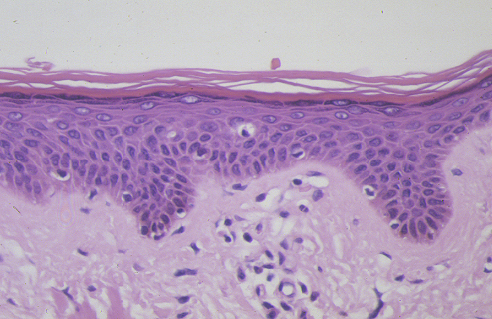

Role in Immunity:
Initiation and control of inflammation
Modulation of Immunity
Interacts with Melanocytes, Langerhans cells, memory T-cells and cytotoxic T-cells
Produce a large number of cytokines
Produce antimicrobial products; including nitric oxide, β-defensins and LL-37. Express Toll-like Receptors that recognise pathogens to stimulate danger signals

Cytokines produced by kerationocytes

- Pro-inflammatory cytokines
  - IL1
  - GM-CSF
  - TNFa
  - IL6
  - IL7
  - IL12
  - IL15
  - IL18

- Growth Factors
  - GM-CSF – moncytes/macrophages
  - IL7 – B cells
  - IL15 – T cells
  - SCF – Mast cells
  - VEGF – blood vessels

- Chemoattractant Cytokines
  - IL1 – neutrophils and macrophages
  - CCL27 – T cells
  - CCL5 – eosinophils and memory T cells
  - CXCL10 – T cells
  - Mig – T cells
  - IP9 – T cells
  - CCL20 – Langerhans cells

- Down regulatory cytokines
  - IL1Ra
  - IL10
  - a-MSH
  - CXCL10
  - PGE2

The Langerhans cell (LC)
- 1-2% of cells in the epidermis
- Derived from CD34+ bone marrow precursors
- Migrates to the skin – expresses CTA - Cells express CCR6 receptor for CCL20 produced by keratinocytes
- Localised in the basal and suprabasal layers of the epidermis
- Forms a regular network with their protrusions spanning the epidermis
- Expresses a unique phenotype – CD1a, Langerin, HLA DR.

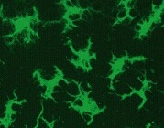

Ultra-structural examination:
Interdigitating shape, Lobulated nucleus and clear cytoplasm containing Birbeck but lacking tonofilaments and desmosomes.

Role in Immunity:
- Represents the antigen presenting dendritic cell of the skin
- Recognition of Danger signals
- Central to immune surveillance in the skin
- Target for allogeneic attack
- Immature dendritic cells of the skin
- Activation changes function
- Processing and presentation of antigen
- Transport of antigens to regional lymph nodes
- Expression of additional stimulatory molecules and
stimulation of naïve T-cells
- Presentation of antigen to memory cells in-loco

Interacts with Keratinocytes, endothelium, Naive and memory T-cells

The Mast Cell
Resident in dermis
10,000 /mm³
Rounded / Ovoid
Contain secreatory granules
Near hair follicles, sebaceous and sweat glands and near blood vessels
IgE receptors
Toll-Like Receptors
complement receptors

Role in immunity:
- Recognition, Phagocytosis and killing of bacteria
- Increased vasodilation and chemotaxis
- Produces cytokines: IL-4, IL-5, IL-6, IL-13 and TNFα
- Immunoglobulin E antibody activation
(involved in parasite reactions and allergy)

Lymphocytes: T-Cells
Lymphocyes 7-12 µm in diameter
Nucleus occupies most of the cell
Infiltrate from blood and leave through lymphatics
CLA expressed by 15% circulating T-cells – homing for skin
In normal skiun predominant phenotype is CD8, in inflammatory reactions it is the CD4 T cell

Role in immunity:
- Memory cells survey skin for recurrent infections
- Provide help to boost immune response
- Cytotoxic killing
- Peripherial tolerance

Helper T Cells: TCR and CD4 co-receptor,
recognise MHC class II + peptide
Cytotoxic or Killer T Cells: TCR and CD8 co-receptor
recognises MHC class I + peptide

Location of T-cells within Skin:
Intraepidermal cells
- 2% of skin T-cells
- Predominance of CD8’s over CD4’s
- Shift to CD4 predominance in epidermis following UV irradiation

Dermal T-cells
- 98% of Skin T-cells
- Predominantly CD4s

Tissue resident Macrophages
Macrophages 15-80 µm in diameter with irregular shapped nucleus
Cells contains phagocytic vacuoles
Resident in dermis
Mature from blood monocytes

Role in immunity:
- Engulf and eliminate pathogens
- Present Antigens
- Provide costimulation of T-cells by IL-12 generation

Interact with T-cells by contact and cytokine generation

Interaction by soluble Protein Messengers
Types of Cytokine
- Interleukins (IL-X) – Interactions between leukocytes
- Interferons (IFNx) – Anti-viral effects
- Chemokines – attraction, chemotaxis, movement
- Cytotoxic – Tumour necrosis factor (TNF)

Non-cytokines:
- Antibodies – Recognition of foreign pathogens
- Complement components – Chemotaxis

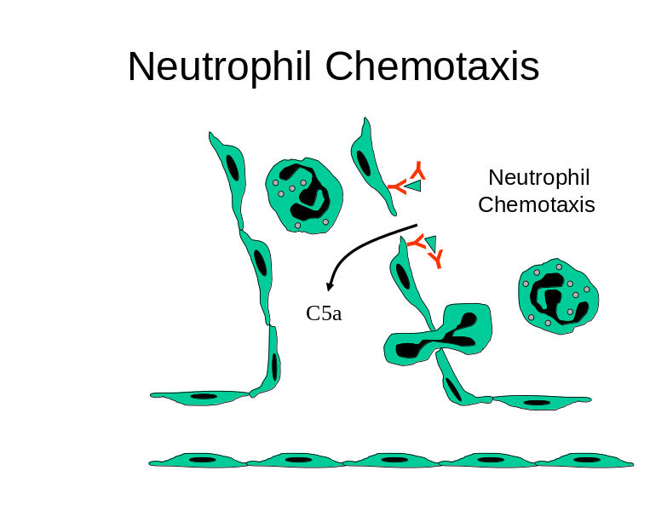

Interaction by Cell contact
Types of Receptor
- Major Histiocompatability Complex (MHC) – Presentation of peptides
- T-Cell Receptors (TCR) – Recognition of self/non-self peptides
- Co-stimulatiory Molecules – Danger and cell survival signals

Function of the Skin
Tony Chu, Hammersmith Campus

Role in Social and Sexual Interactions
The skin plays a major part in our social and sexual interactions. To display sexuality or to exert social status it is necessary to have skin and hair which looks, feels and smells attractive. The importance of the skin in social and sexual interactions is highlighted by the effect of disfiguring skin conditions or other disfiguring conditions on this important activity. People with disfigurement will often perceive themselves to be unattractive and this will have an impact on their quality of life and their confidence in social and other interactions. This may lead to general loss of confidence; unwillingness to partake in various activities which may display the disfigured areas of skin, reclusiveness, depression and suicidal ideation.

Studies have been conducted examining the effect of various diseases on physical and mental quality of life indices. Skin disease ranks high as having a significant effect on quality of life and diseases such as psoriasis and acne have a greater effect on mental quality of life than diseases such as myocardial infarction and rheumatoid arthritis.

Skin as a barrier:
The skin acts as a two-way barrier to prevent inward and outward passage of water and electrolytes. Much of this function resides in the epidermis and much of the epidermal barrier is localised to the stratum corneum. The barrier depends on both the fibrillar material of the keratinocyte and the intercellular material, particularly lipid. Within keratinocytes are synthesised both the fibrous protein of keratin and the histidine rich protein known as keratohyalin or flaggrin. As keratinocytes develop into corneocytes they are surrounded by an envelope formed by cross-linkage of a precursors of involucrin and keratohyalin which forms an insoluble exoskeleton and acts as a ridged scaffold for the internal keratin filaments.

The intercellular cement is the product of ovoid organelles known as membrane coated granules or Odland bodies. Odland bodies first become identified in the cells of the spinus layer and migrate to the cell periphery where they fuse with the plasma membrane in the granular cell layer. They then discharge their contents into the intercellular spaces, which expand to form 10-40% of the total volume of the tissue. As keratinocytes mature neutral lipids and sphingolipids in particular ceramides are increased. Within the Odland bodies biolayers become arranged to form discs which represent flattened uni-lamellar liposomes. After extrusion in the intercellular space the discs become arranged parallel to the cell membrane and then fuse to form uninterrupted sheets or intercellular lamellae consist of two lipid biolayers in close apposition. These intercellular lamellae are the main barrier for transepidermal water loss and also for the prevention of water absorption through the skin.

Percutaneous Absorption
The skin is a target of many different drugs that can be absorbed either locally into the skin for the treatment of various skin conditions or absorbed into the bloodstream for systemic therapy – common examples are nicotine patches for those trying to give up cigarettes, forms of hormone replacement therapy and topical non-steroidal anti-inflammatory agents used in arthritis. Human skin is slightly permeable to water but is relatively impermeable to sodium, potassium or other ions in aqueous solution. In general, drug penetration rates are determined largely by their lipid water co-efficient, water soluble ions and polar molecules being excluded. Percutaneous absorption is affected by a number of factors, such as, age, environmental conditions and physical trauma. The efficiency of the barrier also differs between body sites. The scrotum is particularly permeable and the face, forehead and dorsum of the hands may be more permeable to water than trunk, arms and legs. In diseased skin, where the stratum corneum is improperly formed, drug absorption may be greatly increased.

Protection against micro-organisms and destructive chemicals
An intact stratum corneum prevents invasion of the skin by normal skin flora or pathogenic microorganisms. Minor injury as well as skin disease can provide portals of entry of microorganisms by breakdown of this barrier function. Sebaceous lipids are reported to possess antibacterial properties and glycophospho-lipids and free fatty acids of the stratum corneum have bacterio-static effects selective for pathogenic organisms. The innate and adaptive immune responses in the skin will be discussed in a later lecture.

Blood Vessels and Nerves

Dr Sue May Ang - Learning Objectives
- Understand the size, structure and organization of blood vessels in the skin
- Understand the different mechanisms to control skin perfusion
- Recognize the different nerve endings in the skin and function
- Recognize the role of the sympathetic nervous system in efferent nerves

Blood Vessesls

Structure
Aorta 24,000µm Arterioles 20-200µm Capillary(RBC) 6µm Venule 20-500µm

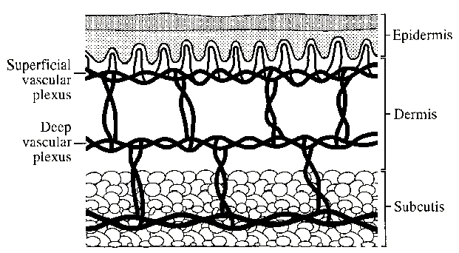

Arteries enter the skin from the fascial network. From here vessels rise to the border between the subcutaneous adipose tissue and the dermis and these form the deep plexus. This gives branches to the various cutaneous appendages (eg sweat glands, hair follicle) and provides ascending arterioles to supply the superficial plexus which itself forms capillary loops in the papillary layer between the ridges of the dermo-epidermal junction. The vascular network is more elaborate than would be necessary solely for nutrition of the skin and temperature control is an important function.

Cellular Components
- Endothelial Cells – single layer
- Pericyte – contractile, maintains static vascular achitechture, multilayered in venules
- Basement Membrane – Type IV collagen, laminin
- Veil Cell – Function ? , unique to the skin

Control of Skin Perfusion
- Vascular tone

- Precapillary sphinters – can affect a x1000 fold difference in cross sectional area and therefore flow
- AV shunts – shunts mainly at the deep plexus. Usually only 60% open. Found in acral sites (hands, feet) and earlobes
These are under autonomic (sympathetic) control and can also respond to local factors (eg vasodilation 2er ischaemia).
Used for THERMOREGULATION

Blood Vessels – Function
- Coagulation – Weibel-Palade Body in venuous endothelial cells
- Cell Traffiking – expression of adhesion molecules for WBC eg selectin P,E for adhesion, ICAM 1,2 and VCAM for adhesion for cell migration out of vasculature
- Angiogenesis following injury. Angiogenesis can be induced in chronic inflammatory condition eg psoriasis and cancer. Interactions between the Angiopoetins and VEGF ( see lecture slides)
- Localized neurogenic inflammation. Nerves can respond to local stimuli by inducing a local chemotactic inflammatory response.

Lymphatic system
The lymphatic system serves to transport cells and liquid material from the extra cellular compartment of the dermis to regional lymph nodes and thus back to the circulation.

Nerves and sense organs
The skin is innervated by around 1 million afferent nerve fibres. Most terminate in the face and extremities. Relatively few supply the back. Cutaneous nerves contain axons with cell bodies in the dorsal root ganglia. The main nerve trunks enter the subdermal fatty tissue and then divide into small bundles. Groups of myelinated fibres fan out in a horizontal plane to form a branching network from which fibres ascend, usually accompanying blood vessels to form a web of interlacing nerves in the superficial dermis. Throughout their course the axons are enveloped in Schwann cells. Most end in the dermis but some penetrate the basement membrane but do not travel far into the epidermis. Sensory endings are of two kinds: corpuscular, which embrace non-nervous elements and free, which do not. Corpuscular endings can be subdivided into encapsulated receptors and non-encapsulated receptors exemplified by the Merkel cell within the epidermis.

Free nerve endings, which appear to be derived from non-myelinated fibres, occur in the superficial dermis and in the overlying epidermis. Those in the dermis are arranged in a tuft like manner and are called penicillate nerve endings. Hair follicles have nerve terminals of varying degrees of complexity. Fine nerve filaments run parallel to and encircle the hair follicles forming a palisade. These are the most common nerves found in the skin and are polymodal i.e. can transmit multiple sensory modalities
Meissner’s Corpuscle – lamellated, encapsulated, unmyelinated. Found in the superficial dermis is concentrated in non-hair bearing skin. It mediates light touch

The Pacinian corpuscle is an ovoid structure about 1 mm in length found within the dermis, which is a striking example of an encapsulated receptor. The corpuscle is laminated in cross-section like an onion and is innervated by myelinated sensory axons. It is located deeper in the dermis and mediates deep touch (pressure and vibration)
Efferent nerves from the sympathetic nervous system innervate vasculature, eccrine glands, arrector pili muscles of the pilosebaceous unit.

The Merkel cell -These cells are located in the basal layer of the epidermis, in close proximity to axonal processes, and are believed to be involved in sensory perception (sustained touch and pressure). Although they can be found on the whole surface of the skin, they are more numerous on more sensitive areas, as the tip of the nose, the lips, around hair follicles or the fingertips.
Merkel cells are not seen in routine histologic preparations, and electron microscopy and immunostaining are required for their identification. Under transmission electron microscopy, Merkel cells are seen to contain dense granules that are morphologically identical to the chromaffin granules found in the adrenal medulla. Although they do not contain catecholamines, other substances, as metencephalin, ACTH, substance P, bombesin and vasoactive intestinal polypeptide have been found in Merkel cells. Neurofilaments can be found as perinuclear balls.
In spite of the controversy regarding the origin of Merkel cells- neuroectodermal versus ectodermal- they contain keratin filaments and desmosomes, and very probably are of epithelial derivation. It is believed that traction on the epidermis is transmitted to Merkel cells, which stimulate the nearby axons, so contributing to local sensation

Sensory Pathway

Modality | Nerve Ending | Fibre
Touch | Meissner ,Pacinian, Free | Aβ
Touch, Pressure | Merkel, Ruffini, free | Aβ, Aδ
Vibration | Meissners, Pacinian | Aβ
Temperature | Thermoreceptor | Aδ, C
Pain | Free nociceptor | Free, Aδ, C

Nerves then ascend via the spinothalamic tracts – contra laterally from the level of insertion to the spinal cord to the thalamus or the doral columns tracts - ipsilaterally from the level of insertion to the spinal cord to the thalamus (where they cross the midline).

WOUND HEALING

Fernanda Teixeira, Hammersmith Campus

After injury to the skin, two broad types of healing can occur: regeneration and repair. In regeneration, there is restitution of the skin to its previous texture, although there might be some changes in the pigmentation that tend to improve with time. During repair, a scar is formed, which won’t ever disappear, although treatments can be used to improve its appearance.

Phases of the healing process in the skin

Healing is the result of the interaction of many events, that can be divided into three phases: the inflammatory, proliferative and maturation phases.

In the first phase, for example, following a cut in the skin, there will be disruption of the normal structures, rupture of blood vessels and bleeding. When bleeding stops, a clot will be present at the area of damage. The clot is a very important element of healing, as it contains white blood cells that contain growth factors that will be important for cell proliferation and increased cell activity. Also, histamine released from platelets anc circulating mast cells produce vasodilatation and increased permeability of the post-capillary venules, so that the affected area will be red and swollen. Cell debris originated from the trauma are also important, especially cell membranes, which contain phospholipases, that stimulate the production of prostaglandins, which will also help to dilate the arterioles to the skin.

The macrophages present in the clot, and the ones that come through the dilated blood vessels, arrive to the area of damage and start actively phagocytosing the dead cell products. These cells also secrete collagenases and elastases, which break down the affected tissue. They also secrete growth factors, particularly Platelet-derived growth factor (PDGF), an important cytokine that will attract the migration of fibroblasts to the area and their proliferation, so that new collagen will be deposited and a scar will be formed. Macrophages also produce angiogenesis factors, that is, cytokines that will promote the proliferation of endothelial cells and formation of new blood vessels that will infiltrate and bridge the damaged area. This new tissue, composed of many fibroblasts, numerous newly formed blood vessels and a soft matrix, rich in collagen type III and glucosaminoglycans, is called granulation tissue. By days 3 to 5 after injury, granulation tissue should already be seen. The granulation tissue is typical of the proliferative phase of healing.

Meanwhile, the epidermis , when cut, is replaced by a scab, formed by the blood clot. The dead epithelium also produces many cytokines, particularly epithelial growth factor (EGF). This will stimulate basal cells on the margins to proliferate, and migrate over the denuded surface and under the scab, at a speed of 7 micrometers per hour. The newly-formed epithelium subsequently becomes thicker by the proferation of basal cells and formation of the intermediate and superficial layers of the epidermis. When the scab finally detaches, a new epidermis is found underneath it.

After the first 5 days of granulation tissue formation, collagen type III begins to be replaced by collagen type I. The synthesis and deposition of collagen is a critical event in the proliferative phase and to wound healing in general. Collagen consists of 3 polypeptide chains, each twisted into a left-handed helix. Three chains of collagen aggregate by covalent bonds and twist into a right-handed superhelix, forming the basic collagen unit. A striking structural feature of collagen is that every third amino acid is glycine. This repeating structural feature is an absolute requirement for triple-helix formation. Collagen is rich in hydroxylysine and hydroxyproline moieties, which enable it to form strong cross-links. The hydroxylation of proline and lysine residues depends on the presence of oxygen, vitamin C, ferrous iron, and a-ketoglutarate. Deficiencies of oxygen and vitamin C, in particular, result in underhydroxylated collagen that is less capable of forming strong cross-links and, therefore, is more vulnerable to breakdown.
Collagen is secreted to the extracellular space in the form of procollagen. This form is then cleaved of its terminal segments and called tropocollagen. Tropocollagen can aggregate with other tropocollagen molecules to form collagen filaments. Filaments consist of tropocollagen molecules arrayed in a staggered fashion, joined by intermolecular cross-links. Filaments aggregate to form fibrils. Collagen fibrils, in turn, aggregate to form collagen fibers.

In the maturation phase, collagen type III is replaced by collagen type I, the number of newly formed blood vessels decreases, and the amount of glucosaminoglycans of the matrix diminishes. As a consequence, the soft, red appearance of the early scar is progressively replaced by a harder, whiter scar. Myofibroblasts, cells with the appearance of fibroblasts, but which also contain actin filaments, appear in the maturation phase. Their function is to contract the scar, so that it will become narrower.

The full maturation of a scar in the skin can take up to 12 months, and even so, the tensile strength of the scar will never be the same as that of the uninjured skin- at most, will reach 80%.

Closure by primary intention and secondary intention

A wound is said to be closed by primary intention when it is approximated, usually by suturing. This will approximate the borders, and promote faster healing, with a smaller scar. In closure by secondary intention, the would is left to heal by itself. This occurs, for example, when the would is infected, and it is not advisable to close the area. Secondary intention will produce larger scars.

Complications in the process of healing

The process of would healing can go wrong in many ways.

Vitamin C is essential for collagen synthesis. Persons with deficiency of this vitamin will have difficulty to heal. In diabetics, glucose molecules are attached to all types of proteins- a process called non-enzymatic glycosylation. This makes proteins less active, including proteins important for the defense agains bacterial infection. Healing takes much longer in diabetics, and the risk of infection is high.

Keloids are dermal fibrotic lesions that are a variation of the normal wound healing process. They usually occur during the healing of a deep skin wound, because of excessive production of extracellular matrix proteins, collagen, elastin, and proteoglycans, presumably due to a prolonged inflammatory process in the wound.
Hypertrophic scars are raised, erythematous, fibrotic lesions that usually remain confined within the borders of the original wound. These scars occur within months of the initial trauma and have a tendency to remain stable or regress with time. In contrast, keloid formation can occur within a year after injury, and keloids enlarge well beyond the original scar margin. The most frequently involved sites of keloids are areas of the body that are constantly subjected to high skin tension. Wounds on the anterior chest, shoulders, and anterior neck and wounds that cross skin tension lines are more susceptible to abnormal scar formation. Keloids are also common in the earlobes, after piercing.
The most important risk factor for the development of abnormal scars such as keloids is a wound healing by secondary intention, especially if healing time is greater than 3 weeks. Wounds subjected to a prolonged inflammation, whether due to a foreign body, infection, burn, or inadequate wound closure, are at risk of abnormal scar formation. Areas of chronic inflammation, such as an earring site or a site of repeated trauma, are also more likely to develop keloids. Occasionally, spontaneous keloids occur without a history of trauma.
After the initial insult to the skin and the formation of a wound clot, the balance between granulation tissue degradation and biosynthesis becomes essential to adequate healing. Extensive studies of the biochemical and cellular composition of keloids compared to mature scar tissue demonstrate significant differences. Keloids have an increased blood vessel density, a thickened epidermal layer, and increased mucinous ground substance. The myofibroblasts important for contraction of the scar are few, if present at all.
The collagen fibrils in keloids are more irregular and abnormally thick. Biochemical differences in collagen content in normal scars and keloids have been examined in numerous studies. Collagen synthesis in keloids is 20 times greater than in normal scars. Collagen cross-linking is greater in normal scars, while keloids have immature cross-links that do not form normal scar stability.
These changes seem to be mediated by cytokines. Keloids demonstrate an amplified production of tumor necrosis factor (TNF)–alpha, interferon (INF)–beta, and interleukin-6. Production of INF-alpha, INF-gamma, and TNF-beta is diminished. INF-alpha, INF-beta, and INF-gamma reduce fibroblast synthesis of collagen types I, and III.
This abnormal cytokine production is possibly due to genetic predisposition. Associations for the development of abnormal scars have been found for HLA-B14, HLA-B21, HLA-BW16, HLA-BW35, HLA-DR5, HLA-DQW3, and blood group A. No consistent pattern exists in the mode of genetic transmission, which is reported to occur as both an autosomal dominant and autosomal recessive pattern.

Cytokines
Cytokines have emerged as important mediators of wound healing events. By definition, a cytokine is a protein mediator, released from various cell sources, which binds to cell surface receptors to stimulate a cell response. Cytokines can reach their target cell by endocrine, paracrine, autocrine, or intracrine routes. Some important cytokines are described as follows:

- Epidermal growth factor was the first cytokine described and is a potent mitogen for epithelial cells, endothelial cells, and fibroblasts. Epidermal growth factor stimulates fibronectin synthesis, angiogenesis, fibroplasia, and collagenase activity.

- Fibroblast growth factor is a mitogen for mesenchymal cells and an important stimulus for angiogenesis. Fibroblast growth factor is a mitogen for endothelial cells, fibroblasts, keratinocytes, and myoblasts. This factor also stimulates wound contraction and epithelialization and production of collagen, fibronectin, and proteoglycans.

- PDGF is released from the alpha granules of platelets and is responsible for the stimulation of neutrophils and macrophages and for the production of transforming growth factor-b. PDGF is a mitogen and chemotactic agent for fibroblasts and smooth muscle cells and stimulates angiogenesis, collagen synthesis, and collagenase. Vascular endothelial growth factor is similar to PDGF but does not bind the same receptors. Vascular endothelial growth factor is mitogenic for endothelial cells and plays an important role in angiogenesis.

- Transforming growth factor-b is released from the alpha granules of platelets and has been shown to regulate its own production in an autocrine manner. This factor is an important stimulant for fibroblast proliferation and the production of proteoglycans, collagen, and fibrin. The factor also promotes accumulation of the extracellular matrix and fibrosis. Transforming growth factor-b has been demonstrated to reduce scarring and to reverse the inhibition of wound healing by glucocorticoids.

- Tumor necrosis factor-a is produced by macrophages and stimulates angiogenesis and the synthesis of collagen and collagenase. Tumor necrosis factor-a is a mitogen for fibroblasts.

Thermoregulation

Sangeeta Punjabi, Hammersmith Campus

Introduction
The body’s core temperature is tightly regulated. The normal temperature for an individual is between 36.7 and 37ºC (if measured orally) and 0.6ºC higher when measured rectally. Mammals regulate their core temperature so they can function optimally, independently of the environment. The peripheral temperature of the skin changes with both the core temperature and the environment and has a much wider spectrum.

Sources of Heat
Basal Metabolic Rate
Muscle Activity
Effects of Thyroxine
Effects of Adrenaline, Noradrenaline & sympathetic stimulation

Sources of Heat Loss
Conduction 18%
Radiation 60%
Evaporation 22%

The Feedback Loop
When there is an imbalance between the rate of heat production and the rate of heat loss, the body reacts in a number of ways.
Temperature
Hypothalamus
Peripheral Sensors
Vasoconstriction
Piloerection
Shiver
Chemical Thermogenesis
Behaviour
Vasodilation
Sweat
Decrease heat production
Behaviour

Too hot
Too cold
-
+

Insulation
Fat is a poor conductor of heat. It conducts a 1/3 of amount of heat as other tissues. Subcutaneous fat is therefore an excellent insulator.

Dermal Capillary Network
The vascular supply to the skin far outweighs its metabolic needs. There is a network of arterioles and venules that form the dermal capillaries. The blood is supplied to these capillaries through muscular arteriovenous anastomoses. These are under sympathetic nervous control. The blood flow can vary from almost nothing to 30% of cardiac output.

When dilated, larger volumes of blood reach the surface of the skin and heat is conducted from the core more efficiently. In cold weather, very little blood reaches the superficial capillaries, minimising heat loss. Conductance can vary up to eight fold.

Sweating
For every gram of water that evaporates, 0.58 Calories of heat is lost. Insensible water loss from the skin and lungs account for 12-16 Calories per hour (about 600mls per day). This can not be controlled and is affected by the ambient humidity and the surrounding movement of air.
Sweating is under nervous control and can respond to changes in core and ambient temperature. Sweat ducts are innervated by sympathetic cholinergic nerve fibres. They also respond to adrenaline and noradrenaline.

A Sweat gland consists of 2 parts.
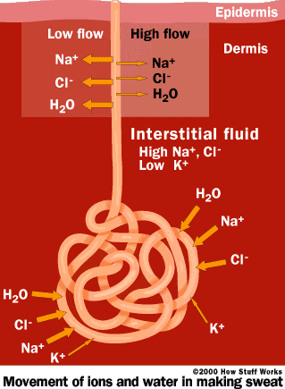
1. A Coiled subdermal component – this produces the sweat. It consists mainly of a protein free filtrate of the plasma and is secreted actively.

2. The sweat duct passes through the dermis and epidermis, opening to the surface of the skin as a sweat pore. Most of the sodium, chloride and therefore water are reabsorbed in the duct. This mainly leaves urea, lactic acid and potassium.
The Sodium content can vary, depending on the amount of sweat produced. It can be as low as 5mEq/litre when hardly sweating and absorption is at its highest to 60mEq/litre (about ½ concentration of plasma) when an unacclimatized person is sweating excessively and time for reabsorption is minimised. In this situation 15 to 30g of salt can be lost per day.

Sensors
The preoptic area in the anterior hypothalamus contains heat and cold sensitive neurones. These theromreceptors respond to the temperature of the blood in the hypothalamus and reflect the core temperature.
There are also thermoreceptors in the skin and a handful in the deep tissues such as around the spinal cord, abdominal viscera, near the great veins. These measure the peripheral temperature and the core temperature. Cold thermoreceptors predominate here and are primarily concerned in preventing cold induced injury and hypothermia.
The posterior hypothalamus processes the peripheral and central signals and co-ordinated the body’s response. The signals from the preoptic areas have a greater effect on the autonomic regulation of temperature. The peripheral signals have a greater effect on the ‘set-point’ of the hypothalamus.
During an fever caused by infection, pyogens in the circulation cause the set point to increase. The body then behaves as if it were cold until the new, higher set point is reached.

If Cold
- Vasoconstriction - sympathetic vasoconstriction of the dermal capillaries
- Piloerection – sympathetic stimulation of arrector pilli muscle. Decreases heat loss. More important mechanism in lower animals.
- Shivering – peripheral muscle tone is increased leading to shivering
- Chemical Thermogenesis – Cellular metabolism can be increase by adrenaline or noradrenaline. Brown fat which is found in infants is important in this context. Thyroxine is also upregulated.
- Behaviour – move, wear more clothes

If Hot
- Vasodilation - sympathetic inhibition of vasoconstriction of the dermal capillaries
- Sweating
- Decrease heat production – inhibition of shivering and chemical thermogenesis.
- Behaviour – move, wear less clothes, drink cold drink

Skin in Innate and acquired Immunity
Dr Bernadetta Brazzini
Learning objectives:
1. To be able to specify the types of immune response.
2. To understand how these responses differ
3. To be able to give an example of an Acquired immune reaction.

Innate system:
The innate immune system is responsible for the detection and control of initial immune insult Simplest mechanism of protection. Recognition molecules are already present and no refinement of receptors occurs. Rapid and no prior exposure is required.
- Initial response to bacteria, fungi and viruses
- Broad spectrum
- Prevents infection
- Damages cell wall of bacteria and fungi
- Removal by ingestion

Functions of Innate Immunity
- Danger signal
- Chemotaxis
- Phagocytosis and opsonisation
- Oxidative burst
- Inflammation
- Induction of Acute phase Proteins
- Complement mediated lysis

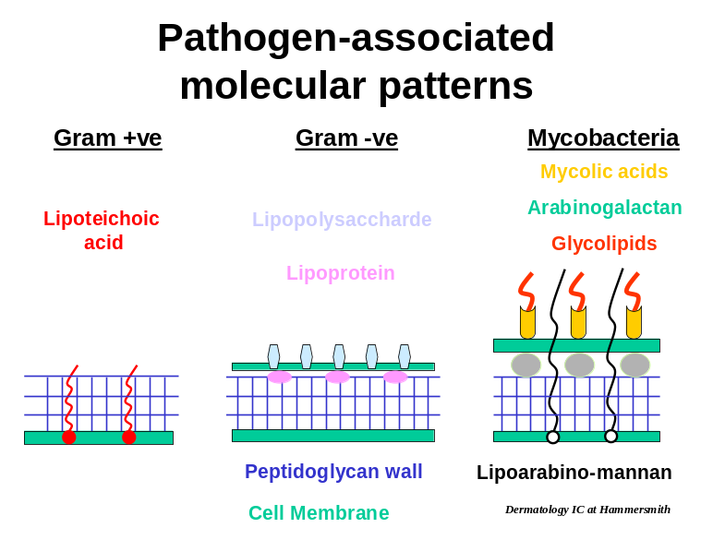

Innate system recognition of pathogens:
Pathogens have foreign molecules known as pathogen associated molecular patterns. These molecules are recognised as being non-human. Pattern recognition receptors stimulate cells to respond to the presence of non-self. Several families of receptors exist, including: Toll-like receptors, complement receptors (CR3) and CD14/ Lipopolysaccharide Binding Protein.

Complement components:
These have two roles in innate immunity:
- Assemble to for a membrane attack complex and destroy pathogens
- Chemotaxis
- Opsonise microbes to help with phagocytosis

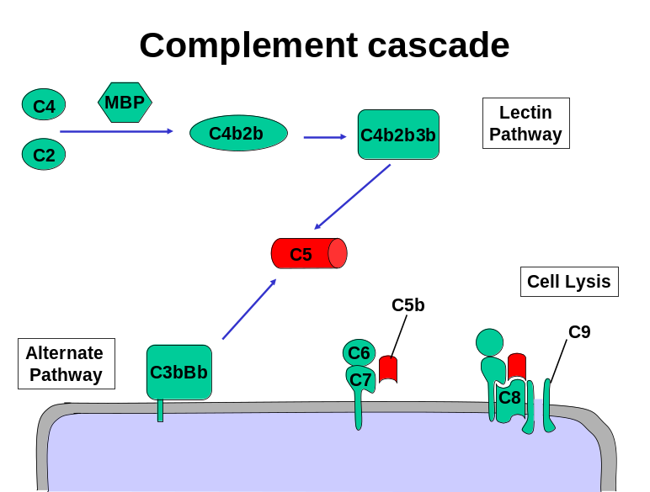

Lipopolysaccharide-binding protein:
- Lipopolysaccharide (LPS) is a pathogen specific pattern molecule
- Binds to Lipopolysaccharide-binding protein
- Stimulates CD14/ Toll-like receptor 4
- Danger signal
- Production of cytokines

Toll-like receptors (TLR):
In humans there are 10 toll-like receptors (TLR) with different binding specificities. TLRs are found on mast cells, macrophages, dendritic cells and epithelial cells.
- Cell surface pattern recognition receptors
- DNA encoded genes
- Recognise evolutionary conserved proteins within cell wall of bacteria and fungi
- Activates cell to produce chemokines and cytokines

Acquired System:
The Acquired system is responsible for the establishment of immunological recognition and memory of a particular pathogen. Requires danger signals from the Innate system and rearrangement of receptor DNA to generate specific recognition receptors. System requires: Specificity, Diversity, Memory, Self-limitation and tolerance
- Secondary response initiated by Innate response
- Generation of specific receptors to recognize bacteria, fungi or viruses
- Response to peptide/antigen
- Provides help for prolonged response
- Eliminates infected cells
- Creation of “memory” cells
B-cell receptor stimulation results in B-cell maturation into an antibody producing cell (plasma cell). T-cell receptor stimulation results in activation of naive T-cells and their proliferation.

Functions of Acquired Immune System:
- Recognition of Danger signals
- Generation of foreign peptides
- Transport and presentation of foreign peptides
- Maturation of T- and B-cells
- Life long surveillance and response to subsequent infection

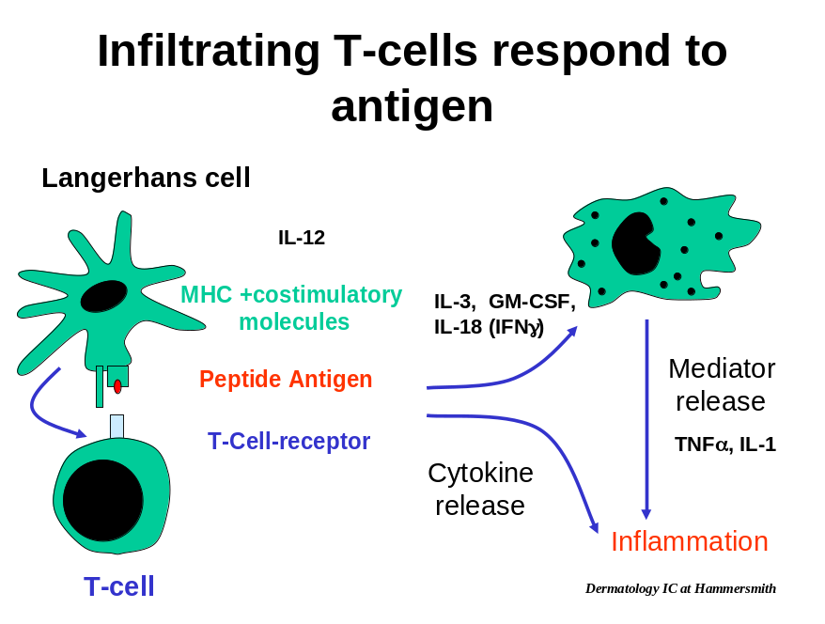

Contact dermatitis:
This is an acquired sensitivity to haptans (small molecules such as the metal Nickel)
The immune system is triggered to respond at site of contact once memory T-cells have been generated.
- Haptans disguises normal proteins
- Langerhans cells see protein as foreign
- Migrate to Lymph nodes and stimulate naïve T-cells
- Creation of “memory” cells
- Dermal circulating memory T-cells respond to haptan/protein
- Normal protein is attacked and surrounding cells are damaged

Review of Cells and Humoral Factors role in immunity

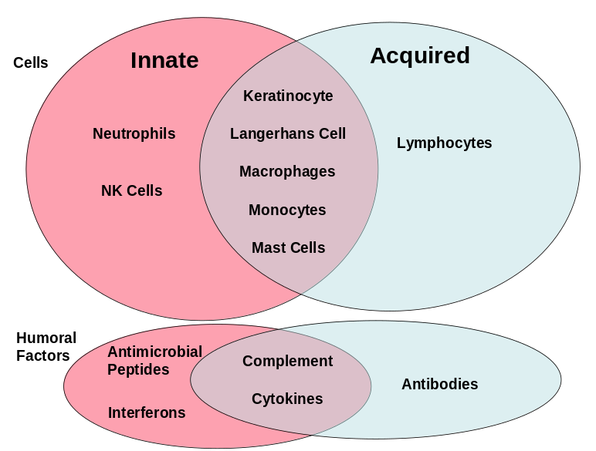

Hair and Nails
Due May Ang

Learning Objectives
- Understand the structure and function of hair
- Recognize the different types of hair
- Understand the hair cycle and influences to it
- Understand the anatomy and growth of finger and toe nails

Hair

The Function of Hair
- Protect the skin
- physically e.g. eyelashes
- UV damage e.g. especially scalp hair
- Thermoregulation
- piloerection when cold/scared
- Evaporation of sweat from hair when hot (increased surface area than skin alone)
- Communication
- Provide sexual attraction
- Suggest information about health, youth and fertility
- Convey threatening behavior or fright by becoming erect
- Camouflage by its color (mainly animal)
- Provide sensation
- Amplify movement. Therefore sensation is more sensitive e.g. movement from wind

Developmental
All hair follicles develop in utero with none developing postpartum. Initially 2 hairs grow from each follicle. This lanugo hair develops during the 3rd trimester and is shed by 8 months gestation. The second hair is shed at 3-4 months postpartum. Approximately 5 million follicles present at birth.

Types of Hair
Scalp hair density in Caucasian populations is between 250-320 hairs/cm², whilst in Africans it is about 180 hairs/cm². The size of a hair follicle varies with time and where it is in the hair cycle. Hair is present all over the epidermis except the palms, soles and mucous membranes. Only 5% is present on the scalp.

Lanugo hair – this is fine, soft, usually unpigmented, unmedullated prenatal hair. It can be seen in premature babies.

Vellus hair – postnatal hair, soft, occasionally pigmented, usually <2cm long and unmedullated, covers most of the skin.

Terminal hair – postnatal hair, longer than vellus hair, pigmented, coarse and medullated. Prior to puberty terminal hair is limited to the scalp, eyebrows and eyelashes. Under the influence of sex hormones, vellus hairs can transform into terminal hairs, after puberty. e.g. beard, public hair.

Structure and Anatomy of the Hair & Hair Follicle
Hair is the keratinized product of the hair follicle. Keratin is an intermediate filament (cytoskeleton). It is intermediate in size between the smaller actin fibres and larger microtubules and a fibre is 8-10nm in diameter. The basic structural unit consists of dimers of Type I (acidic) and Type II (basic) intermediate filaments. These form alpha helical structures that further polymerise into protofibrils and finally make the cortex of the hair.

In cross section a Terminal hair has 3 main areas – medulla, cortex, outer cuticle. A fully mature hair follicle can be divided into 3 segments (see diagram from lecture slides)

- Infundibulum – skin surface to point of entry of the sebaceous duct. Has same epithelial structure as the skin surface.

- Isthmus – Short portion between entry of sebaceous ducts and attachment of the arrector pili muscle. Hair follicle stem cells are thought to reside in the lower part of the isthmus close to the insertion of the arrector pilli muscle.

- Suprabulbar region – The region between the isthmus and hair bulb

- Bulb – expanded lower end of the follicle which includes the dermal papillae.

Hair Bulb - This region consists of a dermal papilla and hair bulb matrix (germinative epithelium). The cells of the hair bulb matrix have high mitotic rates and produce the various parts of the hair. The epithelial cells in the lower, more lateral part of the matrix give rise to the inner root sheath, whilst cells located in the upper and more central parts of the matrix give rise to the hair shaft. In pigmented hair follicles, melanocytes are situated in the cells destined to become the cortex and they give rise to pigment in the hair shaft. Langerhans cells may also be found in the hair matrix.

The dermal papilla is made up of specialized fibroblast-like cells embedded in an extracellular matrix rich in basement membrane proteins and proteoglycans, it also contains capillary blood vessels. The dermal papilla is important in the induction and maintenance of follicular epithelial differentiation and the volume of the dermal papilla may be responsible for controlling the size of the hair follicle and that of the hair fibre.

At the level of the hair bulb there is an outer root sheath surrounding the inner root sheath. Surrounding all the above is a dermal sheath. The dermal sheath is a collagenous layer.
As the hair growth cycle changes, communication between the hair bulb and the dermal papilla means that the vasculature to the hair follicle grow and shrink in response to the metabolic needs of the follicle.

Hair Shaft - The cortex forms the bulk of the hair shaft. The cells of the cortex consist of hair specific keratins (i.e. not the cytokeratins seen intracellularly) and proteins.
The cuticle consists of 5-10 overlapping cell layers, with compact cuticular keratins, associated with sulphur containing proteins e.g. cysteine. This leads to the important protective role of the cuticle to physical and chemical insults. With wear and tear, gradual degradation of the cuticle occurs, with breaking and lifting of the free margins of the cuticle cells. This leads to exposure of the cortex, with fracture of the hair shaft.
The medulla is a variable structure in human hairs.
Inner Root Sheath - This consists of three layers; Henle’s layer, Huxley’s layer and the inner root sheath cuticle. The cells of the inner root sheath have hair specific keratin and it hardens before the hair shaft within it. For this reason it is thought to control the definite shape of the hair shaft.

Outer Root Sheath - This forms the most peripheral layer of hair follicle epithelium, enclosing the inner root sheath.

Hair Cycle
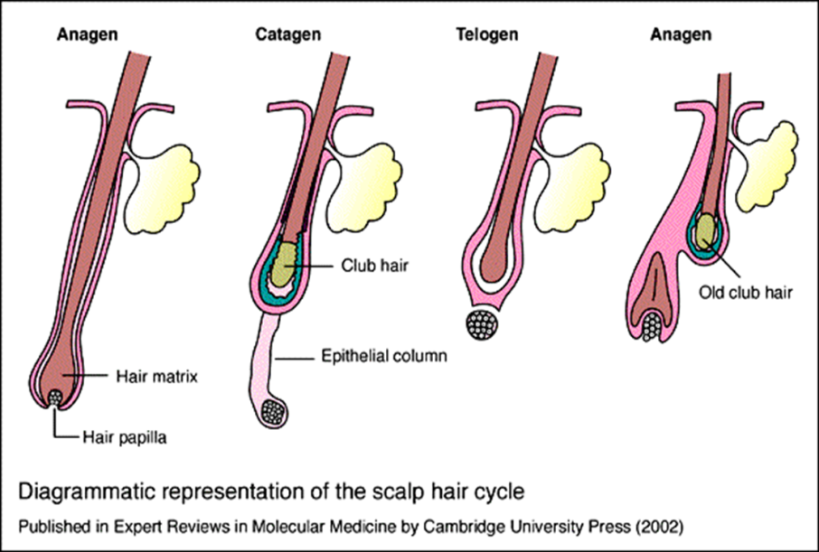

- Anagen – This is the period of active hair growth and its duration determines the final length of hair. For example scalp hair remains in anagen for 2-8 years, whilst eyebrow hair remains in this stage for 2-3 months. On the scalp 80-90% of all hair follicles are in anagen. As each cycle occurs , the anagen phase shortens and the telogen phase elongates.

- Catagen – This is the brief period when the proximal part of the hair shaft keratinizes to form a club-shaped structure and the lower part of the follicle involutes by apoptosis. The base of the follicle moves upwards to lie below the level of the arrector pili muscle insertion.

- Telogen – This is the phase when hair is not being produced and the club hair is shed. This period lasts about 3 months for scalp hair. Human follicles re-enter anagen prior to shedding the club hair.

The maximum hair length for a given body site is determined by the length of time the hair is in anogen and the speed of hair growth (for that body site) whilst growing (see lecture slides)
In humans each hair follicle follows its own biological clock which is similar for a given body site. Initially these hairs grown synchronous, however, over time there is an asynchronous pattern of growth and regression. Therefore hair is shed in an diffuse pattern and no ‘apparent’ focal areas of hair loss is seen.

Influences on the hair cycle
pregnancy, Testerone (The testosterone Paradox-see lecture slides) , prolactin, oestrogens, melanin.

Increased anagen duration: - hypertrichosis, trichostasis spinulosa, pregnancy

Decreased anagen duration: - androgenic alopecia, alopecia areata, telogen effluvium.

Causes of telogen effluvium – severe physiological stress – starvation, major surgery, blood loss

Hair colour
Fully differentiated melanocytes can be found mainly in the hair bulb of the skin (but also in the infundibulum). They secrete melanosomes into the surrounding keratinocytes leading to melanized hairs. The colour of hair is based on its pigment content.
Eumelanin: brown/black hair
Phaemelanin: red or blond hair

Greying hair is the most familial manifestation of the ageing process, with onset being determined largely by hereditary factors, usually occurring in the fourth or fifth decade.
In senile grey or white hairs, there is reduced number of melanocytes in the melanocytic zones of the hair bulb and the cells also show little melanogenic activity and have few melanosomes. In addition, α-MSH binding sites normally present in pigmented human scalp follicles are absent in senile white hair follicle.

Disease of hair
Hirsutism: development of terminal hairs in a ‘male’ pattern on a female. There is genetic variability with this presenting diagnosis. Depending on the local culture, the degree of hirsuitism deemed socially acceptable in a female changes. It may or may or may not be part of a generalized disorder (known as virilization). It can arise as part of the normal variation within an ethnic group, due to increase local sensitivity to androgens, due to increased circulating androgens.

Hypertrichosis: growth of terminal hair in areas which is not hairy. This can be localized (Becker’s naevi) or generalized (porphyria or drugs)

Hypertrichosis lanuginosa: This maybe congenital or acquired, consisting of persistence of fetal lanugo hair which grows excessively and is renewed throughout life or a previously normal hair follicle reverts to producing hair with lanugo characteristics. Excessive hair growth is generalized but does not involve the palms or soles. The congenital form is often autosomal dominantly inherited, whilst the acquired form is often seen in association with malignancy (GI, bronchus, breast, gall bladder, uterus, bladder or other organs). The excessive hair growth in the acquired form may precede the diagnosis of malignancy by several years.

Androgenic Alopecia – This occurs in both men and women. It is characterized by a defined pattern of hair loss from the scalp, short anongen, long telogen and androgen dependent miniaturizsation of the hair follicles. Biochemically raised dihydrotestosterone (DHT) and 5α-reductase are seen.
Up to 50% of 50 year olds and 80% of 70 year olds have the condition. Many genes have been implicated and it is listed as an autosomal dominant condition. Circulating androgens are necessary for the condition to manifest. Pre-pubertal castration prevents androgenic alopecia and it is not seen in pseudohermaphrodites, who lack 5α-reductase. Testosterone is converted to DHT by the enzyme 5α-reductase.

The condition has only been successfully controlled by oral finasteride (type II 5α- reductase inhibitor) and topical minoxidil (vasodilator that prolongs anagen-mechanism unknown).

Nails

Function
- Touch - increases manual dexterity
- Protection of distal phalanx (chemical, physical)
- Communication (social)
- Weapon (usually, but not always restricted to animals)

Structure
The nail is composed of 80% hair keratins and also 20% cytokeratins. . It also has calcium deposits within it. Its strength is contributed by it longitudinal ridging between the nail plate and the nail bed. This provides immense resistance to sheering forces. It is also curved longitudinally and laterally.

The nail unit can be divided into a number of distinct areas
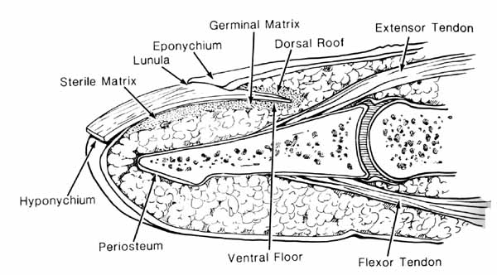

- Germinal Matrix - This ranges from 4-9mm in length, with most of it located under the proximal nail fold. The distal end of the nail matrix is visible in most people and is represented by the distal end of the lunula. It is formed from a thick epithelium consisting mostly of matrix cells. There are some poorly developed melanocytes also present.

- Nail Plate - This originates from the nail matrix. The proximal portion is usually white and defined as the lunula. The middle section overlies the nail bed. The distal part is the free edge of the nail plate. It is made from closely packed, fully keratinized, multilayered lamellae of cornified cells. It is only smooth on the dorsal surface. Over 80% of the nail plate is formed from the proximal 50% of the nail matrix. The ventral surface shows longitudinal folds and grooves that adhere to the nail bed.

- The Cuticular system – this ensheathes the nail plate from both above and below. It acts as a barrier to the external environment. It includes the proximal eponychium and the deeper and more distal cuticle. The hyponychium is more superficial. The hyponychium can been seen on the nail by the ‘Onychodermal band’ on the nail. This is an area of erythema seen at the distal nail

The rate of nail grow is determined by a number of factors. The fingernails grow on average 3mm/month and toenails at 1mm/month. The thickness of the nail varies from 0.6 to 1mm. The surface of the nail is produced by the proximal nail bed, the undersurface of the nail is produced by the distal nail bed.

Diseases of nails
Nail changes may be non-specific, or characteristic of specific processes. The nails can be abnormal in several disorders.

Psoriasis – This condition involves the apical and/or the dorsal matrix resulting in pitting of the nail plate through loss of cells from the upper layer of the plate. When paraheratotic cells appear in the distal third of the matrix, onycholysis may occur. 1/3 patients will show nail changes.

Sudden Illness – Illness or trauma may lead to an arrest of the apical nail matrix growth. This results in Beau’s lines (a transverse depression along the nail plate) e.g seen after chemotherapy, originally described after Thyphoid.

Systemic Disease - horizontal and longitudinal curvature of the nail can occur in response to a number of systemic diseases e.g lung disease, cyanotic heart disease, inflammatory bowel disease (see lecture slides for a brief list).

Nail Pigmentation
Linear pigmented streaks along the nail have various causes. It is important to distinguish benign from malignant causes.
Melanonychia Striata – benign Melanoma – malignant
These can’t be distinguished easily by clinically examination alone.

The Hair and Nails can be used diagnostically too
- -cystic fibrosis (increased chlorine)
- -drug compliance
- -Illicit drug intake (cocaine, amphetamines)
- -Environmental exposure (heavy metals, nickel)
_______________________________________________________________________________

Skin Organ Failure

Fernanda Teixeira, Hammersmith Campus

Our knowledge of the function of the skin comes from conditions in which there is partial or total skin failure. Whilst this is not exhaustive, it allows us to build a picture of the important functions of the skin.

Functions of the skin :-
- Prevent infection/immunity – bacteria, fungi, virus, cancer
- Maintain a Barrier – physical, chemical, uv radiation
- Repair Injury
- Provide Nutrition – vitamin D, oxygen to skin
- Thermoregulation – dermal capillaries
- Attraction
- Communicate information about the environment – nerves, chemokines, hormones

Toxic Epidermal Necrolysis (TEN)

TEN is an acute severe bullous cutaneous disease characterised by extensive areas of skin necrosis.
TEN is a potentially life-threatening skin disorder that most commonly is drug induced. However, other aetiologies, including infection and malignancy, may exist. TEN is idiosyncratic, and its occurrence is not predicted easily. Some authors believe Stevens-Johnson syndrome is a manifestation of the same process, with TEN representing more extensive necrotic epidermal detachment. It can occur in all age groups.

It is associated with an acute phase (8-12 d) consisting of persistent fevers, generalized epidermal sloughing, and mucous membrane involvement. Complications include stomatitis and mucositis, which are painful and hinder oral intake; therefore, patients are at risk for dehydration and malnutrition. The conjunctivae are commonly affected 1-3 days prior to the appearance of skin lesions. All mucous membranes can become denuded (loss of epidermis) including buccal, nasal, pharyngeal, tracheobronchial, oesophageal, perineal, urethral, and anal mucosa.
Skin infection, excess electrolyte loss and dehydration, hypothermia commonly occur once the surface area of the epidermal loss becomes extensive. Much of the morbidity and the mortality are from these results of ‘skin failure’.

The treatment for the condition is to remove the underlying cause and supportive measures to prevent the possible complications. These patients should be treated like burns patients and are often better looked after on a burns unit than a general ward.
The pathophysiology has not been fully elucidated; however, various theories have received wide acceptance. TEN is believed to be an immune-related cytotoxic reaction aimed at destroying keratinocytes that express a foreign antigen.Explanations for the generalized nature of TEN include the belief that overexpression of tumor necrosis factor- (TNF-) in the epidermis occurs. Therefore, TNF- is likely to play an important role in epidermal destruction directly through apoptosis, indirectly through stimulating cytotoxic T lymphocytes, or both.
Mortality is estimated to be 10-70%, depending on the quality of care and the rapidity with which treatment is initiated. Morbidity depends on the aggressiveness of the treatment strategy. TEN is associated with a slow healing and recovery of 3-6 weeks, which depends on the extensiveness and severity of the lesions and associated complications.
Erythroderma
It is defined as an erythematous dermatitis involving 90% or more of the cutaneous surface. It is associated with extensive desquamation in some cases. It often develops as a result of another primary dermatosis. Causes of Erythroderma :-

Idiopathic - 30%
Drug allergy - 28%
Lymphoma and leukemia - 14%
Atopic dermatitis - 10%
Psoriasis - 8%
Contact dermatitis - 3%
Seborrheic dermatitis - 2%

The erythema is due to an increased skin blood perfusion from dilation of the dermal capillaries. This results in temperature dysregulation (resulting in heat loss and hypothermia) and possible high-output cardiac failure. The basal metabolic rate rises to compensate for the resultant heat loss. Fluid loss is increased in proportion to the basal metabolic rate. The situation is similar to that observed in patients following burns (negative nitrogen balance characterized by edema, hypoalbuminemia, loss of muscle mass). A marked loss of exfoliated scales occurs that may reach 20-30 g/d. This contributes to the hypoalbuminemia . Hypoalbuminemia results, in part, from decreased synthesis or increased metabolism of albumin. Oedema is a frequent finding, probably resulting from fluid shift into the extracellular spaces.
Treatment is to discontinue all unnecessary medications. Carefully monitor and control fluid intake, since patients can dehydrate or go into cardiac failure; monitor body temperature, since patients may become hypothermic. Institute systemic antibiotics if signs of secondary infection are observed. Antihistamines help reduce pruritus and provide needed sedation. Increased capillary permeability occasionally is severe enough to justify plasma infusion. Preexisting malnutrition may become more marked and require nutritional intervention in older patients.

The prognosis of erythroderma depends largely on the underlying aetiology. The overall mortality is in the range of 20-40%.

Sample MCQs

1 Regarding the epidermis and the dermis:
  - Melanocytes originate from the mesoderm. F
  - Mitotic figures can be normally found in the basal, spinous and granular layers of the epidermis. F
  - Filaggrin promotes the aggregation of filaments of keratin. T
  - Transforming growth factor beta inhibits the division of basal cells, although it stimulates the fibroblasts’ growth and collagen production. T
  - Merkel cells are located in the granular layer of the epidermis, in close proximity to axonal processes, and are believed to be involved in sensory perception. F

2 Considering the pigmentation of human skin:
- Both eumelanin and phaeomelanin are derived from tyrosine. T
- Patients with Addison’s disease are dark because of increased MSH secretion. T
- Melanin absorbs UV radiation and thus protects the lower layers of the skin against changes in the DNA and the development of skin cancer. T
- In immediate tanning there is proliferation of melanocytes, increase in their tyrosinase activity, intense production of new melanosomes and enhanced transfer of melanosomes to keratinocytes. F
- Once melanocytes reach the skin, they become incapable of cell division.F

3 The following statements regarding hair biology is/are true
- Lanugo hair is present in utero. T
- Vellus hair is present on the palms & soles. F
- Hair follicles first occur at about nine weeks of embryonic development. T
- In the normal hair scalp about 50% of hair follicles are in anagen at any one time. F
- Vitamin D receptor has a role in the regulation of the normal hair cycle. T

4 Which of the following statements are true?
- Telogen effluvium is a cause of hair loss. T
- Hypertrichosis lanuginosa may be congenital or acquired. T
- Porphyria cutanea tarda is a cause of hypertrichosis. T
- Menke’s disease is caused by defects in iron transport. F
- In androgenetic alopecia there is an increased duration of telogen. F

5 The following statements about sweat glands are correct.
- Their secretions are merocrine, meaning that the secretory cells are not destroyed in the process of secretion. T
- Apocrine glands are most numerous on the palms and soles of the feet. F
- Eccrine glands have important functions in thermoregulation. T
- The post-ganglionic neurotransmission for sympathetic nerves supplying eccrine glands is unusual in that it is adrenergic. F
- Eccrine sweat is hypotonic and contains sodium, potassium, chloride, urea and lactate. T

Recommended books

There are few simple textbooks which detail the structure and function of the skin. We would recommend looking up relevant parts of:

Textbook of Dermatology, Eds Champion, Burton, Burns and Breathnach, Blackwell Science

