Practical 2

Measuring Respiratory Parameters in a Healthy Person (that’s you!)

Compared to Patients with Respiratory Disease

Prof Mary Morrell (m.morrell@imperial.ac.uk)

In laboratory sessions 1 and 2 you will carry out 4 procedures:
- Measurement of respiratory parameters. You will measure your own lung volumes.
- Simulating COPD. In this exercise you will simulate breathing with hyperinflated lungs.
- Pulmonary function tests. You will measure the parameters of forced expiration that are used in evaluating pulmonary function.
- Peak flow. In this exercise you will measure your own Peak Flows.
- Patient Case Study. You will ‘meet’ Mrs M, a patient with a respiratory disorder, and examine the results of her investigations compared to your own.

Why measuring respiratory parameters accurately is important clinically
Patients with chronic lung disease can be divided into 2 categories – obstructive lung disease e.g. Chronic Obstructive Pulmonary Disease (COPD) and restrictive disease. To assess these patients, and their progress over time, a range of respiratory tests are performed. Therefore it is important that you understand how these respiratory tests are performed and their significance.

Random Facts
The term vital capacity was first used by John Hutchinson (1811–1851) an English surgeon and physician. He recognized that the volume of air that can be exhaled from fully inflated lungs is a powerful indicator of longevity. He also invented the spirometer, which is still in use today to measure lung function.

How respiratory parameters are measured
Gas exchange between air and blood occurs in the alveolar air sacs (Link: Gas transport and ventilation lecture). The efficiency of gas exchange is dependent on ventilation (Link: Hypoxia in health & disease lecture). Spirometry is the method of choice for a fast and reliable screening of patients suspected of having COPD. COPD is the 12th leading cause of death worldwide and 5th in Western countries. Studies suggest COPD could climb to be the 3rd leading killer by 2020. Most COPD cases are completely avoidable with 85–90% of cases being caused by tobacco smoking (Link: Lung cell biology tutorial).
Many important aspects of lung function can be determined by measuring airflow and the corresponding changes in lung volume. In the past the most common method of doing this was using a sealed spirometer. You may see these machines used in some hospitals. A sealed spirometer gives a measure of changes in lung volume. Airflow (F) is then calculated from the rate of change (d) of the volume (V):
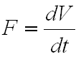

The Pneumotachometer
Airflow can now be measured directly with a pneumotachometer (from Greek roots meaning "breath speed measuring device"). The pneumotachometer arrangement you will be using in your practical session is shown in Figure 1.
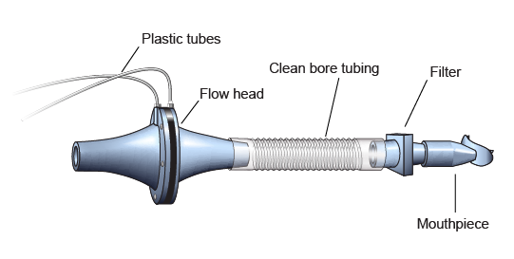
Figure 1. The pneumotachometer.

The Airflow Head contains a fine mesh. Air breathed through the mesh produces a small pressure difference on one side of the mesh compared to the other side. The pressure drop is proportional to the airflow rate. Two small plastic tubes transmit this pressure difference to the Spirometer Pod, where a transducer converts the pressure signal into a changing voltage that is recorded by the analogue-to-digital converter, and displayed in computer screen. The volume (V) can then be calculated as the integral (or summation) of airflow over time:
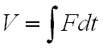
The volume traces that you will see during the experiment are obtained by adding successive sampled values of the airflow signal and scaling the sum appropriately. N.B: the integral is reset to zero every time a recording is started.
A complication in volume measurement is caused by the difference in air temperature between the Spirometer Pod (at room temperature) and the air exhaled from the lungs (at body temperature, 37°C). Because gas expands with warming, it's volume increases. For this reason, the air volume expired from the lungs will be slightly greater than that inspired. Thus a volume trace, as calculated by integration of flow, drifts in the expiratory direction. To reduce the drift, the flow has to be integrated separately during inspiration and expiration, with the inspiratory volume being corrected by a factor related to the BTPS factor (body temperature, atmospheric pressure, saturated with water vapor). The software makes this correction automatically.

Lung volumes and capacities
The common respiratory parameters that can be measured (and calculated) using spirometry are shown in Figure 2.

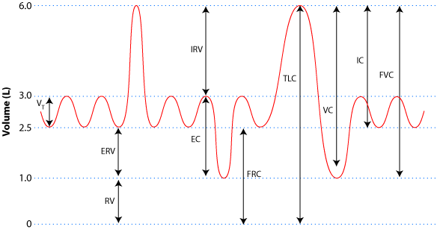
Figure 2. Lung volumes and capacities, the values are representative of a healthy young male adult.

Looking at the spirometry graph from left to right the various lung volumes are:
- The vital capacity, V_{T} – volume breathed in and out in each breath.
- The inspiratory reserve volume (IRV) – maximum volume above the tidal volume that we can inhale into our lungs.
- The expiratory reserve volume (ERV) – maximum volume we can exhale from our lungs at the end of a normal breath.
- The residual volume (RV) – volume of air remaining in the lungs which is impossible for use to expire.

Then we have the lung capacities:
- The expiratory capacity (EC) – volume of air that we can expire after a normal inspiration and = V_{T} + ERV.
- The functional residual capacity (FRC) – volume of air remaining in the lungs at the end of a normal expiration and = ERV + RV.
- The total lung capacity (TLC) – all the air that it is possible for the lungs to contain and = RV + ERV + V_{T} + IRV.
- The vital capacity (VC) – all the air that can be expired following a maximal inhalation and = ERV + V_{T} + IRV.
- The inspiratory capacity (IC) – all the air breathed in during a maximal inhalation and = V_{T} + IRV.

Remember: lung capacities are always the sum of at least two lung volumes, e.g., vital capacity (VC) is the sum of tidal volume (V_{T}), expiratory reserve volume (ERV) and inspiratory reserve volume (IRV).

During the respiratory cycle, a specific volume of air is drawn into and then expired from the lungs. This volume is the Tidal Volume (V_{T}). In normal ventilation, the rate of breathing (breaths/minute) is approximately 15 respiratory cycles per minute. This value varies with the level of activity. The product of breaths/minute and V_{T} is the Expired Minute Volume – the amount of air exhaled in one minute of breathing, which also changes according to the level of activity.
Note that the volume of air remaining in the lungs after a full expiration, residual volume (RV), cannot be measured by spirometry as it is impossible to exhale all the gas in the lungs. There are specialized techniques to measure RV e.g. the helium dilution method. However, often RV is estimated from Tables that predict RV based on age, sex, height and weight.

Pulmonary function tests
Table 1 lists common pulmonary function tests. Clinically, peak flows are measured with a Peak Flow Meter that you will use in session 2. In spirometry, the peak flows are the rates of airflow at the beginning of inspiration or expiration. The Forced Vital Capacity and FEV₁ will also be measured in session 2. By the end of sessions 1&2 will have measured all of these parameters.
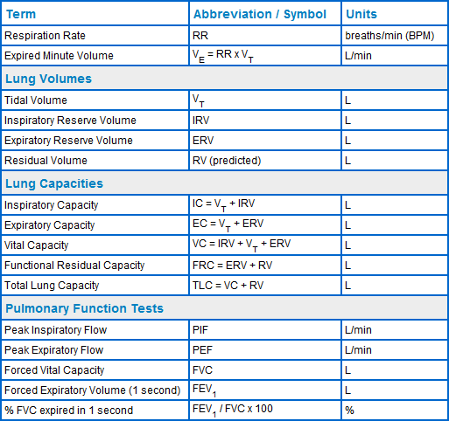
Table 1. Respiratory-related terms, abbreviations, and units.

Hyperinflated lungs (Link: Lung mechanics lectures)
As a consequence of the tissue damage in patients with COPD, air is trapped in the lungs at the end of expiration and gradually the RV increases; the patient breathes with a hyperinflated lung.
Hyperinflation of the lungs flattens the diaphragm, causing breathing to be less efficient because the flattened diaphragm is less able to regulate the pleural pressures necessary for breathing. Therefore the chest and neck muscles must work harder to assist with breathing. This increases the work of breathing and the patients suffer from dyspnea. COPD patients breathe faster in an effort to ventilate their lungs normally.
On physical examination COPD patients oftein have a larger than normal chest (so called, barrel-shaped), with decreased movements during the respiratory cycle. Hyperinflation of the lungs is also demonstrated by an increase in FRC. Characteristically, expiration becomes prolonged relative to inspiration. As the condition worsens, and the alveolar surface area available for gas exchange is reduced, there is an increase in the partial pressure of carbon dioxide (PCO₂) and decrease in partial pressure of oxygen (PO₂) in the alveolar air at the end of expiration. The decreased arterial PO₂ may result in cyanosis.

Session 2

Peak flow and the peak flow meter
The maximum expiratory flow that a person can produce provides an indication of respiratory health. Peak flow readings reflect the resistance to flow in the airways. Bronchial constriction and mucus secretion block the bronchi, thereby increasing resistance and lowering peal flow accordingly. For people with asthma or chronic respiratory obstruction, peak flow measurements provide a way for them to check on their respiratory function so that treatment can be initiated early if function begins to deteriorate.
Remember: A person with decreased lung volumes, e.g. restrictive lung disease, will also have a lower than normal peak flow.

Random Facts
The measurement of peak expiratory flow was pioneered by Dr. Martin Wright (1912–2001), who, in the late 1950s, produced the first airflow meter specifically designed to measure lung function. Subsequent miniaturization in the 1970s provided the tool that is now widely used throughout the world to monitor respiratory health in obstructive lung disease and asthma (Figure 3).

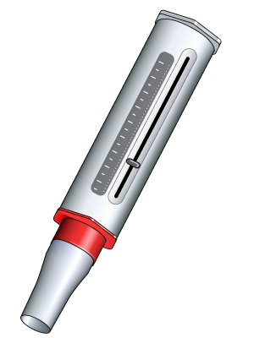
Figure 3. Peak Flow Meter.

People need to be trained in the correct use of the instrument for accurate measurements. It is the trend from day to day that is important (so called within-subject variability), rather than the specific value on any one day. For this reason, people are encouraged to graph their daily readings. It is also important to measure peak flows at the same time each day. Usually, the early morning readings are lower than those obtained later in the day.
The normal (predicted) values depend upon the volunteer's age, sex, height and weight. In session 2 Tables will be available showing these predicted values. Peak flow meters are not suitable for use by children under 12 years old.

Respiratory Diseases

Obstructive Respiratory Diseases
Chronic Obstructive Pulmonary Disease (COPD) is an obstructive disease that causes the airways become permanently narrowed. This narrowing increases the resistance to flow so that airflow to the alveoli becomes limited causing dyspnea (see section below). In contrast to asthma, this limitation of airflow is often not reversible and usually gets progressively worse over time.
COPD develops when noxious particles or gases trigger an abnormal inflammatory response in the lung. Over time, repetitive exposure results in a chronic inflammation. The condition is called chronic bronchitis when the bronchi are affected. When the alveoli are involved, there is destruction of lung tissue with loss of the normal lung elasticity and the development of emphysema. The major irritant responsible for COPD is tobacco smoke and about half the people who smoke will eventually develop COPD.

Blood gases
In patients with COPD blood tests often reveal an increased hemoglobin level with an increased red blood cell count and a raised hematocrit. These findings reflect the body's attempt to compensate for the lower PO₂ by increasing the O₂ carrying capacity of the blood. The raised PCO₂ results in chronic respiratory acidosis (Link: blood gases & acid-base data workshop).
COPD patients are prone to acute respiratory infections which may precipitate them into acute respiratory failure. It is essential to understand that, under these circumstances, the arterial PCO₂ can be so high that, rather than being a respiratory stimulant, CO₂ becomes a central nervous system depressant. Under such circumstances, the low PO₂, acting through peripheral chemoreceptors, is providing the only respiratory drive. Well intentioned administration of O₂ to these patients, in an attempt to relieve their hypoxia, may cause the patient to STOP breathing as the hypoxic respiratory drive is removed.
Remember: Lung function tests in patients with COPD will often show that increased residual volume and total lung capacity, with a relatively normal vital capacity. The FEV₁/FVC ratio <70%, and is not improved significantly after administration of a bronchodilator.

Restrictive Disease
Restrictive respiratory disease can result from either lung (intrinsic) or chest wall (extrinsic) conditions.
Intrinsic restrictive lung disease may result from, for example:
  - inorganic dust exposure – e.g., asbestosis, silicosis
  - organic dust exposure – e.g., farmer's lung
  - collagen diseases – e.g., scleroderma
Extrinsic restrictive diseases may result from, for example:
  - neuromuscular disorders – e.g., various myopathies
  - disorders causing kyphoscoliosis – e.g., ankylosing spondylitis
In restrictive disease, the major problem is an inability to ventilate the lung adequately. Either the lungs are 'stiffer', because of fibrosis, or the chest wall is less expandable. In either case, there is a loss of lung compliance. Since CO₂ diffuses some 30 times faster across membranes than does O₂, in severe cases, patients are hypoxic but with a normal arterial PCO₂.
The main symptoms restrictive respiratory diseases are shortness of breath and cough.
Remember: In restrictive lung disease, residual volume and total lung capacity are both reduced. FEV₁ and FVC are both reduced to much the same extent, so the FEV₁/FVC ratio is relatively normal or even increased a little.

Asthma (Link: Airways function lecture)
Asthma is a chronic respiratory disease in which the bronchi are hypersensitive to cold air or, more commonly, a variety of dusts, pollens or other air particles. These trigger chronic inflammation with excess production of mucus and narrowing of the airways. Sometimes, exercise is a trigger.
It has been estimated that asthma affects over 300 million people worldwide.
The airway narrowing causes symptoms such as recurring episodes of wheezing, breathlessness, tightness in the chest, and coughing, particularly at night or in the early morning.
During an attack, the FEV₁/FVC is below normal (i.e. <70%). This ratio is usually improved significantly after administration of a bronchodilator. Between acute attacks, a peak flow meter can be used to monitor respiratory status and to determine the necessity of using a bronchodilator.

Symptoms of Respiratory Diseases
Respiratory disorders are generally characterized by shortness of breath (dyspnea), coughing, wheezing, chest tightness and increased production of mucus (sputum). Furthermore, patients with a respiratory problem can be anxious or become confused. This is important, since nonadherence with prescribed medications and incorrect use of inhalers can result in ineffective treatment.

Dyspnea (Link: Sensory aspects of respiratory disease, and control of breathing lectures)
Dyspnea refers to difficulty in breathing. What is difficult for one person is not necessarily so for another, so dyspnea (like pain) has a psychological dimension. Perhaps the simplest view is to regard dyspnea as being a consequence of a mismatch between the afferent inputs that stimulate breathing (such as decreased PO₂, increased PCO₂, decreased pH, and activation of lung and chest wall receptors) and the efferent output to the muscles of respiration. That is, for whatever reason, breathing cannot increase sufficiently to match the perceived, CNS (central nervous system) requirements, leading to feelings of distress and breathlessness.
Dyspnea may be acute (coming on over minutes to hours) or chronic (developing slowly over weeks to months). When people tell you they are ‘breathless’, it is necessary to try to understand what they mean by this. Everyone gets breathless if they exercise vigorously. This is physiological and reversed rapidly when exercise finishes and should not be regarded as dyspnea. Illnesses that can be associated with the acute onset of dyspnea include pneumothorax, acute asthmatic attacks, pneumonia, plus cardiac diseases such as myocardial infarction and heart failure.

Treatment of Respiratory Diseases (link: Lung immunology: allergic airway disease lecture)

Bronchodilators: Bronchodilators are a class of drugs that act to relax the bronchioles, thereby opening up the airways and increasing airflow to the lungs. Bronchodilator drugs fall into four categories; β2-adrenoceptor agonists, muscarinic receptor antagonists, xanthines and cysteinyl leukotriene receptor antagonists. Bronchodilators are also classed as short-acting or long-acting. Short-acting agents are used as required for symptom management, and have a quick onset of action (usually <20 minutes), but their effects last only 2–4 hours. Long-acting bronchodilators, on the other hand, are used routinely to provide long-term management of symptoms, and although they take longer to act (up to 45 minutes), their effects last for around 12 hours.

Nebulizers and inhalers: Respiratory medications are administered using nebulizers or inhalers. A nebulizer is an electronic device that uses compressed air or ultrasonic sound waves to convert liquid medicine into a fine mist ready for inhalation. Nebulizers are often preferred as they can be used with a mouthpiece or face mask, but they do require an exact volume of medication to be poured into the machine before use. In contrast, metered dose inhalers deliver a fixed quantity of medication as an aerosol, and are small and portable. Furthermore, the addition of a spacer makes the inhaler easier to use and improves drug deposition.

Exercise programs and breathing techniques: The aim of pulmonary rehabilitation is to maintain a patient's maximum lung function and independence. These programs, can improve dyspnea, quality of life and increase the ability of patients to perform everyday activities. There are also several breathing techniques and comfortable positions that can be taught to COPD patients to help manage their dyspnea. These include pursed-lip breathing, diaphragmatic breathing to strengthen the diaphragm, and controlled coughing to clear mucous from the lungs.

Antibiotics and influenza vaccinations: Antibiotics are advised when there is increased sputum production. Likewise, yearly or twice-yearly vaccinations can help prevent the flu, which exacerbates respiratory problems.

References:
- Vander, Sherman & Luciano’s, Human Physiology (Widmaier, Raff & Strang): McGraw-Hill (2004) Pages 464-479. The recommended general physiology textbook for LSS course
- John B. West, Respiratory physiology: the essentials. This is the classic respiratory physiology textbooks and there are lots in library
- Respiratory Physiology: A Clinical Approach. Michael J. Parker (ISBN-13: 978-0781757485). This integrated physiology textbook won an award in 2006 for Special Contributions to Medical Education. It also contains 39 interactive animations that can be viewed on line – my top pick

