Practical 1

Respiratory Muscles
Dr Kevin Murphy (kevin.murphy@imperial.ac.uk)

Aims and objectives
The aim of this session is to identify the muscles for breathing and to illustrate their function in controlling alveolar ventilation.
By the end of this session you should be able to:
- Identify the principal muscles associated with inspiration and expiration.

- Summarise the additional non-respiratory actions of these muscles.

- Explain how contraction of inspiratory muscles causes the chest wall to expand and the lungs to enlarge.

- Explain how contraction of expiratory muscles causes the chest wall to contract and the lungs to reduce in size.

- Demonstrate an awareness of differentially activated muscles of inspiration and expiration during different breathing states:

- Identify which muscles will be active during quiet breathing.
- Identify which muscles will be active when ventilatory demand is increased e.g. during exercise or in lung disease

- Demonstrate an awareness of which respiratory muscles control air movement during other activities including, speech, laughter, coughing, sneezing and vomiting in addition to maintaining alveolar ventilation.

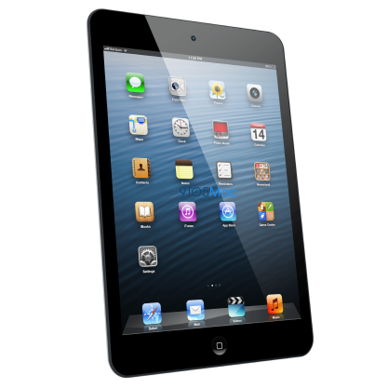
How this Tutorial will be delivered

Revision e-module (https://bb.imperial.ac.uk)
Before attending the tutorial you need to complete a revision
e-module available through Blackboard
(Year 1 – LSS – Respiratory System). This module has been designed to support your revision of the anatomy associated with the Respiratory System. Please note you will not be assessed on this e-module.
At the Tutorial
The tutorial session will be delivered using a mixture of traditional and mobile learning methods. Each student will be provided with an iPad. The iPad will be used during the session to deliver interactive content such as simulations, interactive quizzes, Drag & Drop exercises, etc. using the NearPod App already installed on the device.
Before the tutorial starts you will be asked to complete a pre-test focused on the content of the revision e-module delivered on Blackboard. Once the pre-test is completed the interactive session starts.
At the end of the session you will be asked to complete a survey titled ‘My attitude when learning in an interactive session using iPads’ which will be anonymous, as well as a post-test focused on the content learned at the tutorial.
Please note your performance in the pre and post-tests do not count towards your final mark in this course.
The session will last approximately 70-80 minutes.
The answers to the pre and post-tests as well as the hand-out of the tutorial will be available through Blackboard (Year 1 – LSS – Respiratory System) at the end of all the Respiratory Muscles tutorials.
Please note that you are required to attend the tutorial session to which you have been assigned. This will help us manage the distribution of iPads at the sessions.
For any further information related to the interactive session please contact the E-learning team at: webmaster.feo@imperial.ac.uk

To access the e-module please follow the steps below
- Log into blackboard https://bb.imperial.ac.uk
- Select the course Year – 1 LSS – Respiratory Systems
- Select Learning Materials
- Select Respiratory Muscles
- Click Launch

