Lecture 4

Ventilation and Gas Exchange
Professor Mary Morrell (m.morrell@imperial.ac.uk)

Learning objectives

At the end of this lecture you should be able to:

- Distinguish between alveolar and pulmonary ventilation.
- Define the common lung volumes and describe how they alter in restrictive and obstructive disease
- Define anatomical and physiological dead space and recall approximate volumes for both in a typical healthy adult
- Explain the effect of increased breathing frequency compared with increased depth of breathing on alveolar ventilation
- Define Fick’s law of diffusion
- Implement Fick’s law of diffusion to gas exchange in health and disease

Ventilation: Volumes and Capacities
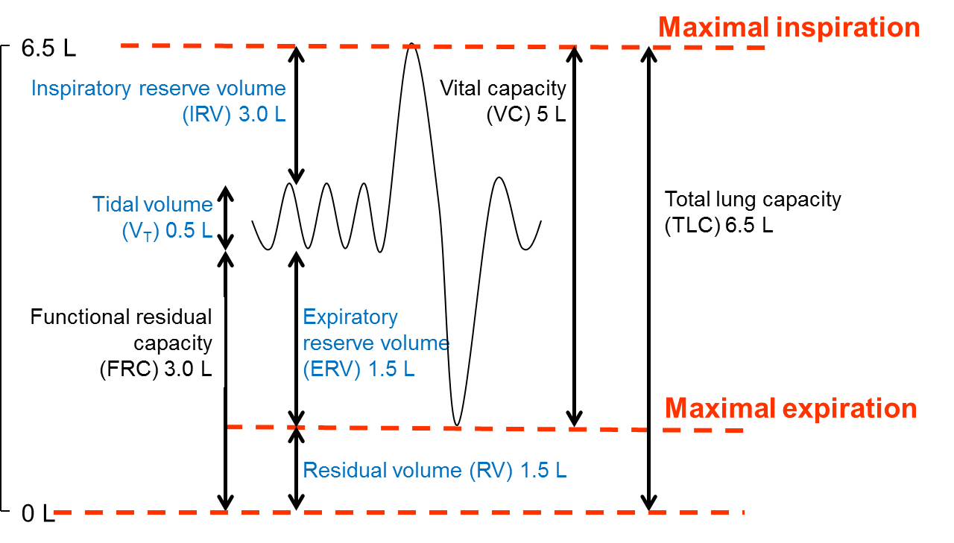

Volumes and Capacities

Name 3 factors affecting lung volumes and capacities:

- ______________________

- ______________________

- ______________________

Name the volume that cannot be measured by simple spirometry

_____________________

This volume is measured using the Helium dilution method

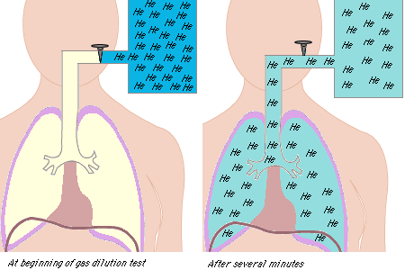

Classification of Respiratory disease

Obstructive | Restrictive
COPD | Lung fibrosis
Cystic Fibrosis | Motor neurone disease
(Asthma)

Disease progression is also monitored using Peak Flow and Forced Expiratory Volume in 1 Second (FEV₁)

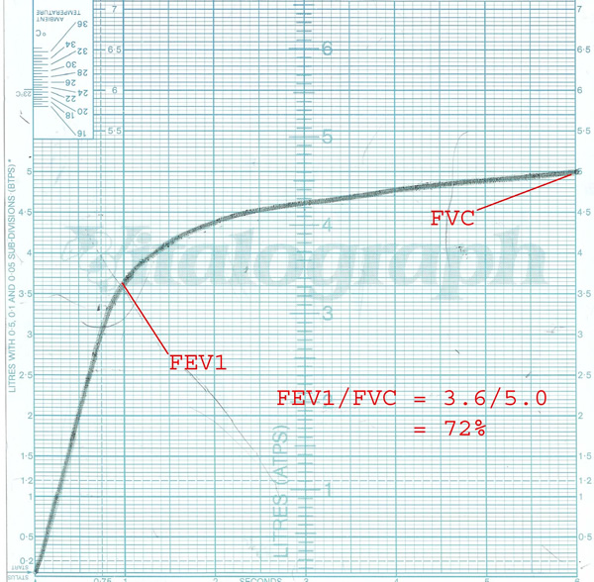

Spirometry trace for healthy patient

Fig 3 The Respiratory tree

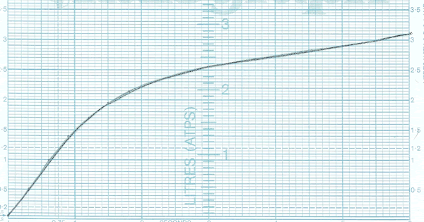
Spirometry from a patient with ________________ disease

Ventilation

Tidal volume (V_{T}): The amount of air inspired during quiet respiration. Normal respiratory frequency 12 bpm, average volume 500 mls

Minute ventilation (V_{E}): The amount of air entering lungs per min
(12 x 500 = 6.0 L min⁻¹). Not all tidal volume air is used in gas exchange

Dead space is term for the V_{T} NOT involved in gas exchange. There are 2 types of dead space:

Anatomical Dead space
Alveolar Dead space

Alveolar ventilation is amount of minute ventilation reaching respiratory zone used in gas exchange

- V_{T} – anatomical dead space = alveolar ventilation
- 500ml – 150ml = 350 mls
- 350ml x 12bpm = 4.2 L min⁻¹

Hypoventilation
When the ratio of CO₂ production to alveolar ventilation increases above normal values
  - i.e. inadequate alveolar ventilation

Hyperventilation
When the ratio of CO₂ production to alveolar ventilation decreases below normal values
  - i.e. excess alveolar ventilation

Can you name 3 causes of hyperventilation?

- ______________________

- ______________________

- ______________________

Gas Exchange

- The lungs are very good at maintaining blood oxygen O₂ levels. What was previously thought to be an active process is now known to be purely the result of diffusion and requires a concentration gradient.

Fick’s law
- The rate of transfer of a gas through a sheet of tissue is proportional to the area of the tissue, the solubility of the gas in the tissue and the difference in gas partial pressure between the two sides. It is inversely proportional to the square root of the gas’s molecular weight and the thickness of the tissue.

- The ability of lungs to permit diffusion is often reduced in diseases causing destruction of the normal architecture, such as emphysema and lung fibrosis. The area available for gas exchange in a healthy adult is 50 - 100 m² and the thickness of the alveolar membranes is less than 0.5 μm.

- The partial pressures of gases are determined by a number of physical laws. Dalton’s law states that in a gas mixture, the pressure exerted by each individual gas is independent of the pressures of other gases in the mixture. The partial pressure of a gas is equal to the fractional concentration of the gas multiplied by the total pressure of all the gases in the mixture, or:
P_{gas} = % total gas x P_{tot}

- Assuming standard barometric pressure of 100 kPa (at sea level), partial pressures for dry atmospheric gas (oxygen, pO_{2;} carbon dioxide, pCO₂) are therefore as follows: pO₂ =21% x 100 kPa = 21 kPa and pCO₂ = 0.04% x 100 kPa = 0.04 kPa

- However, inspired air is heated and humidified. When calculating partial pressures for humidified gas one therefore has to take into account the presence of water vapour. The partial pressure of water vapour is fairly constant. Humidification of a dry gas in a closed container would increase total pressure. In the body, gas instead expands and is diluted by added water vapour. Partial pressures for inspired gas can therefore be calculated as follows: PIO₂ = FIO₂ (PB - PH₂O). Assuming standard barometric pressure of 100 kPa this becomes: PIO₂ = 21% (100 - 6.3) = 19.7 kPa for oxygen and PICO₂ = 0.04% (100 - 6.3) = 0.04 kPa for carbon dioxide

The path of oxygen

- The physical path of oxygen from air to blood is a series of steps through components that are in series, like hosepipe segments. Alveolar gas consists of 2.5-3 L of gas already in the lungs at FRC, and around 350 ml per breath entering and leaving the alveoli. 300 ml of oxygen diffuses from the alveoli into the pulmonary capillary blood every minute. Alveolar pO₂ is determined by alveolar ventilation, pulmonary capillary perfusion and oxygen consumption. The mean alveolar pO₂ is around 13.3 kPa. Alveolar pCO₂ depends on CO₂ production and the mean alveolar pCO₂ is around 5.3 kPa.
The path of oxygen. The y axis shows the partial pressure of oxygen. The steady fall in partial pressure along the oxygen pathway is the head of pressure driving movement

diffusion
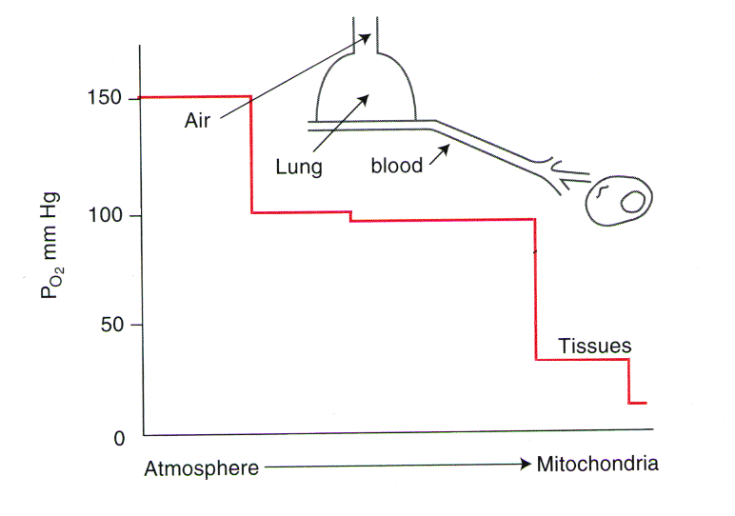

The partial pressure of oxygen in a red blood cell entering a capillary is around 5.3 kPa. Across the blood-gas barrier, less than 0.5μm away, the alveolar pO2 is around 13.3 kPa. Oxygen therefore diffuses down this large pressure gradient and the pO₂ in the red blood cells rises rapidly. Under normal circumstances, the difference in pO₂ between alveolar gas and end-capillary blood is very small.

We noted above that the diffusion of a gas across a tissue is proportional to the solubility of the gas and inversely proportional to its molecular weight. Carbon dioxide therefore diffuses around 20 times more rapidly than oxygen, because it is much more soluble but of similar weight.

Carbon dioxide transport in blood

As we have seen, the rate of diffusion of CO₂ is around 20 times greater than that of O₂, so that CO₂ elimination is not normally affected by a reduction in diffusion capacity. The pCO₂ of blood as it enters the pulmonary capillary is around 6 kPa and the pCO₂ of alveolar gas is around 5.3 kPa. The time taken to equilibrate is similar to that for oxygen.

Carbon dioxide is a major product of our metabolism. Highly acidic, it has to be eliminated. 200 to 250 ml of CO₂ is produced by tissue metabolism each minute. Assuming a CO of 5L/min, each 100 ml of blood passing through lungs must unload 4-5 ml of CO₂. Carbon dioxide is carried in blood in physical solution, as bicarbonate ions, and chemically combined with amino acids in blood proteins including haemoglobin.

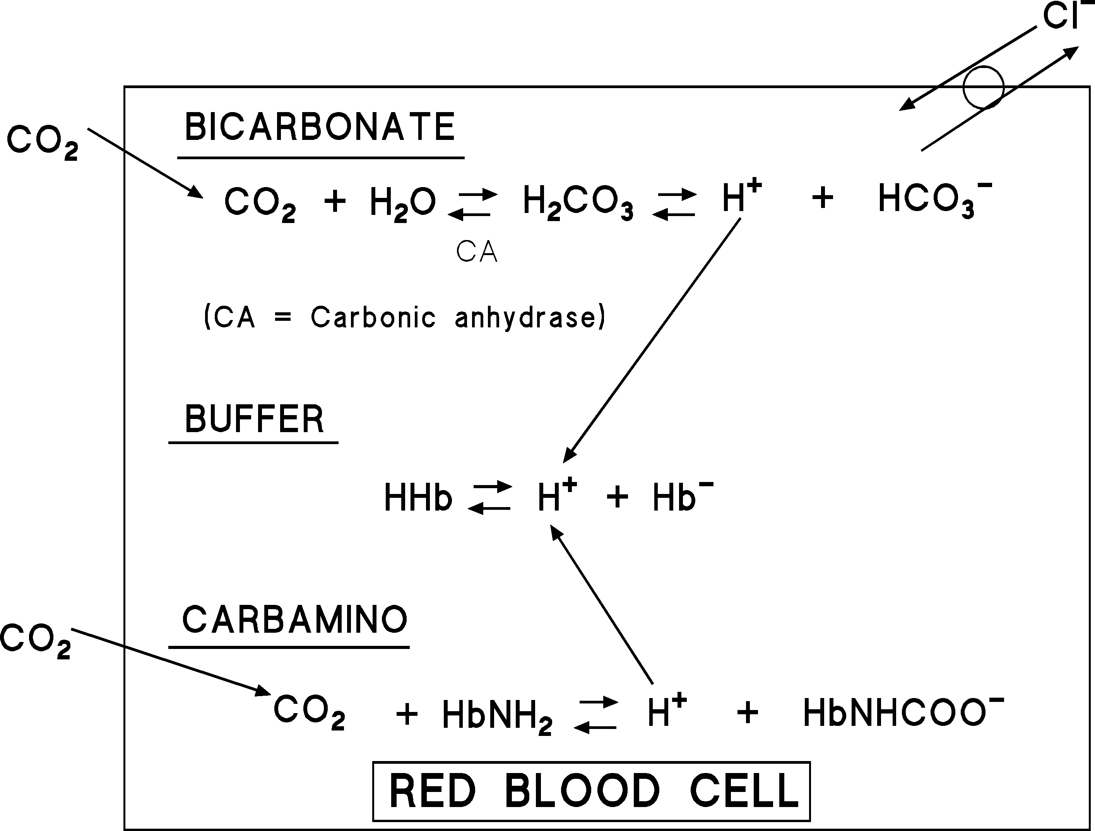
Carbon dioxide transport in blood takes three forms: physical solution, bicarbonate ion formation and chemical combination with amino acids in blood proteins including haemoglobin

Carbon dioxide carried in blood thus alters blood pH. Since CO₂ + H₂O ⇔ H₂CO₃ ⇔ H⁺ + HCO₃⁻, a raised arterial pCO₂ indicates a respiratory acidosis and a lowered arterial pCO₂ indicates a respiratory alkalosis.

Suggested further reading
- Respiratory Physiology by John West (the classic text)
- Pulmonary Physiology by Michael Lewitzky (a more recent text for American undergraduates)
- The Respiratory System by Andrew Davies + Carl Moores (a recent, easy to read and well illustrated British text integrating basic science and clinical conditions)

