Lecture 10

Structure & Function of the Airways
Dr Duncan Rogers (duncan.rogers@imperial.ac.uk)

This presentation concentrates on the structure and function of airways which have cartilage as a mechanical support (see dark gray areas in Figure 1 below – page L10.3) – generally the more proximal airways that are greater than ~2 mm in diameter (the ‘conducting zone’ in Figure 2 below – page L10.3); NOT the more distal, non-cartilaginous airways (the latter are covered in another presentation).

Learning Objectives

At the end of the session, the student should be able to:

1. Describe the main functions of the airways

2. Describe the structure of the principal cells of the airways (including epithelial cells, smooth muscle cells, submucosal glands, inflammatory cells)

3. Draw a diagram of an airway showing the relative location of the cells

4. Describe the main functions of the airway cells

5. Relate the location of the cells to their function

6. Relate the functions of the airway cells to the overall functions of the airways

7. Describe the humoral control of the function of the airway cells

- Describe the neuronal control of the function of the airway cells

- Briefly relate changes in control mechanisms to the pathophysiology of
respiratory diseases

10. Briefly outline the altered functions of airway cells to the pathophysiology of respiratory diseases

Lecture Content

1. Consideration of the airways as a multi-functioning unit and its contribution to:
- conductance of, and resistance to, airflow to and from the alveoli (oxygen delivery and carbon dioxide disposal, respectively) via regulation of airway calibre
- ‘conditioning’ (e.g. humidification) of inspired air
- primary airway defence via functioning of the mucociliary ‘escalator’
- homeostatic control via the activity of ‘resident’ immune/inflammatory cells
- pathophysiology of respiratory disease via the activity of inflammatory cells recruited to the airways, as well as changes in activity of resident structural and inflammatory cells
2. Examination of how the above functions are achieved with respect to:
- mucus secretion from epithelial goblet cells and submucosal glands
- electrolyte and water flux across the epithelium
- ciliary activity of epithelial ciliated cells
- contraction and relaxation of airway smooth muscle leading to constriction and dilation of the airways
- contraction and relaxation of vascular smooth muscle in the bronchial circulation leading to vasoconstriction and vasodilatation of bronchial vessels with consequent effects on mucosal thickness (leading to constriction or dilation of the airways)
- mediator release by ‘structural’ airway cells (eg epithelial cells and smooth muscle cells) and inflammatory cells (eg mast cells, eosinophils, neutrophils and macrophages)
3. Outline of the humoral and neuronal mechanisms controlling:
- goblet cell secretion
- submucosal gland secretion
- transepithelial ion transport
- ciliary beating
- airway smooth muscle contraction and relaxation
- vascular smooth muscle contraction and relaxation
- mediator release by structural and inflammatory cells
- attraction of inflammatory cells into the airways

Organisation of the airways and lungs
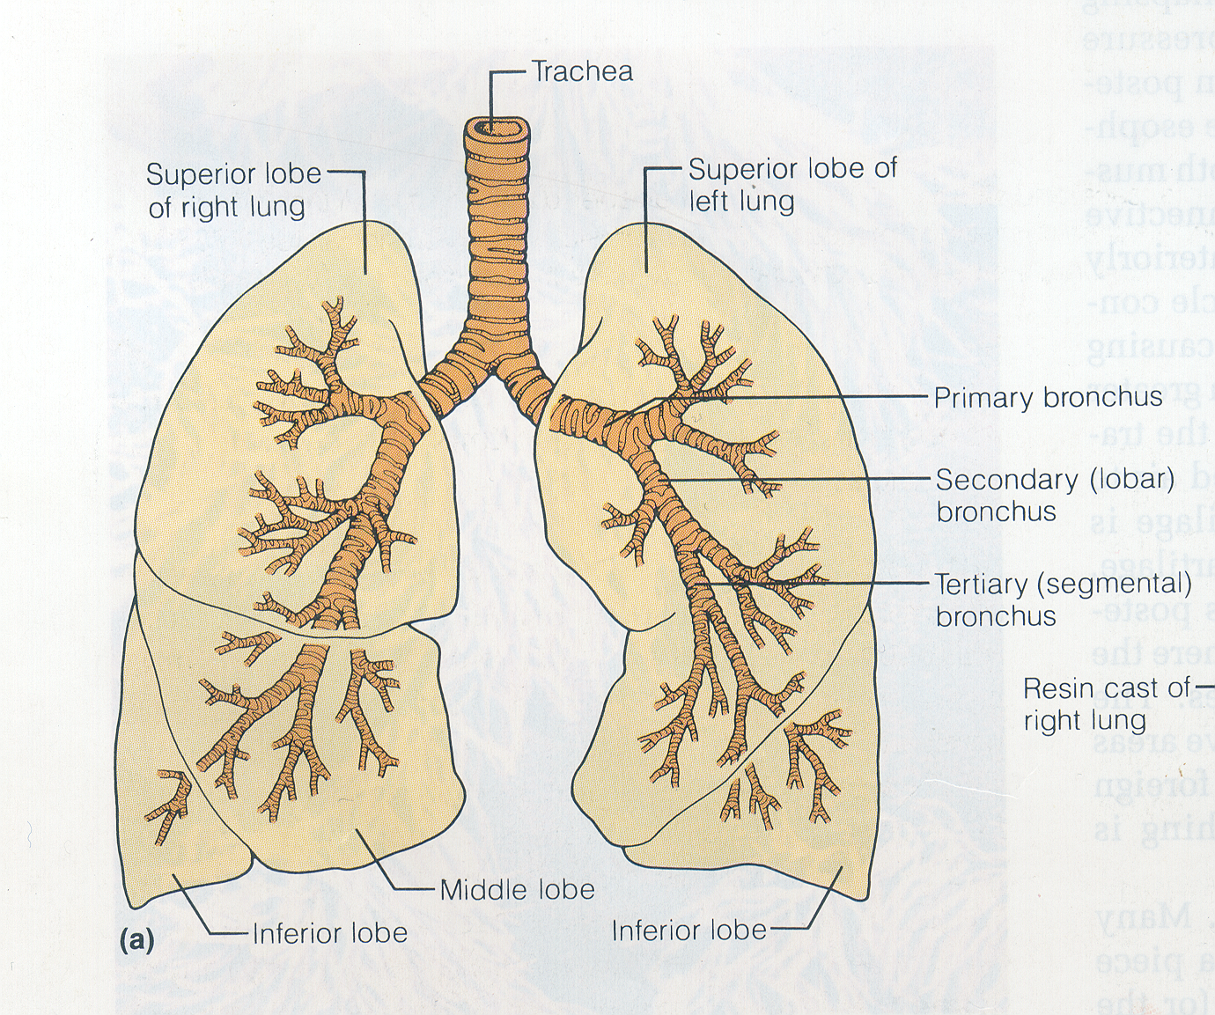
Cartilage
Cartilage
Figure 1
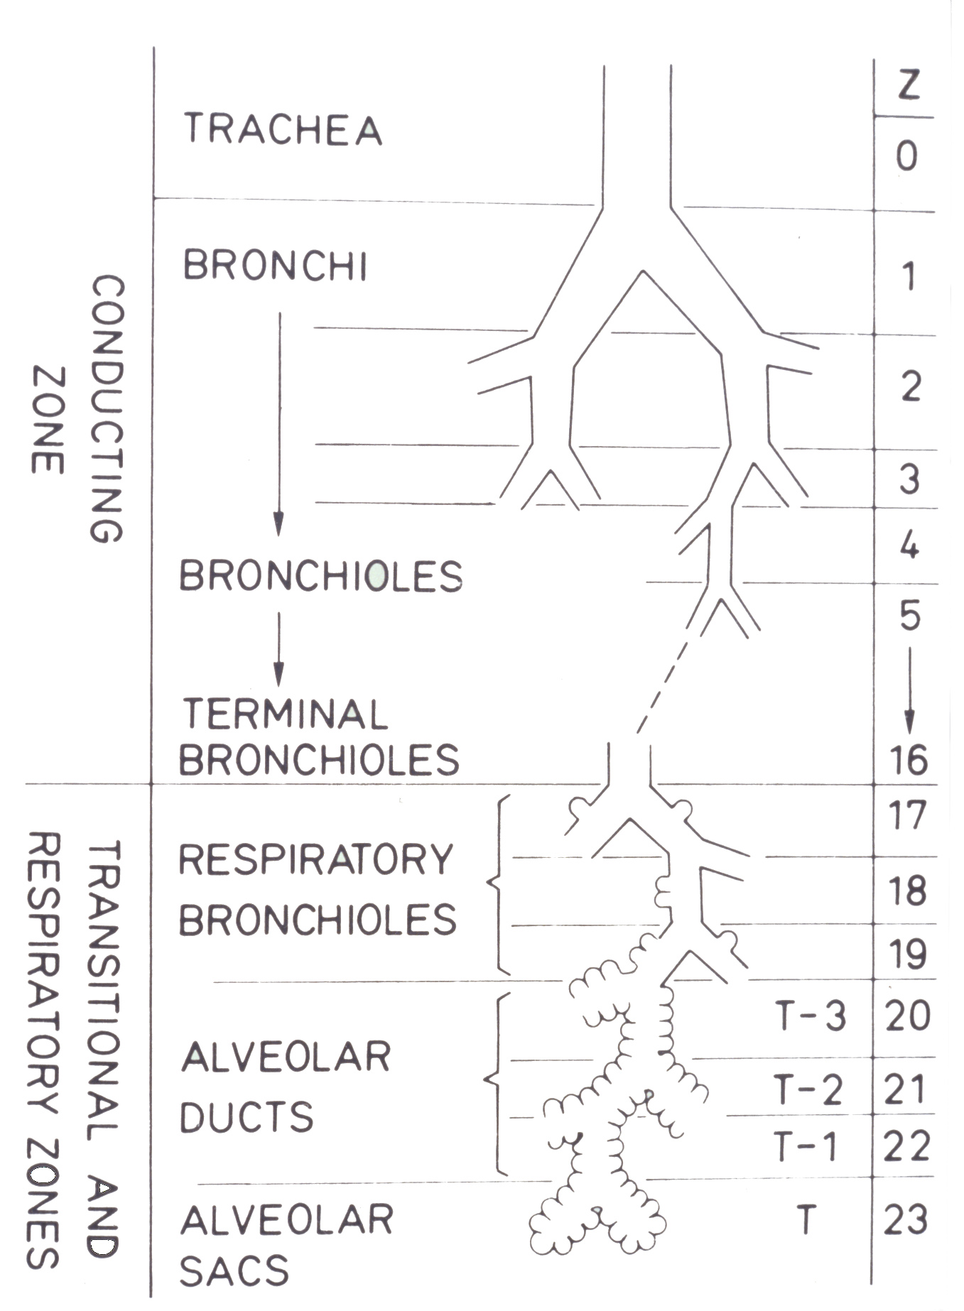
Figure 2
Basic structure of the airways
The organisation of the different structural elements of the airways is complex, but can be simply represented as below (transverse section through airway):


