School of Medicine

Year 1 – 2012/13

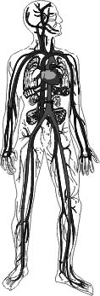

LIFE SUPPORT SYSTEMS

## Cardiovascular System

Core Course Guide

Course Leader: **Dr Ken MacLeod**

email: [k.t.macleod@imperial.ac.uk](mailto:k.t.macleod@imperial.ac.uk)

<https://education.med.imperial.ac.uk>

Cardiovascular system

Year 1 – Spring term core course guide

CONTENTS

Page

SOLE *iii-viii*

INTRODUCTION 1-2

ASSESSMENT DETAILS 2

PRACTICAL & TUTORIAL SESSIONS 2

READING LIST 3-4

CONTACT DETAILS 4

LEARNING OBJECTIVES 5

BP PRACTICAL MATERIAL 43

ECG PRACTICAL MATERIAL 50

<https://education.med.imperial.ac.uk>

**SOLE FEEDBACK – *Cardiovascular System***

The following pages provide you with templates on which you can record your thoughts as the course proceeds. At the end of the course you can enter your views onto SOLE.

**Please answer all questions by selecting the response which best reflects your view.**

|  |  |  |  |  |  |
| --- | --- | --- | --- | --- | --- |
|  | Very Good | Good | Satisfactory | Poor | No Response |
| The support materials available for this module (e.g. handouts, web pages, problem sheets and/or notes on the board). |  |  |  |  |  |
| The organisation of the module. |  |  |  |  |  |
|  | Strongly Agree | Agree | Neutral | Disagree | Strongly Disagree |
| Feedback on my work has been prompt (this refers to any work you submit being commented upon within a specified time). Not applicable for this course. |  |  |  |  |  |
| Feedback on my work has helped me clarify things I did not understand. |  |  |  |  |  |

Please use this box for constructive feedback and suggestions for improvement.

|  |
| --- |
|  |

**SOLE FEEDBACK - INDIVIDUAL LECTURERS**

Please note that for SOLE, a Lecturer’s name will only appear once. This template gives you the opportunity to record your comments about each lecture in the order of delivery.

**On the following section, you have an opportunity to record any comments and constructive feedback you have for each lecturer.**

|  | **The structure and delivery of the lecture(s)** | | | | | **The explanation of concepts given by the lecturer** | | | | | **The approachability of the lecturer** | | | | |
| --- | --- | --- | --- | --- | --- | --- | --- | --- | --- | --- | --- | --- | --- | --- | --- |
| **Lecturer, Number and Lecture Title** | Very Good | Good | Satisfactory | Poor | Very poor | Very good | Good | Satisfactory | Poor | Very poor | Very good | Good | Satisfactory | Poor | Very poor |
| Dr Ken MacLeod **1** Introduction to the course |  |  |  |  |  |  |  |  |  |  |  |  |  |  |  |
| Dr Paul Strutton **2**  Anatomy of the heart and circulation |  |  |  |  |  |  |  |  |  |  |  |  |  |  |  |
| Dr Ken MacLeod **3** Mechanical properties of the heart 1 |  |  |  |  |  |  |  |  |  |  |  |  |  |  |  |
| Dr Ken MacLeod **4** Mechanical properties of the heart 2 |  |  |  |  |  |  |  |  |  |  |  |  |  |  |  |
| Dr Ken MacLeod **5** Electrical activity of the heart |  |  |  |  |  |  |  |  |  |  |  |  |  |  |  |
| Dr Chris John **6**  The Microcirculation |  |  |  |  |  |  |  |  |  |  |  |  |  |  |  |
| Dr Pradeep Luther **7** Understanding the ECG |  |  |  |  |  |  |  |  |  |  |  |  |  |  |  |
| Dr Sanjay Prasad **8** ECG – Identifying disturbances in rhythm |  |  |  |  |  |  |  |  |  |  |  |  |  |  |  |
| Prof Alun Hughes **9** Blood vessels and blood flow |  |  |  |  |  |  |  |  |  |  |  |  |  |  |  |
| Dr Adrian Chester **10** Blood vessel function & specialization |  |  |  |  |  |  |  |  |  |  |  |  |  |  |  |
| Dr Mike Schachter **11** Sympathetic nervous and RAS systems |  |  |  |  |  |  |  |  |  |  |  |  |  |  |  |
| Dr Ken MacLeod **12** Regulation of the cardiovascular system |  |  |  |  |  |  |  |  |  |  |  |  |  |  |  |
| Dr Chris John **13** Responses to CVS stress |  |  |  |  |  |  |  |  |  |  |  |  |  |  |  |
| Prof.David Lane **14** Haemostasis |  |  |  |  |  |  |  |  |  |  |  |  |  |  |  |
| Dr Mike Laffan **15** Abnormalities of haemostasis |  |  |  |  |  |  |  |  |  |  |  |  |  |  |  |
| Dr Pradeep Luther **16** Practical ECG methods |  |  |  |  |  |  |  |  |  |  |  |  |  |  |  |
| Dr Joe Boyle **17** Atherosclerosis |  |  |  |  |  |  |  |  |  |  |  |  |  |  |  |
| Dr Anna Randi **18** Vascular endothelium |  |  |  |  |  |  |  |  |  |  |  |  |  |  |  |
| Prof Peter Collins **19** Heart failure |  |  |  |  |  |  |  |  |  |  |  |  |  |  |  |
| Prof Alun Hughes **20** Hypertension I |  |  |  |  |  |  |  |  |  |  |  |  |  |  |  |
| Dr Ranil De Silva **21** Coronary heart disease |  |  |  |  |  |  |  |  |  |  |  |  |  |  |  |
| Dr Ken MacLeod **22** Integration of CVS responses |  |  |  |  |  |  |  |  |  |  |  |  |  |  |  |

| **Lecturer and Lecture Title** | **Please use this box for additional constructive feedback.** |
| --- | --- |
| Dr Ken MacLeod **1** Introduction to the course |  |
| Dr Paul Strutton **2**  Anatomy of the heart and circulation |  |
| Dr Ken MacLeod **3** Mechanical properties of the heart 1 |  |
| Dr Ken MacLeod **4** Mechanical properties of the heart 2 |  |
| Dr Ken MacLeod **5** Electrical activity of the heart |  |
| Dr Chris John **6** The Microcirculation |  |
| Dr Pradeep Luther **7** Understanding the ECG |  |
| Dr Sanjay Prasad **8** ECG – Identifying disturbances in rhythm |  |
| Prof Alun Hughes **9** Blood vessels and blood flow |  |
| Dr Adrian Chester **10** Blood vessel function and specialisation |  |
| Dr Mike Schachter **11** Sympathetic nervous and RAS systems |  |
| Dr Ken MacLeod **12** Regulation of the cardiovascular system |  |
| Dr Chris John **13** Responses to CVS stress |  |
| Prof.David Lane **14** Haemostasis |  |
| Dr Mike Laffan **15** Abnormalities of haemostasis |  |
| Dr Pradeep Luther **16** Practical ECG methods |  |
| Dr Joe Boyle **17** Atherosclerosis |  |
| Dr Anna Randi **18** Vascular endothelium |  |

| **Lecturer and Lecture Title** | **Please use this box for additional constructive feedback.** |
| --- | --- |
| Prof Peter Collins **19** Heart failure |  |
| Prof Alun Hughes **20** Hypertension |  |
| Dr Ranil De Silva **21**  Coronary heart disease, angina, MI… |  |
| Dr Ken MacLeod **22** Integration of CVS responses |  |
|  |  |
|  |  |
|  |  |
|  |  |
|  |  |
|  |  |
|  |  |
|  |  |
|  |  |
|  |  |
|  |  |
|  |  |
|  |  |

**SOLE FEEDBACK - INDIVIDUAL TUTORS**

This template gives you the opportunity to record your comments about your tutor.

**On the following section, you have an opportunity to record any comments and constructive feedback you have for each tutor.**

|  | **The tutorial was well structured** | | | | | **The tutor explains concepts clearly** | | | | | **The tutor engages well with the students** | | | | |
| --- | --- | --- | --- | --- | --- | --- | --- | --- | --- | --- | --- | --- | --- | --- | --- |
| **Tutor** | Strongly Agree | Agree | Neutral | Disagree | Strongly Disagree | Strongly Agree | Agree | Neutral | Disagree | Strongly Disagree | Strongly Agree | Agree | Neutral | Disagree | Strongly Disagree |
|  |  |  |  |  |  |  |  |  |  |  |  |  |  |  |  |
|  |  |  |  |  |  |  |  |  |  |  |  |  |  |  |  |
|  |  |  |  |  |  |  |  |  |  |  |  |  |  |  |  |
|  |  |  |  |  |  |  |  |  |  |  |  |  |  |  |  |
|  |  |  |  |  |  |  |  |  |  |  |  |  |  |  |  |

Please use the space below for additional constructive feedback on each tutor.

|  |  |
| --- | --- |
| **Tutor** | **Comments** |
|  |  |
|  |  |
|  |  |
|  |  |
|  |  |

Cardiovascular System

**Introduction**

The ***Cardiovascular System*** course is taught in the Spring Term of year 1. The course teaches you a large amount of physiology. Physiology is the study of how organisms and their body parts work. It involves understanding how cells function, how they combine in specific organs such as the heart or kidney and how these organ systems work together to maintain a stable environment inside the body.

The cardiovascular system course is designed to teach you firstly the anatomy, then the physiology of the cardiovascular system. Some parts of the course will take place in parallel with your anatomy course studies of the thorax. After learning the basic principles you will then be introduced to the pathophysiology of the cardiovascular system ie the disordered physiological processes associated with disease or injury.

It is important to grasp the physiology since most diseases and impaired bodily functions are disturbances, or result in disruptions, of physiological processes.

It is not our intention to teach you detailed clinical medicine at this stage but we want you to have a foundation on which you can build during the subsequent years of your undergraduate programme. By the end of the course we hope you will understand the physiology of the cardiovascular system and the pathophysiology of some major cardiovascular diseases.

**Course structure**

There are 22 lectures, 1 tutorial, 2 practicals and 5 quiz sessions

**Core course guide**

***The CVS course has not produced a fully comprehensive course guide*.** This smaller core guide provides you with learning objectives for each lecture, short key notes and all lectures will be available on the intranet prior to the course. It is intended that you use the learning objectives to clarify, organize and prioritize your learning and the lecture material and your own written notes to produce a focused set of course notes. These notes, in addition to the course quizzes will, hopefully, encourage you to take responsibility for your learning and help you evaluate your progress. You are expected to use other sources of information to strengthen your own notes. For some lectures, additional material has been be provided in the guide and put on the intranet and your attention also drawn to various useful web sites. In general, the information provided in the lectures can be supplemented by reading the recommended 1st year physiology textbook.

**Several words of warning**

* **Keep reviewing lecture material.** Students find the cardiovascular system course one of the most difficult. This is usually because the concepts are new, there is a lot of information to learn and there is profound integration with other “life support systems” for example, the respiratory and renal systems. The best advice is “be prepared”. Read ahead if you can and review lecture material following the lecture. You will retain more of the information when it is reviewed on a daily basis.
* **Keep testing yourself.** There are a number of quizzes built into the course. These provide almost instant feedback on your understanding of key concepts. The questions are true/false style but are pitched at a similar level as the questions you will be asked to answer in the main examinations. Use these wisely to assess your class performance and if you are not achieving reasonable marks, ask yourself why.
* **Self-study sessions.** There are self-study sessions built into the course. This is so that you can revise areas of weakness and prepare for the practicals and tutorials. It is essential that you use this time to look at the material referenced on pages 7 and 8.
* **Read learning objectives carefully.** Learning objectives are statements that describe what you should be able to do as a result of learning the material in the lecture. Objectives are given for each lecture. Do not underestimate what the learning objectives entail. If they say, for example, that you should be able to state the normal duration and amplitude of the components of the ECG waveform, be aware that is exactly the information the lecturer wishes you to learn.

**Practical and tutorial sessions**

The lectures provide you with knowledge of the cardiovascular system but you also need to acquire some practical skills to help you when you need to make diagnoses. Having these basic clinical skills is a vital part of general medicine.

There are 4 practical and tutorial sessions in total: Tuesday 19 (am), Wednesday 20 (am), Friday 22 (am) and Tuesday 26 (pm) February 2013. During these sessions, students will (a) perform a blood pressure practical, (b) perform an ECG practical and (c) attend a tutorial on haemorrhage. The sessions will be done in rotation. **You will be involved only in one session.** The other 3 occasions you have free for private self-study.

Group A will have their practical and tutorial sessions on Tuesday 19 February, Group B will be on Wednesday 20, Group C on Friday 22 and Group D on Tuesday 26 February.

Details of these arrangements are on the Intranet timetable.

**NB:**  In order that the practical and tutorial sessions run smoothly you must complete your tasks in a timely manner and move onto the next session quickly so that it can start on time. You must attend Dr Luther’s short talk on practical ECG methods on Wednesday 13 February at 11:00 hrs and you need to read thoroughly the self-study papers referenced on pages 3 and 4.

**ASSESSMENT**

**Summative Assessment**

The course will be examined as part of the Life Support Systems examination. There will be 11 single best answer questions and 2 short answer questions set on the cardiovascular system and 1 short answer question that will test combined (and integrated) knowledge of the cardiovascular, respiratory and/or renal systems. Further details about examinations are provided on the Intranet.

**Recommended reading**

We recommend as a main textbook:

Vander, Sherman & Luciano’s *Human Physiology – The mechanisms of body function.* 10th edition. Widmaier EP, Raff H, Strang KT editors. McGraw-Hill. ISBN: 0-07-111678-8

The following also contain good explanations of cardiovascular system physiology:

Berne R, Levy M. *Physiology.*  5th edition. Mosby (2004)

Levick JR. *An Introduction to Cardiovascular Physiology*. 3rd edition. Oxford University Press (2000)

For explanations of cardiovascular and cardiac diseases there are many specific cardiology texts but some recommendations are:

Swanton RH. *Cardiology.*  4th edition. Blackwell Science

Julian D, Cowan CJ, McLenachan JM. *Cardiology* 7th edition. Saunders

**Articles for self-study**

Please read the following articles in the box *before* the Practical and Tutorial sessions. Links to the articles will be placed on the College Intranet.

*Two articles in the British Medical Journal on ECG basics*

S Meek, F Morris. Introduction. I. Leads, rate, rhythm, and cardiac axis [BMJ (2002) 324:415-418 (16 February 2002)](http://bmj.com/cgi/content/full/324/7334/415).

S Meek, F Morris. Introduction. II. Basic terminology [BMJ (2002) 324:470-473 (23 February 2002)](http://bmj.com/cgi/content/full/324/7335/470).

*One article on Blood Pressure measurement*

G Beevers, G Y H Lip, E O'Brien. ABC of hypertension: Blood pressure measurement Part I – Sphygmomanometry: factors common to all techniques BMJ (2001) 322:981–985 (21 April 2001)

<http://bmj.bmjjournals.com/cgi/content/full/322/7292/981>?

*An article on haemorrhage*

MS Roth. Bleeding and hypovolaemic shock

Student BMJ (2005)13:139-141 (April 2005)

<http://archive.student.bmj.com/issues/05/04/education/139.php>

*Further articles on ECG interpretation*

D Da Costa, WJ Brady, J Edhouse. (2002) Bradycardias and atrioventricular conduction block

[BMJ (2002) 324: 535-538 (2 March 2002)](http://bmj.com/cgi/content/full/324/7336/535).

<http://bmj.bmjjournals.com/cgi/content/full/324/7336/535>

#### S Goodacre, R Irons. (2002) Atrial arrhythmias

[BMJ (2002) 324: 594-597 (9 March 2002)](http://bmj.com/cgi/content/full/324/7337/594).

<http://bmj.bmjjournals.com/cgi/content/full/324/7337/594>

#### D Esberger, S Jones, F Morris. (2002) Junctional tachycardias

[BMJ (2002) 324: 662-665. (16 March 2002)](http://bmj.com/cgi/content/full/324/7338/662).

<http://bmj.bmjjournals.com/cgi/content/full/324/7338/662>

#### J Edhouse, F Morris. (2002) Broad complex tachycardia-Part I

[BMJ 2002;324 719-722. (22 March 2002)](http://bmj.com/cgi/content/full/324/7339/719).

<http://bmj.bmjjournals.com/cgi/content/full/324/7339/719>

#### J Edhouse, F Morris. (2002) Broad complex tachycardia-Part II

[BMJ 2002;324 776-779. (30 March 2002)](http://bmj.com/cgi/content/full/324/7340/776).

<http://bmj.bmjjournals.com/cgi/content/full/324/7340/776>

*Historical perspective*

T. Maoukbary (2007) Willem Einthoven (1860-1927): Father of electrocardiography

Cardiology Journal 14:316-317

*Articles with a clinical emphasis*

MJ Davies (2000) Pathophysiology of acute coronary syndromes.

Heart 83:361-366

<http://heart.bmjjournals.com/cgi/content/full/83/3/361>

RM Norris (2000) Natural history of acute myocardial infarction

Heart 83:726-730

<http://heart.bmjjournals.com/cgi/content/full/83/6/726>

F Zijlstra (2001) Acute myocardial infarction: primary angioplasty

Heart 85:705-209

<http://heart.bmjjournals.com/cgi/content/full/85/6/705>

**Contact details**

Course Leader: Dr Ken MacLeod - k.t.macleod@imperial.ac.uk

Administrative support: Jo Williams - jo.williams@imperial.ac.uk

**Lecture 1 – Introduction to the course**

Dr Ken MacLeod

k.t.macleod@imperial.ac.uk

Learning Objectives

This is an introductory lecture covering administrative and broad aspects of the course. There are no specific learning objectives for this session.

Notes:

**Lecture 2 – Anatomy of the heart and circulation**

Dr Paul Strutton

p.strutton@imperial.ac.uk

Learning Objectives

Following this lecture students should be able to:

* Identify the pericardium in the cadaver and describe its organisation
* Demonstrate the four chambers of the heart
* List the vessels that enter or leave each of the chambers of the heart
* Identify the origin of the brachiocephalic artery, the subclavian arteries and the carotid system of arteries in a cadaver
* Describe the position and relations of the aortic arch and descending aorta
* Explain how blood returns from the head and neck to the heart
* Identify the superior vena cava in a cadaver
* Outline the coronary circulation and be able to identify the main coronary arteries and cardiac veins
* Identify and label the heart valves and their locations, and state the structural similarities and differences
* Explain how blood leaving the heart reaches (a) head and neck, (b) lungs, (c) thoracic and abdominal cavities
* Describe the components of the conduction system

Additional reading:

Drake, Richard L; Vogl, Wayne; Mitchell, Adam W M Gray’s Anatomy for Students 2nd Ed: 2009: Churchill Livingstone

Notes:

**Lecture 3 – Mechanical Properties of the Heart 1**

Dr Ken MacLeod  
k.t.macleod@imperial.ac.uk

Learning Objectives

At the end of this lecture students should be able to:

* Describe the relationship between ventricular wall tension, chamber radius, and chamber pressure (Law of Laplace)
* List the sequence of events from excitation that bring about contraction then relaxation of a ventricular cell
* State Starling’s Law of the Heart
* Explain the mechanisms underlying Starling’s Law of the Heart
* Use a graph to compare the length-tension relationships for cardiac and skeletal muscle
* Explain the concepts of preload and afterload

**Key notes**

Sydney Ringer (1883) established the importance of extracellular Ca2+ ions to the heart beat and its strength of contraction. He examined the consequence of the bathing solution and its ionic constituents to the well-being of tissues in isolation. The bathing solution became known as *Ringer's solution* still used today albeit in more modified forms.

Link between the excitatory event (the action potential) and the contractile event is provided by *Ca2+ influx through L-type Ca2+channels* that causes further *Ca2+ release from intracellular stores* (sarcoplasmic reticulum). These sources of Ca2+ produce the *Ca2+transient* that causes contraction of the myofibrils. The process is known as Ca-induced Ca release.

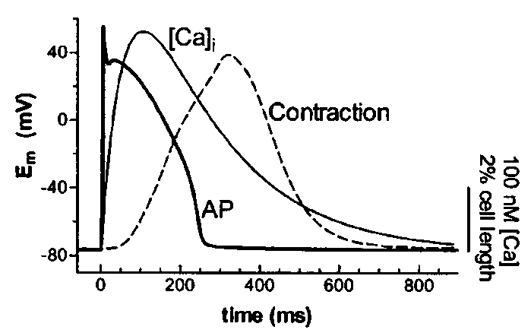On a beat-to-beat basis two main systems involved in removing Ca2+ from the cytoplasm and so inducing relaxation. Ca pumped back into the SR by the *SR CaATPase (SERCA2a)* and extruded from the cell by the sarcolemmal *Na+/Ca2+ exchange*. In steady-state conditions, the amount of Ca2+ leaving the cell is the same as the amount entering so that precise Ca2+ homeostasis is achieved.

Force production by heart muscle proportional to the amount of Ca2+ released into the cytoplasm.

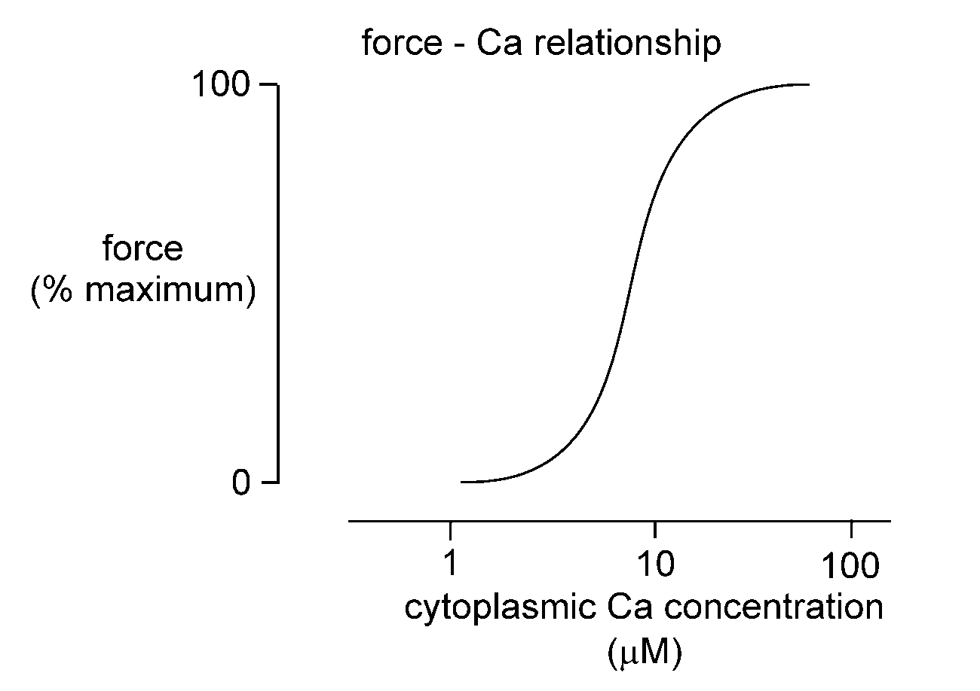

Force produced by muscle fibre activation (active force) dependent on initial length of fibre. This property is described by the *length-tension (or force) relationship*.

A

B

C

Muscle length

Force

Active force production

Only the ascending phase of the length-tension (or force) relationship important for cardiac muscle *cf* skeletal muscle.

*Passive force is the elastic recoil of the muscle fibres* which becomes larger as the muscle is stretched. Passive force due to cytoskeletal proteins such as titin. Such polypeptides function as “molecular springs”. Titin joins the Z line to the M line. Cardiac muscle more resistant to stretch (ie less compliant) than skeletal muscle due to properties of the extracellular matrix and cytoskeleton.

*Preload* is a weight that stretches muscle before it is stimulated to contract. Increases in preload stretch the muscle so that it is capable of producing larger forces when stimulated.

This effect underlies *Starling’s Law of the Heart* which states that *increased diastolic fibre length increases ventricular contraction*. Due to two factors:

the number of myofilament cross bridges that interact and the Ca2+ sensitivity of the myofilaments.

Passive force

Isometric (no shortening)

contraction

*Afterload* is a weight not apparent to muscle in resting state; only encountered when muscle has started to contract. As (after)load increases the amount of shortening of the muscle fibres decreases.

*In vivo correlates of preload and afterload:*

Preload – as blood fills the ventricles during the relaxation phase (or diastole) of the cardiac cycle it stretches the resting ventricular walls. The stretch or filling determines the preload on the ventricles before they eject blood. Preload is dependent upon venous return to the heart.

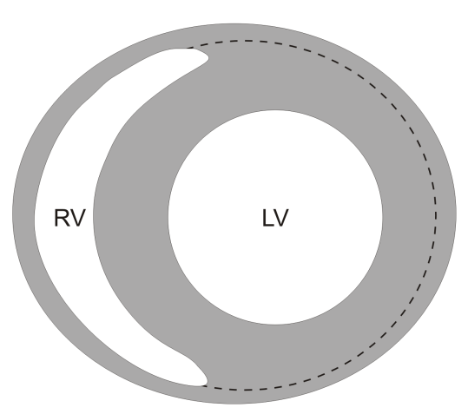Afterload – the load against which the left ventricle ejects blood after opening of the aortic valve. Afterload is therefore the diastolic arterial blood pressure. Any increase in afterload (or diastolic blood pressure) decreases muscle shortening and velocity of shortening. This reduces the rate of ejection of blood from ventricle so that more blood is left in the ventricle after systole.

*Law of Laplace*: when the pressure within a cylinder is held constant, the tension (force) on its walls increases with increasing radius. Therefore to increase P whilst keeping wall tension (T) constant either decrease radius (R) or increase wall thickness (h).



Radius of walls of LV less than that of RV allowing LV to generate higher pressures with similar wall tension.

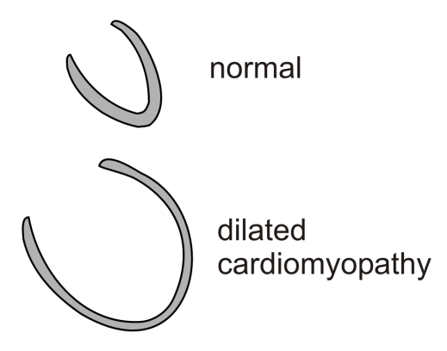Failing hearts often become dilated which decreases pressure generation and ejection of blood and increases wall tension.

**Lecture 4 – Mechanical Properties of the Heart 2**

Dr Ken MacLeod  
k.t.macleod@imperial.ac.uk

Learning Objectives

At the end of this lecture students should be able to:

* Describe the mechanical events of the cardiac cycle
* Use a graph to correlate electrocardiographic events and pressure events of the atria, ventricles, aorta and pulmonary artery
* Indicate on the graph the phases of the cardiac cycle and the corresponding pressure changes, valve openings and closures
* Define and state normal values for right and left ventricular end-diastolic volume, end-systolic volume, stroke volume, end-diastolic pressure and peak systolic pressure
* State the origin of the heart sounds
* Provide the mathematical equation for ejection fraction
* Define cardiac output and indicate its determinants
* Construct simple pressure-volume diagrams from the events during the cardiac cycle and annotate these graphs appropriately

Notes:

**Volumes**

End-systolic volume (ESV) = volume left in ventricle at end of contraction

End-diastolic volume (EDV) = volume in ventricle at the end of the ventricular filling phase

Stroke volume (SV) = volume of blood ejected by ventricular contraction

EDV - ESV = SV

~130 ml - ~ 60 ml = ~70 ml

Made up from:

ESV (~ 60 ml)

+ amount passively added to ventricle during atrial diastole (~ 40ml)

+ amount added by atrial systole (~ 30 ml)

Ejection fraction (EF) = percentage of EDV ejected. (i.e. EF = SV / EDV). In this case EF is ~ 54 %. EF dependent upon physical state. At peak exercise EF >80 %; in heart failure <40%.

**Pressures**

* The patterns of pressure changes in the right heart are essentially identical to those of the left
* Quantitatively, the pressures in the right heart and pulmonary circulation are much lower

Right atrium (mean) 0 - 8 mmHg Left atrium (mean) 8 - 10 mmHg

Right ventricle 25/5 Left ventricle 120/5

Pulmonary artery 25/12 Aorta 120/80

PA wedge (mean) 4 - 12 mmHg

**Timings**

Systole ~ 0.3 sec; entire cardiac cycle ~0.8 sec; average heart rate (HR) = 72 beats / min

Cardiac output (CO) = amount of blood ejected by each ventricle in 1 minute

CO = HR x SV

At rest, a typical value for CO is 72 (beats / min) x 70 (ml / beat) = 5.04 litres / min

**Pressure – volume loops**

Since the force of contraction of the heart is typically measured as pressure, the length –tension relationship in heart is usually measured as a pressure – volume relationship. The ventricle must develop sufficient pressure to exceed that in the aorta before ventricular volume can decrease during the cardiac cycle. Aortic pressure during ejection is the afterload.

**cardiac_cycle_total_bw.tif**

**Lecture 5 – Electrical Activity of the Heart**

Dr Ken MacLeod

k.t.macleod@imperial.ac.uk

Learning Objectives

At the end of this lecture students should be able to:

* Describe how a membrane potential is formed across an excitable cell membrane.
* Describe the changes in ionic permeability of a typical cardiac ventricular cell membrane that occur during the action potential.
* Explain why the ventricular action potential has a long duration and relate this to the function of the ventricles.
* Explain why refractory periods occur and why they are important in the functioning of the heart.
* Sketch an intracellular action potential for a) a sino-atrial node cell and b) a ventricular cell.
* State that the sino-atrial (SA) node is the normal pacemaker and explain why and how this is so.
* Briefly describe the pathways of the heart that subserve the normal orderly passage of electrical activity through it.
* Describe how electrical activity is transmitted to all parts of the ventricles through the Bundle of His and the Purkinje fibres.
* Describe the ECG waveforms using the conventional PQRST nomenclature and state the electrical events that each represents.

Notes:

**Origin of the membrane potential**

The membrane potential depends on the flow of potassium (K+) out of cells. We can predict what a potential will be across a semi-permeable membrane using the Nernst equation. If the membrane is only permeable to K+ at rest (diastole) then the potential across it will equal the K+ equilibrium potential, EK. The equilibrium potential is calculated by solving the Nernst equation.



The Nernst equation:

K+ concentration difference across the membrane is maintained by the Na/K ATPase.

**Key points about the cardiac action potential**

* Cardiac action potential is long (several hundred milliseconds) eg compared with nerve
* Duration of action potential controls the duration of contraction of the heart
* Long, slow contraction is required to produce an effective pump
* At rest membrane potential determined by K+
* Large membrane permeability to K+ (PK) stabilizes membrane potential reducing risk of arrhythmias by requiring a large stimulus to excite the cells
* A large change in PNa causes the action potential upstroke. This is followed by an influx of calcium (Ca2+) early in the plateau through L-type Ca2+ channels. This influx provides the trigger for Ca2+ release from intracellular stores and is required for contraction.
* The plateau ends when PCa decreases and a slow and small increase in PK occurs. Fast repolarization occurs when the membrane becomes greatly permeable to K+ (PK1).

**Refractory periods**

AP_currents_simple.tif

Absolute refractory period (ARP) = time during which no action potential can be initiated regardless of stimulus intensity

Relative refractory period (RRP) = period after ARP where an action potential can be elicited but only with stimulus strength larger than normal.

Full recovery time = the time at which a normal action potential can be elicited with normal stimulus.

Refractory periods are a result of Na+ channel inactivation. Na+ channels recover from inactivation when the membrane is repolarized.

**SA node**

The electrical properties of the heart are intrinsic (ie inherent to the heart itself). The heart can independently generate and propagate its own electrical activity. The generation of electrical activity occurs at the sino-atrial node (abbreviated to SA node or SAN). It can also be termed the sinus node. The SA node is the pacemaker of the heart and produces sinus rhythm. This specialized cardiac tissue is situated in the superior aspect of the right atrium at the anterolateral margin between the orifice of the superior vena cava and the atrium.

Most channels that exist in ventricular myocytes also exist in SA nodal cells but may be poorly expressed. There are no channels that cause IK1 in SA node so the resting membrane potential is not stable. There are very few Na+ channels so there is no fast upstroke. The upstroke in SA nodal cells is produced by Ca2+ influx. In the SA node there are also T-type Ca2+ channels that activate at more negative potentials than L-type Ca2+ channels. “Pacemaker currents” are present which slowly depolarize the cells. The pacemaker currents are inhibited by acetylcholine (ACh) so depolarization slows and heart rate decreases and stimulated by noradrenaline (NA) so the rate of depolarization is enhanced and heart rate increases.

The heart can beat independently even after being separated from its nerve supply. The extrinsic nerve supply coming from the autonomic nervous system serves to modify and control the intrinsic beating established by the heart.

**Conduction through the heart**

The intrinsic electrical activity in the SA node is conducted to the other parts of the heart by a specialized conduction system. Since the cells of the SA node fuse with the surrounding atrial muscle fibres, the action potential generated in the nodal tissue spreads throughout both atria and produces atrial contraction.

There are four basic components to the heart's conduction system

(1) sinoatrial node (SA node)

(2) inter-nodal fibre bundles

(3) atrioventricular node (AV node)

(4) ventricular bundles (bundle branches and Purkinje fibres)

*Inter-nodal fibre bundles*: interspersed among the atrial muscle fibres; they conduct the action potential to the atrioventricular (AV) node with a greater velocity than ordinary atrial muscle.

*AV node*: located in the right atrium near the lower part of the interatrial septum. Short delay (approximately 0.1 second) in transmission of the impulse to the ventricles (important because it permits the atria to complete their contraction and empty their blood into the ventricles before the ventricles contract). The delay occurs within the fibres of the AV node itself as well as in special junctional fibres that connect the node with ordinary atrial fibres.

*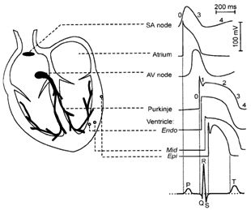Bundle branches*: Once an impulse leaves AV node, it descends in the interventricular septum for a short distance (via the Bundle of His) and then divides into two large branches, right and left bundle branches. These comprise of specialized muscle fibres called Purkinje fibres which terminate in a finger-like fashion on the working myocardial cells.

*Purkinje fibres*: conduct the action potential at about six times the velocity of ordinary cardiac muscle. The terminal Purkinje fibres extend beneath the endocardium and penetrate approximately one-third of the distance into the myocardial wall. The excitation of the ventricles proceeds from the endocardial surface through to the outer epicardium and upward from the apex of the heart towards its base.

**The electrical basis of the electrocardiogram (ECG)**

The effects of a wave of depolarization are detected as the potential difference between two electrodes.

When a wave of depolarization is moving TOWARDS a positive electrode it causes an UPWARD deflection on the ECG trace.

When it is moving AWAY from a positive electrode it causes a DOWNWARD deflection.

When a wave of repolarizing current is moving AWAY the positive electrode it causes an UPWARD deflection.

**Lecture 6 – The Microcirculation**

Dr Chris John  
c.john@imperial.ac.uk

Learning Objectives

At the end of this lecture students should be able to:

* Describe the branching structure of the microvasculature. List the three types of capillary and order them in terms of their permeability to water and small lipophobic solutes
* Describe the factors controlling capillary blood flow and explain the functional importance of capillary density
* Identify the different mechanisms by which solute is transported between blood and tissue (depending on size and lipid solubility). Explain how the “Starling forces” influence fluid transfer across the capillary wall
* Describe the origin of lymph fluid. Describe the branching structure of the lymphatic system. Understand how clinical oedema arises

Notes:

Microcirculation is made up of first order arterioles that branch off the arteries. The first order arterioles lead to the terminal arterioles that lead to the capillaries. The capillaries drain into the post-capillary venules and then into the venules which finally drain into the veins.

*Arterioles* are the major resistance vessels. Blood entering the arteriole has an average pressure of 93mmHg and blood leaving the arteriole (ie entering the capillary) is at an average pressure of 37mmHg. Vascular resistance proportional to 1/diameter4.

Radii of arterioles (and therefore vascular resistance) are adjusted to accomplish two functions;

1. Match blood flow to metabolic need of the tissue – regulated by local controls

2. Help regulate arterial blood pressure – regulated by extrinsic controls.

*Capillaries*. Delivery of metabolic substrate to the cells of the organism. (Ultimate function of the cardiovascular system)

Capillary density determines;

1. Total area for exchange between blood and tissue

2. Intercapillary spacing – influences diffusion time from blood to cell

Regulation of capillary density = Regulation of gas exchange efficiency

A. ↑ capillary density – ↑ area available for gas exchange

B. ↑ cross sectional area available for blood flow – flow velocity in each capillary ↓ (transit time for diffusion ↑)

*Capillary structure*. Continuous vs Fenestrated vs Discontinuous

*Circulation of fluid*. Capillary blood pressure (derived from the heart) drives filtration into the tissue *(ultrafiltration*). Osmotic ‘suction’ pressure (due to differences in protein concentration between the blood and the interstitial fluid) promotes absorption from the tissue (*oncotic pressure*). These ‘*Starling Forces*’ give rise to the ‘Starling hypothesis’

Filtration rate proportional to (hydraulic drive – osmotic suction)

The result is a small, continuous but significant loss of water from the blood (and any leaked protein). Returned to the blood via the Lymphatic System

**Lecture 7 – Understanding the ECG**

Dr Pradeep Luther  
p.luther@imperial.ac.uk

Learning Objectives

At the end of this lecture, students should be able to:

* Understand the presentation of the 12-lead ECG.
* Describe how the recordings of the six standard limb leads are obtained from the four electrodes attached to the limbs.
* Explain the principles underlying the concept of Einthoven’s Triangle.
* Appreciate why the magnitude and direction of components of the ECG vary from lead to lead.
* Estimate the mean frontal plane axis from the limb leads and know its normal physiological range.
* Describe how the recordings of the six pre-cordial (chest) leads are obtained.
* Understand how the information from the chest leads is different from that derived from the limb leads.
* Explain why the magnitude and direction of the components of the ECG vary as the recording electrode is moved across the chest from V1 to V6.

At the end of the self-study period students should be able to:

* Describe how depolarization of cardiac muscle creates a field
* Describe how the body, acting as a volume conductor, makes it possible to detect the electrical field with distant electrodes

Notes:

Comprehensive notes for this lecture (pages 48-55) and the ECG practical (pages 56-63) are printed later in this guide.

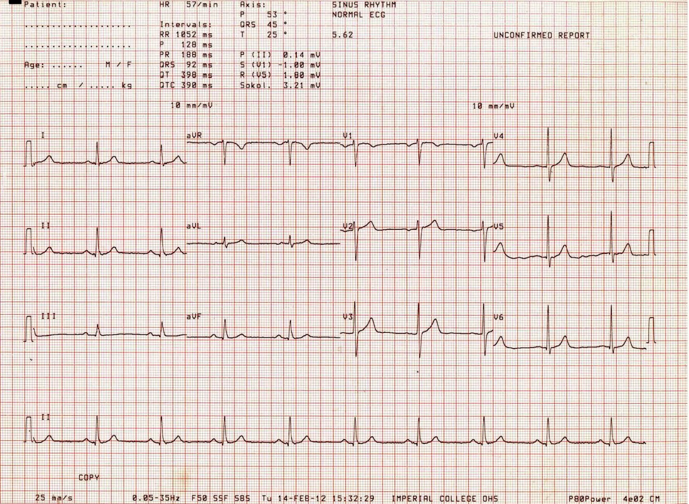A typical ECG from a patient in normal sinus rhythm

**Lecture 8 – ECG - Identifying Some Basic Disturbances of Cardiac Rhythm**

Dr Sanjay Prasad  
s.prasad@imperial.ac.uk

Learning Objectives

At the end of this lecture students should be able to:

* Describe a systematic approach to ECG interpretation
* Know the normal duration and amplitude of the components of the ECG waveform
* Recognize normal sinus rhythm on the ECG
* Recognize common abnormalities of cardiac rhythm on the ECG
* Recognize a common pattern of acute myocardial infarction on the ECG

**Table 1. Normal electrocardiographic values**

|  |  |
| --- | --- |
| **P wave** | Duration < 0.11s, Amplitude < 2.5mm in lead II |
| **PR Interval** | 0.12-0.20s |
| **QRS complex** | Duration < 0.12s |
|  | Amplitude: R wave in V6 < 25mm, or R wave in V6 + S wave V1 < 35mm |
|  | Axis: -30 to + 90 degrees |
| **Q wave** | Duration < 0.04s |
|  | Amplitude: < 25% of total QRS complex amplitude |
| **QT interval** | 0.38-0.42s (corrected for heart rate) |
| **ST segment** | Should be isoelectric |
| **T wave** | May be inverted in III, aVR, V1 and V2 without being abnormal |

**Steps in ECG interpretation**

It is important to be able to recognise what is normal, as a first step towards identifying what is abnormal. ECG interpretation is ultimately about pattern recognition

Learn the normal values for the duration and amplitude of components of the ECG (Table 1).

Every time you come across an ECG in a textbook or on the ward, go through the steps listed below.

**Step 1: Is it the correct recording?** Patient details and date of recording. Often it is the sequence of changes in an ECG over time that help arrive at the diagnosis. Putting ECGs in the correct order is essential.

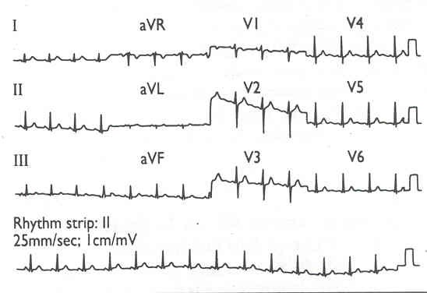**Step 2: Identify the leads.** The ECG is laid out in a standard format (See Figure 1), with a rhythm strip (showing a longer recording of one or more particular lead) along the bottom. Older machines may still print out one lead after another on a long strip of paper.

**Step 3: Check the calibration and speed of the paper.** The standard speed is 25 mm/s, and 1mV will produce 10mm vertical deflection on the trace.

**Step 4: Identify the rhythm.**

* Is the rhythm regular? If it is you can calculate the heart rate by dividing 300 by the number of large squares between the QRS complexes e.g. if four large squares (20 small squares) lie between each QRS complex then the heart rate is 300/4=75 beats per minute.
* If the heart rate is less than 60 beats per minute it is *a bradycardia*
* If the heart rate is more than 100 beats per minute it is *a tachycardia*
* Next, determine the cardiac rhythm. *Is it sinus rhythm?* In sinus rhythm each P wave (of atrial depolarisation) is followed by a QRS complex, andthere are no QRS complexes without a preceding P wave.
* If the rhythm is irregular, *what form does the irregularity take?* Is there an occasional extra QRS complex due to an ectopic beat, or is the rhythm completely irregular due to atrial fibrillation? When trying to identify the underlying rhythm you should look for a lead that shows P waves if they are present (try looking at leads II, III, aVf, or V1) and a section that shows a long enough tracing – usually the ‘rhythm strip’ is best.
* Figure 2 shows some *examples of common rhythm abnormalities*. Note that sinus bradycardia, sinus tachycardia, and sinus arrhythmia (where the heart rate varies in phase with respiration) can be physiological. They are only abnormal if very pronounced or inappropriate for the physiological setting e.g. exercise, fever, anxiety. The other abnormalities are due to the cardiac rhythm originating from a site other than the sinus node – i.e. ectopic impulse formation.

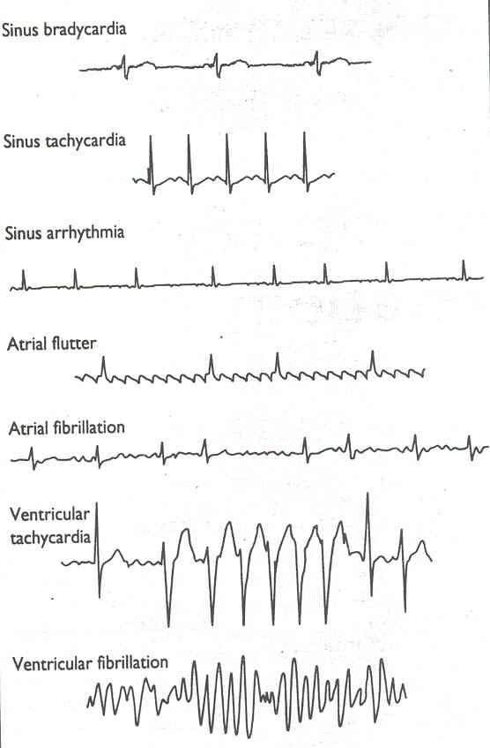

Figure 2 Examples of common rhythm abnormalities.

**Step 5: Look at the QRS axis.** The QRS axis tells you several things about the heart: its *orientation within the chest* (horizontal in obese patients and more vertical in thin patients); the *thickness of the ventricular muscle* (axis tends to shift ‘leftwards’ in left ventricular hypertrophy, and ‘rightwards’ in right ventricular hypertrophy); and *abnormalities in the direction of ventricular depolarisation* due to extensive disease in the specialised conducting tissue below the atrioventricular node.

**Step 6: Look at the P wave.** Determine the amplitude and duration of the P wave. If these are greater than normal then atrial hypertrophy is present: a long P wave, often with two peaks to its waveform, suggests left atrial enlargement; a high amplitude P wave suggests right atrial hypertrophy. Left atrial hypertrophy can occur in patients with mitral stenosis, and right atrial hypertrophy in pulmonary hypertension, for example.

**Step 7: Look at the PR interval.** If the length of the PR interval is *prolonged*, but every P wave is still followed by a QRS complex then the patient has *first degree heart block*, due to delayed conduction through the atrioventricular node from the atria to the ventricles. A PR interval that increases with each successive beat until one P wave is not followed by a QRS complex and then returns towards normal before lengthening with each successive beat again indicates *second degree heart block type 1* (often called ‘Wenckebach’s phenomenon’). If the PR interval is constant but occasionally a P wave is not followed by a QRS complex the patient has *second degree heart block type 2*. If there is no relation between the P waves and the QRS complexes, with the atria and ventricles depolarising independently (the ventricles usually at a slower rate than the atria) the patient has *complete heart block*. Figure 3 shows examples of heart block.

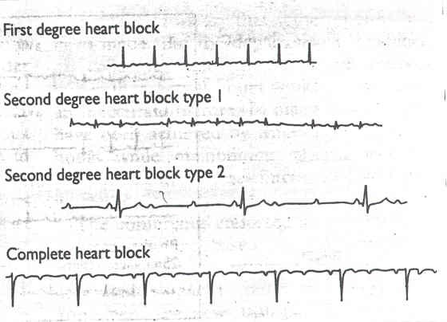

If the PR interval is *short*, then an *‘accessory’ pathway* is present, which is conducting electrical activity from the atria through to the ventricles more rapidly than is normal. This abnormality may be associated with recurrent supraventricular tachycardia (often termed *Wolff-Parkinson-White* syndrome if there is also a slurred upstroke to the QRS complex), due to a re-entrant activation (short circuit) bypassing the regulating influence of the AV node.

**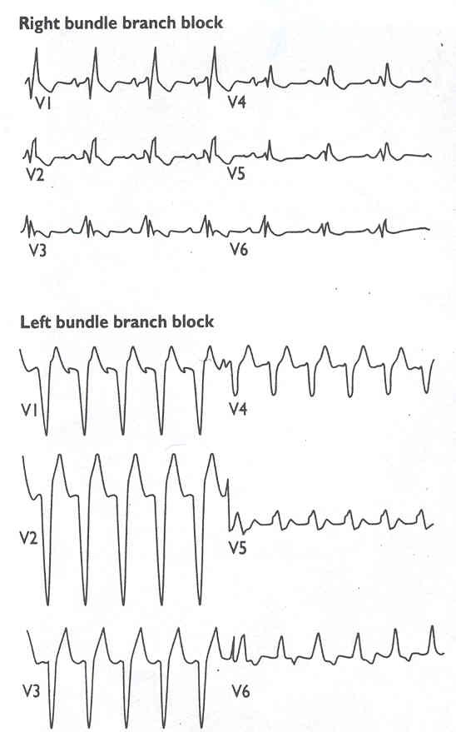Step 8: Look at the QRS complex.** Determine the *amplitude* of the QRS complex. If *high amplitude* it may reflect *left ventricular hypertrophy* (or a thin chest wall). If very *low amplitude* then it may reflect *obesity*, *chronic airways disease* with hyperinflated lung, a *pericardial effusion*, or *hypothyroidism*. Look at the *duration* of the QRS complex. Ventricular depolarisation (which causes the QRS complex) is usually rapid due to the specialised conducting tissue in the His-Purkinje system. The normal duration of the QRS complex is only up to 120 msec. If the duration is longer, then depolarisation is taking longer. This is usually due to one of two causes. Firstly, the point from which ventricular depolarisation starts is not high up the specialised conducting tissue –e.g. ventricular ectopic beat, or beat arising from a ventricular pacemaker lead. Secondly, the specialised conducting tissue is not functioning properly and the impulse leaves the AV node and travels through the ventricular muscle in a slower and less organised way than usual – bundle branch block. You can usually differentiate between these causes by looking at the rest of the ECG, particularly the ‘rhythm’ strip. If all the complexes are broad then conduction through the ventricular muscle is always slow – and this is most likely to be due to disease of the specialised conducting tissue (bundle branch block). The shape of the broadened QRS tells you whether it is the right or left bundle that is ‘blocked’ (Figure 4).

Shortening

If, however, there are beats with a normal QRS duration, and others with a broad QRS it is likely that this is due to ventricular ectopic beats. These can occur singly, or alternating with normal beats (‘bigemini’), or can occur in salvoes of 5 or more beats sequentially (ventricular tachycardia if rate greater than 100 beats per minute).

**Step 9: Determine the position of the ST segment.** If the ST segment lies below the isoelectric line the patient is said to have *‘ST depression’*. This may be due to a number of factors, including drugs, myocardial ischaemia, or ventricular hypertrophy. The development of ST depression with exercise is often used to determine whether a patient’s chest pain on exertion is due to myocardial ischaemia (treadmill test). An *elevated ST segment is also abnormal*. If the elevation is only in one ‘area’ of the heart, it *may reflect acute myocardial infarction*, or even aneurysm formation. If the elevation is more widespread and concave upwards it may reflect underlying pericarditis. As always, *the clinical context aids interpretation*. During acute myocardial infarction the electrocardiogram changes with time. Initially the abnormality may be ST elevation, followed by T wave inversion, and finally the development of Q waves if the full thickness of muscle in the affected area dies (Figure 5). The ST elevation usually only occurs for a short period of time, but the other changes may persist indefinitely.

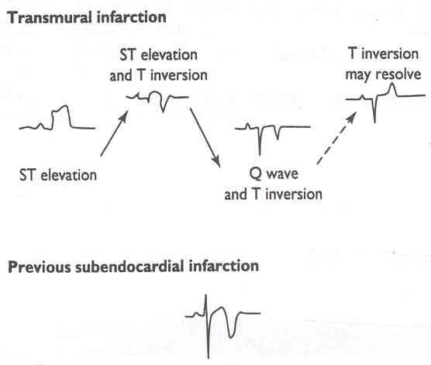

Figure 5 ECG changes of acute myocardial infarction.

**Step 10: Calculate the QT interval.** The length of time between the onset of the Q wave and the end of the T wave reduces as the heart rate increases. Most modern ECG machines adjust for this and give a ‘corrected’ QT interval reading. This interval may be prolonged by drugs (such as amiodarone), by hypocalcaemia, and in congenital syndromes associated with a risk of sudden death (Jervell-Lange-Nielson syndrome, and Romano-Ward syndrome).

**Step 11: Look at the T wave.** The amplitude and duration of a T wave, and whether it is upright or inverted are important. T wave inversion can be a sign of previous infarction, in which case the abnormality is usually localised to a particular area of the heart. It can also indicate underlying structural heart muscle disease – for example myocarditis or hypertrophy. Once again, the clinical context aids interpretation.

Additional reading:

Hampton JR. *The ECG made easy,* 6th edition *or 150 ECG problems, or ECG in practice.* All three published by Churchill Livingstone, Edinburgh.(2003)

**Lecture 9 – Blood Vessels and Blood Flow**

Prof Alun Hughes  
a.hughes@imperial.ac.uk

Learning Objectives

At the end of this lecture students should be able to:

* Understand the fundamentals of the role and design of the normal circulation
* Be able to describe the basic physical principles governing flow in the circulation
* Know ‘Ohms law for the circulation’
* Know the components of the Poiseuille’s equation
* Be able to describe physical forces acting on blood vessels
* Know the Laplace equation,
* Know the basic mechanisms by which flow of blood and transmural pressure influence blood vessel structure and function
* Understand how standing (gravity) affects the circulation
* Understand how the compliance of the aorta and elastic arteries affect pulse pressure.

Notes:

More detailed notes are provided for each slide in the Powerpoint file of this lecture.

* **Lecture 10 – Blood Vessel Order, Function and Specialisation of Cells in the CVS**

Dr Adrian Chester  
a.chester@imperial.ac.uk

Learning Objectives

At the end of this lecture students should be able to:

* Appreciate the function of the endothelium as a generator of hormones that regulate vascular and cardiac muscle form and function
* Describe ways in which the endothelium can be stimulated and how this results in release of the named hormones: NO, prostacyclin, endothelin-1.
* Describe in general terms the renin-angiotension system and know how its major components regulate vascular function
* Describe how the following work:
  + low dose aspirin
  + calcium channel blockers
  + nitrovasodilators
* Appreciate why these drugs carry side effect risks along with their therapeutic benefits

Notes: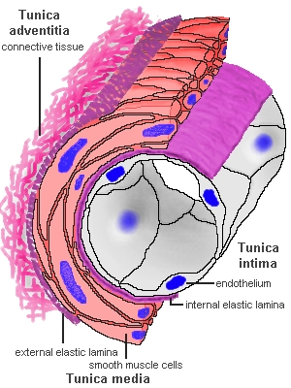

* Vascular system comprises a continuous network or arteries, capillaries veins.
* There are important functional and structural differences to each vessel type
* Regulation of the size (diameter) of blood vessels is important to the regulation of blood flow under different physiological and pathophysiological conditions
* All vessels are lined by a continuous layer of endothelial cells which play a key role on maintaining vessel homeostasis and regulating the flow of blood.
* The endothelium releases a number of key mediators that may increase (dilate) or decrease (contract) the size of blood vessels and thereby change the rate of blood flow to the target tissues.

Afterload

Figure 3 Examples of heart block.

Figure 4 Examples of bundle branch block.

**NE**

**SMC**

**EC**

**Adventitia**

**Media**

**Intima**

**Blood**

**Ad/NA**

**Ang II**

**Peptides**

**ADH**

**5-HT**

**TXA2**

**Endotoxin**

**Insulin**

**Glucose**

**Shear Stress**

**±**

**±**

**±**

NO

* The response of the vessel wall should be considered as a balance of opposing forces (contraction & relaxation).
* Disruption of this balance may lead to reduced supply of blood to certain organs and pathophysiological changes.
* Vasoactive agents generated or released by the endothelium may be a target for drug therapy to increase blood flow.
* The success of drug therapies to achieve desired effects is limited by side-effects caused by a lack or selectivity for the target receptor, enzyme or organ.

**Lecture 11 – The Sympathetic Nervous System and Renin Angiotensin System**

Dr Mike Schachter  
m.schachter@imperial.ac.uk

Learning Objectives

Following this lecture students should be able to:

* Describe the principles of the organisation of the sympathetic nervous system
* Describe the synthesis, release and removal of the neurotransmitter, noradrenaline
* Outline the types of adrenoreceptor in the sympathetic nervous system
* Evaluate the cardiovascular effects of infusion of some common adrenergic agonists
* Describe the principles of the organisation of the renin-angiotensin-aldosterone system
* Describe the biosynthetic pathway for angiotensin II synthesis
* Evaluate the individual roles the SNS and RAS play in modulating the behaviour of the CVS
* Recognize some of the pharmacological concepts involved in how important sympathetic neurotransmitters interact with receptors to evoke downstream effects

Notes:

**Adrenoceptors**

Two groups of effects:

**Response of major vascular beds to catecholamines**

|  |  |  |  |  |
| --- | --- | --- | --- | --- |
| Vascular bed | **Receptor** | **Noradrenaline** | **Adrenaline** | **Isoprenaline** |
| Skin | α | constriction | constriction | none |
| Visceral | α | constriction | constriction | none (dil) |
| Renal | α (β) | constriction | constriction | none (dil) |
| Coronary | α, β1 | dilation | dilation | dilation |
| Skeletal muscle | α, β2 | constriction | dilation | dilation |

**Selectivity**

|  |  |
| --- | --- |
| Noradenaline | α > β |
| Adrenaline | α = β |
| Isoprenaline | β (non-selective) |
| Phenylephrine | α1 |

**RAS**

Juxtaglomerular cells - afferent arteriole entering renal glomerulus primary site of renin storage and release.

A reduction in afferent arteriole pressure causes release.

Macula densa cells of distal tubule lie adjacent to JG cells and sense amount of Na and Cl in tubular fluid. When [NaCl] increased in tubular fluid, renin release inhibited.

Renin catalyses proteolytic cleavage of angiotensinogen to form decapeptide angiotensin I. Vascular endothelium contains angiotensin converting enzyme (ACE) that forms octapeptide, angiotensin II (AII).

AII:

* constricts resistance vessels increasing systemic vascular resistance and arterial pressure
* acts on the adrenal cortex to release aldosterone,
* stimulates release of ADH from the posterior pituitary,
* stimulates thirst centres in brain,
* stimulates cardiac and vascular hypertrophic responses

Angiotensinogen

**+**

Angiotensin I

**-**

**-**

Angiotensin II

**+**

**-**

**Lecture 12 – Regulation of the CVS**

Dr Ken MacLeod  
k.t.macleod@imperial.ac.uk

Learning Objectives

At the end of this lecture students should be able to:

* Describe the local mechanisms that regulate blood flow
* Describe how blood vessel diameter and heart rate are controlled by the autonomic nervous system
* Describe how the autonomic nervous system changes the force of contraction of the heart
* State the location of the baroreceptors
* Define cardiac output, stroke volume and mean systemic arterial pressure and state their determinants
* Indicate, using simple flow diagrams, how baroreceptors control blood pressure
* Describe the changes in impulse activity in the carotid sinus nerve, parasympathetic and sympathetic nerves to the heart and sympathetic vasoconstrictor nerves that take place following an increase or decrease in mean blood pressure
* Construct an integrated picture of the various systems that control blood pressure and be able to apply this to specific clinical examples involving blood loss or fluid overload

Notes:

**Equations**

CO = HR x SV

SV = End-diastolic volume (EDV) - End-systolic volume (ESV)

Mean systemic arterial pressure (MAP) = CO x total peripheral resistance (TPR)

MAP not simply the average of systolic and diastolic pressures as diastole lasts longer than systole. A good estimate of MAP is diastolic pressure + ⅓ pulse pressure (pulse pressure being the difference between systolic and diastolic pressures). Thus normal MAP ≈ 80 + (40/3) ≈ 93 mmHg.

**Control of arteriolar radius**

**CVS_control_arteriole radius.tif**

* All blood vessels receive symp. post-ganglionic innervation
* Transmitter = noradrenaline
* Always some level of tonic activity
* Control of nerve activity can accomplish dilation or constriction

CVS_control_1.tif

* No parasympathetic innervation to vascular system
* Major exception to above: symp. cholinergic fibres to skeletal muscle blood vessels produce vasodilation

**Control of stroke volume**

Two ways of changing stroke volume:

* Increasing end-diastolic ventricular volume increases force of contraction (Starling’s Law of the Heart)
* Changing the activity of the symp. nerves to the heart alters its force of contraction as Ca delivery to the myofilaments and uptake into the intracellular stores is changed.

**Afferent and efferent nerve activity from baroreceptors**

**CVS_control_2.tifLecture 13 – Responses to CVS Stress**

Dr Chris John  
c.john@imperial.ac.uk

Learning Objectives

At the end of this lecture students should be able to:

* Describe the cardiovascular problems associated with:
  + movement from a supine to standing position
  + haemorrhage
  + exercise
* Explain how the components of the cardiovascular system respond to these various challenges

Notes:

**Posture**

*Problem -* Movement from a supine to standing position is a severe challenge to human circulation.

↑ gravity = ↑ transmural pressure in dependent veins. Venous blood redistribution (20% ↓central blood volume). Cardiac filling pressure falls so myocardial contraction ↓. Stroke volume declines. Arterial (albeit transient) hypotension.

Result = Postural giddiness; impaired cerebral perfusion – dizziness and visual fading

Compensatory response –

Carotid baroreceptors input to brainstem ↓ due to fall in pulse pressure

Cardiopulmonary receptors input to brainstem ↓ due to fall in cardiac blood volume

These reduced inputs to the brainstem elicit a reflex reduction in parasympathetic activity to the heart and an increased sympathetic outflow to the heart and vasculature

Heart rate ↑ by 15-20 beats/min; ↑ heart contractility so that CO only falls by approx 20%

Vasoconstriction in skeletal muscle, splanchnic & renal vascular beds so peripheral resistance ↑ by 30-40%

Net result - Arterial pressure (and therefore cerebral perfusion pressure) is safe-guarded. If compensatory reflexes are overcome – postural syncope (fainting).

**Haemorrhage**

*Problem* - Essentially same as change of posture ie lack of filling of the heart

Major difference is that effects of haemorrhage are longer.

Compensatory response –

Reflex tachycardia and peripheral vasoconstriction

Low pressure at the kidney ↑ renin release and angiotensin activation = ↑ aldosterone Reflex ↑ secretion of vasopressin from hypothalamus

If capillary pressure ↓ significantly, osmotic pressure of plasma proteins predominate and IF is absorbed back into the blood – preserves BP.

However, compensatory mechanisms leave patient with reduced perfusion of most major organs and reduced body water content, electrolytes, plasma protein and red cells. Deficiencies corrected gradually.

**Exercise**

*Problem* -

(1) ↑ pulmonary blood flow – enhance gas exchange

(2) ↑ blood flow through working muscle

(3) Stable blood pressure maintained

Inadequate blood supply so pO2 falls and pCO2 rises.

Compensatory response –

Autoregulatory activity leads to vasodilatation and a drop in resistance (solves problem 2 by ↑ muscle perfusion). Sympathetic activity is ↑, leading to ↑ cardiac activity (solves problem 1 - ↑ right ventricular output) and compensatory ↑ vasoconstriction - *not in muscle where it is overridden by autoregulation* (solves problem 3 - balance between vasodilatation and vasoconstriction). Therefore increase in cardiac output and increase blood flow to vessels where resistance has fallen ie active muscles (including coronary circulation) and skin

**Lectures 14 & 15 – Haemostasis and Thrombosis**

Prof David Lane and Dr Mike Laffan  
d.lane@imperial.ac.uk and m.laffan@imperial.ac.uk

Learning Objectives

Following this lecture session students should be able to:

* Describe in outline the normal haemostatic mechanisms including the interaction of vessel wall, platelets, clotting factors and fibrinolytic system
* Describe the causes of bleeding disorders
* Describe the types of bleeding seen in different haemostatic disorders
* Describe in outline how coagulation is regulated by the natural anticoagulant pathways
* Describe the manifestations of venous thrombosis
* List the main risk factors for venous thrombosis
* Provide a rough estimate of its prevalence
* Appreciate the principles of treatment of bleeding disorders and of thrombosis

**Key notes:**

**Normal Haemostasis**

For convenience and to assist understanding, we divide normal haemostasis into a series of distinct stages, although in fact their timing largely overlaps.

1. Primary haemostasis is initiated by the exposure of collagen and other matrix proteins to blood when the vessel wall is damaged. Collagen can bind platelets directly and also indirectly via von Willebrand factor (VWF). VWF in plasma binds to collagen and then captures platelets under conditions of high shear stress.
2. Primary haemostasis results in the formation of a platelet plug.
3. Secondary haemostasis occurs when the Coagulation Cascade is initiated as blood comes into contact with Tissue Factor, which is also strongly expressed on cells outside the vessel. The cascade is a series of enzymes and cofactors which form an amplification system whose purpose is to rapidly generate a a high concentration of thrombin 
4. The thrombin converts soluble fibrinogen to insoluble fibrin which forms the clot and holds the platelet plug together.
5. The clot is made more secure by FXIII which cross links the fibrin.
6. After the clot has formed, the fibrinolytic system is activated which will eventually dissolve the clot as part of the healing process.
7. Coagulation system activation is normally held in check by a number of anticoagulant proteins to prevent inappropriate coagulation.

**Abnormal Haemostasis**

It is useful to think of the normal coagulation system as existing in balance between the pro- and anti-coagulant mechanisms. This balance can be disturbed by abnormalities or deficiencies of any of its components. A deficiency of procoagulant factors (eg Factor VIII or platelets) will result in an increased tendency to bleeding. The pattern of bleeding differs somewhat for different deficiencies. In general these can be treated by replacing the missing factors,

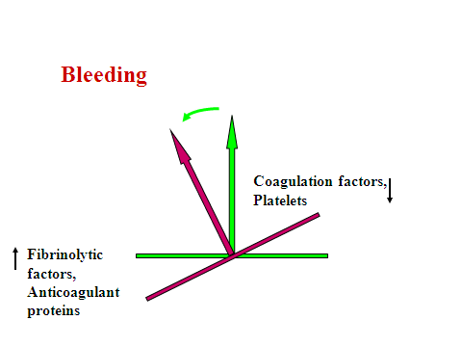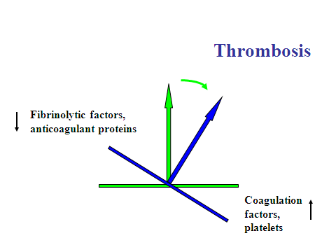

On the other hand, deficiency of one of the anticoagulant proteins such as antithrombin, will result in an increased tendency to abnormal or inappropriate coagulation called thrombosis. Abnormalities of blood flow or of the vessel wall can also contribute to the risk of thrombosis.

Thrombosis is a major cause of mortality and morbidity. We can prevent or treat thrombosis by manipulating the coagulation system to reduce its tendency to clot. Most important is understanding the mechanisms involved in order that we can avoid thrombosis occurring.

**Lectures 16 – Practical ECG methods**

Dr Pradeep Luther  
p.luther@imperial.ac.uk

Dr Luther will cover important practical aspects of recording ECGs in this lecture and in so doing refer to pages 55-61 of this guide.

**Lecture 17 – Atherosclerosis**

Dr Joe Boyle   
joseph.boyle@imperial.ac.uk

Learning Objectives

At the end of this lecture students should understand:

* the pathology and natural time-course of atherosclerosis, including the meaning of commonly used pathological terms.
* the connection between cholesterol and the development of atherosclerosis.
* the contributions that vascular endothelial cells, macrophages and vascular smooth muscle cells make to the development of lesions.
* the association between atherosclerosis and non-laminar blood flow at arterial branch-points and curvatures.
* the reasons for atherosclerotic plaque instability leading to acute clinical events.
* the link between the pathology of atherosclerosis and clinical symptoms.

**Key notes**

* Atherosclerosis is one of the most common diseases in the UK and is responsible for the majority of deaths from cardiovascular disease.
* Atherosclerosis is a disease of medium and large arteries. Although the clinical manifestations usually do not appear until middle-old age, the disease has a long “lead in”, with changes in arteries occurring from early life. There is therefore plenty of time for prevention.
* The disease starts as a thickening on one side of the artery. This develops into an atherosclerotic “plaque”, consisting of a necrotic core of dead tissue covered and separated from the blood by a fibrous cap.
* Probably the first event in the development of atherosclerosis is trapping within the arterial wall of low density lipoproteins (LDL) rich in cholesterol. This occurs through the binding of LDL to proteoglycans in the arterial intima, such as biglycan and versican.
* Once trapped in the arterial wall, LDL becomes chemically denatured by reactive oxygen free radicals and/or by tissue enzymes (such as phospholipases). This results the phagocytosis of LDL by macrophages, via scavenger receptors such as Scavenger Receptor A and CD36. Macrophages that have taken up an excess of lipid are known as “foam cells”.
* Release of inflammatory mediators by macrophages and other cells results in the activation of vascular endothelial cells with expression of adhesion molecules and chemo-attractants for monocytes, recruitment of more monocytes from the blood and their differentiation within the arterial wall into macrophages. Hence the process is self-perpetuating.
* The distribution of atherosclerotic lesions is not random, with branch points and curvatures being “hot spots”. This is probably because of the non-laminar blood flow at these sites. There is evidence that laminar blood flow suppresses inflammatory activation of endothelial cells, whereas non-uniform blood flow at hot spots may enhance it,
* As the plaque grows it is invaded by small blood vessels that develop from the vasa vasorum in the adventitia. These vessels tend to bleed, and thereby contribute to the growth of the necrotic core through the supply of erythrocyte-derived cell membranes.
* The stability of an atherosclerotic plaque is related to the strength of the fibrous cap separating the blood from the necrotic core. The fibrous cap consists largely of collagens synthesized by vascular smooth muscle cells.
* Rupture of the plaque is probably usually caused by the activity of proteases expressed by macrophages fragmenting the matrix of the fibrous cap, but can also be caused by intra-plaque haemorrhage (see above).
* Chronic symptom (eg angina, intermittent claudication) are attributable to limitation of blood flow through atherosclerotic narrowing (stenosis) of the arterial lumen. More acute symptoms are either due to occlusive thrombosis at the site of plaque rupture or to the distant effects of dislodged thrombus or plaque contents on down-stream smaller blood vessels (embolism).

**Lecture 18 – Vascular Endothelium**

Dr Anna Randi

a.randi@imperial.ac.uk

**Learning Objectives**

At the end of the lecture the student should understand:

* the basic functions of endothelial cells
* the importance of vascular endothelium for the health of blood vessels
* the importance of vascular endothelium in Cardiovascular diseases, including atherosclerosis
* How the endothelium regulates leukocyte recruitment and inflammation
* How the endothelium drives the formation of new vessels (angiogenesis)
* The importance of angiogenesis in cardiovascular diseases

**Key notes**

* The vascular endothelium is a crucial regulator of vascular health
* Endothelial dysfunction is crucial to the pathogenesis of atherosclerosis
* In healthy blood vessels, endothelial cells maintain the homeostatic balance
* A key function of the endothelium is the control of the flux of molecules and cells from the blood into tissues
* The formation of new blood vessels (angiogenesis) is essential for physiological processes, in development and in the adult, but is also very important in diseases, including cardiovascular diseases.

**Lecture 19 – The Pathophysiology of Heart Failure**

Prof Peter Collins  
peter.collins@imperial.ac.uk

Learning Objectives

At the end of this lecture students should be able to:

* Establish that patient has heart failure
* Determine the aetiology of heart failure
* Identify the concomitant diseases relevant to heart failure
* Assess the severity of symptoms
* Predict prognosis
* Anticipate complications
* Choose appropriate treatment
* Monitor progress and tailor treatment

**Key requirements**

Establish that heart failure is a clinical syndrome with a variety of causes

Identify the clinical components of heart failure and be able to construct clinical algorithms in order to establish the diagnosis

Be able to identify the clinical symptoms and signs

Be able to assess the severity of the syndrome and know the basics of the up-to-date treatment and management of the condition

**Lecture 20 – Hypertension**

Prof Alun Hughes  
a.hughes@imperial.ac.uk

Learning Objectives

Following this lecture students should know that:

* Blood pressure (BP) levels are continuously distributed in a population
* Increased BP across the whole range of BP is associated with increased risk of cardiovascular disease (strokes, heart attacks heart failure and atheromatous disease)
* The definition of hypertension is arbitrary and is based on the balance of the risks of elevated BP versus the risks of investigation and treatment
* 90-95% of cases of hypertension have no identifiable cause (primary or essential hypertension).
* Secondary hypertension is rare, but important causes include renal disease, tumours secreting aldosterone (Conn’s syndrome), and tumours secreting catecholamines (pheochromocytoma)
* Established hypertension is due to elevated peripheral vascular resistance
* Increased peripheral vascular resistance in established hypertension is due to a combination of active vasoconstriction and structural narrowing of small arteries and loss of capillaries (rarefaction)
* Hypertension is associated with left ventricular hypertrophy, increased wall thickness in large arteries, remodelling in smaller arteries and rarefaction of the microvasculature
* The cause of primary hypertension is unknown but the strongest evidence implicates renal abnormalities and/or excessive activity of the sympathetic nervous system

Additional reading:

Lip GYH, O'Brien E, Beevers GH *ABC of Hypertension* 4th Ed (2000) BMJ Books ISBN: 0727915223.

More detailed notes are provided for each slide in the Powerpoint file of this lecture.

**Lecture 21 – Coronary heart disease, angina, myocardial infarction and embolism**

Dr Ranil de Silva

r.desilva@imperial.ac.uk

Learning Objectives

By the end of this lecture students should be able to:

* Appreciate the global and UK burden of coronary heart disease
* Appreciate the different clinical presentations of coronary heart disease
* Define myocardial ischaemia and its pathophysiology
* State the main cardiac factors which give rise to chest pain
* State the main clinical investigations that help diagnose angina
* State some of the drug treatments for angina
* Define thrombus, embolus, infarction
* Define Virchow's triad and compare/contrast the three elements
* State which of the triad has the dominant influence in arterial thrombosis
* State in what clinical situations endothelial injury is of particular importance
* Describe normal blood flow and the importance of turbulence and stasis to thrombus formation
* State in what clinical situations an alteration in blood flow is of particular importance
* List some of the more important genetic and acquired causes of hypercoagulability states
* Describe the general morphology of thrombi
* Compare the morphological characteristics of arterial versus venous thrombi
* Explain why thrombi are clinically important
* Describe the inciting events leading to infarction and the characteristics of infarctions, including the differences between red and white infarctions
* Outline the sequence of events following infarction and the factors that influence their development
* Describe the pathogenesis and clinical consequences of deep vein thrombosis and pulmonary embolism
* Describe pathogenesis and clinical consequences of fat embolism, gas embolism, and amniotic fluid embolism

**Key requirements**

* Understanding the clinical spectrum of thrombosis, embolism, ischaemia and infarction in cardiovascular disease
* Ischaemia results from a mismatch between myocardial oxygen supply and demand. If unresolved this can lead to infarction. Understanding the mechanisms of underlying ischaemia enables the development of appropriate therapies.
* The role of thrombosis and embolism in common cardiovascular diseases will be discussed
* Endothelial dysfunction, flow disturbance, and hypercoagulability are the key determinants of thrombus formation
* Infarction can arise from either ischaemia or haemorrhage
* The pathogenesis of arterial and venous thrombosis is different, and explains the rationale for the differing treatment approaches in these conditions.
* The general approach to the prevention and treatment of arterial and venous thrombosis will be discussed

**Lecture 22 – Integration of CVS responses**

Dr Ken MacLeod  
k.t.macleod@imperial.ac.uk

The lecture will summarise many aspects of the various lectures you have had during the course. You will be expected to listen and take your own notes during this lecture.

Practical

Measurement of systemic arterial blood pressure

**BACKGROUND**

Arterial blood pressure is a measurement routinely made for diagnostic purposes on many patients. The pressure that is measured is pulsatile, having its maximum value during ventricular systole (when the heart contracts and expels blood into the arterial system) and its minimum immediately prior to the next cardiac systole (i.e. after some blood has left the arterial system and so the pressure has fallen). Arterial blood pressure is determined by physical factors (e.g elasticity of arterial walls) and the physiological factors; stroke volume, heart rate and vascular peripheral resistance.

OBJECTIVES

At the end of this class you should be able to:

1 *Obtain* an accurate measurement of systolic and diastolic blood pressures using a sphygmomanometer and stethoscope. A core skill which you will use for the rest of your working life.

2 *Explain* how methodological factors can affect the accuracy of measurement of arterial blood pressure and take appropriate precautions to obtain 'correct' values.

3 *Explain* the principles of the methods used.

4 State the value for systolic and diastolic arterial blood pressure measured in the arm using a sphygmomanometer and stethoscope.

BASIC METHOD

Arterial blood pressure (BP) is sometimes measured directly by inserting a needle or catheter attached to a pressure transducer into a peripheral artery. This is an invasive technique and needs to be carried out under sterile conditions, it is not therefore suitable for universal quick usage.

Arterial BP may be estimated indirectly by means of a sphygmomanometer (See Fig 1). This instrument consists of an inextensible material cuff containing an inflatable bag The cuff is wrapped around an extremity (usually the arm, occasionally the thigh) so that the inflatable bag lies between the cuff and the skin, and is directly over the artery to be compressed The pressure in the cuff is raised, using the rubber squeeze bulb until the artery is occluded The pressure is then released at a rate of 2 to 3 mmHg per second, by means of the valve on the inflating bulb As the pressure in the arm cuff is gradually reduced, a series of sounds (Korotkoff sounds) can be detected using a stethoscope placed over the artery.

Two assumptions are made: (1) that the pressure in the limb tissue under the centre of the cuff is the same as that in the bag, and (2) that the artery offers no resistance to col- lapse by the external pressure. If these assumptions are true then when the pressure in the bag exceeds the systolic blood pressure, the flow of blood in the artery will be com- pletely prevented. When the pressure in the bag is between systolic and diastolic pres- sure, blood will flow in the artery periodically, for only part of the cardiac cycle. When the pressure in the bag is below diastolic pressure, a continuous flow of blood will occur.

SOUNDS HEARD

Cuff pressure mm Hg

High say>130

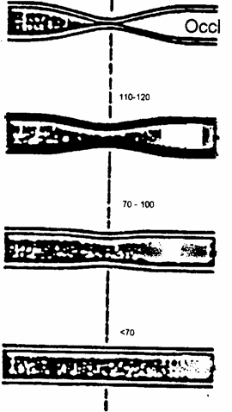Silence Occluded, no flow at all

Snapping Brief Spurting flow tones

Murmurs to Flow over most of cardiac cycle muffling

Silence Smooth laminar flow

FIGURE 1

The transition from no flow to periodic flow in the artery can be determined by listening with a stethoscope over the vessel. The pressure in the bag at this point gives the systolic pressure.

**Practical details for measurement in the arm of systolic and diastolic blood pressure by auscultation.**

Work in pairs. The subject should be seated or lying down and relaxed with the arm level with the heart. Apply the cuff on the upper arm above the elbow. Locate, by palpation, the brachial artery at the inside of the elbow in the antecubital fossa (see fig 2). Inflate the cuff. Apply the stethoscope bell over the brachial artery. Apply the stethoscope to the arm with just enough force to keep the entire circumference of the bell in contact with the

skin, do not however, use too much force or the vessel will be obstructed by the rim of the bell. Lower the pressure in the cuff until sounds are heard.

As the pressure is allowed to drop the following sounds can usually be heard:

Nothing (the vessel is fully occluded)

then a series of taps (Phase 1);

a murmurish sound (Phase 2);

a loud banging sound (Phase 3)

a sudden softening and muffling of the sound (Phase 4);

cessation of all sound (Phase 5) (there is laminar flow the vessel).

Systolic pressure corresponds to the start of Phase 1. Diastolic pressure is usually taken as corresponding to the cessation of the sounds (Phase 5 )

Pressure

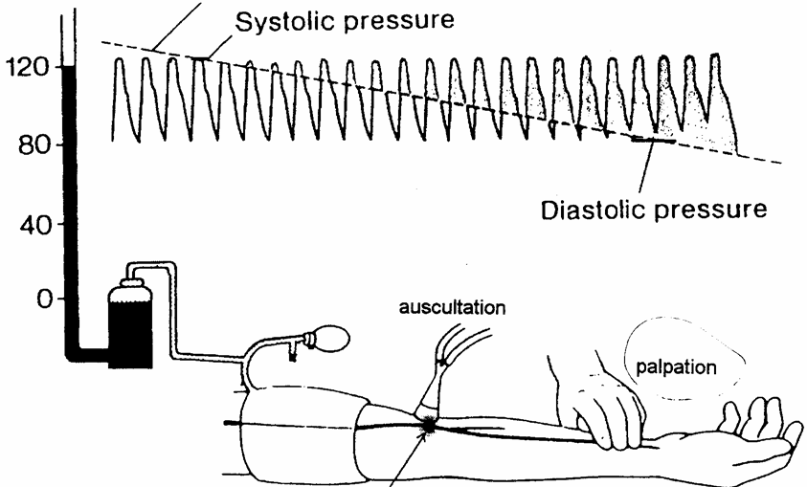mm Hg Cuff pressure

Cuff antecubital fossa region

Note that due to physiological factors, measurements of arterial blood pressure may be abnormally high when first recorded. Therefore, make **at least** 5 measurements with the subject comfortably at rest with his/her arm at heart level and record them on the data sheet.

NB FULLY deflate the cuff after each measurement.

FACTORS AFFECTING ACCURACY OF BLOOD PRESSURE MEASUREMENTS: These may be due to errors in the method or to physiological factors

Methodological Factors: When you are confident that you are able to measure blood pressure accurately, with your partner investigate possible "procedural error" in your measurements of blood pressure.

For example:

Does the position of the arm relative to the heart affect your measurement of BP?

i.e. arm raised, arm lowered.

Does the position of the manometer relative to the cuff (above or below) affect the value obtained?

If you apply the cuff too tightly or too loosely, what values do you obtain?

If, instead of inflating the cuff rapidly, you half inflate it, wait 30 seconds, then continue to inflate it how does this effect your ability to determine the sounds?

Record your observations on your data sheet.

PHYSIOLOGICAL FACTORS:

If the subject has recently been active or is feeling 'stressed', the recorded arterial blood pressure does not represent a 'resting' value, the recorded values may fluctuate between measurements or show a trend to converge towards a repeatable set of values.

Although these may be very important in the practise of diagnosis in medicine,

the factors cannot be readily investigated here.

**RESULTS**

Write your findings in the following table

|  |  |  |  |
| --- | --- | --- | --- |
| M/F | Age (years) | Systolic BP (mmHg) | Diastolic BP (mmHg) |
|  |  |  |  |

RESULTS: FACTORS AFFECTING ACCURACY OF MEASUREMENT

Record all measurements taken

|  |  |  |
| --- | --- | --- |
| Manoeuvre | BP (mmHg) | Comments |
|  |  |  |

You should be able to offer explanations for your findings below.-

Q.I. Why may blood pressure be abnormally high when first recorded?

Q.2. How variable were your measurements'. What is the difference between the highest and lowest diastolic and the highest and lowest systolic pressures.

Q.3. What was your resting blood pressure

Q.4. What precautions must be taken to allow an accurate measurement of arterial blood pressure to be made?

Q. 5. Given that the normal values of systolic and diastolic pressures for young adults are usually given as 120/80, do you consider yours to be normal? Explain your reasoning with reference to your answer for Q2.

**Information sheet on the practical class “Measurement of blood pressure”**

You are being invited to be the subject in a practical class where fellow students will be measuring your blood pressure. Before you decide to be the subject, it is important that you understand why this practical exercise is being done and what it will involve. Please take time to read the following information carefully and discuss it with others if you wish. Ask us if there is anything that is not clear or if you would like more information.

**What is the purpose of the practical?**

The purpose of this practical is to learn how to perform blood pressure measurements on your fellow students. The ability to measure blood pressure quickly and accurately is an important skill for all doctors to acquire as it forms a basis of many clinical assessments. The practical may involve you being the subject and having your blood pressure measured. If you feel uneasy or disturbed at being touched and examined by another student, remember two important points. If you feel that you are unable to act as a subject in this practical class you will not be subjected to any pressure to do so and your progress through the course will not be affected in any way. However, you must take a full part in examining other students and you should reflect on the fact that you are missing a valuable experience in developing empathy with patients undergoing physical examinations.

**What will happen to me if I take part?**

A sphygmomanometer cuff will be placed around your arm between your shoulder and elbow. The cuff will be inflated to well above your systolic blood pressure for about 5 – 10 seconds then slowly deflated. Using a stethoscope placed on the brachial artery just below the cuff, a fellow student will listen to the sounds made by turbulent blood flow in your arm as the cuff deflates over a period of 10 – 20 seconds.

**What do I have to do?**

You need do nothing apart from roll up the sleeve of your shirt! You should sit comfortably and remain as relaxed as you can.

**What are the side effects of taking part?**

There are no known side effects. As the cuff inflates it can feel quite tight but this feeling will only last for a few seconds before the cuff is deflated again. This is a standard, non-invasive measurement that, as doctors, you will use on a daily basis.

**What are the possible disadvantages and risks of taking part?**

There are no disadvantages in taking part in the study and no risks associated with the measurements being taken. Taking part can be advantageous; not only will you develop empathy with patients undergoing physical examinations, but also you may find out if you have high blood pressure, a risk factor for many conditions including stroke and heart disease.

**Who has reviewed this practical?**

The practical has been reviewed by the Riverside Research Ethics Committee, Chelsea & Westminster Hospital, 369 Fulham Road, London, SW10 9NH.

**Contacts for further information**

If you need more information please contact Dr K. MacLeod (k.t.macleod) or Professor J Laycock (j.laycock) (all @imperial.ac.uk).

Practical

The Electrocardiogram

**Learning objectives for this practical:**

(these are in addition to those associated with the lectures)

1. Be familiar with the normal ECG waveform.

2. Describe the precautions and conventions employed in recording the standard 12-lead human ECG.

3. Know how the recordings of the six standard limb leads are obtained from the four electrodes attached to the limbs.

4. Know how the recordings of the six pre-cordial (chest) leads are obtained.

5. Measure the standard intervals of the ECG, as described in the schedule, and know the normal physiological ranges of these values.

6. Be able to measure heart rate from an ECG recording.

7. Estimate the mean electrical axis of the ventricle of the heart in the frontal plane by inspection of the ECG.

**1) Why can we record electrocardiograms at all?**

Electrocardiography, and the interpretation of the ECG are highly complex subjects, which you will learn more about as the course progresses. The object of this introductory section is to try to “de-mystify” the topic in the hope that when you record ECG’s yourselves in the practical class you will have some appreciation of the nature of the signals you are looking at.

Although you have probably come across the electrocardiogram (ECG) before, it may not have occurred to you to wonder why such useful information about the electrical activity of the heart can be obtained by simply attaching four leads to the body.

The heart may be regarded as a group of excitable cells arranged in such a way that changes in their electrical potential normally occur in an orderly manner. This electrical activity can be recorded by placing recording electrodes directly on the heart but the dis- advantages of actually doing this clinically are self-evident. However, the heart is sur- rounded by body fluids that are good electrical conductors (the body is said to be a good “volume conductor”) so net potential changes caused by the myocardial action potentials may be recorded at a distant point on the skin surface.

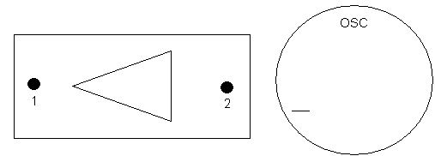The principle may be more readily understood if the heart is represented as a triangular wedge of cells (Fig. 1) in a large dish of saline with two electrodes placed at 1 and 2 (the distance between them being large compared to the length of the wedge of cells.)

Saline Bath

**FIGURE 1**

Initially the muscle cells are in their resting state, and although there is a potential across the membrane of each cell, there is no potential between the extracellular electrodes 1 and

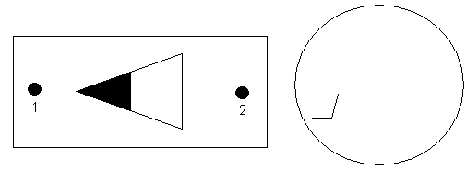2 as shown on the oscilloscope (OSC).

*Wave of Depolarization* →

**FIGURE 2**

When the cells closest to electrode 1 depolarize, (Fig. 2) their membrane potential is reversed, and a wave of depolarization spreads through the cells. This creates a “front”, a boundary between the depolarized cells and those still in their resting state. Because the cell contents and the surrounding medium are good conductors, this front acts as a current generator, or “dipole”. Dipoles usually create a uniform field around them. However the cells which are already depolarized create an area of local negativity in the surrounding solution, therefore the depolarizing (positive) current for the next cells to fire is drawn predominantly from the region in advance of the dipole rather than behind it. As a result electrode 2 becomes negative with respect to electrode 1, and the recording apparatus is arranged so that this potential difference results in an upward deflection of the oscilloscope beam.

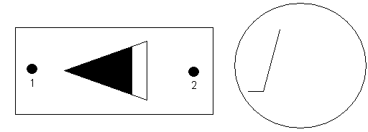

**FIGURE 3**

Provided that electrodes 1 and 2 remain in a fixed position, and the distance between them is large compared to that between the poles of the dipole, the magnitude of the deflection will depend on the voltage of the dipole itself. This is determined by the demand for depolarizing current, which depends on the conduction velocity towards electrode 2 and also on the fact that the width of the wedge is increasing (Fig. 3).

(N.B. That the front has moved closer to electrode 2 could also be significant - but only if the electrode were much closer to the wedge of cells than assumed here.)

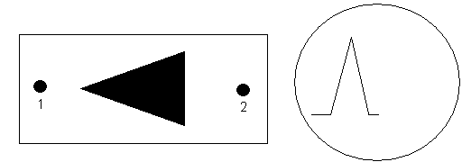

**FIGURE 4**

When all the cells of the wedge are depolarized, (Fig. 4) the dipole ceases to exist. There is therefore no longer any potential difference between electrodes 1 and 2.

*Wave of Repolarization* →

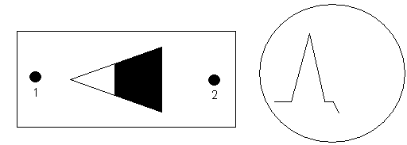**FIGURE 5**

The cells will not, of course, remain in their depolarized state indefinitely. A wave of repo- larization - shown here in Figure 5 starting at those cells closest to electrode 1 - follows the wave of depolarization. This creates another dipole, but with its poles reversed, resulting in a downward deflection of the oscilloscope beam.

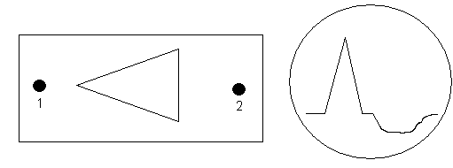

**FIGURE 6**

At the end of repolarization, all the cells have returned to their resting state, and there is again no potential difference between the electrodes (Fig. 6) Notice that the deflection caused by the repolarization is longer but smaller than that caused by depolarization. This is because the time course of repolarization of myocardial cells is much longer than that of depolarization (think of the ventricular action potential).

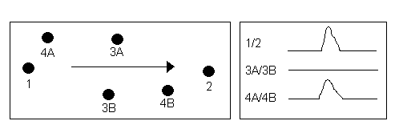

**FIGURE 7**

It should now be possible to extend the concepts described above to explain why, in principle, the different limb leads produce ECG recordings that look so different, even though the signal they record comes from the same source. As explained previously, the field change that results from a wave of depolarization spreading from 1 to 2 causes electrode 2 to become negative and BY CONVENTION this is recorded as an upward deflection of the oscilloscope. The effects of this wave of depolarization could have been recorded from the points labelled 3A and 3B in Figure 7, a line joining these two being exactly at right-angles to the direction of the wave of depolarization. However, in this case the field changes at 3A would be very similar to those at 3B, and one would therefore expect no potential difference between these two points, and thus no deflection on the oscilloscope. In practice, the highly sensitive amplifiers often record a very small biphasic potential (e.g. ) in which the upward and downward deflections are of identical amplitude, that is **equipotential deflections.** A further possibility would be to record the field changes between electrodes 4A and 4B. In this case the dipole would be expected to produce a difference in potential between the electrodes, but not such a big difference as was the case between electrodes 1 and 2. A small upward-going deflection would therefore be recorded. It is apparent that the size of the deflection recorded depends

on the angle between the axis of the recording electrodes and the direction of the depolarizing wave. One more point can be made from this model of the ECG. It has been assumed throughout that the depolarization passes from electrode 1 towards electrode 2. If the depolarization were exactly reversed (whilst leaving all the recording arrangements the same) then clearly the observed potentials will be reversed, so that leads 1 and 2 will give a large negative deflection.

**2) How the electrocardiogram is recorded in Man**

**THE LIMB LEADS**

In electrocardiography four leads are connected to the limbs of the patient. One of these, the right foot, is connected to a

zero volts reference point and the remaining three are used as recording electrodes. For the purpose of analysis each electrode is assumed to be at the point of an equilateral triangle. This triangle is called **EINTHOVEN’S TRIANGLE**. The heart is assumed to lie at the centre of this triangle, and the tissues of the body surrounding it to be a homogeneous volume conductor. In practice, of course, the leads are attached

at the wrists and ankles. However because of the large distance between the heart and the recording point, the actual point of attachment is of little importance; you may view the leads as if they were attached at the left shoulder, right shoulder and pubic symphysis - thus forming the triangle described. Notice that these three points all

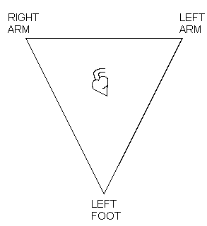

**FIGURE 8:** EINTHOVEN’S TRIANGLE

lie in one plane (imagine you have just walked into a door!) - the limb leads ONLY record activity of the heart in this one plane which is called the frontal plane.

The three electrodes can be connected together in different combinations to record the ECG. The first three leads - the standard limb leads - are bipolar electrodes formed by connecting together two limb leads. In each case it is necessary to designate one electrode as positive and one negative. BY

CONVENTION the apparatus is connected so that when a wave of depolarization moves **towards** the **positive** electrode, an **upward** deflection is recorded (c.f. previous section). The leads are:

**Lead I**

**Lead II Lead III**

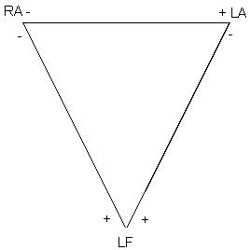**FIGURE 9:** STANDARD LIMB LEADS

Notice that any given wave of depolarization and its derived vector will be “seen” by these leads from a different angle, just as was the case for the electrodes in the model of the ECG described in the previous section.

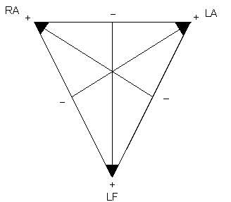It is also possible to record between a single limb lead as one electrode (designated +) and the remaining two leads connected together to form the indifferent (-) electrode. In this arrangement - called the augmented limb leads - the negative electrode may be assumed to be situated halfway between the two points of the triangle that are connected together (Fig. 10).

**FIGURE 10:** AUGMENTED LIMB LEADS

|  |  |  |  |  |
| --- | --- | --- | --- | --- |
| **aVR** | RA | → | (LA + LF) | RA designated as + |
| **aVL** | LA | → | (RA + LF) | LA designated as + |
| **aVF** | LF | → | (RA + LA) | LF designated as + |

The main advantage of this seemingly complicated arrangement is that it provides three more angles from which the electrical activity of the heart may be recorded. Although this is very useful, the additional three angles are still in the same plane - the frontal plane - as the standard limb leads. It is often essential to record the heart’s electrical activity from a plane at right angles to this, and this may be accomplished by placing electrodes on the chest itself.

**THE CHEST LEADS (or Precordial Leads)**

With the chest leads, the three limbs are electronically connected together to form one, (the indifferent) electrode, whilst the other consists of a unipolar positive exploring electrode which is placed on the chest wall. In practice six positions are used routinely; these are labelled V1 - V6 (using Arabic numerals) and their anatomical locations are as follows:

Note: i.c.s = Intercostal space

V1 - Right 4th i.c.s., parasternal

V2 - Left 4th i.c.s., parasternal

V3 - Left, midway between V2 and V4

V4 - Left 5th i.c.s., mid-clavicular line

V5 - Left anterior axillary line on the same horizontal plane as V4

V6 - Left mid-axillary line

**3) The normal ECG waveform**

Each beat of the heart is initiated by depolarisation at the sino-atrial node and the depolar- isation spreads across the atria of the heart. The first electrical signal recorded by the elec- trocardiogram therefore comes from the atria, and is called the P wave. Because the mus- cle mass of the atria is relatively small, the amplitude of the P wave is correspondingly small.

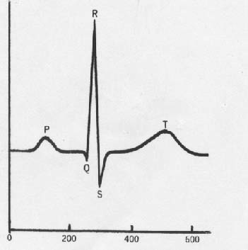After the P wave, the recording returns to the baseline. There is then an interval (caused by delay in conduction through the junctional fibres and AV node) before the next poten- tials are seen. This is called the QRS complex, and is caused by depolarisation of the sep- tum and ventricles. Because the muscle mass of the ventricles is relatively large, the Q wave is much larger than the P wave. By convention the first upward deflection is always called the R wave, regardless of whether or not it has been preceded by a downward-going Q wave. Any deflection going below the baseline immediately after the Q wave is called the S wave. After another interval with the signal at the baseline there is a further deflection – the T wave – caused by repolarisation of the ventricles. A typical ECG record is shown in Figure 11 below.

Time (ms)

FIGURE 11: Typical ECG waveform

Although the depolarisation that generates the QRS complex spreads across both v entricles, it has a mean direction or vector. This is actually towards the left ventricle rather than right because of its greater muscle mass. This mean direction is referred to as the MEAN FRONTAL PLANE AXIS OF THE VENTRICLES. Its exact direction depends on two main factors a) the physical way in which the heart lays in the chest and b) the relative muscle masses of the two ventricles. The direction of the mean frontal plane axis can therefore change (for instance if the left ventricle hypertrophies) and its direction can be an important sign of cardiac pathology.

Note that the six limb leads “look” at this mean ventricular depolarisation from different angles. In section one it was explained that the axis of the recording electrodes relative to the wave of depolarisation greatly affects the size and direction of the recording seen. It should therefore come as no surprise that each of the six limb leads will show a different form of the ECG, even though the signals all come from the same source. Some leads will have a predominantly positive-going QRS complex whilst others will have predominantly negative QRS complexes. It is by examining these different waveforms that it is possible to estimate the mean frontal plane axis of the ventricles.

The same considerations apply to the chest leads. Remember all the chest electrodes are positive electrodes. The first part of the ventricles to depolarise is the septum, and it does so from left to right (see Figure 12). This is followed by ventricular depolarisation, where (as before) the left ventricle makes the greater contribution to the signal recorded.

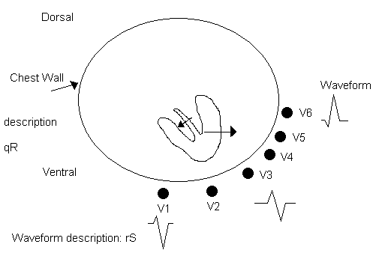

**FIGURE 12:** Transverse section of the chest (viewed from above). The two arrows represent vectors of ventrical depolarisation. These will be recorded as positive and negative going potentials in different electrodes as indicated.

Lead V1 shows a “right ventricular complex”. The small septal depolarisation moving towards the electrode give a small upright r wave, which is followed by a deep S waves caused by ventricular depolarisation. V6 shows a “left ventricular complex”, a small q wave (septal depolarisation) followed by a large upright R wave (ventricular depolarisation). A transition between these two usually occurs in the region of V3. As shown in Figure 12 this “transition zone” is characterised by the ECG displaying a biphasic equipotential.

**4) Instructions for the electrocardiography practical**

Note: You will find this practical easier to understand if you have read the first three parts of this introduction to electrocardiography BEFORE coming to the practical class.

**INTRODUCTION**

The spread of electrical excitation through the heart results in potential changes at points remote from the heart itself. A record of the electrical activity that can be detected by placing electrodes on the surface of the body is called an **electrocardiogram** (ECG or EKG in the USA) and the machine used to detect the activity is known as an **electrocardiograph**.

Electrocardiography is a very important technique which provides information about the heart that it would otherwise be difficult, or impossible, to obtain. The time course of the spread of excitation through the heart, the nature of the rhythm, whether normal or abnormal, the electrical axis of the heart and its degree of rotation may all be judged from the electrocardiogram. In this practical you will be making a recording an ECG

yourselves and measuring conduction times. Electrocardiography is used to obtain other types of information in the clinical situation but you will be studying these aspects later in your course.

**You will be working in small groups, and one of you will act as the subject. You will be using chest electrodes, so it would be helpful to wear clothes that can be easily removed or loosened for the purpose.**

**THE ELECTROCARDIOGRAPH**

All electrocardiographs have two essential parts: an **amplifier**, which is needed to magnify the very small potential differences (a peak of about 1mV) that are produced at the surface of the body by the electrical activity of the heart; and a **recording system**, which

is used to give a visual display and/or a permanent record of these potential changes. The instrument that you will be using is a single-channel recorder, of the sort quite often used by G.P.s. The recording system consists of a high-density thermal print head that records the ECG (and text) on special heat-sensitive paper.

Electrocardiograms may be recorded at a number of different “gains” (amplification) and paper speeds. However there is an internationally agreed standard for these as follows:

GAIN: A signal of 1mV produces a deflection of 10mm.

SPEED: Paper emerges at a rate of 25mm per second. This means that each large square on the paper represents 0.2s and each small square 0.04s.

The machines you will use will have been set to these standards.

The electrodes used to detect the electrical activity are placed on the limbs and chest and connected according to the following convention.

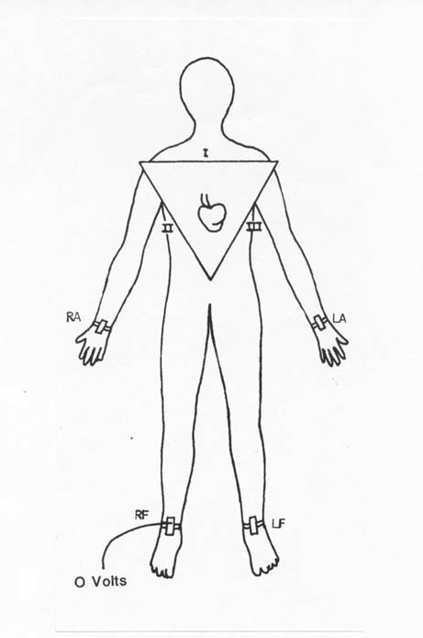

FIGURE 13: Attachment of Electrodes to the limbs and chest

ELECTROCARDIOGRAPH LEADS

The R foot is always connected to zero volts.

STANDARD LIMB LEADS

These are bipolar leads formed by connecting the electrocardiograph between any two of the remaining limbs. The three possible arrangements are: -

I LA RA II LF RA III LF LA

AUGMENTED LIMB LEADS

An indifferent point is formed by connecting the electrodes on two limbs together, and the ECG is recorded between the remaining limb and this indifferent point.

aVR RA (LA + LF) aVL LA (RA + LF) aVF LF (RA + LA)

UNIPOLAR CHEST (OR PRECORDIAL) LEADS

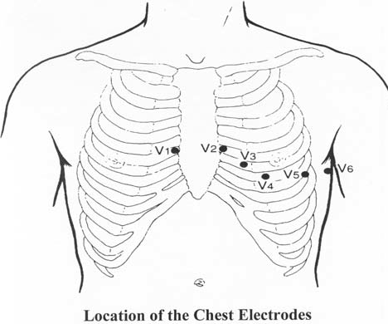The electrocardiograph is connected between an exploring electrode placed on the chest and an indifferent electrode consisting of the three limb leads joined together. The leads are numbered in Arabic numerals according to the position of the exploring electrode.

**Note:** i.c.s. = intercostal space

V1 - R 4th i.c.s. parasternal

V2 - L 4th i.c.s. parasternal

V3 - L midway between V2 and V4

V4 - L 5th i.c.s. mid-clavicular line

V5 - L anterior )

axillary line ) same

) horizontal

V6 - L mid-axillary ) plane as V4

Line )

**ROUTINE ELECTROCARDIOGRAPHY**

The leads used for routine purposes are the standard limb leads I, II, and III; the augmented limb leads aVR, aVL and aVF, and the unipolar chest leads V1 to V6. The

recording machine you use will select the appropriate electrodes for each of these in

turn, and print a short length of the recording to the heat-sensitive paper. In the time available it will probably only be possible to record the ECG from one subject. **Make sure you obtain enough good quality records from each lead for all of you.**

**PROCEDURE**

(a) Connect the subject to the ECG recorder - taking care to ensure the leads are correctly arranged and that there is proper contact between the limbs and the electrodes.

(b) Make recordings of the ECG of your subject (who should be relaxed - why?) using the six limb leads. Include a longer strip from the lead that gives you large QRS complexes – this is the rhythm strip.

(c) Consult a demonstrator to ensure your recordings are suitable.

(d) With the aid of a demonstrator if necessary, locate the correct recording positions of the six unipolar chest leads.

(e) Record the six chest leads and check the results with a demonstrator.

**ANALYSIS**

Mount the records on the ECG worksheet (next page). (Warning**: do not use spirit- base glue).** Analyse the records as follows:

(a) **Rate**. Determine the mean heart rate using the rhythm strip.

(b) **Conduction of excitation**. Conduction is considered in two phases:-

(i) P-R interval - which measures the time required for activity to propagate through the atria, the A-V node and the Bundle of His.

(ii) QRS duration - which gives the time required for excitation to spread throughout the ventricles.

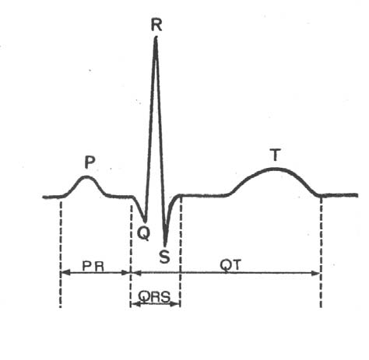(c) **Duration of electrical systole**

The duration of electrical systole and the duration of the ventricular action potential are closely related, and by measuring the Q-T interval it is possible to estimate the duration of systole.

(d) **Find Normal Values**

Compare the values you obtain with the normal range given in textbooks, and enter both on the worksheet below.

FIGURE 14: Measurement of ECG Intervals

**ECG WORKSHEET Subject…………………………………… Date……………**

Lead I Lead II Lead III

aVR aVL aVF

V1 V2 V3

V4 V5 V6

**Estimated Mean Frontal Plane Axis ……………………**

**Rhythm Strip**

**Mean Heart Rate shown in Rhythm Strip……………………..beats/minute**

**Paper Speed normally 25mm/s**

Thus 1 Large Square = 0.2s, 1 Small Square = 0.04s

Small squares x 0.04 and divided into 60 = HR in bpm

**Conduction Times**

**Cells**

**N.B. Recommended reading for this practical will be found on the next page.**

**Additional reading and website**

Hampton, John R (1997). The ECG Made Easy. (5th Edition) Churchill Livingstone. ISBN 0 443 05681 1. *The fact that this text is nearly 30 years old and is in its fifth edition indicates how helpful it has been to countless medical students.*

W. Brady, J Camm, J Edhouse and F Morris (2002) ABC of Clinical Electrocardiology*.* BMJ Books. ISBN 0727915363. T*he first two chapters by Steve Meek and Francis Morris are particularly helpful, and are also available on line in the British Medical Journal as shown below:*

Introduction I - Leads, rate, rhythm and cardiac axis. BMJ 324 415-418 (16 Feb 2002)

Introduction II - Basic Terminology. BMJ 324 470-473 (23 Feb 2002) Some of the remaining chapters will prove useful later in the course. The BMJ is available electronically on [www.bmj.com.](http://www.bmj.com/)

**Information sheet on the practical class: Electrocadiography**

You are being invited to be the subject in a practical class where fellow students will be recording your electrocardiogram (ECG). Before you decide to be the subject, it is important that you understand why this practical exercise is being done and what it will involve. Please take time to read the following information carefully and discuss it with others if you wish.

Ask us if there is anything that is not clear or if you would like more information.

**What is the purpose of the practical?**

The purpose of this practical is to learn how an ECG is recorded and what measurements may be made on it. The ability to record and interpret accurately an ECG recording is an important skill for all doctors to master, as it is a common procedure in medical practice. The practical may involve you being the subject and having your ECG recorded. This may require the removal of some outer clothes, but underwear need not be removed. If you feel uneasy at being touched and examined by another student, remember two important points. If you feel that you are unable to act as a subject in this practical class you will not be subjected to any pressure to do so and your progress through the course will not be affected in any way. However, you must take a full part in examining other students and you should reflect on the fact that you are missing a valuable experience in developing empathy with patients undergoing physical examinations.

**What will happen to me if I take part?**

Recording electrodes will be placed on the skin of your wrists, ankles and chest. This does **not** involve penetration of the skin. The electrodes will be connected to the ECG recording machine. You will be asked to lie on a couch whilst the recordings are made by other students. This should take about thirty minutes.

**What do I have to do?**

Once the electrodes have been connected you need do nothing apart from remain as relaxed as you can. Movement can affect the quality of the recordings.

**What are the side effects of taking part?**

There are no known side effects. This is a standard, non-invasive measurement used regularly in medical practice and you will be given your own ECG recording.

**What are the possible disadvantages and risks of taking part?**

There are no disadvantages in taking part in the study and no risks associated with the measurements being taken. The machines you will use meet current safety standards and will have been professionally checked before you use them. You should realize that the supervisors of this practical are mostly not medically qualified, but in the unlikely event that any obvious abnormalities are found on the ECG tracing you will be assisted in obtaining appropriate medical advice from the Imperial College Health Centre or your GP.

**Who has reviewed this practical?**

The practical has been reviewed by the Riverside Research Ethics Committee, Chelsea & Westminster Hospital, 369 Fulham Road, London, SW10 9NH.

**Contacts for further information**

If you need more information please contact Dr Pradeep Luther (p.luther), Dr Ken MacLeod

(k.t.macleod) or Professor John Laycock (j.laycock) (all @imperial.ac.uk).