School of Medicine

Year 1 – 2012/13

LIFE SUPPORT SYSTEMS



## The Urinary System

Summer term course guide

Course Leader: **Dr Paul Kemp**

tel: 020 7594 1716

email: [p.kemp@imperial.ac.uk](mailto:p.kemp@imperial.ac.uk)

<https://education.med.imperial.ac.uk>

Year 1 Urinary System, Summer term

**CONTENTS** Page

SOLE *iii*

INTRODUCTION 1

COURSE STRUCTURE 1

ASSESSMENT DETAILS 1

TIMETABLE 2

LEARNING OBJECTIVES 4

READING LIST 8

CONTACT DETAILS 8

SESSION MATERIALS

Lectures

The Kidney and Urinary Tract 9

The Structural Basis of Kidney Function 12

Renal blood flow and Glomerular filtration 16

Basic tubular function 18

Control of water, Sodium and Potassium balance 20

Mechanisms of Acid/Base balance 24

What happens when the kidneys stop working? 24

Practicals

Structural organisation of the kidney and urinary tract 25

GFR and Renal Clearance Practical 29

CAL Worksheet 36

Directed study worksheet 38

Specimen exam questions 41

Multiple choice question answers 43

<https://education.med.imperial.ac.uk>

**SOLE FEEDBACK – Urinary System**

The following pages provide you with templates on which you can record your thoughts as the course proceeds. At the end of the course you can enter your views onto SOLE.

**Please answer all questions by selecting the response which best reflects your view.**

|  |  |  |  |  |  |
| --- | --- | --- | --- | --- | --- |
|  | Strongly Agree | Agree | Neutral | Disagree | Strongly Disagree |
| The content of this module is useful. |  |  |  |  |  |
| The support materials available for this module (e.g. handouts, web pages, problem sheets) are helpful. |  |  |  |  |  |
| I receive sufficient feedback and guidance. |  |  |  |  |  |
| Overall, I am satisfied with this module. |  |  |  |  |  |

Please use this box for constructive feedback and suggestions for improvement.

|  |
| --- |
|  |

**SOLE FEEDBACK - INDIVIDUAL LECTURERS**

Please note that for SOLE, a lecturer’s name will only appear once. This template gives you the opportunity to record your comments about ***each*** lecture in the order of delivery.

**On the following section, you have an opportunity to record any comments and constructive feedback you have for each lecturer.**

|  | **The lecture(s) are well structured** | | | | | **The lecturer explains concepts clearly** | | | | | **The lecturer engages well with the students** | | | | |
| --- | --- | --- | --- | --- | --- | --- | --- | --- | --- | --- | --- | --- | --- | --- | --- |
| **Lecturer and lecture title** | Strongly Agree | Agree | Neutral | Disagree | Strongly Disagree | Strongly Agree | Agree | Neutral | Disagree | Strongly Disagree | Strongly Agree | Agree | Neutral | Disagree | Strongly Disagree |
| Professor Ceri Davies  The Urinary System |  |  |  |  |  |  |  |  |  |  |  |  |  |  |  |
| Dr Vikram Khullar Structural basis of kidney function |  |  |  |  |  |  |  |  |  |  |  |  |  |  |  |
| Dr Mike Emerson  Glomerular Filtration |  |  |  |  |  |  |  |  |  |  |  |  |  |  |  |
| Dr Paul Kemp  Tubular funciton |  |  |  |  |  |  |  |  |  |  |  |  |  |  |  |
| Dr Daqing Ma  Acid-Base balance |  |  |  |  |  |  |  |  |  |  |  |  |  |  |  |
| Dr Paul Kemp  Water Balance |  |  |  |  |  |  |  |  |  |  |  |  |  |  |  |
| Dr Paul Kemp  Sodium/potassium balance |  |  |  |  |  |  |  |  |  |  |  |  |  |  |  |
| Dr Andrew Frankel  Clinical Aspects |  |  |  |  |  |  |  |  |  |  |  |  |  |  |  |
|  |  |  |  |  |  |  |  |  |  |  |  |  |  |  |  |
|  |  |  |  |  |  |  |  |  |  |  |  |  |  |  |  |
|  |  |  |  |  |  |  |  |  |  |  |  |  |  |  |  |
|  |  |  |  |  |  |  |  |  |  |  |  |  |  |  |  |

| **Lecturer and lecture title** | **Please use this box for additional constructive feedback.** |
| --- | --- |
| Professor Ceri Davies  The Urinary System |  |
| Dr Vikram Khullar Structural basis of kidney function |  |
| Dr Mike Emerson  Glomerular Filtration |  |
| Dr Paul Kemp  Tubular funciton |  |
| Dr Daqing Ma  Acid-Base balance |  |
| Dr Paul Kemp  Water Balance |  |
| Dr Paul Kemp  Sodium/potassium balance |  |
| Dr Andrew Frankel  Clinical Aspects |  |
|  |  |
|  |  |
|  |  |
|  |  |
|  |  |
|  |  |
|  |  |
|  |  |
|  |  |

The Urinary System

**INTRODUCTION**

The overall objective of the urinary course is to enable you to relate the structure of the kidney and urinary system to their function and thereby understand the mechanisms by which the urinary system contributes to the excretion of waste products and the regulation of extracellular fluid volume, ions, water balance and pH. In studying the function of the kidney you will learn about major physiological mechanisms that regulate the environment of the body, a process you will know of as homeostasis. Many diseases are caused and/or exacerbated by a failure of these homeostatic mechanisms. As a result, understanding renal function and the maintenance of homeostasis is critical to understanding and managing many disease processes.

The Urinary Systems course is taught in the Summer Term of year 1.

**COURSE STRUCTURE**

There are six sessions in the Urinary System course in the first year, scheduled in the summer term together with teaching on the Alimentary System and the Anatomy of the Abdomen. By the end of the course you should have a good grounding in the structure and function of the kidney and urinary tract. It is important for you to understand these basics if you are to make sense of disorders of the urinary system and of salt and water balance generally and such an understanding will allow you to go on to understand the role of the kidney in pathophysiology.

Teaching format: there are 8 lectures, and 2 practicals in the course with 2 additional periods one for a computer based learning and the other for a period of directed study.

**ASSESSMENT**

**Formative Assessments**

Not applicable

**Summative Assessment**

The course will be examined in a single examination as part of the Life Support Systems examinations

Urinary Systems —**LSS** **Paper 1 Section 2 (1.5h) in June 2013**

The questions will be SAQ and SBA format.

**Examples of specimen questions**

See pages 43-45

Further details about examinations are provided on the Intranet.

**TIMETABLE 2012/13 – Summer term**

Details are correct at the time of going to press. ***Check the intranet for the most up-to-date timetable.***

|  |  |  |  |
| --- | --- | --- | --- |
| **Date and campus** | **Time** | **Lecture topic** | **Lecturer** |
| Wednesday  08-May-2013  Brian Drew LT CX | 9.00 AM | The urinary system | Prof Ceri Davies |
| 10.00 PM | Structural basis of kidney function | Dr Vikram Khullar |
| Friday  10-May-2013  SAF G16 | 9:00 AM | Renal blood flow and flomerular filtration | Dr Mike Emerson |
| Monday  13-May-2013  SAF G16 | 2:00 PM | Basic tubular function | Dr Paul Kemp |
| Wednesday  15-May-2012  SAF G16 | 9:00 AM | Mechanisms of acid/base balance | Dr Daqing Ma |
| Friday  17-May-2013  SAF G16 | 2:00 PM | Control of water balance | Dr Paul Kemp |
| Wednesday  22-May-2012  Brian Drew LT CX | 9:00 AM | Control of sodium and potassium balance | Dr Paul Kemp |
| 10:00 AM | What happens when the kidneys stop working? | Dr Andrew Frankel |

**Session 1: Wednesday 8 May (am**):

This will consist of two lectures one delivered by Professor Ceri Davies and one delivered by Dr Vikram Khullar. The first lecture will provide an overview of the organisation of the urinary system and (after a break) the second lecture will described the structural basis of kidney function

### Sessions 2 - 5: 10 May (am), 13 May (pm), 15 May(am) and 17 May (pm)

Each of these sessions has the same structure. Each will begin with a ¾ hour lecture by Dr Mike Emerson, Dr Paul Kemp or Dr Daqing Ma, covering basic renal function acid-base balance and water balance. The lecture on 10 May will be on glomerular filtration; that on 13 May on basic tubular function; that on 15 May on the acid-base balance; and on 17 May on water balance. In the remainder of each session you will be assigned to one of four activities, depending on your student group.

1. Practical 1; in which you will study the anatomy and histology of the kidney and urinary tract.
2. Practical 2; in which you will study the concept of renal clearance and learn how it is used for the measurement of glomerular filtration rate. ***Please bring your calculator; you will need it*.**
3. Computer-aided learning (CAL); using a program which will help you understand the origin and maintenance of the cortico-medullary osmotic gradient.
4. Directed study; on transport maxima and the renal handling of glucose.

The time at which your group has been assigned to each activity is given in the small group teaching timetable.

### Session 6: 22 May (am)

This session will begin (at 09:00h) with a 1h lecture by Dr Paul Kemp covering sodium/potassium balance. After a short break Dr Andrew Frankel a Renal Medicine Physician, will give a clinical lecture called “what happens when the kidneys stop working” this lecture illustrating some of the problems that can arise in renal disease and their pathophysiological basis. This session will enable you to see the clinical relevance of some of the basic science that has been introduced in the rest of the course.

### *Please note:*

1. *Your attendance is mandatory at the two classes in the MDLs. Please attend at the times shown in the table below – the equipment and staffing for these classes have been arranged on the basis of this table and it is unfair to your fellow students to come at a time different to the scheduled session.*
2. *Examination questions will be set on the basis of the learning objectives and there are learning objectives for all parts of the course (including the directed study and CAL)*

**Small group teaching: May 2013**

|  | Practical 1:  Anatomy & Histology of the Kidney & Urinary tract  Group Location | Practical 2: GFR and Renal Clearance  *You will find a calculator very useful for this class*  Group  Location | | | | CAL:  The cortico-medullary osmotic gradient | Directed study  Renal glucose transport |
| --- | --- | --- | --- | --- | --- | --- | --- |
| Friday 10 May  10.15h | A  2MDL | B1&B2  1MDL/A | B3&B4  1MDL/B | B5&B6  1MDL/C | B7  1MDL/D | C  G28/G29 | D |
| Monday 13 May  15.00h | B  2MDL | C1&C2  1MDL/A | C3&C4  1MDL/B | C5&C6  1MDL/C | C7  Rm 119 | D  G28/G29 | A |
| Wednesday 15 May  10.15h | C  2MDL | D1&D2  1MDL/A | D3&D4  1MDL/B | D5&D6  1MDL/C | D7  Rm 119 | E  G28/G29 | B |
| Friday 17 May  15.00h | D  2MDL | A1&A2  1MDL/A | A3&A4  1MDL/B | A5&A6  1MDL/C | A7  1MDL/D | F  G28/G29 | C |

Please Note:

1. You must attend for your practical classes at the times that your group has been assigned and NOT on one of the days on which you are assigned to CAL or directed study. However, if you unavoidably miss your practical class, consult the demonstrator.

2. The CAL session and the period for directed study will be unsupervised; you may choose to undertake these studies at times other than those shown above, if you wish. However, note that at the above times Dr Kemp will be available in the first floor MDL to (try to) answer questions, should you have any.

Learning objectives - Year 1 Urinary System, Summer 2012/13)

These session objectives may include tasks you should be able to carry out after you have completed the relevant activity. They provide you with a way to assess how well you are keeping up with the material. Note that they are also provided to the external examiners as a guide to what you should know at the end of the course.

**Lecture 1** (Professor Ceri Davies) **The urinary system**

Draw a simple diagram of the urinary system indicating the following: kidney, renal pelvis, ureter, bladder, urethra, sphincter vesicae, sphincter urethrae.

Outline the means of urine transport down the ureters into the bladder and explain the mechanism preventing reflux of urine from the bladder.

Describe the anatomical and histological features allowing expansion of the bladder as it fills with urine.

Distinguish between the sphincter urethrae and sphincter vesicae muscles and their nerve supplies.

Describe the mechanisms involved in the reflex contraction of the bladder in response to distension. State the approximate volume of urine in the bladder that normally initiates a reflex contraction in the adult.

**Lecture 2** (Dr Vikram Khullar) **Structural basis of kidney function**

Describe the structural organisation of the kidney, as seen at a macroscopic level.

Draw a diagram showing the main constituent parts of a nephron.

# Draw a diagram of the structures separating glomerular capillary plasma from the fluid in Bowman's capsule.

List the features of the cellular structure of the tubules in different parts of the nephron which make possible the concentration of urine.

Draw a diagram showing the pattern of blood vessels in the kidney, and state which features contribute to the filtration process, to the reabsorption process, and to the countercurrent mechanism.

**Lecture 3** (Dr Mike Emerson) **Renal blood flow & glomerular filtration**

Indicate what proportion of the cardiac output normally perfuses the kidney.

Define the term “freely filtered”. State that the permeability barrier in the glomerulus discriminates mainly on the basis of size (although electrical charge also influences the filtration of charged proteins). Compare the composition of the glomerular filtrate and the plasma.

Define glomerular filtration rate (GFR) and filtration fraction and give typical values for each in a normal healthy young adult. Write an equation for the net filtration pressure across the glomerular membrane in terms of the hydrostatic and osmotic pressures involved. Explain how net filtration pressure will be affected by (a) a large fall in arterial blood pressure (b) a fall in plasma protein concentration and (c) ureteral obstruction

Describe and explain the effect of changes in renal blood flow on GFR.

Define renal clearance and explain its use in assessing renal function.

**Lecture 4** (Dr Paul Kemp) **Basic tubular function**

In the context of renal function, define the terms reabsorption and secretion. Explain the meaning of transcellular and paracellular transport.

Draw a diagram of the wall of the early proximal tubule showing the following: tubular fluid, luminal membrane, basolateral membrane, peritubular capillary, tight junction, Na+/K+ “pump” and one example of each of the following: an ion-selective channel, co-transport of two solutes, counter-transport of two solutes.

Explain how active sodium transport acts as a driving force for the reabsorption of water and many other ions and molecules.

Describe the main routes for Na+ entry into tubular cells in the thick ascending limb of the loop of Henle, in the distal convoluted tubule and in the principal cells in the cortical collecting tubule.

Contrast the osmolarity of the tubular fluid (a) in Bowman’s space (b) at the end of the proximal tubule and (c) emerging from the loop of Henle.

**Lecture 5** (Dr Paul Kemp) **Control of water excretion**

State the meaning of the term osmolarity

State the minimum and maximum osmolarity of the urine in humans and indicate the nephron sites responsible for the production of (a) dilute urine and (b) concentrated urine.

Explain why the final concentration of the urine depends on:

(a) the osmolarity of the medullary and papillary interstitium;

(b) the permeability of the collecting ducts to water.

Explain the mechanisms by which that the medullary and papillary interstitium becomes hypertonic as a result of the accumulation of NaCl and urea.

Describe how changes in plasma osmolarity influence the release of vasopressin (antidiuretic hormone) from the posterior pituitary, using the term 'hypothalamic osmoreceptors'.

Describe the action of vasopressin on the collecting ducts, and hence explain how urine volume is regulated in accordance with the state of hydration of the body.

Describe how changes in plasma osmolarity and volume influence thirst.

**Lecture 6** (Dr Daqing Ma) **Mechanisms of acid-base balance**

Give the normal arterial plasma pH and the limits compatible with life.

Explain in terms of physiological buffering the importance of the bicarbonate buffer system.

Give the Henderson-Hasselbach equation when applied to the bicarbonate buffer system. Cite a normal value for plasma HCO3- concentration.

State that the kidneys help to control plasma HCO3- concentration by (a) variable reabsorption of filtered HCO3-, and (b) variable addition of new HCO3- to the blood perfusing the kidneys.

Explain the mechanism and indicate the sites of HCO3- reabsorption.

State the limits of urine acidity and alkalinity. Thus explain why it is impossible for the kidneys to add significant amounts of new bicarbonate to the blood simply by excreting free H+ ions.

Describe in outline the mechanisms involved in the excretion of acid phosphate and of ammonium salts. Indicate how these events contribute new bicarbonate to the blood.

Explain the terms: respiratory acidosis, respiratory alkalosis, metabolic acidosis, metabolic alkalosis.

Explain in general terms what is meant by respiratory compensation and renal compensation for acid-base disturbances.

**Lecture 7** (Dr Paul Kemp) **Control of Na+ and K+ excretion**

Explain why extracellular fluid volume is determined primarily by the body's sodium content. Thus explain the importance of the renal control of sodium excretion in the control of extracellular fluid volume.

Compare the daily amounts of sodium filtered with the amounts normally appearing in urine.

State the approximate proportions of filtered sodium normally reabsorbed in (a) the proximal tubule and (b) the loop of Henle.

State that the bulk of the glomerular filtrate is reabsorbed in the proximal tubule and loop of Henle and that the fraction of the filtered load reabsorbed in these segments is not very responsive to changes in sodium, potassium or water balance. Contrast this with the function of the distal nephron.

Name the site of secretion of aldosterone and list three factors that influence the rate of production of this hormone.

Describe the effect of aldosterone on sodium reabsorption, indicating its principal site of action.

Explain three ways in which an increased concentration of Angiotensin II can influence renal function.

Give three stimuli that lead to an increase in renin release

Name one other hormone that can directly influence renal sodium reabsorption

Describe the effect of renal sympathetic nervous activity on the renal vasculature and on renin release.

Understand how small variations in Na+ intake can be counterbalanced by changes in Na+ reabsorption in the collecting ducts (under the influence of aldosterone)

Explain why substantial variations in Na+ result in extracellular fluid volume contraction or expansion and lead to widespread co-ordinated changes in renal function

Explain that the prime function of diuretics is to increase renal Na+ excretion (usually by reducing Na+ intake into the tubular cells). Give one example of a class of diuretic drug acting in each of the following sites: the proximal tubule, the loop of Henle, the early distal tubule and the cortical collecting ducts.

Compare the daily amount of potassium filtered with the amount normally appearing in the urine.

Describe the movement of potassium ions under normal conditions; reabsorption in the proximal tubule and loop of Henle but secretion into the lumen of the late distal tubule and cortical collecting duct. Describe the contribution of secretion to the level of potassium excreted.

Describe the cellular mechanism of potassium secretion

Explain how potassium secretion (and therefore excretion) is influenced by:

(a) plasma potassium concentration

(b) aldosterone

(c) tubular fluid flow rate

(d) acid-base balance

**Lecture 8** (Dr Andrew Frankel), **What happens when the kidneys stop working?**

1. To understand that the broad physiological functions of the kidney include a) its role in homeostasis, b) excretory function and c) endocrine function.

2. To appreciate that the clinical features associated with loss of kidney function are highly dependent on speed, as well as extent, of the loss of function

3. When loss of kidney function is slow the associated symptoms may be subtle and include lethargy, anorexia and pruritis, which may be multifactorial in origin.

4. To understand the potential effects of kidney failure on salt and water balance and that this can result in either an oedematous and hypertensive presentation where there is retention, or a hypotensive state where salt and water is lost.

5. To understand that the clinical consequences of inadequate potassium clearance includes the development of hyperkalaemia, which can result in associated heart rhythm disturbances.

6. To understand that the loss of endocrine function of a failing kidney can effect calcium/phosphate/PTH homeostasis and result in the development of anaemia

7. To be aware of the different methods available to estimate global kidney filtration function and to understand the advantages and pitfalls of each.

**Practical 1** (Dr Vikram Khullar)

**Practical 2** (Dr Paul Kemp)

Understand the meaning of the terms glomerular filtration and freely filtered

Explain which measurements are required to calculate GFR and perform the appropriate calculation

Explain which measurements required to calculate renal clearance and perform the appropriate calculation

Explain which measurements required to calculate renal plasma flow rate and perform the appropriate calculation

Describe the use of creatine in the determination of GFR and the effect of altered renal function on plasma creatine concentrations

**Recommended reading**

# Recommended reading:

E. Widmaier, H. Raff & K. Strang (2006). Vanders Human Physiology 10th Edition. (McGraw-Hill).

K. van de Graaff & S.L. Fox (1998) Concepts of Human Anatomy and Physiology, 5th Edition (McGraw-Hill)

K.L. Moore & A.M. Agur (2002) Essential Clinical Anatomy, 2nd Edn (Williams & Wilkins)

C.J.Lote (1994) Principles of Renal Physiology, 4th Edition (Chapman & Hall)

B.M.Koeppen & B.A.Stanton (2001) Renal Physiology, 3rd Edition (Mosby)

W. F. Ganong (2003) Review of Medical Physiology, 21st Edition (McGraw-Hill)

The above physiology books are well represented in the South Kensington library. However, IF you choose to buy a book it would be more sensible to purchase one that also covers the renal medicine taught in later years. The following two recently published books would be more appropriate.

M.J.Field, C.A Pollock & D.C. Harris (2001) The Renal System (Churchill Livingstone)

C O.Callaghan (2006) The Renal System at a Glance (Blackwell)

**Online resources**

You may also find the following online essays an interesting way of looking at things

<http://academic.sun.ac.za/medphys/kidney.htm>

<http://academic.sun.ac.za/medphys/counter.htm>

**CONTACT DETAILS**

**Course Leader:** Dr Paul Kemp p.kemp@imperial.ac.uk

**Session organizers**

**Practical session 1:** Dr Vikram Khullar v.khullar@imperial.ac.uk

**Practical Session 2:** Dr Paul Kemp p.kemp@imperial.ac.uk

The Kidney and Urinary Tract

**(Lecture 1)**

Professor Ceri Davies

# Organization and function

The main functional components of the urinary tract are:

* Kidneys
* Calyces, Renal Pelvis and Ureters
* Urinary Bladder
* Urethra and associated sphincters
* Neurological control systems for the bladder muscle and the sphincters
* A well-adapted blood vascular supply

This lecture provides an overview of the organization of these components and their roles in urine production and handling. It provides a bridge between thinking about the physiology of the urinary system and studying the system’s structure and relations in Anatomy. Details of mechanisms and regulation within the kidneys will form the subject of the classes on subsequent days.

Kidneys and urine production

The production of urine from blood plasma is a two-stage, divided into an initial *ultrafiltration* step and modification of the ultrafiltrate by *absorptive and secretory* mechanisms.

Ultrafiltration is driven by the arterial blood pressure, so the renal arteries are short, wide, direct branches of the abdominal aorta.

Each kidney lies in the upper part of the posterior abdomen, embedded in the retroperitoneal fat, which is particularly abundant in this area. The upper part of each kidney rests on the diaphragm and is protected from behind by the lowest two ribs.

The outer layer of the kidney is a dense, fibrous envelope named the *capsule*.

In section a kidney shows an outer, granular-looking *cortex* (Latin for *rind*) and an inner, radially striated *medulla* (Latin for *marrow*). Each contains distinct parts of the *nephrons* – the million or so urine-producing units of each kidney. The cortex consists of the glomeruli (the ultrafiltration sites) surrounded by the convoluted parts of the tubules, whereas the medulla contains parallel bundles of straight tubules.

The kidneys of animals such as rodents are termed *simple kidneys*, as each bean-shaped kidney consists of a single core of medulla surrounded by cortex. Human kidneys are different. They develop from about ten simple kidney-like units that fuse together to form a *multilobar* kidney. This origin explains a few otherwise puzzling facts, for example:

* Renal columns, consisting of cortex, reach right through the medulla at the boundaries of the kidney lobes
* Each lobe drains into its own part of the renal pelvis, called a minor calyx.

The minor calyces join to form a few major calyces, all of which open into a funnel shaped structure named the renal *pelvis* (Latin for *basin*).

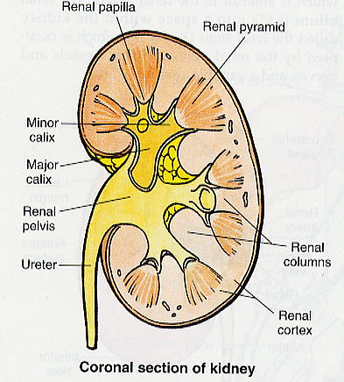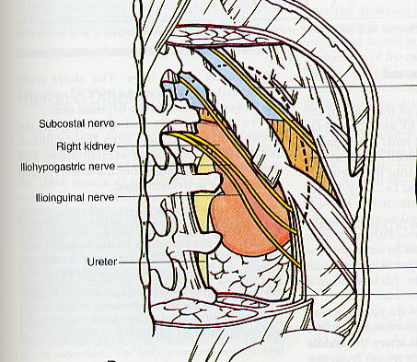

Ureters, urine transfer and storage

The calyces, renal pelvis and ureters provide the means by which urine reaches the urinary bladder where it is stored. Urine transfer down the ureters takes place by peristalsis carried out by smooth muscle in the ureteric walls. The ureters have several narrow points at which kidney stones (renal calculi) are likely to stick and cause severe pain – it is best to think about these when looking at the ureters in Anatomy classes.

Urine is often very hypertonic or hypotonic, so osmotic and diffusive processes between urine and extracellular fluid would undo much of what the kidneys have achieved. The urinary tract, from the calyces through the renal pelvis, ureters and bladder to the beginning of the urethra, is lined by a unique epithelium called *urothelium* or *transitional epithelium*. This consists of three layers of epithelial cells, of which the urine-facing layer not only has high-resistance tight junctions but also an unusually thick apical plasma membrane, both important in minimising trans-epithelial exchange. The pleated borders of the urothelial cells allow very extensive unfolding and flattening as the bladder fills with urine.

The urinary bladder when empty is a small, muscular, tetrahedral organ lying below the pelvic peritoneum and not rising much above the top of the pubic symphysis. As it fills with urine, it relaxes and expands upwards into the loose connective tissue between the deep surface of the anterior abdominal wall and the parietal peritoneum.

Things related to the urinary bladder are often referred to as *vesical* (e.g. vesical arteries) –from the Latin *vesica* (= urinary bladder).

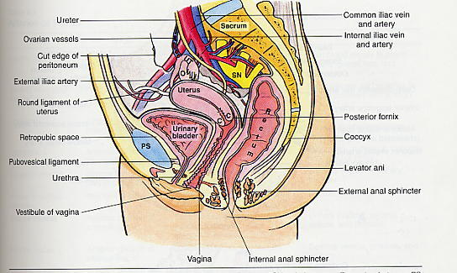

The urethra

Not to be confused with the ureters, the urethra carries urine from the bladder to the exterior. In the female it is short and simple, and passes through the perineum to open into the *vestibule*, the space between the labia minora. In the male it is long and has an intra-pelvic part within the prostate gland and a part within the penis in addition to the trans-perineal part.

Urinary sphincters and urinary continence

As the bladder fills it become very thin walled (accounting for the popularity of inflated pigs bladders in as party decorations and football inner tubes in the pre-rubber era). Beyond a certain level of fullness the tension in the bladder wall increase, stimulating receptors that trigger a sacral parasympathetic reflex leading to contraction of the bladder smooth muscle and relaxation of the bladder-+’s smooth muscle sphincter (*sphincter vesicae*) at the junction of bladder and urethra. Ascending pathways make the individual aware of bladder fullness. A decision to empty the bladder (micturate) leads to voluntary relaxation via descending inhibitory pathways that reduce the pudendal nerves’ stimulation of the skeletal muscle sphincter (*sphincter urethrae*) that surrounds the urethra in the perineum. The In the absence of a decision to empty the bladder (e.g. if socially inappropriate or during sleep), the urethral sphincter stays closed and this leads to a return to closure of the vesical sphincter and reduction of bladder tone.

**The Structural Basis of Kidney Function**

**(Lecture 2)**

Dr Vikram Khullar



### Function of Kidney

Production of urine:

Filtration of blood plasma

Selective reabsorption of contents to be retained

Unwanted contents remain in urine

Concentration of urine as necessary

Sensitive to body needs via hormones, nerves

Endocrine function - signals to rest of body (hormones include renin, erythropoietin, 1,25-OH vitamin D)

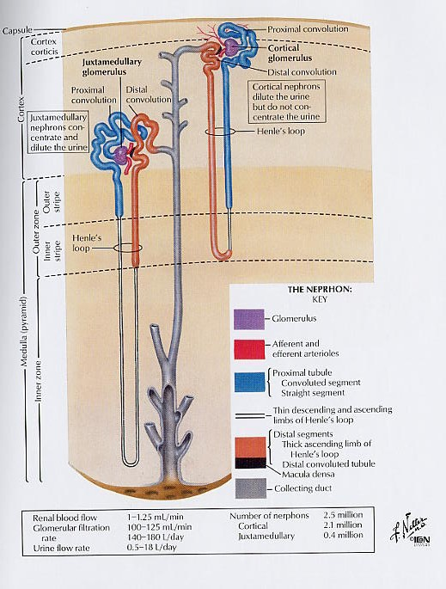**Mechanism of urine production in kidney**

# *Filtration*:

Blood passing through glomerulus is filtered

Filtrate consists of all components <~50 000 mw

# *Reabsorption*:

Material to be retained is reabsorbed in proximal convoluted tubule

Includes ions, glucose, amino acids, small proteins, water

# *Creation of hyper-osmotic extracellular fluid*:

Main function of loop of Henle and vasa recta

Countercurrent mechanism

# Adjustment of ion content of urine:

Occurs at distal convoluted tubule and collecting duct. Controls amounts of Na+, K+, H+, NH4+ excreted

# *Concentration of urine*:

Occurs at collecting duct

Movement of water down osmotic gradient into extracellular fluid

Controlled by vasopressin (=ADH, antidiuretic hormone)

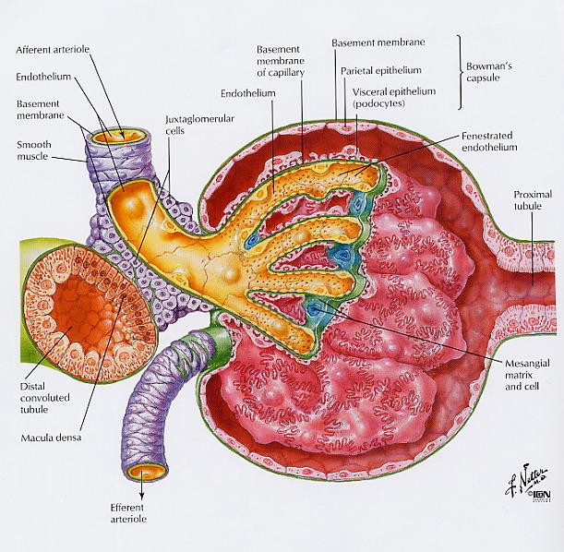

**Renal corpuscle**

# *Components*:

Bowman’s capsule containing glomerulus (capillaries) podocytes and mesangial cells associated with glomerulus

# *Blood supply*:

at vascular pole of corpuscle

from afferent arteriole, exit to efferent arteriole

glomerular capillaries at high pressure

# *Filtration barrier*:

# fenestrae (“windows”) in capillary endothelium

specialised basal lamina

filtration slits between foot processes of podocytes

allows passage of ions and molecules <~50 000

# *Drainage of filtrate*:

to proximal convoluted tubule, at urinary pole

*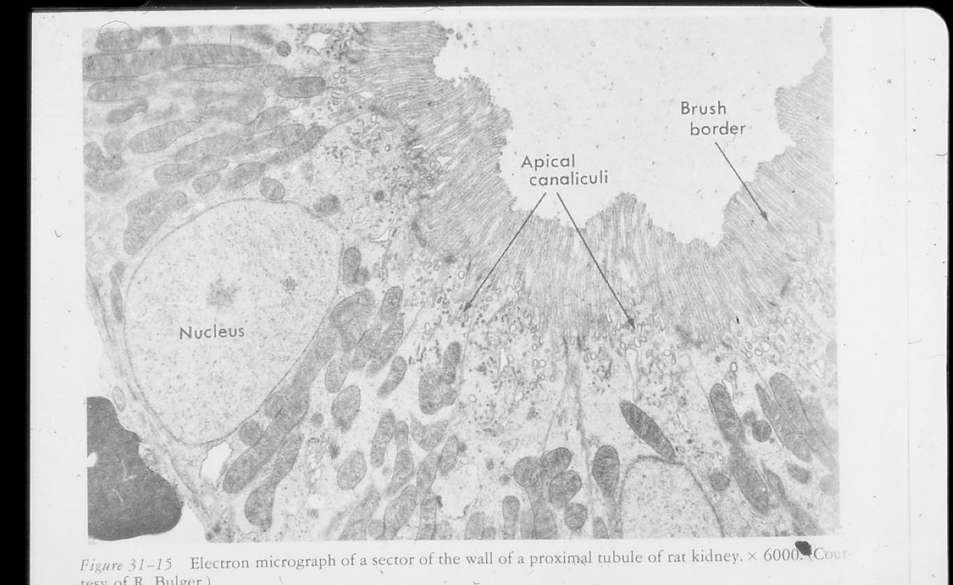***Proximal convoluted tubule**

# *Function*:

Reabsorption of 70% of glomerular filtrate

Na+ movement by basolateral Na+ pump

Water and anions follow Na+

Glucose uptake by Na+/glucose co-transporter

Amino acids by Na+/amino acid co-transporter

Protein uptake by endocytosis

# *Structure*:

Cuboidal epithelium, sealed with tight junctions

Membrane area increased to maximise rate of resorption

brush border at apical surface

interdigitations of basolateral membrane

Contains aquaporin proteins – mediate water diffusion

Prominent mitochondria reflect high energy requirement

### Loop of Henle - the countercurrent mechanism

# *Kid11Descending thin tubule*:

Passive osmotic equilibrium (aquaporins present)

Simple squamous epithelium

# *Ascending thick limb*:

Na+ and Cl- actively pumped out of tubular fluid

Membranes lack aquaporins - low permeability to water

Results in hypo-osmotic tubular fluid, hyper-osmotic extracellular fluid

# Cuboidal epithelium, few microvilli

High energy requirement - prominent mitochondria

*Vasa recta*:

Blood vessels also arranged in loop

Blood in rapid equilibrium with extracellular fluid

Loop structure stabilises hyper-osmotic [Na+]

### Distal convoluted tubule/Cortical collecting duct

Adjustment of Na+/K+/H+/NH4+ (control by aldosterone)

Cuboidal epithelium, few microvilli

Specialisation at macula densa, part of juxtaglomerular apparatus

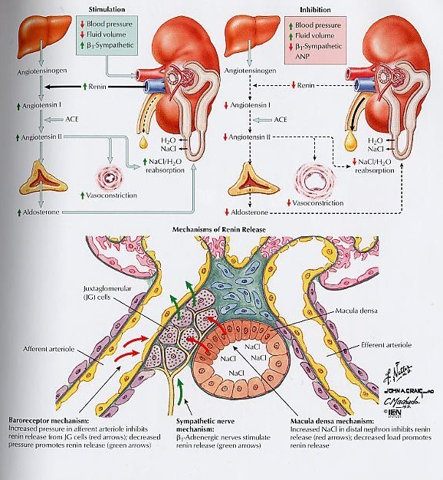

### Juxtaglomerular apparatus

Endocrine specialisation

Secretes renin to control blood pressure via angiotensin

### Medullary collecting duct

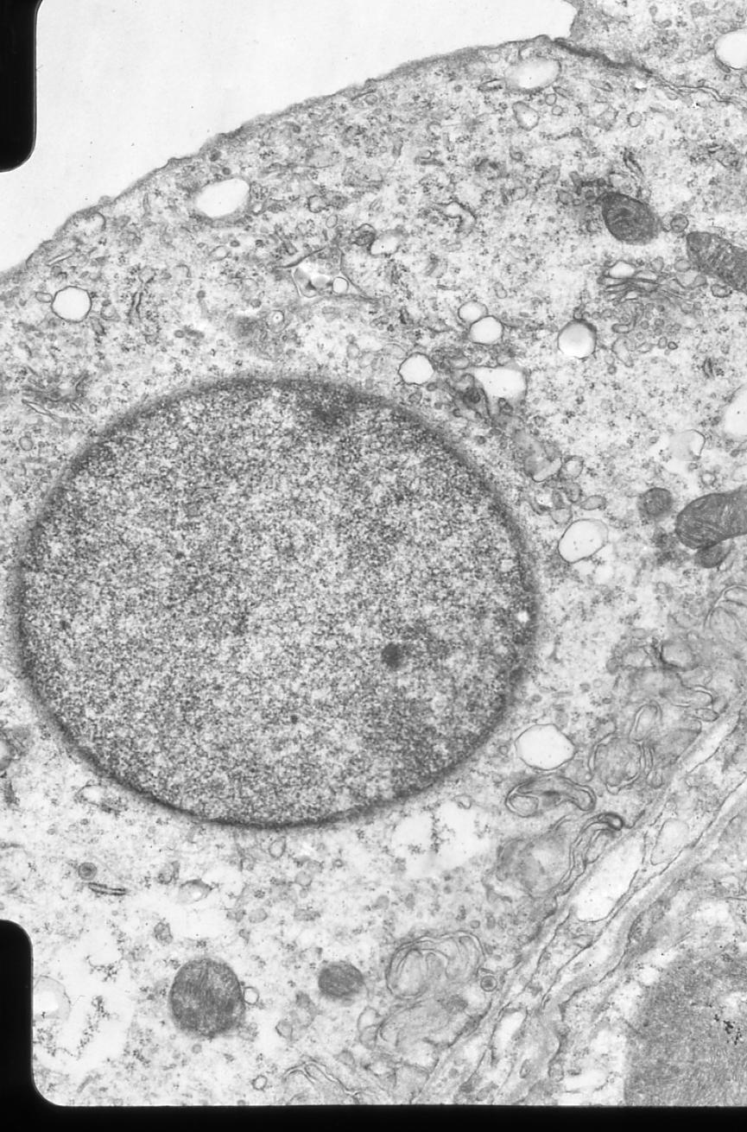Completes ion adjustment and controls urine osmolarity

Passes through medulla - hyper-osmotic extracellular fluid

Water moves down osmotic gradient to concentrate urine

Rate due to aquaporin-2 in apical membrane

***content varied by exo-/endocytosis mechanism under control from the pituitary hormone vasopressin***

Basolateral membrane has aquaporin-3, not under control

Duct simple cuboidal epithelium, single cilium per cell

Cell boundaries don’t interdigitate

Smooth muscle wall for peristalsis (2 layers)

Cells contain organelles associated with secretory activity

Little active pumping so fewer mitochondria

Drains into minor calyx at papilla of medullary pyramid

Minor and major calyces and pelvis have urinary epithelium

### Ureters

Drain urine from kidneys

Peristaltic movement towards bladder

Urinary epithelium resists damage by urine

### Bladder

Urine storage organ (capacity ~500 ml)

2 ureters enter posterior wall, urethra leaves inferiorly

Urinary epithelium resists damage and allows expansion

Smooth muscle wall (“detrusor muscle”)

Autonomic innervation

Sphincter vesicae (involuntary) at urethral exit

### Urinary epithelium

A specialised form of epithelium found only in the urinary tract: parts of kidneys, ureters, bladder, parts of urethra

(Also called “urothelium” or “transitional epithelium”)

All cells contact basal lamina (but epithelium looks stratified)

Properties are resistance to urine, and ability to stretch

Cells appear squamous or cuboidal according to degree of stretch

# Luminal cells are specialised for extremely low permeability

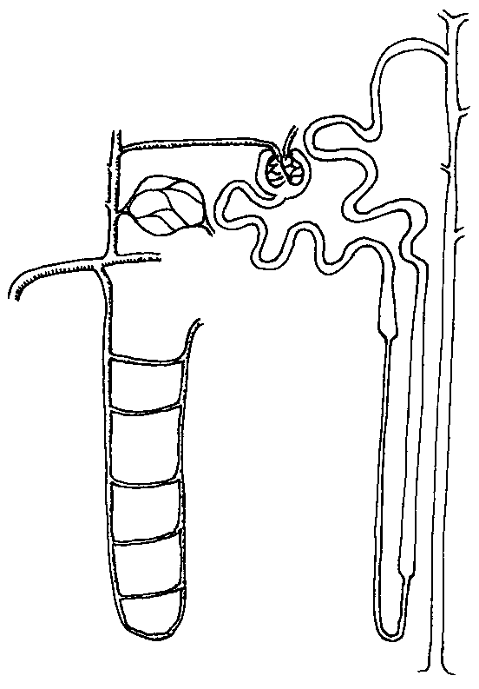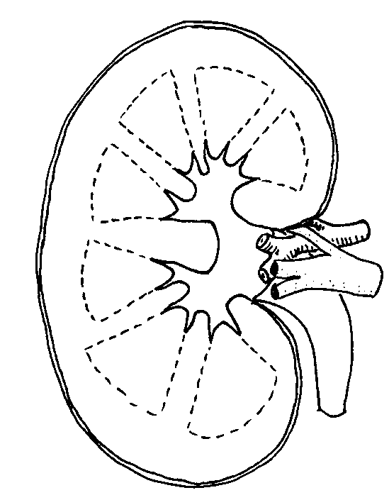

**Renal blood flow and Glomerular filtration**

**(Lecture 3)**

Dr Michael Emerson

**Kidney Stats**

Kidneys receive 20% of cardiac output (C. O is approx 5 L/min).

Cardiac output is 5L/min and so renal blood flow is approx 20% of 5L/min i.e. 1L/min.

Glomeruli of each nephron filter only plasma, not blood cells, plasma makes up 55% of blood, thus renal plasma flow = 0.55L/min.

Glomerular Filtration Rate (GFR) = the amount of plasma filtered from the glomeruli into the Bowmans capsule per minute.

Each nephron unit can filter 20% (0.2=filtration fraction) of the blood plasma each cycle.

Thus, *a typical adult GFR* = 20% of 550ml/min = *110ml/min*

### Dynamics of ultrafiltration

The filtration process is based on passive forces where fluid is “forced” through the semi-permeable walls of the glomerular capiliaries into Bowman’s capsule. The hydrostatic pressure generated by the heart is the principal driving force. However this pressure is partially opposed by two pressures acting to restrain filtration – hydrostatic pressure in lumen of tubules and the oncotic pressure of plasma proteins in the capillary.

Thus the net ultrafiltration pressure (Puf) comprises the hydrostatic pressure in glomerular capillaries (Pgc) minus the hydrostatic pressure in the tubules (Pt) minus the oncotic pressure generated by plasma proteins (πgc):

**Puf = Pgc –Pt – πgc**

From Puf, GFR can be calculated:

**GFR = Kf x Puf**

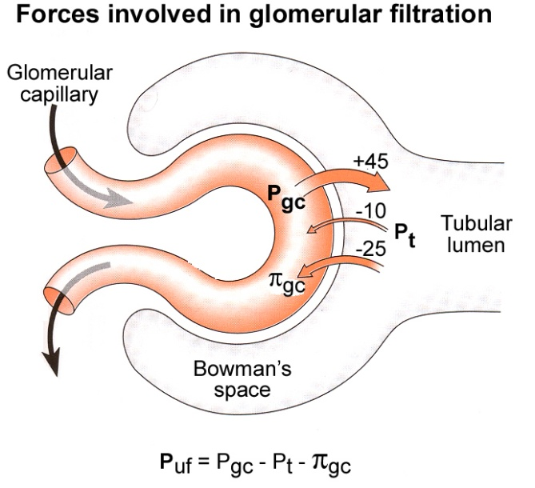Where Kf is an ultrafiltration coefficient (membrane permeability and SA available for filtration – differs for each tissue type – but glomerular capillaries extremely permeable).

There is a net ultrafiltration pressure of 10-20mmHg.

GFR is not a fixed rate, it is subject to physiological regulation according to the body’s needs and requirements. However it is kept under good control by the *tuberoglomerular feedback mechanism* and the *myogenic mechanism.*



**Some values for Renal Clearance :**

Na 1.0ml/min

K 11.0ml/min

Ca 1.8ml/min

Glucose 0.05ml/min

Urea 17.0ml/min

Inulin 120.0ml/min

PAH 625.0ml/min

**Basic tubular function**

**(Lecture 4)**

Paul Kemp

(These notes should give you an idea of the things that will be covered and can be used to help your revision. The slides will be available shortly before the lecture and should help you answer the questions**)**

Every day we absorb more water and salt than we need to replenish the amounts we lose by non renal routes. This allows us to respond to changes in our environment but causes a problem as we must get rid of the excess to maintain a normal balanced internal environment. We must also get rid of waste products and principal amongst these is urea.

The simplest solution: Pump out the excess of everything.

The problem with this is that evolution has not come up with discriminating pumps for water and urea.

Evolutions response: Throw out baby and bath water then retrieve the baby.

The process: Glomerular filtration filters a proportion of all small molecules/ions into a tube (the nephron). Useful molecules and ions are then retrieved at differing points along the tube. The proportion reabsorbed is approximately 99%!

Each nephron can be divided into at least 6 distinct functional parts

1. Glomerulus
2. Proximal convoluted tubule
3. Descending loop of Henle
4. Ascending loop of Henle
5. Distal convoluted tubule
6. Collecting duct

Each part has its own function and energy requirements



Ions transported across each region (fill in at end of lecture!)

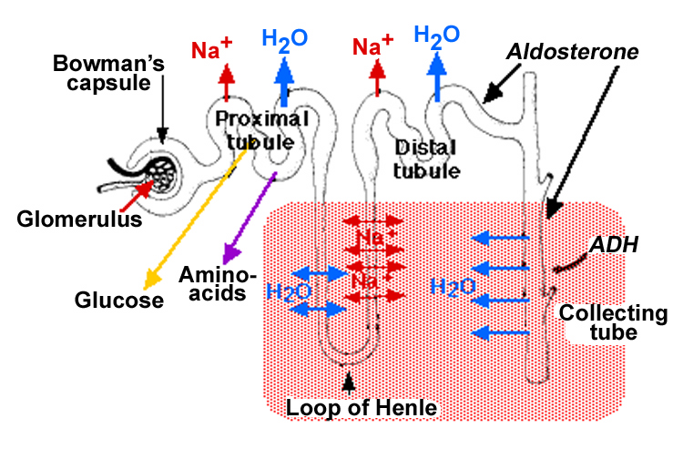

The bulk of the movement of molecules and ions is dependent on protein transporters. These are either energy dependent or independent.

Important questions

1. What sort things are transported in a protein independent fashion?
2. What is the source of all the energy used in transport?
3. How is use of the energy coupled to the movement of different chemicals
4. How is movement regulated?

*Proximal tubule*: reabsorbs ____% of all solute, which includes ____% of glucose and amino acids, ____% of bicarbonate and water, &____% filtered Na.

*Loop of Henle*: allows urine concentration; reabsorbs ____% of filtered Na.

*Distal tubule*: reabsorbs ___% of filtered Na.

*Collecting duct*: reabsorbs remaining ___% Na only if ________ present.

**Control of water, Sodium and Potassium balance**

**(Lectures 6 and 7)**

Dr Paul Kemp.

**How do we maintain a constant osmotic internal environment and why would we want to?**

Many essential functions are dependent on the ratio of the ion concentrations on the inside and outside the cell membrane. These functions include nerve conduction and muscle contraction. To achieve the regulation of these essential processes we expend large amounts of energy each day maintaining intracellular ion concentrations within tight limits. It is therefore essential to maintain the extracellular ion concentrations within similarly tight limits.

**Important Concept**

**Osmolarity =** measure of the solute concentration in a solution (osmoles/liter; 1 Osmole = 1 mole of dissolved solutes per liter); depends on the number of dissolved solutes present. The greater the number of dissolved particles, the greater the osmolarity

As we need to maintain a constant osmolarity but to be able to adapt to changing intake of water and salt. The only way to avoid significant fluctuations in osmolarity is to change our volume. Thus the main determinant of ECF volume is the number of osmoles present – the most abundant is Sodium.

As a consequence of this the amount of sodium determines extracellular fluid (ECF) volume.

To stop our volume fluctuating wildly (with all the implications for blood pressure) we must, however, regulate sodium and water balance together. However, for ease of description we will examine water balance first and then talk about sodium balance in the second lecture.

**Water balance is used to regulate Osmolarity**

We lose water in a number of different ways, but urine is the only one that is both variable and controllable.

Water must be reabsorbed along the nephron and this occurs at all points except the ascending loop of Henle.

Urine output is a variable amount of the filtered load varying from much less that 1% to about 10% dependent on hydration.

Almost all other reabsorbed products are pumped in one way or another. However, we don’t have any protein based pumps for water just channels so how can we reabsorb almost all of the water?

Water moves across membranes in the body by osmosis so we have to generate osmotic gradients that can transport the water. Such a gradient is generated by the counter-current mechanisms of the loop of Henle. This gradient allows us to generate a very high interstitial osmolarity. The mechanism by which the loop of Henle generates an interstitial osmotic gradient involves the shape of the tubular system at that point together with the limited permeability of specific parts of the loop to water and salt.

Then by regulating the permeability of the collecting duct to water by the amount of vasopressin we can reabsorb more or less water.

How much water as a percentage of filtered volume is present at each point?

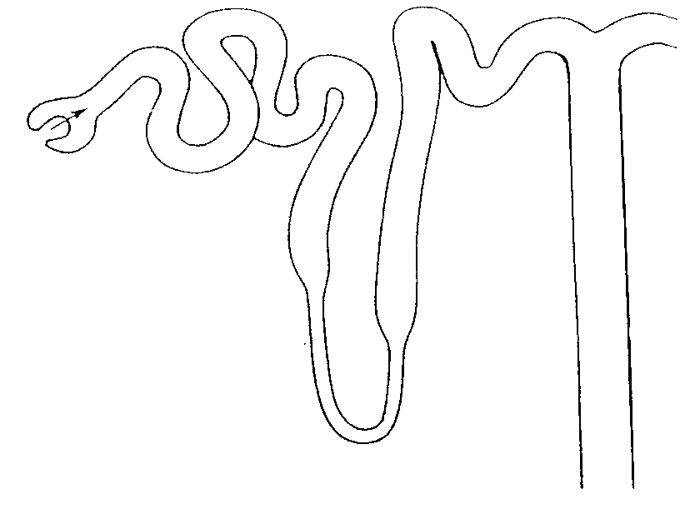

c

b

a

This leads to a series of questions

1. Where is vasopressin synthesized?
2. How are levels of vasopressin controlled?
3. How does increased vasopressin increase the water permeability of the collecting duct?
4. what is the effect of high levels of water reabsorption on the osmotic gradient?

**Sodium balance is used to regulate ECF fluid volume because we need to maintain a constant ______________**

We must therefore increase Na+ secretion in response to excess and conserve Na+ in times of low intake. Otherwise we will either increase our volume and therefore our blood pressure or reduce our volume and thereby our blood pressure. There are negative consequences to both of these scenarios.

Most regulation occurs through the renin angiotensin system and the aldosterone system

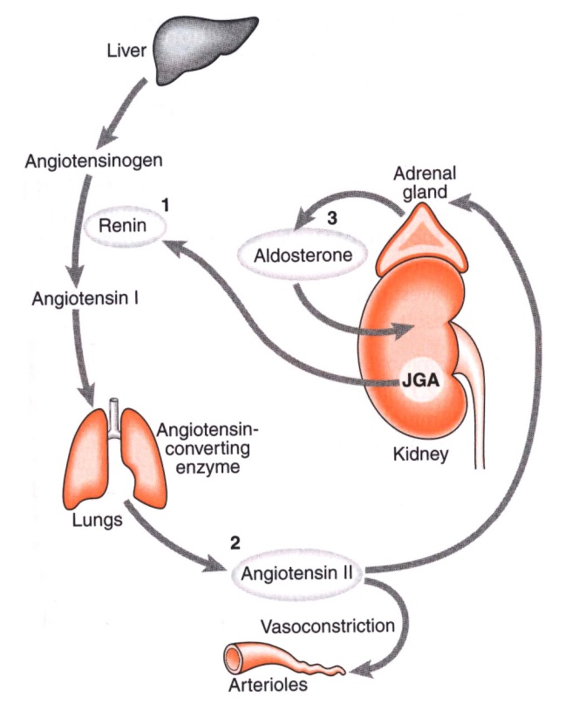

Renin is regulated by

1. renal perfusion pressure (what is the effect of increased perfusion pressure?)
2. [Na+] (where?)
3. AII (how is this made?)
4. sympathetic nerve activity (which receptors and what do they do?)

Angiotensin has a range of effects on the body

1. what is the effect of AII on blood pressure and why
2. what is the effect of AII on the adrenal gland?

Aldosterone

1. Steroid hormone (how does it work)
2. Synthesised and released from the _____________
3. Released in response to ______I

Na+ and ECF volume are regulated as an integrated system. Here is an example

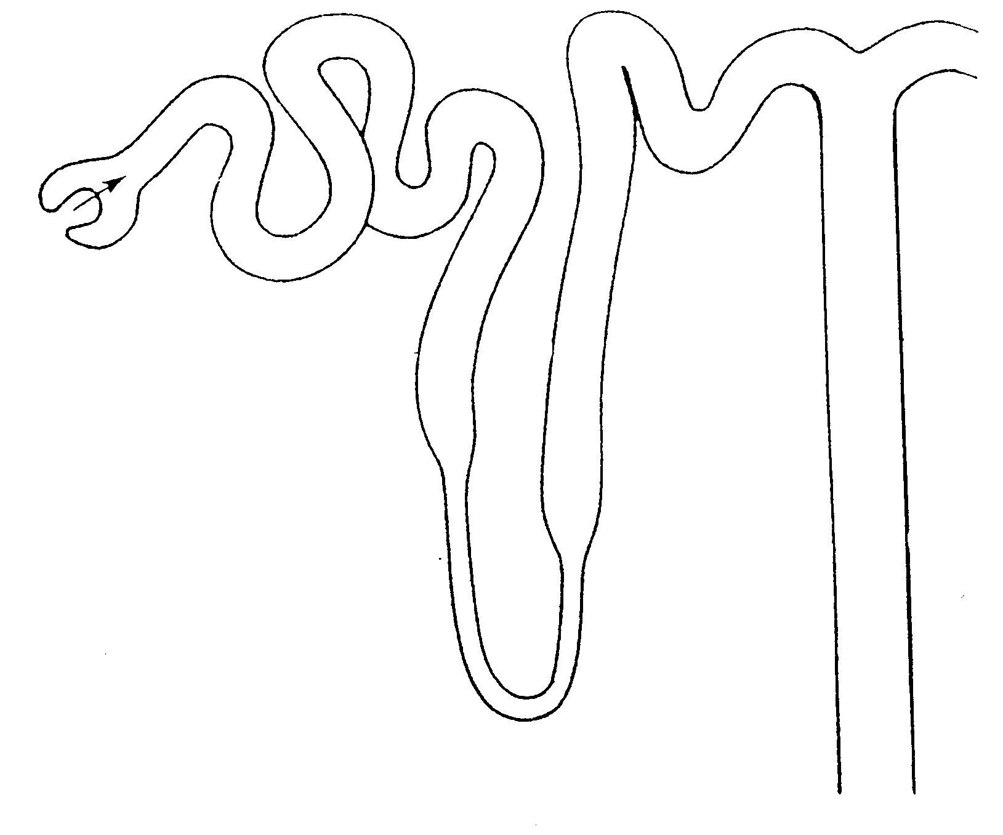

Volume contraction

Lung

Adrenal gland

Heart

Brain

How do we reduce water content if blood pressure is too high?

Describe the common principal by which diuretics work, why do they reduce blood pressure?

What are the mechanisms of diuretics that work on

1. the proximal convoluted tubule
2. the loop of henle
3. the distal convoluted tubule

In addition to regulating sodium, we also need to regulate the amount of potassium in the body. K+ is a major intracellular ion and the ratio of intracellular to extracellular K+ is important in controlling the membrane potential. This importance is particularly evident in excitable cells such as the myocytes of the heart. Indeed one of the symptoms of acute K+ overload is a disturbance of contractile rhythm.

K+ is freely filtered and reabsorbed in the PCT and the loop of Henle. Levels of K+ are primarily regulated by controlling the secretion of K+ in the DCT and the collecting ducts.

The amount of K+ secreted is

1. Regulated by a hormone (which one?)
2. affected by tubular flow rate (which way?)
3. increased in the DCT and collecting ducts by a change in plasma pH (which way?)
4. increased in response to increased [K+]

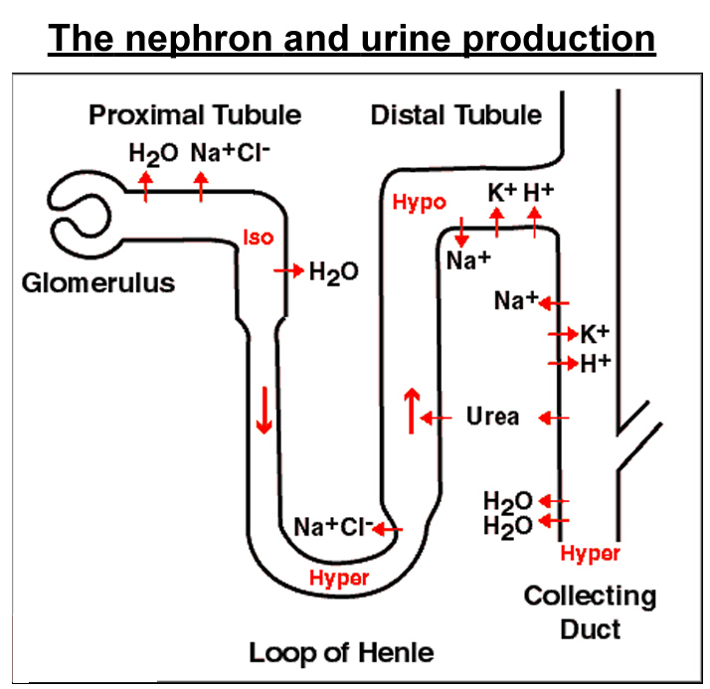

**What happens when the kidneys stop working?**

**(Lecture 8)**

Dr Andrew Frankel

In this session the clinical implications of a reduction in renal function, will be demonstrated using a clinical case presentation to illustrate the salient points.

The clinical effects of failure of kidney function can be predicted on the basis of the physiological functions of the kidneys

Excretion of waste products

Homeostatic function

Electrolyte

Acid-Base

Volume

Endocrine/Metabolic functions

However, the presentation of renal failure is highly dependent on the speed of the process and the extent of the failure.

Distinguishing acute from chronic kidney damage is an important aspect of the management of kidney disease, however, many clinical features are common to both disorders. The demonstration will highlight opportunities for picking up renal disease across a variety of clinical interactions.

The abnormalities of blood tests that may be present in a patient with kidney disease will be reviewed and related to the clinical state of the patient. In particular the relationship of kidney dysfunction to the following abnormalities will be reviewed

1. Symptoms of lethargy and anorexia
2. The effects of kidney dysfunction on the maintenance of extracellular fluid volume
3. The development of metabolic acidosis
4. Hyperkalaemia
5. The production of erythropoietin and its relationship to the anaemia of renal failure
6. The production of activated Vitamin D and the development of abnormalities of bone and parathyroid gland

Finally the demonstration will highlight the methods to assess global kidney function and the pitfalls of relying on creatinine to assess GFR.

**Please note: slides for the following will be made available shortly before the lectures are given**

**Mechanisms of Acid/Base balance - Dr D Ma**

##### Practical 1: Structural organisation of the kidney and urinary tract

**NB The wall of the distal convoluted tubule is also virtually water impermeable**

*The purpose of this practical is to study the structure of the urinary system by direct examination. CCTV will be used at intervals during the practical to guide your work. The worksheet contains frequent prompt questions to help you with observation and to encourage you to use your observations to consolidate your understanding of kidney and urinary tract function. Try to answer questions yourself from what you see in the task set, and know from the preceding lectures. Demonstrators will come round to discuss any questions that you have and to check that you can relate what you are seeing to your knowledge of kidney and urinary tract function.*

**A Histology of the kidney (Slides U1, U2)**

Slide U1 shows an entire rat kidney stained with H&E (haematoxylin and eosin) which gives the classic purple and pink appearance. Slide U2 shows a portion of the cortex of a monkey kidney processed in a different way which allows much thinner sections to be cut and finer detail to be seen. The stain used gives a rather different coloration from H&E but all the same structures can be found.

To interpret the structures seen, bear in mind the diagrammatic outline of a **nephron** below. Remember that you will have to interpret the shapes you see in terms of how a tubule winds around in and out of the plane of the section.



## You should be able to find examples of all the structures labelled in this diagram*First examine slide U1 with the naked eye to distinguish cortex (external and darker staining) and medulla. Identify the position of the renal pelvis. At low power (×4) observe that the whole tissue of the kidney consists largely of tubules. In the cortex these mostly have relatively thick walls and take up more stain, and there are also the circular cross sections of renal corpuscles, containing the easily recognised glomeruli.*

**Now look at the cortex in slide U2**. The **renal corpuscle** consists of **Bowman’s capsule** (the blind proximal end of the nephron) into which projects a **glomerulus** of capillaries. Each has a **vascular pole** where the blood vessels enter and leave the glomerulus, and a **urinary pole** where the filtrate drains into the proximal convoluted tubule. Since the corpuscles are oriented randomly you will have to search around the slides to find examples of glomeruli where you can see one or other pole.

Find an example with a vascular pole. ***What are the blood vessels supplying and draining blood from the glomerulus?***

Within the glomerulus, look for individual capillaries. ***Name the type of cells that line capillaries.***

Another important cell type in the glomerulus is the **podocyte**. Podocytes develop from the visceral layer of Bowman’s capsule that enwraps the glomerular capillaries. In slide U2 you should be able to see the tiny foot processes of podocytes as rows of dots on the outside of each capillary (this depends on you setting up the microscope properly and finding a place where the orientation of the processes allows them to be visualised). ***Name the components through which the blood in the glomerulus is filtered.***

The space into which the filtrate is initially collected is called **Bowman’s space**, surrounded by the outer (parietal) layer of **Bowman’s capsule**. ***How would you classify this lining epithelium?***

Bowman’s space drains into the **proximal convoluted tubule** at the **urinary pole** of the renal corpuscle. Find a corpuscle where the section includes the urinary pole. This will enable you to identify positively a proximal convoluted tubule and distinguish it from **distal convoluted tubules** which you will also find nearby.

Which, of the proximal and distal convoluted tubules, appears more abundant? Explain the difference in terms of nephron function.

The epithelium lining the proximal tubules appear striated, and with the better resolution of slide U2 it is possible to recognise that this is due to an abundance of organelles within the cells. Those organelles are mainly mitochondria. ***Why are they abundant in these locations?***

In the cortex, and passing down into the medulla, you will also find **collecting ducts** which are readily distinguished by their paler stain and obvious cell-cell boundaries. ***Which pituitary hormone do the collecting duct cells respond to when controlling the degree of concentration of the urine produced?***

Turn your attention to the medulla (slide U1). It appears to consist of a mass of tubular structures of different sizes and thicknesses, with the majority oriented radially. ***List the types of tube you would expect to find, and try to identify examples of each:***

Finally, examine slide U1 to identify components of the vascular system supplying blood to the kidney.

**B Histology of the urinary tract (slides U3, U4)**

Slide U3 shows a section through a ureter and slide U4 through part of a urinary bladder, both of guinea pig.

A major feature of both these tissues is the presence of a urinary epithelium termed **urothelium** (its old name was transitional epithelium**)**. Examine both slides to see the nature of this epithelium, with its specialised lumenal cells which often have a dome-shaped surface. ***What are the special properties of the urothelium?***

***Can you see any evidence of the cellular features responsible for these properties?***

Both the ureter and bladder have smooth muscle walls, and you will also find layers of connective tissue containing blood vessels. In the case of the ureter the muscle fibres are said to be aligned both longitudinally and circularly in order to carry out peristalsis. In the case of the bladder the smooth muscle wall, also known as **detrusor**, is usually described as consisting of three obliquely oriented layers. ***From your own examination of the slides, do you agree with these descriptions?***

**Practical 2: GFR and Renal Clearance Practical**

You will find a calculator very useful for this class.

*This class consists of some questions (below) relating to the material displayed on the boards in the laboratory. Students are expected to complete these questions during the allotted time. There will be demonstrators on hand to help you and (we hope) clear up any points about which you are confused. Below is a potted version (without diagrams) of the material on the posters. In my view this includes everything you need*.

**NB In your answers, make sure that the units are, where appropriate, included (correctly !)**

# *Why measure Glomerular Filtration Rate (GFR) ?*

*Measurement of GFR is the most important single means of assessing renal function. Most renal diseases result in a progressive destruction of functioning nephrons. Since total GFR is equal to the sum of the filtration rates of each of the functioning nephrons, a reduction in their number will result in a fall in total GFR. Thus GFR can be used to document the presence, estimate the severity, and follow the course of kidney disease.*

*In addition, measurement of GFR is useful in determining the correct dosage of certain drugs. Many drugs, notably digoxin (used in the treatment of heart conditions) and certain antibiotics, are excreted from the body primarily by glomerular filtration in the kidneys. Therefore, if GFR is reduced, the excretion of the drug will fall and it will accumulate in the body, possibly to toxic levels. To prevent this, the dosage must be reduced appropriately.*

# *Normal values for GFR*

*The figure usually given as the normal value for GFR in young adults is:*

***120 ml.min-1 per 1.73 m2***

*[1.73 m2 is a fairly typical value for the body surface area of an adult]*

*The normal range, however, is quite wide: 90-150 ml.min-1 per 1.73 m2.*

*After the age of 40, GFR falls by about 10 ml.min-1 per decade.*

**Question 1** Explain what is meant by the following:

(i) glomerular filtration rate

(ii) “freely filtered”

# *How can we measure GFR?*

*Obviously, direct measurement is impossible. However, an indirect determination can be made using a marker substance with certain properties.*

*Consider a substance Y, present in the plasma, small enough to be freely filtered into Bowman’s capsules, but neither reabsorbed from nor secreted into the tubules. Consequently, the amount of Y excreted per unit time will be the same as the amount filtered per unit time. If so, then, since the subtance is freely filtered (and hence its concentration in the glomerular filtrate is the same as in plasma) it follows that:*

*GFR x Plasma conc of Y (PY) = urine flow rate (V) x Urine conc of Y (UY)*

*and therefore GFR =V x UY / PY*

*Very few substances fit the criteria set out for substance Y. One that does is inulin (not to be confused with insulin), a polysaccharide with a molecular weight of approximately 5000 Daltons.*

**Question 2** In a normally-built young subject whose renal function was being assessed, the following values were obtained

Plasma inulin concentration = 0. 12 mmol/l

Urine inulin concentration = 12 mmol/l

Urine flow rate = 1.2 ml/min

(a) What was the GFR?

(b) Is this a normal value?

***The important characteristics of inulin that enable us to use it as a marker of GFR are that it is:***

***1. freely filtered at the glomerulus***

***2. not reabsorbed***

***3. not secreted***

**Question 3** Suggest two other properties (not necessarily related to its renal handling) that would be essential for any substance we wished to use - in man - as a marker of GFR.

# *Clearance*

*The expression we have just used for calculating GFR is known as the* ***RENAL CLEARANCE*** *of inulin (Cinulin). Renal clearance is a general concept and can be applied to any substance, not just to inulin.*

***DEFINITION****: The renal clearance of a substance is equal to the volume of plasma which would be required to supply that amount of the substance excreted by the kidneys per unit time.* ***An important point to remember is that clearance will always be expressed as a volume of plasma per unit time.***

*For any substance Z, the renal clearance, CZ, is calculated as*

***CZ = V x UZ /PZ***

*where P****Z*** *and U****Z*** *are the concentrations of Z in plasma and urine, respectively and V is the urine flow rate.*

NB: Only if the substance is freely filtered and neither reabsorbed nor secreted will its clearance equal GFR. If we apply the clearance expression to other substances a different answer will be obtained for each, depending on how that substance is handled by the kidneys.

**Question 4** The following values were also obtained in the subject referred to in question 2 above:

Plasma Na concentration = 140 mmol/l

Urine Na concentration = l00mmol/I

What was the sodium clearance?

**Question 5** (a) You should have found that the sodium clearance in this person was very very much lower than the inulin clearance (less than 1%). Given that sodium is freely filtered at the glomerulus what can you conclude from that?

(b) If the renal clearance of a substance is higher than that of inulin what can you conclude?

**Question 5** (c) If the renal clearance of yet another substance (X) is lower than that of inulin, does this rule out the possibility that X is secreted into the tubular fluid in some segment(s) of the nephron ?

# *Measurement of renal plasma flow rate*

*One substance, called para-amino hippuric acid (PAH), is secreted avidly into the proximal tubules. Provided the plasma concentration isn’t too high, the combination of filtration and secretion ensures that* ***practically all the PAH arriving at the kidneys in the plasma appears in the urine****, and virtually none leaves in the renal vein. (NB: PAH does not occur naturally in the body; it has to be infused.)*

*Because of the unusual way in which PAH is handled by the kidneys, PAH clearance can be used to give an estimate of the volume of plasma perfusing the kidneys per unit time (renal plasma flow rate).*

**Question 6** Using the terms renal plasma flow rate (RPF), the concentrations of PAH in plasma and urine (PPAH and UPAH) and urine flow rate (V), and assuming (correctly) that PAH in the blood is only found in the plasma (not in the cells), complete the following equations:

(a) the rate at which PAH enters the kidneys per minute in the renal arteries =

(b) the rate of excretion of PAH in the urine =

**Question 7** Hence explain why the clearance of PAH can give an estimate of the rate of renal plasma flow:

**Question 8** If, in a given individual the PAH clearance = 625 ml/min and the inulin clearance = 125ml/min, what proportion of the plasma entering the glomeruli is filtered?

**Question 9** If, in the same person, the arterial plasma inulin concentration were 1mmol/l, what would be the plasma inulin concentration in:

(a) the efferent arteriole

(b) the renal vein?

**Question 10** Measurement ofPAH clearance is rarely performed clinically when renal disease is suspected. Can you think why?

(The answer 'No' is not considered sufficient)

1. ***Practical Determination of GFR***

*There are 3 main methods of estimating GFR in current use - listed below*

***(a) Inulin Clearance.***

*Inulin does not occur naturally in the body, so, in order to measure its renal clearance, it has to be infused intravenously*

**Question 11** Why isn't inulin given orally?

*The requirement for intravenous infusion causes several problems, which mean that measurement of inulin clearance is rarely used clinically. In particular, it is time consuming and tedious, requires several blood samples, and, because of the short duration over which measurements are usually made, bladder catheterisation (since voluntary bladder emptying may be incomplete).*

***(b) Creatinine clearance (Ccreatinine)***

*Creatinine has a major advantage over inulin in that it is an endogenous substance, produced from the metabolism of muscle creatine. Moreover, it is released into the blood at a relatively constant rate, so the plasma concentration of creatinine remains fairly stable in a given individual. For measurement of Ccreatinine all that we require, therefore, are:*

# *a 24-h urine collection;*

# *a single plasma sample taken at some time during the clearance period.*

**Question 12** Bladder catheterisation is not usually considered necessary when creatinine clearance is measured (as above) although it is required for measurement of inulin clearance. Why the difference ?

*Creatinine shares most of the properties of inulin. It is freely filtered and neither reabsorbed nor metabolized by the kidneys. However, since a small amount of creatinine enters the urine by secretion into the proximal tubule, the amount excreted slightly exceeds the amount filtered. In addition, the method used to measure creatinine concentrations is not sufficiently specific: in addition to creatinine it measures the concentrations of so-called “non-creatinine chromogens” present in plasma but not usually in urine. However, these two errors tend to cancel out and because of its simplicity Ccreatinine is widely used as an estimate of GFR*

**Question 13** (a) In a 30 year old woman of normal build being investigated for the possibility of renal disease, the following data were obtained.

24 hour urine volume = 2 litres

Urine creatinine concentration = 8 mmol/l

Plasma creatinine concentration = 0.4 mmol/l

Is her GFR normal ? (NB It is acceptable to express GFR in terms of litres/day; 120 ml/min is equivalent to approximately 180 litres/day)

On the basis of this answer, what do you think the normal plasma creatinine concentration would be (approximately)? [Clue: The rate of creatinine production is pretty stable and in a steady state matched by the rate of creatinine excretion. What would happen to creatinine excretion if the GFR was suddenly and permanently reduced. What effect will this have on the plasma concentration ?]

***(c) 51 CrEDTA clearance***

*From the foregoing we can say that in the measurement of GFR, Cinulin is accurate but inconvenient, whilst Ccreatinine is convenient but not so accurate. Because of these problems, many clinical laboratories now use substances with the same properties as inulin, but which can be measured more easily, by virtue of the fact that they emit radiation. This allows them to be readily and accurately quantified in plasma. The clearance of such substances can be determined by monitoring their disappearance from the plasma after administering a given dose, thus eliminating the need to collect urine.*

*The substance usually used is EDTA, which can be conveniently labelled with 51CrEDTA, a  emitter. 51CrEDTA clearance can be determined by administering the substance as a single injection, and then measuring the plasma activity of 51Cr at subsequent intervals. On the left below is an example of a typical curve found using this method. The second part of the curve is exponential, so that if the plasma activity is plotted on a log scale is plotted on a log scale a straight line is obtained, as shown on the right below.*

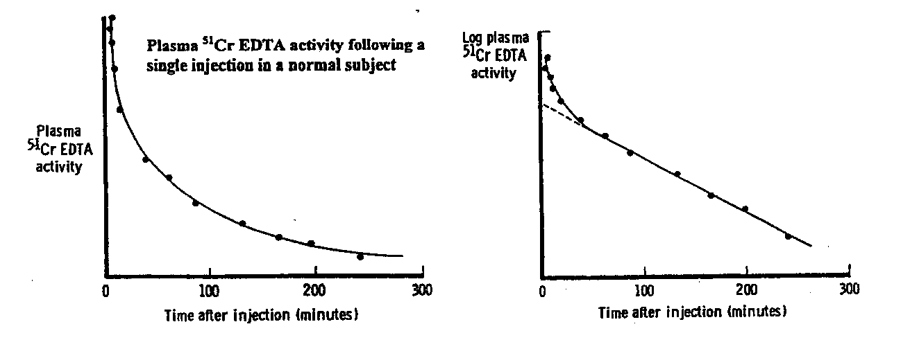

*The clearance of 51Cr EDTA can be calculated from the slope of the straight line (The greater the slope the greater the clearance)*

*The advantage of this method is that in practice it requires only*

*(i) injection of a single dose of 51Cr EDTA*

*(ii) collection of 2-3 plasma samples taken at appropriate times after the injection (i.e. on the straight line portion of the curve; far fewer samples are necessary than are shown, for the purpose of illustration on the graphs above)*

**Question 14** Given the fact that 51Cr EDTA is free to permeate the whole of the extracellular fluid, how do you explain the initial steep phase of the plasma disappearance curve (log plasma 51Cr EDTA vs. time) following a single IV injection of 51Cr EDTA.

**Question 15** Draw on the above axes the type of plasma disappearance curve (log plasma 51Cr EDTA vs. time) you would expect in someone suffering from severe renal failure?

##### CAL Worksheet:

##### 

##### The cortico-medullary osmotic gradient

If you undertake this program at the scheduled time, Dr Kemp will be available in the first floor MDL to try to answers any questions you may have. The program can be found with the self tests in blackboard.

<https://vle.imperial.ac.uk/webct/logonDisplay.dowebct>

1. Contrast the thick ascending limb of the loop of Henle with the descending limb with respect to:

(a) water permeability

(b) active transcellular solute transport

2. The osmotic gradient between the cortex and the renal papillae is most marked in the **INNER** medulla. Why is this particularly difficult to explain ?

3. What are the main constituents of the interstitial fluid deep in the inner medulla ?

4. Contrast the osmolarity of the tubular fluid (a) entering the loop of Henle from the proximal tubule and (b) leaving the loop of Henle and entering the distal tubule. Are these osmolarities greatly dependent on the body’s water balance ?

5. What is special about the layout of the blood vessels providing the blood supply to the medulla that helps to maintain the cortico-medullary gradient ? [Keep it simple !]

**Directed study worksheet:**

**Transport maxima and the renal handling of glucose**

The questions below are designed to keep you “happy” (or at least occupied) during your study period in the US course. You probably won’t get enough information from the lectures to enable you to answer all of them - unless this sort of thing comes naturally to you. I anticipate that you will need to consult a text book (and use your brain). [You should at least try to do questions 2&6 from first principles - rather than just looking them up.] If you are stuck, you will find me (during your study period) in the first floor MDL - feel free to come and ask me questions there. Alternatively, if you have problems or doubts, e-mail me (p.kemp@ic.ac.uk).

1. ***Briefly explain, in the context of renal function, what is meant by a “Transport maximum” [and (even more briefly) why it occurs]***



1. Suppose in a given individual the Tm for glucose reabsorption is 2 mmol/min and the glomerular filtration rate is 100 ml/min (0.1 litres/min). Show on the axes above the way in which (a) the rate of filtration of glucose (b) the rate of renal glucose reabsorption and (c) the rate of glucose excretion in the urine are related (in this individual) to the plasma glucose concentration. *[Helpful hints: For (a) remember glucose is freely filtered (do you know what that means ?); how much do you think will be filtered if the GFR is 0.1 litres per minute and the plasma glucose concentration is 10 mmol/l ?; for (b) how much of the filtered glucose will be reabsorbed if the amount filtered is less than/more than the Tm?; (c) what happens to the glucose that is filtered but not reabsorbed ?]*

3 The chances are, unless you are particularly perceptive (or have copied straight out of a text book), that in your graph the plasma concentration at which glucose begins to be excreted in the urine (the threshold) is shown as identical to the plasma concentration at which the maximum rate of glucose reabsorption is first reached. In fact, the former is normally substantially lower than the latter - a phenomenon known as “splay”. Can you work out why this is the case*. [Clue: very little in Biology is absolutely uniform.]*

4 Mark on your graph a vertical line through the normal plasma glucose concentration. Why, in a normal individual, does little or no glucose appear in the urine ??

5 One common disorder, in which the primary abnormality is nothing to do with renal function, can lead to significant amounts of glucose appearing in the urine. Name it and explain the cause of the glycosuria. [In fact, renal failure is a potential cause of death in this disease - but that is another story.]

6 ***[NB Knowing about this condition is not “core”.]*** In renal glycosuria, as its name suggests, significant amounts of glucose are present in the urine as a result of a renal defect. How do you think the graphs you have drawn in answer to question 2 will differ from normal in someone with this disorder?

**Multiple Choice questions**

1. Which of the following statements are inconsistent with the presence of hyperkalaemia

1. Potassium levels can be reduced by the administration of IV Bicarbonate
2. There is a significant risk of asystole
3. Broadening of the QRS complex may be present
4. Acute rise in serum potassium is more dangerous than a chronic rise
5. Hyperkalaemia associated with renal failure is usually caused by a reduction in proximal tubule potassium excretion.

2. Which of the following clinical features is most helpful in distinguishing chronic from an acute cause of kidney dysfunction

1. The presence of an Hb of 10g/l
2. An elevated serum potassium
3. Small shrunken kidneys on ultrasound examination
4. Elevated serum phosphate
5. Bicarbonate levels <18mmol/L

3.The sodium/potassium ATPase in the basolateral membrane of the cells of the proximal convoluted tubule

a) pumps potassium into the capillary to promotes potassium reabsorption

b) is increased in the absence of aldosterone

c) reduces the intracellular sodium concentration to facilitate active transport from the tubular lumen

d) is electro-neutral

e) pumps sodium and potassium into the cell to facilitate sodium exchange for tubular components

4. water excretion

a) is dependent on the localization of aquaporin molecules in the collecting duct

b) is increased by the action of vasopressin on the collecting duct

c) is dependent on the amount of water reabsorbed in the loop of Henle

d) is independent of the medullary urea concentration

e) is increased by the action of vasopressin on the proximal convoluted tubule

5. sodium and extracellular fluid volume control

a) increased sodium intake results in increased water secretion

b) increased ANP produced in the heart increases sodium excretion

c) sodium excretion is independent of plasma osmolarity

d) volume expansion increases renin activity through increased syumpathetic nerve activity

e) volume contraction reduces ADH expression in the brain

6. Glomerular filtration rate:

1. Is not affected by blood loss
2. Can be estimated in humans by measuring sodium clearance
3. Is the amount of fluid filtered by a kidney nephron
4. Is the sum of filtration from all functioning nephrons
5. Is independent of the myogenic mechanism

**Short Answer Question**

Bowman’s Loop of Henle Urine

Space Descending Ascending Distal Collecting

Limb Limb Convoluted Ducts

tubule

100

50

0

(a) Draw a graph to show the percentage of the filtered sodium that typically under normal conditions in a healthy individual remains in the tubular fluid as it passes alone the nephron. Label this graph **Na**

**N.B.** THIS AND ALL LATER GRAPHS SHOULD START AT THE LARGE ARROW AT THE START OF THE NEPHRON INDICATING 100%

1. Draw a second graph to show the percentage of the filtered glucose that typically under normal conditions in a healthy individual remains in the tubular fluid as it passes alone the nephron. Label this graph **Gluc**
2. Draw a third graph to show the percentage of the filtered inulin (infused iv) that remains in the tubular fluid as it passes alone the nephron. Label this graph **In**
3. Draw a fourth graph to show the percentage of the filtered water that in a healthy individual remains in the tubular fluid as it passes alone the nephron during the production of a maximally concentrated urine. Label this graph **Conc**
4. Draw a final graph to show the percentage of the filtered water that in a healthy individual remains in the tubular fluid as it passes alone the nephron during the production of a maximally dilute urine. Label this graph **Dil**

MCQ answers

* + - 1. e
      2. c
      3. c
      4. a
      5. b
      6. d