Practical – 2MDL

There are three parts to this practical, each reinforcing topics covered in the lecture. Get into groups of 4/5 to study the laminated sheets on the tables, and answer the questions in this worksheet.

Part 1 – peripheral nerve lesions

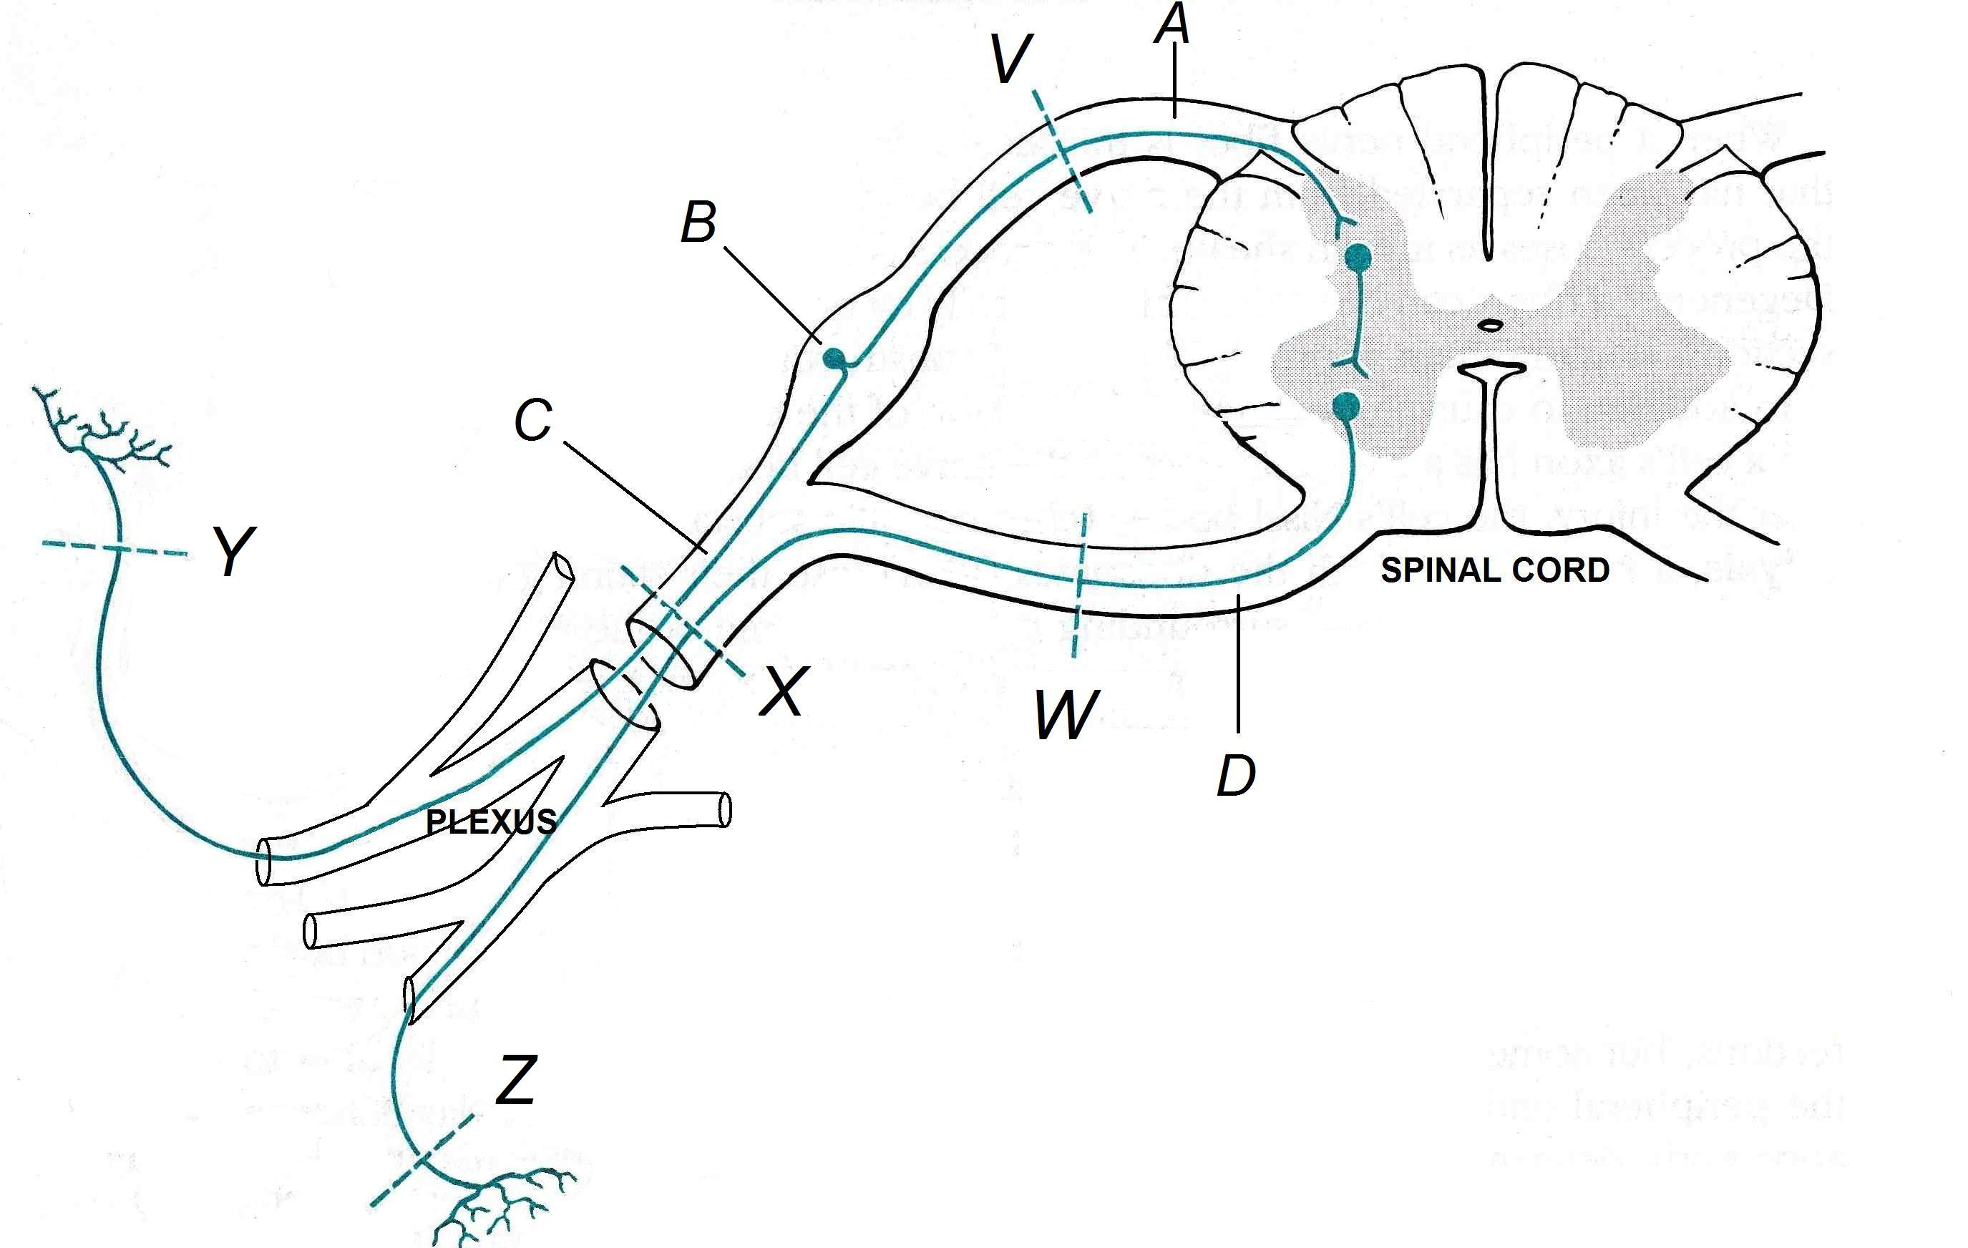

A. Name the structures A, B, C and D:

A | Dorsal root
B | Dorsal root ganglion
C | Spinal nerve
D | Ventral root
B. V, W, X, Y, Z are possible sites of lesions (injury or disease). In each case explain what kind of deficit(s) the lesion would produce and how it would be distributed in the body:

V –Damage to dorsal root leads to loss of sensation in dermatome supplied by the corresponding spinal nerve. (Probably not detectable if only one root affected as there is considerable overlap of dermatome innervation by adjacent spinal nerves)

W –Damage to ventral root leads to weakness of muscles supplied by the corresponding spinal nerve. (Most limb muscles are innervated by 2 or more spinal nerves therefore paralysis is unlikely unless all spinal roots are damaged)

X – Damage to spinal nerve leads to combined effects of V and W above

Y –Damage to a sensory nerve (eg. in the skin) leads to loss of sensation in the area of distribution of that peripheral nerve

Z –Damage to a muscle nerve leads to weakness/paralysis of muscle supplied by that peripheral nerve

In this diagram lesions Y and Z are shown affecting nerve branches close to their targets and would therefore have a purely sensory or motor effect. More proximal lesions to peripheral nerves would probably affect both motor and sensory function.

Contrasting the effects of V/W v Y/Z demonstrates the effect of the plexus which redistributes the axons from spinal nerves into the peripheral nerves.

Suggest common medical scenarios which might result in a lesion occurring at each point.
Spinal root and spinal nerve damage is most often a consequence of strain injuries to the spine, eg. prolapsed disc.

Peripheral nerves may be affected by trauma or disease (peripheral neuropathy)

The brachial plexus may be affected by trauma to the shoulder joint. The lumbosacral plexus is much better protected and therefore unlikely to be injured.

Part 2 – Myelinated fibres

A. Examine photomicrograph A of normal nerve fibres and name the labelled structures:

Y | Node of Ranvier
Z | Schwann cell containing myelin wrapped around the axon

What is the function of structure Y?
Gap between Schwann cells which allows saltatory conduction (has high concentration of sodium channels)

Give 2 ways in which the process of myelination differs between peripheral and central axons.

B. Examine photomicrograph B of a pathological nerve.

What do you think has happened to this nerve?

This nerve was crushed 3 days earlier. It shows degenerating myelin that is paler staining and ‘ovoid’ in shape.

An alternative explanation would be demyelinating neuropathy but this is less likely as you would expect a less uniform appearance at such an early stage.

Part 3 – Degeneration and regeneration
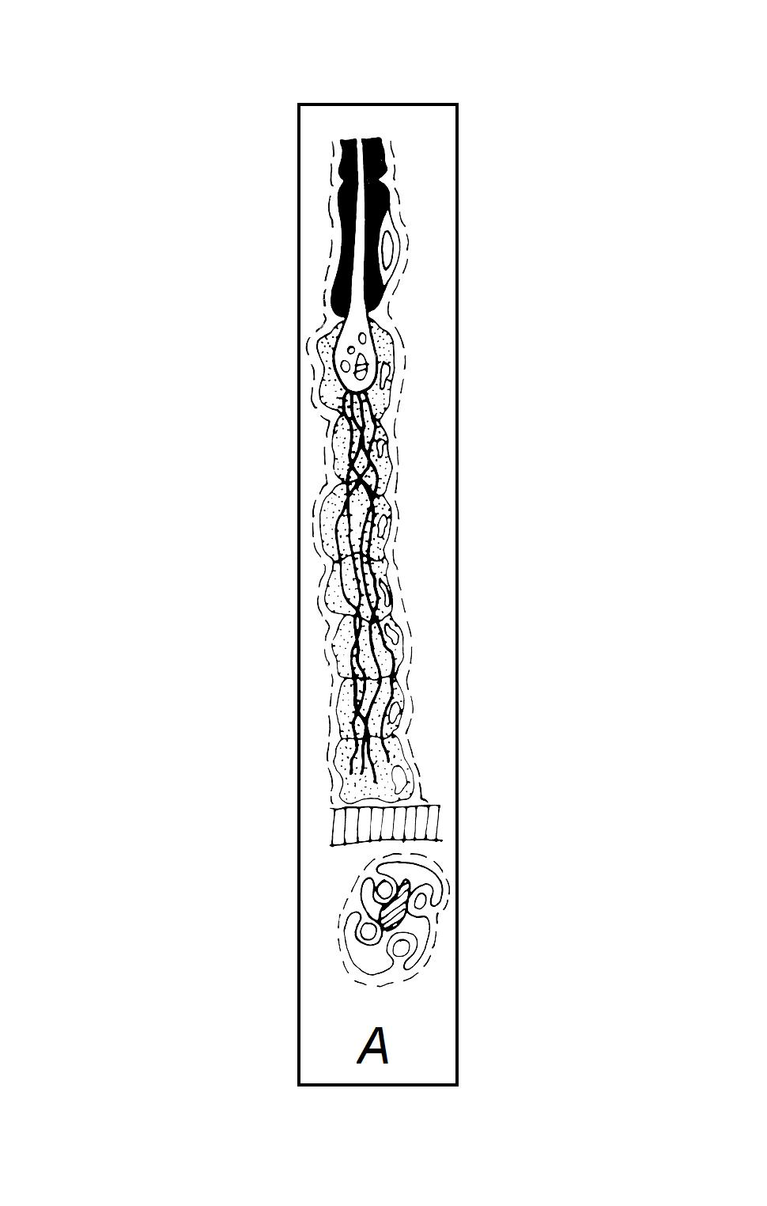
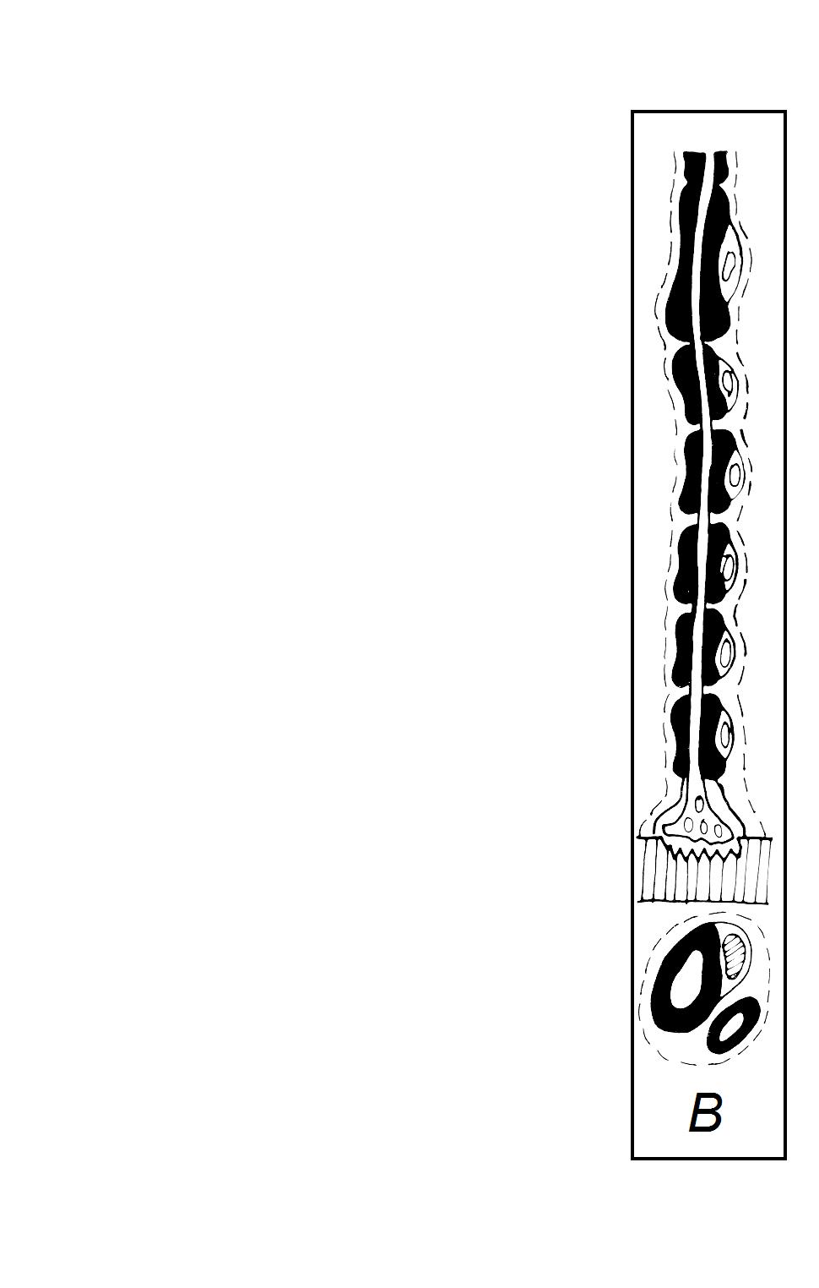
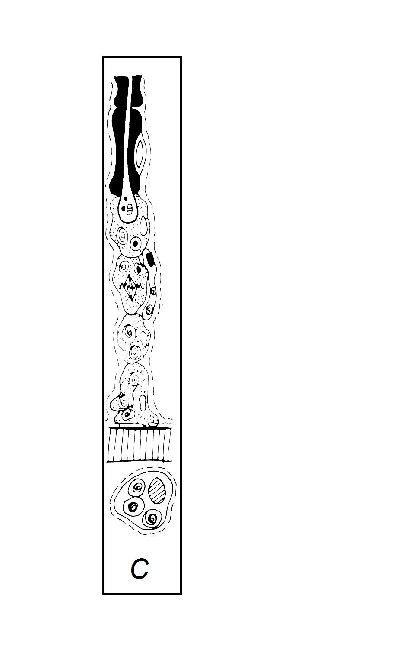
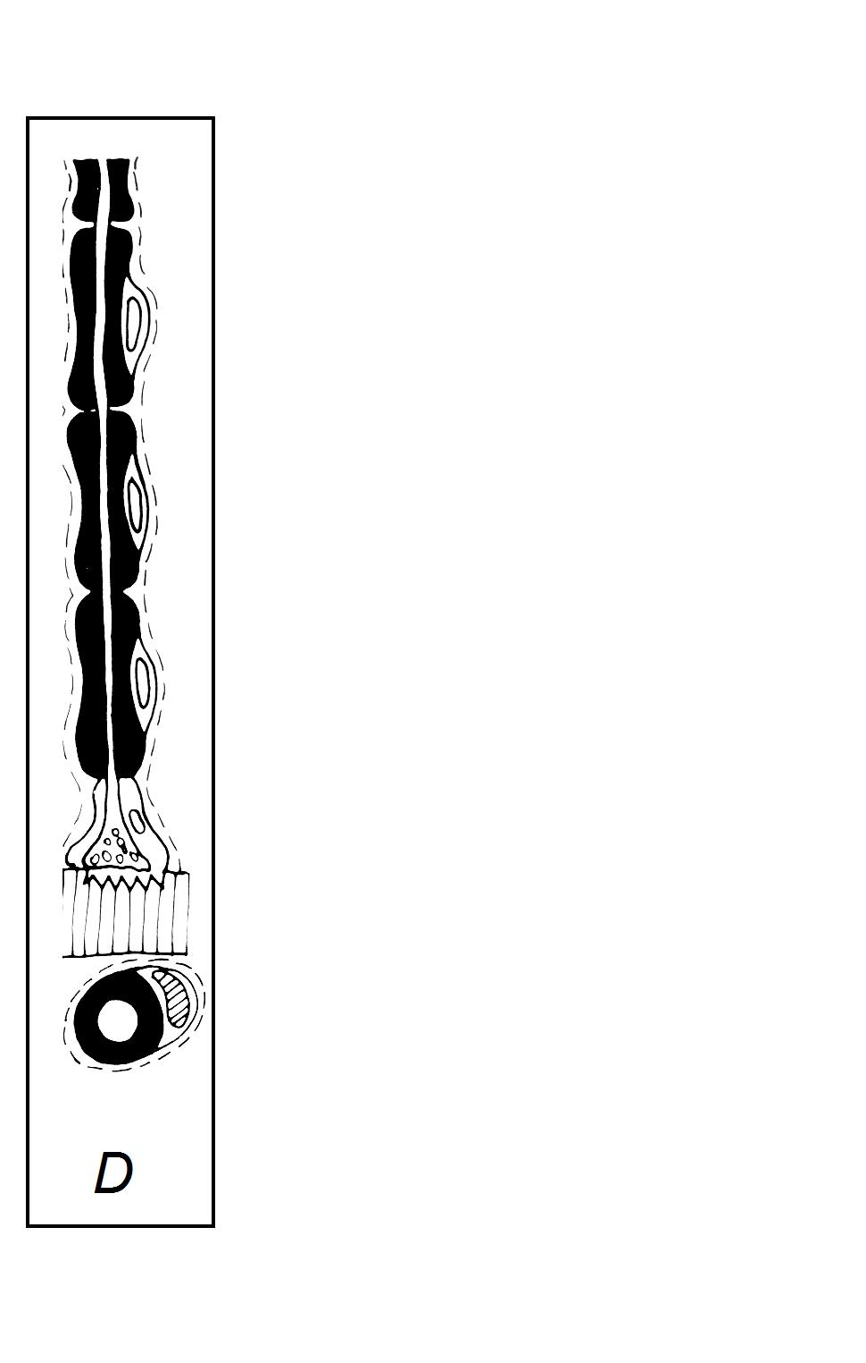
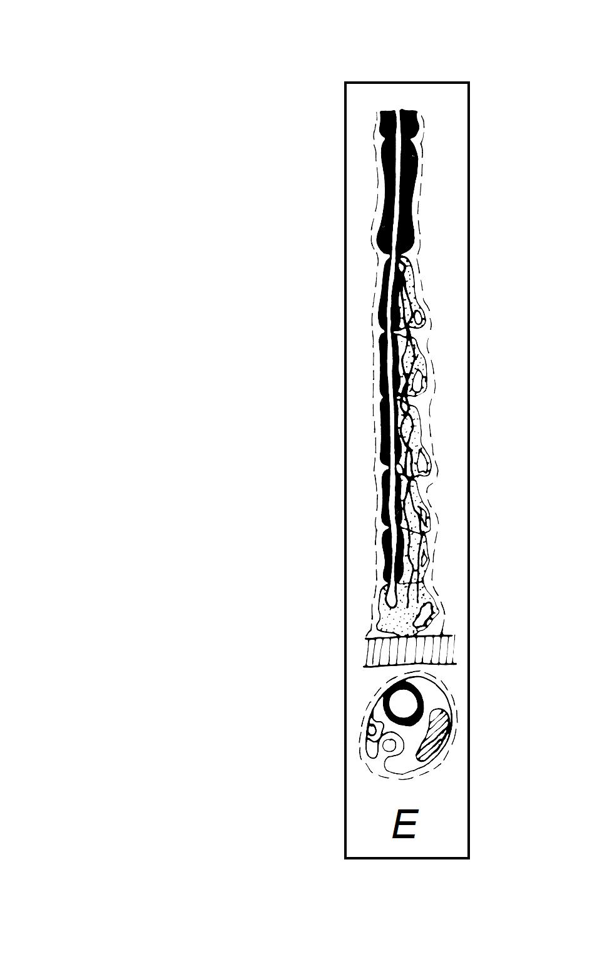

The 5 diagrams represent the main stages of degeneration and regeneration that follow axonal damage – but they are NOT in the correct order.

List them in the correct order, from normal axon to regenerated axon, and briefly describe the main events of each stage.

1 | D | Normal myelinated axon.
2 | C | After nerve section the distal part of the axon degenerates and Schwann cells proliferate.
3 | A | Sprouts grow out from the proximal stump of the axon, guided by Schwann cells
4 | E | One sprout becomes myelinated; the others regress.
5 | B | The regenerated axon, usually with slightly shorter internodes.

When would you expect the best recovery of function: after nerve crush or nerve section?

Better recovery would be expected after nerve crush because the nerve sheath (endoneurium) remains intact and helps to guide regeneration.

