Practical Worksheet – 1MDL

In this practical you will be working in groups of 4-5. Each group will have a skull, plastic model brain and examples of normal brain images. Work through the questions and ask a demonstrator to check your answers.

- THE SKULL
Compare the base of the skull with the diagram in the lecture handout and identify the labelled structures.
Compare the inferior surface of the model brain with the skull and answer the following questions.

Which part of the brain:
lies in the anterior cranial fossa | Frontal lobe of cerebral hemisphere
lies in the middle cranial fossa | Temporal lobe of cerebral hemisphere
lies in the posterior cranial fossa | Cerebellum
lies directly above the body of the sphenoid bone | Hypothalamus
passes through the foramen magnum | Medulla

- THE BRAIN
Carefully take apart the model brain. As you do so make sure that you can identify the following structures:
Cerebral hemisphere Thalamus
Corpus callosum Hypothalamus
Frontal lobe Optic chiasm
Parietal lobe Infundibulum (stalk of pituitary)
Occipital lobe Cerebellum
Temporal lobe Brainstem
Basal ganglia

- THE VENTRICULAR SYSTEM
Name the components of the ventricular system (the transparent structure at the centre of the model). Rebuild the model brain around this and as you do so answer the following questions:

Which part of the ventricular system relates to:
the cerebral hemisphere | Lateral ventricle
the diencephalon | Third ventricle
the midbrain | Aqueduct
the pons and medulla | Fourth ventricle

There should be time for every student to attempt to reassemble the model brain.

PLEASE LEAVE THE MODEL ASSEMBLED AT THE END OF THE PRACTICAL.

- THE BRAIN IN DIFFERENT PLANES
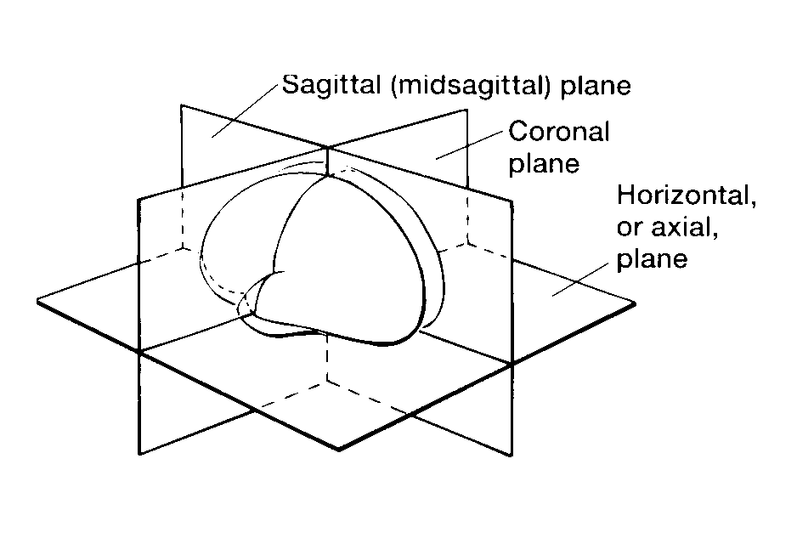
There are 3 pairs of brain slice/MRI photographs, each in a different plane of section. Miniaturised versions of these photographs have been included in this worksheet. Use the model brain and the diagrams in the lecture handout to identify the numbered structures in the table overleaf. [Structures are labelled consistently across all planes in which they appear.]
anterior
posterior
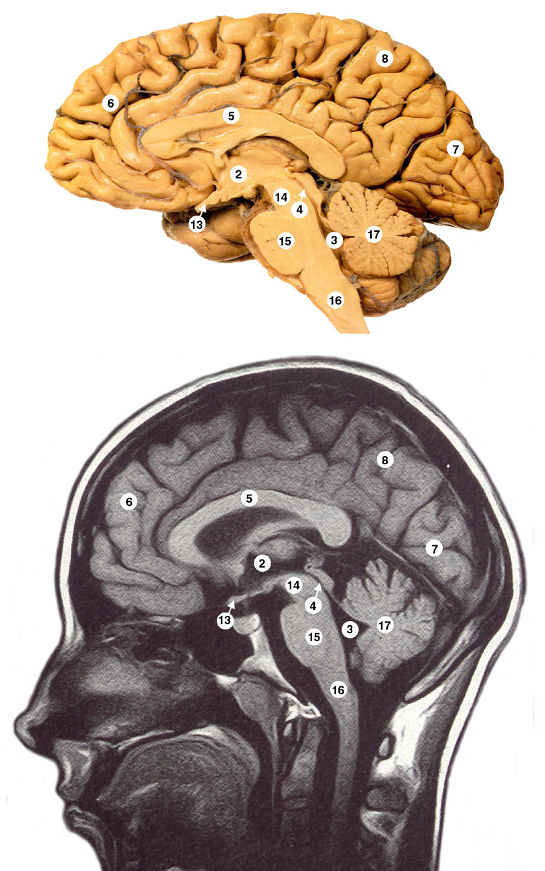
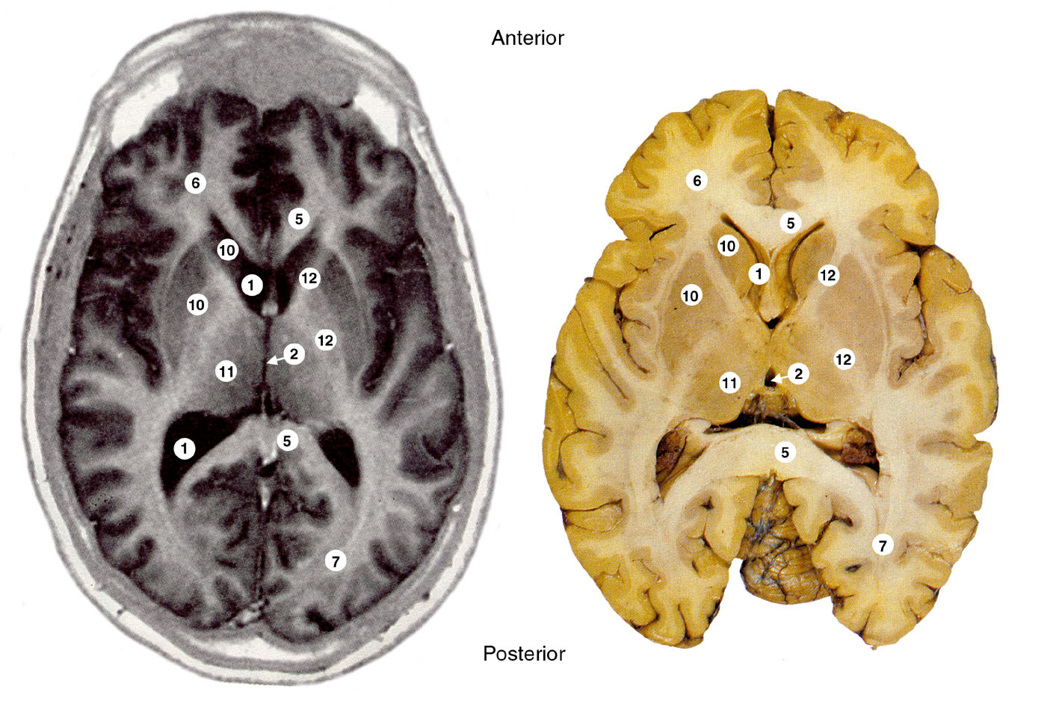
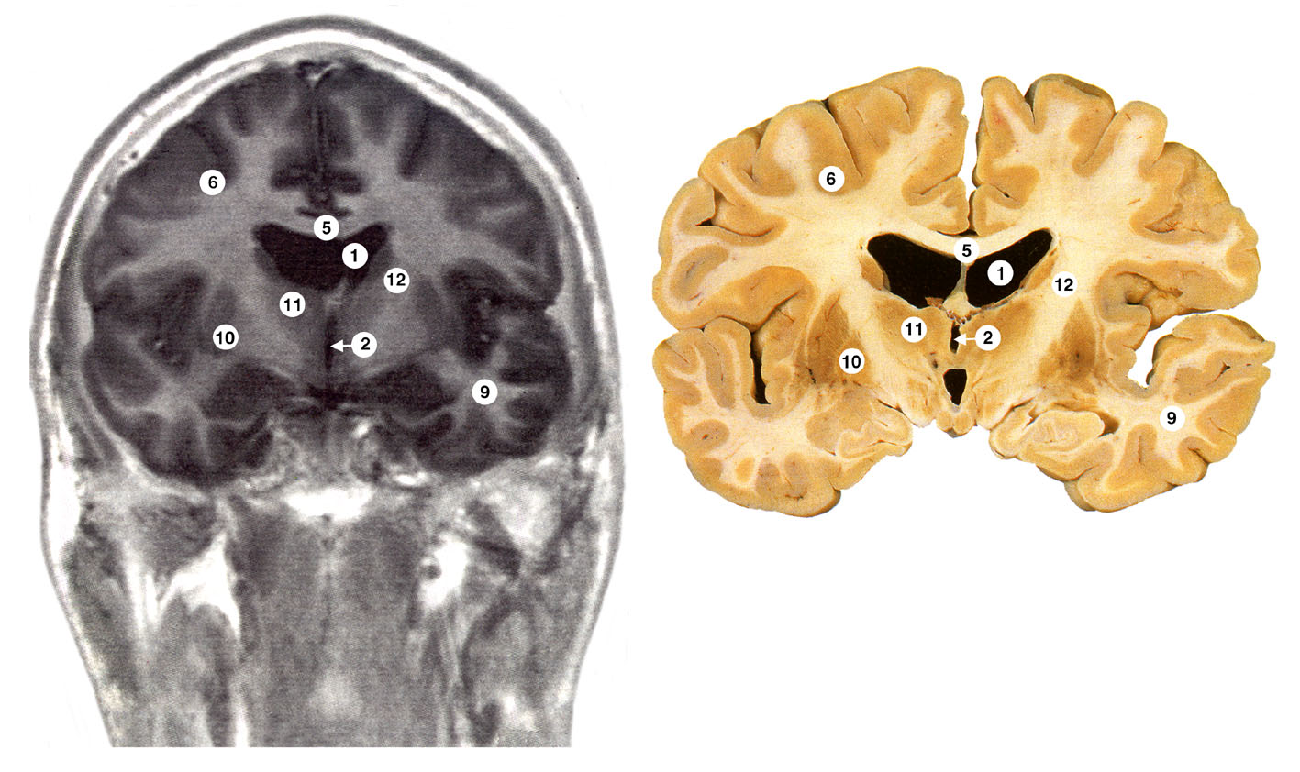
1 | Lateral ventricle [may be cut through twice in horizontal or coronal plane]
2 | Third ventricle [may look like a hole or a slit in coronal and horizontal plane, depending on angle of section]
3 | Fourth ventricle
4 | Aqueduct
5 | Corpus callosum [may be cut through twice in horizontal plane]
6 | Frontal lobe
7 | Occipital lobe
8 | Parietal lobe
9 | Temporal lobe
10 | Basal ganglia [may be more than one part]
11 | Thalamus
12 | Internal capsule [both anterior and posterior limbs seen in horizontal plane]
13 | Optic chiasma
14 | Midbrain
15 | Pons
16 | Medulla
17 | Cerebellum

Practical worksheet – 2MDL
There are three parts to this practical, each reinforcing topics covered in the lecture. Get into groups of 4/5 to study the laminated sheets on the tables and answer the questions in this worksheet. There is additional material displayed around the room.

PART 1 – Spinal cord
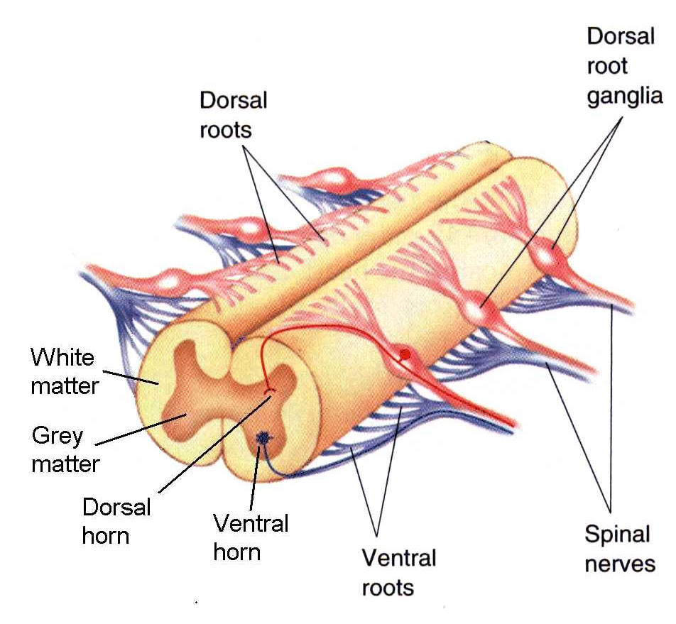
A. What is the function of the ventral and dorsal horns?
Ventral horn: Contains motoneurone cell bodies

Dorsal horn: Contains interneurones which receive sensory information from the body

Flow of information: towards sp cord in dorsal root (afferent); away from sp cord in ventral root (efferent); both ways in spinal nerve.

Mark on the diagram the direction of flow of information in the dorsal root, ventral root and spinal nerve

- Look at the diagram showing the relationship of spinal cord to vertebral column.
How many vertebrae are there?
How many pairs of spinal nerves are there?
Does each spinal nerve exit above or below the corresponding vertebra?
Put your answers in the table below
 | Number of vertebrae | Number of spinal nerves | Relationship of nerve to vertebra
Cervical | 7 | 8 | All above corresponding vertebra except for C8
Thoracic | 12 | 12 | All below corresponding vertebra
Lumbar | 5 | 5 | All below corresponding vertebra
Sacral | 5 | 5 | All below corresponding vertebra
Coccyx | 1 fused (or up to 4 unfused) | 1 | below (or between if unfused)
Total | 30 | 31

C. Look at one of the plastic models of the vertebral column placed at each end of the room.
Note how the vertebral bodies bear weight anteriorly, while posteriorly the vertebral arches protect the spinal cord in the vertebral canal. Gaps between the arches laterally (intervertebral foramina) allow the spinal nerves to exit. (Note that there are 2 pairs of spinal nerves missing on these models)
Below the spinal cord. Usually between L3 and L4 or L4 and L5

When performing a lumbar puncture, between which vertebrae would you insert the needle in order to obtain a sample of CSF safely?
PART 2 – CSF Circulation

- Label the diagram below and draw arrows to indicate the flow of CSF

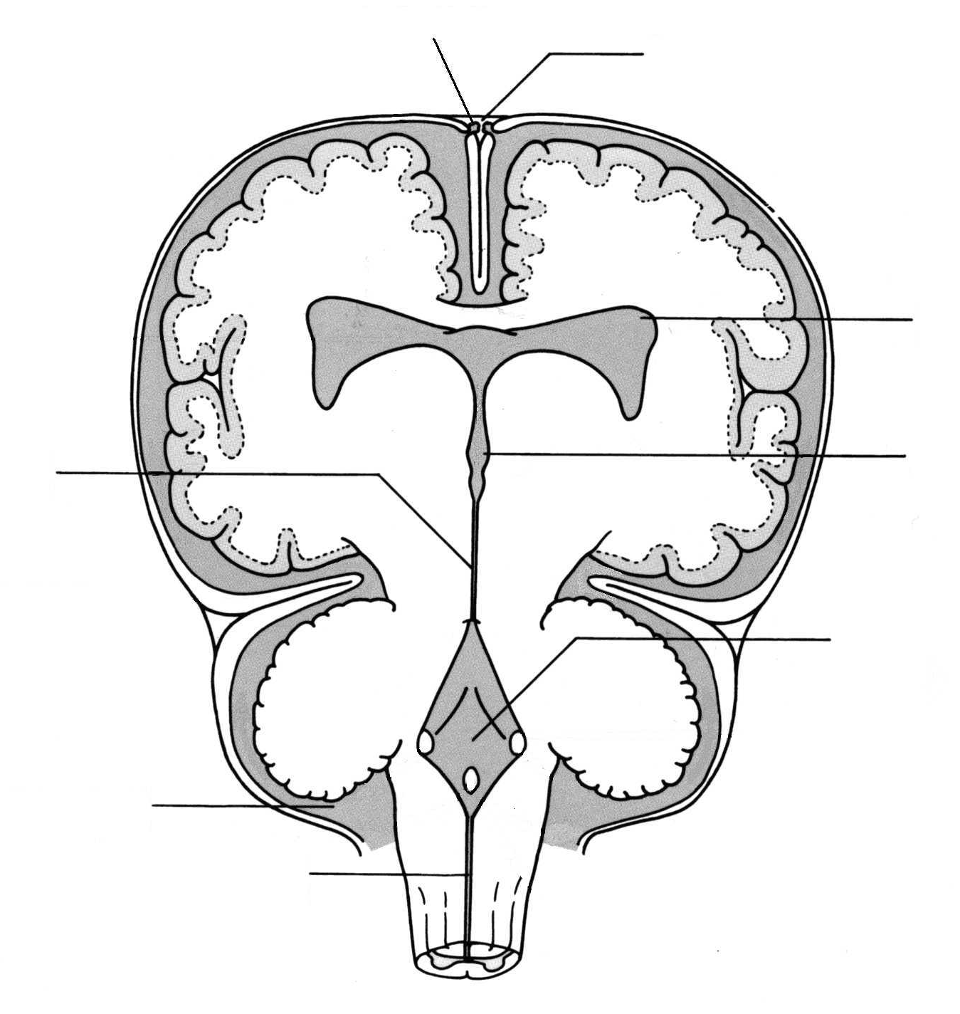
Coronal section through ventricular system
Sagittal dural sinus
Arachnoid villus
Lateral ventricle
Third ventricle

Aqueduct
How does the composition of CSF differ from blood?
Fourth ventricle
Subarachnoid space
Central canal

Normally contains few cells
Much less protein
Reduced concentration of potassium and calcium ions
Higher concentration of magnesium and chloride ions

What is the normal volume and flow rate of CSF?

150 ml

approx 500 ml/day

B. HYDROCEPHALUS

Look at the poster showing clinical aspects of hydrocephalus and answer the following questions:

What are the 2 main types of hydrocephalus and their causes?

COMMUNICATING (all 4 ventricles affected)

Causes: Block in CSF absorption or CSF flow over brain surface caused by:
Meningitis
Head injury
Congenital
Haemorrhage (sub-arachnoid)

NON-COMMUNICATING (not all ventricles enlarged)

Causes: Block in ventricular system caused by:

Aqueduct stenosis
Ventricular tumours
Paraventricular tumours

What are the main signs and symptoms?
Headache
Drowsiness
Blackouts
Raised intracranial pressure
Increased head circumference (in child)

How may hydrocephalus be treated?

Remove cause, e.g. papilloma

Divert CSF, e.g. shunt

Open alternate pathway, e.g. ventriculostomy

PART 3 – The meninges

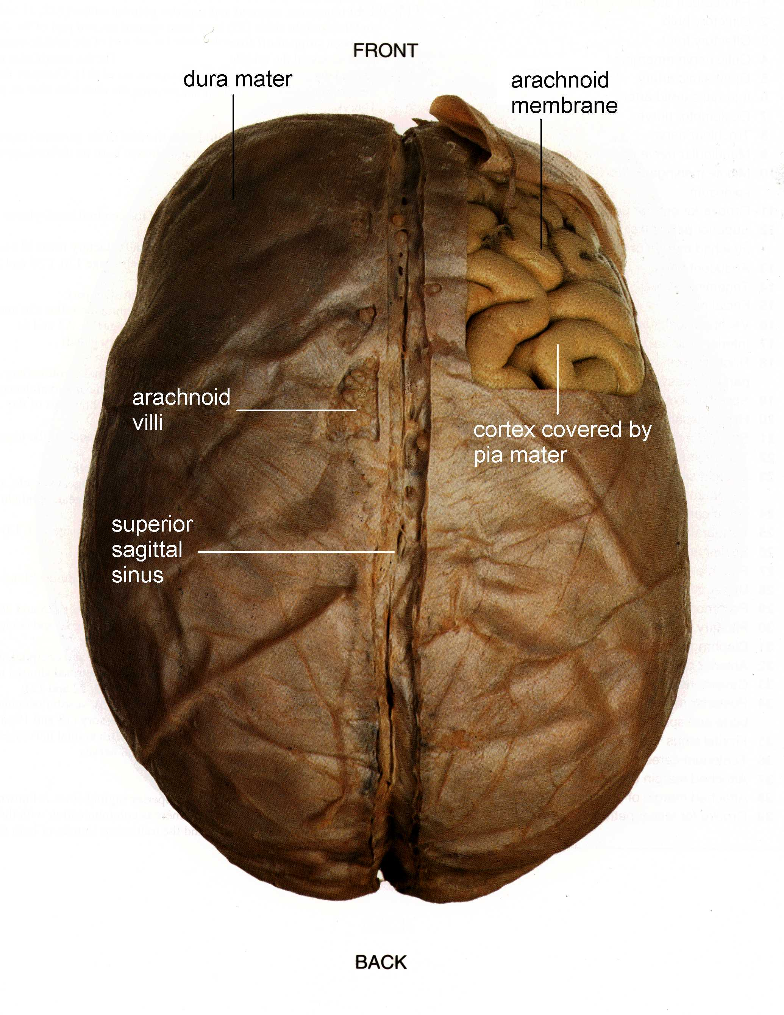
A. The photograph shows the brain, viewed from above, covered in the 3 layers of the meninges.
Haemorrhages can occur between these layers:

Epidural/ extradural haemorrhage – usually due to a damaged meningeal artery between the skull and the dura after head trauma.

Subdural haemorrhage – usually due to a damaged vein between the dura and arachnoid membrane.

Both can cause a space-occupying lesion in the confined space of the cranium and hence neurological deficits.

How might you distinguish between an epidural and subdural haemorrhage?
The first symptoms (which may be headache, drowsiness, vomiting or seizure) are likely to arise promptly after arterial bleeding in an epidural haemorrhage whereas symptoms may be delayed by hours or days after venous bleeding in a subdural haemorrhage.

Can confirm with imaging.

- MENINGITIS

What structures are usually infected in meningitis?

Pia mater and subarachnoid space, with some spread to the upper layers of the cortex in severe cases.

Analysis of a sample of CSF should distinguish between bacterial and viral meningitis. What would you look for?

With bacterial infection there will be a high white cell count, with neutrophils predominating.
Protein concentration is increased and glucose concentration is decreased.
Bacteria may be identifiable.

With viral infection any increase in white cells is predominantly lymphocytes.
Protein and glucose level of the CSF are usually normal
Viral identification is unlikely.

