School of Medicine

Graduate Entry
Foundations of Clinical Practice

Society and Health

2012-13

Student course guide

Academic coordinator: Dr Mariam Sbaiti Mariam.Sbaiti@imperial.ac.uk
Course administrator: Ms Helen King Helen.King @imperial.ac.uk

https://education.med.imperial.ac.uk

Contents

Introduction 2
Sessions: 6
Biographies 32

Introduction

The ultimate end to which health care professionals strive is to improve the health of patients. The Society and health course will introduce you to basic concepts of sociology and other social sciences which study health in the context of society.

Browsing through the leading medical journals, it is difficult to find an issue which does not contain an editorial or a paper relating to the links between health, medicine and society. Being part of the healthcare profession, you are in a privileged position to gain an insight into these links from the clinical context. Also, sociology helps us to be better medical practitioners, and more reflexive professionals in the health system we work in.

These links have also been the object of much study from sociologists and other social science disciplines. The Society and Health course aims to give you a basic introduction to these scholarships in a way which is relevant to your current role as a medical student and to your future medical practice.

Sociology in Medicine studies health in the context of society and sessions 1 to 3 of the course relate to this. Sociology also contributes to our understanding of the medical profession and the complex health system we work in. Therefore, you will be introduced to the Sociology of Medicine in sessions 4 and 5.

The First Clinical Attachment (FCA) will be your first opportunity in the medical curriculum to meet patients as a medical student. During the year you will have the opportunity to gain insight into patients’ experiences of symptoms and disease by spending some time in a primary care practice (Module 1). You will also be in a position to witness the experiences of patients with long-term problems (chronic diseases and disabilities) through patient visits and through a poster presentation in Module 3. This is also aimed to help you develop an understanding of how people affected by medical conditions experience long term care and to explore the complex web of support that is available in the community for these people (Module 2).

Society and Health and FCA are complementary courses, and the learning outcomes for each course are continuous with each other. FCA is taught in small groups and through patient contact, and aims to bring you to talk to patients and integrate this knowledge with the theory which we introduce in Society and Health and which can be applied to people’s experience of health, illness and healthcare.

There is some overlap between these courses and other courses, including Medical Ethics (GE Year 2), Epidemiology in Practice (Year 1), Problem-Based Learning and the Clinical Communication.

Overview of Society and Health

The course introduces you to the main sociological perspectives on health and medicine. It explores current debates concerning the nature and role of biomedicine. Lay experiences and health beliefs will be studied, and lay/professional interactions explored. The role of the professions, and changing power relationships within the health services is an important learning outcome for the future medical practitioner. You will evaluate the changing profile of health and illness in contemporary society, and consider the experience of chronic illness and disability. The social patterning of health, and competing explanations for this, are considered. Geographic inequalities in health status will be explored. Finally, we will consider the role of the medical doctor, as a professional, scholar, citizen and the role of the patient in addressing social determinants of health and making a change.

How you can make the most out of the Society and Health course

The course comprises 15 hours of large group teaching, divided into 5 sessions. Each session comprises 2 lectures, and 1 interactive seminar.
- 1st lecture
- Interactive seminar
- Break
- 2nd lecture

The taught sessions are intended to give you an overview of the Society and Health material and complement your self-directed learning in Society and Health and FCA. You will have the opportunity to ask questions in class and we hope you will want to contribute to class discussions. Some sessions will also involve the use of PRS clickers. These will be handed out at the start of the session. To help you get the most out of the taught sessions, we have indicated the Essential reading you will be expected to do in advance of each of these.

We will be using Scambler 2008 as our main textbook for the course. Any extra essential readings will be posted on the intranet.

Relevance of the Society and Health Course in the context of your medical training

The GMC details the competencies medical graduates are expected to have acquired by the end of their medical training in Tomorrow’s Doctor 2009. The Society and Health course will help you build on the competencies from the following 2 sets, which relate to sociology:

Competency 10
Apply social science principles, method and knowledge to medical practice.
(a) Explain normal human behaviour at a societal level.
(b) Discuss sociological concepts of health, illness and disease.
(c) Apply theoretical frameworks of sociology to explain the varied responses of individuals, groups and societies to disease.
(d) Explain sociological factors that contribute to illness, the course of the disease and the success of treatment − including issues relating to health inequalities, the links between occupation and health and the effects of poverty and affluence.
(e) Discuss sociological aspects of behavioural change and treatment compliance.
Competency 11
Apply to medical practice the principles, method and knowledge of population health and the improvement of health and healthcare.
(a) Discuss basic principles of health improvement, including the wider determinants of health, health inequalities, health risks and disease surveillance.
(b) Assess how health behaviours and outcomes are affected by the diversity of the patient population.
(d) Discuss the principles underlying the development of health and health service policy, including issues relating to health economics and equity, and clinical guidelines.
(g) Recognise the role of environmental and occupational hazards in ill-health and discuss ways to mitigate their effects.
(j) Discuss from a global perspective the determinants of health and disease and variations in healthcare delivery and medical practice.
Box 1: General Medical Council Tomorrow’s Doctor 2009 Competencies relevant to Society & Health: Competencies 10 and 11. Available from: http://www.gmc-uk.org/education/undergraduate/tomorrows_doctors_2009.asp (accessed 1 August 2012)

Terminology

Some of the terms commonly used in sociology can be difficult to understand at first. The following website has a useful list of definitions which you may find useful to refer to during the course:

http://www.saps.canterbury.ac.nz/soci/resources/glossary/

Assessments

Epidemiology and Society & Health are assessed by a classroom based summative test (under exam conditions) in April 2013. The questions will be EMQ and SBA format. Assessment of epidemiology and society and heath make up 50% of the total FOCP score.

This assessment has to be passed, and students will be expected to pass each of the two sections (EIP and S&H). Students who do not pass will be required to resit the test.

Full details of the assessment including the number of questions, times and instructions can be found here: https://education.med.imperial.ac.uk/Years/GE1213/exams/index.htm . You should ensure that you check the information posted here as this will be more up-to-date than any details contained in this guide at the time of going to press.

Studying sociology can require you to understand different ways of thinking about reality and how this can be researched. The scholarship also includes a specific language. Therefore we have tried to make the sociological contents of this course as relevant and to reduce any unnecessarily complicated terms, so that it is an introduction to the concepts of sociology that we believe will be most relevant to you as a future medical practitioner, scholar and professional.

Not all details contained in the preparatory reading are core examination material. Indeed, the reading indicated under Further Reading is given to help you develop this understanding of sociological concepts if you wish to take this beyond the core material. Examinable material includes the points which are directly related to the session learning outcomes, as well as what is pointed out during the lectures as core material. We include a revision session at the end of the course which will include some advice on how to prepare for the in-class test as well as some practice questions.

Furthermore, you may find that the material covered here is relevant to your reflective portfolio and essay in FCA.

Ultimately, we hope that Society and Health will enable you to develop your understanding of the social sciences in a way that will enable you to become a competent practitioner, professional, and scholar. We also hope that this will help you consider your own experiences as a person, a family member, a citizen, a patient, as valuable sources of information in practising medicine, and will help you develop your ability to develop your own knowledge and critically appraise various sources of information in developing your own practice.

SOLE Feedback
The student on-line evaluation (SOLE) is an important way for you to contribute to improving our teaching material and methods through constructive feedback. We take your feedback very seriously and we are continually looking at ways in which to improve our teaching. SOLE will be open at the end of the course, so please fill it in when you receive the notification.

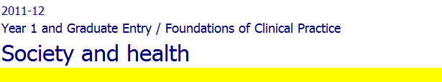
Intranet

Preparatory readings will be posted on the Intranet page for Society and Health. The version of this course guide on the intranet and Blackboard has the electronic links to readings and relevant websites.

Attendance

Attendance at lectures is compulsory.

Allowance is made for absences due to illness and other extenuating circumstances. This may be monitored by spot checks of attendance, during which you are required to swipe your ID card on a reader during lectures. Students who fail to swipe their ID card on this occasion will be considered absent.

Session 1: Society and Health: an overview

Question: Why should we study society and health when we want to be doctors?

Introduction and Background Notes for Session 1

In Session 1, we consider a range of definitions of health. Defining disease, as we will see in Session 2, is sometimes considered relatively straightforward, when an ‘objective’ measure of disease is available. However, health is a more elusive concept and different definitions of this also imply different approaches to healthcare and social policy.

Two major and differing models of health are the social and medical models. The medical model of health is based on knowledge about the physical and biological causes of disease. It represents health as the absence of disease and therefore tends to indicate a curative approach to care.

Sociology on the other hand is interested in the social model of health, which focuses on the subjective nature of the experience of health and on the social distribution of health and illness between different groups. For instance, in Session 3 of Society and Health, we will explore differences in health outcomes between social classes. The social model is interested in the environmental and social causes of ill health and therefore tends to justify more preventive approaches.

In recent years, health has been increasingly conceptualised as being related to a range of social influences, such as stress factors and lifestyle, and it is now recognised that good health is more than merely an absence of disease. The World Health Organisation defines it as ‘a state of complete physical, mental and social wellbeing’.

Disease is a term to describe a biological malfunction. Sociology uses the term illness to describe the individual’s subjective experience of ‘feeling unwell’. Sickness refers to a social status which is defined professionally, for instance, by a doctor who issues a sick note. However, it is also defined socially, when a person’s subjective feeling of being ill becomes recognised by kith and kin.

As health professionals, we tend to think that people who are ill seek appropriate medical care. Yet research suggests that this is not necessarily so, and also, that the experience of illness, beyond seeking medical care, is constructed and complex. This means that rather than depending on the condition or the physiological changes it causes, the experience of illness depends on many other factors. These are subjective, historically determined, and they can be reinterpreted. Thus the patient is actively involved in determining their own experience (see Gabe et al 2010).

Lecture one: The society in which we practice medicine

Intended learning outcomes: by the end of this session you should be able to:

Recognise the different ways in which social factors affect health

Recognise the ways in which health and healthcare affect society

Background Notes for Lecture 1

This lecture will begin with an introduction to the society within which Imperial College students learn their medicine. Imperial is a world famous, high ranking university based in a part of London that is characterised by contrasts – in wealth, health and experience. In describing the population I will explain how social factors, such as class background, education, poverty, gender, ethnicity, nationality and disability, have a profound influence on health, health-related behaviours, access to healthcare and outcomes.

We will also discuss how medical practice and the health care system impact upon the society in which we live: medicine influences the way we live, for instance through health promotion campaigns. The way we understand certain conditions as “illness” also influences our experience of heath and disease. In many societies, healthcare is a major sector of the economy. The UK National Health Service is a major industry in the country, being the top employer nationally and amongst the top 10 employers globally. These factors need to be understood if you are to become a competent and confident clinician operating in the globalised world of the 21st century.

Sociology is interested both in how health and illness are determined by social factors, and how they are socially constructed. An example of the social causes of ill health is poor living conditions, while an example of the social construction of health is that different cultures have different ideas about what it means to be healthy or ill.

Essential Reading

Fitzpatrick R (2008). Chapter 1: Society and Changing Patterns of Disease. In: Scambler, Graham (ed). Sociology as applied to medicine. 6th Edition, W B Saunders: London, pages 3-17.

Further Reading

British Medical Association. Social determinants of health : what doctors can do. London : BMA, 2011.Available at: Http://bma.org.uk/-/media/files/pdfs/working%20for%20change/improving%20health/socialdeterminantshealth.pdf (accessed on 15.08.2012)

Interactive seminar: Learning real life medicine: what good doctors know about society

By John Chetwood, final year medical student and former president of Medsin

Overview
In this seminar I aim to discuss the reasons why Society and Health lectures are immediately relevant to you. I will discuss, from the point of view of a medical student involved in activism, why understanding Sociology, and global influences on health, is important for future medical practitioners, and how medical students can make a difference. I include a brief overview of a range of opportunities for medical students to be involved in advocacy, as well as how this is relevant for medical and global health work.

Lecture 2: The social construction of health and illness
Intended learning outcomes: by the end of this lecture you should be able to:

Outline the difference between biological, psychological and social perspectives on ill health

Describe varied pathways and patterns of healthcare including lay referral and self-management

Show an appreciation of the significance of lay understandings of health, and understanding of how lay and medical interpretations diverge
- Explain the concept of medical pluralism

Background Notes for Lecture 2

This lecture will give an overview of the sociology of health and illness, looking at different definitions and perspectives on health, illness and disease, and how these affect what people do when they are suffering. This provides an introduction to detailed discussions and explorations that you will undertake in the First Clinical Attachment.

Sick people address their problems in many ways, generally combining different forms of care and expertise in what is known as medical pluralism. Examples will be provided.

Illness and consulting a doctor

Illness is neither a necessary nor a sufficient condition for a consultation: (1) not necessary eg. contraceptive advice; immunisation; screening; (2) not sufficient eg. slow onset chronic diseases and many cancers, where symptoms may not taken to a doctor or are taken only after a prolonged delay ('late presentation').

Overlap and disagreement. Although patients often consult with problems that their doctor thinks appropriate, two types of disagreement occur: (a) patients consult with problems considered insufficiently serious by their doctors ('trivia'); (b) patients do not consult despite a problem their doctor thinks serious (clinical iceberg).

- Clinical iceberg: The proportion of disease in the community which is not taken to a doctor.

eg. SE London Screening study (1977). Study design: all persons aged 40 - 64 from two South London practices; 73% response rate; N of 2,420. Screened using health questionnaire, clinical examination and routine investigations. Findings: 53% of total morbidity was previously unknown to patients' doctors. Among the small proportion of morbidity which was potentially disabling or life-threatening, 44% was previously unknown. These results illustrate the so-called "one-to-one rule": for each case in treatment there is an equivalent case untreated in the community.

Symptom iceberg : The proportion of symptoms experienced by the community which are not taken to a doctor. The symptom iceberg is the clinical iceberg seen from the patient's point of view (the experience of symptoms rather than diagnosed disease). You will cover this in more detail in your FCA course.

For an example of the symptoms iceberg, see: Morrell & Wade (JRCGP 1976,26:389-403). Study design: random sample of women aged 20 - 44 from a South London practice; 48% response rate; N 0f 198. Symptoms recorded by health diary for a month. Findings: 90% of subjects recorded at least one symptom during the month and one in 37 of these was presented to a doctor.

In other words, symptoms are common; and patients have to select which to present to a doctor. Illness behaviour is the process by which lay people decide which symptoms are worthy of a consultation and which should be responded to in other ways.

Illness behaviour
Mechanic & Volkart's definition: "The ways in which symptoms are perceived, evaluated and acted upon by a person who recognises some pain, discomfort or other signal organic malfunction". (Note the three stages - perception, evaluation, action - and the difficulty of defining a symptom - pain, discomfort, organic malfunction).

Most people discuss their symptoms within their social network of family and friends before consulting a doctor. Friedson called this the 'lay referral system' because of its similarity to the medical referral system. An individual's illness behaviour, in consequence, is influenced by the characteristics of their lay referral system.

Characteristics of lay referral system
(a) Expectations. Sub-cultures differ in their expectations of health and the advice which individuals receive from their lay referral system will vary with its sub-culture; eg. working class populations are more likely to equate health with being able to keep going, while middle class populations tend to expect more (a feeling of strength and well being) and consult with less disruptive symptoms. Interpretation of bodily states are also subject to sub-cultural variation; eg. a smoker's cough may be a sign of manhood to a young boy, normality to a smoker, a sign of chronic bronchitis to a doctor. Expectations also vary with age; an elder may tolerate a symptom about which a younger person would consult.
(b) Disruption. An individual's social network may be able to accommodate the disruption caused by a symptom. Zola's (1973) triggers describe the several ways in which this accommodation can break down; a crisis at home, the demands of everyday life and so forth. Consequently, consultation may be triggered by a change in accommodation, rather than a change in symptom, and networks with small powers of accommodation are more likely to advise a medical consultation. NB. It is therefore important for the clinician to elicit the trigger factors and find out whether their patient came to them through lay referral. The doctor can only understand the patient’s experiences if they gain an understanding of this journey. This is the clinical aspect of the concept of “patient pathways” which we explore in Lecture 6. The concept of Patient experience has received increasing attention in healthcare sciences, and is the focus of research at the recently launched Centre for Patient experience, led by Professor Helen Ward and Professor Sophie Day.
(c) Culture and structure. Lay advice on coping with illness is more similar to doctors when other social factors are shared (such as class). Middle class networks are more likely to give advice with which a doctor agrees. This agreement is less likely where the network's culture differs from the doctor's, especially where the network is large and tightly knit.

Medical factors
(a) Doctor's attitude. General practitioners have been found to vary considerably in the frequency with which their patients consult them. Logan & Cushion (1958), for example, found that the average number of consultations per patient per year varied from 2.7 to 9.2 among the general practitioners they studied. Cartwright has shown that the general practitioners who have lower than average consultation rates are those who consider many consultations trivial or who appear to patients to be busy or uninterested.
(b) Ease of access. The distance from home to surgery may deter consultation, especially among the elderly and infirm; eg. Parkin (1979) found that women over 65 years consulted an average of 9.0 times per year if they lived within 1/4 mile of the surgery compared with 3.0 times for those living more than 5/8 mile away; eg. lower consultation rates of men working several miles from home. The more rushed, less personal, service offered by medical facilities in the worst served areas may also discourage consultation; eg. ante-natal clinic attendance.
(c) Alternatives. Self-medication, OTC (Over The Counter) medicines, self-help groups (eg. Alcoholics Anonymous), other therapies (homeopathy, acupuncture) and other medical traditions (eg. psychoanalysis), as well as different consultation spaces (such as private e-consultations) may all be used as alternatives to a clinic-based consultation.

Thus, the norm is that symptoms are not taken to a medical practitioner and seeking advice for a bodily change is an exception to this norm.

Outcomes
14-day incidence of symptoms and subsequent illness behaviour of 1,000 randomly selected persons from two London boroughs (Wadsworth et al 1971):

Illness behaviour category | Number of subjects
Symptom-free | 49
Symptoms, but not taking any action | 188
Symptoms and taking non-medical action | 562
Symptoms and taking medical action | 196
Symptoms and hospital in-patient | 5

The sick role
The sick role describes the general cultural response to illness. It can be seen at its most formal in sickness certification from work, but it informally structures the wider social response to those who are unwell.

Like any social role, the sick role involves rights and obligations:
Rights: Temporarily excused normal obligations.
Not held responsible for this deviance.
Obligations: Must want to get well.
Must seek out and co-operate with technically competent help.

The sick role was first described by Talcott Parsons, a Harvard University sociologist, in 'The Social System' published in 1951. Parsons was interested in social order, which he thought was dependent on: (a) socialisation; and (b) social control of deviant behaviour. The form of social control varied with imputed responsibility. Willed deviance was dealt with by the law and punishment; unwilled deviance (e.g. accident, child, illness) by care. Parsons saw illness as a form of unwilled (non-responsible) deviance, the sick role as the culturally appropriate response and doctors as the 'gate-keepers' who prevent the sick role's abuse.

Advantages of the sick role. For doctors: the sick role provides the patient with rest and low anxiety which maximises their chance of recovery from illness. For patients: the sick role allows normal role responsibilities to be dropped temporarily without punishment. For society: the sick role controls deviance due to illness and hastens the return to normal role performance.

Limitations of the sick role. (a) Relieved of normal responsibilities? This may not be possible for Eg. those caring for a baby or a severely disabled person; a self-employed worker; workers at times of high employment. (b) Not held responsible? May be challenged by (bi) disagreement about whether a condition is medical or moral eg. drug addiction, alcoholism, repeat para-suicide, smoking-related diseases, sports injuries (bii) suspicion that an episode of relapse in a chronic disease may be feigned. Whenever responsibility for deviance is suspected the response tends to shift from sympathy and care to blame and punishment. (c) Want to get better? This s is an unrealistic obligation to place on those suffering from a chronic disease. The sick role assumes recovery and a return to health. For those suffering from chronic disease, the temporary respite of the sick role tends to be replaced by stigma.

In the same way that people take different actions on given symptoms in terms of consulting a medical practitioner or not consulting one, sociologists and anthropologists have been very interested in the choices that people make to seek care from different systems including the folk system, formal professional sector and the popular sector. This is sometimes referred to as Medical Pluralism. Anthropologist Arthur Kleinman (1980) has classified this into the popular, professional and folk sector, and highlighted how the boundaries between these sectors can be blurred.

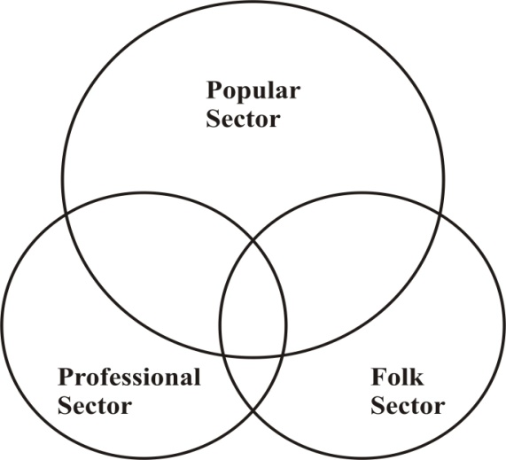
Figure 1: Kleinman’s model of overlapping sectors within a healthcare system

In all societies, some medical traditions are regarded as superior to - and more prestigious than - others. Biomedicine often is the dominant system over other less formal systems of care. Yet most people make use of some form of folk sector medicine and most care occurs outside of the formal sector.

Essential Reading - NB these are the same as for FCA Module 1.

How should we define health? BMJ 2011;343:doi:10.1136/bmj.d4163 (Published 26 July 2011) http://www.bmj.com/content/343/bmj.d4163.full

What is health? The ability to adapt [editorial]. Lancet 2009;373:781
http://www.thelancet.com/journals/lancet/article/PIIS0140-6736(09)60456-6/fulltext

Scambler, Graham. Ch 3 Health and Illness behaviour In: Sociology as applied to medicine. Scambler G (ed.). 6th Edition. W B Saunders. London. pp37-48

Also:

Goldstein MS. The Persistence and Resurgence of Medical Pluralism. Journal of Health Politics, Policy & Law. 2004. Available from: http://web.ebscohost.com/ehost/pdfviewer/pdfviewer?sid=9438ac0b-bc8b-4f93-a8b9-7b714a2bb784%40sessionmgr13&vid=2&hid=13 (accessed 10 September 2012)

Kelly M and Nazroo J. Ch 10: Ethnicity and health. In: Sociology as applied to medicine. Scambler G (ed.). 6th Edition. W B Saunders. London. Pp: 159- 175.

Further reading

Dubos R (2011). Mirage of Health. In: Health and Diseases: A Reader. Seale C (ed). Open University Press. pp 1-3.

Helman C (2011). Feed a cold, starve a Fever. In: Health and Diseases: A Reader. Seale C (ed). Open University Press. Pp 14-20.

On the social construction of illness:

Conrad P and Barker KK. The Social Construction of Illness : Key Insights and Policy Implications. Journal of Health and Social Behavior 2010 51: S67.

Gabe J, Bury M and Elston MJ. Social Constructionism. In: Key Concepts In Medical Sociology. SAGE Publications, London: 2004. This is available for free online at: http://www.scribd.com/doc/33745713/Key-Concepts-in-Medical-Sociology (p 242- 247)

References

Kleinmann A (1980). Patients and Healers in the Context of Culture: An Exploration of the Borderland between Anthropology, Medicine, and Psychiatry. Berkeley: University of California Press.

Logan W and Cushion A (1958). Mortality statistics in General Practice. Studies in Medical and Population Subjects. No 14. London: HMSO.

Parkin D. Distance as an influence on demand in general practice. Epidemiology and Community Health 1979;33:96-9.

Wadsworth, MEJ, Butterfield, WJH, Blaney, R (1971) Health and Sickness The Choice of Treatment. London: Tavistock Publications

Zola I (1973). Pathways to the doctor: from person to patient. Social Science and Medicine 7:677-889.
Sample SBA Question 1
Which one of the following is not included in Parsons’ definition of the sick role :
a. The sick person has the obligation to consult expert medical opinion
b. The sick role mainly applies to a person suffering from a chronic illness
c. The sick person has a right to be regarded as needing care and being unable to get better through her own decisions and will
d. The sick person has the right to be exempt from normal social roles such as work
e. The sick person has to want to get well speedily for instance by taking the advised medical treatment

Session 2: What Is Normal?

Background Notes for Session 2

Modern medicine relies heavily on measurements. A routine general practice visit, as you will have the opportunity to observe in your First Clinical Attachment visits, often involves the clinician measuring the patient’s blood pressure, temperature, height and weight, cholesterol levels, depression score etc... Yet ‘quantification’ is a relatively modern concept in medicine. It was generally thought that numbers were useful for the sciences of engineering and architecture, but not for gaining insight into the how and why of natural processes until the 16th c, when important measuring instruments were developed.

Measurement has also been applied to the population level. During the Enlightenment, analysis based on numbers became considered more objective than qualitative analysis. In 19th c. scientists started to use quantification to determine ‘normal’ ranges for physical features, such as temperature and blood pressure. These numbers were supposed to be the same for every healthy person, allowing scientists to develop statistical approaches which became the basis for great advances in public health. Indeed, beyond individuals, statistics inferences on larger groups started becoming used as a basis for medical research. One such example is the evidence proving a link between smoking and lung cancer which has been available for decades but which only became translated into health policy in the UK in the last decade.

Contemporary medical advances such as those accessible to the UK population would not have been achieved without a solid system of collecting and using evidence on health and healthcare. Indeed, today, certain low-income countries are facing serious challenges linked to poor data collection systems. This leads some commentators, such as Lancet editor Dr. Richard Horton, to describe the lack of progress in civil registration and vital statistics as “the single most critical development failure over the past 30 years.” (Horton 2007:1526).

One impact of this increase in measuring body features was a decrease in the interest for the patient’s individuality. Nicholas Jewson for instance describes the progressive shift from a prescientific bedside medicine, where physicians regarded each patient's case as unique, to hospital medicine. Ultimately, defining the “normal” implies a certain degree of power in society.

This power may be in t he hands of a certain group within society (for instance, the medical profession), but it may also be thought of as

Lecture 3 Norms, science and medicine: the power of the normal

Intended Learning Outcomes: by the end of this lecture you should be able to:
- Describe how concepts of the normal and abnormal are created in social and biological terms.
- Recognise that several forms of social differentiation will influence the doctor-patient encounter.

Background Notes for Lecture 3

The lecture will explore the uses of the concept of normal, in biomedicine, in public health and in society. We will consider the concept of the normal distribution of variables in a given population and how this can influence public health interventions. The concept of the normal at the individual level in a clinical context, e.g. the definition of abnormal clinical signs by the clinician and the process of making a diagnosis balanced against what is considered by the patients to be their normal will also be reviewed.

Beyond science and medicine, norms also exist in society. Some of these norms are considered law and in general are followed by the majority of the population and reinforced. Other norms do not make it into law, but are also followed by most people living in that society. Norms may help to give individuals a sense of cohesion and belonging, but will also create the idea that there are deviants; those who do not follow the norm. On the other hand being a deviant in a society may feel, to some individuals, very uncomfortable.

Certain traits of “normality” become desirable in society e.g. heterosexuality over homosexuality; being able bodied over having certain types of physical disability, having a certain body weight etc. And again the deviants are nor very welcomed in that society…

As expected, norms will vary among different societies. What is accepted and encouraged in one group might be considered a crime carrying an adequate punishment in another. How the doctor and clinicians in general respond to the concept of normal in society and normality for the individual to ensure the best outcome for the patient will be explored with examples.

The doctor patient relationship and the outcome of this interaction are inevitably influenced by the fact that there are at least two people in the room at that moment. How individuals’ assumptions, life experiences and life constrains, (some determined by the concept of normal) will determine the success of this interaction will also be discussed in this session.

Interactive Seminar: Normal Minds? Vignettes from the psychiatric services (Mike Crawford)
This seminar involves a series of vignettes based on patients within the psychiatric services. These will illustrate the concept of norms and the normal in the context of diagnosing patient with potential mental health conditions.

Lecture 4: Norms, science and medicine: normalisation and power (MS)
Intended Learning Outcomes: by the end of this lecture you should be able to:
- Recognise and outline the positive and negative effects of medical power (medicalization) and illustrate this with some examples

Discuss the positive and negative consequences of labelling and stigma and provide examples of the different types of the latter
- Explain why defining “normality” is associated to questions of power in society

Background Notes for Lecture 4

This lecture will contrast the positive and the problematic implications of the use of norms and concepts of the normal in medicine and in society. Following on from the previous lecture, and the interactive seminar, we will explore why, by defining the normal, the medical profession exercises a certain type of power. Indeed the definition of the normal biologically and socially is the basis for our understanding of what does not conform to the “normal”, and is therefore “deviant” in society.

But beyond this, the power of defining the normal is not necessarily “located” in one section of society. Normalisation is a process by which certain characteristics or behaviours come to be seen as expected or “natural” in society. For instance, in terms of mobility, we expect an able-bodied person to be able to climb stairs, but we do not expect of them to jump from one rooftop to the next, as some “free-runners” do in many large cities in the world.

In relation to health and healthcare, these concepts are important because deviance can lead to different labels of behaviours or states of health and ill-health. The lecture will explore the concept of stigma, which you will revisit in your First Clinical Attachment. We will also explore how certain states or problems in society become redefined as medical conditions.

Bilton defines Medicalisation as: ‘A process of increased medical intervention and control in areas that hitherto would have been outside the medical domain’. (Bilton 1996:664)

Stigma
Goffman's definition of stigma is: "The situation of an individual who is disqualified from full social acceptance". (eg. the two meanings of 'invalid').

"Normals" discriminate against those whom they stigmatise, so reducing their life chances. Where the stigmatised person is considered not responsible for their condition, as is usually the case in medical situations, discrimination is less likely to be punitive. Avoidance, neglect (e.g poor access to buildings and public transport for those in wheelchairs) and humiliation (eg. the use of cripple, moron, spastic and mad, which were medical terms originally, as terms of abuse) are more likely.

For many patients the stigma attached to their disease is as incapacitating as the disease itself.

Doctors who understand stigma will be able to communicate more effectively with those affected, for example when: (a) Discussing surgical procedures such as colostomy or mastectomy which may result in stigmatisation; (b) Telling a patient that they suffer from a disease which is widely stigmatised, such as epilepsy or schizophrenia; (c) Managing chronic diseases such as ulcerative colitis and rheumatoid arthritis which produce episodes of relapse and remission.

Living with stigma
There are three strategies for coping with stigma. A stigmatised individual may try to use all three, depending on the situation, but one is likely to predominate. An individual's choice of strategy is influenced by whether or not their stigmatising condition is widely known. If the individual is confined to a wheelchair or has bad facial scars, for example, the freedom to make this choice is severely restricted. Mostly, however, there is a choice between "coming out" and "staying in the closet". The former strategy involves tension management and the latter information management '; both have advantages and disadvantages.

Tension Management Where the stigma is widely known or easily recognised, interaction with "normals" tends to go through a three-stage process (the description is based on Davis' study of polio): (a) ‘fictional acceptance’ - polite acceptance of the stigmatised person as long as the other's stereotypes are not challenged; (b) ‘breaking through’ - the other realises that the stigmatised person is normal apart from the stigmatising characteristic; (c) ‘consolidation’ - maintaining the other's perception of the previously stigmatised person as normal.

Advantage - everything is out in the open, no lies, etc. Disadvantage - demands great patience, continual effort and considerable social skill (consolidation is rarely permanent).

Information Management ‘Passing’ as normal is possible where the stigmatising condition is neither easily recognisable nor widely known.

Advantage - avoids the effort of coping with other people's reactions. Disadvantage - anxiety (eg. making cover stories consistent) and distress (eg. hearing what “normals” say when they believe the stigmatised are not present).

Collective Response Spend one's time with fellow sufferers (deviant sub-cultures, self-help groups).

Advantage - avoids the effort of tension management and the anxiety of information management; for a while the stigmatised become normal; problems and their possible solutions can be shared; attempts can be made to improve society's response (de-stigmatisation) by changing its stereotypes or promoting research. Disadvantage – reinforces 'differentness' and isolates from “normals”.

Essential Reading

Higgs P (2008). The limits and boundaries to medical knowledge. In: Scambler, Graham (ed.). Sociology as applied to medicine. 6th Edition. Chapter 12: The limits and boundaries to medical knowledge. W B Saunders. London. Pages 193-204.

Scambler G (2008). Chapter 12: The limits and boundaries to medical knowledge and chapter 13: Deviance, sick role and stigma. In: Scambler, Graham (ed.). Sociology as applied to medicine. 6th Edition. W B Saunders. London. Pages 205-220.
Further reading

Lupton, D. and Tulloch, J. (2002). Life would be pretty dull without risk: Voluntary risk- taking and its pleasures. Health, Risk and Society 4 (2): 113-124.

Lupton D (1997). Foucault and the medicalisation critique. In: Foucault, health and medicine, edited by Petersen, A. & R. Bunton. London: Routledge, 121-142.

References

Bilton T et al. Introductory Sociology, 3rd edition. London, Macmillan, 1996.

Horton R (2007). Counting for Health. Lancet 370 (9598): 1526

Jewson N.D., ‘The disappearance of the sick-man from medical cosmology, 1770-1870’, in Sociology, 10 (1976), 225-44

Video

This episode of the documentary Medicating Children reports on the diagnosis and treatment of a young child through to teenagehood, and the controversial determination of the different diagnoses he received of Attention Deficit Hyperactivity Disorder (ADHD) and Bi-polar disorder. .

PBS The Medicated Child.
Section 1: Jacob’s diagnosis of Attention Deficit Hyperactivity Disorder (ADHD).

http://www.youtube.com/watch?v=48KnwKGV0Pw

Sections of the Film Philadelphia will be shown in Lecture 3. This film is also relevant for Session 5 and you may be interested to see the full version.

Session 3 Social influences on health
Question: can and should we expect all members of the population to attain the same health status?

“It’s not really a medical problem. It’s something for the politicians to sort out…Give people jobs and the ability to be master of their own destinies and they will make healthy decisions about their lives. …People know what’s wrong with their diet. But what are they going to do to feed hungry children?”, Dr Gerry Spence, Shettleston GP. Life expectancy in Shettleston: 63 years (11 years less than UK as a whole)

“….. social injustice is killing people on a grand scale”, Commission on Social Determinants in Health, 2008

Background Notes for Session 3
Whilst we have discussed the problematic definition of health in session 1, we have also explored the use of physical and statistical measuring instruments as crucial for improving people’s health in session 2.

These, amongst other things, allow us to monitor the progress of disparities in health. A central preoccupation of Public Health Medicine and Sociology, are the continuing disparities in health status achieved between different groups of individuals, at international, regional, national and local level and across a range of “categories” (socioeconomic status, gender, ethnicity). We will be concentrating mainly on differences between individuals from different socio-economic classes. However, one’s gender or ethnicity, will also strongly affect health outcomes (see Chapters 9 and 10, Scambler 2008).

Whilst there are apparent (or proximal) causes of health inequalities – namely people’s behaviour, biological risk factors - a competent medical practitioner also has a duty to be aware of the more distal causes: the so-called causes of the causes, or social determinants of health which reside in the social and economic structures of our society. A growing body of research also indicates that we should understand the cumulative effect of these social determinants of health as being experienced over time, and that we should view these as shaping our life-course from cradle to grave, across different areas of life such as employment, housing and access to healthcare.

Lecture 5: Social determinants of health
Intended learning outcomes: by the end of this lecture, you should be able to:

Recognise the major social factors affecting health and describe their effects

Describe how social factors lead to inequalities in health
- Understand the relative importance of medical advances and social change in improving health
- Recognise how health improvement interventions have increased health inequalities

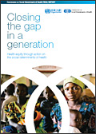 | “... avoidable health inequalities arise because of the circumstances in which people grow, live, work, and age, and the systems put in place to deal with illness.”  WHO Commission on Social Determinants  of Health 2006

Background Notes for Lecture 5

In this lecture I will introduce the major social factors that influence health, including examples of factors such as housing, employment and education, and discuss the relative importance of medical and social change in improving health. Using specific examples and video clips I will introduce some of the main theories and debates about the unequal distribution of health in the population; and lead a discussion about whether health promotion interventions are to blame for widening inequalities in health.

Essential Reading

Bartley M and Blane D. Ch 8: Inequality and social Class. In: Sociology as applied to medicine. Scambler G (ed.). 6th Edition. W B Saunders. London. Pp 115-132.

Fitzpatrick R (2008). Society and Changing Patterns of Disease. In: Sociology as applied to medicine. Scambler G (ed.). W B Saunders. London. Pages 3-17.

Scambler A. Ch 9: Women and health. In: Sociology as applied to medicine. Scambler G (ed.). 6th Edition. W B Saunders. London. P: 133-158.

Wilkinson R. The psychosocial causes of illness. Davey, B, Gray, A. and Seale, C. (2001) Health and Disease: A Reader. (3rd Edition). Buckingham: Open University Press. ?

Further Reading

Fair London, Healthy Londoners? London Health Observatory Data available at: http://www.lho.org.uk/viewResource.aspx?id=17134

Marmot M. Fair society, healthy lives: strategic review of health inequalities in England post-2010. 2010. Available at: www.marmotreview.org

Szreter S. (2008). The importance of social intervention in Britain’s mortality decline c. 1850-1914: a re-interpretation of the role of public health. In: Health and Diseases: A Reader.
Seale C (ed). Open University Press. pp219-226.

WHO (2007). European strategies for tackling social inequities in health. Available at: www.euro.who.int/document/e89384.pdf
Read pp 20-32.

Interactive Seminar
Film (to be confirmed – please check intranet version of this guide)

Lecture 6 Patient experience and patient action

Intended learning outcomes: by the end of this lecture, you should be able to:

To understand the impact of healthcare on patient experience using specific examples

To explore the relationships between patient experience and social movements for health

To explore the relationships between patient experience, patient choice and consumerism

Background Notes for Lecture 6

In preparation for the patient experience survey you will conduct in Module 2 of the FCA course, this lecture will ask what you might be measuring. How is patient experience defined and assessed in relation to social stratification? Can patient-centred care acknowledge social differences and also promote individual autonomy or choice? The high profile for patient experience measurements today can be related to a number of social trends associated with civil or consumer rights on the one hand and market developments on the other. It can also be seen as a response to centralisation and bureaucratic indifference.

Essential Reading

Kupfer JM, Bond EU. Patient Satisfaction and Patient-Centered Care: Necessary but Not Equal. JAMA. 2012;308(2):139-140.

Further Reading

General, Municipal Boilermakers and Allied Trade Unions (GMBATU). 1992. Cancer and Work: guidelines for workers taking collective action over health hazards. Health and Disease A Reader. Black N, Boswell D et al (eds.). Open University Press: Melksham.
(please note this chapter only exists i the old edition, and we will post a scanned copy on the intranet)

Landzelius K., 2006. Introduction: Patient organization movements and new metamorphoses in patienthood. Social Science & Medicine, (3):529-537.

Videos relevant to this session

Medicating Children.
Section 2: Pharmaceutical industry and the use of medical evidence for the treatment of mental health in children in the USA.

http://www.youtube.com/watch?v=5LXINWaQzA0

(also http://www.youtube.com/watch?v=TpKl_GSC_po (from 7min20” to the end) and
http://www.youtube.com/watch?v=SWy9h8WuvuU )

Selling Sickness
http://www.youtube.com/watch?v=iQMO722Ro_U

Sample SBA Question 3
In the Whitehall study amongst a sample of civil servants, which of the following was not true:
a. Men in the lowest grades of employment had a four times higher mortality rate than men in the highest grade
b. A difference in mortality is only observed between the highest and lowest employment grades
c. Lack of social support may contribute to the gradient in mortality
d. The gradient in mortality occurs across all employment grades
e. Socioeconomic position and occupational grade were stronger determinants of the risk of developing cardiovascular disease, compared to any other life circumstances

Session 4: Medicine and health
Background Notes for Session 4

A health system consists of all organisations, people and actions whose primary intent is to promote, restore or maintain health. This includes efforts to influence determinants of health as well as more direct health-improving activities. A health system is therefore more than the pyramid of publicly owned facilities that deliver health services. It includes, for example, a mother caring for a sick child at home; private providers; behaviour change programmes; vector-control campaigns; health insurance organizations; occupational health and safety legislation. It includes inter-sectoral action by health staff, for example, encouraging the ministry of education to promote female education, a well known determinant of better health.

Many of the conditions that now cause a large part of the burden of disease are chronic conditions. Diabetes and HIV, for instance, are both conditions which were rapidly fatal until the discovery of insulin and antiretroviral drugs respectively. In the absence of a functioning health system, both conditions are fatal. In the UK nowadays, these diseases are managed as chronic conditions, with many commonalities:

- People living with HIV and with diabetes mellitus and who benefit from access to good quality healthcare enjoy an almost normal life span, despite large differences in actual attainment of a healthy life
- Medical complications are an important challenge in both groups:
  - HIV: cardiovascular disease, cancers and opportunistic infections
  - Diabetes: cardiovascular disease, nephropathy
- Healthy survival requires co-ordination of efforts by many people and organisations, pharmaceutical supply and distribution, primary care, specialist care and self care

Sociology is also concerned with how a health system operates in the wider sense. Therefore this session will make some references to the Sociology of Medicine.

Lecture 7: Healthcare workers: professions and power
Jane Bruton

Outline of Lecture 7

One of the main components of a health system is the healthcare workforce. Indeed, the health care sector is a major employer in every country. The UK NHS employs 1.2 million people, a significant proportion of the UK population and their families, making it, by far, the largest employer in the UK.

Drawing on her own experience as a trained anthropologist, nurse and nurse consultant, the lecturer will introduce the following topics:
- The workforce in the NHS - Who they are, what they do
- Division of labour in health care
- My position as a nurse
- The relation between health professional and patient is structured by the workplace e.g. gender and ethnicity
- Power/knowledge & social class in health professions (link to Foucault in Session 2)
- The context of health: health services privatisation, neoliberalism and the market place; deskilling of doctors compared to skilling of nurses
- Professional and professionalization

Intended Learning Outcomes: by the end of this lecture you will be able to:
- Recognise the concept of professions as one form of social stratification, and understand the changing role of the medical profession
- Recognise different forms of knowledge and their changing contribution to evidence-based medicine, clinical skills, professional monopoly and asymmetries of power in healthcare
- Outline the recent changes in the structure and administration of UK health services and the implications for power structures within the NHS.

Further Reading

Bradby H (2008). Medical Sociology. Introduction. SAGE Publication Ltd. Available at: http://www.sagepub.com/upm-data/23538_01_Bradby_Introduction.pdf
A provocative piece on power in medicine.

Crinson I (2008). The health professions. In: Scambler, Graham.ì (ed.). Sociology as applied to medicine. 6th Edition. W B Saunders. London. Pages 252-263.

Interactive Seminar
Film Team B6 by Melissa Llewelyn Davies (To be confirmed)

Lecture 8: Healthcare systems, the NHS in context
Sir Liam Donaldson

Intended Learning Outcomes: By the end of this lecture, you should be able to:
- Identify the basic components of a health system
- Compare and contrast different economic models of health care delivery
- Appreciate the economic and political context of health and health care

Background Notes for Lecture 8

Health care consumes large amounts of a country’s resources and health care industry is an important part of a modern economy. Financing of health care involves complex mechanisms which are dealt with differently in different countries. Health care is delivered by a range of professionals in a range of agencies.

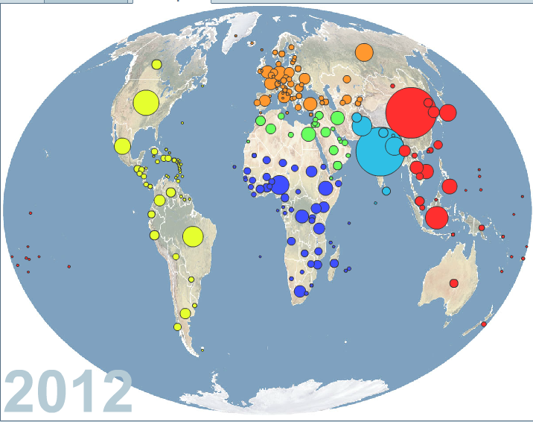

Figure 1: Total health expenditure per capita. Bubble size is proportional to the total expenditure. (GapMinder gapminder.org )

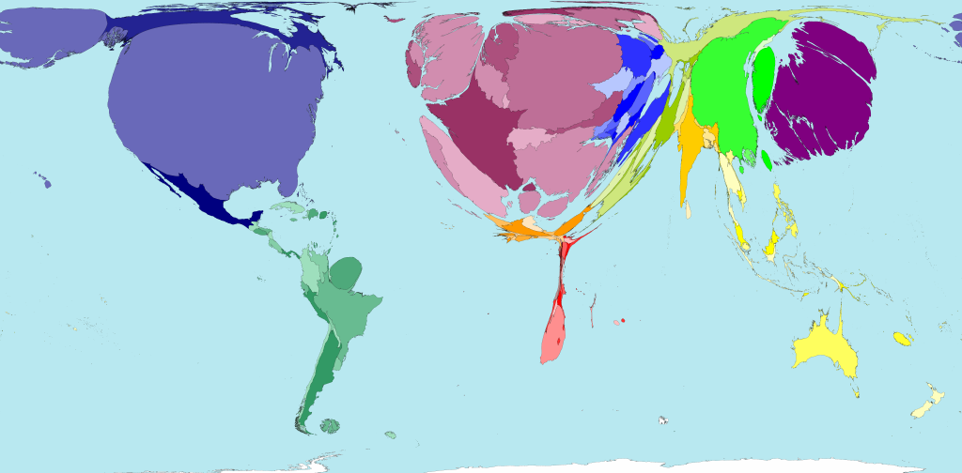
Figure 2: Public Health Spending by Country. Territory size shows the proportion of worldwide spending on public health services that is spent there. This spending is measured in purchasing power parity. (Source: WorldMapper.org)
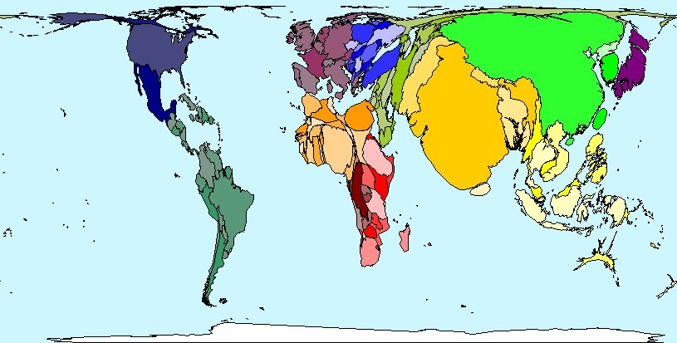Figure 3: Total Population
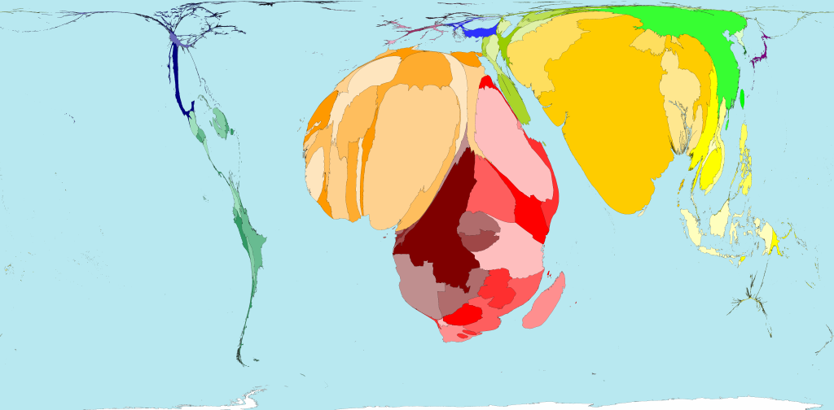
Figure 4: Child Mortality 1-4 years: Territory size shows the proportion of all the years expected to be lived by the current populations based on the projected life expectancies at birth of those born there in 2002 (Source: Worldmapper.org).

Reflection points:
Looking at the above maps, can you make any conclusions on the impact of public health spending on population health?

Based on the above maps can you make any conclusions about any causal relationship between Public Health expenditure and Child Mortality?

Question: which country has the highest spending on health per head of the population? (Please see Table 19.1 in Scambler 2008).

The World Health Organisation defines a health system as: “… all the activities whose primary purpose is to promote, restore or maintain health” (WHR 2000, page 5). The diagramme below illustrates the building blocks of a Health System, and its goals.

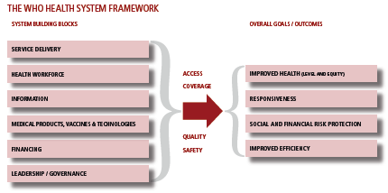
Figure 5: The WHO Health System Framework. Source: World Health Organization (2007). Everybody‘s Business: Strengthening Health Systems

Compared to other nations, the UK National Health Service offers very good protection from the financial consequences of sickness with a minimum of bureaucracy. Below is a diagramme of its structure:

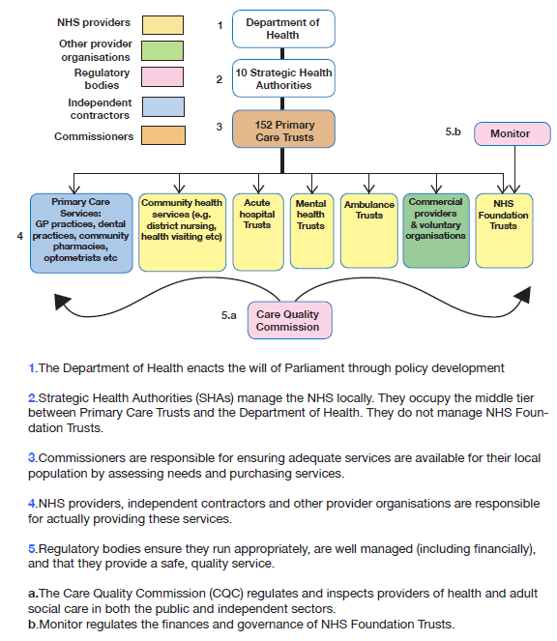
Figure 6: The Structure of the NHS (Source: McCay and Jonas 2009)

Essential reading

Mays N (2008). Origins and development of the National Health Service. Scambler, Graham. Sociology as applied to medicine. 6th Edition. W B Saunders. London. Pages 221-251.

Further Reading

Donaldson’s Essential Public Health, 3rd Edition. Donaldson LJ, Scally G (Eds). London: Radcliffe, 2009.

McCay L and Jonas S. A Junior Doctor’s Guide to the NHS. BMJ/DH 2009: London. Available at: http://group.bmj.com/group/affinity-and-society-publishing/NHS%20Guide.pdf

Timmins N. The Five Giants: a biography of the welfare state. Revised Edition. London: Harper Collins, 2001.

References

WHO 2000. World Health Report 2000. Health Systems: Improving performance. Available at: http://www.who.int/whr/2000/en/

World Health Organization (2007). Everybody‘s Business: Strengthening Health Systems. Available at: http://www.who.int/healthsystems/strategy/everybodys_business.pdf

Sample SBA Question 4:
Regarding the NHS workforce, the largest employment group within the NHS is:
a. medical doctors
b. nurses and clinical support staff
c. technical staff and scientific staff
d. infrastructure workers
e. ambulance staff

Session 5: Heath and Citizenship
“I urge you to look at the population you serve, the communities in which you work, the people you employ and the teams in which you work to think about how you can use the evidence [...] to take ever more action to reduce health inequalities.” Sir Michael Marmot (BMA 2011:2)

We opened the Society and Health course with John Chetwood’s interactive seminar on the role of the medical student in improving health and acting on the social determinants of health through advocacy.

Beyond biomedical therapies, medical practitioners can, as part of their professional role, improve individual patients’ health and that of their families and contacts, through a range of tools including social interventions to modify the impact of the social determinants in a community. These include health promotion interventions.

But beyond their clinical role, doctors are in a privileged position to take action on health inequalities locally, regionally, nationally and internationally. This session follows on from the Interactive Seminar in Session 1 on the role of medical students engaging with health inequalities and societal influences on health, as part of their training and future career. This last session introduces the role of healthcare workers making strategic use of evidence to improve the health of the populations they work in – from local to global level. Doctors can use their position and their expertise to advocate for change to areas outside traditional medical areas, and to promote the generation of research, especially on the efficacy of prevention measures.

On the other hands, patients too have had a central role in identifying and modifying social determinants of health and reduce health inequalities, and speak for health rights.

Background Notes

Picking up the themes of patient experience and patient action (Lecture 6), we will describe how health has become more closely joined to ideas about citizenship and social inclusion over the past fifty years. However, in a global city such as London, some migrants ‘without papers’ may find it hard to access care while others, ‘health tourists’, look for the best deal. In the light of marked differences such as these (and those discussed in previous weeks such as social class or ethnicity), what can health professionals or patients do to improve health or to promote equitable health care? HIV infection provides a specific illustration in this session.

Professor Sophie Day will introduce the background of activism in health. Jon Weber, will then present his own journey from being a young doctor in the 1980s, looking after young patient afflicted by a then fatal disease which was later described as Acquired Immuno-Deficiency Syndrome, cause by HIV infection. He will describe how he became interested in a patient group which not many of his young colleagues were interested to work with in the 1980s. Since then, antiretroviral therapy has entirely changed the lifecourse of patients living with HIV. Their rights became recognised in many regions of the world, and health services in the UK are now much more catered to their needs. Jon will describe some of his current work, researching the technology which could prevent further transmission of HIV in the future. A patient activist will then introduce the role of patients acting on the social determinants of health, promoting patient rights and improving patient experience.

1. Making a difference as a health care professional (Jon Weber)
2. Making a difference as a patient

Essential Reading

British Medical Association. Social determinants of health: what doctors can do. London : BMA, 2011.

Seckinelgin, Hakan (2003). Time to stop and think: HIV/AIDS, global civil society and people's politics. In: Kaldor, Mary and Anheier, Helmut K. and Glasius, Marlies, (eds.) Global civil society 2003. Oxford University Press, Oxford, UK, pp. 422-424. Available at: http://www2.lse.ac.uk/internationalDevelopment/research/CSHS/yearBook/chapterPdfs/2002/chapter5.pdf (accessed 15 August 2012).

Further Reading
Fassin D (2001). The biopolitics of otherness. Anthropology Today 17(1).

Gabe J, Bury M and Elston MA. Citizenship and Health. In: Key Concepts In Medical Sociology. SAGE Publications, London: 2004. This is available for free online at: http://www.scribd.com/doc/33745713/Key-Concepts-in-Medical-Sociology (p 242- 247)

For Reference

The Lancet UK Policy Matters
The UK is undergoing a period of significant policy change from reforms to the national health service in England to much broader areas – such as housing, transport, benefits, and tax reforms – all of which may bring benefits or risks to the health of the population.

The Lancet UK Policy Matters was set up to help the general public, health professionals, policy makers and anyone involved in health to understand what the evidence tells us about whether these policy changes will be beneficial or harmful to health.

The Lancet UK Policy Matters is a project exploring how government reforms might have positive and negative effects on our health, and provides first-hand accounts of how they are already affecting people’s lives. Available at : http://ukpolicymatters.thelancet.com/

This project aims to develop the role of health professionals and members of the public in generating and reporting relevant evidence to shape policy, and respond to social changes which may affect health.

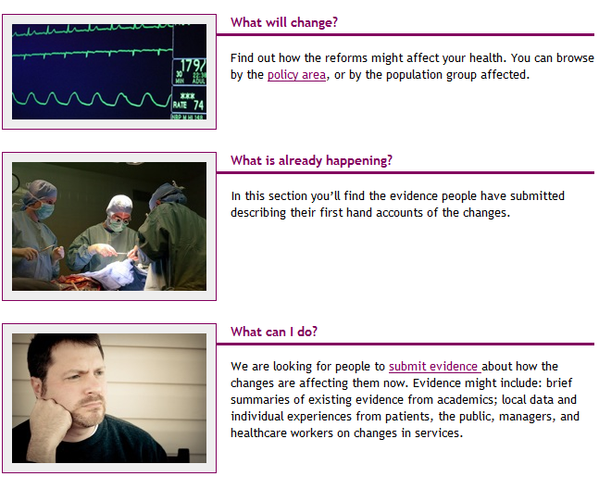

Lecture 10 Revision

This lecture will provide you with some advice on revision. You will have a chance to answer some sample Single Best Answer questions similar to those which you will be tested on in your in-class test.

Biographies

John Chetwood BSc (Hons)
Final Year Medical Student, Imperial College London
John has been heavily involved in Medsin, Global Brigades, Medic2Medic and other Imperial advocacy projects. He has volunteered in Ghana, Bulgaria and Honduras, and researched cholangiocarcinoma in the hill-tribes of Thailand which won both a prize at a national research conference, and a first prize at the Institute of Global Health Innovation’ competition. He has a keen interest in global health and international inequalities, and hopes to enter a career in international humanitarian and development work.
John would be happy to answer any questions you have at jc907@ic.ac.uk
Jane Bruton
Jane Bruton is the Nurse Consultant for HIV at Chelsea and Westminster NHS Foundation Trust. She has been a nurse for 33 years and worked in HIV care both inpatient and outpatient since 1987. She has an MA in Medical Anthropology and spent 3 months working in rural Uganda in the pre-Haart era. She has co-authored the National Sexual Health Nursing Competencies and the HIV Competencies. She has a special interest in patient involvement and the development of advanced nursing practice roles.

John Chetwood
Final Year Medical Student, Imperial College London
John has been heavily involved in Medsin, Global Brigades, Medic2Medic and other Imperial advocacy projects. He has volunteered in Ghana, Bulgaria and Honduras, and researched cholangiocarcinoma in the hill-tribes of Thailand which won both a prize at a national research conference, and a first prize at the Institute of Global Health Innovation’ competition. He has a keen interest in global health and international inequalities, and hopes to enter a career in international humanitarian and development work.
John would be happy to answer any questions you have at jc907@ic.ac.uk

Professor Mike Crawford
Mike is a Professor in Mental Health Research in the Centre for Mental health at Imperial College London. He is also an Honorary Consultant Psychiatrist at Central and North West London Foundation Trust where he works in a specialist treatment service for people with personality disorder. He has published papers on the management of suicidal behaviour, psychosis and personality disorder. Current projects include clinical trials of art therapy and problem solving therapy for people with personality disorder and an examination of service user involvement in efforts to improve service quality.

Professor Sophie Day
Sophie is a visiting professor of anthropology in the school of public health who has conducted a range of research into sexual & occupational health and new technologies. With Helen Ward, she conducted several studies of sex work in London. She approaches medical anthropology through research on work and the division of labour (including the informal economy), sexuality and gender, and the anthropology of temporality. She is currently finishing a project to document, digitalize and return images from her 1980s fieldwork to Ladakh, North India (with Dr Leizaola, supported by the British Academy; see virtual copy of 2011 exhibition, Leh (1981-2010): The Span of a Generation, at http://www.flickr.com/photos/sophieday/sets/72157627076033426/)

Sir Liam Donaldson
Sir Liam Donaldson is Chair of Health Policy at Imperial College, and was England’s Chief Medical Officer for 12 years. In that role, he championed many innovative policies and changes including; smoke-free public places, stem cell research and clinical governance.
He is an international leader in public health, healthcare quality and patient safety. He is the World Health Organisation’s Envoy on Patient Safety and Chairman of the Independent Monitoring Board on polio eradication.

Dr Luciana Rubinstein
Luciana graduated in Medicine in Brazil where she started postgraduate training in Infectious Diseases. She later moved to London and trained in Genitourinary Medicine at the Jefferiss Wing, St. Mary’s Hospital. In 2011 she completed the MSc in Epidemiology at the London School of Hygiene & Tropical Medicine. She currently works as a Consultant in GUM/HIV and as a Teaching Fellow in Epidemiology at the School of Public Health, Imperial College.

Dr Mariam Sbaiti
Mariam graduated in Medicine at King’s College London in 2006. She holds an intercalated BSc in Medical Sciences and International Health from UCL. After completing her Foundation training, she worked as a Trust Grade in Sexual Health & HIV at 56 Dean Street (Chelsea & Westminster). She is currently completing a Masters in Public Health & Policy at the London School for Hygiene & Tropical Medicine and is a Global health Teaching Fellow at Imperial College.

Professor Helen Ward
Helen Ward is Professor of Public Health and Director of Education in the School of Public Health at Imperial College. She trained in medicine in Sheffield and is a consultant in public health and in genitourinary medicine. Professor Ward has carried out extensive research into the epidemiology and control of sexually transmitted infections with a strong focus on social determinants of risk. Together with Professor Sophie Day she established the Praed Street Project, a health and advocacy project for women sex workers in London. She has recently become Director of the Imperial Centre for Patient Experience Research.

Professor Jonathan N Weber
Jonathan Weber is the Jefferiss Professor of Communicable Diseases and GU Medicine, and the Director of Research for the Faculty of Medicine at Imperial College London. He is based at the St Mary’s Hospital campus, within the Wright-Fleming Institute. He is a clinician by training, and has undertaken extensive clinical and laboratory based research on HIV/AIDS, HTLV-I and other STIs. After general medical training he was a Wellcome Clinical Training Fellow at St Mary’s Hospital Medical School (1982-5), subsequently a Wellcome Trust Lecturer in Cell and Molecular Biology at the Institute for Cancer Research Chester Beatty Labs, and then Senior Lecturer in Infectious Diseases at the Royal Postgraduate Medical School, Hammersmith Hospital (1988-1991). He was appointed to his current position at Imperial College in 1990, in order to establish a new academic department studying HIV and other STIs.
Jonathan Weber’s work on HIV infection commenced in 1982, when he established the first UK cohort studies of the natural history of AIDS at St Mary’s Hospital, together with Tony Pinching. He then trained in laboratory retrovirology under Prof Robin Weiss FRS before establishing his own laboratory and clinical investigation centre. His work began with clinical epidemiology and natural history studies, then fundamental research on humoral immunity in HIV infection and viral tropism, and then to early phase clinical investigation of the emerging antiretroviral drugs, potential HIV vaccines and latterly vaginal microbicides.
Jonathan Weber was founding editor of the journal “AIDS” 1987-1992, the leading specialist journal in the field. He co-founded the WHO Network for HIV characterisation in 1992, and advises WHO, UNAIDS, DfID and EC on aspects of HIV infection. He has published over 200 scientific papers on the clinical, epidemiological and virological aspects of HIV infection and other STIs.

