School of Medicine

Year 1

2012/2013



Photos.com

Information Technology & Information Literacy

Dr Michael Barrett  
Head of Learning Resources:  
email: [mike.barrett@imperial.ac.uk](mailto:mike.barrett@imperial.ac.uk)

<https://education.med.imperial.ac.uk>

Information Technology  
& Information Literacy

## Contents

**SOLE** **iii**

**Introduction**

Organisation of the course **1**

Aims **2**

Timetable **3**

Learning objectives **4**

Using your computer account **5**

**Introduction to IT – Lab session**  **7**

**Teaching intranet** and **Blackboard** **15**

**E-Portfolio** **16**

**Information Literacy** **19**

**Questions & Answers**

What facilities are available and when they are accessible **21**

Connecting to the College network, Buying a PC, Software **22**

Anti-Viral software, Software Shop, Rules and Regulations **23**

Security of data, Saving files, Media, Encryption, Patient Data **24**

Monitoring usage, Sharing large files, Changing Password,   
Roaming profile **25**

Disc space quotas **26**

Getting help, reporting faults, helpdesks **27**

Printing, scanning and photocopying **28**

Email *Getting email away from College, Email via Internet, Etiquette* **31**

Staying healthy **35**

College Conditions for Use of IT facilities **42**

College Information Systems Security Policy **44**

Data protection - Policy for Patient Data **44**

Advice on Internet privacy and Use of Social Networking **45**

Food and Drink Policy **46**

**SOLE FEEDBACK – *IT and Information Literacy***

The following pages provide you with templates on which you can record your thoughts as the course proceeds. At the end of the course you can enter your views onto SOLE.

**Please answer all questions by selecting the response which best reflects your view.**

|  |  |  |  |  |  |
| --- | --- | --- | --- | --- | --- |
|  | Strongly Agree | Agree | Neutral | Disagree | Strongly Disagree |
| The content of this module is useful. |  |  |  |  |  |
| The support materials available for this module (e.g. handouts, web pages, problem sheets) are helpful. |  |  |  |  |  |
| I receive sufficient feedback and guidance. |  |  |  |  |  |
| Overall, I am satisfied with this module. |  |  |  |  |  |

Please use this box for constructive feedback and suggestions for improvement.

|  |
| --- |
|  |

**SOLE FEEDBACK - INDIVIDUAL LECTURERS**

Please note that for SOLE, a Lecturer’s name will only appear once. This template gives you the opportunity to record your comments about each lecture in the order of delivery.

**On the following section, you have an opportunity to record any comments and constructive feedback you have for each lecturer.**

|  | **The lecture(s) are well structured** | | | | | **The lecturer explains concepts clearly** | | | | | **The lecturer engages well with the students** | | | | |
| --- | --- | --- | --- | --- | --- | --- | --- | --- | --- | --- | --- | --- | --- | --- | --- |
| **Lecturer and Lecture Title** | Strongly Agree | Agree | Neutral | Disagree | Strongly Disagree | Strongly Agree | Agree | Neutral | Disagree | Strongly Disagree | Strongly Agree | Agree | Neutral | Disagree | Strongly Disagree |
| **Dr Michael Barrett** introduction to IT facilities |  |  |  |  |  |  |  |  |  |  |  |  |  |  |  |
| **Akram Ameen** Introduction to Blackboard |  |  |  |  |  |  |  |  |  |  |  |  |  |  |  |
| **Andrew Regan** Introduction to the Library |  |  |  |  |  |  |  |  |  |  |  |  |  |  |  |

| **Lecturer and Lecture Title** | **Please use this box for additional constructive feedback** |
| --- | --- |
| **Dr Michael Barrett** Learning To Learn introduction to IT facilities |  |
| **Akram Ameen** Introduction to Blackboard |  |
| **Andrew Regan** Introduction to the Library |  |

**INTRODUCTION**

This introduces you to the computer and IT facilities available in the Sir Alexander Fleming Building and at other campuses, and to alert you to the obligations involved in your use of these facilities. The facilities available in Libraries and services provided by Library staff, including training in Information Literacy, are also given.

This is one of a series of courses in Undergraduate Medicine within the “**Foundations of Clinical Practice**” Theme which extends throughout your undergraduate course. All components of this “vertical” theme aim to give you core skills needed throughout your course and later in your professional life.

### Organisation of IT component

This comprises one lecture and a hands-on practical session. Time has been scheduled for you on the afternoon of either Monday 8th or Tuesday 9th October. This is for you to use the PC cluster to explore the IT facilities—staff will be present to answer queries as may arise. You have already been allocated to a group and attendance at the scheduled IT session has been timetabled for you: details have been given separately and also appear in the timetable on page 3.

This **IT Component** is **not** formally assessed. You should assess yourself and ensure that you are competent to perform the tasks in the Learning Objectives for Word Processing, Email, Web Browsing, Spreadsheets and later, Searching for Information.   
If you do not master these at an early stage in Year 1, you will find yourself at a disadvantage when the main course teaching begins.

### Organisation of Library & Information Literacy component

This comprises one lecture and two computer lab workshops (Workshop 1 & Workshop 2). As for the case of the IT component of the course, this component will not be formally assessed although there will be implications for non-completion. The skills and knowledge derived from these sessions will be an essential prerequisite to your becoming a better independent learner. These sessions are being run in conjunction with the Problem Based Learning course and you will be expected to demonstrate these skills in those sessions **and** elsewhere.

See the **Information Literacy Training** section on page 23 of this guide book.

You should take time to read the material in the **IT Facilities – Q & A** section of this handbook - it contains valuable information about using your computer account in College and elsewhere, saving and managing files within your quota of space, reporting faults or seeking assistance, effective and efficient printing, dealing with viruses, email etiquette, ergonomic guidance on using computers, and the College rules and policies for use of IT systems.

### Organisation of e-Portfolio component

There is a session later this term in which we will explain the e-portfolio system, and describe to you how it is to be used. Please note that a separate detailed guidebook to using your e-portfolio will be issued.

Aims of Course

* To provide time during which you should gain an understanding of   
  (i) the IT facilities available to you  
  (ii) the correct way in which they are to be used, and  
  (iii) where you can obtain further information to assist in your use of the IT facilities
* To provide opportunities for some basic IT skills to be revisited in the case of those with IT expertise, or learnt in the case of others
* To allow you to develop information literacy skills required so that you become an independent learner with the confidence and ability to retrieve, evaluate, exploit and manage information
* To allow you to see the Blackboard virtual learning environment and the e-portfolio system and explain how it is used and where use of it is embedded into the curriculum

Timetable

LECTURES

Wednesday 3rd October, commencing 10.30, G16 (LT1) SAFB

**Introduction to the IT Facilities** – Dr Michael Barrett  
**Introduction to Blackboard** – Akram Ameen, Ashish Hemani & Dr Maria Toro-Troconis

**Introduction to Library & Information Literacy** – Andrew Regan

PRACTICAL SESSIONS - Introduction to College IT systems

These sessions are in the Computer lab G29,SAFB. Please do not use the PCs when another group is scheduled to be present—follow the timetables. Access to and exit from the Computer Labs in SAFB requires that you must have your identity swipe card. Note that eating is NOT permitted in the labs at any time and you may only drink from a non-spill container. See page 55 of this guide book.

Please attend these sessions at the scheduled time only.   
See separate timetable of rotations for these two days for Occupational Health appointments and, for some, meeting your Personal Tutor

**Monday 8th October -**14:00 -15:30 Group C

15:30 -17:00 Group D

**Tuesday 9th October** - **Introduction to College IT systems**

14.00 -15.30 Group A

15.30 -17.00 Group B

**Information Literacy Workshops & Introduction to e-Portfolio**

Please note that the schedules (dates/times/groups/location) for these sessions are shown on your electronic timetable.

LEARNING OBJECTIVES

Lectures

By the end of the lectures on this course, students will:

* Understand that the Duties of a Doctor require that professional knowledge and skills are kept up to date
* Respect patients’ dignity and privacy by correct use and storage of confidential data
* Be aware of the IT facilities and electronic resources that are provided and how they should be used
* Be aware of housekeeping tasks required to manage a computer account
* Be aware of “keyboard” and “workstation” skills to remain healthy using computers
* Be aware of the College rules for use of IT facilities and the consequences of misuse
* Know where to find the online teaching resources provided for their courses
* Understand the services and resources provided by the library
* Understand what information literacy is and why it is important
* Understand how being information literate will gain you marks

Practical Sessions in Computer Labs

**Using College IT systems** – see page 7 onwards

By the end of the session, or soon thereafter, students will be able to:

* Understand how to access their personal computer account
* Use College email systems using Outlook and web access
* Explore the teaching Intranet for course support materials and personal and generic timetables
* Login to Blackboard and follow the tasks detailed in the separate Guide which is also available at <http://www1.imperial.ac.uk/medicine/teaching/elearning/blackboard/>
* Be aware of the e-portfolio system and how to access it
* Explore networked teaching software and understand how to access it
* Develop further their skills in browsing, word processing, spreadsheets and use of PowerPoint and to identify deficiencies in these skill sets which will need further attention outside of the session

**Information Literacy Workshops** – see page 19

By the end of the session, students will be able to:

* Access e-resources and understand access issues such as passwords.
* Access the PubMed (Medline) database and complete a basic search.
* Use appropriate information sources.
* Understand various methods of managing information
* Understand the importance of critically appraising research
* Describe what plagiarism is (and the different types that occur) and how to avoid it
* Cite and reference information appropriately using the Vancouver system of referencing.

**E-Portfolio** – see separate Guide – to be issued later

**Your computer account**

You have been allocated a personal computer account **Username** and an initial **Password** to use computers in College. You will need to activate your account before you can begin using it, this can be done from <https://www.imperial.ac.uk/ict/activateaccount> or by logging in at one of the PC Clusters with the username **activate** and password **Activate!**. The unique username and secure password issued for your computer account gives you access to the College computer network and you will be held responsible for any use made of the computers under your username. You must **NOT divulge** your password to **anyone else**. You should test your username and password during your first scheduled practical session. If there are any problems with your account, IT Services staff will be on hand to correct these.

Locations of PC clusters in Sir Alexander Fleming Building

The School of Medicine computer facilities on the South Kensington campus occupy two labs in the SAF building, one large lab (room G29) and a smaller lab (room G28). During the **Introduction to IT systems** session of this course in G29 (within the times scheduled) there will be staff on hand to assist you in getting to know the College systems. At all others times, you have free access to these labs during building opening hours except when the clusters are booked for formal teaching sessions. When this happens, notices will be displayed in good time.

Hands-on in the PC Clusters (8th and 9th October)

Use your time in the scheduled session (see schedule on page 3) to become familiar with the College systems. Ensure you are familiar with Office software

* **Experienced IT users**: Many (all?) of you will already have considerable skills and experience of using computers. You should look at the **Learning Objectives** section and make sure that you can achieve these. You will probably not need to use the timetabled sessions to do this and you will be able to achieve the objectives working on your own using the workbook exercises and the program Help files.
* **Less experienced users:** Those who previously may have had less opportunity to develop computer skills or who are totally unfamiliar with the software that you will be using will need to have a more detailed approach to this Guide. The timetabled session, allied with the Handbook exercises, offers you an opportunity to develop these skills in a situation where staff will be available to assist you or to identify areas that you to work on in your own time to develop skills. If you require help at any time, just ask staff present in the session, or email me at [mike.barrett@imperial.ac.uk](mailto:mike.barrett@imperial.ac.uk).

Whichever category you fall into, you should appreciate that the **Learning Objectives** specify the **minimum essential skills** that you will require. During the first 2 weeks of term you should ensure that you can achieve the objectives as outlined on Page 7.   
Tick off each when you are sure that you can do it.

**Where are the course support materials?**

Information about all your courses is on the School of Medicine Teaching Intranet <https://education.med.imperial.ac.uk>. This website requires you to authenticate yourself by logging on using your computer account details. It is accessible from any internet connection, world-wide. Some institutional systems outside of College may be protected by firewalls. A local firewall on a private system may prevent you accessing some of the teaching web or some resources on the Library website.

In addition, some of your course materials will be found in **Blackboard** – see over.

|  |  |
| --- | --- |
| **Blackboard** Learn- the College’s interactive Virtual Learning Environment, at <http://bb.imperial.ac.uk>, will be used alongside the teaching intranet for various components of your teaching and self-learning this year. You are encouraged to use the various Discussion boards that are set up within Blackboard. In subsequent years, more of your online material will be delivered through Blackboard. See the section later on this Guide which provides further details about how to use Blackboard. | Bb |

**Information Literacy**An understanding of efficient and effective methods of searching for information is especially important in relation to the **Problem Based Learning** (PBL) component of your studies. The online material for the **Information Literacy** aspect of this IT Course will be covered in the practical computer lab workshops. The online module supporting this teaching is within **Blackboard**. This will be demonstrated to you in readiness for the practical session.

**Intellectual Property Rights and Copyright**Material held on or delivered through the Intranet and Blackboard is usually the intellectual property of the teacher or of College. Images and text may also be cited from published works where the copyright is that of the original publisher. The material is provided for your private study only and is not for further distribution except where express permission has been granted. Please respect the copyright of all material you use.

**Confidentiality**  
Some of the material made available to you will contain patient- or subject-identifiers,   
*e.g.* a face or other recognisable feature, together with some clinical data about the person. Maintaining confidentiality is a very important aspect of practicing medicine and you must never divulge such information to others who are not taking, or teaching on, the course.

**Listening to sounds, commentaries, etc**Some software and course material that you may be required to use during your studies will include sound clips and commentary. When using any of the cluster computers in the School of Medicine of Library PC’s, you will need to bring your own earpiece or headphones. The “phones” socket is on the front panel of the computer.

**Acknowledgements**Special thanks to others contributing to this Guide and to the support and teaching materials provided:

* Dr Maria Toro-Troconis (Faculty Education Office) E-Learning Strategy and Development Manager
* Ashish Hemani (Faculty Education Office) – *e*-Learning Project Manager
* Akram Ameen (Faculty Education Office) –Learning Technologist
* Nuala Shiel (Faculty Education Office) – Intranet Resources Officer
* Dr Aaron Vallance (School of Medicine) – *E-Portfolio*
* Dawn Beaumont (ICT) – *Essential Information*
* Emma Shaw & Andrew Regan (College Library) – *Information Literacy*
* Dr Alan Swann (Occupational Health) – *Staying healthy using computers*.

**Course Leader  
Dr Michael Barrett**  
Head of Learning Resources, School of Medicine   
Sir Alexander Fleming Building  
020 7594 9823  
email: [mike.barrett@imperial.ac.uk](mailto:mike.barrett@imperial.ac.uk)

# INTRODUCTION TO IT FACILITIES - LAB SESSIONs

These sessions will be in the Computer lab G29, Sir Alexander Fleming Building

**Timetable**

|  |  |  |  |
| --- | --- | --- | --- |
| **Monday 8th October 2012** | Group C | 14.00-15.30 | Please keep to the allotted time for your session as this programme dovetails with the schedule of Occupational Health appointments and meetings with Personal Tutors |
| Group D | 15.30-17.00 |
| **Tuesday 9h October 2012** | Group A | 14.00-15.30 |
| Group B | 15.30-17.00 |

**Tasks**

You may wish to do some of these tasks outside of the scheduled session but in the scheduled sessions staff will be available to help you have any queries.

* Logon to your account and change password if necessary
* Locate your “H” drive (via “My Computer”)
* Locate the various printer drivers available in a PRINT dialogue box and explore how they might be used
* Explore the desktop icons, including My Imperial
* Start OUTLOOK to use the College email system (page 9)
* Access your College email using web access <https://exchange.imperial.ac.uk>
* Explore the teaching Intranet <https://education.med.imperial.ac.uk>
* Locate your personal timetables
* Go to the *Blackboard* site <http://bb.imperial.ac.uk> and look at the Year 1 Discussion Boards where you will find a Practice Discussion Board to try out
* Explore My-portfolio – note that there are formal sessions later this Term – a separate Guide will be issued
* Explore the collection of networked teaching software (follow the shortcut on the desktop)
* Print short document/webpage to explore the printer control settings
* Use the scanner function on the cluster printer to scan a document and email it to yourself as an image file and as a PDF document
* Logoff and move to another PC and logon to see how your settings follow you around
* Explore use of the FileExchange <https://fileexchange.imperial.ac.uk>
* Review any need to further develop skills in Office applications (Word, Excel, PowerPoint) and web browsing
* Seek help if you are stuck

**MICROSOFT OFFICE 2010 APPLICATIONS**

It is assumed that you are reasonably competent at using a PC with a Windows Operating System. The PC’s you will be using have Windows 7 as the operating system and standard Microsoft Office 2010 applications.

ICT have learning guides on their website. To access these go to <http://www3.imperial.ac.uk/ict/services/training> and select *Learning Guide Software* from the navigation panel at the bottom left hand side of the page.

## EMAIL WITH OUTLOOK

**Outlook** is a multi-purpose program that includes an email client, calendar, task scheduler, contacts list and folders that you can share over the network with other people. Primarily, we are only concerned with the email function and it is assumed that you have considerable experience of using email.

The undergraduate medicine course takes place on a number of different sites and email is   
very important as a means of keeping in contact with students. You may already have a personal email account with a service provider and you can continue to use this via the College network. **However, it is essential that you use Outlook during the course.** The School of Medicine, Imperial College, course organisers and tutors will all use your **College email address to contact you**. You **must** regularly check your account for messages.

### Using Outlook

All email clients have the same basic functions and the following is a brief introduction to these, as they exist in Outlook. The learning objectives below show the minimum level of skill you should acquire.

# Learning Objectives

* Open Outlook
* Read messages sent to your account and respond to these using **Reply**, **Forward** and **New Message** as appropriate.
* Use the **Subject box** to indicate the contents of the message
* Understand the structure of a valid **email address**
* Use **Address Book** to insert an email address on a message
* Add an address to your **Contacts** for an individual and a group of individuals (*e.g.* tutor group)
* **Delete** an email message that is no longer required
* Set up a **New Folder** within the **InBox** and organise messages you wish to keep by transferring them to this folder
* Open and read a file received as an email **Attachment**
* Send an Email message with an **Attachment**
* Access Email by internet using the Web Access <https://exchange.imperial.ac.uk>

### Accessing, saving, organising and deleting messages

Mail arrives by default in the **Inbox** and the messages displayed on the right.

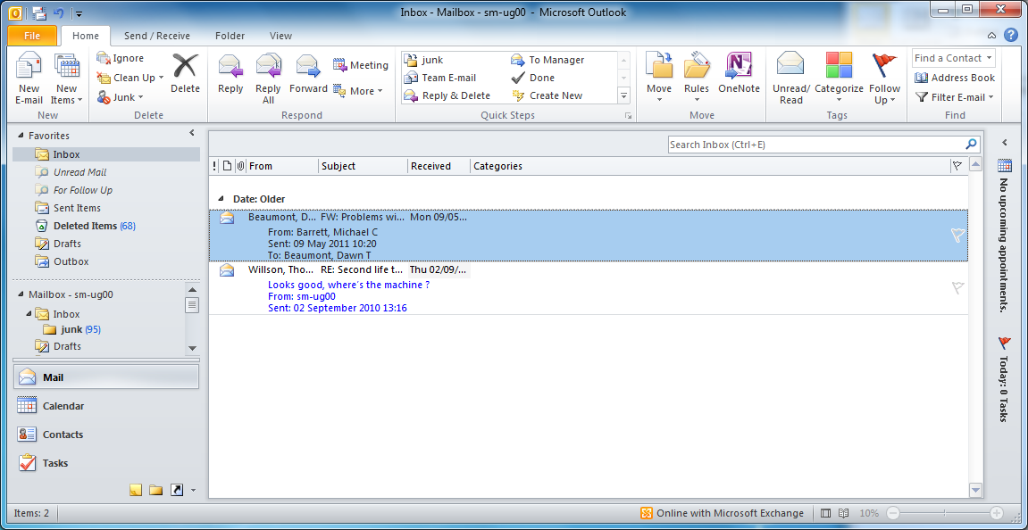Unread messages appear in **bold** text.

**Inbox**

The use of sub-folders you can create within the Inbox keeps it clear for new mail. It also makes it easier to locate any saved messages subsequently. Mail may be moved between boxes by “click and drag” with the mouse.

When you delete mail from the **Inbox** or its sub-folders, it is transferred to the **Deleted Mail** folder but does remain available should you change your mind. To clear out Deleted items, the Menu Bar Tools options include an option to Empty “Deleted Items” Folder.

**Note:** *You have a finite amount of space allocated to you on the College mail server. If you exceed this then your email will stop working and this may also lead to other problems in your use of the network. You should receive an automated message warning you of this situation and then you must make space by permanently deleting messages. The simplest way to avoid this situation is to regularly empty the Deleted Items folder (****Tools*** *menu) and to review saved messages in your sub-folders that may have exceeded their useful life*.

### Address Books in Outlook

You should store your personal collection of email addresses (and postal addresses & phone numbers) using Outlook **Contacts**. The information is stored on the mail server and is available whenever you access your email, including from anywhere outside the College network, including web access. In addition you can create your own Address Book(s) and you can also import other address data into these and export data for use in a personal email system elsewhere. Use the **Outlook Help** function to see more about this.

Open the **Contacts** folder. Yours will probably be empty at this time.

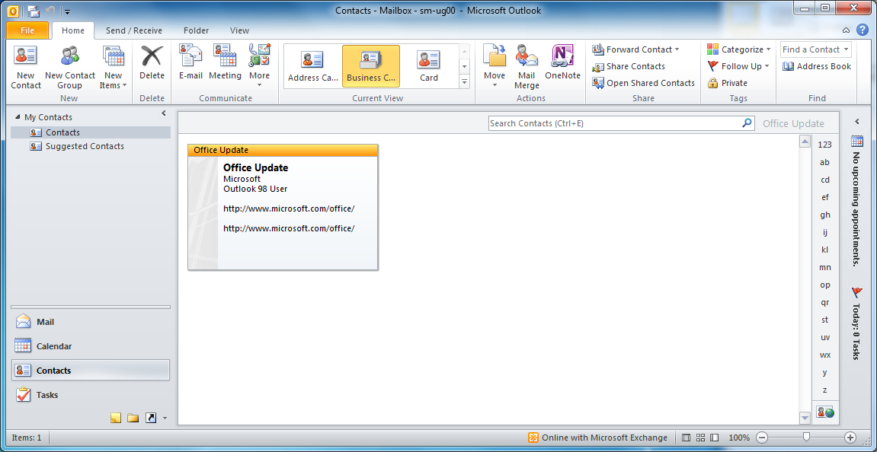

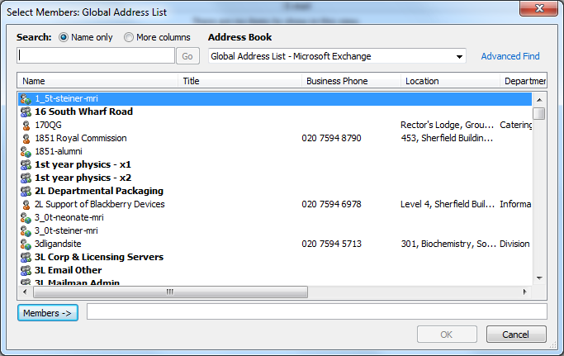To enter details, click on the **New Contact** icon, fill in the required details and then click **Save & Close**. **Group Mailing** is a very useful feature of email when you want to communicate with your tutor group, sports team, *etc*. To use set up a Mail group of multiple recipients, use the **New Contact Group** and add names to the list, either from your own Contacts list or the College Global Address Book and add them as **Members** to your list.

You can select one of the College address books from the drop down menu or use your own personal address book (bottom of list). Names may be removed from a list by highlighting them and clicking **Remove** button. Click OK to **Save & Close** when you have finished.

Please note that bulk emailing to *e.g.* large numbers of names taken from the global address book may be considered by recipients as harassment. It is against College Policy and is a disciplinary offence.

#### Finding someone’s email address

The simplest method is to ask the person. Other possibilities are the in-built global address book in Outlook, ordinary mail letters or advertising material from commercial organisations that have email address.

Additionally, for an address at a UK University, you can try one of the following web addresses for UK academic sites, such as <http://www.scit.wlv.ac.uk/ukinfo/index.php>

Locate the university and then department and see if there is an email address list available.

For wider coverage try one of the *People Finder* options in a portal site such as the Search option in IE or your favourite search engine.

In principle, this enables you to search the world for an address but in practice many organisations do not make this information publicly available.

#### Email Signature

Outlook allows you to create a “signature” which is added to the end of new messages. You can create and modify this if you wish. Go to the **FILE** menu and select the **Options** and click on the **Mail** tab and select **Create / Modify** **Signatures**. Use the editing tool and click OK to save.

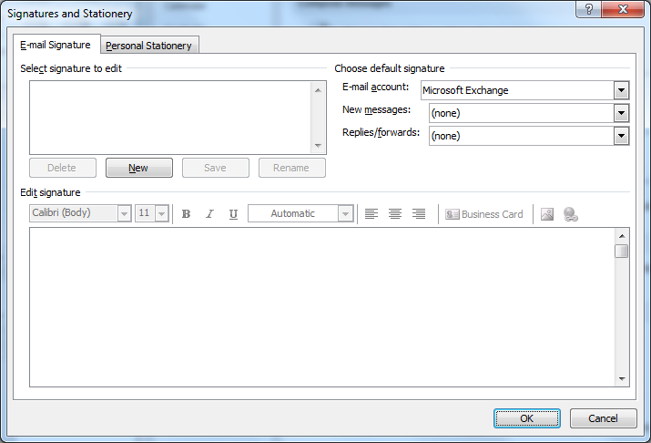

**Email attachments**

A very useful additional feature of email is that you can use it as a “vehicle” to send other computer files to the mail recipient. These can be image files, Word files, Web pages, program files, *etc*. See also **Sharing very large files** (pages 14 and 28) for alternatives for when email cannot handle large attachments.

**Note***: The recipient must have the appropriate software installed to be able to open the attachment.* ***The College system will NOT usually accept mail where the size of the message plus attachment is >10Mb and the success of sending large attachments to external email addresses will depend upon the recipient’s email server allowing large files to be received. See pages 14 and 28 for details of how to share large files using FileExchange.***

In the message composing box (**New Mail Message** icon), select the **Insert** option and navigate to the required item you are attaching. Locate the directory/file you want to add and select it by double clicking. An **Attachment** icon should appear on your email message.

**Note**: When you delete an email message that has an attachment, then the attachment is also deleted. If you want to save the attachment then you should open the attachment and “Save As” somewhere on your network drive or external storage (USB stick) before deleting the message. You may also right-click on the file icon in the email message. This provides a **Save as** option that allows you to save the file with a filename and location of your choice.

### Email your personal tutor

Send an email of greeting to your Personal Tutor. Email addresses for Tutors may be found when in the Computer Lab during the class exercises, or you may look up contact details for your Tutor on Student Welfare/Personal tutor pages of the Teaching intranet (<https://education.med.imperial.ac.uk>) or within Outlook, using the Global Address Book (GAB).   
Some tutors may be using their NHS email accounts so will not appear in the College GAB but their contact details will be shown on the Intranet. Some tutors will have been allocated a College email account but do not use it. Please check the Tutor list to see how to contact them.

### Web Access to Outlook

Your college email can be accessed from anywhere in the world by using the Web (<https://exchange.imperial.ac.uk>). You should also look at the email section of **IT Facilities – Q & A** section (see later) to find out how to **access your Outlook email over the Web when you are away from College** and for some useful tips about making the most effective use of email. When using the web access to your College email, ALWAYS quit the browser at the end of the session to prevent other users of the PC gaining access to your email account.

**SPAM**

As a member of a very large educational establishment, it is inevitable that you will receive SPAM emails from outside College. College strives to restrict access to its global email address lists but merely by using the Internet you may inadvertently provide an external website with details of your account name. Subsequently you may start to receive unsolicited emails of offers of goods and services. You are strongly advised to delete all such messages. College operates a SPAM filtering service on the email servers which you are advised to use. See the ICT webpage describing the service that can be provided on your College email account.

Details may be found at

<http://www3.imperial.ac.uk/ict/services/useremailfileanddirectoryservices/email/emailsecurity/spamfiltering> where you find information on how to change your filtering preferences via the SPAM console.

**Email Etiquette**

See page 33 of this guide.

**POWERPOINT  
Screen Presentations**

Almost all of your lecturers will be using **Microsoft PowerPoint** presentations, and the vast majority of these will be made available to you on the teaching intranet or in Blackboard—some will appear before, and some after, the lecture. As the course progresses, you will need to prepare your own presentations.

**Tips when creating PowerPoint presentations**

* Make the presentation clear. Use a sensible title and include your name on the title page. Avoid too many words on a page. As a rule of thumb, aim for 4-5 bullet points per page to give your presentation greater clarity for the reader.
* PowerPoint design templates are very useful but do be careful as to which you use. Many are business-specific, or have gradated background. These can look “nice” on a computer screen, but less so when projected or when printed.
* Use a font colour that is a high contrast against the background.
* Avoid red and green for font colour and background, as this is causes problems for those with colour-blindness
* Use sensible and clear fonts. **Cursive fonts are OK for invitations, not for professional presentations.** Which in Arial font says “Cursive fonts are OK for invitations, not for professional presentations.“
* Guidance on making your work “inclusive” for others is available at the Tech-Dis website <http://www.jisctechdis.ac.uk/>.
* Further guidance on presentations will also be provided in the Clinical Communications course which is also within the Foundations of Clinical Practice Theme.

**SHARING VERY LARGE FILES**

There will be occasions when you need to share files with colleagues, and the usual way of doing this might be by email. Unfortunately there are limits to many email systems as to the file size they allow. However, you can share very large files using a secure **File Exchange** service provided by College. This is just to make you aware of this service available to you which you can also access remotely.

<https://fileexchange.imperial.ac.uk>

There are two versions.

The “Old FileExchange Service” unfortunately only allows you to upload one file per “job”.   
Logon and upload a single file—The system will show you the location for the saved file and offer you the option of emailing that link back to you. You then share that link information with colleagues by email and they then have 14 days within which to retrieve the file.

The “New FileExchange Service” allows multiple files to be uploaded. This version allows you to specify the recipient’s email address and sends emails to you when the recipient of the attachment has picked it up.

The system deletes all saved files after 14 days of upload so there are no file management issues for the user. Please note that ICT are not able to recover files that have already been deleted by this automated housekeeping.

There is an upper limit on the file size that can be saved per job, but it’s REALLY big – 1Gb.   
It is not recommended you ever create documents that large as most users just will not be able to handle them, and the upload and download times will be considerable, even if you are using a PC in College.

Try it out before you need to use it, so you are confident in how to use it. You can access the service remotely and share files with others outside of College. They can also use it to share files with you.

**Undergraduate Medicine Teaching Intranet and Blackboard resources**

**INTRANET**  
The majority of your course materials will be found online at the Teaching intranet

<https://education.med.imperial.ac.uk>

Authentication is required using your College username and password.

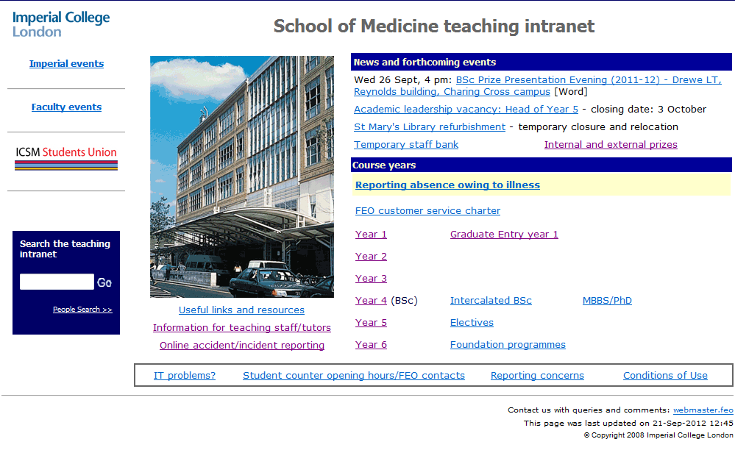You have access to all areas of the intranet. Please explore, starting with Year 1.

**Learning objectives**

* Logon to the intranet and lookup your timetable of rotations in Patient Contact Course (PCC), problem-based learning (PBL), Clinical Communications, etc.
* Discover how the course materials are arranged
* Note the Conditions of Use of materials supplied via the Intranet and Blackboard (see later)
* Explore how in later years you can look back to the previous year’s course materials for revision.

If you have any queries about links, or comments, please email [webmaster.feo@imperial.ac.uk](mailto:webmaster.feo@imperial.ac.uk)

**Blackboard** is the College’s Virtual Learning Environment; <http://bb.imperial.ac.uk> and will be used alongside the School of Medicine Teaching Intranet for various components of your teaching and self-directed learning. Please see the separate [Guidebook](http://www1.imperial.ac.uk/medicine/teaching/elearning/blackboard/) for details about Blackboard and how to personalise your view of the courses.

**My E-portfolio**

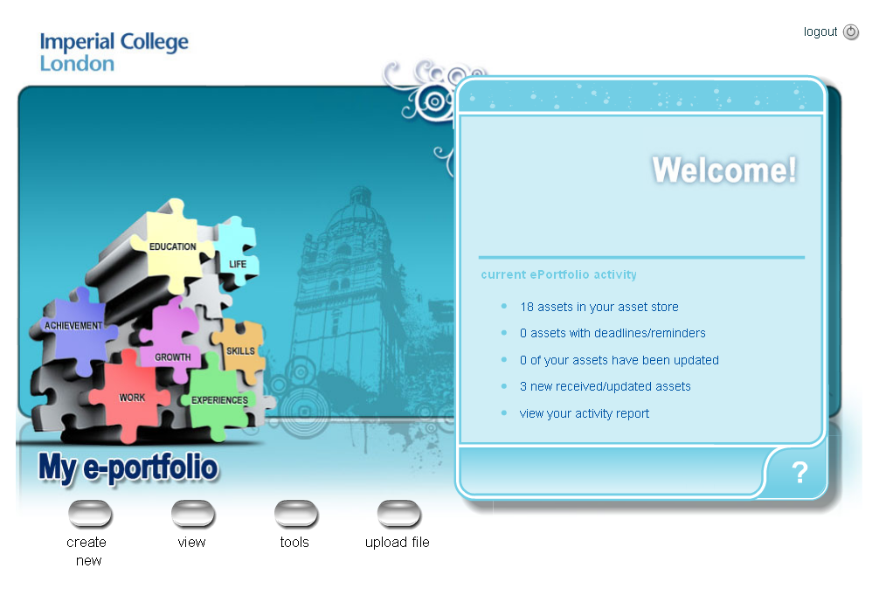

**E-portfolio is a:**

* **PLACE** to keep all your information in one place
* **PROCESS** that facilitates your learning and development

This takes effort. E-portfolio is **YOURS** to: **Record, Reflect, Share and Feedback**

|  |  |
| --- | --- |
| **[edit-largec](https://sites.google.com/a/chelwestedu.com/portal/meded/education-portal/how-to-edit-this-sit) Record**   * + Keep evidence of your skills, activities, events   + Track your progress   + Celebrate your achievements   + Use your records as a basis for applications (e.g. for jobs) | [announcementsc](https://groups.google.com/a/chelwestedu.com/group/year3students/topics?ln) **Reflect**  – experience > evaluate > learn> apply  = improve   * + How well are you doing it?   + What and how can you improve?   + How can you develop further? |
| [keypeoplec](https://groups.google.com/a/chelwestedu.com/group/m1/member) **Share**   * + Submit work for feedback     - To tutors (inc. formal assessments)     - To peers   + Participate     - Learn from others’ experience     - Showcase yourself | [feedbackc](https://sites.google.com/a/chelwestedu.com/portal/undergraduate-education/year-3/firm-pages/m1/m1-feedbac) **Feedback**   * + To/from your peers   + From your tutors |

E-portfolio currently covers Years 1, 2 and 3, with a view to eventually expanding throughout your medical school career. We will be reviewing whether the new VLE could host e-portfolio in 2013-14, which would bring unity across the learning technologies and may help smooth navigation. We will keep you informed about any move to a new system, including how to export work between systems if necessary.

**What does E-portfolio look like in Year 1?**

* Activities specifically within courses:
  + First Year Clinical Attachment
  + Communication Skills
* Activities for you to record your own experiences and skills throughout your time at medical school. This helps you track your progress and learn by reflecting on your experiences. Examples include:
  + Clinical Skills Logbook
  + Professional Skills Logbook
  + Exams Reflections
  + ‘Thoughts’

You will receive a teaching session on e-portfolio later in the Autumn term, where guides will be distributed. In the meantime, if you wish to explore further, you can find your e-portfolioat [**http://www.pebblepad.co.uk/imperial**](http://www.pebblepad.co.uk/imperial) and log on using your Imperial username and password.

Further information on e-portfolio can also be found on: **www.imperial.ac.uk/medicine/elearning/eportfolio**.

**INFORMATION LITERACY TRAINING**

Being information literate empowers you to become an independent learner with the confidence and ability to retrieve, evaluate, exploit and manage information. To help develop your information literacy skills you are required to attend one lecture and two practical workshop sessions run by library trainers.

You are also required to complete an online assessment on plagiarism and referencing.   
The aim of the assessment is to demonstrate that you have accessed and understood the materials on plagiarism and referencing therefore poor performance will not be penalised, however, these skills will be vital to your course as good referencing will gain you marks.

Failure to complete the plagiarism assessment will result in a note on your file explaining that your work is likely to be subjected to extra scrutiny for plagiarism. Non-completion of the assessment means that, if you are found to have committed plagiarism, the failure to help yourself by doing the assessment will be taken into account. Completion of the assessment will be monitored by library trainers during the second practical workshop.

The information literacy sessions are closely linked to the Problem Based Learning course and the PBL tutors will be looking for the skills learnt here to be displayed in PBL sessions and the PBL exam. The workshops use a blended learning approach which means they will use a combination of presentations and hands-on work.

The dates the lecture and practical workshops will be held are shown on page 3. All sessions will be in the Sir Alexander Fleming Building, South Kensington campus. Please note which group you are in & what date and time your lecture & workshops will be held. G29 is the large computer lab, furthest from the entrance to the Computer Labs from the ground floor lobby.

The learning objectives for the lecture and two practical workshops are outlined below:

**Learning Objectives**

By the end of the Library & Information Literacy **lecture**, students will be expected to:

* Understand the services and resources provided by the library
* Understand what information literacy is and why it is important
* Understand how being information literate will gain you marks

By the end of the **2 practical workshop sessions**, students will be able to:

* Access e-resources and understand access issues such as passwords.
* Access the PubMed (Medline) database and complete a basic search.
* Use appropriate information sources.
* Understand various methods of managing information
* Understand the importance of critically appraising research
* Describe what plagiarism is (and the different types that occur) and how to avoid it
* Cite and reference information appropriately using the Vancouver system of referencing.

**Submitting your quiz results**

In order to submit your plagiarism quiz for marking please:

* Log in to Blackboard with your College user name and password at <http://bb.imperial.ac.uk>
* Click on Olivia (Medicine)
* Go to the Course Tools menu on the left hand side (you may need to click on the arrows in order to display the Course Tools menu if it is hidden).
* Click on Assessments in the Course Tools menu (third from the top).
* Click on the Year one plagiarism quiz link, the quiz should now display in the right hand panel

If there are any problems with logging in or accessing the quiz then you should email [library@imperial.ac.uk](mailto:library@imperial.ac.uk).

The Library’s medicine resources page is at: <http://www3.imperial.ac.uk/library/subjectsandsupport/medicine>. You can find contact details for librarians at every medical campus library and links to electronic resources together with links to medical databases and e-journals.

For guidance on access to electronic resources (including remote access) see <http://www3.imperial.ac.uk/library/find/howto>.

IT Facilities - Questions and Answers

#### What PC facilities are available?

The PC facilities in clusters for the Faculty of Medicine use multimedia PCs running   
Windows 7 and Office 2010. On the following campuses the main clusters are managed for the Faculty, but there are also PCs managed by the Library:-

* **South Kensington** - Sir Alexander Fleming Building: there is a cluster of 130 machines in two labs (100 + 30).
* **Charing Cross**: the PC clusters are situated within the Library (2nd floor, Reynolds Building). A smaller cluster is also available at CX during normal working hours in the ICT basement office area.
* **St Mary’s**: the cluster is in the Hynds Computer Lab, 1st Floor Medical School building.
* **Chelsea & Westminster**: the cluster is within the Library (Lower ground floor). There are also a limited number of PC’s in the Student Common room (Lower Ground Floor).
* **Hammersmith**: there is a cluster of 20 machines and printer on the 7th floor, 7206,Commonwealth Building, and 14 machines on 6th floor, Cyclotron Building and a small number of PC’s and printer in the Student Common room (Wolfson Education Centre).
* There are other machines elsewhere in the College that you may also use, e.g. Main Library, as well as machines on the other clinical campuses, including District General Hospitals (Associated University Hospitals). You are able to**logon** at any of these College machines and see exactly the same thing, and have access to all of your files.

These facilities are provided primarily to support your studies. They are not intended to be social/recreational areas but a reasonable amount of “personal” use is permitted, within College Regulations. Please consider those around you when using the cluster PCs.

**Listening**

Some learning materials you will be accessing during your studies will include sound clips and commentary. When using any of the cluster computers in the School of Medicine or in the libraries you will need to bring your own earpiece or headphones. The phones socket is on the front panel of the computer.

**Can I use the PC cluster at any time?**

* There will be times when the School of Medicine cluster machines will be booked for specific teaching classes and so will not be available for general use during these periods. All our clusters are equipped with printers for your use. All of the software that you will need is supplied and it will not be possible for you to load your own favourite programs (see later).
* Charing Cross, the cluster is available all week up to around 10.15 at night except on nights when there are special functions in the building – see local notices. Outside of normal Library opening hours, access is via the lift lobby foyer on the 2nd floor of the Reynolds Building – you will need your ID swipe/proximity card at all times.
* SAFB clusters may be used up to around 10.45pm each night, all week.
* Hammersmith clusters are (currently) available 24/7.
* Chelsea & Westminster cluster is available during library opening hours only.
* Other clusters may have differing closing times.

#### Can I use my home PC for course work?

Certainly, but note that if you are not using the same version of the software at home which is used in College, work produced at home may not run properly on the College network and *vice versa*. You can link in to the College network from home using broadband/modem/phone line connection. Advice on this can be obtained from the Information and Communications Technologies Division – ICT – see below.

#### Can I plug my PC directly into the network in College?

You must register your personal PC with ICT if you wish to connect it to the College network. If you wish to connect your own PC to the College network, you will be required to ensure that it has been updated with the latest security systems patches and has had the antiviral software configured and updated. The local ICT Help Desk team can assist you with this. The MS Vista Home operating system does not include authentication procedures for institutional networks and so cannot be used directly on the College network via a wired connection.

In some areas a wireless network will be available. For connections in Halls of Residence, details are provided locally. Further details are available at:

<http://www3.imperial.ac.uk/ict/services/securitynetworkdatacentreandtelephonyservices/collegenetwork/networkconnections>

#### Can I connect via Wi-Fi?

An increasing number of areas in College are wireless-enabled. See the above link for details of Wireless Connections.

#### What configuration settings do I need for a VPN connection?

These are also available at the ICT Networks link, as above.

#### What about using my PC in Halls?

See the local Halls of Residence documentation about connecting your PC in Halls.

#### Can I buy my own College-specification PC or laptop?

ICT provide guidance about purchasing a laptop for personal use. See the ICT New Students web page <http://www3.imperial.ac.uk/ict/services/newstudents>. Please note that some PC/laptop deals exclude software.

If you are planning to buy a portable with a view to using it on the College network you can also get advice from ICT via the manned Help Desks, or the Service Desk. Other information on personal purchases from the preferred College suppliers may, from time to time, be found on the College Administration’s purchasing website but please note that details are constantly changing. See… <http://www.purchasing.ad.ic.ac.uk/Product%20Areas/Computers/index.htm>

#### Am I allowed to use College software on my own computer?

In general the answer will be **NO**! Most of the programs come from commercial software companies and the College has appropriate licences for use of them but the licences are unlikely to allow students to install the programs on home machines. The good news is that many of the programs are available for purchase at student discount rates through the College’s **ICT Software Shop** on 4th floor Sherfield Building, South Ken <http://www3.imperial.ac.uk/ict/services/personalcomputersupportandmobileservices/softwarepurchase>

For some software used in the course, e.g. some e-learning material, you may install copies on your own machines. Details of these will be available on the School of Medicine Teaching Intranet <https://education.med.imperial.ac.uk> . You are also entitled to the College’s anti-viral software free of charge (see **Essential Information** section, below) and you are strongly urged to take advantage of this offer if you do not already subscribe to antiviral software.

#### How can I protect my PC? Computer Viruses & Security patching

Computer viruses can wreak havoc and can rapidly spread through a large computer network like that at Imperial. Many of these viruses are blocked upon entry into the College networks by the vigilance of ICT-Security services. As an added precaution, College machines have anti-viral software installed which is automatically updated to deal with new virus as they appear. **The licence for this software allows all members of College to install this software on their own personal machine**.

Whilst you are a student of Imperial College London, you may install a copy of Symantec Antivirus (for Windows and Mac). All members of College have the right to use this software and can install it free of charge on their personal systems e.g. in Halls and at home.   
The software can be obtained from the Software Shop at <http://www3.imperial.ac.uk/ict/services/personalcomputersupportandmobileservices/softwarepurchase/softwareshop/priceindex/studentpricelist>

If you install this software on your personal machine, please ensure you configure it to check regularly for the latest virus signature file on the server. Disk sets can also be generated or obtained in other formats from the ICT Shop for a small fee.

You are advised to install anti-malware software onto your own machine and you can download a personal copy of **Malwarebytes**, free of charge.

Further details may be obtained from the ICT Software Shop website. See ICT’s Information for New Students at <http://www3.imperial.ac.uk/ict/services/newstudents>

Security patches for operating systems and common applications are usually available online and you should ensure your system is loaded with the latest systems patches so as to avoid security breaches. The ICT help Desk teams can advise and assist you.

Beware of “phishing” for your login details for bank accounts, email, social networking sites, and sites you use for online purchasing. Never respond to a request to enter username and password onto sites you have not accessed by entering the correct URL that you know. Phishing emails invite you click on a URL link which masquerades as a legitimate site.

Look at the **ICT Security Awareness site** for more advice and help <http://www3.imperial.ac.uk/ict/secureaware>

**Where is the ICT Software Shop and can I get other software through ICT?**

The ICT Software Shop is in the Sherfield Building 4th Floor [west end], South Kensington campus and their opening hours are 9.30am-5.00pm but all software sales have to be completed by 4.30pm. The web site is

<http://www3.imperial.ac.uk/ict/services/personalcomputersupportandmobileservices/softwarepurchase/softwareshop/priceindex/antivirus>

#### Can I load my favourite programs onto the College network?

**NO!** The smooth functioning of the College network depends upon regular behind-the-scenes maintenance by the IT support staff. If all the students were able to load programs then there would be chaos and the network would fail.

#### What are the rules about using College information technology systems?

It will not surprise you that the use of College computing facilities is governed by a number of rules and regulations to which you must conform. Some of these are legal requirements (Data Protection Act, Race Relations Act, *etc*) whilst others are local, College requirements. Details of these have been given to you in the Student Handbook and you must read these before you use the facilities. Misuse of the facilities will be taken very seriously by the College and severe penalties will be imposed on anyone caught. These rules also apply to the College staff in exactly the same ways as to students. Ignorance of the rules will not be accepted as an excuse for misuse. It is your responsibility to ensure that you conform to the requirements in force at the time. Don't be deterred by the **rules** for using the computers. When you read through them you will see that most are just a matter of common sense and politeness. Perhaps the greatest danger lies in the speed of electronic communication. It is so very easy to fire off a reply to a message that is either inappropriate or ill-considered. **Think before you send!**

#### How secure are the IT facilities?

In order to use the computer facilities you will need to **"logon"** which involves entering your personal username and your personal password. **This is your main source of security and you must not reveal these details to anyone else**. If you do, others can use the computers in your name and you will be held responsible for anything that they do. When you have finished your session you must also **logoff** otherwise the machine remains active when you leave and someone else could use your “active” account and **appear to be you!**

**Do I get a personal storage space on the network?**

You have a personal space (**Personal Directory**) on the network, showing as your **“H:” drive**. <http://www.imperial.ac.uk/ict/homedirectory>

Undergraduate (non-research or taught masters courses) student H: drive quotas are **4Gb**.   
This network space is private to you and can only be accessed via your password. You can also access this directory remotely by means of a VPN connection – see <http://www3.imperial.ac.uk/ict/services/securitynetworkdatacentreandtelephonyservices/collegenetwork/networkconnections/vpnconnection> which also gives details of how to view your H: drive

Your personal directory is automatically mapped on login as H:\. . It is backed up every night and your data is kept for 3 months. In order to allow for recovery of overwritten versions of files, ‘Shadow Volume Copying’ is used – right-click to restore earlier versions. You can contact the Service desk to restore any versions of files you can’t find.

**Where can I save documents?**

Work which you produce or files that you download can be “permanently” saved for later use. Apart from the personal storage space on your H: drive, you are likely to want to save files to a **USB device** that you insert in the machine you are using, write to a CD/DVD 9increasing less likely these days) and then subsequently take away with you; or you can save it onto a networked **hard disk**. This is not removable and is **not physically located on the machine you are using**. In some cases you may want to save copies by several methods.

**Do not try to save files on the College PC’s local hard disk C.** Any files saved to **C:** are only accessible on that specific machine at that logon session and would not be available if you were then to logon to a different machine. The machines are “frozen” and overnight they restore to their default state so any file stored during the previous day is then irreparably lost.

**Remember that no security system can guarantee absolute security of information**.   
If you want to save personal information that you would not want others to see, think where to store it. **Note:** when storing personal details about others your use of the computer facilities must be in accordance with legal and College requirements.

**How do I obtain removable storage media?**

Try the Union Shop on the walkway, South Kensington campus.

**Should I encrypt my files?**

The recommendation is that you do so that if any storage media is lost, any private details about yourself or mail list, for example, will be incapable of being high-jacked. However, do remember that if you forget the password for your encrypted files, College ICT may be unlikely to help. See the ICT Security pages for helpful advice about encryption.

**Are there restrictions about storing Patient data?**

Information by which patients can be readily identified, must NOT be stored on the College systems, including email. More information on the Guidelines for handling patient data are to be on the teaching Intranet at <https://education.med.imperial.ac.uk/policies/policies.htm>. We urge you to be especially careful to avoid use of any patient descriptors but if you cannot and they are stored on personal file space/media they must be encrypted.

**Is the network traffic monitored?**

You should also be aware that for network management and maintenance purposes, all activity on the network is automatically recorded in a log. This is not as menacing as it may sound: there is no “Big Brother” looking over your shoulder. No one has the time to routinely examine the huge number of transactions taking place on the College network each day. However, if a question of possible misuse of the facilities arises, that activity will be traceable even if the user has deleted all of the relevant files.

#### How can I share very large files?

Often there is the need to share files with colleagues, and the usual way of doing this might be by email. Unfortunately there are limits to many email systems as to the file size they can cope with. College email restricts total file size (message + attachment) to be 25Mb. You can however share very large files within College using a secure **File Exchange** server system. These notes are just to make you aware of this service which you can also access remotely.

<https://fileexchange.imperial.ac.uk>

Try it out before you need to use it, so you are confident in using the service.

Logon and upload a file. Use the “new system” as that allows you to upload multiple files per “job” or you might wish to create a .zip file of many individual documents and upload that as a single “job”. The system will show you a location for the saved file and offer you the option of emailing that link to yourself or to a designated recipients who have up to have 14 days in which to retrieve the file. You can use this to share files with others in College, or externally.

The system deletes all saved files after 14 days of upload so there are no file management issues for the end user. There is an upper limit on the file size that can be saved per job, but it’s REALLY big – 1 Gb – but it is not recommend that you ever create documents that large as most users just will not be able to handle them, and the upload and download times will be considerable, especially via a home connection.

Currently, there are two versions of the system. If you select the “New Service” the system emails to you when the recipient of the attachment has picked it up.

**Can I change my password without being on a College machine?**

Yes - More information about passwords can be seen at <http://www3.imperial.ac.uk/ict/services/security/securitypolicies/passwords>

Including how to change your password online.

##### What is a Roaming Profile?

Windows 7 allows you to logon to any machine in the Faculty of Medicine clusters together with general access machines in the College Library and to have each logon bring up your personal configuration settings , e.g. for browser favourites, Word settings, etc. You will have access to the same software on all machines in the Faculty of Medicine. The personal profile allows your own ‘personal’ default settings to be used for Outlook, Word, Excel, screen savers, *et*c. which travel with you as you log on and off of different machines. This information is stored in your ‘Roaming Profile’. At the end of any session, when you logoff, your profile information is loaded from the machine you are using to specific areas on a profile server. The next time you login, this latest profile information is loaded back to the machine you are now using, and all the local software is then configured to your settings. Additionally, this means that your web cache (copies of web pages previously visited) is also copied so you have a quicker access the next time you wish to view those pages. These files are therefore also part of your profile quota (see below). Since the profile is important to you, *i.e.* it contains your set-up preferences, it is critical that you do not do anything yourself that may cause it to become corrupted. One way by which you can cause your profile to become corrupted is to go over-quota on your disk space usage (see below).

Additionally, overnight ICT deletes files stored on the C: drives of cluster machines as part of their continual systems housekeeping. Some applications, *e.g.* MS Office applications, will try to save files into your ‘Desktop’ area by default. Avoid using the Desktop to save files because it is part of your roaming profile which is copied back to a fileserver when you log out and then copied back to the PC’s local disk when you log in. If any changes are made to your as to increase the profile size, e.g. by adding large files, this will drastically slow down the logout and subsequent login processes. You are advised therefore to use your home directory on the H: drive for storing files, or to store then direct to removal media. Files stored on the H: drive are only accessed when you need them and are not part of your profile. You can access your H: drive remotely, via a VPN connection.

##### What if I exceed my Disc Space Quota?

Many of the problems when users find that they can no longer perform certain tasks on the College computers are due to the allocation of filing space on the network servers —t he quotas — being exceeded. If you exceed your quota, your roaming profile may become corrupted (see above) and may need to be reset with assistance at ICT Help Desk walk-in sessions. A fixed amount of profile storage space (1Gb) is assigned to your login name. When this quota is used up, you will not be able to store any more files unless you first delete other files. You may therefore wish to transfer them elsewhere, *e.g.* to removal media, for safe keeping.

If you attempt to exceed your **H: drive** quota (4Gb), you will receive a warning message box on-screen showing how much of your quota on the H: drive has been used and you will not be able to logoff until the quota limit is no longer exceeded. You will also receive an email message giving more details, including names of largest files.

Email messages, including any attachments, that you receive (**Inbox**) and send (**Sent Items**), are charged against a **different** quota on the Exchange email server. Your Exchange quota is 1Gb but fortunately Outlook heavily compresses messages and calendars in its database, so this represents a considerable amount of message storage unless you also store attachments within messages. Your usage may therefore be substantial especially if you receive/send multimedia email messages! You should, therefore, ‘purge’ your email folders regularly since going over quota will prevent you from sending any messages. When you delete an email in *Outloo*k, it is transferred to the **Deleted Items** folder and so will remain part of your mail quota. You must empty the **Deleted Items** folder to permanently remove these messages and any attachments (see Workbook). As you approach your quota limit, you will receive an automatic email telling you this is the case. If you go well over your email quota, you will still receive incoming mail but you will not be able to send messages.

If you have any difficulties with these housekeeping issues, attend one of the ICT Helpdesk walk-in sessions for assistance. If problems prove not to be readily resolved by the help desk teams, please send a full description of the problem, and all attempted remedial action taken, to Dr Mike Barrett, Head of Learning Resources, School of Medicine,: mike.barrett@imperial.ac.uk

##### How can I get help with IT?

* College ICT have a webpage with useful details of the services on offer  
  <http://www3.imperial.ac.uk/ict/services/newstudents>
* The new ICT FAQ pages are content rich and many queries will get an answer there <http://www2.imperial.ac.uk/blog/ictfaq/>
* Check any on-line Help menu associated with the program you are using.
* Ask a fellow student - most are happy to share their knowledge.
* Consult documentation available from the ICT Service Desks or on-line via the Web at <http://www.imperial.ac.uk/ict/services/documents> or ask for their assistance at walk-in Help Desk sessions (see details elsewhere in this guide for times/places).
* Email the query to the Service Desk ([service.desk@imperial.ac.uk](mailto:service.desk@imperial.ac.uk)) or phone them on 020 7594 0000 or use their On-line self-service facility (see [www.imperial.ac.uk/ict](http://www.imperial.ac.uk/ict) )

The Service Desk also deals with all faults (hardware and software).

# How can I report faults

Please report all software and hardware faults to the ICT Service Desk as soon as you discover them. Please ensure you have the identified the problem machine in your message.

If you think you have a problem with computer account, please contact the Service Desk teams as soon as possible.

You can report faults and put queries online by following the link to the Self-help Service Desk at <http://www.imperial.ac.uk/ict/>

Alternatively, email **service.desk@imperial.ac.uk**, or phone 020 7594 9000

#### Immediate help for students

The main ICT Service Desk area, 4th floor, Sherfield Building (South Kensington campus), also provides a weekday service from 10AM to 6PM each day. Help will be available to configure student laptops for use with the College network (e.g. in the Library) and also wireless connections if required. The campus ICT support teams also provide drop-in clinics at the times stated in the link above, or by arrangement.

#### Help Desks at Faculty of Medicine sites

Helpdesk staff are located on the following campuses:

Charing Cross Chelsea and Westminster Hammersmith

Northwick Park Royal Brompton St Mary's

South Kensington, Sir Alexander Fleming Building

Further details about these Help Desks can be found at <https://www.imperial.ac.uk/ict/servicedesk/locationsandopeningtimes/icsmlocalhelp/>

The Help Desks at the various campuses normally operate every weekday lunchtime during term, from 12.30 p.m. to 1.30 p.m. when a member of ICT-IT services staff will be available to deal with queries and to give advice. Timings may vary on different days so look out for local notices. Outside of these times, the ICT staff may be available but this cannot be guaranteed. See the URL above for opening times of Help Desk at the campuses.

**PRINTING**

**School of Medicine Computer Labs**

The PrintService for the PC clusters is managed by the ICT. Printing is available from any PC in the PC labs, via a managed printing system operated via a virtual credit account for which your College ID Swipe card is your personal key. Your account is being credited with **£5.00** to get you started and this allows you to print about 170 sides of A4. You cannot draw this credit out as cash! Your account may be “recharged” with cash credits at any time using the money loader situated in Central Library, South Kensington campus, or online by credit or debit card at <http://www.imperial.ac.uk/ict/printservice> - login and select the “**ePay**” option. Please ensure that you have enough credits in your account if you intend to be using the cluster outside of staffed periods. The service also provides for **photocopying** and for **scanning** to your email address. The College Libraries also have printers, some colour, and their charging policy may be different to that applying in the School of Medicine cluster. We encourage you to use the Faculty of Medicine Printers if at all possible.

**Charges**

On Faculty of Medicine printers, all monochrome printing is currently charged at 3p per printed side and colour at 12p per printed side. You can also specify how you wish a PC print job to be printed. The default is full size and double-sided. Within the print job at the PC, you can also specify printing 2-per-page, 4-per-page, *etc*. “Scan to email” is free.

Many students print out all the material that is made available electronically: this will be expensive! Having a paper copy does not automatically mean it is read and understood!   
Do make decisions about what you need to print out. Many lectures contain images, *etc*. that are purely illustrative and do not need to be printed – remember all the material will remain available for you to access online, so you don’t need to print everything out. If you wish to print out material that is not otherwise provided as hard copy, carefully review what you need to print, and how. See below for how to print multiple pages per sheet more clearly.

**How to print**

Print from your PC in the normal way from within the software application that you are using. The print job is written to a special area and does not appear in your own directory. The cost of your print job therefore depends upon whether you selected the monochrome or the colour printer driver from within the print command on the PC. If you use a colour printer for a mono job it will be charged at mono print rates.

(i) Go to the printer in the computer lab; (ii) Swipe your ID card; (iii) Use the touch-screen display panel to select the function required (print from PC, Copy, (scan) to email. Note: FAX facilities are not provided) A directory listing of recent print files belonging to you will be displayed; (iv) Select the file to be printed; (v) Always protect the printer credits on your account by logging off the printer after use; (vi) Collect your pages from the printer.

**SCAN to email**

You can vary the scanning settings to give you different scanning densities and types of output files (PDF, JPEG, TIFF, *etc*.), colour or greyscale. Note that mono printers will scan in colour. You can also configure the scanner to email other email recipients, including external.

### What to do if the printer runs out of paper/jams

See local notices or contact ICT staff or email [Service Desk@imperial.ac.uk](mailto:Service%20Desk@imperial.ac.uk) or telephone on 020 7594 9000. Note that at weekends, evenings, bank holidays and other College closure days, immediate local support is not available.

**Printing Acetates**

Under NO circumstances print to acetate sheets as these damage the laser fuser engine.

**How to print presentations more effectively & cheaply**

You might consider printing multiple pages of the original on each sheet. Within all software applications, there is usually a software-specific set of printer controls. You should use these in conjunction with the printer driver configurations to make your printed output clearer to read and allow you to better organise how it appears when printing multiple pages per sheet.

For example, from PowerPoint you can choose to print the slides as multiple handouts per page. Here are 2 screen shots of the printer dialogue box as viewed from PowerPoint:

Selecting to print slides in different page configurations

Use the Handouts Section to vary numbers of slides per printed sheet

Here, 3 slides per page has been selected   
with lines for notes

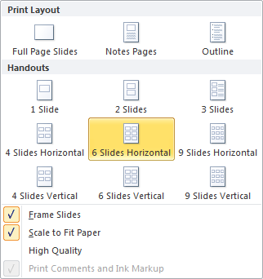 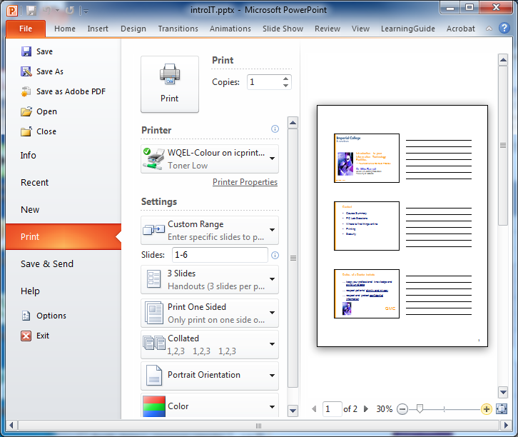

However, if you control how you print using the printer drivers, rather than powerPoint,, you can print the same content but it can be made to appear larger on the sheet and so be more legible.

Thus… at the Printer dialogue window, select “Slides” as what is to be printed, and then via the Properties option of the selected printer, on the “Finishing” tab and select how many pages to print per sheet, and page orientation.   
This example shows “6 pages per sheet” as being selected.

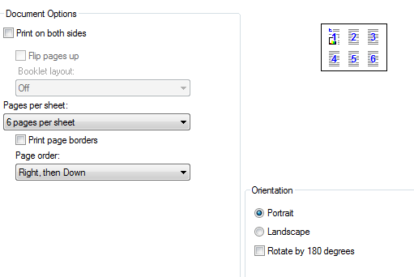

|  |  |
| --- | --- |
| This is what you get from the printer having selected 6 **handouts** per page using the **PowerPoint** printer driver. | This is what you get from the printer having selected 6 **pages per sheet** using the **Printer properties** driver. |
|  | C:\Users\mikeb\Desktop\printerdriver.jpg |

As you can see immediately, the second option on the right gives a much clearer view of the content of the presentation. If you choose to print 4 per page on the printer driver controls, this will usually give a sufficiently large image per page to make even complex diagrams legible, and still give you enough white space to write notes.

### Printing & cluster facilities at College sites

Printing facilities managed by ICT are provided in the computer clusters in the Sir Alexander Fleming Building, South Kensington campus; at main clinical sites (Hammersmith, St Mary's, Charing Cross and Chelsea & Westminster). At St Mary’s the cluster is in the Hynds Computer Lab, 1st Floor Medical School Building. At Chelsea & Westminster the cluster is in the Library. At Charing Cross the main cluster is within the Library (2nd floor) with a small cluster in the basement; at Hammersmith the clusters are in Room 7S06 (+ printer), Commonwealth Building and on the 7th floor of the Cyclotron Building and a small cluster + printer in the Student Common Room, Wolfson Education Centre: Library PC + printer facilities also available on this site. All College site PC clusters require swipe cards for access. District General Hospitals with College PC clusters have local arrangements for printing and you will get details of these when you are attachment at these hospitals.

**Further details about Printing/Scanning**The ICT website has lots of information about using the system.

See [www.imperial.ac.uk/ICT/printservice](http://www.imperial.ac.uk/ICT/printservice)

**Email**

# Using your Email account

You will already be using personal and institutional email accounts which you can continue to use this whilst at Imperial College. However, you **must** regularly check your Imperial email account as well. This is the main means of contacting you for teachers, tutors and admin staff located at the various sites that make up the School of Medicine. It is School of Medicine Policy that information relating to your course, including official examination information, will **ONLY** be sent to your Imperial email account. Usually, when critical documents become available they will be placed on the Teaching Intranet and you will be emailed about them. You will **NOT** be emailed when each new item of lecture support material becomes available as we expect you to regularly visit each course’s web page for new or updated files. On College PCs you are advised to use Microsoft Outlook and on logon you will see a desktop shortcut to it. Please note that all students have a quota of storage in Outlook. If your Outlook folder size goes over 500Mb you will not be permitted to send messages.

## Getting access to your email when you are away from College

##### Direct Connections in Halls of Residence

##### Many of the Halls of Residence are networked. See local documentation in your Hall for details of how you may make use of this.

##### Remote connection through ISP

You can access your College email using any web-browser from anywhere in the World. See the **Workbook for Email** for more details about how to use the web access to College email.

There are two recommended methods for use with a dial-up /broadband connection and ISP account

* **Low usage users,** **or if accessing email from many different offsite locations**, use the **Outlook Web Access** at <https://exchange.imperial.ac.uk>

You will be asked to state whether the machine being used is a public or private PC. enter your **login name** and **password**. You will be able to send and receive email, view your calendar and contacts lists, *etc*.

* **High usage users** or those who regularly wish to connect from a personal machine, should consider using an Outlook client via a VPN connection, or an IMAP or POP3 client such as Outlook Express, as an alternative to the web access. A VPN connection is NOT required for use of an IMAP or POP client, these still work using a VPN connection.

Useful information on how to set this up at home is available at:

<http://www.imperial.ac.uk/ict/services/email>

scroll down the page to the section titled “**Email Application Setup Information**”.

Consult your ISP for details on how to configure their settings. There are too many ISP’s for us to give you specific information, such as what the outgoing SMTP server settings should be. The local ICT Help Desks can offer some assistance, but cannot guarantee a solution.

###### NOTE The College is striving to improve security and intends to phase out the POP3 and IMAP protocols in favour of secure versions (POPS and IMAPS). If your email client supports these secure versions, and many new products do, then you are recommended to use them.

##### Broadband or other fast internet access

You can use Outlook as an Exchange client for your College email with fast connections. Please note that to use Outlook, the College VPN service is required and for which you need to register. Details of how to set up a VPN connection may be found at: <http://www3.imperial.ac.uk/ict/services/networks/networkconnections>

**E-Mail Etiquette**

*This has been modified for local use from an article by L. Rawlinson (Open University) and was presented to the Association of University Administrators Forum March 2000. Despite being 12 years old, the advice is still current.*

Electronic mail is fast becoming a primary means of communication but because it is still a relatively new communications medium, conventions as to how it is used are not well developed. On the one hand an e-mail message is the modern equivalent of an office memo; on the other, it replaces some telephone conversation. Although e-mail is more flexible, easier and quicker to use than a traditional memo, it has its own limitations.

The following notes set down some points of good practice for both senders and receivers of e-mail to help us make more effective use of this medium.

## Some characteristics of e-mail

In considering e-mail, it’s worth noting some of its characteristics, which should influence how we use it.

* E-mail cannot be regarded as secure. Avoid sending confidential information via e-mail unless an encryption tool is available.
* Messages cannot be totally erased: even when deleted they can be retrieved from back-ups and usually traced back to their origin.
* Messages can be stored: unlike telephone conversations they are not ephemeral.
* Messages can be printed, so cannot be regarded as purely electronic.
* Messages can be readily sent to a large number of recipients and forwarded many times.
* Forwarded messages can be invisibly edited, unlike a printed memo which is fairly obvious if altered.
* Depending on the way in which the message was sent, recipients who are on a distribution list may be unaware that they are not the only ones to receive the message. They also may not know who the other recipients are.

## Sending e-mail

* Messages should be short and to the point. A message that makes its point and fits on one screen does its job best.
* Clearly identify the topic in the **Subject** box.
* A message should be about a single topic. If you want to raise a second topic, send another message to avoid having content unrelated to the message heading.
* If you need to cover several related topics, try to make the subject label broad enough to cover the whole. Multiple topics are confusing and frustrating for someone trying to follow a thread through e-mail correspondence.
* Is e-mail really the most appropriate medium? If you are composing a message that is long or requires some care in its construction, language and presentation, ask yourself whether a letter or memo might be more appropriate.
* You can never be sure what system your recipients will use to view your message. Although e-mail systems like Outlook encourage you to format your messages, this formatting may not survive to your recipient. For this reason it is a good idea to treat all messages as plain text (and avoid using £ signs – use GBP instead).
* Use proper spelling, grammar and punctuation. Always proof read and use the spell checker if necessary. Messages are frequently printed and errors that may be overlooked or excused when read on screen are likely to be judged more harshly when seen on paper.
* Choose words carefully, sometimes hastily produced messages can be misinterpreted. Avoid slang and don’t include anything that you would have reservations about appearing in print above your written signature.
* Be careful of your ‘tone of voice’. Because your facial expressions and verbal tone are missing from electronic correspondence, what you write is open to misinterpretation.
* Avoid sarcasm or other forms of dry humour to minimise the risk of misinterpretation.
* Do not use all capitals, which may be interpreted as shouting.
* You should make it clear if you wish your message to be forwarded by its first recipients, or is only for the person (or people) to whom it has been sent.
* Think carefully about sending confidential information about yourself or others. If your message refers to a colleague or their work, make sure you include that colleague in the circulation of the message.

## Replying to e-mail

* Reply as soon as possible, at least within 24 hours. If you cannot answer a message within this time, send a message saying when you will be able to respond.
* Make use of the “Out of Office Assistant” when on leave or out of the office for any period of time making sure you give a contact name for urgent messages.
* Change the subject line if the topic changes in your reply.
* Use a signature that gives contact information i.e. extension/fax number and department.
* Do not include the original message automatically. Consider whether it is necessary   
  e.g. where the recipients of your reply include people who did not receive the original.
* Without sacrificing brevity unduly, try to make your reply intelligible on its own, without requiring reference back to the original message.
* When responding to a message to several colleagues, check whether others have already responded.
* When replying to a message that has been sent to a list of recipients, only reply to the whole list if your answer is of interest to them all. If you are taking up specific points with the sender of the original message, send your response only to that person.
* Watch **cc’s** when replying to make sure you reach your intended audience.

## Forwarding e-mail

* Take care in forwarding a message: would the original sender wish you to do so?  
  You may need to seek their permission first.
* It may be a good idea to remove a lengthy distribution list from the head of a message before forwarding it. If you do this (or make other changes), it would be appropriate to write a note, perhaps in square brackets, indicating what you have done.
* If, instead of forwarding a message, you extract a chunk from it and send that as a new message, or as part of a new message, make sure it is clear what you have done.

## E-mail addresses

* Where there is more than one user with similar name, check that you have chosen the intended recipient.
* Users’ internal e-mail addresses do change from time to time, e.g. when a new mailbox is established for the user on a different e-mail system. The College’s global address list is updated (usually nightly), but until the old mailbox has been removed, two separate addresses will appear in the list.

## E-mail attachments

* E-mail can be an extremely convenient way to send files: Word documents, templates, style sheets, spreadsheets and graphics can all be sent as e-mail attachments. However, these files may be large and take up a lot of room on mail servers; this can seriously impair the performance of the e-mail system (and can lead to you exceeding your own Exchange quota when you try to send or receive large files).
* Think carefully before sending any message with an attachment to a large distribution list. Place it instead in a shared area and e-mail people with the file name and its location.
* When you receive an e-mail message with an attachment, save the attachment to your own H: drive folder or external storage as soon as possible, and remove the message and attachment from your mail box.

## Unwanted e-mail

* Because the Internet is largely unregulated, it is difficult to prevent unsolicited messages reaching you. You can limit who gets hold of your e-mail address by being circumspect when visiting web sites and by thinking carefully before subscribing to any mail service. However, lists of e-mail addresses are bought and sold in the same way as lists of postal addresses are (but with less scope for regulation).
* Just as the best way to deal with ‘junk’ postal mail is to put it in the bin unopened, the best way to deal with ‘junk’ e-mail is to delete it.

## Think before you send

* E-mail is a fast and effective way of communicating and sharing information but should not be used as a substitute for other forms of communication, for example where face-to-face contact, phone or memo would be more appropriate. It is easy to be overloaded with e-mails in which case the benefits will be lost.
* E-mail communications can be presented as evidence in court and are legally binding.

## 

## WORKING SAFELY WITH COMPUTERS

### These Guidance Notes provide important information for anyone who works with computers. <http://www3.imperial.ac.uk/occhealth/guidanceandadvice/computerhealth/computerhealthgeneralguidance>

### They:

* Give a brief summary of Regulations explaining how they are applied at College and how they may affect you;
* Suggest some simple adjustments that can be made to your workstation and screen to make them more comfortable and easy to use;
* Answer the questions that are most commonly asked about Computers and health.

### WHY IS COLLEGE CONCERNED?

More and more people are using computers and inevitably we are seeing people in college who are experiencing health problems, notably affecting the hands and arms. This is usually caused by prolonged use of the keyboard and mouse coupled with unsatisfactory workstation layout and/or poor keyboard or mouse technique.

### What has College done to ensure your health is protected?

The College has developed a specific policy on work with computers. You can see a copy of the [Policy](http://www3.imperial.ac.uk/portal/page?_pageid=44,395019&_dad=portallive&_schema=PORTALLIVE) and its [Code of Practice](http://www3.imperial.ac.uk/portal/page?_pageid=44,461946&_dad=portallive&_schema=PORTALLIVE) on the [Occupational Health (OH) web page](http://www3.imperial.ac.uk/portal/page?_pageid=44,1&_dad=portallive&_schema=PORTALLIVE) on the College intranet system. These documents outline responsibilities, standards and procedures to maintain healthy working conditions. To assist you, as a computer user, the College has implemented a number of things pertaining to training and general computer health and safety.

### The following applies to everyone using a computer at College:

* **Workstation assessments** - Everyone should do an assessment of their own workstation and to assist you there is a checklist for you to work through which can be printed off the OH page on the College intranet system. Each Department has at least one person trained to assess computer workstations and equipment and they will help you sort out what measures are necessary to reduce any risks that you may have identified in the assessment of your workstation.
* **Minimum workstation requirements** - These are mainly features to ensure that individuals can adjust and organise their workstations to suit their particular needs. Details of the requirements are given in the College's Computer Health [Code of Practice](http://www3.imperial.ac.uk/portal/page?_pageid=44,461946&_dad=portallive&_schema=PORTALLIVE).
* **Provide information** - This should cover what an employer has done to comply with the Regulations, such as the action taken to reduce the risks and arrangements for breaks. These Guidance Notes and the College's computer Policy and Code of Practice provide this information.
* **Eyesight Screening** - Everyone at College can have eyesight screening at their local OH clinic. See the information on eligibility for eyesight tests on the OH web page.

**If you are a member of staff at Imperial** and use a computer for a significant amount of time for work purposes, then you may be classed as a significant user. The full definition of a significant user can be found in the Computer Health and Safety Handbook or by clicking here. If you are classed as a significant user then you will also be entitled to the following:

* **Eye and eyesight tests** - Everyone at College can have eyesight screening at their local OH clinic. Specified users are also entitled to an eye test by one of the appointed opticians. For more information, contact your local OH Service or view the eye-test information on the OH website.
* **Provide health and safety training** - This is to make sure 'Users' can use all aspects of their workstation equipment safely, and know how to make best use of it to avoid health problems. The College's Safety and OH Advisors run one or two 'micro-workshops' around the College every term. There are also training courses for specific software packages and there use. Details of workshops can be found in the College Training Programme.

### What about work at home?

Provided that it is an agreed part of your usual work, periods of computer work at home should be taken into account when deciding if you are a 'specified user'. If your computer equipment used at home is supplied by College, it is required that a workstation assessment be carried out. It is also recommended that where possible, your personal computer equipment be set up to similar standards as that of your work equipment, to prevent you developing any health problems.

## DON'T IGNORE THE SYMPTOMS

If your arms or shoulders start aching/tingling, take a break and then reorganise your work to give yourself more breaks in the future and reorganise your workstation to ensure that your equipment is correctly set-up for you. If symptoms persist or keep occurring then you should contact the experts.

### Who are the experts:

1. Your department will have a DSE Assessor who knows about computer ergonomics & can help you check your workstation. They'll help you with the computer checklist if you do not feel confident enough to complete it yourself. They will also assist you if you identify problems through the checklist which you can't solve yourself or which may affect your or others safety.
2. The College Safety Unit holds regular health & safety training sessions for computer users. Contact your DSE assessor or the Safety Unit for details.
3. If you are unable to solve the problem by re-organising your workstation and are experiencing difficulties, your local Occupational Health Service can assess and advise on how to overcome them.

## ADJUSTING YOUR WORKSTATION TO SUIT YOU

You should make full use of the adjustment facilities for your computer and work environment to get the best from them and avoid potential health problems. Here are some useful tips:

### A. Workstation Set-up:

**Tip A1:** Adjust your chair and computer to find the most comfortable position for your work. As a broad guide, your arms should be approximately horizontal and your eyes at the same height as the top of the computer casing.

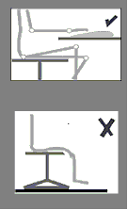

**One:** Adjust seat height to ensure hands are perpendicular to keyboard (height adjustment is usually achieved by a handle to the left underside of the chair).

**Two:** If, with the chair set at the correct height feet cannot be placed flat on the floor, ask for a footrest. A footrest will be provided for you if required.

**Tip A2:** Make sure there is enough space underneath your desk to move your legs freely. Move any obstacles such as boxes or equipment.

**Tip A3:** Position your screen at a comfortable viewing position, height and distance. As a general rule, the top of the screen should be roughly at eye level. The screen should be positioned at about 350 - 600 mm away from you. Adjusting the swivel and tilt mechanism will allow a comfortable viewing angle and will help avoid neck muscles becoming fatigued.

**Tip A4:** Adjust your keyboard and screen to get a good keying and viewing position. A space in front of the keyboard is sometimes helpful for resting the hands and wrists while not keying.

**Tip A5:** You should ensure that you sit 'face on' to your computer screen. This will avoid you twisting your body and placing unnecessary strain on muscles and tendons.

**Tip A6:** Arrange your desk and screen so that bright lights are not reflected in the screen. You shouldn't be directly facing windows or bright lights. Adjust curtains or blinds to prevent unwanted light. Ideally your screen should be at 90 degrees to the source of the reflection / glare. Screens that use dark characters on a light background are less prone to glare and reflection. If these 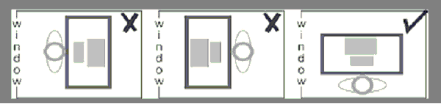measures do not work then you should consider anti-glare screen filters.

### B. Workstation use:

**Tip B1:** Don't sit in the same position for long periods. Make sure you change your posture as often as practicable. Some movement is desirable, but avoid repeated stretching movements.

**Tip B2:** Screen-based work should be broken up by other tasks such as filing, photocopying, etc. Computer work should be organised so that you do not work for periods of one hour or more on a computer without a change to some other work or a 5 minute rest break. This is especially important if the computer work is particularly intensive or requires a high degree of concentration. It is recommended that you should have a break of at least 5 minutes for every hour spent doing screen-based work.

**Tip B3:** With the chair set to the correct height it should not be too high to create pressure under your thighs nor too low to give no thigh support. As a rough guide, your knees should be at right 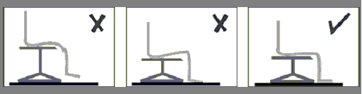angles. Remember about a footrest if you cannot touch the floor.

|  |  |
| --- | --- |
| **Tip B4:** The seat back height should be adjusted to provide support for the small of your back when you are sitting erect but comfortable.   Seat back height adjustment should be independent of chair height adjustment and is often adjusted by loosening control to rear of chair.   Adjust to correct height and then re-tighten control. | Image showing proper lower back support |

**Tip B5:** Be aware of your posture at all times.   
Don't slouch as this could lead to back problems.

**Tip B6:** Make sure the characters on your screen are sharply focused and can be read easily. They shouldn't flicker or move. If they do then you should get your screen serviced or replace it.

**Tip B7:** Make sure there are no layers of dirt, grime or finger marks on the screen (or your glasses, if you wear them.)

**Tip B8:** Use the brightness control on the screen to suit the lighting conditions in the room. These controls can be found on the lower front side of the monitor itself.

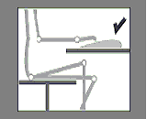

**Tip B9:** Don't bend your hands up at the wrist when keying. Try to keep a soft touch on the keys and don't overstretch your fingers.

Good keyboard technique is important.

Don't rest your forearms on the edge of your desk as this can lead to health problems in the forearms.

**Tip B10:** Ensure that you use your mouse correctly. The mouse should be positioned close to your body to avoid excessive reaching to operate it. Your fingers should be placed down the body of the mouse to reduce movement at the knuckles and operation should be from the elbow to limit bending and twisting at the wrist.

**Tip B11:** Try different layouts of keyboard, screen and document holder to find the best arrangement for you. **Tip B12:** Make sure you have enough workspace to take whatever documents you need.   
A document holder may help you to avoid awkward neck movements.

## C. Office Environment

### C1. Temperature, Ventilation and Humidity

Individuals will have different tolerances for these environmental factors. However, task, work volume, clothing and your health all affect the temperature at which you feel comfortable. Office environments should not be lower than 16 degrees Centigrade. You should avoid locating a workstation where temperature problems are foreseeable. Consider local variations e.g. a workstation adjacent to a south facing window may be much warmer than the same set-up located in an area away from the window or a self closing mechanism on a door next to a workstation may prevent the DSE user suffering from unpleasant draughts.  
Extremely dry air can cause discomfort to the eyes of DSE users. Excessive humidity is also unpleasant. Build up of static electricity is also more likely in areas of low humidity.

**Tip C1:** Temperature, air flow and humidity are environmental factors that require particular attention when planning computer clusters. Additional environmental control in the form of a potable fan or air conditioning may be required. One or two potted houseplants may help to control low humidity, in addition to making the room seem pleasant.

### C2. Noise

In open plan/shared offices background noise may be distracting to DSE users and may contribute to reduced efficiency or errors. Noise levels experienced at a work station should not be sufficiently high as to cause unreasonable distraction. This will again be subject to individual tolerances.

**Tip C2:** Noisy equipment (i.e.: dot matrix printers, photocopy machines, etc.) may need to be placed behind screens to limit noise or placed further away from occupants. During refurbishments and/or building projects local noise levels may increase. If these levels become problematic you should consult your line manager.

### C3. Lighting

Office lighting should allow you to read documents and your keyboard without visual discomfort. A desk lamp may be required if the lighting in the office is insufficient for the tasks you are performing. If your office environment is too bright there are a number of things you can do, see overleaf:

* Repositioning your desk to avoid glare is important as reflections off one screen can cause discomfort and may even cause headaches. This has already been discussed earlier in Tip A6.
* Blinds can be installed to allow you to regulate the amount of light entering your work environment locally. This is effective as it will allow you to vary it according to the change in season (i.e.: In winter you may require more light in the late afternoon).
* Dimmer switches can also be installed if required.

### C4. Layout of Office Area

The layout of your office area should not interfere with your health and safety. If you find that you frequently bump into certain items they should be repositioned so this does not occur. There should be no trip hazards (i.e.: trailing wires; piles of documents; etc) that someone may encounter as these have the potential to cause serious injury.

## EXAMPLE OF WORKSTATION SET-UP

The following checklists should help you determine the ideal workstation set up and seating arrangement.

### Figure 1: Workstation Layout

1. 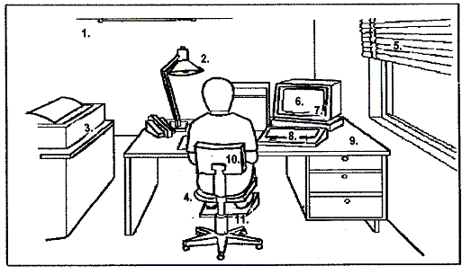Adequate Lighting
2. Adequate contrast - no glare or distracting reflections
3. Distracting noise decreased to a minimum
4. Leg room and clearances to allow postural changes
5. Window covering
6. Appropriate software
7. Screen: stable image, adjustable, readable, glare/reflection free
8. Keyboard: usable, adjustable, detachable, legible
9. Work surface: allow flexible arrangements, spacious, glare free
10. Work chair: Adjustable Footrest

### Seating arrangementsFigure 2: Seating Arrangement

## FURTHER INFORMATION

For further information visit the Health & Safety Executive web site <http://www.hse.gov.uk/>   
  
Direct link to HSE- VDU Guidance <http://www.hse.gov.uk/pubns/indg36.pdf>

#### 

# College Information Systems Security Policy - Supporting Policy 2: Conditions of Use of IT Facilities

The User agrees and accepts that:

**1.** Use of College IT facilities, and their use to access non-College IT facilities, must be for the purpose of University research, teaching, coursework, associated administration or other authorised use. No 'private/commercial' work is permitted without prior authorisation. College IT facilities include the network, the virtual private network (VPN), computers, printers and the associated services e.g. software, data, email, Web, E-journals, bulletin boards, data bases but do not exclude any other part of the College IT facilities.

Occasional personal use of the Desk top computer, e-mail and web access is permitted provided such use does not disrupt the conduct of College business or other Users. Recreational use of the Halls of Residence network is also permitted, subject to these conditions.

**2.** When using College IT facilities the user must comply with the College Information Systems Security Policy and all relevant statutory and other provisions, regulations, rules and codes of practice. Specifically, but not exclusively, the User must:

**2.1** Not disclose to others her/his College login name/password combination(s) or access or attempt to access IT facilities at College or elsewhere for which permission has not been granted or facilitate such unauthorised access by others.  
**2.2** Not use or produce materials or resources to facilitate unauthorised corruption, changes, malfunction or access to any IT facilities at the College or elsewhere. Attempted access to IT facilities includes scanning activities (e.g. port scanning).  
**2.3** Not display, store, receive or transmit images or text which could be considered offensive e.g. material of a sexual, pornographic, paedophilic, sexist, racist, libellous, threatening, defamatory, of a terrorist nature or likely to bring the College into disrepute.  
**2.4** Not forge email signatures and/or headers, initiate and/or forward 'chain' or 'junk' or 'harassing' email.  
**2.5** Not play unauthorised games.  
**2.6** Respect the copyright of all material and software made available by the College and third parties and not use, download, copy, store or supply copyright materials including software and retrieved data other than with the permission of the Copyright holder or under the terms of the license held by the College.  
**2.7** When holding data about living individuals, covered by the College Data Protection Policy, register that data and its uses, and treat it in accordance with the Principles, as required by the Data Protection Act. Student users must not construct or maintain computer files of personal data for use in connection with their academic studies/research without the express authority of the Departmental/Divisional Data Protection Co-ordinator.  
**2.8** When responsible for Information Servers or the information held thereon abide by the College Code of Practice for Information Servers and be aware that a User may be considered in law to be a Publisher in certain circumstances.

**3.** All data/programs created/owned/stored by the user on or connected to College IT facilities may, in the instance of suspected wrong doing, be subjected to inspection by College or by statutory authorities. Should the data/programs be encrypted the User shall be required to provide the decryption key to facilitate decryption of the data/programs.

**4.** Other than any statutory obligation, the College will not be liable for any loss, damage or inconvenience arising directly or indirectly from the use of, or prevention of use of, any IT facility provided and/or managed by the College.

**5.** Whilst the College takes appropriate security measures against unauthorised access to, alteration, disclosure, destruction or accidental loss of personal and other data it cannot and does not give any warranties or undertakings to the USER about security, confidentiality or integrity of data, personal or other. The same applies to other IT material submitted to or processed on facilities provided or managed by the College or otherwise deposited at or left on its premises.

**6.** His/her name, address, photograph, status, e-mail name, login name, alias, College Identifier (CID) and other related information will be stored in computerised form for use for administrative and other purposes e.g. monitoring system usage.

**7.** As provided by the Telecommunications (Lawful Business Practice) (Interception of Communications) Regulations 2000, made under the Regulation of Investigatory Powers Act 2000 the College will intercept and monitor electronic communications for the purposes permitted under those Regulations in accordance with the Code of Practice on Monitoring Electronic communications in the College Information Systems Security Policy.

**8.** These conditions apply to non-College owned equipment e.g. personal Laptops, home PCs when connected to the College network, directly and/or via the VPN, for the duration that the equipment is using the College network.

**Breach of these conditions may lead to College disciplinary procedures being invoked, with penalties which could include suspension from the use of all College computing facilities for extended periods and/or fines. Serious cases may lead to expulsion or dismissal from the College and may involve civil or criminal action being taken against the User.**

If you have any difficulty, please contact your Departmental/Divisional Computing Representative or the ICT Service Desk (Ext. 49000) or the ICT User Registration Office (Ext. 49008).

You can also see this information at

http://www3.imperial.ac.uk/secretariat/collegegovernance/provisions/policies/infosystems

**College Information Systems Security Policy**

Your attention is also drawn to this Policy which may be viewed online on the ICT website <http://www3.imperial.ac.uk/ict/services/securitynetworkdatacentreandtelephonyservices/security/securitypolicies>

This page links to the different sections of the Policy, the Codes of Practice, and a set of Guidelines. For example, There is information about Password, and on protecting sensitive data In summary, the Policy reveals the extent to which the College acts in order to keep safe all critical College information and information systems.

You should note **Guideline 5** which deals with *Misuse of College IT Systems by Students* and provides a list of the Summary Punishments.

It is known that the student-community share “recreational” files such as music and video clips. Often this material is obtained by looking for “open shares” on the network. This activity is contrary to College Policy. You are also reminded that acquisition of such material should be in an authorised manner as much of it is copyright. Re-use of material provided to you is also copyright and you should respect it and not re-distribute in any way except with express and prior permission of the copyright holder.

**Peer-to-Peer software**

Whilst the use of Peer-to-Peer file transfer software on the campus network is not explicitly forbidden, since it can have some legitimate uses, such software must never be used to transfer copyrighted materials without the permission of the copyright holder.

College reserves the right to investigate and close down any systems which:

* Use Peer-to-Peer software to transfer copyrighted materials without the permission of the copyright holder
* Make excessive demands on College network bandwidth
* Are suspected of being involved in a security breach

The owners and/or users of such systems could face disciplinary action.

This also applies to personal computers in Halls, at home or elsewhere and which are connected to the College network remotely by VPN, and by wireless or wired-connections in College.

**Protecting Sensitive Data**

The College Policy for handling sensitive data is given at <http://www3.imperial.ac.uk/ict/services/security/helpandadvice/sensitivedata> .

**Protecting Patient Identifiable Data**

When considering Patient Identifiable Data, the Code of Practice 2 applies see <http://www3.imperial.ac.uk/legalservicesoffice/dataprotection/codesofpractice/cop2>

This requires that data on living individuals e.g. clinical data, collected for whatever purpose, must not be stored or transmitted on the College network unless it is both registered and adequately protected to prevent disclosure of that data to unauthorised persons.

**Internet privacy**

Alongside the College policies, ICT also provides more guidance on.

Email, Backing up data, Computer security basics, Copyright, How not to respond to “phishing”, Internet privacy, Keeping your password safe, and Protecting sensitive data  
  
See <http://www3.imperial.ac.uk/ict/secureaware/internetprivacy>

# GMC and BMA Guidance on use and role of Social Media

Many health professionals use websites such as Facebook, Twitter and various different internet forums. While the use of social media can bring both personal and professional benefits, it can also present a number of risks to doctors and medical students.

# GMC: Social media: what does it mean for you? See <http://www.gmc-uk.org/information_for_you/11851.asp>

## BMA - Discretion the better part of social media valour <http://bma.org.uk/news-views-analysis/news/2012/march/discretion-the-better-part-of-social-media-valour>

Your Ethics course will also make reference to this topic.

# Illegal Transfer or use of Copyright Material

This ICT website <http://www3.imperial.ac.uk/ict/services/securitynetworkdatacentreandtelephonyservices/security/securitypolicies/copyrightmaterial>   
provides further information about copyright for music, movie and images files. Teaching materials, novels, etc., are also copyright. Statutory regulations cover what you are permitted to do with material where others own the Copyright and Intellectual Property Rights. The teaching intranet has Conditions of Use concerning reuse of all the teaching materials which are provided for your person use.

****Faculty of Medicine

Faculty of Natural Sciences

Computer Laboratory   
Food and Drink Policy

The “misuse of computer facilities or activities” is a disciplinary offence, as defined in paragraph A. 1(vi) of the College Procedures[1] for dealing student disciplinary offences.   
The action described below is in accordance with and subject to the College Procedures.

1. **Any student found to be visibly in possession of food or drink in a student computer laboratory will, on the first offence, have his/her password removed by the ICT Support staff.** It will not be reinstated until the student has seen a senior member of staff* to request reinstatement of the account, but loss of access to the account will normally be for less than seven days. At the time of interview, the student will be reprimanded, fined **£10** (to go to the Student Hardship Fund) and informed of his/her right of appeal.

*

for Medicine undergraduate students – the Head of Learning Resources or chairman of a campus IT committee

for Medicine postgraduate students – the chairman of a campus IT committee or the Departmental Administrator

for Life Sciences undergraduate students – the Director of undergraduate Studies or Senior Tutor

for Life Sciences postgraduate students – the Divisional Administrator

1. **The exception will be that drinking from a container with a non-spill cap will be permitted.**
2. **Loss of access to a computer account will not be regarded as an extenuating circumstance** in the event that either (i) deadlines are missed, *e.g.* for submission of coursework and completion of on-line assessments, or (ii) that senior staff are not immediately available to interview the student.
3. **A repeat offence will again lead to immediate removal of password.**   
   The student will be called before the Director or Education (Medicine) or delegate, or the Director of Undergraduate Studies for Life Sciences or delegate, as appropriate.   
   The student will be reprimanded, informed that the password will be removed for seven days, fined **£100** and informed of his/her right of appeal.
4. **A further offence will precipitate a full College Discipline Committee hearing.**   
   The student will have his/her password removed until such time as the Committee has come to a decision.

|  |  |
| --- | --- |
| **Professor Jenny Higham**  Director of Education  Faculty of Medicine | **Dr Stephen Curry**  Director of Undergraduate Studies (Life Sciences)  Faculty of Natural Sciences |

September 2012

1. <http://www3.imperial.ac.uk/registry/information/formsproceduresandregulations>