Editing Refworks Vancouver Settings

- Open and log-in to Refworks

- Click on the Bibliography tab on the top navigation bar and select output style editor.

- Select the referencing style you wish to edit (in this case ‘Imperial College London – Vancouver’) from the drop-down menu.

- Click on the ‘Save As’ button and create a new style name e.g. ‘Imperial college London – Vancouver version 2’

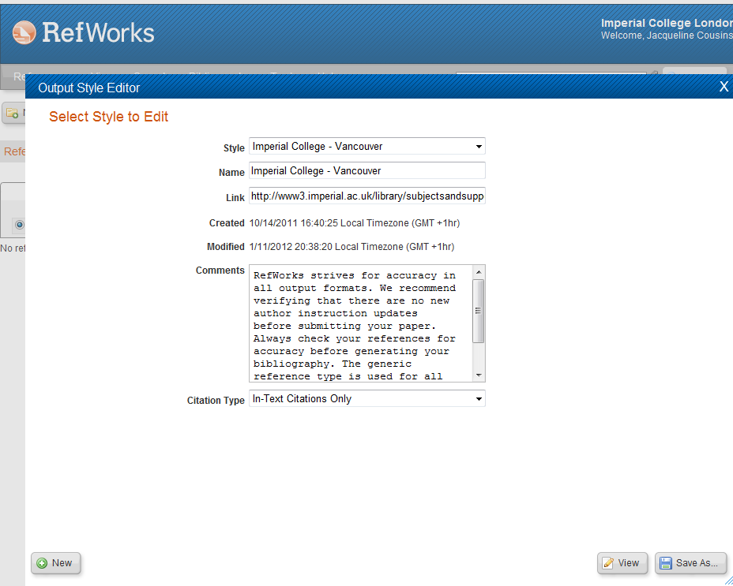

- Once you have created and Saved the new style, click the “Edit” button at the bottom of the box

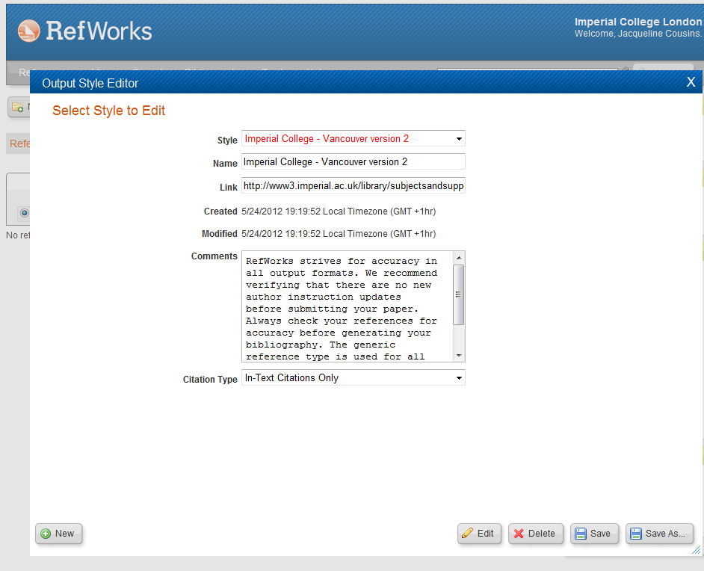

Now you can choose how many authors should be displayed in the references

If you want All authors to appear you will need to edit each Reference Type (e.g. ‘journal article’, ‘Book, whole’ etc.)

Below I have chosen ‘Journal Article’ next to ‘Reference Type’

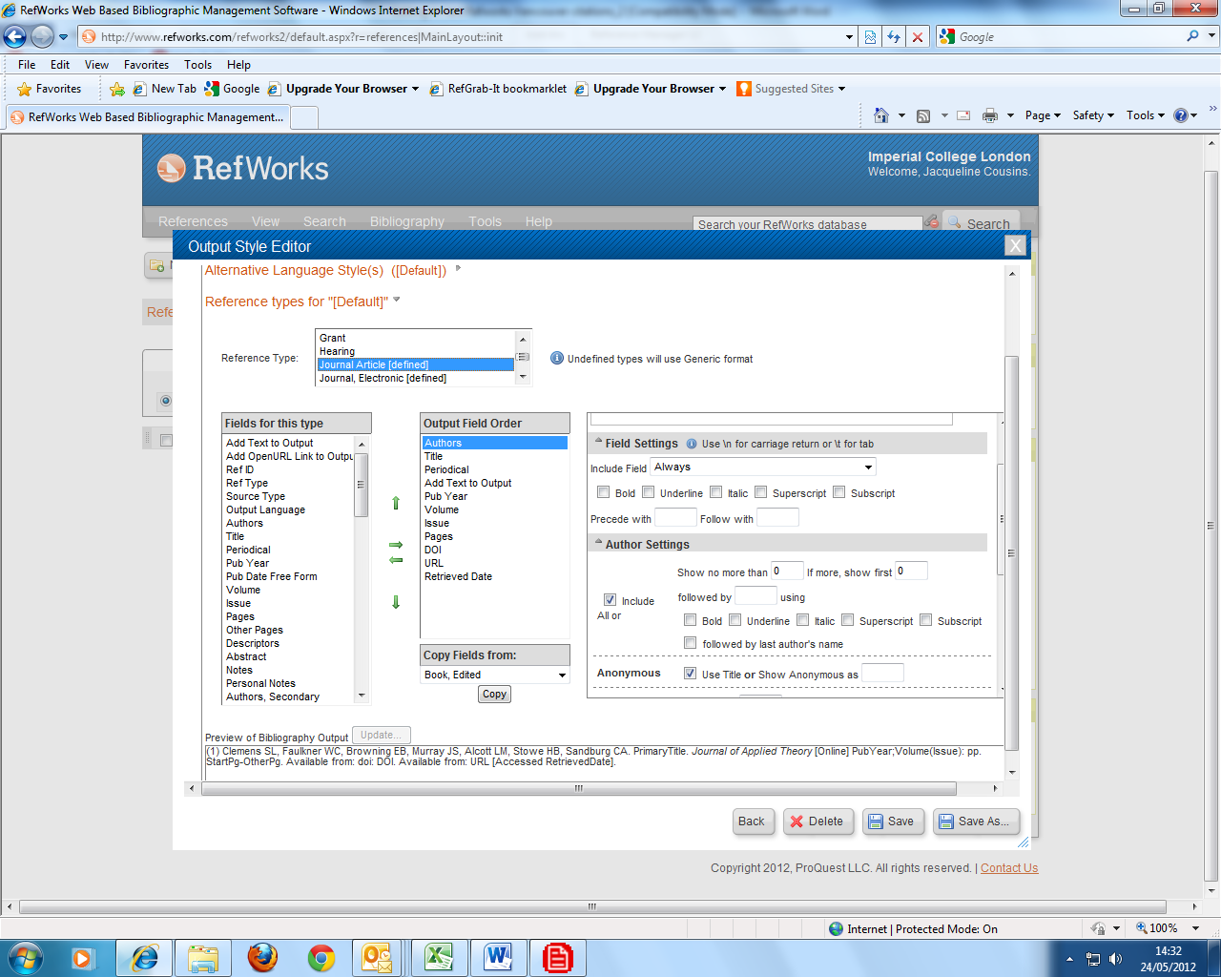

On the Bibliography tab place a tick in the “Include All” box under “Authors settings” and remove any numbers in the ‘show no more than’ boxes and remove ‘et al’ from the ‘Followed by’ box.

- Now click on the ‘Save’ button at the bottom of the page and then make the same changes to any other reference types you have used.

- In Microsoft Word: open Write-N-Cite and use as it normal. However, when you format the document make sure that you use your new style (Imperial college London – Version 2) and the reference list should show all authors.

