
An Introduction to Spirometry

It is important to remember that there are well over 40 common lung diseases and that the symptoms of lung disease may be shared with disorders of other systems. For example breathlessness may be due to:

- Lung disease
- Heart disease
- Pulmonary Thrombo Embolic disease
- Systemic disorders (such as Anaemia, Obesity and Hyperthyroidism)
- Respiratory muscle weakness

Over the last few years the wider availability of Mini Peak Flow meters has meant that measurement of Peak Expiratory Flow has become widespread but Spirometry is probably under used. Perusal of the list of possible lung diseases in Table 1 shows that they may be divided into either infections or into the two major categories of small lung disorders or airway disorders. Peak Expiratory Flow monitoring is an acceptable measurement for the serial monitoring of those with diagnosed airway narrowing (especially asthma) but it is a poor diagnostic test, does not differentiate between airway and small lung disorders and is not good for assessing the severity of common disorders such as Chronic Obstructive Pulmonary disease.

Spirometry is therefore the preferable surgery, ward or clinic based test for use in the initial evaluation of those presenting with respiratory symptoms and also as an adjunct to Peak Flow Monitoring for those with established airway disease, where it should form part of the serial follow up of patients in the same way as does measurement of blood pressure and blood sugar in those with hypertension or diabetes.

Spirometry is undertaken using either a low resistance spirometer of bellows type (See Figure 1) or an electronic version. The procedure involves the patient undertaking a maximum forced expiration after a full inspiration. The most common measurements are the FEV1.0 and the FVC and these are presented as absolute figures which are compared to predicted normal figures which vary according to age, sex, and height. The FEV1.0/FVC ratio is usually expressed as a percentage.

The Forced Expiratory Volume in 1 second (FEV1.0) is the volume of air expelled in the first second of a forced expiration starting from full inspiration.

The Forced Vital Capacity (FVC) is the total volume of air expelled in a forced expiration, starting from full inspiration.

The FEV1.0/FVC ratio is the percentage of the FVC exhaled in the first 1 second of the forced expiration.

It is important to think simply about what is happening during these forced expiratory manoeuvres and not to be obsessed with the calculation of the ratio. In a normal person their Forced Vital Capacity will be 4, 5, 6 or 7 litres depending upon their age, sex and height, and the key thing to note is that they will be able to blow out more than three quarters of this volume in the first second. Their FEV1/FVC ratio is thus more than 75% (the exact ratio falling a little with age).

In somebody with generalised airway narrowing on the other hand, the amount of air they can blow out after a maximum inspiration (the FVC) may well be reduced, but the most marked abnormality to note is that it takes them longer to blow out than normal. In the old days, wise clinicians listened to the duration of expiration over the trachea and if it took the patient longer than 4 seconds to exhale fully they regarded that as being clear evidence of airway narrowing. Undertaking Spirometry in somebody with severe generalised airway narrowing will therefore reveal a reduced FVC but the subject will only be able to exhale 30/40/50 or 60% of that FVC in the first 1 second and the process of forced expiration is extended. An FEV/FVC ratio or percentage of less than 75% is therefore referred to as Obstructive Spirometry.

In contra distinction to this, Spirometry on somebody with a small lung (restrictive) disorder such as Fibrosing Alveolitis, Obesity or Scoliosis (see the Table), will show a reduced Forced Vital Capacity. However because the airways are not narrowed the vast majority of this Forced Vital Capacity will still be exhaled in the first 1 second giving a FEV/FVC ratio of more than 75%.

In summary, if you undertake Spirometry, and the subject has an FVC which is normal for their age, sex and height and they blew out more than 75% of that FVC in the first second they are likely to be normal. If on the other hand the Forced Vital Capacity is reduced you then need to note whether it was reduced but associated with a normal FEV1.0/FVC ratio, in which case they have a small lung/restrictive disorder, or if the FVC ratio is less that 75% they clearly have an airway disorder. An apparent restrictive lung disorder due to anything other than Obesity should be investigated by chest radiography and referral for measurement of total lung capacity in the Lung Function Laboratory and for a specialist opinion.

Pictorial examples of these patterns are shown in the Spirograms in Figure 2 below.

Steps involved in performing spirometry:

- Introduce yourself to the patient.
- Explain the purpose of the test to the patient (“We are going to undertake a test to examine the function of your lungs”).
- Explain to the patient that the procedure involves a forced expiration. This means the patient taking a very large breath in, followed by them blowing out through the mouthpiece as hard and as fast as they can, right the way out, until they have squeezed the last bit of breath out of the lungs.
- Ask the patient if they have any concerns or questions about the procedure.
- Explain to the patient that they need to wear a nose clip to prevent air escaping through the nose.
- Explain that they will need to put the mouthpiece into their mouth and close their lips tightly around the mouthpiece.
- Ask the patient if they understand everything you have told them so far and if there are any questions.
- Press the Power switch to |.
- Insert a Vitalogram chart in the chart carrier.
- If the chart carrier is not in the start position, i.e. as far to the left as it can go, press the Record switch to .
- Set the stylus on the Stylus Start point.
- Inform the patient that you are measuring how much and how fast they can exhale after filling their lungs completely.
- Press the Record switch to .
- With the patient sitting comfortably in front of the machine and wearing the noseclip ask them to take a very large breath in, and then place the mouthpiece into their mouth and with their lips tightly closed around the mouthpiece, blow out as hard and as fast as they can until they are red in the face.
- Whilst the patient is blowing out, encourage them to really exhale as hard and as fast as they can. Continue the test until the stylus ceases to rise. When they’ve really blown right the way out allow them to come off the mouthpiece, congratulate them on their effort and let them relax, and allow the patient a reasonable rest between efforts.
- Repeat the procedure until you have three reproducible results.
Note: If safety mouthpieces are being used it will be necessary to remove the mouthpiece to empty the bellows prior to re-testing.
- Calculate the FEV1 and the FVC ratio as on the diagrams below. Look up the patient’s predicted values according to their age, sex and height from the charts kept alongside the Spirometer.
- Remove the mouthpiece ready for the next patient and insert a new sheet.

Pitfalls
The commonest error when supervising spirometry is not to ensure that the patient undertakes a maximal inspiration followed by a maximal expiration. Poorly performed spirometry may give misleading results and if the patient does not breathe out fully an obstructive defect may falsely appear as a restrictive defect. Watch also for leaking around the mouthpiece.

MRP 20/06/02

Figure 1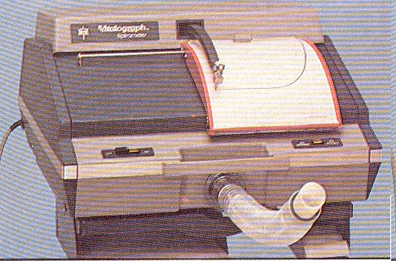
Table 1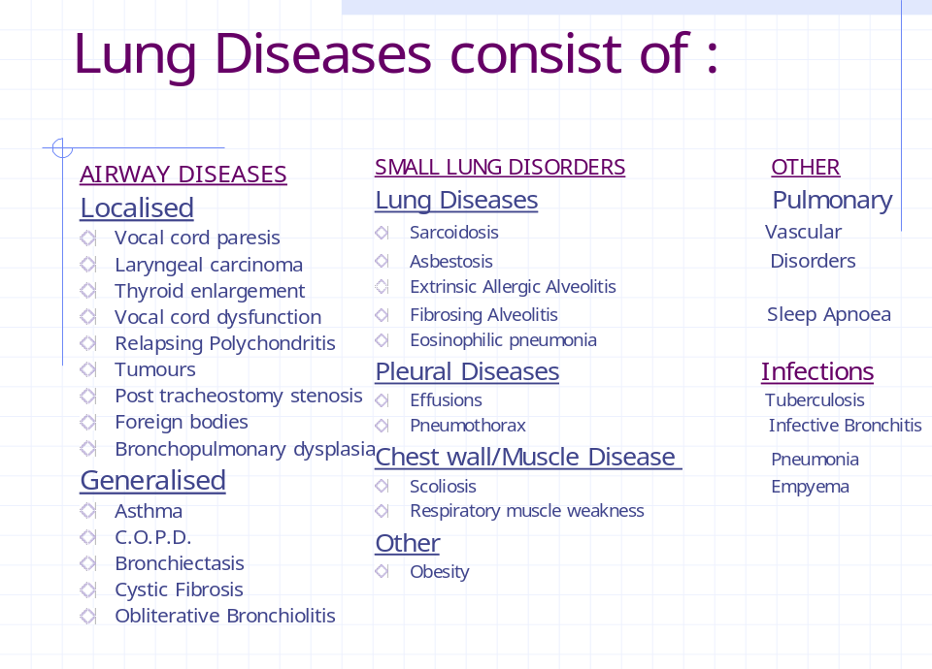
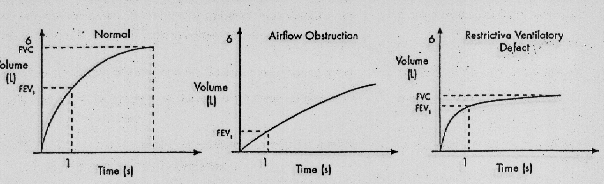
Figure 2

