Faculty of Medicine
Faculty Education Office

Health and Safety Code of Practice for Undergraduate courses

Table of Contents
1 Introduction 2

2 Practical classes, lone working and out-of-hours working 2
2.1 Practical Classes 2
2.2 Lone working in academic departments 2
2.3 Out-of-hours working in academic departments 2
3 Clinical attachments (including General Practice) 2
4 Campus Safety information 2
5 Accident and Incident reporting 2
5.1 Completing an incident report 3
5.2 Types of incidents which must be reported 3
5.3 What happens to the incident report? 3
6 Sharps and inoculation injuries - Occupational Health 4

Your clinical course 6
7 Clinical and personal safety 6
8 Vaccinations 6
9 Infection Control: Reducing the spread of infections 6
10 Infection Control: Barrier Nursing 7
11 Dressings 7
12 Safe Sharps Practice 7
12.1 Action following a sharps injury 8
13 Disposal of sharp instruments 8
14 Fire alarms and building evacuations 8
15 Moving Patients 8
16 Comments and feedback 8

Introduction
Your health and your safety are very important to us, and both staff and students must, by adopting safe working practices, also take every reasonable care of their own and other’s health and safety. Such practices are set out in the College’s Health and Safety Policy and associated Codes of Practice, which can be found on the College web site http://www3.imperial.ac.uk/safety/policies

Practical classes, lone working and out-of-hours working

Practical Classes
The academic course organiser will ensure that, for each of their practical classes or student projects, a risk assessment has been completed and reviewed with the Campus Safety Manager before commencement of each class or project. The objective is to ensure that all such classes are conducted in a safe manner, where exposure to any hazard is eliminated, or minimised as far as is practicable. Where procedures are amended, a revised risk assessment must be undertaken and be approved. All relevant safety information will be provided in the instructions and protocols issued for each class. Risk assessments for all practical classes are subject to annual review.

Lone working in academic departments
Students working in academic departments are required to be under supervision at all times and are not permitted to undertake lone working at any time in laboratory or workshop areas. Students may work alone in areas designated suitable for private study.

Out-of-hours working in academic departments
Students are not permitted to work out of routine hours as designated by the Faculty of Medicine, except on projects where the academic supervisor of the out-of-hours activity has made a specific risk assessment concerning out-of-hours working.

Clinical attachments (including General Practice)
All students on clinical placements must follow the Trust’s or GP’s Health and Safety Policy and procedures and are reminded that they should be supervised for all tasks until signed off as competent. They must also follow the College/Faculty procedures for reporting accidents and incidents, and always follow “Safe Sharps Practice” (see below). Relevant information will be provided on each Firm/attachment. Students on these attachments will not be asked to undertake invasive procedures on patients known to be blood borne virus (HIV/HCV) positive.

Campus Safety information
Be aware of the local safety information for each campus and especially familiarize yourself with local fire safety rules, including different alarm systems in different buildings and of the means of safe escape. Further details for each campus are to be found at.
http://www1.imperial.ac.uk/medicine/intranet/healthandsafety/

Accident and Incident reporting
Accidents and incidents are to be reported to College using the online reporting tool link here http://www3.imperial.ac.uk/safety/ and follow the SALUS link. This requires that you are connected to the College network or a VPN connection in order to report directly to the Safety Department. If you are outside of the College and cannot connect via a VPN, then use the alternative report form available on the Safety Department (SALUS) webpage and send this back to Medicine UG Accidents

See the flowchart in Section 5.3 below, showing what must be done if you are injured, or if there is a near miss or if a control measure fails. For College guidance, see http://www3.imperial.ac.uk/safety/subjects/reportingaccidents

Completing an incident report
This must be completed by the student concerned with the supervising clinician or academic, as soon as practicable after the incident. They should always:
1) attempt to determine the cause of the accident;
2) record any actions they took immediately following it; and
3) report any longer term actions they took or which are required to prevent recurrence.

Types of incidents which must be reported
In College areas - all accidents and near misses must be reported to the academic member of staff giving the lecture/tutorial, or supervising the practical class who is obliged to inform the local safety officer. This includes incidents: in the Multi-Disciplinary Labs in the Sir Alexander Fleming Building, in the Anatomical Skills Laboratories at Charing Cross, in the Communication Skills Labs and Clinical Skills rooms at Charing Cross and St Mary’s, in the 3rd floor teaching labs (Commonwealth Building, Hammersmith campus) and in all lecture theatres, seminar rooms and Faculty of Medicine PC clusters.

In BSc classes undertaken in the Academic Departments - all accidents and near misses must be reported to the lecturer or the supervising member of staff, who must also complete the online incident reports (URL for SALUS reporting online http://www3.imperial.ac.uk/safety/formsandchecklists/accidents ).

On clinical placements, students must report all incidents via the relevant Trust’s reporting system and to the Director of Clinical Studies and the Teaching Coordinator, or to the Primary Care Practice. In addition, a copy of the Trust incident report should be sent to Medicine UG Accidents

Any incident requiring medical attention by a GP, an Occupational Health Department (College or Trust) or the College Health Centre, must be reported by them to the College Safety Department as soon as possible, together with a brief written report, including details of any time taken off due to the incident. Absence from study must also be reported to the FEO.

What happens to the incident report?
On receiving an incident report, the College Safety Department may decide to investigate any incident in greater depth. In such an instance, the Safety Department will send a written report of any such investigation to the Director of Education and the Undergraduate Teaching Safety Officer. The Director of Education will undertake any further action that is necessary.
Data from all College incidents is collated and trend analysis conducted; some more serious incidents are reported to the HSE.

The following flowchart (Figure 1) explains what to do in the event of an accident in College.

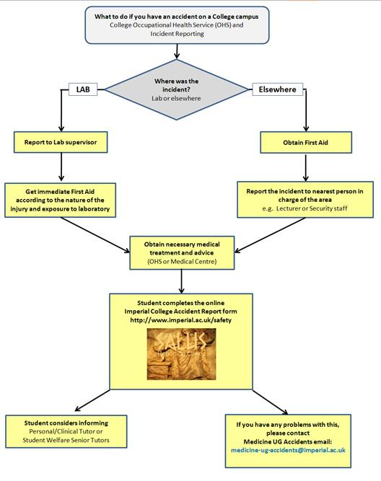
Figure 1

Sharps and inoculation injuries - Occupational Health
Any inoculation accident involving exposure to blood or other body fluids should be reported to the College Occupational Health Department. For inoculation accidents at South Kensington, the student must attend the College Occupational Health Department (OH) clinic as soon as possible for assessment by an Occupational Health Adviser. Students will also be provided with written information on local arrangements for obtaining assistance after an inoculation accident at the start of each clinical attachment.

For any injury occurring on clinical placement, the flowchart in Figure 2 explains what you need to do.
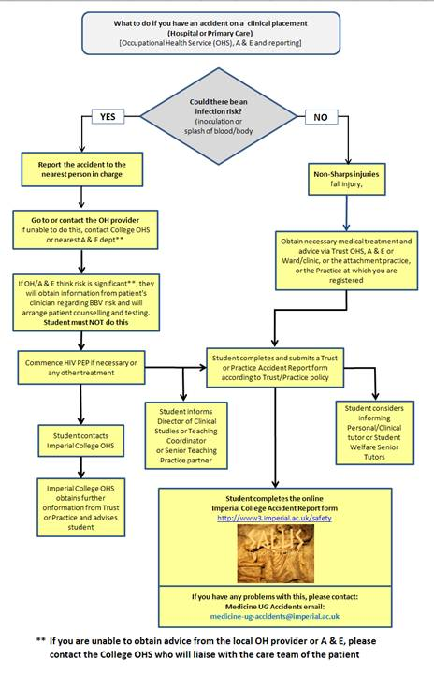
Figure 2

Your clinical course
The following are intended to guide your work on the wards and in clinics and also your reading during your clinical course.

Clinical and personal safety
Personal and clinical safety is often taken for granted by medical students, but it may be too late once an incident has taken place. In addition to the normal hazards associated with student life, clinical students may be exposed to high-risk situations on hospital wards, or when visiting patients in the community. The College, the Hospital Trusts and General Practices have procedures to minimise these risks and to deal with incidents which may occur. You must recognise your own individual responsibility to be aware of and to comply with all health and safety requirements of the College and hospitals to which you are attached. Specific guidance will be issued in separate leaflets.

Vaccinations
You must be up to date with all your vaccinations before being allowed on the wards. If you are in any doubt about your status, you should consult the Occupational Health Service on the South Kensington campus. You should always carry your vaccination record card or Smart Card with you on clinical attachments.

NB: Any student failing to observe this policy will be suspended from the course.

Infection Control: Reducing the spread of infections
You have a duty of care towards the patients, but also to the staff, visitors, yourself and other students. You must follow best practice at all times.

High standards of hygiene are required to protect you from acquiring an infection (sub-clinical or clinical) from patients. Good hygiene standards reduce the likelihood of cross infection, which can significantly lower the incident of hospital-acquired infections amongst patients. However, you must NOT enter a clinical area if you are suffering a suspected or proven gastrointestinal infection. If you have such a condition, the Teaching Coordinator for your Trust, or the General Practice to which you are attached, will provide more information according to local policies. You should also seek medical treatment. If you are unwell or unable to work in a clinical area you must also inform the relevant Year Curriculum Assistant in the FEO.

Personal effects, e.g. bags and coats, should not be taken into treatment areas, including patient bed areas. Remove wrist watches and jewelry before commencing activity that might contaminate such items.

Always decontaminate your hands by washing or using disinfectant hand gel before and after examining a patient, as well as:
Before:
- Going onto a ward or clinic
- Eating, drinking or handling food
- Performing a clinical procedure and/ or aseptic technique
- Donning gloves
- Leaving an Isolation room
- Giving personal care to a patient
After:
- Leaving the ward or clinic
- Performing a clinical procedure
- Direct contact with blood or body fluids
- Using the toilet, blowing your nose, or covering a sneeze
- Removing protective clothing, especially gloves
- Handling contaminated items, such as dressings, bedpans, urinals and catheter bags, even if you have worn gloves

To effectively clean hands, you should remove jewellery and wrist watches. You need to cleanse all areas of skin, including wrists. Use a moisturiser after cleaning hands, before work breaks and at the end of the day, to avoid skin dryness caused by frequent decontamination.

Infection Control: Barrier Nursing
Patients suffering from contagious infections or those who are vulnerable to infection are barrier nursed.
To prevent transmission of infection always:
- Wear all protective equipment provided - gloves, aprons
- Remove protective equipment before leaving the room
- Close the door after entering and leaving the room
- Wash hands after examining the patient and before leaving the room, even if you have worn gloves
- Follow any additional precautions specified for the particular patient you are seeing.
- If face masks are necessary, this should not be removed until after you leave the room. You must decontaminate your hands again after removing and disposing of the mask

Dressings
Wounds are especially vulnerable sites for cross-infection. You should never disturb a wound dressing without first checking with the nurse responsible for the patient. You must also always wear gloves and decontaminate your hands before and after handling dressing or inspecting a wound.

Safe Sharps Practice
Do:
- wear appropriate protective clothing, gloves, aprons and, where necessary, mask and eye protection.
- seek advice if you are uncertain of any procedure involving the use and handling of sharps.
- use the procedure trolleys, kidney dishes or paper trays to layout sharps.
Never use the bed as your work surface.
- discard all your sharps in the sharps disposal bin (see below) as a single unit as soon as you have used them. You are NOT to delegate this duty to anyone else.

Do not:
- re-sheath needles.
- attempt to retrieve sharps from the sharps bin.
- leave sharps unattended or for someone else to discard.
- throw sharps in a rubbish bag or waste bin.
- leave sharps in your coat pockets.
- attempt to flush sharps down the sink or sluice.
- use any sharp instrument unless you have received all the necessary instruction from a competent person and YOU feel confident to carry out the procedure.
- Do not take blood from patients known to be infected with HIV or other blood borne viruses.

It is Faculty policy that students on clinical attachments in Trusts and General Practice are not to take blood or carry out invasive procedures, e.g. involving the use of sharps, on patients known to be infected with HIV or other blood borne viruses.

Action following a sharps injury
If you are pricked or scratched with a used needle or other instrument, or if blood or any other bodily fluid is splashed into your eye, mouth or on broken skin, you need to:
- wash off the contaminated material immediately.
- encourage bleeding by shaking. Do not suck or squeeze a wound.
- wash in running water.
- use tap water or normal saline to wash out an eye splash.

You should then immediately report the injury to the person in charge and attend the hospital Occupational Health Service, and inform the DCS/TCO (Trust) or the Senior Practice Teaching partner (Primary Care) – see flowchart (Figure 2) above.

Disposal of sharp instruments
Used sharps must be treated as if potentially infected. Careless disposal of sharps cause accidents that can put you and others at risk of serious infection. Most accidents happen to nursing and support staff as doctors and medical students have not safely disposed of the sharps they have used.
Yellow sharps disposal bins are provided in all clinical areas and pathology laboratories. You must use them when disposing of sharps.

Fire alarms and building evacuations
Please familiarise yourself with the local arrangements to be followed in the event that an evacuation from a building or area is required and follow all instructions given to you. Under no circumstances attempt to deal with a fire yourself or re-enter an area in which there is a fire, chemical spillage or other significant hazard. When it is safe to re-enter an area you will receive instruction. All areas will have designated assembly points in the event of evacuations and these will be made known to you in your joining instructions. Do not re-enter a building to collect personal belongings until you are informed that it is safe to do so. It is illegal to tamper with any fire safety equipment, including fire doors.

Moving Patients
Students are not expected to lift or carry heavy objects, but you may be required to assist patients in and out of wheelchairs, beds, etc. Always follow the local procedures.

Comments and feedback
Finally, I would be very grateful if you could let me know if you have any comments relating to this Code of Practice. We review it every year and want to make it a useful document.

Deputy Director of Education
Professor Karim Meeran Date: 27 July 2012

Faculty Education Office, Sir Alexander Fleming Building, South Kensington campus
Tel: 020 8846 1065
k.meeran@imperial.ac.uk

